Confluent Kafka 3 node cluster setup.
Ubuntu 20.04
On all three nodes, add the GPG key and package repository, then install Confluent and Java:

wget -qO - https://packages.confluent.io/deb/5.2/archive.key | sudo apt-key add -
sudo add-apt-repository "deb [arch=amd64] https://packages.confluent.io/deb/5.2 stable main"
sudo apt-get update && sudo apt-get install -y openjdk-8-jdk confluent-community-2.12
On all three nodes, edit the hosts file:
sudo vi /etc/hosts
Add the following content
<server 1 private IP> zoo1
<server 2 private IP> zoo2
<server 3 private IP> zoo3
On each server, edit the Zookeeper config file:

sudo vi /etc/kafka/zookeeper.properties
Delete the contents of the config file, and add the following:
tickTime=2000
dataDir=/var/lib/zookeeper/
clientPort=2181
initLimit=5
syncLimit=2
server.1=zoo1:2888:3888
server.2=zoo2:2888:3888
server.3=zoo3:2888:3888
autopurge.snapRetainCount=3
autopurge.purgeInterval=24
Set the Zookeeper ID for each server:
sudo vi /var/lib/zookeeper/myidOn each server, set the contents of /var/lib/zookeeper/myid to the server's ID:
- On Server 1, enter 1.
- On Server 2, enter 2.
- On Server 3, enter 3.

On each server, edit the Kafka config file:

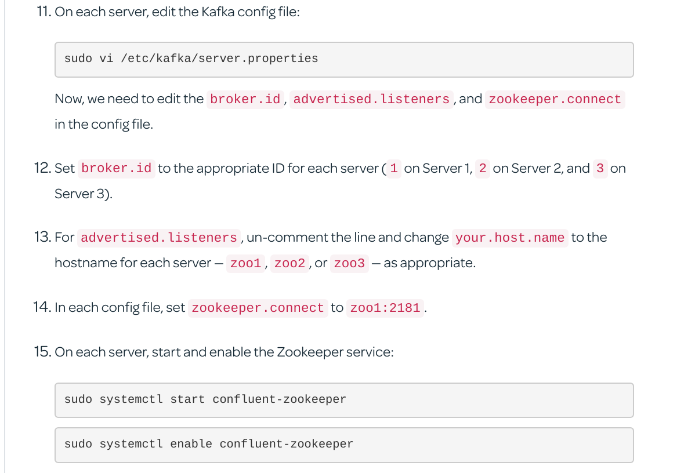
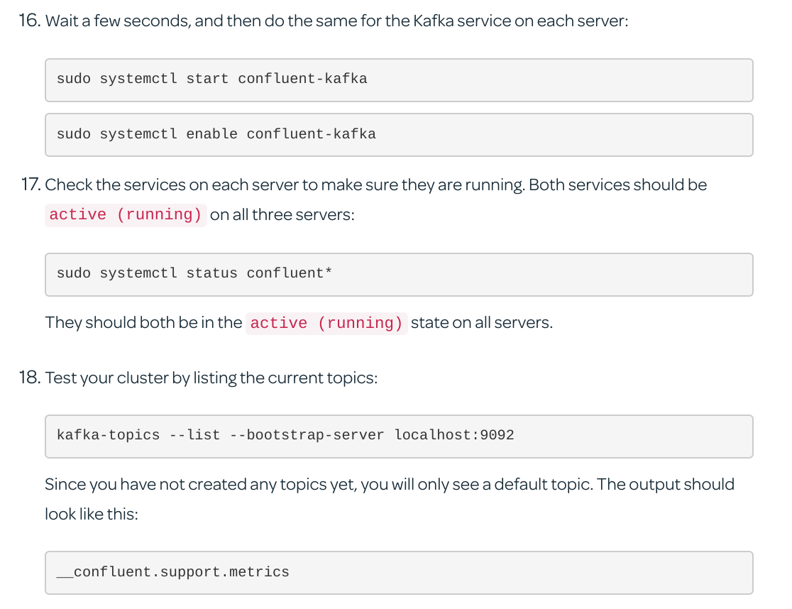

kafka-topics --bootstrap-server localhost:9092 --create --topic gp-topic --partitions 3 --replication-factor 3

