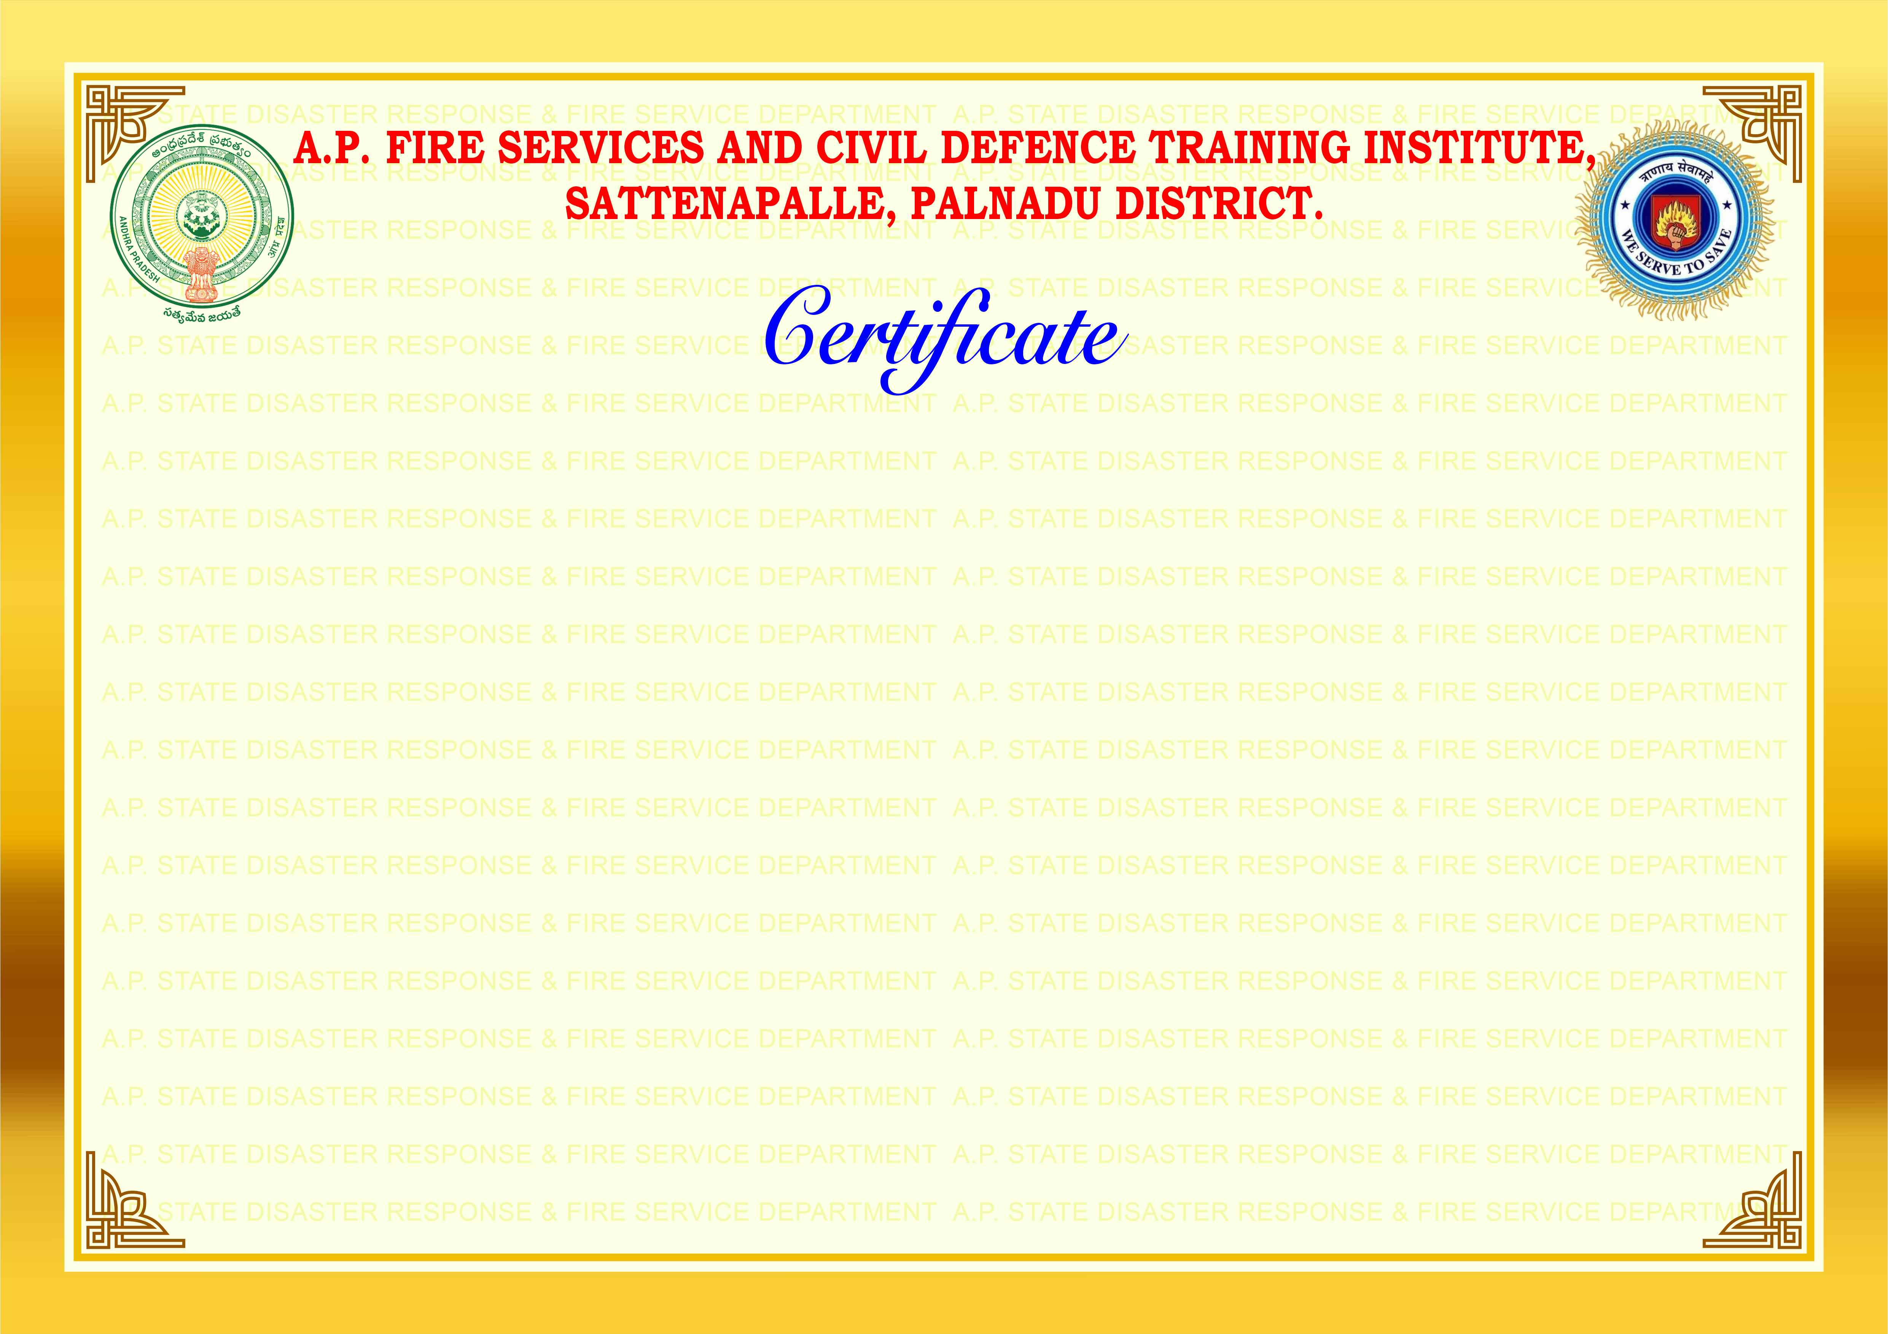


SI.No.14313

This is to certify that Mr./Ms D.GOPINADH, S/O D.BHASKAR RAO, OF THE KCP LIMITED, UNIT-II, Andhra Pradesh has undergone “Basic Fire Prevention and First Aid Fire Fighting “for a period of 3 Days from 16.09.2026 to 18.09.2026 AT PREMISES OF THE KCP LIMITED, UNIT-II, RAMAKRISHNAPURAM, MUKTYALA (VILLAGE), JAGGAIAH PETA (MANDAL) NTR (DIST), PIN -521457.

P. VENKATA RAMANA,
Director, A.P. Fire Services and Civil Defence

.

