Double click on run.bat file to get below page
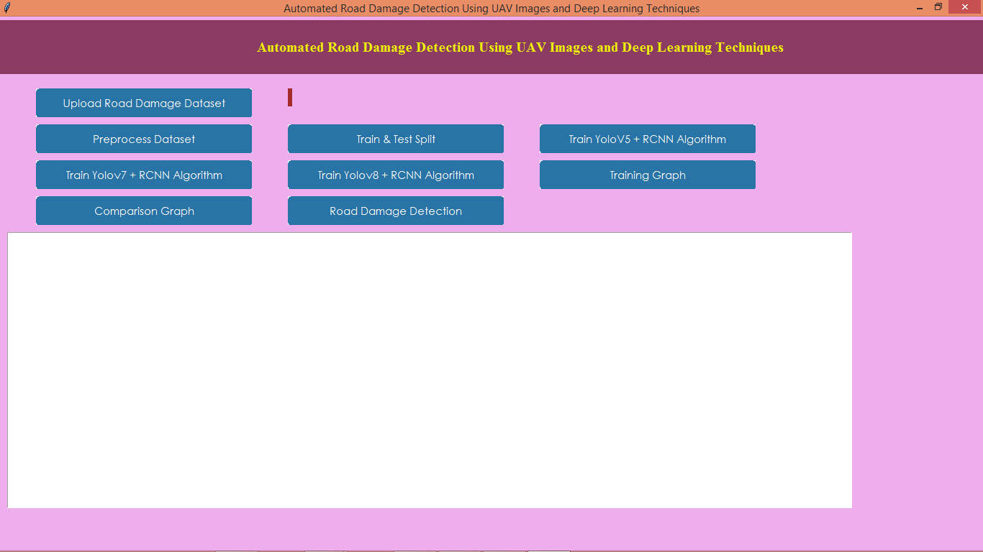
In above screen click on ‘Upload Road Damage Dataset’ button to get below page
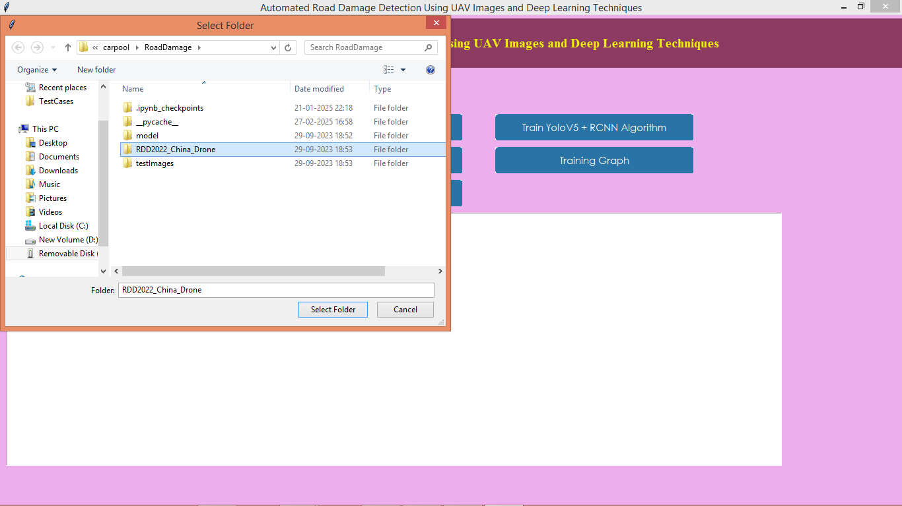
In above screen loading dataset
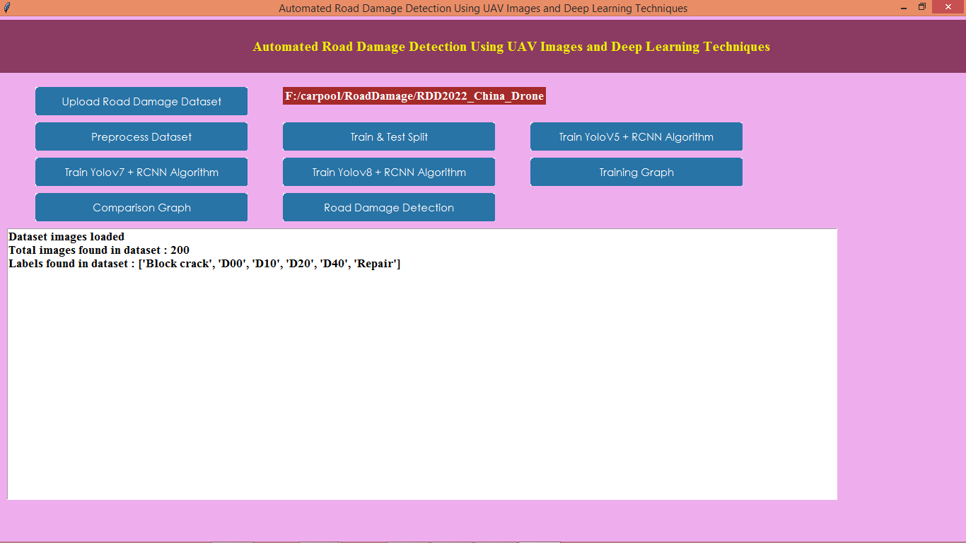
In above screen dataset loaded
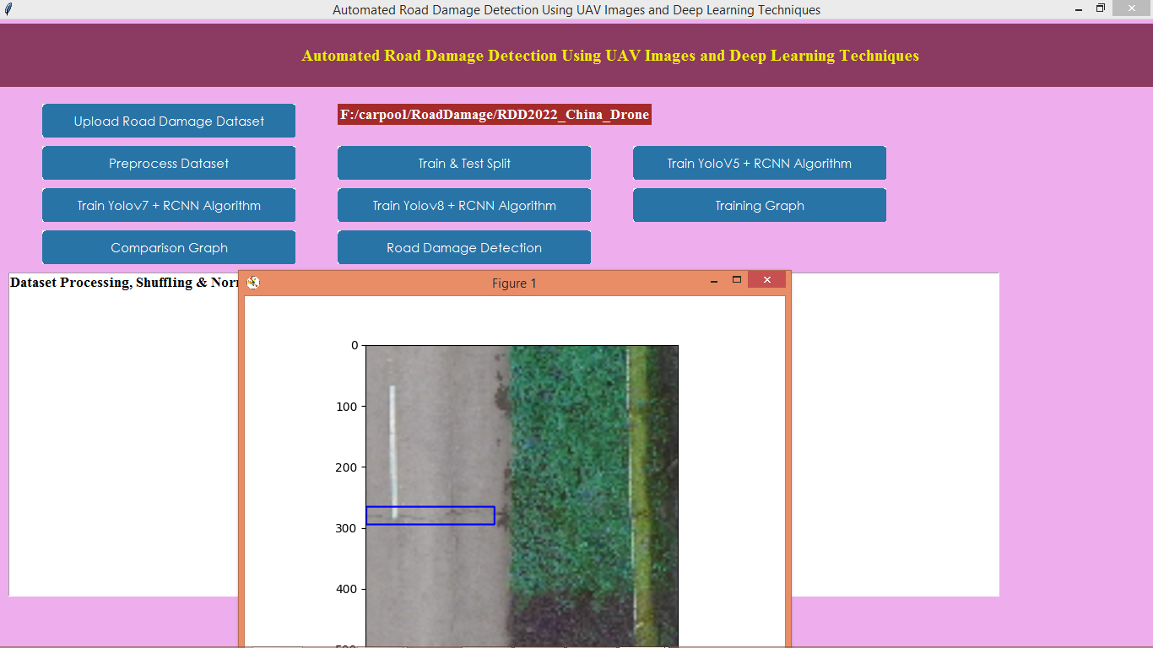
In above screen processing completed
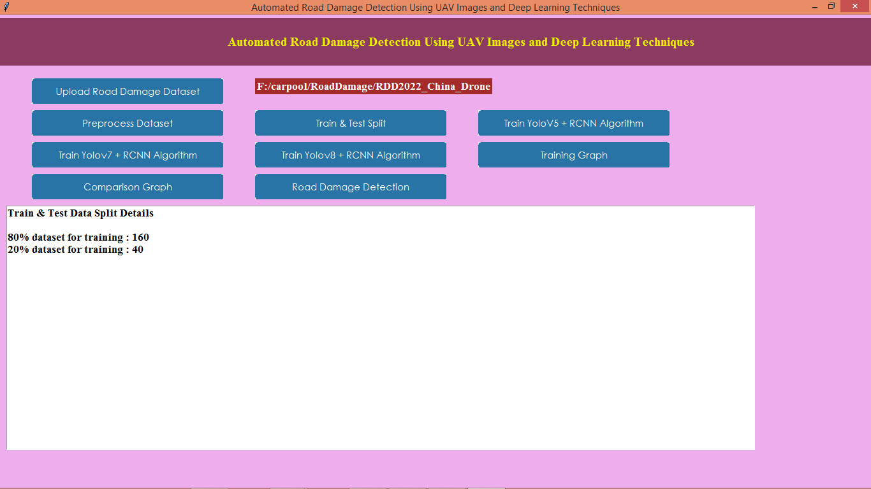
In above screen train test completed
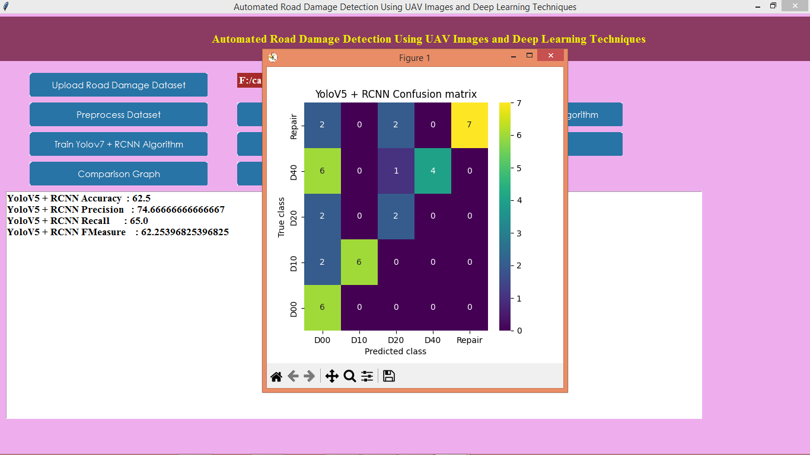
In above screen can see Yolo5 + RCNN accuracy
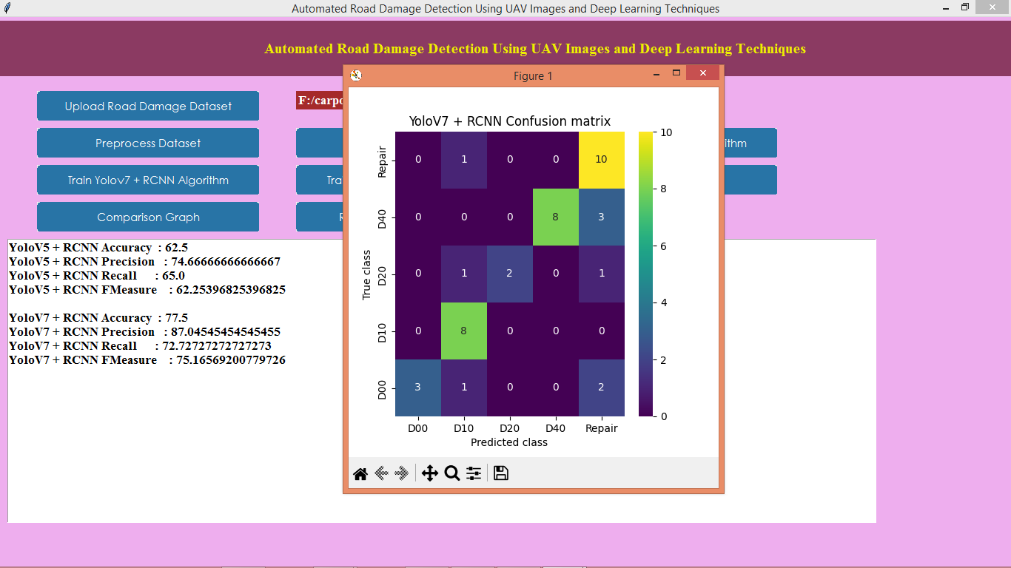
In above screen can see Yolo7 + RCNN accuracy
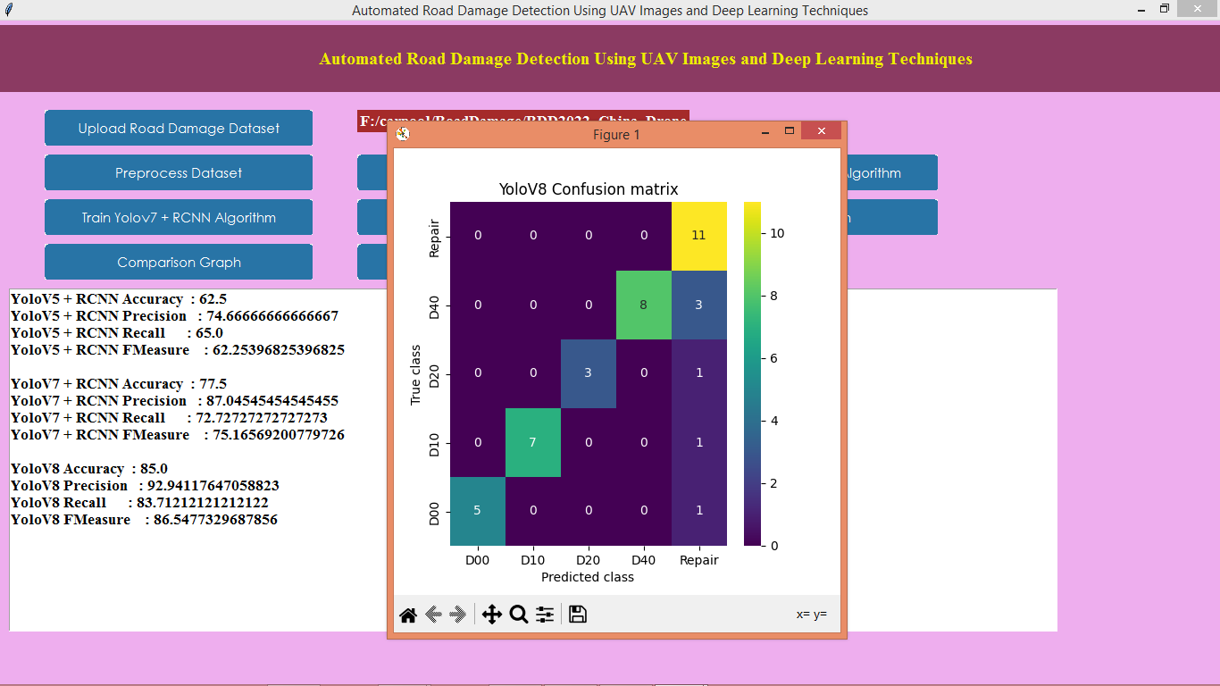
In above screen can see Yolo8 + RCNN accuracy
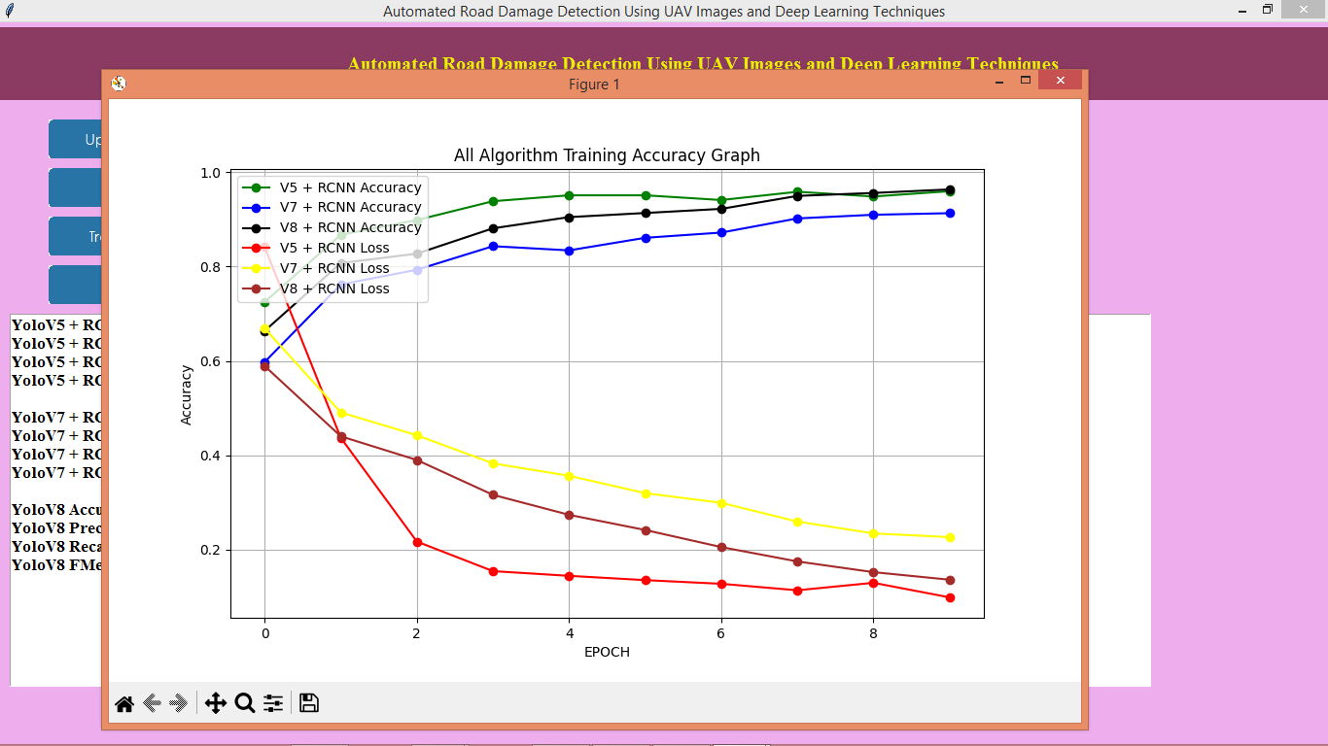
In above screen can see training accuracy and loss graph of all algorithms where x-axis represents training epochs and y-axis represents accuracy and loss values
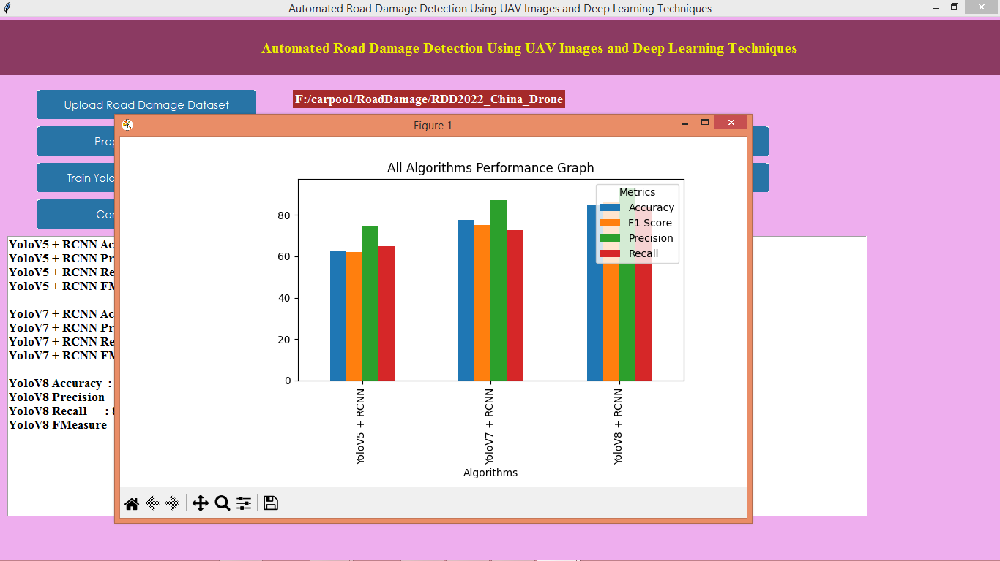
In above screen can see comparison graph between all algorithms and now click on ‘Road Damage Detection’ button to upload test image and then will get below output
