Galo Paz

CS311D

Assignment #1

Setup the Message

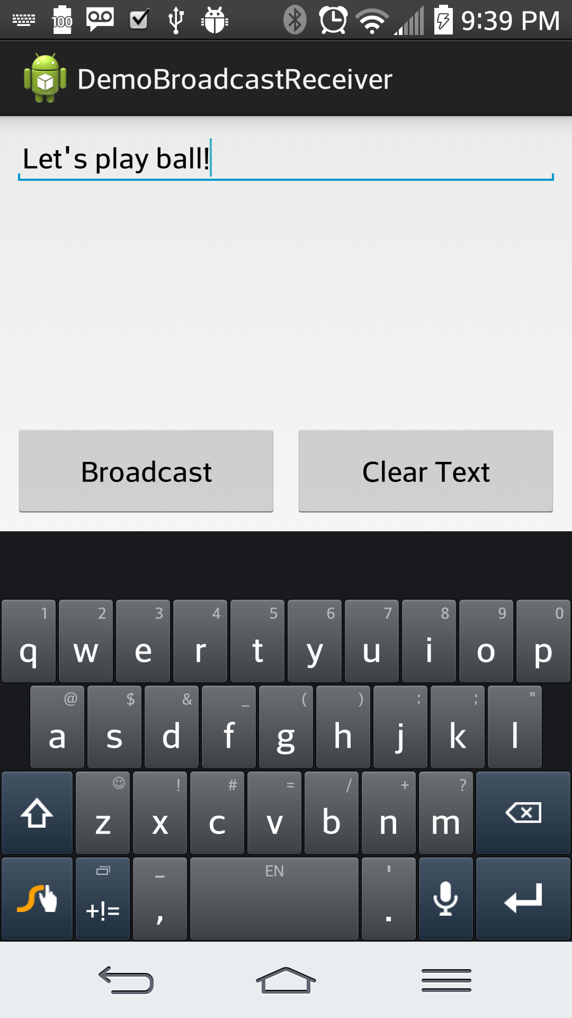

Broadcast Message

