Project Details:

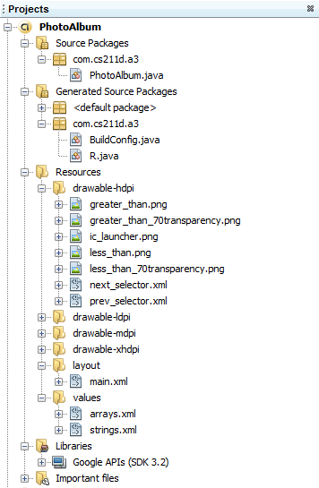

LANDSCAPE MODE

Start Up

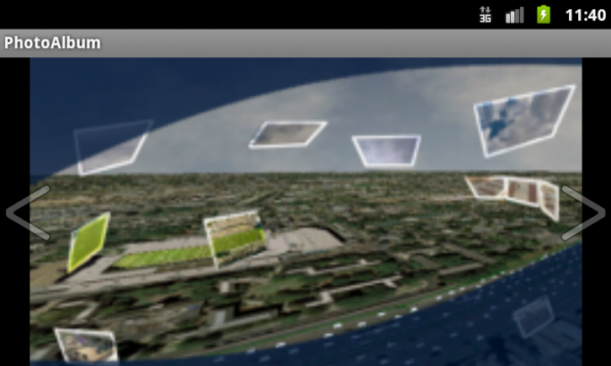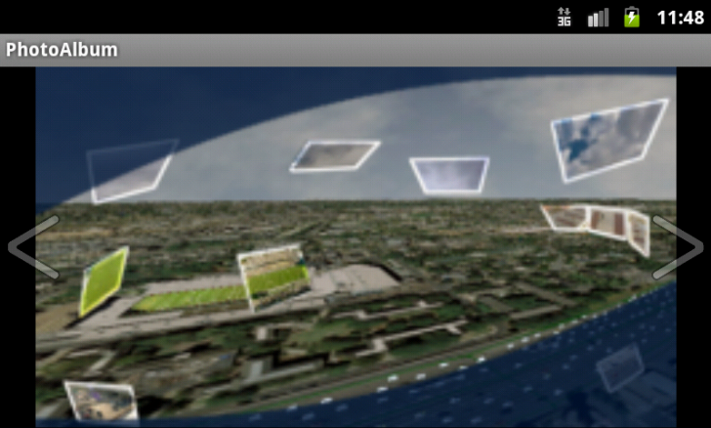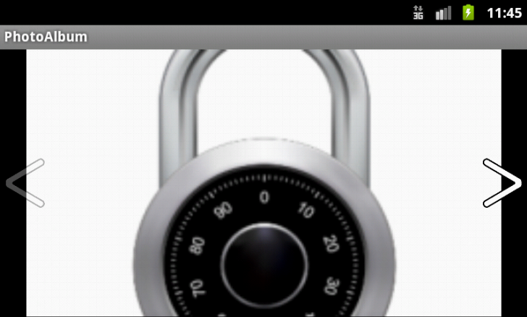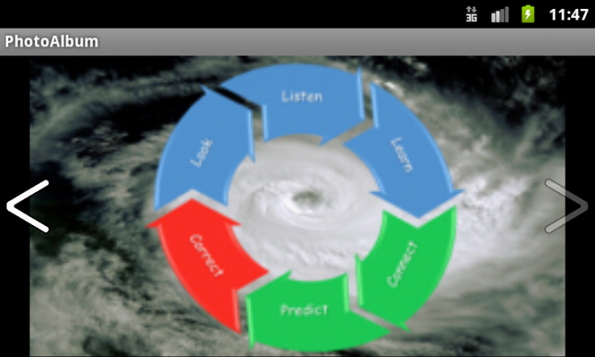

→Back to the First Image←

Continuing Left...

Continuing Right....

Right Arrow pressed

↓

Left Arrow pressed

↓

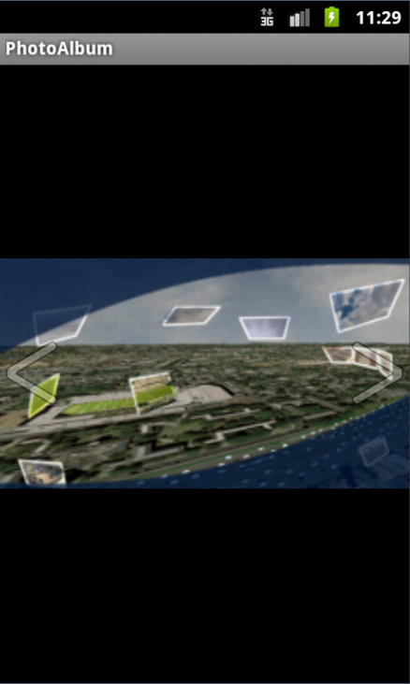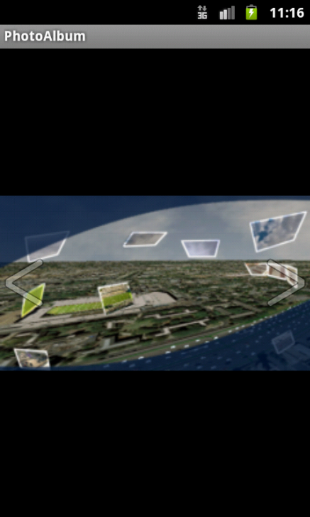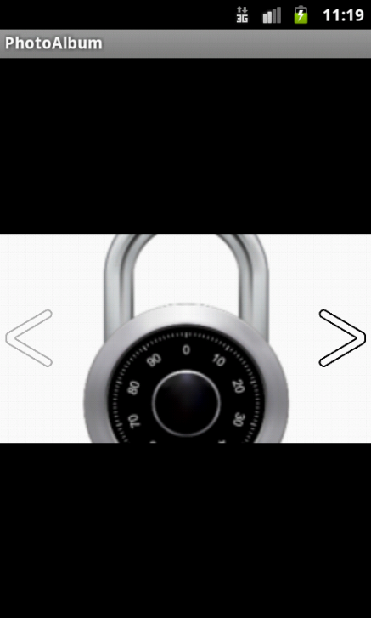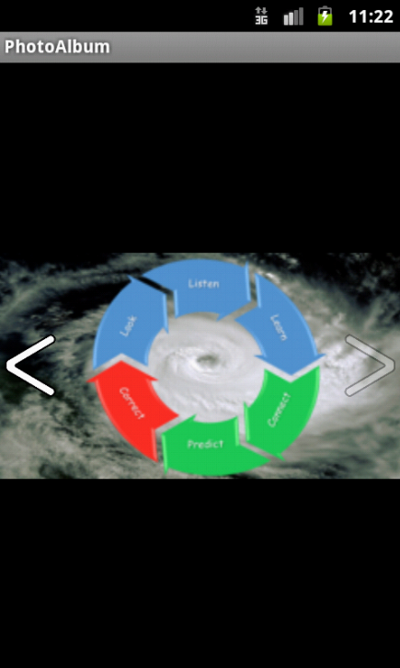

PORTRAIT MODE

Start Up

Continuing Left...

Continuing Right....

Right Arrow pressed

↓

Left Arrow pressed

↓

→Back to the First Image←