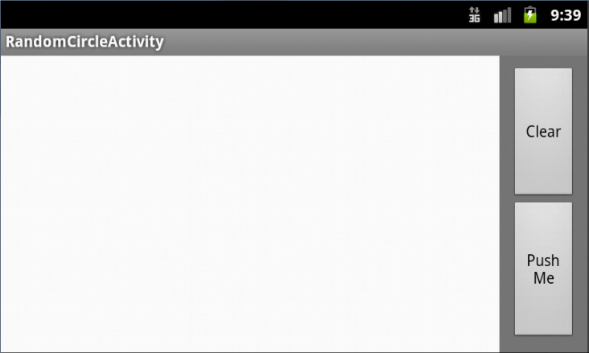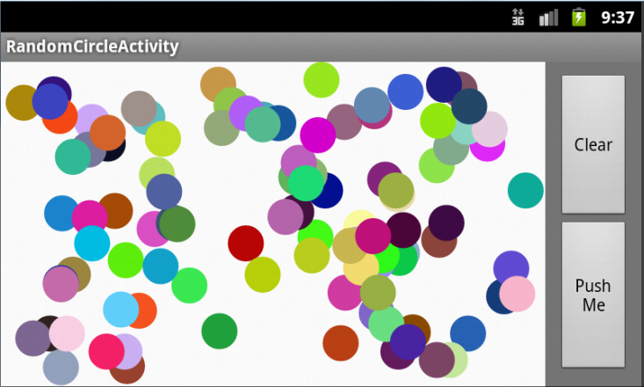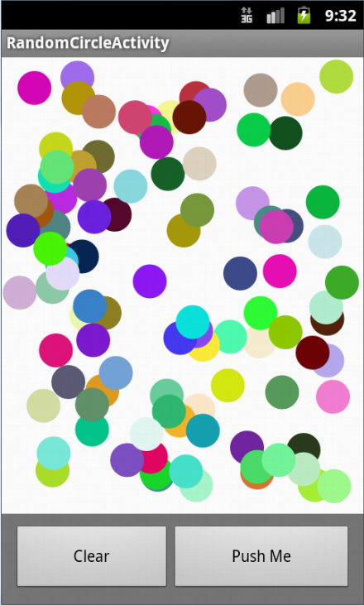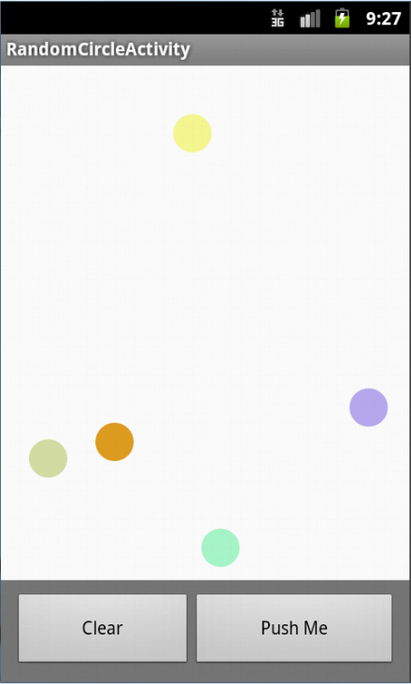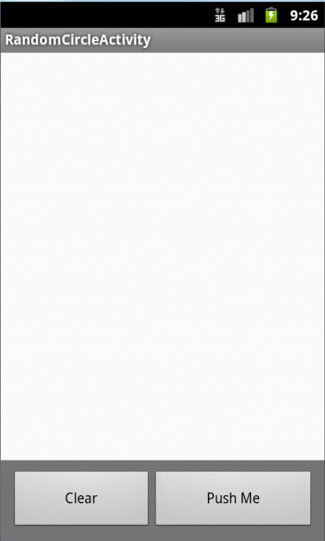

When the device is flipped on its side, random circles are drawn within the new space.

After the 'Clear' button has been clicked, all the drawn circles are erased.

...clicked 100 times

'Push Me' button Clicked 5 times

Startup : Portrait