**Problem 2a)**

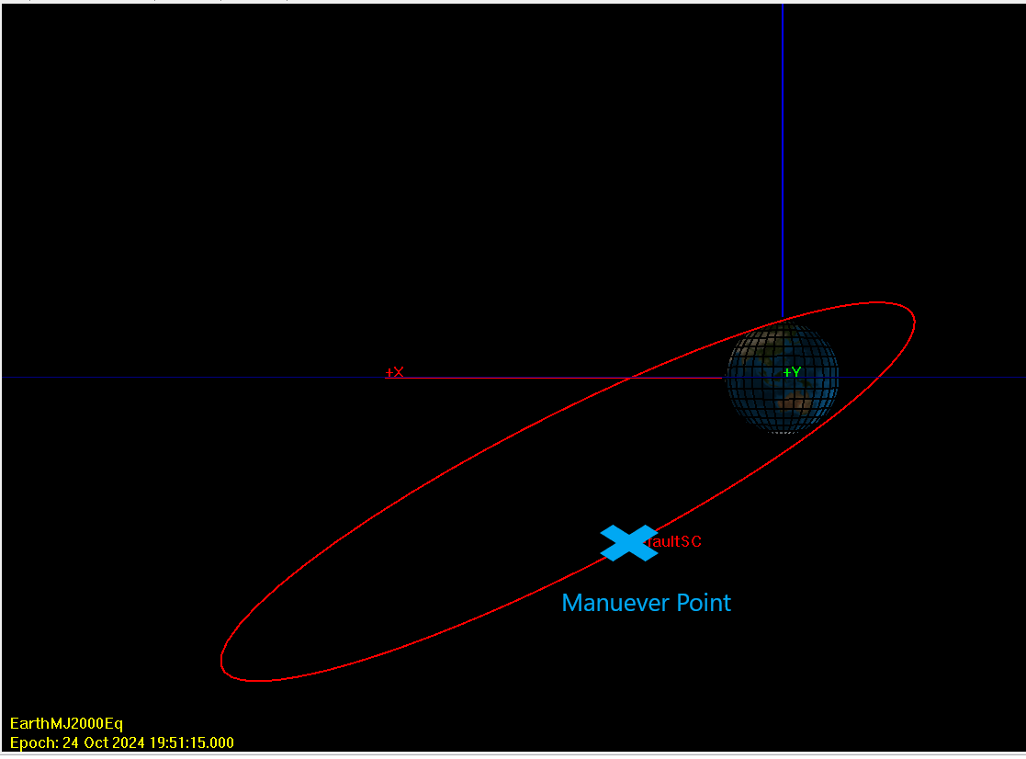

Figure 1: Problem 2a Orbit - Y Axis View

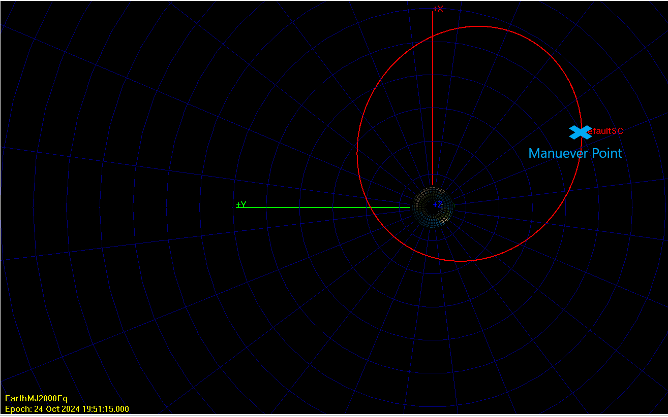

Figure 2: Problem 2a Orbit - Z Axis View

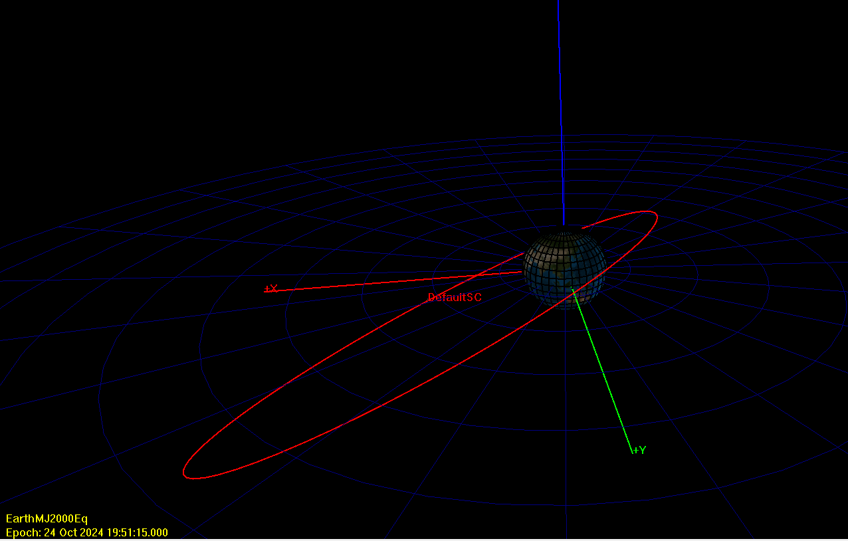

Figure 3: Problem 2a Orbit: Angled View

**Problem 2c)**

In the figures below, there are three colored lines. The pink line is the initial orbit, pre-maneuver. The white line, is the start of the initial orbit to the maneuver point in the initial orbit. The yellow line is the final orbit, post-maneuver.

The equatorial plane is denoted by the blue grid line spanning from the Earths equator (in the X-Y plane) in each image.

The J2000 unit vectors are given by red +X, green +Y, and blue +Z lines originating at the Earth in each image.

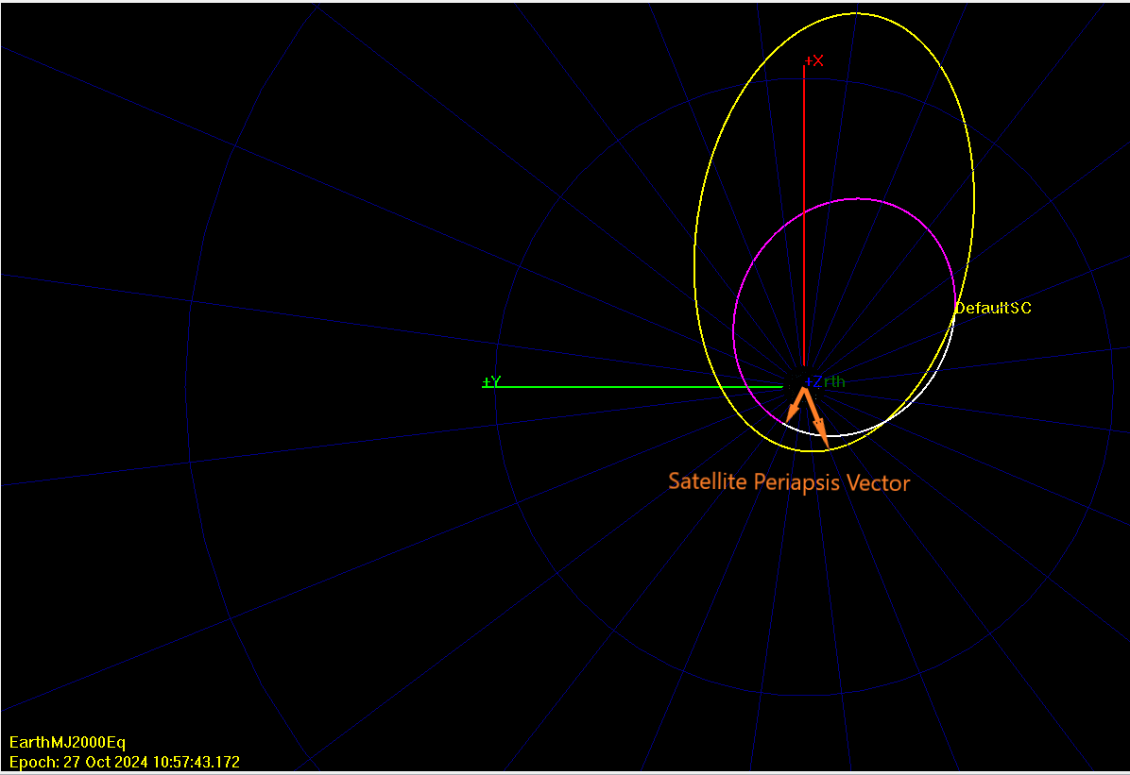

Figure 4: Problem 2c Orbits - Includes Periapsis Vectors, Z Axis View

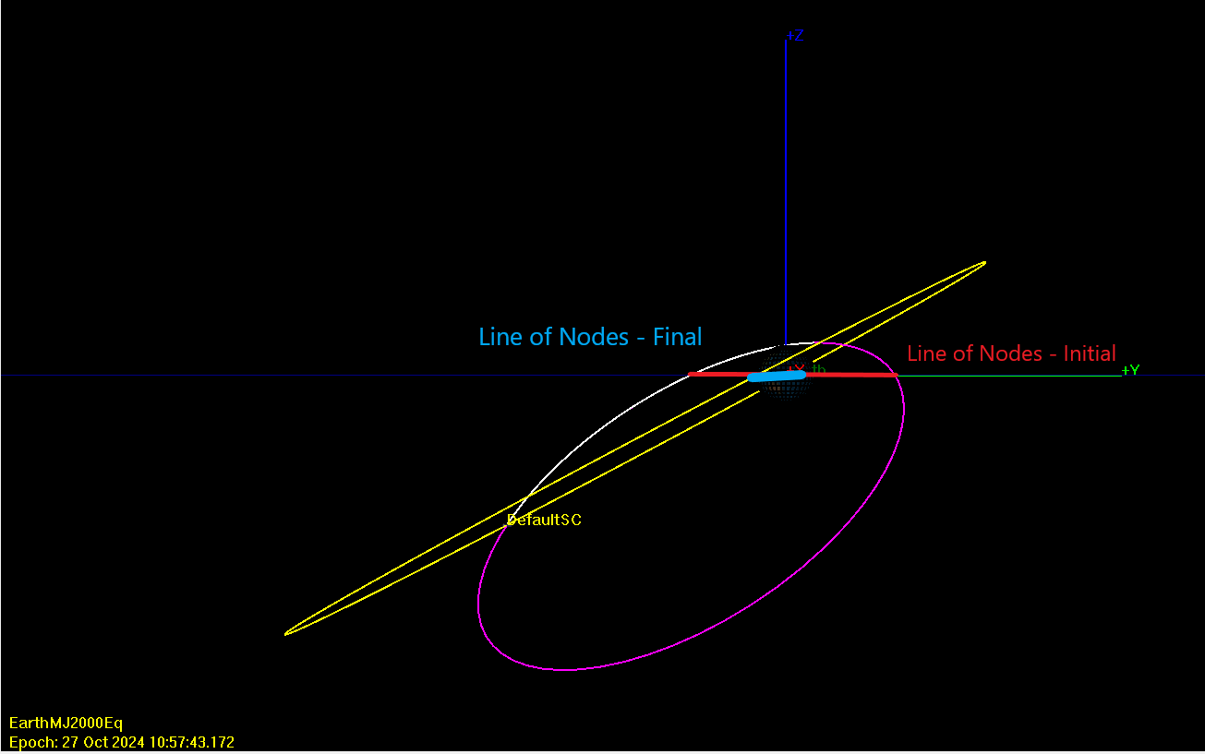

Figure 5: Problem 2c Orbits - Includes Line of Nodes, X Axis View

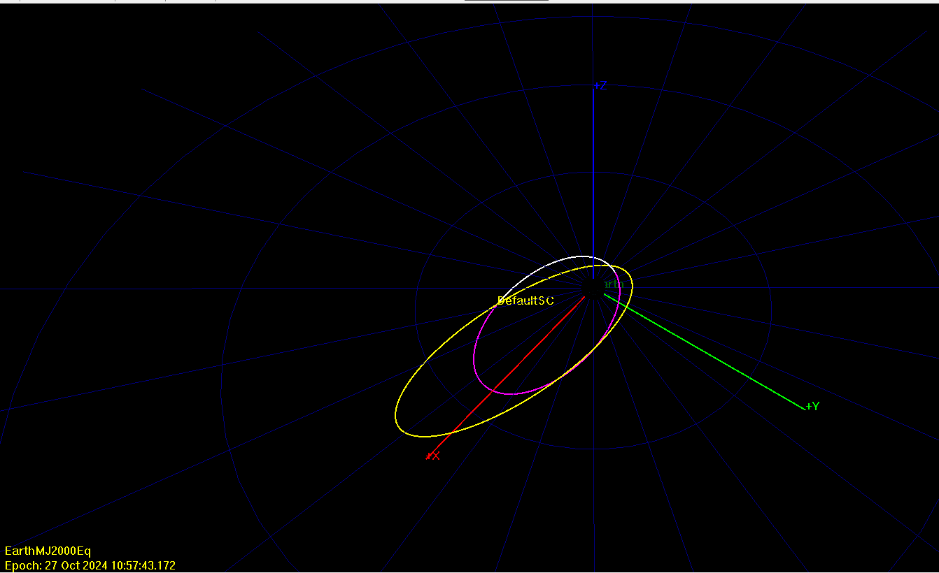

Figure 6: Problem 2c Orbits - Angled View

Below is tabulated data from the maneuver point. The first row is GMAT data at the maneuver point, prior to the maneuver in the initial orbit. The second row is GMAT data at the maneuver point, after the maneuver in the final orbit.



These values align with what was calculated in problem 2a and problem 2b, note that the flight path angle (FPA) was adjusted to reflect the 90 degree offset caused by the FPA definition in GMAT.