Safety-Silence Tradeoff Equation in Various Traffic Conditions

S V S U F A C U L T Y - L E D
U N D E R G R A D U A T E R E S E A R C H

Faculty: George Corser, Assistant Professor (CSIS)

Student: Alejandro Arenas, SVSU Undergraduate (CSIS)

Budget: $1000

Completion Date: May 30, 2015

ABSTRACT

In vehicular ad-hoc networks every 10 ms vehicles broadcast

“heartbeat” messages, basic safety messages (BSMs) which include precise location coordinates. Vehicles use each other’s coordinates to avoid crashes, but eavesdroppers might use the same information for tracking or stalking. To confuse eavesdroppers, some privacy researchers recommend silent periods, spans of time during which vehicles cease transmissions. To what extent do silent periods impair safety? This research applies the Safety-Silence Tradeoff Equation, which estimates the probability of a crash given the proportion of vehicles transmitting BSMs in a region, to a range of vehicle traffic conditions.
Safety-Silence Tradeoff Equation in Various Traffic Conditions

Safety-Silence Tradeoff Equation

in Various Traffic Conditions

S V S U F A C U L T Y - L E D U N D E R G R A D U A T E R E S E A R C H

Contents

FACULTY REPORT 2

Research Results 2

Student Learning Outcomes 2

Budget Performance 3

Final Thoughts 3

STUDENT REPORT 4

Knowledge Gained 4

Feelings about Experience 5

Impact on Future 5

PENDING PUBLICATION (EXTERNAL DOCUMENT) 6

Screenshot of First Page 6
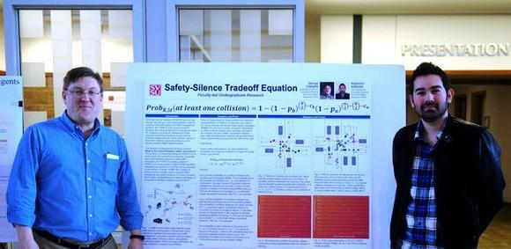

FIGURE 1: GEORGE CORSER AND ALEJANDRO ARENAS AT SVSU UGRP SYMPOSIUM (APRIL 7, 2014)

Page 1

Safety-Silence Tradeoff Equation in Various Traffic Conditions

FACULTY REPORT

Research Results

The purpose of this research was to conceptualize and to simulate the performance of vehicle network protocols in various traffic scenarios. The measurable result was to be an equation, a formalization and quantification of the relationship between safety/security, network/application service quality/efficiency and availability, and privacy, i.e. anonymity of motorists. This would be called the Safety-Silence Tradeoff Equation. Ideally, the research would also result in a paper publication prepared for submission to an IEEE-sponsored conference.

This research produced the first equation for such a relationship.

Please refer to the draft paper (an external document) to see the definitions of the equation’s terms.

The project was designed to be completed in the time allotted, so except for the final submission of the paper (due in July), the project is complete.

Student Learning Outcomes

The role of the undergraduate student, Alejandro Arenas, was essential. He prepared the visualizations and acted as a sounding board for discussions, both of which led to the development of the equation and preparation of the simulations and the paper. The student was to learn how to apply hands-on technical programming skills to a real-world problem: analyzing vehicle privacy protocols. The programming skills are well within the skill limits of an undergraduate programmer. Prior to working on this project Alejandro did not have the ability to analyze research parameters (for example: communication range of antennae, density of vehicles, distances between vehicles, etc.).

Today, Alejandro can see (a) how to set up a vehicle simulation program, (b) how to tweak the parameters to test the limits of the protocols and (c) how to document and write up the research in a proper scholarly fashion. To accomplish these three results, Alejandro prepared a range of visualizations for the project, mostly using MS-Visio. By discussing the problem with the lead researcher, he helped conceptualize the problem which was eventually formed into an equation and verified in simulation. Some of the software tools Alejandro used or touched on were MS-Visio, MS-Word Equation Editor, MS-PowerPoint, Matlab and C++.

Alejandro’s learning outcomes were measured using Bloom's Taxonomy. The participant was examined to determine if he was advancing from the "remembering" and "understanding" levels and moving toward the "applying", "analyzing" and "evaluating" levels. It may take years to be able to creatively conceptualize new research problems and solutions; this level of mastery was not achieved. However, iIt is the assessment of this faculty that the participant now has a solid understanding of the combinatorics involved in evaluating vehicle crash scenarios that might be more likely in the absence of vehicle-to-vehicle ad-hoc network communications. Alejandro’s detailed observations and his prepared visualizations represent his most important contributions to the project and to the advancement of scholarship. He is rightly now the co-author of a scholarly paper pending publication.

Page 2

Safety-Silence Tradeoff Equation in Various Traffic Conditions

Budge t Performance

The budget called for $1000 toward student work hours at $9 per hour. The actual number of hours used were 95.5 hours, or $859.50.

Final Thoughts

Not all research lends itself to collaboration, especially collaboration with people who do not have a deep foundation in the research field. However, this project allowed faculty to publish with an undergraduate co-author who helped conceptualize and more thoroughly document the work. The overall effort might be more aptly characterized as “undergraduate-assisted faculty research” rather than “faculty-led undergraduate research,” however, it was not always clear where one ended and the other began.

This was the PI’s first grant. The research project produced a paper and was delivered on time and within budget. The work also contributed directly and significantly to the long term research goals of this faculty. The student was exposed to graduate level research activities. All in all, SVSU appears to have been well served by this effort.

Page 3

Safety-Silence Tradeoff Equation in Various Traffic Conditions

STUDENT REPORT

Knowledge Gained

The main things I learned were:

- Diagramming. I learned how vehicle networks are supposed to prevent car crashes and how turning them off might increase the chances of car crashes. I learned how diagramming intersections where cars might crash in to each other can help people figure out the risk, the probability of a crash.

- Research Paper Writing. I learned how to write a research paper, at least the basic parts of what’s in a research paper. I attended a presentation by Professor Corser hosted by the ACM, an SVSU RSO, on March 18, 2015 on the topic, “how to write a research paper.” Professor Corser did most of the writing up of the paper, but I did the diagramming. We also talked over how we could mathematically explain the probabilities of cars crashing in to each other by using a thing called the “Safety-Silence Tradeoff Equation.” This equation is the main contribution of the paper.

- Research Presentation. How to do a poster presentation. Professor Corser and I presented a poster of the work at SVSU UGRP SYMPOSIUM on April 7, 2015.

Take a look at the diagrams below. These are two of the diagrams I made (with Prof. Corser’s help).
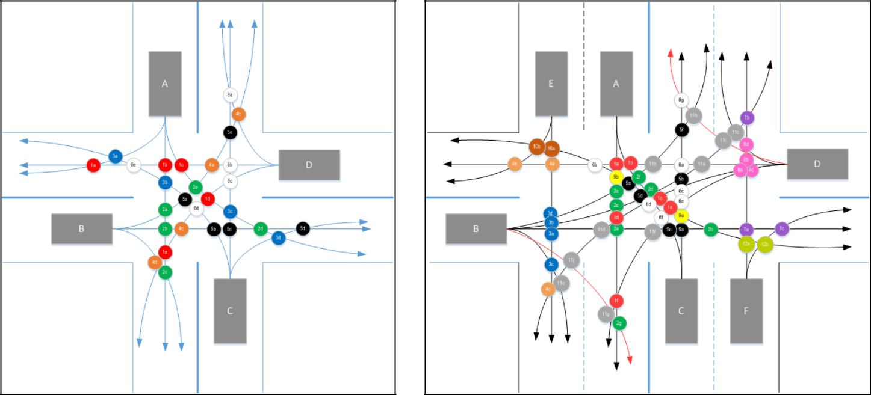

FIGURE 2: INTERSECTION OF TWO TWO-LANE ROADS FIGURE 3: INTERSECTION OF TWO-LANE AND FOUR-LANE ROADS

Figure 2 shows an intersection of two two-lane roads. Think of it as a four-way stop. There are four cars, labeled A, B, C, and D, starting at top and labeling counterclockwise. With four cars there are six possible pairs which might crash into each other, AB, AC, AD, BC, BD and CD. Each colored dot in the diagram represents a possible crash location between a specific pair of cars. For example, each green dot indicates a possible crash location between AB, that is, between car A and car B. So even though there are only two cars, there are five possible places for them to crash in that intersection. But there are only four places where car A might crash with car C, as shown by the blue dots. If we assume every dot has an equal probability of being a crash, then there is a bit higher probability of a crash between AB than a crash between AC because there are more possible crash locations.

Page 4

Safety-Silence Tradeoff Equation in Various Traffic Conditions

Figure 3 shows an intersection of one four-lane road and one two-lane road. With six cars there are fifteen possible pairs which might crash into each other, AB, AC, AD, AE, AF, BC, BD, BE, BF, CD, CE, CF, DE, DF, and EF. Note there are ten possible crash locations for BD (light gray dots), but only two for CE (dark brown dots). Also note there are no possible crash locations for AE, CF and EF. In this case we have to reduce the number of pairs by those three, so the possible pairs where crashes could occur are only twelve, not fifteen. This is just an assumption. Of course it is possible that there could be a crash between especially AE or CF because they are right next to each other. A crash between EF would be a real long shot, though, because they are so far away from each other.

Feelings about Experience

I am an international student so the only work I can do is work-study or certain internships. I can’t apply for jobs at regular companies because I only have a student visa, not a work visa. This opportunity gave me a chance to financially support my studies while also contributing to SVSU’s research. I feel pretty great about that!

Impact on Future

I took CIS-255 from Professor Corser. When I heard he was interested in doing some research and needed a (paid) student assistant, I applied. I still have not decided my long term career or anything but now that I have seen what it is like to do research work, I am definitely more likely to go to graduate school.

Page 5

Safety-Silence Tradeoff Equation in Various Traffic Conditions

PENDING PUBLICATION (EXTERNAL DOCUMENT)

Please find the current draft of the publication as a PDF included with this document.

Screenshot of First Page
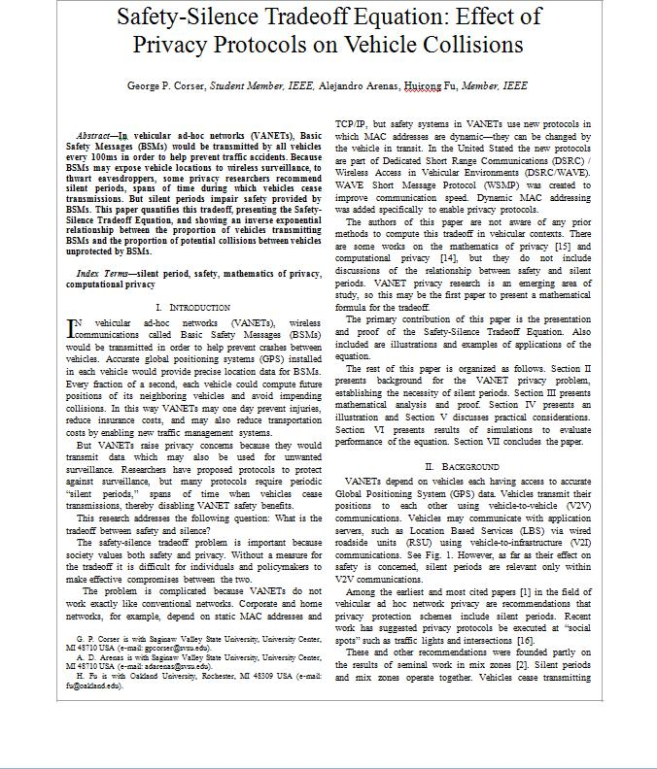

Page 6

