Collaborative Computer Science Education (CCSE)

Final Report

# Abstract

The Collaborative Computer Science Education (CCSE) project creates lesson incubators, which are close-knit groups of computer science teachers and an online system which helps them build outstanding lesson materials. Computer science course materials change rapidly, with new programming languages, software upgrades and professional best practices changing almost as fast as curricula can be developed. Computer science teachers must work together to keep their materials up-to-date. CCSE builds computer science education materials, not only for students in the classroom, but also materials for teachers to continuously improve their domain-specific skills in both technology and pedagogy. Audience: CS teachers and students. Goals: highly rated lesson materials, as perceived by teachers and students, and a system for continuous improvement. Outcomes: higher performance scores by students, more time for one-on-one instruction by teachers.

# Project Title

Collaborative Computer Science Education (CCSE)

# Name of Researcher

George Corser, PhD

# Discipline of Study

Computer Science

# Goals Achieved

* Produced 40+ videos, step-by-step classroom materials or quizzes conforming to project standards
* Accessed four communities (20+ contributors): client-side web development (CSI 255), server-side web development (CIS 355), mobile app development (CS 403, theory of computation (CS 461)
* Produced website to organize the materials: www.teacherati.com
* List of lessons learned and next steps: www.teacherati.com (click: Next Steps)

# Pedagogical Innovative Methods Used:

Adapted "Learning by teaching" (Frager, 1970) to present day high tech environgment. Specifically, utilized professional and/or highly motivated students to prepare and deliver course materials. See also: "Learning through teaching" (Cortese, 2005).

# Outcomes

The primary outcomes were a website and a set of lessons

## Table of Attributes (Teacherati vs. Regular/Online Classrooms and YouTube)

|  |  |  |  |  |
| --- | --- | --- | --- | --- |
| Attribute | In-person Class | Online Class | YouTube + In-person | Teacherati + In-person |
| Students Can Contribute Course Materials |  |  | **√** | **√** |
| Standard Measure of Learning Results |  |  |  | **√** |
| Standard Form of Lessons |  |  |  |  |
| Does NOT Require Teacher with Expertise in Computer Science to Deliver the Lesson |  |  | **√** | **√** |
| Allows Ratings and Comments for Continuous Improvement of Materials |  |  | **√** | **√** |
| Allows Development of Materials in Private, Supportive Group |  |  |  | **√** |

## Website Screenshots

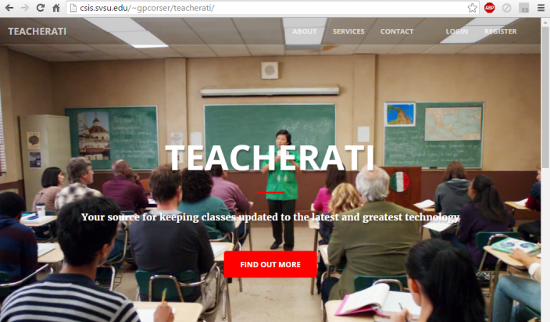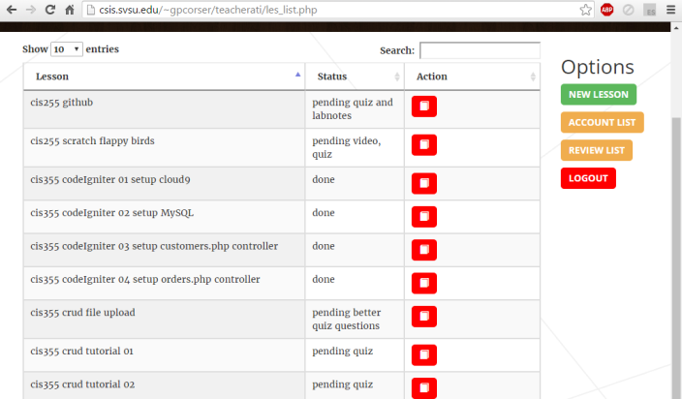

To test it for yourself, visit www.teacherati.com.

# Number of faculty implementing this method:

1

# Estimated number of students impacted by this practice

150

# Courses/Sections That Implemented the Methods

CIS 255 11 SP15, CIS 355 31 SU15, CIS 255 01 FA15, CIS 355 01 WI16, CS 403 01 FA15, CS 461 01 FA1

# Data measuring student retention and success

Data collected is in the form of case studies. There were not enough data points to perform meaningful statistical analysis. The purpose of this project was to develop a template and identify case studies which would raise research questions which could be investigated on a larger scale.

## Contributors:

Andrew York, Mike Roof, Chad Schroder, Waqas Qureshi, Jessica Todoroff, Elijah Wilson, Graham Bewley, Dan Delano, Brian Cobb, Dustyn Tubbs, Joe Nicklyn, Charles Liggett, Brad Chippi, Aaron Hooper

# Final Budget Expenditures

The budget was hardly touched. It became clear early in the project that food and meetings were not necessary. The people who wanted to do the work were eager to do so without compensation. The people who wanted the food and meetings did not do much if any work.

## Budget (Actual)

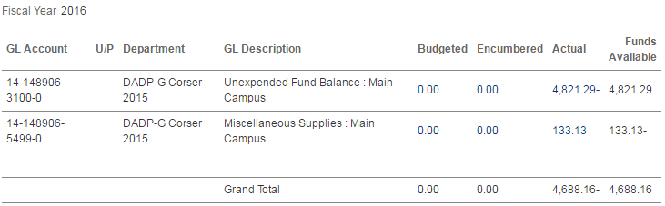

## Budget (Proposed)

|  |  |  |  |
| --- | --- | --- | --- |
| Item | Qty | Rate | Subtotal |
| Mileage | 2000 miles | 0.50 / mile | $1000.00 |
| Food | 6 meetings | $500.00 / meeting | 3000.00 |
| Printing / Supplies | Est. | Est. | $1000.00 |
| TOTAL | **$5000.00** | | |

# Summary of Results

The original intention of this project was to produce (1) a website, (2) a set of lessons and (3) a test of the results of using the lessons in class. Specifically, The intention was to identify two teacher groups, a test group and a control group. The control group would do nothing but report as it normally would. The test group will meet regularly (monthly) as time and budget permit. It quickly became apparent that just building the website and lessons would be a year’s worth of work. What was observed was the effect that assembling the lessons had on the students. Research continues as the material is applied in classroom and online learning contexts.

# Contact

George Corser, Assistant Professor (CSIS), [gpcorser@svsu.edu](mailto:gpcorser@svsu.edu), (989)964-2756.