

Enterprise Network Computer System for Early Career Academy

*A proposal to implement hardware and software according to a grant awarded by the State of Michigan*

ABSTRACT: The purpose of this proposal is to implement a $141,800 grant awarded to Early Career Academy (ECA) by the State of Michigan. The grant is designed to help ECA students develop real-world career experience by providing access to enterprise-class computer hardware and software. The implementation would have three overall goals (1) to improve hands-on learning and employability of current students, (2) to increase enrollment/recruitment by enhancing the learning environment with a marketable feature, a corporate-grade computer network, clearly distinguishing ECA from competing institutions, and (3) to investigate an innovative new teaching model: teachers collaborating with working technical experts to deliver real-world lessons and work-ready graduates.

Dr. George Corser, ECA Board Secretary

1/4/2016

Enterprise Network Computer System for Early Career Academy

A proposal to implement hardware and software according to a grant awarded by the State of Michigan

# I. Purpose

**The proposed activity would implement an enterprise network computer system** for Early Career Academy (ECA). The result would be one (or ideally two) moveable server racks which teachers could use to supplement teaching resources.

The State of Michigan awarded a grant of $141,800 to ECA to achieve several goals (1) to improve hands-on learning and employability of current students, (2) to increase enrollment by enhancing the learning environment with a marketable feature, a corporate-grade computer network, clearly distinguishing ECA from competing institutions, and (3) to investigate an innovative new teaching model: teachers collaborating with working technical experts to deliver real-world lessons and work-ready graduates.

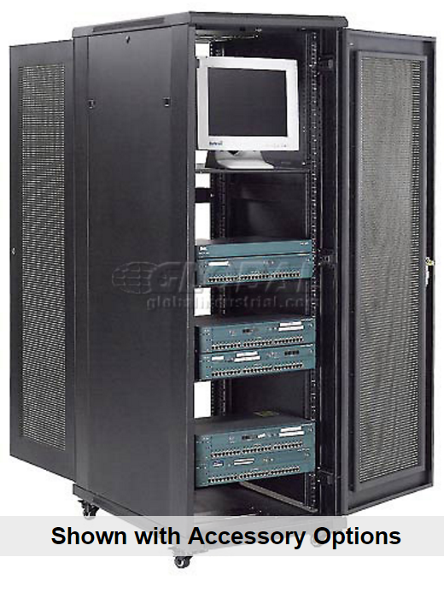

Figure 1: Full Height Server Cabinet (Image Source: Global Industries)

# II. Background

The Bureau of Labor Statistics reports that Michigan ranks among US states with the highest number of computer network support specialists. It also reports that the job outlook for computer support specialists is 17% (faster than average). These positions often require an associate’s degree, not always a bachelor’s degree.

Early Career Academy teaches traditional high school courses, but what sets it apart is its commitment to preparing secondary school students for information technology positions, including network support positions. For these reasons a significant percentage of ECA graduates are expected to pursue computer network support specialist positions.

Computer network support specialist positions require an understanding of corporate computer networks. Corporate networks are more elaborate and much more expensive than home “wifi” networks. Consequently, entry-level career candidates rarely have exposure to such equipment.

This proposal, if implemented, would change that. The project would give high school students access to corporate enterprise equipment prior to graduation.

# IT-guys-for-Career-Book.jpg

Figure 2: Network Engineers (Image Source: Valencia College)

# III. System Implementation

The implementation would be achieved by assembling one or two movable computer cabinets which would contain hardware and software comparable to that used by a small corporate enterprise. Hardware would include rack mount servers, storage devices, routers, switches, firewalls, and console interconnected by CAT5/CAT6 cables, all mounted in one or two enclosed movable server cabinets on casters.

## Space Requirements for Hardware

The footprint of each cabinet would be 2 feet wide and 3 feet deep. Cabinet height is variable depending on the number of components it stores.

* **This proposal requests classroom space be dedicated for two tall enclosed but vented cabinets on casters, measuring 24” wide by 36” deep by 72” tall.** See example at: [Global Industrial Products](http://www.globalindustrial.com/p/office/computer-furniture/network-cabinets/37u-72-data-cabinet-unassembled?infoParam.campaignId=T9F&gclid=CITc9ozBkcoCFcMbgQodpNMO0g).

## Power Requirements for Hardware

Data centers use a great deal of power, but this system would be used for educational purposes, not actual production. The system would be turned off most of the time. According to [ZDnet](http://www.zdnet.com/article/toolkit-calculate-datacenter-server-power-usage/), maximum power draw for a Dell PowerEdge R610 is 717 watts, about the same power as seven 100-watt light bulbs. In practice the system would never reach that maximum.

* **This proposal requests access to building’s power supply.**

According to Electricity Local, “The average commercial electricity rate of 10.93¢/kWh in MI is 8.33% greater than the national average commercial rate of 10.09¢/kWh.” If the system were operational 25% of the time the cost would be roughly $180.00 per year.

## Internet Access

Most any computer requires access to the internet, and enterprise systems are no different. The main use of the internet would be to download software and test its functionality. Students will need to look up reference material and download software. Remote internet access would be useful for technical support purposes, especially considering the project leader lives and works in Saginaw, 90 miles away from ECA’s Troy, Michigan location. A dedicated Cable TV or telephone line connection would be ideal, but a wi-fi hotspot could work for short term temporary connections. Cable packages that include internet could be $50.00 per month, or $600 per year.

* **This proposal requests the installation of a dedicated broadband cable internet connection to be paid by ECA Board.**
* **This proposal requests that teachers, students and technical support personnel be permitted to access the system remotely via the internet.**

## Software Licensure

Software would include operating systems (Windows Server 2008 R2 and Linux), virtualization software (VMware), open source backup (Bacula), sniffer/packet analyzer (WireShark) and other similar software used by corporate enterprises. Some software is free and open source. All purchased software would be licensed to ECA.

## System Independence

The system and its internet connection would be separate and distinct from all other computers systems. It would not be part of ESI’s network. This minimizes the risk of ESI’s computers being compromised by an outside entity, while still permitting teachers and students to explore the networking concepts at root access levels.

## Technical Personnel

Technical experts would support the effort, and would include both volunteers interested in high-tech learning and paid consultants experienced in the particular hardware and software. Some volunteers have already been identified by the proposed project leader.

The proposed activity would be led by Dr. George Corser, the ECA Board Secretary. His qualifications include a PhD in Computer Science and Informatics and current employment as Assistant Professor of Computer Science and Information Systems at Saginaw Valley State University.

* **This proposal requests that Dr. Corser and other project personnel be permitted on the premises for the purpose of installing, maintaining and supporting the system.** No technical personnel from ESI are requested to support this system, but they certainly would be welcome as volunteers.

## Learning Materials

Learning materials would be contributed by the technical experts and tested by classroom teachers. The long-term goal would be to build a set of lessons which could leverage the enterprise system as a learning tool for high schools throughout the state, enabling any high school teacher to teach college- and even corporate-level computer concepts.

* **There would be no change to the curriculum.** All hardware, software and lessons would be offered as a supplement to existing curricula, which teachers could use, or not, purely at their own discretion.

# IV. Timeline

The project would proceed as follows.

1. ECA Board orders equipment (the equipment list and vendors have already been identified, almost completely)
2. ESI receives and stores equipment (a clearly identified location for system storage and usage is the primary request of this proposal)
3. Dr. Corser assembles technical experts to perform a test setup and document steps for initial computer lessons (some volunteers have already been identified, and a sample lesson has been sent to Dr. Noda and two teachers)
4. Technical experts, including Dr. Corser, train teachers and/or teachers schedule technical experts to appear in classroom with teacher (either way works)
5. Teachers and/or technical experts supervised by teachers present lesson(s) to students
6. Teachers and students evaluate lessons
7. ECA Board and ESI review results and revise process if necessary
8. ECA Board reports results to State of Michigan

# V. Issues Previously Raised by ESI

Below is a list of questions from email discussions prior to the preparation of this proposal. While these questions may already have been answered elsewhere in this document, they are addressed here, too, for convenience.

## What is the overview/purpose of the proposed activity?

* Overview: make available enterprise network computer hardware and software to ECA students.
* Purpose: To give relevant hands-on technical experience to students.

## What are specific requirements (space, power, functionality, usability…)?

* Space: 4 feet wide by 3 feet deep by 6 feet tall (for 2 cabinets)
* Power: about the same as seven 100-watt light bulbs, but note devices would not always be powered on.
* Functionality: as many server side functions and network functions as possible.
* Usability: it would not be deployed for anything... just used for classes.

## How do lessons align with current curriculum, or introduce curriculum changes?

* Dr. Noda, the computer science teachers and Dr. Corser had a meeting regarding how the equipment could be used to supplement the curriculum. There would be no curriculum changes. There are only new lessons which could be plugged into the existing curriculum at points deemed proper by the particular teacher at the particular time. These lessons would come with personnel to train the teachers and assist with technical details in setting up system and refining lessons.

## What issues or risks exist regarding safety, security, and accountability?

* Safety: ITT campuses already house server racks on site in classrooms so it appears there are no physical safety issues that have not already been addressed by ESI.
* Security: The main security concern would be theft. Dr. Noda, Emily Campbell and teachers could keep keys to the cabinets to mitigate this problem. (Open issue: Should ECA purchase renters’ insurance?)
* Accountability: ECA owns other computer equipment, for example, iPad tablets. Persons assigned to manage the new equipment would be accountable in the same fashion as those who are already managing existing equipment.

## What maintenance requirements are involved?

* None. While the system components are production grade devices they would not be used in a commercial production environment, so they are not likely to wear out from overuse. But the devices will eventually expire or become obsolete. Computer hardware rarely requires external service. Nonfunctioning devices are usually discarded or recycled. In order to mitigate this problem the system includes multiple components of each type.

# VI. Summary

The ECA Board proposes to implement an enterprise network computer system for the use of teachers and students per the aforementioned grant awarded by the State of Michigan. This system is important to students because it will help give students real-world career-relevant experience. This system is important to ESI and ECA Board because it provides a valuable marketing tool for recruiting new ECA students. If successful, the system may be used as a model and may eventually have a broader impact across the state or the country.

For the project to be successful, the following must be approved.

1. Allocate space for one or two server racks near an electrical outlet.
2. Request the local cable company install a dedicated TV-internet connection. Invoices for such a connection can be sent to ECA board.
3. Inform relevant personnel and ask for volunteers.

The system would require no ESI personnel to set up or maintain. Classroom space for the system should be part of the current lease agreement. There is no obligation to use the system. Teachers could use the system, or not, at their discretion, however the ECA Board believes the system would be as valuable for teacher development as for student development. Teacher training would be provided by volunteers or hired external technical consultants covered by the grant. This process will certainly take time but nothing can be done until the hardware is in place.

The ECA Board regards this project as a low-risk, high-reward opportunity for all concerned, and requests ESI’s acceptance of this proposal.

Sincerely and respectfully,



George Corser, Secretary

ECA Board