Draft Proposal

Code Name: REACH (Real-world Education Applying Computer Hardware)

Descriptive Title: Corporate Enterprise Computer Hardware, Software and Support Services as a Secondary School Teaching Platform

Summary: Acquire industry standard corporate enterprise computer hardware, software and support services and use these as a platform for teaching high school students real-world job skills

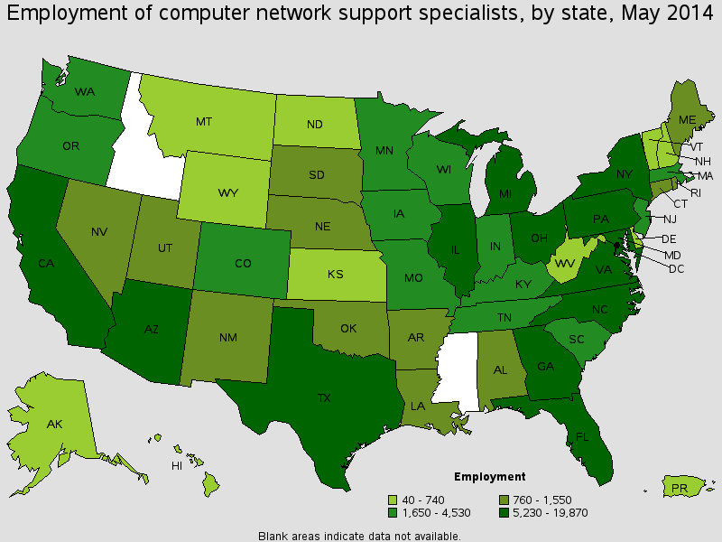

Figure : Employment of computer network support specialists (Source: BLS)

The Bureau of Labor Statistics reports that Michigan ranks among US states with the highest number of computer network support specialists.[1] It also reports that the job outlook for computer support specialists is 17% (faster than average).[2] These positions often require an associate’s degree, not always a bachelor’s degree.[3] For these reasons a significant percentage of Early Career Academy (ECA) graduates are expected to pursue computer network support specialist positions.

Computer network support specialist positions require an understanding of corporate computer networks.[4] Corporate networks are more elaborate and much more expensive than home “wifi” networks.[5] They draw more electrical power and use more Internet bandwidth. Consequently, entry-level career candidates rarely have exposure to such equipment.

This proposal, if implemented, would change that. The project would give high school students access to corporate enterprise equipment prior to graduation. Specifically, the project would implement the configuration in Figure 2, or as many of the components as possible within budget.

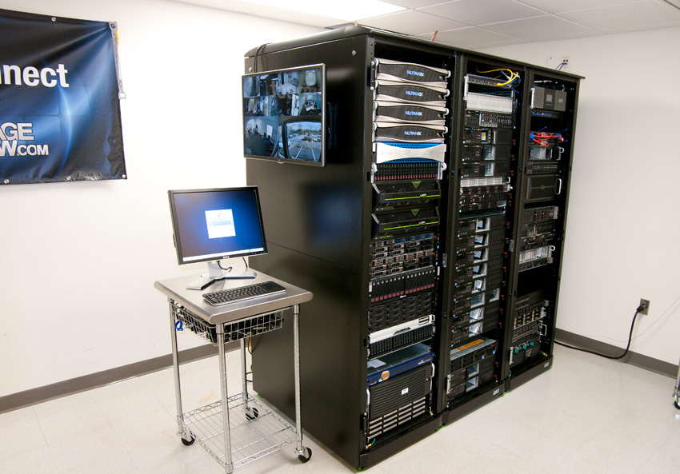

Figure : Corporate computer network equipment (Source: StorageReview)

Hardware prices change rapidly, even from month to month, so it is difficult to predict future prices with precision. The budget is expected to be under $75,000 for hardware. A complete list of hardware components desired for this project can be found at the StorageReview website. The same list appears in this proposal as Appendix A.

Software will also be required. There are many options but VMware vSphere is available for just over $21,000.[6] Virtualization software may be another $10,000.

Professional services may be required during initial implementation and teacher training. These are expected to be less than $25,000 (500 hours x $50 per hour, all hours worked within the first year).

Internet services will be required. The proposal would prepay internet for 3 year contract at $300 per month, or $10,800.

Total estimated budget: roughly $141,800.

$75,000 Hardware

$31,000 Software

$25,000 Professional Services (set-up and teacher training)

$10,800 Internet Services (3-year prepaid contract)

______ ______

141,800 TOTAL (Est.)

The project is expected to develop the skills of both students and teachers. Students and teachers would be part of the set-up process. The set-up consultant and teacher-trainer would be managed at no cost initially by George Corser, Secretary of the ECA Board. After the first year, one or more teachers will be identified to coordinate the continuing project. It is expected that a teacher can transition into this role because, unlike in corporate environments, the educational environment will not require frequent reconfiguration, except as learning exercises prepared by teachers for students.

External resources include local corporate professionals in the computer networking field. It is expected that local corporations will participate with varying levels of involvement, from technical demonstrations to hiring graduates. Since these personnel are always hard to find there is motivation for corporations to maintain access to a pool of trained potential employees. For a list of local potential employers, see the following link.

* http://help.desk.technician.job.info/?location=Michigan

Appendix A: Hardware List (Only items within budget will be purchased.)

|  |
| --- |
| * [**Enterprise Storage Performance Benchmarks**](http://www.storagereview.com/enterprise_storage_benchmarks) * [StorageReview NAS Lab Overview](http://www.storagereview.com/storagereview_nas_test_lab) * **Rack Hardware**   + [Eaton 42U S-Series Enclosed Rack](http://www.storagereview.com/storagereview_test_lab_eaton_sseries_rack) (x3)   + [StarTech 15U Black Server Rack Cabinet](http://www.storagereview.com/startech_15u_server_rack_review_2636cabinet) * **Power / Temperature Monitoring**   + [Eaton 5PX-2200RT UPS](http://www.storagereview.com/storagereview_enterprise_testing_environment_eaton_5px_ups_review) (1950VA/1920W)   + [Eaton 9PX6K UPS](http://www.storagereview.com/eaton_9px_ups_review) (6000VA/5400W)   + [Eaton Advanced Monitored ePDU](http://www.storagereview.com/eaton_advanced_monitored_epdu_review_eam001)   + Eaton Environmental Rack Monitor (ERM)   + Dell 12-Outlet PDU (x2)   + [TrippLite SmartOnline SU3000RTXL2U UPS](http://www.storagereview.com/tripp_lite_smartonline_review_su3000rtxl2u) (6000VA/2500W)   + TrippLite Basic PDU 20A * **Cooling**   + [TrippLite SRCOOL12K](http://www.storagereview.com/tripp_lite_smartrack_srcool12k_review) (12,000 BTU) x 2 * **Networking**   + [**StorageReview Test Lab Networking Overview**](http://www.storagereview.com/enterprise_test_lab_networking_overview)   + [Netgear ProSecure UTM150 4 x WAN Firewall](http://www.storagereview.com/netgear_prosecure_utm150_review)   + [Netgear ProSafe GSM7352S 48-Port 1GbE Switch](http://www.storagereview.com/storagereview_enterprise_testing_environment_netgear_prosafe_gsm7352s_48port_switch)   + [Netgear ProSafe M7100 24-Port 10GbE Switch](http://www.storagereview.com/netgear_m7100_switch_review_xsm7224)   + [Netgear ProSafe XS712T 12-port 10GbE Switch](http://www.storagereview.com/netgear_prosafe_xs712t_10gigabit_ethernet_smart_switch_review)   + Netgear ProSafe GS752TS 52-Port 1GbE Switch   + Netgear ProSafe M4100 POE+ 24-Port 1GbE Switch   + [Netgear ProSafe GS752TXS 52-Port 1GbE Switch x 2](http://www.storagereview.com/netgear_prosafe_gs752txs_smart_switch_review)   + [Netgear ProSafe WNDAP660 x 2](http://www.storagereview.com/netgear_prosafe_wndap660_dualband_wireless_access_point_review)   + Netgear ProSafe WNDAP620   + [Mellanox SX1036 36-Port 40GigE Switch](http://www.storagereview.com/mellanox_sx1036_1040gb_ethernet_switch_review)   + Mellanox SX1024 40GigE Switch   + [Mellanox SX6036 36-Port 56Gb/s InfiniBand Switch](http://www.storagereview.com/mellanox_sx6036_56gb_infiniband_switch_review)   + [Brocade 6510 16Gb Fibre Channel Switch](http://www.storagereview.com/brocade_6510_16gb_s_fibre_channel_switch_review) * **Compute**   + Dell PowerEdge R730 G13 (x12)   + [Dell PowerEdge R720 G12](http://www.storagereview.com/dell_poweredge_r720_12g_review) (x2)   + [Dell PowerEdge R820 G12](http://www.storagereview.com/dell_poweredge_r820_12g_review)   + [Dell PowerEdge FX2](http://www.storagereview.com/dell_poweredge_fx2_review)   + [EchoStreams GridStreams High‐Density Quad‐Node Computing Platform](http://www.storagereview.com/echostreams_gridstreams_quadnode_server_review)   + [HP ProLiant DL380p Gen8](http://www.storagereview.com/hp_proliant_dl380p_gen8_server_review) (x2)   + [HP ProLiant DL360p Gen8](http://www.storagereview.com/hp_proliant_dl360p_gen8_server_review)   + [HP ProLiant DL360 Gen9](http://www.storagereview.com/hp_proliant_dl360_gen9_review)   + [HP Z620 WorkStation](http://www.storagereview.com/hp_z620_workstation_review)   + [Lenovo ThinkServer RD630](http://www.storagereview.com/lenovo_thinkserver_rd630_review) (x13)   + [Lenovo ThinkServer RD530](http://www.storagereview.com/lenovo_thinkserver_rd530_review) (x2)   + [Lenovo ThinkServer RD240](http://www.storagereview.com/storagereview_enterprise_testing_environment_lenovo_thinkserver_rd240_review) (x4)   + [Supermicro SuperWorkstation 5037A-i](http://www.storagereview.com/supermicro_superworkstation_5037ai_review)   + [Supermicro SuperStorage Server 2027R-AR24NV](http://www.storagereview.com/supermicro_superstorage_server_2027rar24nv) (x2)   + [Supermicro SuperServer 6047R-TXRF (X9DRX+-F)](http://www.storagereview.com/supermicro_x9drxf_review) * Enterprise NAS/SAN   + [DotHill AssuredSAN Ultra48](http://www.storagereview.com/dot_hill_assuredsan_ultra48_hybrid_review)   + [Synology RackStation RS3614xs+](http://www.storagereview.com/synology_rackstation_rs3614xs_review)   + [Synology RackStation RS10613xs+](http://www.storagereview.com/synology_rackstation_rs10613xs_review)   + [Echostreams DuraStreams DSS320](http://www.storagereview.com/synology_rackstation_rs10613xs_review) * **Storage Groups**   + Toshiba MBF2600RC 600GB 10K SAS x 16   + [Toshiba MK01GRRB 147GB 15K SAS](http://www.storagereview.com/toshiba_mk01grrbr_25_15k_sas_enterprise_hard_drive_review) x 16   + Seagate Enterprise Performance 10K.7 x 16   + Seagate Enterprise Performance SSHD x 16   + Seagate Enterprise Performance 15K.4 Turbo x 16   + Seagate Enterprise Capacity 2TB x 16   + Seagate Enterprise Capacity 6TB x 16   + Seagate Enterprise NAS 6TB x 16   + Seagate NAS 4TB x 16   + [Hitachi Ultrastar 4TB 7K4000 SATA](http://www.storagereview.com/hgst_ultrastar_7k4000_review_hus724040ale640) x 16   + HGST Deskstar NAS 4TB x 8   + HGST He8 8TB x 16   + HGST SSD800MM 400GB x 20   + Toshiba HK3R2 480GB x 24   + [WD Xe SAS HDD](http://www.storagereview.com/wd_xe_sas_hard_drive_review) x 16   + WD Red 3TB x 12   + WD Red 4TB x 8   + WD Red 6TB x 8   + WD Red Pro 4TB x 16   + WD Se 4TB x 16   + [Intel SSD 520](http://www.storagereview.com/intel_ssd_520_review) 180GB x 48   + [Corsair Enterprise SSD](http://www.storagereview.com/corsair_neutron_gtx_ssd_review) 200GB x 48 * **Protective Storage**   + [Turtle Case by Perma-A-Store](http://www.storagereview.com/permastore_turtle_drive_case_review)     - [039 2.5" 60 Capacity Waterproof Case](http://www.turtlecase.com/ProductDetails.aspx?productid=614&parentid=0&directoryid=67&ctrl=productdetails) (x2)     - [549 3.5" 30 Capacity Waterproof Case](http://www.turtlecase.com/ProductDetails.aspx?productid=612&parentid=0&directoryid=67&ctrl=productdetails) (x3) |

1. http://www.bls.gov/oes/current/oes151152.htm
2. http://www.bls.gov/ooh/computer-and-information-technology/computer-support-specialists.htm
3. http://www.bls.gov/ooh/computer-and-information-technology/computer-support-specialists.htm#tab-4
4. http://www.bls.gov/ooh/computer-and-information-technology/computer-support-specialists.htm#tab-2
5. http://www.storagereview.com/storagereview_enterprise_test_lab
6. http://www.mychoicesoftware.com/products/vs5-vepl-ak-c/vmware-vsphere-with-operations-management-enterprise-plus-acceleration-kit?dfw_tracker=6617-1203&gclid=CPzl2O7H-MUCFdgegQodsJ4AxQ