CIS-355: CodeIgniter

This tutorial uses Cloud9 username: mdroof. You must use your own Cloud9 username. The MySQL username is ci_crud, not the Cloud9 username.

# Video 1: Setup Cloud9

https://youtu.be/WuUoIHdj1qA

1. Cloud9: go to c9.io and create new PHP workspace called ci_crud
2. Google (in browser): “grocerycrud” and download stable version (www.grocerycrud.com)
3. Google (in browser): “codeIgniter” and download current version
4. Merge zip files (in Windows) into one zip file called crud.zip (merging the zip files simplifies unzipping process in Cloud9 later)
5. Copy merged zip file to cloud9
6. Unzip (in terminal in Cloud9): **unzip crud.zip**
7. Click: Run project
8. Click on link: https://ci-crud-mdroof.c9.io (You should see "Welcome to CodeIgniter")

# Video 2: Setup MySQL

https://youtu.be/4ym4nyfuGbM

1. Type (in terminal window in Cloud9): **phpmyadmin-ctl install** (This is specific to Cloud9)
2. Click on link to phpmyadmin: https://ci-crud-mdroof.c9.io/phpmyadmin
3. Log in using Username: mdroof (your Cloud9 username), Password: (blank)
4. Click: Users tab
5. Click: Add User (username: ci_crud, host: localhost, password: password, and check "create database with the same name" and "grant all privileges" checkboxes and "Global privileges (Check all"… then click Go button). You should see new ci_crud database in left column
6. Click on ci_crud database in left column
7. Under Create table, enter Name: customers (Enter 4 columns)
8. Create fields as follows: **id**, INT, check A_I for auto_increment; **name**, VARCHAR(255); **status**, VARCHAR(255); **image**, VARCHAR(255), check Null, then click Save button

# Video 3: Setup Customers.php Controller

https://youtu.be/EMZff_UncAs

1. In Cloud9: Edit file: application/config/database.php (‘hostname’ => ‘localhost’, ‘username => ‘ci_crud’, ‘password’ => ‘password’, ‘database’ => ‘ci_crud’) Control-s saves file.
2. Open file: application/controllers/examples.php to see sample code
3. Cloud9: rename file: capitalize file name and class of example.php (to Example.php)
4. Create new file: application/controllers/Customers.php
5. Copy first 70 lines of Example.php into Customers.php
6. Add a closing curly brace, }, at end of Customers.php
7. Rename class Examples to Customers
8. Rename function _example_output() to function show _output() (throughout code)
9. Remove all lines code of function offices_management()
10. Remove all lines code of function offices()
11. Comment out the contents of function index()
12. Rename function employees _management() to display()
13. Within function display()
    1. Remove line of code containing: set_theme
    2. Change $crud->set_table(‘employees’) to $crud‑>set_table(‘customers’)‑>columns(‘name’,’status’,’image’)
    3. Comment out line of code containing: set_relation
    4. Change $crud‑>display_as(‘officeCode’,’Office City’) to $crud‑>display_as(‘name’,’Customer Name’)‑> $crud‑>display_as(‘status’,’Customer Status’)‑>$crud‑>display_as(‘image,’Customer Image’)
    5. Move line of code containing set_subject above line containing set_table and change argument from ‘Employee’ to ‘Customer’
    6. Add line after last line containing display_as: $crud‑>fields(‘name’,’status’.’image’). This shows which fields will be displayed in the views.
    7. Add line right after above: $crud‑>required(‘name’,’status’)
    8. Change line containing set_field_upload to $crud‑>set_field_upload(‘image’,’assets/uploads/files’)
    9. The function display() should appear as pictured below.
14. Rename file application/models/grocery_and_model.php to Grocery_and_model.php
15. Open a browser tab and type https://ci-crud-mdroof.c9.io/index.php/customers/display You should see a list screen with Add Customer at the top.
16. Try adding, reading, updating, deleting a customers.
17. Try uploading a picture.

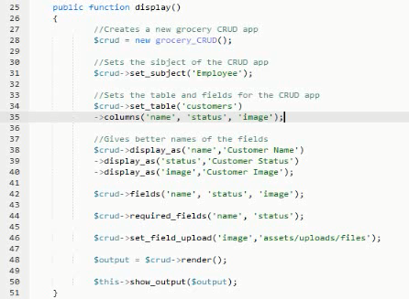

For more info, view grocerycrud documentation API and function list. For example, try function field_type.

# Video 4: Setup Orders.php Controller

https://youtu.be/o1EqNIqTsAk

1. Open: https://ci-crud-mdroof.c9.io/phpmyadmin
2. Click on database: ci_crud
3. Create table: orders, with 3 columns, order_id (INT, auto_increment), customer_id (INT), and item (VARCHAR(255))
4. Open Customers.php
5. Copy function display()
6. Rename first function display() to customers()
7. Rename second function display() to orders()
8. Revise the code for orders() as shown below. Be sure to add the set_relation code.
9. Navigate to https://ci-crud-mdroof.c9.io/index.php/customers/orders to see the results.

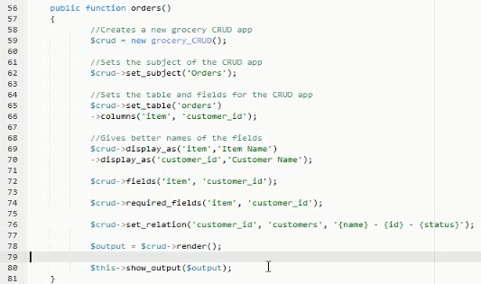

To change the links at the top of the application, edit views/errors/example.php