**Lab Notes for Button and Toast**

1. Open Android Studio
2. Start a new Project, give your Project an unique name and click Next

Step 2.

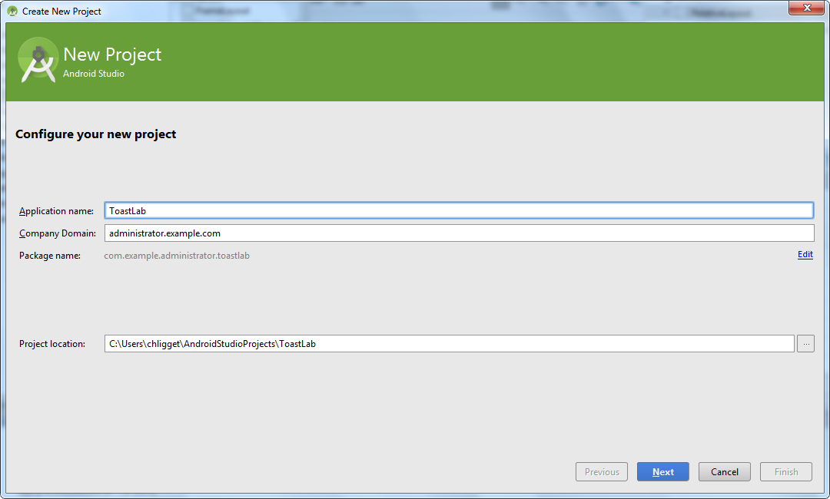

1. Leave default >> Next

Step 3. 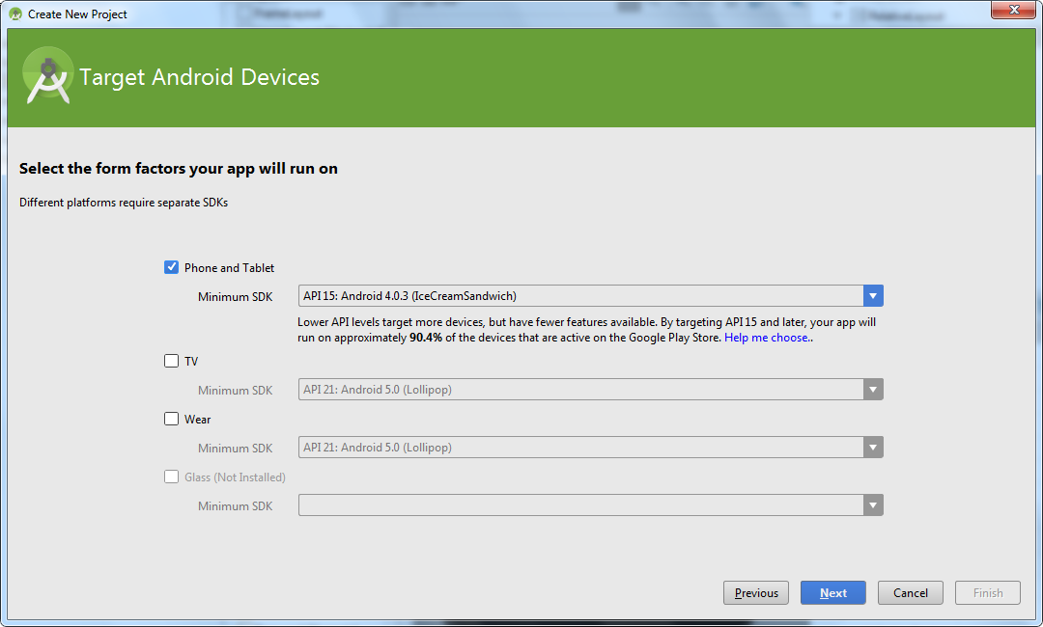

1. Blank Activity >> Next

Step 4.

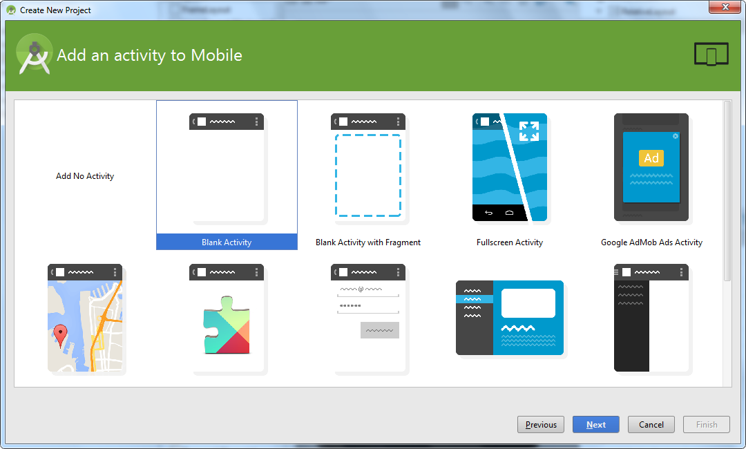

1. Give your main activity an unique name >> Finish

Step 5.

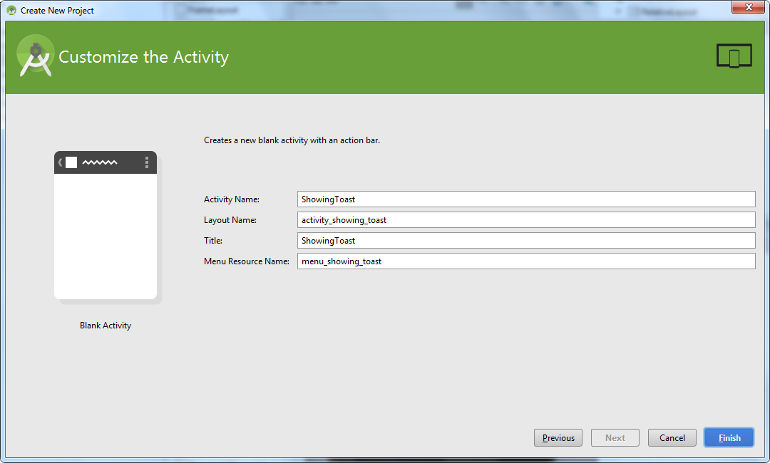

1. By default, your application opens up on your main activity's xml designer view and has a TextView with "Hello World" on. Select the TextView and delete it.

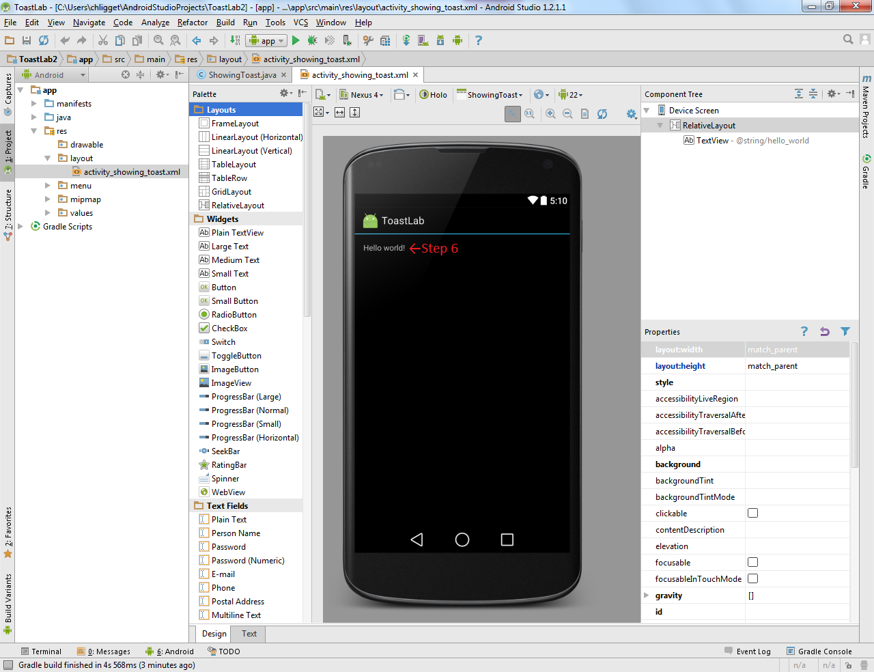

1. Now from the Palette pane on the left, under the "Widgets" category, drag and drop a button onto the preview screen.

Step 7.

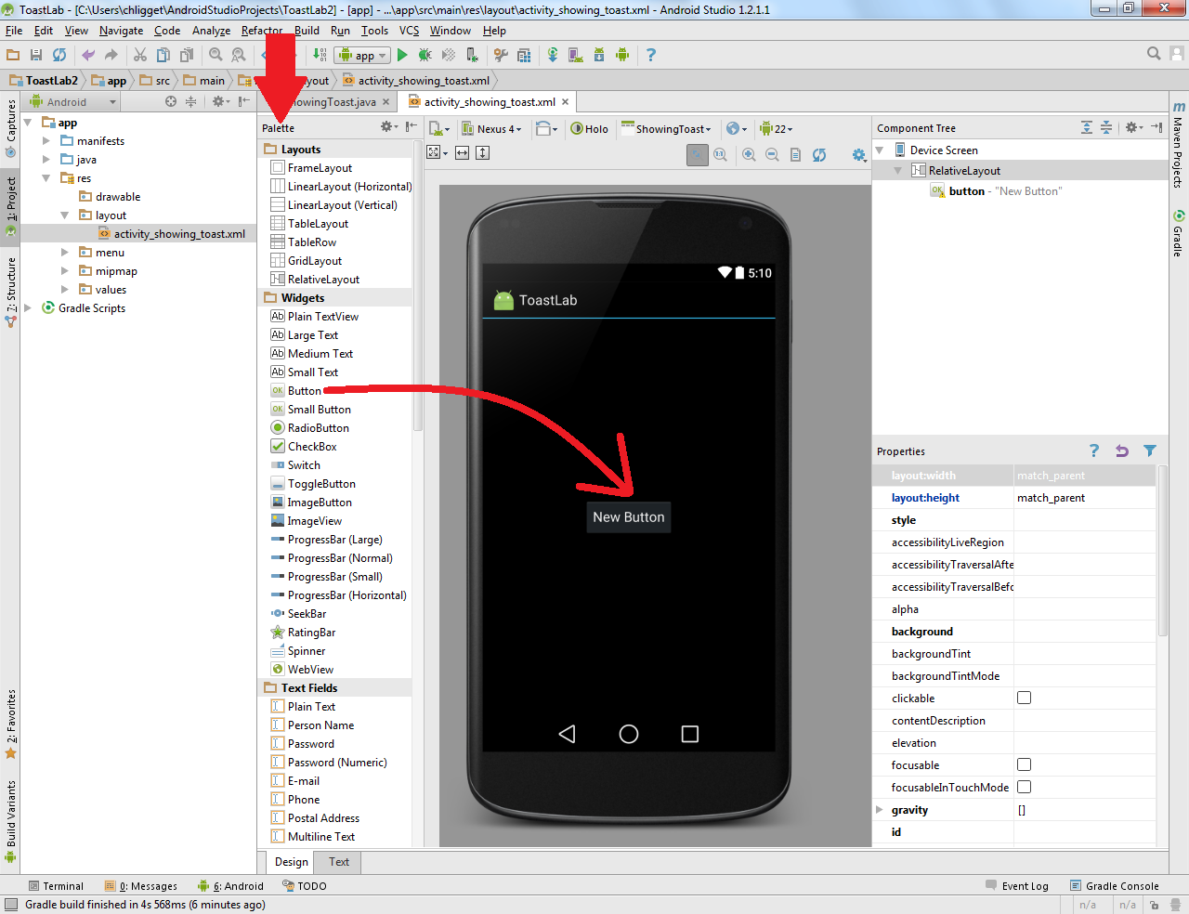

1. Now for some Java. Below the toolbar is a tab with the name of your project .java. Select it to jump to your java code.

Step 8.

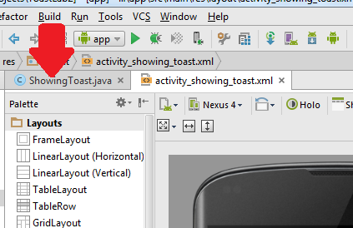

1. Underneath the "onOptionsItemSelected" function, create a new function as so:

Step 9.

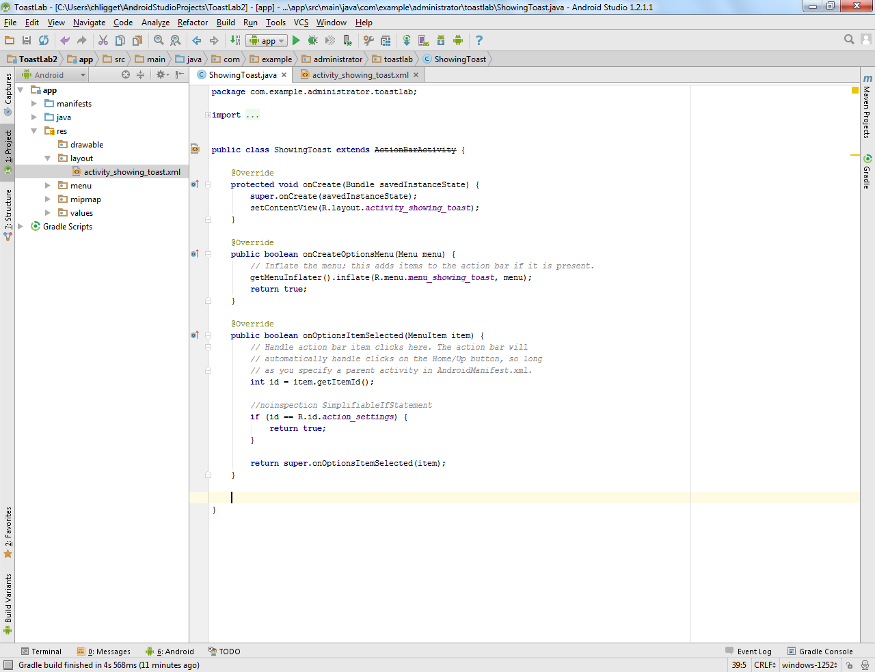

**public void** showToast(View view)   
{  
 Toast.makeText(getApplicationContext(), **"Hello Toast"**, Toast.LENGTH_SHORT).show();  
}

10. You should notice that both "View" and "Toast" will appear red and be underlined. This is simply Android Studio making you aware that the system libraries for these particular objects needs to be imported.

* 1. To do this automatically, select the line of each object and press Alt+Enter.
  2. To do this manually, type "import android.view.View;" and "import android.widget.Toast;" under the other import calls at the top of the java question.

Step 10.

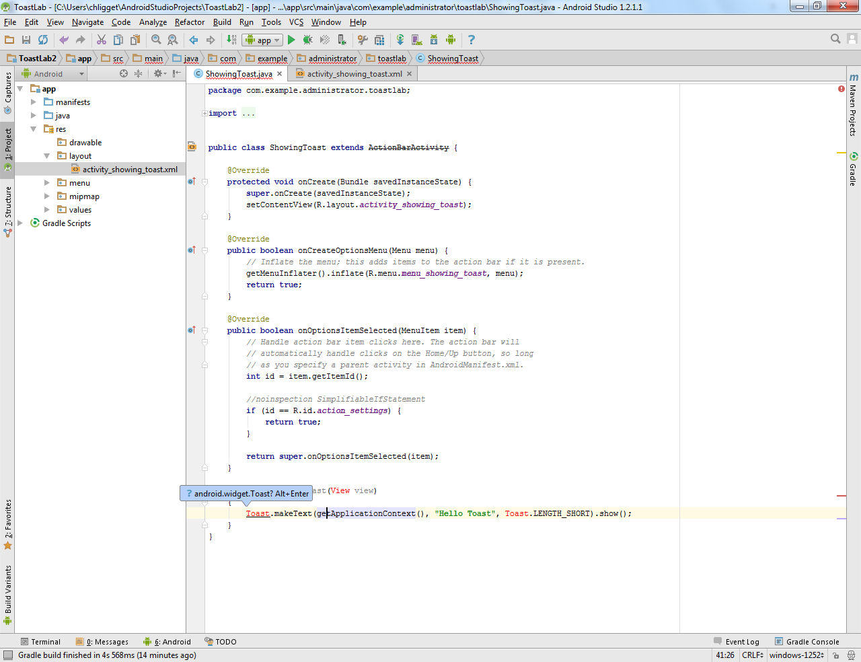

1. Return to xml file and select the button. Under the "Properties" panel will be a property "text", with the value "New Button". Change this value to something unique, like "Show Toast".
2. Finally, edit the value of the "onClick" property. There should be a down arrow. Clicking that will show a selection of available methods to subscribe to. Select the method you made earlier, "showToast".

Step 11 & 12.

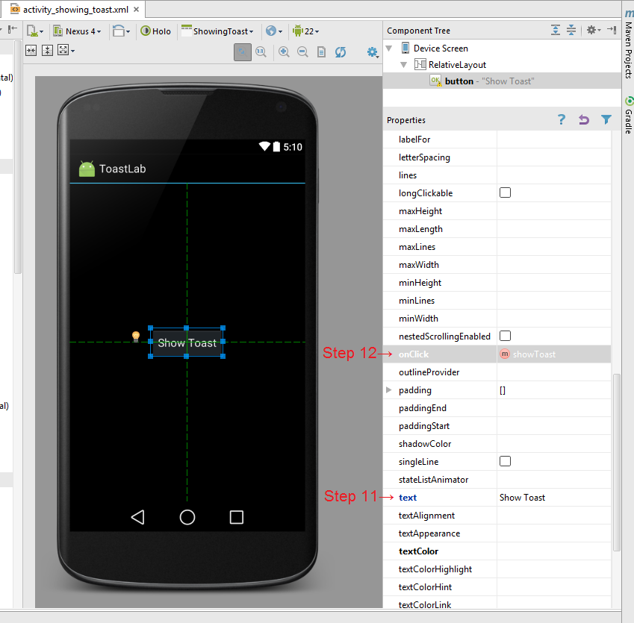

1. You may now run the app! Press the green play button in the toolbar up top (or press Shift+F10) and press OK to run the emulator.

Step 13.

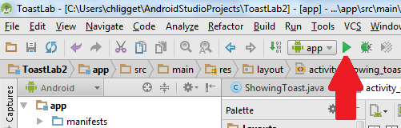

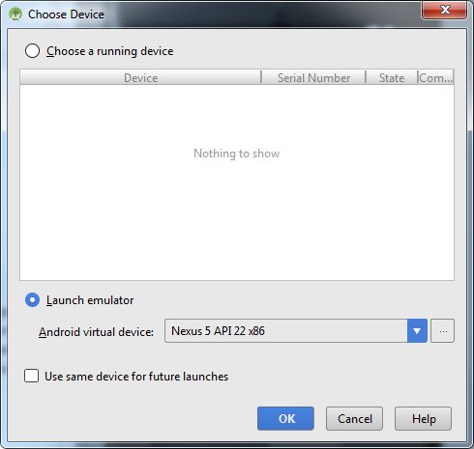

1. The emulator may take a while the first time but once it is up and running, your application should pop right up. If it does not, you can navigate to it in the App Drawer. Press your button and your toast message will pop up, before disappearing.

Step 14.

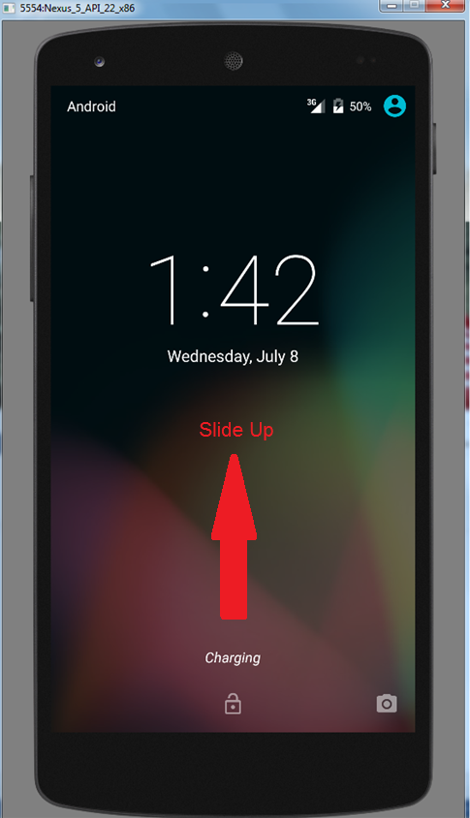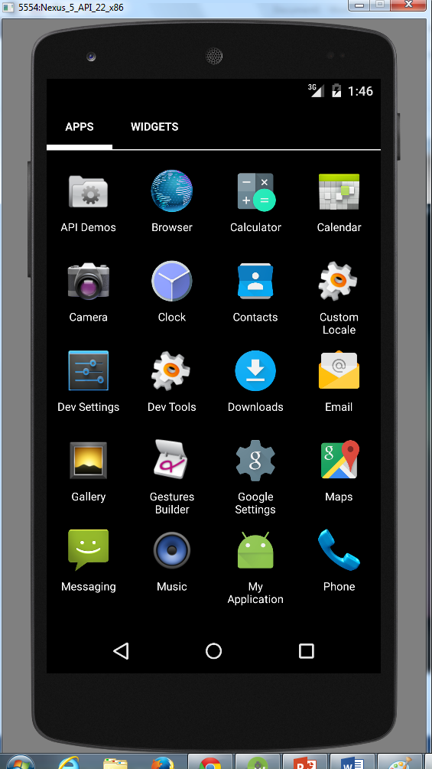

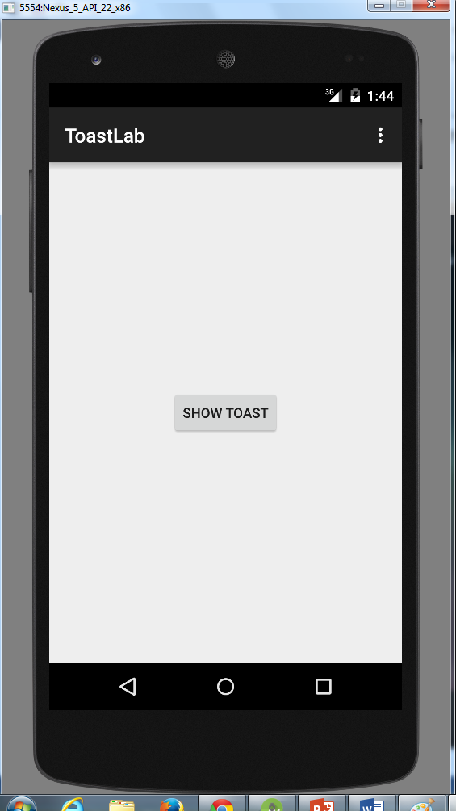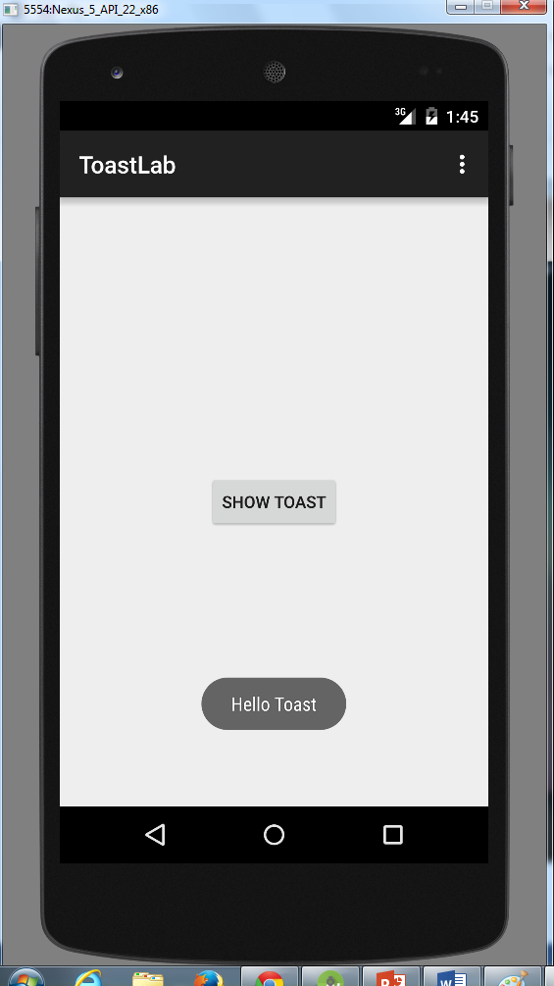

1. Now I would like for you to go play with some of the properties of either the button or the toast message. You may achieve this both programmatically or statically.