**APPENDIX**

Module 1

## Processing of data in the Central processing Unit (CPU)

In section 1.2.6, we described what motherboards and CPUs are. In this section, we will explain in brief how the CPU operates.

A CPU has the following components:

* 1. Control unit – controls all parts of the computer system. It manages the four basic operations of the fetch-execute-cycle as follows:
  + Fetch – gets the next program command from the computer’s memory
  + Decode – deciphers what the program is telling the computer to do
  + Execute – carries out the requested action
  + Store – saves the results to a register or memory

1. Arithmetic logic unit – performs arithmetic and logical operations
2. Register – saves the most frequently used instructions and data.

The process of fetch-decode-execute cycle is depicted on the diagram below.

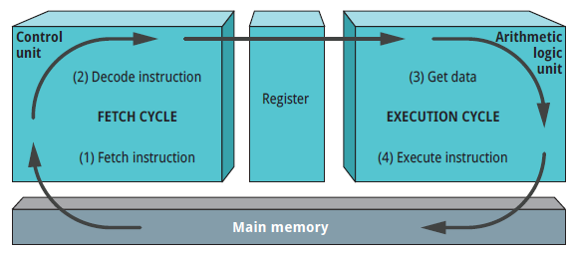

**Module 3**

# Number Conversions using Scratch

**Convert Binary to Decimal**

We have learnt how to do binary to decimal conversion. We are going to implement the same code using Scratch

**Here are the steps for converting a binaru number to a decimal number**

**Step 1**: Add the *when () clicked* block from the Event under the code tab

**Step 2**: Click Sensing under the code tab and drag the *say ()..* and *wait* block

**Step 3**: Click on Variables and select *Make a Variable*. Name the first variable i. Click on Make a Variable again and name it result and click OK

**Step 4**: Select the set () to () block. Change the variable name to i and set i to 1.

Step 5: Add another *set () to ()* block. Edit the variable to result and set it to 0

**Step 6**: Click on Control under the code tab and select *repeat* block

**Step 7**: In front of repeat text, add a *length of ()* block from the operators. Select answer block from Sensing and set the length of to answer.

**Step 8**: Click on Variables and select the *set ()* block.

**Step 9**: Select *change() by ().* Set variable to I and change by 1.

**Step10:** Click Looks from the code tab and select say () block. Add the result in the say block.

Your code will look as the one below.

**Converting decimal numbers to binary numbers**

Every day, we use decimal numbers. You have already been introduced to manually converting decimal numbers to binary numbers. Here is the Scratch script for converting decimal numbers to binary numbers. Take note that in this script you just need to create three variables, which are:

* decimal number
* binary number
* remainder

