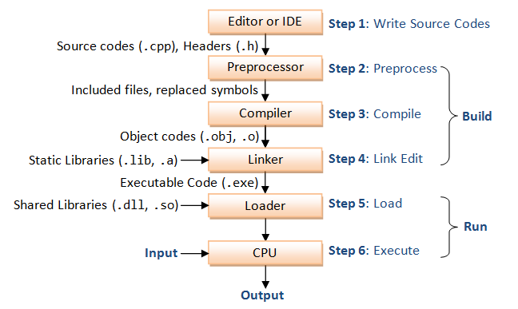

C++ source code is pre-processed before it is compiled into object code (as illustrated). A preprocessor directive, which begins with a # sign (such as #include, #define), tells the preprocessor to perform a certain action (such as including a header file, or performing text replacement), before compiling the source code into object code. Preprocessor directives are not programming statements, and therefore should NOT be terminated with a semi-colon. For example,