Transcriptome pipelines
Peñaloza-Bojacá, G.F.; Villarreal, J.C.; Villarreal Lab.
2026-06-19
Table of Contents

Introduction
The goal of this tutorial is to document a step-by-step transcriptome analysis pipeline using a de novo assembly approach. This workflow has been developed for the Zamia RNA-seq dataset, and includes quality control, trimming, transcriptome assembly, annotation, and gene expression analysis.
All commands, scripts, and outputs have been organized to promote reproducibility and clarity. The pipeline is optimized for SLURM-based HPC environments, but can be adapted for other systems.

Disclaimer
This document provides an example workflow for transcriptome processing and analysis based on the tools, datasets, and objectives used in this project. It is intended as a practical guide rather than a definitive protocol.
Bioinformatics pipelines are continuously evolving, and alternative approaches, parameters, and software may be equally valid depending on the research question and available resources. Users are encouraged to consult the official documentation, recent literature, and software repositories for updates, best practices, and new features.
All scripts presented here are open and can be modified, adapted, and improved according to the needs of each project. Parts of the code, documentation, and workflow descriptions were developed with the assistance of artificial intelligence tools and subsequently reviewed and adapted for this analysis.

Transcriptome Analysis Workflow for Zamia RNA-seq Data
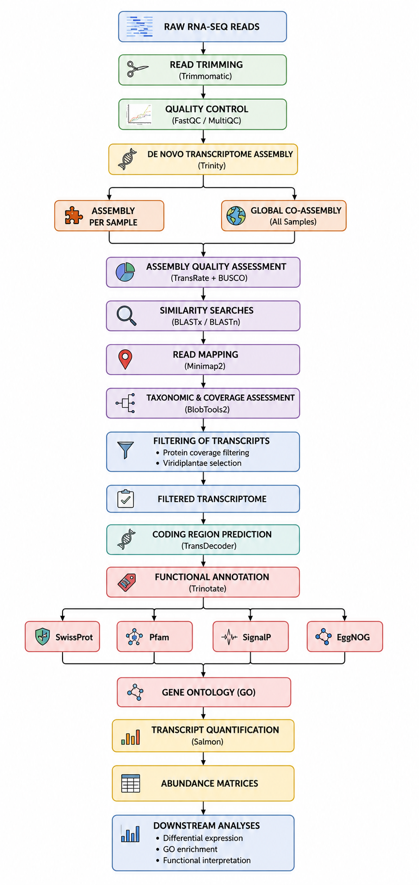

Files and Folders Organisation
Note: it is not advisable to change folder names once you’ve started processing.
We used WinSCP as SFTP. WinSCP is an open source free SFTP client for Windows. An SFTP client is a software which uses the SFTP protocol to transfer files securely to and from a remote computer.
Take your time to choose meaningful and structured names. A good folder name should help you quickly identify:
- the type of analysis included (e.g., raw reads, QC, assembly)
- the organism or project (e.g., Zamia)
- the type of molecular data (e.g., RNA, DNA)
Recommended directory structure
- 00_data/ – Reference files, genome indices, annotations
- 01_raw_reads_Zamia_RNA/ – Raw RNA-seq reads (FASTQ files)
- 02_clean_reads_Zamia_RNA_trimmomatic/ – Cleaned reads after trimming
- 03_fastqc_Zamia_RNA_clean/ – FastQC and MultiQC results for cleaned reads
- 04_trinity_Zamia_RNA/ – De novo transcriptome assembly (Trinity output)
- 05_busco_results_Zamia_RNA/ – Assembly completeness assessment with BUSCO
Alternative folder structure example
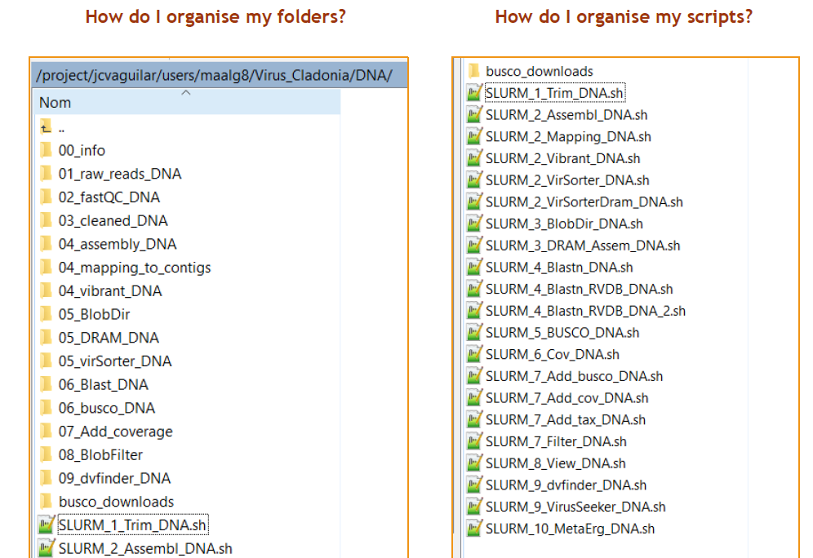
Example of a folder structure used in the genome pipeline, adapted from Alonso Garcia (2021).

Raw Reads
The first step in the pipeline is to inspect and verify the structure of the raw sequence data. For this project, paired-end FASTQ files were generated from RNA extracted from Zamia. Files are stored in the 00_raw_reads_Zamia_RNA/ folder.
The raw reads are organized in one folder per sample and include two paired-end FASTQ files:
00_raw_reads_Zamia_RNA/
└── Raw-HM-JCV23-0101/
├── Raw-HM-JCV23-0101_R1_paired.fq.gz # forward reads (R1)
└── Raw-HM-JCV23-0101_R2_paired.fq.gz # reverse reads (R2)
These files are gzip-compressed (.fq.gz) and follow a consistent naming pattern for compatibility with batch processing scripts.

Trimming – Cleaning raw reads with Trimmomatic
Trimming is an essential step to remove adapter sequences, low-quality bases, and very short reads from raw data. For this project, trimming was performed using Trimmomatic on paired-end reads.
For more information, see Trimmomatic manual.
Each input sample produced:
- Two clean paired-end reads (*_R1_paired.fq.gz, *_R2_paired.fq.gz)
- Two unpaired reads (*_R1_unpaired.fq.gz, *_R2_unpaired.fq.gz)
- A log file (.log) containing quality and trimming statistics
The output files were stored in:
01_clean_reads_Zamia_RNA_trimmomatic/

Trimmomatic parameters used
The following parameters were used in the trimming step to ensure high-quality reads for transcriptome assembly:
ILLUMINACLIP:<adapters>:2:30:10
LEADING:3
TRAILING:3
SLIDINGWINDOW:4:15
MINLEN:100
Parameter explanations:
ILLUMINACLIP::2:30:10:
Removes adapter sequences from reads.
- 2: Maximum mismatches allowed in adapter alignment
- 30: Minimum alignment score to remove a paired-end read
- 10: Minimum length of adapter match for single-end trimming
LEADING:3:
Removes low-quality bases from the start of each read (Phred score < 3).
TRAILING:3:
Removes low-quality bases from the end of each read (Phred score < 3).
SLIDINGWINDOW:4:15:
Performs quality trimming within a 4-base sliding window. Trimming starts when the average quality in the window drops below 15.
MINLEN:100:
Discards any read that becomes shorter than 100 nucleotides after trimming. This ensures that only reads of sufficient length are retained for downstream mapping and assembly.
These settings provide a good balance between removing sequencing noise and retaining informative RNA-seq reads, especially for Illumina paired-end data of 150 bp.

SLURM script used for trimming
The following script was used to trim all samples using a SLURM job array.
SLURM script: 01_A_Trim_Zamia_RNA.sh
#!/bin/bash
#SBATCH --partition=BRYOFIT
#SBATCH -J TrimArray_Zamia
#SBATCH -o Zamia_Trim_RNA_%A_%a.out
#SBATCH -e Zamia_Trim_RNA_%A_%a.err
#SBATCH -p medium
#SBATCH --array=1-12
#SBATCH --mail-type=ALL
#SBATCH --mail-user=gfpeb@ulaval.ca
#SBATCH --ntasks=1
#SBATCH --cpus-per-task=10
#SBATCH --mem-per-cpu=4G
#SBATCH --time=24:00:00
module load trimmomatic/0.36
# --- Configuración ---
base_dir="/project/jcvaguilar/users/jcvil9/Gab_Zamia_Transcri"
trimmomatic_jar="${base_dir}/Programas/trimmomatic_0.36/trimmomatic-0.36.jar"
adapters="${base_dir}/Programas/trimmomatic_0.36/adapters/TruSeq3-PE.fa"
input_parent="${base_dir}/00_raw_reads_Zamia_RNA"
output_parent="${base_dir}/01_clean_reads_Zamia_RNA_trimmomatic"
# Obtener el nombre de muestra desde la lista
sample_name=$(sed -n "${SLURM_ARRAY_TASK_ID}p" ${base_dir}/samples_list.txt)
sample_dir="${input_parent}/Raw-HM-${sample_name}"
# Verifica si la muestra existe
if [[ ! -d "$sample_dir" ]]; then
echo "Carpeta no encontrada: $sample_dir"
exit 1
fi
# Archivos de entrada
R1="${sample_dir}/${sample_name}_R1.fastq.gz"
R2="${sample_dir}/${sample_name}_R2.fastq.gz"
# Crear carpeta de salida
output_dir="${output_parent}/${sample_name}"
mkdir -p "$output_dir"
# Archivos de salida
R1_paired="${output_dir}/${sample_name}_R1_paired.fastq.gz"
R1_unpaired="${output_dir}/${sample_name}_R1_unpaired.fastq.gz"
R2_paired="${output_dir}/${sample_name}_R2_paired.fastq.gz"
R2_unpaired="${output_dir}/${sample_name}_R2_unpaired.fastq.gz"
log_file="${output_dir}/${sample_name}_trimmomatic.log"
# Ejecutar Trimmomatic
echo "Procesando $sample_name..."
java -jar "$trimmomatic_jar" PE -phred33 \
-threads 10 \
"$R1" "$R2" \
"$R1_paired" "$R1_unpaired" \
"$R2_paired" "$R2_unpaired" \
ILLUMINACLIP:"$adapters":2:30:10 \
LEADING:3 TRAILING:3 SLIDINGWINDOW:4:15 MINLEN:100 \
&> "$log_file"
echo "Finalizado $sample_name"

Trimming output files per sample
The output files will be stored in a new folder named 01_clean_reads_Zamia_RNA_trimmomatic, organized into subdirectories by sample, each containing the trimmed read files and associated logs.
01_clean_reads_Zamia_RNA_trimmomatic/
├── JCV23-0101/
│ ├── JCV23-0101_R1_paired.fq.gz # Forward reads after trimming
│ ├── JCV23-0101_R1_unpaired.fq.gz # Unpaired forward reads
│ ├── JCV23-0101_R2_paired.fq.gz # Reverse reads after trimming
│ ├── JCV23-0101_R2_unpaired.fq.gz # Unpaired reverse reads
│ └── JCV23-0101_trimmomatic.log # Log file with trimming summary
├── JCV23-0102/
│ └── ...
Each sample is stored in its own subfolder to simplify downstream processing and maintain a clean directory structure.

Example .log output file
The Trimmomatic log files report the number of paired-end reads processed and how many of them were retained after trimming. Below is an example summary for one sample:
TrimmomaticPE: Started with arguments:
Using PrefixPair: 'TACACTCTTTCCCTACACGACGCTCTTCCGATCT' and 'GTGACTGGAGTTCAGACGTGTGCTCTTCCGATCT'
ILLUMINACLIP: Using 1 prefix pairs, 0 forward/reverse sequences, 0 forward only sequences, 0 reverse only sequences
Input Read Pairs: 31773254 Both Surviving: 29326932 (92.30%) Forward Only Surviving: 2230442 (7.02%) Reverse Only Surviving: 88908 (0.28%) Dropped: 126972 (0.40%)
TrimmomaticPE: Completed successfully
- Input Read Pairs: The total number of read pairs provided to Trimmomatic.
- Both Surviving: Pairs where both reads passed quality and length filters — retained as paired reads.
- Forward/Reverse Only Surviving: Cases where only one read from the pair survived. These reads are kept in the unpaired output files.
- Dropped: Read pairs where neither read passed the filters — these are discarded.
In this example, 92.3% of read pairs were successfully retained as clean paired-end reads, indicating good initial data quality. Only 0.4% of pairs were discarded entirely, which is a very low loss rate and suggests minimal adapter contamination or poor-quality bases.

Log summarization script
To summarize the number of reads retained and discarded during the trimming process, the following script 01_B_Trim_Summary_Zamia_RNA.sh was used. It parses all Trimmomatic .log files and extracts key statistics such as the number of surviving read pairs, unpaired reads, and dropped pairs.
SLURM script: 01_B_Trim_Summary_Zamia_RNA.sh
#!/bin/bash
#SBATCH -J TrimSum_Zamia
#SBATCH -p small
#SBATCH --ntasks=1
#SBATCH --cpus-per-task=1
#SBATCH --mem=2G
#SBATCH --mail-type=ALL
#SBATCH --mail-user=gfpeb@ulaval.ca
#SBATCH --time=1:00:00
########
# Configuración general
base_dir="/project/jcvaguilar/users/jcvil9/Gab_Zamia_Transcri"
samples_list="${base_dir}/samples_list.txt"
output_dir="${base_dir}/01_clean_reads_Zamia_RNA_trimmomatic"
resumen_file="${output_dir}/Trimmomatic_summary.csv"
########
# Encabezado
echo "Sample,Input_Pairs,Both_Surviving,Forward_Only,Reverse_Only,Dropped" > "$resumen_file"
########
# Procesar cada muestra
while IFS= read -r sample; do
log="${output_dir}/${sample}/${sample}_trimmomatic.log"
if [[ -f "$log" ]]; then
# Extraer la línea que contiene los resultados
stats_line=$(grep "Input Read Pairs" "$log")
if [[ -n "$stats_line" ]]; then
# Extraer valores usando expresiones regulares
input=$(echo "$stats_line" | sed -n 's/.*Input Read Pairs: \([0-9]*\).*/\1/p')
both=$(echo "$stats_line" | sed -n 's/.*Both Surviving: \([0-9]*\).*/\1/p')
forward=$(echo "$stats_line" | sed -n 's/.*Forward Only Surviving: \([0-9]*\).*/\1/p')
reverse=$(echo "$stats_line" | sed -n 's/.*Reverse Only Surviving: \([0-9]*\).*/\1/p')
dropped=$(echo "$stats_line" | sed -n 's/.*Dropped: \([0-9]*\).*/\1/p')
echo "$sample,$input,$both,$forward,$reverse,$dropped" >> "$resumen_file"
else
echo "$sample,ERROR: No data found" >> "$resumen_file"
fi
else
echo "$sample,ERROR: Log file not found" >> "$resumen_file"
fi
done < "$samples_list"
echo "Resumen generado en: $resumen_file"

Trimming summary table
The following table summarizes the results of the trimming step for all samples. It includes the total number of input read pairs, the percentage of pairs that survived, and those that were partially or fully discarded.
library(readr)
library(dplyr)
library(knitr)
# Leer el archivo CSV desde tu computadora
trim_summary <- readr::read_csv(file.path(FIG, "Trimmomatic_summary.csv"))
# Mostrar tabla ordenada por muestra
trim_summary <- trim_summary %>% arrange(Sample)
# Mostrar tabla
kable(trim_summary, caption = "Table 2. Trimming summary for each sample")
Table 2. Trimming summary for each sample
Sample | Input_Pairs | Both_Surviving | Forward_Only | Reverse_Only | Dropped
JCV23-0101 | 31773254 | 29326932 | 2230442 | 88908 | 126972
JCV23-0102 | 36485938 | 34163732 | 2133170 | 83887 | 105149
JCV23-0201 | 32697196 | 31007931 | 1508918 | 104751 | 75596
JCV23-0202 | 33684743 | 31596155 | 1914412 | 87691 | 86485
JCV23-0301 | 32871179 | 30831693 | 1847803 | 92105 | 99578
JCV23-0302 | 36643793 | 34760975 | 1697357 | 98848 | 86613
JCV23-0401 | 30131960 | 28252449 | 1705129 | 92830 | 81552
JCV23-0402 | 32456879 | 30377489 | 1897022 | 84033 | 98335
JCV23-0501 | 35067922 | 32650201 | 2236630 | 80287 | 100804
JCV23-0502 | 36945684 | 34429194 | 2318389 | 91581 | 106520
JCV23-0601 | 28889052 | 25648588 | 2970012 | 101352 | 169100
JCV23-0602 | 33737733 | 31452369 | 2027863 | 137290 | 120211
Trimming summary plot
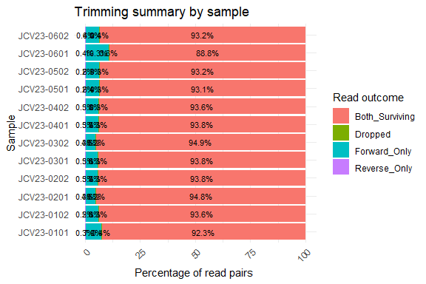

FastQC - Quality Control
After trimming, we assessed the quality of the cleaned reads using FastQC, a tool designed to provide quick diagnostics of sequencing data. FastQC generates per-sample HTML reports summarizing base quality, adapter content, GC distribution, and more.
For more information, see FastQC
The analysis was performed on the cleaned paired-end reads (*_R1_paired.fq.gz and *_R2_paired.fq.gz) located in the folder 01_clean_reads_Zamia_RNA_trimmomatic/.
The output files were saved in a dedicated folder:
02_fastqc_Zamia_clean

FastQC parameters
FastQC was run with default parameters. The only specified option was the output directory:
By default, FastQC performs the following checks:
- Per base sequence quality
- Per sequence quality scores
- Per base sequence content
- Per base GC content
- Per sequence GC content
- Per base N content
- Sequence length distribution
- Sequence duplication levels
- Overrepresented sequences
- Adapter content
No custom adapters or contaminants were specified, and no filtering or trimming was applied at this step — FastQC is purely diagnostic and does not modify the input data.

SLURM script used for FastQC
The following script was used to FastQC all samples using a SLURM job array.
SLURM script: 02_A_fastqc_Zamia_RNA.sh
#!/bin/bash
#SBATCH --partition=BRYOFIT
#SBATCH -J fastqc_zamia_array
#SBATCH -o fastqc_zamia_%A_%a.out
#SBATCH -e fastqc_zamia_%A_%a.err
#SBATCH -p medium
#SBATCH --array=1-12
#SBATCH --ntasks=1
#SBATCH --cpus-per-task=2
#SBATCH --mem-per-cpu=2G
#SBATCH --time=01:00:00
#SBATCH --mail-type=ALL
#SBATCH --mail-user=gfpeb@ulaval.ca
module load fastqc/0.11.8
# Configuración de directorios
base_dir="/project/jcvaguilar/users/jcvil9/Gab_Zamia_Transcri"
input_dir="${base_dir}/01_clean_reads_Zamia_RNA_trimmomatic"
output_base="${base_dir}/02_fastqc_Zamia_clean"
samples_list="${base_dir}/samples_list.txt"
# Obtener nombre de muestra
sample_name=$(sed -n "${SLURM_ARRAY_TASK_ID}p" "$samples_list")
sample_folder="${input_dir}/${sample_name}"
# Verificar si existe la carpeta de la muestra
if [[ ! -d "$sample_folder" ]]; then
echo "Carpeta no encontrada: $sample_folder"
exit 1
fi
# Crear carpeta de salida para la muestra
sample_out="${output_base}/${sample_name}"
mkdir -p "$sample_out"
# Ejecutar FastQC para cada archivo .fastq.gz de la muestra
for file in "$sample_folder"/*.fastq.gz; do
echo "Procesando $file ? $sample_out"
fastqc -o "$sample_out" "$file"
done
echo "FastQC finalizado para muestra $sample_name

FastQC output files per sample
The output files will be stored in a new folder named 02_fastqc_Zamia_cleanc, organized into subdirectories by sample.
02_fastqc_Zamia_clean/
└──JCV23-0101
├── JCV23-0101_R1_paired_fastqc.html
├── JCV23-0101_R1_paired_fastqc.zip
├── JCV23-0101_R2_paired_fastqc.html
├── JCV23-0101_R2_paired_fastqc.zip
└──...
└──JCV23-0102
├──...
- An .html report that provides a detailed visual summary of read quality and sequence statistics.
- A .zip archive containing raw data files used to generate the report (e.g., tables, images, summary text).
The .html files can be opened directly in a web browser to inspect per-base quality scores, GC content, adapter contamination, sequence length distribution, and other metrics. These diagnostics help assess whether the reads are suitable for downstream processing (e.g., transcriptome assembly or quantification).
Important Metrics
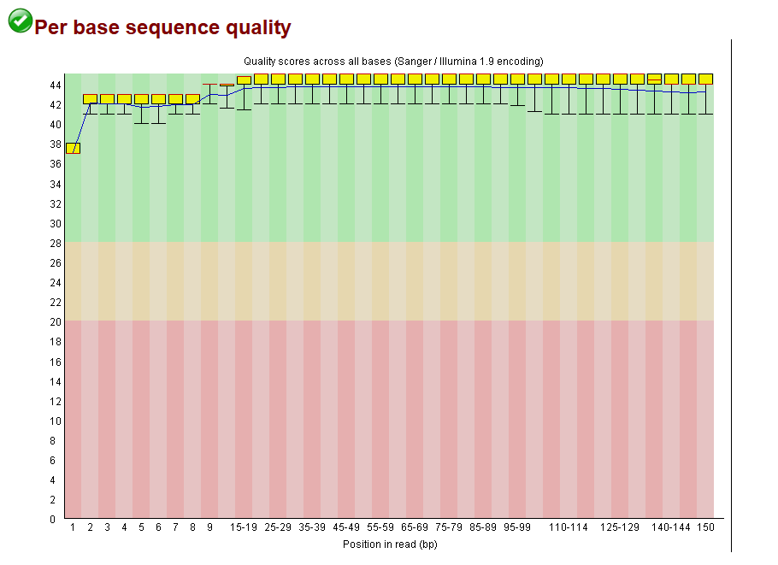
Per base sequence quality
- Assesses the average quality score at each base position in the read.
- Look for Phred scores >30 across most positions. A slight drop at the end is normal, but sharp declines may require trimming.
- This is the most critical plot to determine base-by-base quality.
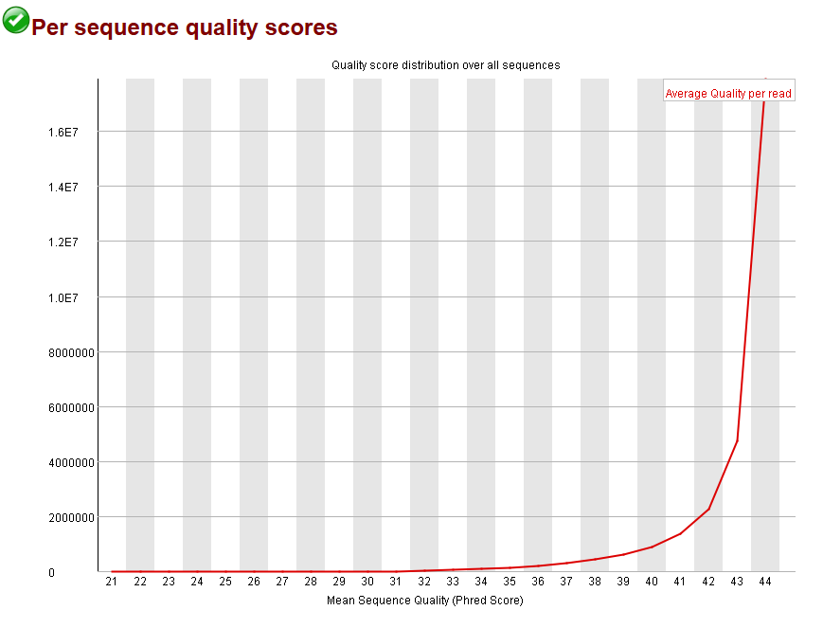
Per sequence quality scores
- Displays the distribution of average quality scores per read.
- Single sharp peak in the high-quality range is ideal. A bimodal or flat distribution may indicate library issues.
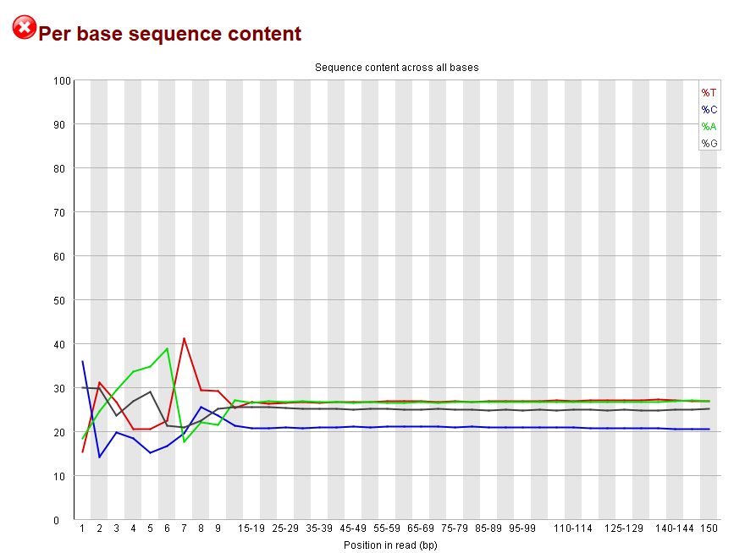
Per base sequence content
- Shows the proportion of A, T, G, and C at each base position.
- For RNA-seq, deviations from uniformity are expected due to transcript biases.
- Often marked as [FAIL], but this is not necessarily a problem in RNA-seq.
Useful Additional Metrics
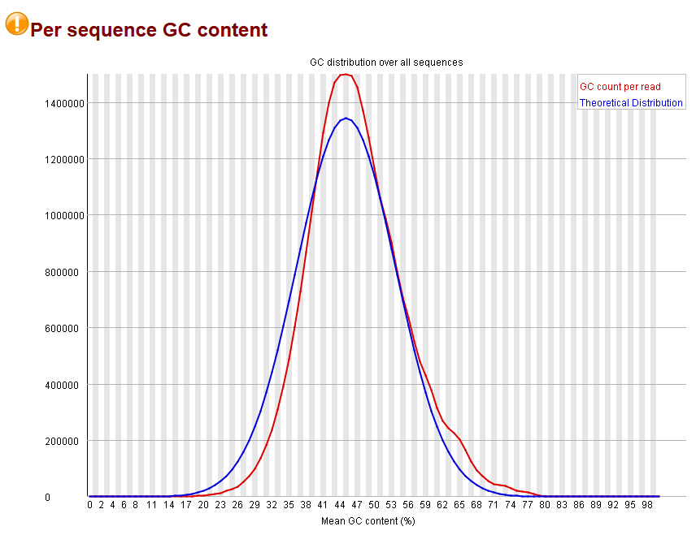
GC content
- Displays the distribution of GC content across reads.
- Single bell-shaped curve centered around the expected GC content is ideal.
- Bimodal or skewed distributions may suggest contamination.
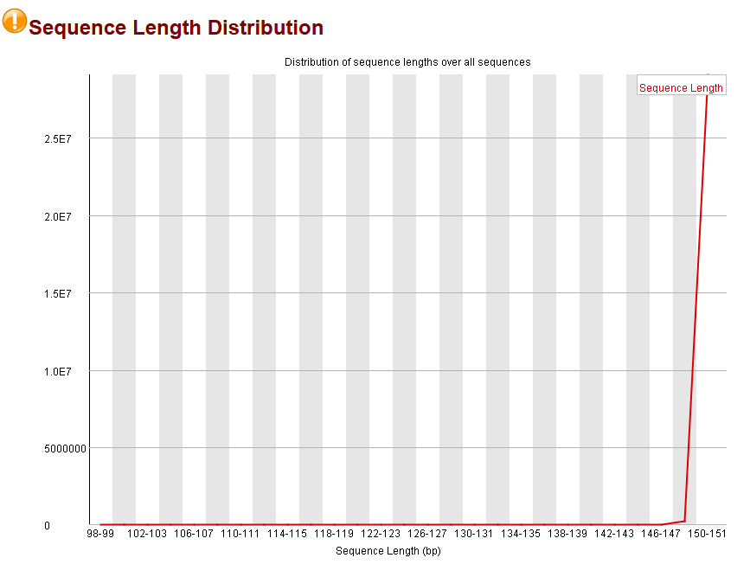
Sequence length distribution
- Indicates the length of reads in your dataset.
- Most reads should have the same length (e.g., 150 bp), unless trimming or filtering was applied.
Secondary Metrics (review if flagged)
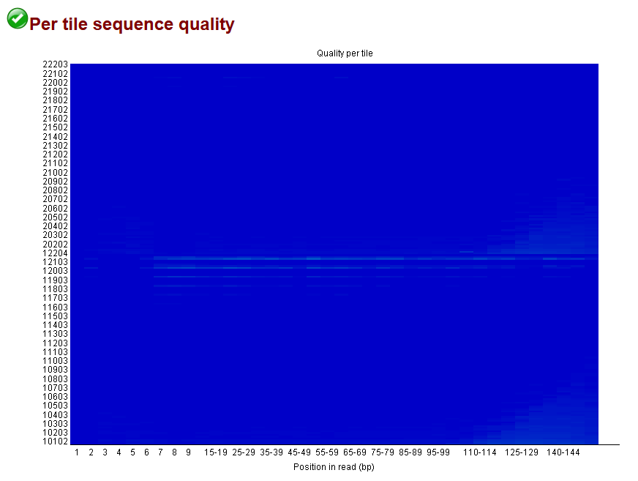
Per tile sequence quality
- Detects systematic problems across different areas (“tiles”) of the flowcell.
- Usually not an issue, unless you observe significant [FAIL]s.
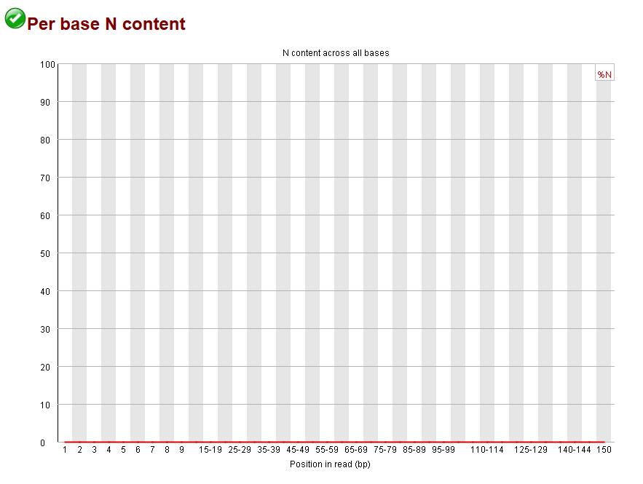
Per base N content
- Measures the proportion of unidentified bases (N) at each position.
- Should be near 0%. Peaks may indicate sequencing issues.
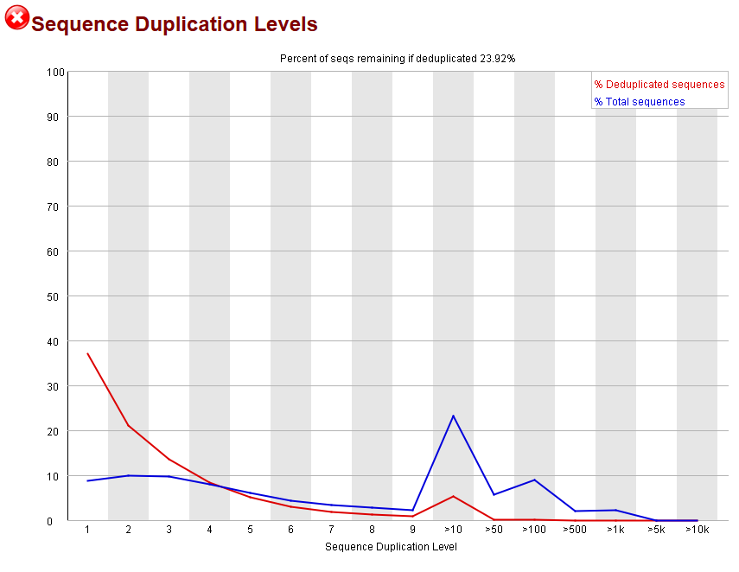
Sequence duplication levels
- Evaluates how many reads are duplicated.
- Some duplication is normal in RNA-seq due to highly expressed genes.
- High duplication (>50%) may suggest PCR artifacts or low library complexity.

Trinity: De novo transcriptome assembly
Trinity is a widely used tool for de novo transcriptome assembly from RNA-seq data. It reconstructs full-length transcripts by combining short reads into contigs using a modular approach: Inchworm, Chrysalis, and Butterfly. This step is critical for building a reference transcriptome in non-model organisms, such as Zamia.
Trinity works best on high-quality, paired-end reads that have already been trimmed (e.g. with Trimmomatic) and quality-checked (e.g. with FastQC).
For more information, see Trinity
The analysis was performed on the cleaned paired-end reads (*_R1_paired.fq.gz and *_R2_paired.fq.gz) located in the folder 01_clean_reads_Zamia_RNA_trimmomatic/.
The output files were saved in a dedicated folder:
03_trinity_separated

Trinity command parameters
The Trinity assembly was executed using the following key parameters:
- --seqType fq: Specifies that input files are in FASTQ format.
- --left and --right: Paired-end reads used for assembly.
- --max_memory 80G: Limits RAM usage to 80 GB, which aligns with the SLURM job allocation.
- --CPU 4: Trinity ran on 4 threads, balancing performance and cluster availability.
- --output: Output directory specific to each sample.
- --full_cleanup: Removes intermediate files after completion to reduce disk space.
- > "$log_file" 2>&1: Redirects both standard output and error messages to a log file for later inspection.
These parameters ensure that the assembly is efficient, reproducible, and does not overload the compute node.

SLURM script used for Trinity
We used a SLURM array job to run Trinity in parallel for each sample.
SLURM script: 03_C_Trinity_Zamia_RNA.sh
#!/bin/bash
#SBATCH -J Tri_Zam_RNA
#SBATCH -o Trinity_Zamia_%j.out
#SBATCH -e Trinity_Zamia_%A_%a.err
#SBATCH -p medium
#SBATCH --array=6
#SBATCH --ntasks=1
#SBATCH --cpus-per-task=4
#SBATCH --mem=80G
#SBATCH --time=6-00:00:00
#SBATCH --mail-type=ALL
#SBATCH --mail-user=gfpeb@ulaval.ca
source /prg/miniconda/3/etc/profile.d/conda.sh
conda activate /home/jcvil9/.conda/envs/trinity_env
# Rutas
base_dir="/project/jcvaguilar/users/jcvil9/Gab_Zamia_Transcri"
samples_list="${base_dir}/samples_list.txt"
input_base="${base_dir}/01_clean_reads_Zamia_RNA_trimmomatic"
output_base="${base_dir}/03_trinity_separated"
# Obtener muestra actual
sample=$(sed -n "${SLURM_ARRAY_TASK_ID}p" "$samples_list" | tr -d '[:space:]')
fecha=$(date +%Y%m%d)
output_dir="${output_base}/${sample}_${fecha}_trinity"
log_file="${output_dir}/${sample}_${fecha}_trinity.log"
# Archivos de entrada
left_reads="${input_base}/${sample}/${sample}_R1_paired.fastq.gz"
right_reads="${input_base}/${sample}/${sample}_R2_paired.fastq.gz"
# Verificar existencia
if [[ ! -f "$left_reads" || ! -f "$right_reads" ]]; then
echo " FASTQ no encontrados para muestra $sample" >&2
exit 1
fi
mkdir -p "$output_dir"
# Ejecutar Trinity directamente
echo "Ejecutando Trinity para $sample..."
Trinity \
--seqType fq \
--left "$left_reads" \
--right "$right_reads" \
--max_memory 80G \
--CPU 4 \
--output "$output_dir" \
--full_cleanup \
> "$log_file" 2>&1
echo "Trinity finalizado para $sample"
conda deactivate

Trinity output files per sample
The output files will be stored in a new folder named 03_trinity_separated, organized into subdirectories by sample.
03_trinity_separated/
├──JCV23-0101_20250617
├──JCV23-0102_20250617
├──JCV23-0201_20250617
├──...
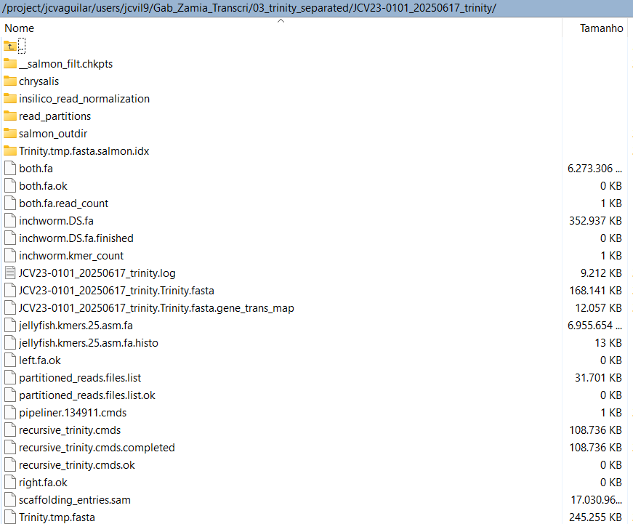

Trinity Assembly Statistics
The following table shows the basic statistics of the transcriptome assembly produced by Trinity, obtained with the script TrinityStats.pl.
The following summary shows the basic assembly statistics generated by TrinityStats.pl for the sample JCV23-0101, including the number of genes and transcripts, GC content, N statistics, contig lengths, and total assembled bases.
################################
## Counts of transcripts, etc.
################################
Total trinity 'genes': 209841
Total trinity transcripts: 260669
Percent GC: 40.80
########################################
Stats based on ALL transcript contigs:
########################################
Contig N10: 4185
Contig N20: 3054
Contig N30: 2338
Contig N40: 1799
Contig N50: 1265
Median contig length: 271
Average contig: 586.99
Total assembled bases: 153009149
#####################################################
## Stats based on ONLY LONGEST ISOFORM per 'GENE':
#####################################################
Contig N10: 3561
Contig N20: 2379
Contig N30: 1602
Contig N40: 784
Contig N50: 418
Median contig length: 260
Average contig: 435.42
Total assembled bases: 91368473
These metrics provide a general overview of transcriptome assembly quality:
Number of transcripts and genes: A high number (260k transcripts from 209k genes) is expected for de novo assemblies in non-model species, though redundancy can occur.
GC content (40.80%): Within the typical range for plant transcriptomes (usually between 40–45%), suggesting no major contamination.
N50 and contig length: N50 of 1,265 bp (all contigs) and 418 bp (longest isoforms only) are moderate values. A higher N50 generally reflects longer, more complete transcripts.
Total assembled bases: ~153 Mbp (all contigs) → a good indication of coverage. ~91 Mbp (longest isoforms) is more useful for downstream gene expression analysis.
Tip: A high average contig length and N50, along with reasonable GC content and number of transcripts, support a reliable assembly. However, functional completeness (BUSCO) and read support (TransRate) are also important.

Trinity Co-assembly Using All Samples
In addition to the individual transcriptome assemblies generated for each sample, a global de novo transcriptome assembly was performed using all cleaned RNA-seq libraries combined into a single dataset. This co-assembly strategy increases sequencing depth, improves transcript recovery, and provides a comprehensive reference transcriptome for downstream analyses such as BUSCO, BLASTx, Minimap2, BlobTools2, contamination filtering, and functional annotation.
The analysis was performed using all cleaned paired-end reads (*_R1_paired.fastq.gz and *_R2_paired.fastq.gz) located in the folder 01_clean_reads_Zamia_RNA_trimmomatic/.
The output files were saved in a dedicated folder:
03_trinity_separated/Zamia_all_YYYYMMDD_trinity

Read concatenation
Prior to assembly, all cleaned paired-end reads were concatenated into two compressed FASTQ files:
- all_samples_R1.fastq.gz
- all_samples_R2.fastq.gz
This procedure allowed Trinity to reconstruct a reference transcriptome containing transcripts expressed across all samples included in the study.

Trinity co-assembly command parameters
The Trinity co-assembly was executed using the following key parameters:
- --seqType fq: Specifies that input files are in FASTQ format.
- --left and --right: Combined paired-end reads from all samples.
- --max_memory 200G: Allocates up to 200 GB of RAM for assembly.
- --CPU 8: Uses 8 processing threads.
- --normalize_max_read_cov 200: Performs in silico read normalization to reduce redundancy and computational requirements while maintaining transcript diversity.
- --output: Defines the output directory.
- --full_cleanup: Removes intermediate files after completion to reduce disk space usage.
- > "$log_file" 2>&1: Redirects standard output and error messages to a log file for troubleshooting and reproducibility.
To improve performance and reduce I/O bottlenecks, Trinity was executed in the local /scratch directory of the compute node. The resulting assembly files were subsequently copied to permanent storage.

SLURM script used for Trinity co-assembly
We used a SLURM job to generate a global transcriptome assembly from all RNA-seq libraries.
SLURM script: 03_E_Trinity_Zamia_ALL_RNA.sh
#!/bin/bash
#SBATCH -J TriAll_Zam
#SBATCH -o Tri_ALL_Zam_%j.out
#SBATCH -p large
#SBATCH --cpus-per-task=8
#SBATCH --mem=200G
#SBATCH --time=21-00:00:00
#SBATCH --mail-type=ALL
#SBATCH --mail-user=gfpeb@ulaval.ca
Job Runtime JobId Partition | Cpu Cpu(%) | Mem(Go) Used Unused Mem(%)
--- ------- ----- --------- + --- ------ + ------- ---- ------ ------
TriAll Zam 367h52m 323921 ibismini | 8 18.40% ** | 200.00 162.34 37.66 81.17%
#############################################
# 1. Activar entorno conda con Trinity
#############################################
source /prg/miniconda/3/etc/profile.d/conda.sh
conda activate /home/jcvil9/.conda/envs/trinity_env
#############################################
# 2. Definir rutas
#############################################
base_dir="/project/jcvaguilar/users/jcvil9/Gab_Zamia_Transcri"
input_base="${base_dir}/01_clean_reads_Zamia_RNA_trimmomatic"
output_base="${base_dir}/03_trinity_separated"
# Fecha y nombres
fecha=$(date +%Y%m%d)
scratch_dir="/scratch/${USER}/${SLURM_JOB_ID}/Zamia_all_${fecha}_trinity"
final_dir="${output_base}/Zamia_all_${fecha}_trinity"
# Crear carpetas
mkdir -p "$scratch_dir"
mkdir -p "$final_dir"
# Archivos concatenados
R1_all="${output_base}/all_samples_R1.fastq.gz"
R2_all="${output_base}/all_samples_R2.fastq.gz"
#############################################
# 3. Concatenar lecturas si no existen
#############################################
if [[ ! -f "$R1_all" || ! -f "$R2_all" ]]; then
echo "Concatenando lecturas limpias..."
cat ${input_base}/*/*_R1_paired.fastq.gz > "$R1_all"
cat ${input_base}/*/*_R2_paired.fastq.gz > "$R2_all"
# Guardar listado de muestras usadas
ls ${input_base}/*/*_R1_paired.fastq.gz > "${output_base}/samples_concat_R1.txt"
ls ${input_base}/*/*_R2_paired.fastq.gz > "${output_base}/samples_concat_R2.txt"
fi
#############################################
# 4. Ejecutar Trinity en /scratch
#############################################
log_file="${final_dir}/Trinity_all_${fecha}.log"
echo "Ejecutando Trinity conjunto en /scratch..."
Trinity \
--seqType fq \
--left "$R1_all" \
--right "$R2_all" \
--max_memory 200G \
--CPU 8 \
--normalize_max_read_cov 200 \
--output "$scratch_dir" \
--full_cleanup \
> "$log_file" 2>&1
#############################################
# 5. Copiar resultados esenciales a /project
#############################################
echo "Copiando resultados de Trinity a $final_dir ..."
cp "$scratch_dir"/Trinity.fasta \
"$scratch_dir"/Trinity.fasta.gene_trans_map \
"$scratch_dir"/Trinity.timing \
"$scratch_dir"/Trinity.stats \
"$scratch_dir"/Trinity.fasta.seqLengths \
"$scratch_dir"/recursive_trinity.cmds \
"$scratch_dir"/*.log \
"$final_dir/" 2>/dev/null || echo "Algunos archivos opcionales no se encontraron."
echo "Trinity co-assembly finalizado el $(date)"
conda deactivate

Trinity co-assembly output files
The output files were stored in a dedicated directory containing the global transcriptome assembly and associated metadata.
03_trinity_separated/
└── Zamia_all_20250617_trinity/
├── Trinity.fasta
├── Trinity.fasta.gene_trans_map
├── Trinity.stats
├── Trinity.timing
├── Trinity.fasta.seqLengths
├── recursive_trinity.cmds
└── Trinity_all_20250617.log
The resulting assembly represents a comprehensive reference transcriptome for Zamia and was used in all subsequent analyses, including assembly quality assessment, contamination filtering, taxonomic assignment, and functional annotation.

Assembly quality assessment with TransRate
TransRate is a reference-free tool that evaluates de novo transcriptome assemblies based on: - Read mapping rates, - Fragment coverage, - Potential chimeras or incomplete contigs.
It generates a set of statistics that help determine how well the reads support the assembled transcripts. This provides a complementary perspective to tools like TrinityStats or BUSCO.
For more information, see TransRate site.

SLURM script used for TransRate
The following script was used to all individual samples using a SLURM job array.
SLURM script: 04_TransRate_Zamia_RNA.sh
#!/bin/bash
#SBATCH -J TraRate_Zam
#SBATCH -o TransRate_Zam_test.out
#SBATCH -p small
#SBATCH --cpus-per-task=1
#SBATCH --array=6
#SBATCH --mem=8G
#SBATCH --time=1-00:00:00
#SBATCH --mail-type=ALL
#SBATCH --mail-user=gfpeb@ulaval.ca
###############
module load usearch/9.2.64_i86linux32
module load bowtie/2.3.4.1
module load eXpress/1.5.1
module load salmon/0.11.0
module load transrate/1.0.3
###############
# Definir rutas
base_dir="/project/jcvaguilar/users/jcvil9/Gab_Zamia_Transcri"
samples_list="${base_dir}/samples_list.txt"
reads_base="${base_dir}/01_clean_reads_Zamia_RNA_trimmomatic"
trinity_base="${base_dir}/03_trinity_separated"
results_base="${base_dir}/04_transrate_results"
###############
# Obtener nombre de muestra
sample=$(sed -n "${SLURM_ARRAY_TASK_ID}p" "$samples_list" | tr -d '[:space:]')
fecha=$(date +%Y%m%d)
###############
# Buscar ensamblaje más reciente
assembly_dir=$(find "$trinity_base" -maxdepth 1 -type d -name "${sample}_*_trinity" | sort | tail -n 1)
assembly_fasta=$(find "$assembly_dir" -maxdepth 1 -type f -name "${sample}_*_trinity.Trinity.fasta" | head -n 1)
###############
# Definir rutas de archivos
left_reads="${reads_base}/${sample}/${sample}_R1_paired.fastq.gz"
right_reads="${reads_base}/${sample}/${sample}_R2_paired.fastq.gz"
output_dir="${results_base}/${sample}_${fecha}_transrate"
log_file="${output_dir}/${sample}_${fecha}_transrate.log"
###############
# Crear directorio de salida
mkdir -p "$output_dir"
###############
# Ejecutar Transrate
transrate -a "$assembly_fasta" \
--left "$left_reads" \
--right "$right_reads" \
-t 1 \
--output "$output_dir" &> "$log_file"

Transrate output files per sample
The output files will be stored in a new folder named 04_transrate_results, organized into subdirectories by sample, each containing the trimmed read files and associated logs.
The following statistics summarize the quality of the de novo transcriptome assembly (Trinity output) as assessed by TransRate:
...
[ INFO] 2025-06-25 15:20:54 : Calculating contig metrics...
[ INFO] 2025-06-25 15:21:37 : Contig metrics:
[ INFO] 2025-06-25 15:21:37 : -----------------------------------
[ INFO] 2025-06-25 15:21:37 : n seqs 260669
[ INFO] 2025-06-25 15:21:37 : smallest 182
[ INFO] 2025-06-25 15:21:37 : largest 21955
[ INFO] 2025-06-25 15:21:37 : n bases 153009149
[ INFO] 2025-06-25 15:21:37 : mean len 586.97
[ INFO] 2025-06-25 15:21:37 : n under 200 26
[ INFO] 2025-06-25 15:21:37 : n over 1k 36339
[ INFO] 2025-06-25 15:21:37 : n over 10k 78
[ INFO] 2025-06-25 15:21:37 : n with orf 37212
[ INFO] 2025-06-25 15:21:37 : mean orf percent 56.19
[ INFO] 2025-06-25 15:21:37 : n90 236
[ INFO] 2025-06-25 15:21:37 : n70 363
[ INFO] 2025-06-25 15:21:37 : n50 1265
[ INFO] 2025-06-25 15:21:37 : n30 2338
[ INFO] 2025-06-25 15:21:37 : n10 4185
[ INFO] 2025-06-25 15:21:37 : gc 0.41
[ INFO] 2025-06-25 15:21:37 : bases n 0
[ INFO] 2025-06-25 15:21:37 : proportion n 0.0
[ INFO] 2025-06-25 15:21:37 : Contig metrics done in 43 seconds
...
The following metrics were extracted from the transrate.log output and provide a snapshot of assembly quality:
library(knitr)
library(tibble)
# Crear tabla con métricas e interpretaciones
transrate_metrics <- tribble(
~Metric, ~Value, ~Interpretation,
"Number of contigs", "260,669", "Total assembled transcripts; reflects transcriptome complexity.",
"Smallest contig", "182 bp", "Very short contigs; often discarded in downstream analysis.",
"Largest contig", "21,955 bp", "Longest assembled sequence; may represent full-length gene.",
"Total bases", "153,009,149", "Total number of assembled bases; reflects overall assembly size.",
"Mean contig length", "586.97 bp", "Average transcript length; indicates assembly fragmentation or completeness.",
"Contigs < 200 bp", "26", "Very short contigs; likely non-informative.",
"Contigs > 1,000 bp", "36,339", "Putative full-length or near-complete transcripts.",
"Contigs > 10,000 bp", "78", "Very long transcripts; may indicate full-length genes or chimeras.",
"Contigs with ORFs", "37,212", "Transcripts with open reading frames; suggests coding potential.",
"Mean ORF %", "56.19%", "Average percentage of transcript covered by an ORF.",
"GC content", "41%", "Consistent with plant transcriptomes.",
"N50", "1,265 bp", "Half of the assembly is in contigs of this length or longer.",
"N90", "236 bp", "Length above which the top 90% of contigs fall.",
"N70", "363 bp", "Length above which the top 70% of contigs fall.",
"N30", "2,338 bp", "Length above which the top 30% of contigs fall.",
"N10", "4,185 bp", "Length above which the top 10% of contigs fall."
)
# Mostrar tabla
kable(transrate_metrics, caption = "Summary of Trinity assembly metrics and interpretations.")
Summary of Trinity assembly metrics and interpretations.
Metric | Value | Interpretation
Number of contigs | 260,669 | Total assembled transcripts; reflects transcriptome complexity.
Smallest contig | 182 bp | Very short contigs; often discarded in downstream analysis.
Largest contig | 21,955 bp | Longest assembled sequence; may represent full-length gene.
Total bases | 153,009,149 | Total number of assembled bases; reflects overall assembly size.
Mean contig length | 586.97 bp | Average transcript length; indicates assembly fragmentation or completeness.
Contigs < 200 bp | 26 | Very short contigs; likely non-informative.
Contigs > 1,000 bp | 36,339 | Putative full-length or near-complete transcripts.
Contigs > 10,000 bp | 78 | Very long transcripts; may indicate full-length genes or chimeras.
Contigs with ORFs | 37,212 | Transcripts with open reading frames; suggests coding potential.
Mean ORF % | 56.19% | Average percentage of transcript covered by an ORF.
GC content | 41% | Consistent with plant transcriptomes.
N50 | 1,265 bp | Half of the assembly is in contigs of this length or longer.
N90 | 236 bp | Length above which the top 90% of contigs fall.
N70 | 363 bp | Length above which the top 70% of contigs fall.
N30 | 2,338 bp | Length above which the top 30% of contigs fall.
N10 | 4,185 bp | Length above which the top 10% of contigs fall.
High ORF content (~56%) and a substantial number of contigs >1,000 bp suggest good assembly completeness and biological relevance.
Low number of short contigs (<200 bp) indicates good filtering or normalization.
N50 = 1,265 bp is typical for de novo assemblies from short-read RNA-seq data.
GC content (41%) matches plant expectations and suggests no major contamination.

TransRate Assessment of the Global Trinity Assembly
In addition to the quality assessment performed for each individual transcriptome assembly, TransRate was also used to evaluate the global Trinity co-assembly generated from all RNA-seq libraries combined.
The analysis was conducted using the reference transcriptome obtained from the Trinity co-assembly and the concatenated paired-end reads used during assembly. This approach provides an overall assessment of assembly quality and read support across the complete dataset.
The assembly file was automatically identified from the most recent Trinity co-assembly directory:
03_trinity_separated/Zamia_all_YYYYMMDD_trinity/
The paired-end reads used for evaluation corresponded to the concatenated files:
- all_samples_R1.fastq.gz
- all_samples_R2.fastq.gz
The resulting TransRate output files were stored in:
04_transrate_results/Zamia_all_transrate

TransRate command parameters
The global assembly assessment was executed using the following key parameters:
- -a: Trinity co-assembly FASTA file used as the reference transcriptome.
- --left and --right: Concatenated paired-end reads from all samples.
- -t 2: Number of threads used by TransRate.
- --output: Directory where all quality assessment results were stored.
- &> "$log_file": Redirects standard output and error messages to a log file for reproducibility and troubleshooting.
Unlike the individual analyses, which evaluated each sample independently, this assessment measures the overall support of the complete RNA-seq dataset for the global transcriptome assembly.

SLURM script used for global TransRate assessment
We used a dedicated SLURM job to evaluate the Trinity co-assembly generated from all RNA-seq libraries.
SLURM script: 04_B_TransRate_Zamia_ALL_RNA.sh
#!/bin/bash
#SBATCH -J TraRa_Zam_All
#SBATCH -o TraRa_Zam_All.out
#SBATCH -p medium
#SBATCH --cpus-per-task=5
#SBATCH --mem=30G
#SBATCH --time=7-00:00:00
#SBATCH --mail-type=ALL
#SBATCH --mail-user=gfpeb@ulaval.ca
#############################################
# 1. Cargar módulos necesarios
#############################################
module load usearch/9.2.64_i86linux32
module load bowtie/2.3.4.1
module load eXpress/1.5.1
module load salmon/0.11.0
module load transrate/1.0.3
#############################################
# 2. Definir rutas
#############################################
base_dir="/project/jcvaguilar/users/jcvil9/Gab_Zamia_Transcri"
trinity_dir="${base_dir}/03_trinity_separated"
results_base="${base_dir}/04_transrate_results"
# Detectar ensamblaje conjunto automáticamente
assembly_dir=$(find "$trinity_dir" -maxdepth 1 -type d -name "Zamia_all_*_trinity" | sort | tail -n 1)
assembly_fasta="${assembly_dir}/Trinity.fasta"
# Reads concatenados
left_reads="${trinity_dir}/all_samples_R1.fastq.gz"
right_reads="${trinity_dir}/all_samples_R2.fastq.gz"
# Salida Transrate
output_dir="${results_base}/Zamia_all_transrate"
log_file="${output_dir}/transrate_zamia_all.log"
# Crear directorio de salida
mkdir -p "$output_dir"
#############################################
# 3. Ejecutar Transrate
#############################################
transrate -a "$assembly_fasta" \
--left "$left_reads" \
--right "$right_reads" \
-t 2 \
--output "$output_dir" &> "$log_file"
echo "Transrate global finalizado el $(date)"

TransRate output files
The quality assessment results generated by TransRate were stored in a dedicated output directory.
04_transrate_results/
└── Zamia_all_transrate/
├── assemblies.csv
├── contigs.csv
├── transrate.log
├── metrics.json
├── reads_mapped.bam
└── ...
The resulting metrics provide a global assessment of transcriptome quality and read support across all RNA-seq libraries and complement the individual assembly evaluations presented above.

BUSCO: Assembly Completeness Assessment
To assess the completeness of the assembled transcriptome, we used BUSCO (Benchmarking Universal Single-Copy Orthologs). BUSCO evaluates the presence of evolutionarily conserved genes expected to be found in a given lineage—in this case, Embryophyta (land plants). The tool classifies each ortholog into four categories:
- Complete (C): the ortholog is fully present in the assembly.
- Single-copy (S): appears only once, as expected.
- Duplicated (D): appears more than once; common in transcriptomes due to isoforms.
- Fragmented (F): only partial gene sequences were found.
- Missing (M): the ortholog was not detected.
For more information, see BUSCO site.

SLURM script used for BUSCO
Note: Before running BUSCO, it is necessary to download the appropriate ortholog database (e.g., embryophyta_odb10). We recommend storing it in a local directory for efficient and reproducible access, especially when working on shared computing environments or clusters.
BUSCO database.
The following script was used to all samples using a SLURM job array.
SLURM script: 05_A_BUSCO_Zamia_RNA.sh
#!/bin/bash
#SBATCH -J BUSCO_Zam
#SBATCH -o BUSCO_Zamia_RNA_%j.out
#SBATCH -p medium
#SBATCH --array=6
#SBATCH --ntasks=1
#SBATCH --cpus-per-task=2
#SBATCH --mem=15G
#SBATCH --time=2-00:00:00
#SBATCH --mail-type=ALL
#SBATCH --mail-user=gfpeb@ulaval.ca
#############
## activo phyton aunque Stephan me dice que no para ver quÃ© pasa.
#module load python/3.7
module load ncbiblast/2.11.0
module load hmmer/3.3
module load bamtools/2.5.1
module load augustus/3.3.2
module load miniconda/3
module load busco/5.0.0
#########
# Activar entorno conda con BUSCO
eval "$(conda shell.bash hook)"
conda activate busco5
#########
# Rutas
base_dir="/project/jcvaguilar/users/jcvil9/Gab_Zamia_Transcri"
samples_list="${base_dir}/samples_list.txt"
trinity_base="${base_dir}/03_trinity_separated"
busco_base="${base_dir}/05_A_Busco_Zamia_RNA"
busco_data_dir="${base_dir}/busco_downloads"
#########
# Bases de datos a comparar (versiones ODB12 descargadas localmente)
# viridiplantae_odb10 – plantas verdes (algas + terrestres)
# embryophyta_odb10 – plantas terrestres
# eukaryota_odb10 – eucariotas generales
# eudicots_odb10 - solo angiospermas eudicotiledóneas.
# liliopsida_odb10 - solo monocotiledóneas.
#dbs=("viridiplantae_odb10" "embryophyta_odb10" "eukaryota_odb10" "eudicots_odb10" "liliopsida_odb10")
dbs=("viridiplantae_odb10" "embryophyta_odb10")
#########
# Obtener muestra
sample=$(sed -n "${SLURM_ARRAY_TASK_ID}p" "$samples_list" | tr -d '[:space:]')
fecha=$(date +%Y%m%d)
trinity_dir=$(find "$trinity_base" -maxdepth 1 -type d -name "${sample}_*_trinity" | sort | tail -n 1)
fasta_file=$(find "$trinity_dir" -maxdepth 1 -type f -name "*.Trinity.fasta" | head -n 1)
#########
# Ejecutar BUSCO para cada base de datos
for db in "${dbs[@]}"; do
db_path=$(find "$busco_data_dir" -maxdepth 1 -type d -name "${db}*" | head -n 1)
if [[ ! -d "$db_path" ]]; then
echo " Base de datos BUSCO no encontrada: $db" >&2
echo -e "${sample}\t${db}\tNA\tNA\tNA\tNA\tNA" >> "$summary_table"
continue
fi
db_flag="-l $db_path"
db_suffix=$(basename "$db_path")
output_dir="${busco_base}/${sample}_${fecha}_busco_${db_suffix}"
mkdir -p "$output_dir"
log_file="${output_dir}/${sample}_${db_suffix}.busco.log"
echo "Ejecutando BUSCO para $sample con DB: $db_suffix"
echo "Salida BUSCO se guardará en: $log_file"
busco -i "$fasta_file" \
-o "${sample}_${db_suffix}" \
-m transcriptome \
$db_flag \
--cpu 1 \
--out_path "$output_dir" \
> "$log_file" 2>&1
echo "BUSCO finalizado para $sample con DB: $db_suffix"
done
conda deactivate

BUSCO output files per sample
The output files will be stored in a new folder named 05_A_Busco_Zamia_RNA, organized into subdirectories by sample, each containing the BUSCO files and associated logs.
# BUSCO version is: 5.0.0
# The lineage dataset is: embryophyta_odb10 (Creation date: 2024-01-08, number of species: 50, number of BUSCOs: 1614)
# Summarized benchmarking in BUSCO notation for file /project/jcvaguilar/users/jcvil9/Gab_Zamia_Transcri/03_trinity_separated/JCV23-0101_20250617_trinity/JCV23-0101_20250617_trinity.Trinity.fasta
# BUSCO was run in mode: transcriptome
***** Results: *****
C:90.2%[S:50.6%,D:39.6%],F:3.0%,M:6.8%,n:1614
1456 Complete BUSCOs (C)
817 Complete and single-copy BUSCOs (S)
639 Complete and duplicated BUSCOs (D)
48 Fragmented BUSCOs (F)
110 Missing BUSCOs (M)
1614 Total BUSCO groups searched

BUSCO summary
The following SLURM summarizes the results of the BUSCO step for all samples.
SLURM script: 05_B_BUSCO_resumen_Zamia_RNA.sh
#!/bin/bash
#SBATCH -J BUSCO_Zam_Sum
#SBATCH -o BUSCO_Zamia_RNA_Sum_%j.out
#SBATCH -e BUSCO_Zamia_RNA_Sum_%A_%a.err
#SBATCH -p small
#SBATCH --ntasks=1
#SBATCH --cpus-per-task=1
#SBATCH --mem=2G
#SBATCH --time=1-00:00:00
#SBATCH --mail-type=ALL
#SBATCH --mail-user=gfpeb@ulaval.ca
#############
module load miniconda/3
#########
# Activar entorno conda con BUSCO
eval "$(conda shell.bash hook)"
conda activate busco5
#########
# Ruta base de resultados BUSCO
busco_base="/project/jcvaguilar/users/jcvil9/Gab_Zamia_Transcri/05_A_Busco_Zamia_RNA"
# Obtener fecha actual
fecha=$(date +%Y%m%d)
# Nombre del archivo de salida con fecha
output_file="${busco_base}/busco_multi_summary_${fecha}.tsv"
# Crear encabezado del resumen
echo -e "Sample\tDatabase\tComplete\tSingle\tDuplicated\tFragmented\tMissing" > "$output_file"
#########
# Buscar todos los archivos short_summary*.txt y extraer info
find "$busco_base" -type f -name "short_summary*.txt" | while read summary_file; do
filename=$(basename "$summary_file")
# Extraer base de datos y muestra
db=$(echo "$filename" | cut -d '.' -f3)
sample_full=$(echo "$filename" | cut -d '.' -f4)
sample=$(echo "$sample_full" | sed "s/_${db}//")
# Extraer línea de resumen con los porcentajes
summary_line=$(grep "C:" "$summary_file" | head -n 1 | \
sed 's/.*C:\([0-9.]*\)%\[S:\([0-9.]*\)%,D:\([0-9.]*\)%\],F:\([0-9.]*\)%,M:\([0-9.]*\)%.*/\1\t\2\t\3\t\4\t\5/')
# Verificar que los campos sean válidos
if [[ -n "$sample" && -n "$db" && -n "$summary_line" ]]; then
echo -e "${sample}\t${db}\t${summary_line}" >> "$output_file"
fi
done
echo "Tabla resumen generada: $output_file"
conda deactivate
library(readr)
library(dplyr)
library(knitr)
# Leer el archivo CSV desde tu computadora
Busco_summary <-read_tsv(file.path(FIG, "busco_multi_summary_20250701.tsv"))
# Mostrar tabla ordenada por muestra
Busco_summary <- Busco_summary %>% arrange(Sample)
# Mostrar tabla
kable(Busco_summary, caption = "Busco summary for each sample")
Busco summary for each sample
Sample | Database | Complete | Single | Duplicated | Fragmented | Missing
JCV23-0101 | viridiplantae_odb10 | 97.2 | 43.3 | 53.9 | 2.1 | 0.7
JCV23-0101 | embryophyta_odb10 | 90.2 | 50.6 | 39.6 | 3.0 | 6.8
JCV23-0102 | viridiplantae_odb10 | 96.9 | 40.7 | 56.2 | 2.4 | 0.7
JCV23-0102 | embryophyta_odb10 | 89.6 | 50.6 | 39.0 | 3.9 | 6.5
JCV23-0201 | viridiplantae_odb10 | 96.7 | 44.7 | 52.0 | 2.6 | 0.7
JCV23-0201 | embryophyta_odb10 | 90.6 | 55.9 | 34.7 | 3.3 | 6.1
JCV23-0202 | viridiplantae_odb10 | 95.8 | 37.4 | 58.4 | 3.5 | 0.7
JCV23-0202 | embryophyta_odb10 | 87.1 | 47.3 | 39.8 | 5.0 | 7.9
JCV23-0301 | viridiplantae_odb10 | 94.1 | 40.5 | 53.6 | 4.7 | 1.2
JCV23-0301 | embryophyta_odb10 | 84.2 | 49.6 | 34.6 | 6.4 | 9.4
JCV23-0302 | viridiplantae_odb10 | 98.6 | 41.4 | 57.2 | 0.5 | 0.9
JCV23-0302 | embryophyta_odb10 | 93.3 | 51.1 | 42.2 | 2.0 | 4.7
JCV23-0401 | viridiplantae_odb10 | 92.5 | 45.4 | 47.1 | 6.4 | 1.1
JCV23-0401 | embryophyta_odb10 | 83.2 | 50.2 | 33.0 | 6.1 | 10.7
JCV23-0402 | viridiplantae_odb10 | 95.3 | 44.5 | 50.8 | 3.8 | 0.9
JCV23-0402 | embryophyta_odb10 | 87.5 | 51.3 | 36.2 | 4.9 | 7.6
JCV23-0501 | viridiplantae_odb10 | 86.8 | 45.9 | 40.9 | 9.6 | 3.6
JCV23-0501 | embryophyta_odb10 | 74.0 | 49.4 | 24.6 | 11.0 | 15.0
JCV23-0502 | viridiplantae_odb10 | 89.9 | 40.0 | 49.9 | 8.0 | 2.1
JCV23-0502 | embryophyta_odb10 | 80.7 | 48.6 | 32.1 | 7.3 | 12.0
JCV23-0601 | viridiplantae_odb10 | 77.2 | 46.1 | 31.1 | 16.7 | 6.1
JCV23-0601 | embryophyta_odb10 | 63.8 | 42.9 | 20.9 | 13.4 | 22.8
JCV23-0602 | viridiplantae_odb10 | 95.5 | 42.8 | 52.7 | 3.8 | 0.7
JCV23-0602 | embryophyta_odb10 | 87.4 | 51.9 | 35.5 | 4.6 | 8.0
library(readr)
library(dplyr)
library(tidyr)
library(ggplot2)
# Leer datos
Busco_summary <- read_tsv(file.path(FIG, "busco_multi_summary_20250701.tsv"))
# Crear columna combinada de muestra y base de datos
busco <- Busco_summary %>%
mutate(Sample_DB = paste(Sample, Database, sep = " | ")) %>%
select(Sample, Sample_DB, Single, Duplicated, Fragmented, Missing)
# Ordenar muestras alfabéticamente
busco <- busco %>% arrange(Sample)
# Convertir a formato largo
busco_long <- busco %>%
pivot_longer(cols = c(Single, Duplicated, Fragmented, Missing),
names_to = "Category", values_to = "Percent")
# Definir orden de categorías y muestras
busco_long$Category <- factor(busco_long$Category,
levels = c("Single", "Duplicated", "Fragmented", "Missing"))
busco_long$Sample_DB <- factor(busco_long$Sample_DB,
levels = unique(busco$Sample_DB))
# Colores personalizados
busco_colors <- c(
"Single" = "#66c2a5",
"Duplicated" = "#3288bd",
"Fragmented" = "#fee08b",
"Missing" = "#d53e4f"
)
# Crear gráfico
ggplot(busco_long, aes(x = Percent, y = Sample_DB, fill = Category)) +
geom_bar(stat = "identity") +
geom_text(aes(label = sprintf("%.1f%%", Percent)),
position = position_stack(vjust = 0.5),
size = 3, color = "black", check_overlap = TRUE) +
scale_fill_manual(values = busco_colors) +
theme_minimal() +
theme(axis.text.x = element_text(angle = 45, hjust = 1)) +
labs(
title = "BUSCO Categories per Sample and Database",
x = NULL,
y = "Category",
fill = "Percentage"
)
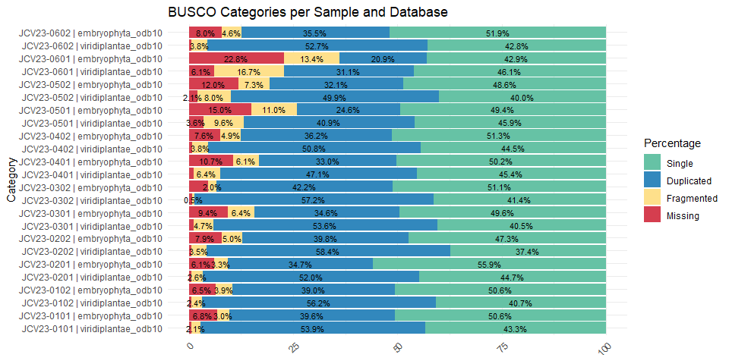
BUSCO categories and reference values
Single-copy (Single): - Represents the percentage of complete BUSCO genes that were found as single copies. - Reference: Values above 40–50% are generally acceptable, especially in transcriptomes; higher values indicate less duplication and better gene model representation.
Duplicated: - Indicates complete genes that appear more than once. - Reference: A moderate percentage (e.g., 30–60%) is common in transcriptomes due to isoforms or gene families. Very high duplication (>70%) might suggest assembly artifacts.
Fragmented: - BUSCO genes detected but not in full length, indicating partial or incomplete gene reconstruction. - Reference: Should be kept below 10% for good assemblies; higher values may point to fragmentation or low expression levels.
Missing: - BUSCO genes not found in the assembly. - Reference: Ideally below 5–10%. Higher values suggest incomplete transcriptome coverage, insufficient sequencing depth, or taxonomic mismatch with the BUSCO database

Sequence Similarity Searches: BLASTx and BLASTn
To identify potential homologous sequences and obtain taxonomic information for the assembled transcripts, sequence similarity searches were performed using both BLASTx and BLASTn. These analyses provide complementary information by comparing the assembled transcripts against protein and nucleotide databases, respectively.
BLAST results were subsequently used for taxonomic assignment, contamination assessment, and downstream filtering steps.

BLASTx: Similarity Search Against the NR Protein Database
BLASTx translates nucleotide sequences into all six possible reading frames and compares the resulting protein sequences against a protein database. This approach is particularly useful for transcriptome analyses because protein sequences are generally more conserved than nucleotide sequences, allowing the detection of distant homologs and functional annotation of assembled transcripts.
For this study, Trinity transcript assemblies were searched against the NCBI non-redundant protein database (NR release 115).
The analysis was performed on the Trinity assemblies located in:
03_trinity_separated/
The output files were stored in:
06_BlastX_Zamia_RNA/

BLASTx command parameters
The BLASTx searches were executed using the following key parameters:
- -db nr.115: NCBI non-redundant protein database.
- -max_target_seqs 10: Retains up to 10 hits per query sequence.
- -best_hit_score_edge 0.05: Filters suboptimal hits based on score proximity.
- -best_hit_overhang 0.25: Controls the best-hit filtering algorithm.
- -max_hsps 1: Retains only the best alignment segment per subject sequence.
- -evalue 1e-25: Stringent significance threshold.
- -num_threads: Number of CPU threads allocated by SLURM.
- -outfmt 6: Tabular output containing taxonomic and alignment information.
These parameters were selected to maximize annotation reliability while reducing the number of low-confidence matches.

SLURM script used for BLASTx analysis
We used a SLURM array job to perform BLASTx searches independently for each Trinity assembly.
SLURM script: 06_A_BlastxTrinity_proteins_Zamia_RNA.sh
#!/bin/bash
#SBATCH -J blastx_Zamia.s
#SBATCH -o blastxnr115-%j.out
#SBATCH -p large
#SBATCH --array=6
#SBATCH --ntasks=1
#SBATCH --cpus-per-task=14
#SBATCH --mem=50G
#SBATCH --time=7-00:00:00
#SBATCH --mail-type=ALL
#SBATCH --mail-user=gfpeb@ulaval.ca
#########
######### Job Runtime JobId Partition | Cpu Cpu(%) | Mem(Go) Used Unused Mem(%)
######### --- ------- ----- --------- + --- ------ + ------- ---- ------ ------
######### blastx Zamia.s 40h15m 311385 9 ibismini | 14 96.39% | 200.00 0.10 199.90 0.05% ****
#########
module load ncbiblast/2.16.0
######### Rutas generales
base_dir="/project/jcvaguilar/users/jcvil9/Gab_Zamia_Transcri"
samples_list="${base_dir}/samples_list.txt"
trinity_base="${base_dir}/03_trinity_separated"
blastx_base="${base_dir}/06_BlastX_Zamia_RNA"
taxdump_dir="${base_dir}/new_taxdump"
######### Exporta la ruta donde está tu NR, base de datos taxonomicos
export BLASTDB=/biodata/blast
######### Obtener muestra
sample=$(sed -n "${SLURM_ARRAY_TASK_ID}p" "$samples_list" | tr -d '[:space:]')
fecha=$(date +%Y%m%d)
trinity_dir=$(find "$trinity_base" -maxdepth 1 -type d -name "${sample}_*_trinity" | sort | tail -n 1)
fasta_file=$(find "$trinity_dir" -maxdepth 1 -type f -name "*.Trinity.fasta" | head -n 1)
######### Crear carpeta de salida
output_dir="${blastx_base}/${sample}_${fecha}_blastx_nr115"
mkdir -p "$output_dir"
log_file="${output_dir}/${sample}_blastx_nr115.log"
######### Ejecutar BLASTx contra NR.115
blastx -query "$fasta_file" \
-db nr.115 \
-max_target_seqs 10 \
-best_hit_score_edge 0.05 \
-best_hit_overhang 0.25 \
-max_hsps 1 \
-evalue 1e-25 \
-num_threads "$SLURM_CPUS_PER_TASK" \
-outfmt "6 \
qseqid \
staxids \
bitscore \
sseqid \
sscinames \
pident \
length \
mismatch \
gapopen \
qstart \
qend \
sstart \
send \
evalue" \
-out "${output_dir}/${sample}_blastx.outfmt6" \
>> "$log_file" 2>&1

BLASTx output files
06_BlastX_Zamia_RNA/
├── JCV23-0101_20250617_blastx_nr115/
│ ├── JCV23-0101_blastx.outfmt6
│ └── JCV23-0101_blastx_nr115.log
├── JCV23-0102_20250617_blastx_nr115/
├── JCV23-0201_20250617_blastx_nr115/
└── ...
The BLASTx output contains taxonomic identifiers, protein matches, alignment statistics, and sequence similarity metrics that are later used for taxonomic classification and contamination filtering.

BLASTn: Similarity Search Against the NT Database
BLASTn compares nucleotide sequences directly against a nucleotide database. In transcriptome analyses, BLASTn complements BLASTx by identifying highly similar nucleotide sequences and providing additional taxonomic evidence, particularly for transcripts lacking protein-level matches.
For this study, Trinity transcript assemblies were searched against the NCBI nucleotide database (NT).
The analysis was performed on the Trinity assemblies located in:
03_trinity_separated/
The output files were stored in:
07_BLASTn_Zamia_RNA/

BLASTn command parameters
The BLASTn searches were executed using the following key parameters:
- -db nt: NCBI nucleotide database.
- -max_target_seqs 10: Retains up to 10 hits per query sequence.
- -best_hit_score_edge 0.05: Best-hit filtering threshold.
- -best_hit_overhang 0.25: Controls the best-hit selection algorithm.
- -max_hsps 1: Retains only the best alignment segment.
- -evalue 1e-25: Stringent significance threshold.
- -num_threads: Number of CPU threads allocated by SLURM.
- -outfmt 6: Tabular output format including taxonomic information and alignment statistics.
These settings prioritize highly confident matches while maintaining computational efficiency.

SLURM script used for BLASTn analysis
We used a SLURM array job to perform BLASTn searches independently for each Trinity assembly.
SLURM script: 07_blastn.sh
#!/bin/bash
#SBATCH -J Blastn
#SBATCH -o Blastn-%j.out
#SBATCH -p medium
#SBATCH --array=6
#SBATCH --ntasks=1
#SBATCH --cpus-per-task=2
#SBATCH --mem=20G
#SBATCH --time=5-00:00:00
#SBATCH --mail-type=ALL
#SBATCH --mail-user=gfpeb@ulaval.ca
#module load ncbiblast/2.9.0
module load ncbiblast/2.16.0
#Path to nt database
db="/biodata/blastdb_new/nt"
################
# Rutas base
base_dir="/project/jcvaguilar/users/jcvil9/Gab_Zamia_Transcri"
samples_list="${base_dir}/samples_list.txt"
trinity_base="${base_dir}/03_trinity_separated"
blast_base="${base_dir}/07_BLASTn_Zamia_RNA"
# es necesario confirmar la ruta con el archivo nt en el servidor
# Base de datos BLAST
db="/biodata/blast/nt"
################
# Obtener nombre de muestra
sample=$(sed -n "${SLURM_ARRAY_TASK_ID}p" "$samples_list" | tr -d '[:space:]')
fecha=$(date +%Y%m%d)
################
# Buscar el archivo .Trinity.fasta correspondiente
trinity_dir=$(find "$trinity_base" -maxdepth 1 -type d -name "${sample}_*_trinity" | sort | tail -n 1)
fasta_file=$(find "$trinity_dir" -maxdepth 1 -type f -name "*.Trinity.fasta" | head -n 1)
################
# Directorio y archivo de salida
output_dir="${blast_base}/${sample}_${fecha}_blastn"
mkdir -p "$output_dir"
log_file="${output_dir}/${sample}_blastn_${fecha}.log"
################
# Ejecutar BLASTn
blastn -db "$db" \
-query "$fasta_file" \
-outfmt "6 qseqid sseqid staxids sscinames pident length mismatch gapopen qstart qend sstart send evalue bitscore" \
-max_target_seqs 10 \
-best_hit_score_edge 0.05 \
-best_hit_overhang 0.25 \
-max_hsps 1 \
-evalue 1e-25 \
-num_threads "$SLURM_CPUS_PER_TASK" \
-out "${output_dir}/${sample}_blastn.tsv" >> "$log_file" 2>&1
echo "BLASTn terminado para $sample" >> "$log_file"

BLASTn output files
07_BLASTn_Zamia_RNA/
├── JCV23-0101_20250617_blastn/
│ ├── JCV23-0101_blastn.tsv
│ └── JCV23-0101_blastn_20250617.log
├── JCV23-0102_20250617_blastn/
├── JCV23-0201_20250617_blastn/
└── ...
The BLASTn results provide complementary nucleotide-level evidence that can be integrated with BLASTx results to improve taxonomic assignment and identify potential contaminant sequences during downstream filtering procedures.

Minimap2: Mapping assembled transcripts
Minimap2 is a fast and accurate aligner designed for mapping long or short sequences to a reference genome or assembly. In transcriptome projects, it is commonly used to:
- Assess transcriptome completeness, by aligning assembled transcripts to a genome or reference sequence.
- Detect possible contamination, if transcripts align to unexpected taxa.
- Support structural annotation, by mapping to well-characterized genomes.
- Generate alignment files (e.g., BAM), which can be used for downstream analyses such as BlobToolKit or coverage estimation.
In this project, Minimap2 was used to align assembled transcripts to a reference genome in order to evaluate overall coverage and genomic distribution of the assembled data. The alignment results are also used as input for visualization tools and contamination assessment (e.g., BlobTools2).
For more information, see Minimap2 site.

Minimap2 command parameters
In this analysis, we used the following command:
minimap2 -ax sr --MD reference.fasta left_reads.fq right_reads.fq | \
samtools sort -@2 -O BAM -o output.bam
- -ax sr: This preset is used for short paired-end reads (e.g., Illumina). It activates spliced alignment with appropriate scoring and filtering for short-read RNA data.
- –MD: Instructs minimap2 to add MD tags to the alignment, which record mismatched positions. This is useful for downstream tools that inspect mismatch patterns or calculate coverage and identity.
- reference.fasta: Reference genome or transcriptome to which the reads were aligned. In this case, it corresponds to the assembled transcriptome or a reference genome of the closest species.
- left_reads.fq and right_reads.fq: Forward and reverse trimmed paired-end reads used for alignment.
- [-@2]: Sorts the resulting alignments using 2 threads for parallelism ([-@2]), optimizing speed on limited CPU systems.
- -O BAM: Specifies BAM format (binary version of SAM) as the output.
- -o output.bam: Names the final sorted BAM file.
This approach produces clean, indexed BAM files suitable for quality evaluation, coverage statistics, and integration with tools like BlobToolKit.

SLURM script used for Minimap2
SLURM script: 08_Minimap2_cov.sh
#!/bin/bash
#SBATCH -J Minim_Zam
#SBATCH -o Minim_Zamia_RNA_%j.out
#SBATCH -p medium
#SBATCH --array=6
#SBATCH --ntasks=1
#SBATCH --cpus-per-task=1
#SBATCH --mem=10G
#SBATCH --time=2-00:00:00
#SBATCH --mail-type=ALL
#SBATCH --mail-user=gfpeb@ulaval.ca
################
module load minimap2/2.28
module load samtools/1.21
################
# Rutas base
base_dir="/project/jcvaguilar/users/jcvil9/Gab_Zamia_Transcri"
samples_list="${base_dir}/samples_list.txt"
trinity_base="${base_dir}/03_trinity_separated"
reads_base="${base_dir}/01_clean_reads_Zamia_RNA_trimmomatic"
output_base="${base_dir}/08_minimap2_bams"
################
# Obtener nombre de muestra
sample=$(sed -n "${SLURM_ARRAY_TASK_ID}p" "$samples_list" | tr -d '[:space:]')
fecha=$(date +%Y%m%d)
################
# Rutas de entrada
trinity_dir=$(find "$trinity_base" -maxdepth 1 -type d -name "${sample}_*_trinity" | sort | tail -n 1)
fasta_file=$(find "$trinity_dir" -maxdepth 1 -type f -name "*.Trinity.fasta" | head -n 1)
left_reads="${reads_base}/${sample}/${sample}_R1_paired.fastq.gz"
right_reads="${reads_base}/${sample}/${sample}_R2_paired.fastq.gz"
################
# Directorio de salida
output_dir="${output_base}/${sample}_${fecha}_minimap2"
mkdir -p "$output_dir"
bam_file="${output_dir}/${sample}_assembly.bam"
log_file="${output_dir}/${sample}_minimap2_${fecha}.log"
################
# Ejecutar alineamiento
echo "Iniciando alineamiento para ${sample} el ${fecha}" | tee "$log_file"
minimap2 -ax sr --MD "$fasta_file" "$left_reads" "$right_reads" 2>>"$log_file" | \
samtools sort -@2 -O BAM -o "$bam_file" 2>>"$log_file"
echo "Alineamiento completado para ${sample} el ${fecha}" | tee -a "$log_file"
#Use interactive mode and blobtools add --cov assembly.bam pour ajouter l'info au BlobDir

Minimap2 output files per sample
The output files will be stored in a new folder named 08_minimap2_bams, organized into subdirectories by sample, each containing the Minimap2 files and associated logs.
The alignment process completed successfully for all samples, and no errors or interruptions were reported in the log files.
Iniciando alineamiento para JCV23-0101 el 20250625
[M::mm_idx_gen::3.316*1.42] collected minimizers
[M::mm_idx_gen::4.286*1.55] sorted minimizers
[M::main::4.444*1.50] loaded/built the index for 260669 target sequence(s)
[M::mm_mapopt_update::4.444*1.50] mid_occ = 1000
[M::mm_idx_stat] kmer size: 21; skip: 11; is_hpc: 0; #seq: 260669
[M::mm_idx_stat::4.689*1.47] distinct minimizers: 15037121 (70.56% are singletons); average occurrences: 1.625; average spacing: 6.263; total length: 153009149
[M::worker_pipeline::20.510*1.80] mapped 333642 sequences
[M::worker_pipeline::2434.531*1.75] mapped 333568 sequences
[M::worker_pipeline::2435.246*1.75] mapped 282054 sequences
[M::main] Version: 2.28-r1209
[M::main] CMD: minimap2 -ax sr --MD
[M::main] Real time: 2435.312 sec; CPU: 4264.802 sec; Peak RSS: 1.905 GB
[bam_sort_core] merging from 16 files and 2 in-memory blocks...
Alineamiento completado para JCV23-0101 el 20250625
The resulting BAM files will be used in subsequent analysis steps, including coverage estimation and contamination filtering with BlobToolKit.
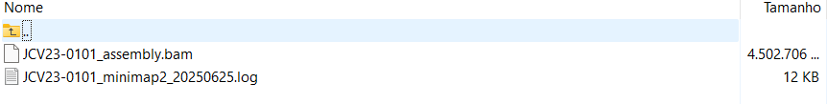
Example of the output structure generated by Minimap2.

BlobTools2: Taxonomic and Coverage-Based Assessment of Transcriptome Assemblies
BlobTools2 is a framework designed to integrate sequence composition, read coverage, taxonomic assignments, and completeness metrics into a unified dataset. It facilitates the identification of contaminants, assessment of assembly quality, and visualization of taxonomic patterns within genome and transcriptome assemblies.
For this study, BlobTools2 was used to combine information from Trinity assemblies, BUSCO assessments, read coverage estimates generated with Minimap2, and taxonomic assignments obtained from BLAST analyses.
Additional information about BlobTools2 can be found at:
- https://blobtoolkit.genomehubs.org/blobtools2/
- https://github.com/genomehubs/blobtoolkit
The BlobTools2 workflow was performed in three major steps:
- Creation of the BlobDir database.
- Integration of BUSCO completeness information.
- Addition of read coverage information from Minimap2 alignments.

BlobTools2 Database Creation
The first step consisted of creating a BlobTools2 database (BlobDir) using the Trinity assembly generated for each sample.
The analysis was performed using the transcriptome assemblies located in:
03_trinity_separated/
The resulting BlobDir databases were stored in:
09_BlobTools2_Zamia_RNA/

BlobTools2 create parameters
The database creation was executed using the following parameters:
- --fasta: Trinity assembly used as the reference dataset.
- --taxid 33090: Assigns Viridiplantae as the root taxonomic identifier.
- create: Generates a BlobDir database containing sequence information and metadata.
The resulting BlobDir serves as the central repository to which coverage, BUSCO, and taxonomic information are subsequently added.

SLURM script used for BlobDir creation
SLURM script: 09_Blob_create.sh
#!/bin/bash
#SBATCH -J Blob_Zamia
#SBATCH -o Blob_Zamia_%j.out
#SBATCH -c 1
#SBATCH -p small
#SBATCH --array=1
#SBATCH --time=1-00:00:00
#SBATCH --mail-type=ALL
#SBATCH --mail-user=gfpeb@ulaval.ca
#SBATCH --mem=8G
module load miniconda/3
module load blobtools/2
#Activate conda environment before running
eval "$(conda shell.bash hook)"
conda activate btk_env
################
# Rutas base
base_dir="/project/jcvaguilar/users/jcvil9/Gab_Zamia_Transcri"
samples_list="${base_dir}/samples_list.txt"
trinity_base="${base_dir}/03_trinity_separated"
blob_base="${base_dir}/09_BlobTools2_Zamia_RNA"
################
# Obtener nombre de muestra
sample=$(sed -n "${SLURM_ARRAY_TASK_ID}p" "$samples_list" | tr -d '[:space:]')
fecha=$(date +%Y%m%d)
################
# Buscar el archivo .Trinity.fasta correspondiente
trinity_dir=$(find "$trinity_base" -maxdepth 1 -type d -name "${sample}_*_trinity" | sort | tail -n 1)
fasta_file=$(find "$trinity_dir" -maxdepth 1 -type f -name "*.Trinity.fasta" | head -n 1)
################
# Directorio y archivo de salida
output_dir="${blob_base}/${sample}_${fecha}_blobdir"
mkdir -p "$output_dir"
log_file="${output_dir}/${sample}_blobtools_${fecha}.log"
################
# Iniciar log
{
echo "==== BlobTools2 analysis for sample: $sample ===="
echo "Fecha: $(date)"
echo "FASTA: $fasta_file"
echo "Output: $output_dir"
echo "---------------------------------------------"
} > "$log_file"
################
# Crear base de datos BlobTools (solo fasta)
# --taxid 33090 \ para Viridiplantae
/prg/blobtools/2/blobtools2/blobtools create \
--fasta "$fasta_file" \
--taxid 33090 \
"$output_dir" \
>> "$log_file" 2>&1
conda deactivate

BlobDir output files
09_BlobTools2_Zamia_RNA/
├── JCV23-0101_20250617_blobdir/
│ ├── meta.json
│ ├── identifiers.json
│ ├── summary.json
│ ├── views/
│ └── ...
├── JCV23-0102_20250617_blobdir/
├── JCV23-0201_20250617_blobdir/
└── ...
The BlobDir contains the sequence metadata and serves as the foundation for all subsequent BlobTools2 analyses.

Integration of BUSCO Completeness Metrics
To facilitate completeness-based filtering and visualization, BUSCO results were incorporated into each BlobDir database.
Because BUSCO reports included coordinate suffixes in transcript identifiers (e.g., TRINITY_DN6269_c0_g1_i12:763-7038), a preprocessing step was required to remove the coordinate information and ensure consistency with Trinity sequence identifiers.
The BUSCO analyses used in this study were:
- embryophyta_odb10
- viridiplantae_odb10
Input files were obtained from:
05_A_Busco_Zamia_RNA/
Cleaned BUSCO tables were stored in:
05_B_cleaned_busco/
The updated BlobDir databases remained in:
09_BlobTools2_Zamia_RNA/

BlobTools2 BUSCO integration parameters
The BUSCO integration was performed using:
- --busco: BUSCO full_table.tsv file.
- --replace: Replaces any previous BUSCO dataset already present in the BlobDir.
- add: Adds BUSCO information to the existing BlobDir database.

SLURM script used for BUSCO integration
SLURM script: 10_A_Blob_add_Busco.sh
#!/bin/bash
#SBATCH -J Blob-busco_cle-Zamia
#SBATCH -o Blob_add_busco_%j.out
#SBATCH -p small
#SBATCH --array=2-12
#SBATCH --ntasks=1
#SBATCH --cpus-per-task=1
#SBATCH --mem=8G
#SBATCH --time=1-00:00:00
#SBATCH --mail-type=ALL
#SBATCH --mail-user=gfpeb@ulaval.ca
################
# se ejecuto este codigo porque no estaban concordando los nombres entre el archivo .fasta de trinity y los resultados de Busco
# TRINITY_DN6269_c0_g1_i12 cotra TRINITY_DN6269_c0_g1_i12:763-7038, se elimina :763-7038 para que concuerden los datos.
################
module load miniconda/3
module load blobtools/2
module load python/3.11
#Activate conda environment before running
eval "$(conda shell.bash hook)"
conda activate btk_env
################
# Rutas base
base_dir="/project/jcvaguilar/users/jcvil9/Gab_Zamia_Transcri"
samples_list="${base_dir}/samples_list.txt"
blobdir_base="${base_dir}/09_BlobTools2_Zamia_RNA"
busco_base="${base_dir}/05_A_Busco_Zamia_RNA"
clean_busco_dir="${base_dir}/05_B_cleaned_busco"
mkdir -p "$clean_busco_dir"
################
# Obtener muestra seg n SLURM_ARRAY_TASK_ID
sample=$(sed -n "${SLURM_ARRAY_TASK_ID}p" "$samples_list" | tr -d '[:space:]')
echo "Procesando muestra: $sample"
blobdir=$(find "$blobdir_base" -maxdepth 1 -type d -name "${sample}_*_blobdir" | sort | tail -n 1)
if [[ ! -d "$blobdir" ]]; then
echo "BlobDir no encontrado para $sample"
exit 1
fi
log_file="${blobdir}/${sample}_add_busco_cleaned.log"
{
echo "==== Limpieza + Integraci n BUSCO para muestra: $sample ===="
echo "Fecha: $(date)"
echo "BlobDir: $blobdir"
echo "--------------------------------------------"
} > "$log_file"
################
# Funci n de limpieza (conserva todas las columnas, limpia solo Sequence)
limpiar_busco() {
local original="$1" cleaned="$2"
{
# 1) Versi n completa
grep -m1 "^# BUSCO version" "$original"
# 2) Dataset completo (con par ntesis intactos)
grep -m1 "^# The lineage dataset" "$original"
# 3) Encabezado completo de BUSCO (sin # para que sea columna)
grep -m1 "^# Busco id" "$original"
# 4) Datos reales, limpiando solo el sufijo :start-end en la columna 3
awk -F'\t' 'BEGIN { OFS="\t" }
!/^#/ && NF >= 3 {
gsub(/:.*/, "", $3)
print
}' "$original"
} > "$cleaned"
}
################
# BUSCO embryophyta
busco_embryo_raw=$(find "$busco_base" -type f -path "*${sample}*_busco_embryophyta_odb10*" -name "full_table.tsv" | head -n 1)
busco_embryo_clean="${clean_busco_dir}/${sample}_embryophyta_clean.tsv"
if [[ -f "$busco_embryo_raw" ]]; then
echo "Limpieza y carga BUSCO embryophyta para $sample" | tee -a "$log_file"
limpiar_busco "$busco_embryo_raw" "$busco_embryo_clean"
/prg/blobtools/2/blobtools2/blobtools add \
--replace \
--busco "$busco_embryo_clean" \
"$blobdir" >> "$log_file" 2>&1
else
echo " No se encontr BUSCO embryophyta para $sample" | tee -a "$log_file"
fi
################
# BUSCO viridiplantae
busco_viridi_raw=$(find "$busco_base" -type f -path "*${sample}*_busco_viridiplantae_odb10*" -name "full_table.tsv" | head -n 1)
busco_viridi_clean="${clean_busco_dir}/${sample}_viridiplantae_clean.tsv"
if [[ -f "$busco_viridi_raw" ]]; then
echo "Limpieza y carga BUSCO viridiplantae para $sample" | tee -a "$log_file"
limpiar_busco "$busco_viridi_raw" "$busco_viridi_clean"
/prg/blobtools/2/blobtools2/blobtools add \
--replace \
--busco "$busco_viridi_clean" \
"$blobdir" >> "$log_file" 2>&1
else
echo " No se encontr BUSCO viridiplantae para $sample" | tee -a "$log_file"
fi
echo " Finalizado: $sample" | tee -a "$log_file"
echo "--------------------------------------------" >> "$log_file"
conda deactivate

BUSCO variables integrated into BlobTools2
The BUSCO datasets incorporated into BlobTools2 provide information on transcript completeness:
- Complete BUSCOs (C)
- Single-copy BUSCOs (S)
- Duplicated BUSCOs (D)
- Fragmented BUSCOs (F)
- Missing BUSCOs (M)
These metrics facilitate the identification of transcripts that are likely to represent biologically relevant plant genes.

Integration of Read Coverage Information
Read coverage estimates generated with Minimap2 were incorporated into the BlobDir databases to provide quantitative support for each assembled transcript.
Coverage information is one of the most informative variables in BlobTools2 because contaminants frequently exhibit coverage patterns that differ from those of genuine host transcripts.
Input BAM files were obtained from:
08_minimap2_bams/
The updated BlobDir databases were stored in:
09_BlobTools2_Zamia_RNA/

BlobTools2 coverage integration parameters
Coverage information was added using:
- --cov: BAM alignment file generated with Minimap2.
- --replace: Replaces any previously loaded coverage dataset.
- add: Adds coverage information to an existing BlobDir.

SLURM script used for coverage integration
SLURM script: 10_C_Blob_add_Minimap2.sh
#!/bin/bash
#SBATCH -J MInblob_add_cov_Zam
#SBATCH -o MInblob_add_cov_Zamia_RNA_%j.out
#SBATCH -p small
#SBATCH --array=6
#SBATCH --ntasks=1
#SBATCH --cpus-per-task=2
#SBATCH --mem=20G
#SBATCH --time=1-00:00:00
#SBATCH --mail-type=ALL
#SBATCH --mail-user=gfpeb@ulaval.ca
################
module load miniconda/3
module load blobtools/2
module load python/3.11
#Activate conda environment before running
eval "$(conda shell.bash hook)"
conda activate btk_env
################
# Rutas base
base_dir="/project/jcvaguilar/users/jcvil9/Gab_Zamia_Transcri"
samples_list="${base_dir}/samples_list.txt"
bam_base="${base_dir}/08_minimap2_bams"
blobdir_base="${base_dir}/09_BlobTools2_Zamia_RNA"
################
# Loop por muestra
while read -r sample; do
sample=$(echo "$sample" | tr -d '[:space:]')
echo "Procesando muestra: $sample"
################
# Buscar BAM
bam_dir=$(find "$bam_base" -type d -name "${sample}_*_minimap2" | sort | tail -n 1)
bam_file="${bam_dir}/${sample}_assembly.bam"
################
# Buscar BlobDir
blobdir=$(find "$blobdir_base" -maxdepth 1 -type d -name "${sample}_*_blobdir" | sort | tail -n 1)
################
# A adir cobertura
echo " A adiendo cobertura para $sample"
/prg/blobtools/2/blobtools2/blobtools add \
--replace \
--cov "$bam_file" \
"$blobdir"
echo "Finalizado: $sample"
echo "-----------------------------------------"
done < "$samples_list"
conda deactivate

Coverage variables integrated into BlobTools2
The Minimap2 alignments provide:
- Mean read coverage per transcript.
- Total mapped reads.
- Coverage distribution across transcripts.
- Relative abundance of assembled sequences.
These metrics help distinguish highly supported transcripts from low-coverage sequences that may represent assembly artifacts or contaminants.

Key BlobTools2 Variables for Transcriptome Assessment
The most important variables incorporated into BlobTools2 and used during downstream contamination filtering include:

Taxonomic Assignment
Obtained from BLAST analyses and later integrated into the BlobDir database.
Important fields include:
- Taxonomic identifier (TaxID)
- Scientific name
- Taxonomic lineage
- Assigned kingdom
These variables facilitate the identification of non-target organisms such as fungi, bacteria, viruses, or metazoan contaminants.

GC Content
Represents the percentage of guanine and cytosine nucleotides in each transcript.
Sequences belonging to different taxonomic groups often exhibit distinct GC-content distributions.

Transcript Length
The length of each assembled transcript.
Very short transcripts frequently correspond to fragmented assemblies or low-confidence sequences.

Read Coverage
Derived from Minimap2 alignments.
Coverage values provide evidence supporting transcript validity and expression level.

BUSCO Status
Indicates whether transcripts contain conserved orthologs expected in plants.
BUSCO-supported transcripts are generally more reliable candidates for downstream analyses.

BlobTools2 Output Files
After all datasets have been incorporated, each BlobDir contains a complete collection of metadata describing the transcriptome assembly.
09_BlobTools2_Zamia_RNA/
├── JCV23-0101_20250617_blobdir/
│ ├── meta.json
│ ├── summary.json
│ ├── identifiers.json
│ ├── busco/
│ ├── coverage/
│ ├── views/
│ ├── filters/
│ └── ...
├── JCV23-0102_20250617_blobdir/
├── JCV23-0201_20250617_blobdir/
└── ...
These BlobDir databases serve as the primary input for subsequent taxonomic assignment, contamination filtering, visualization, and extraction of Viridiplantae transcripts used in downstream transcriptome analyses.

BLASTx Against the Cycas Reference Proteome
In addition to the searches against the NCBI NR database, each Trinity assembly was compared against the predicted proteome of Cycas panzhihuaensis (Cycas_panzhihuaensis_genome.pep). Because Cycas and Zamia belong to the order Cycadales, this analysis provides an independent assessment of transcriptome completeness and gene recovery using a closely related reference species.
The analysis was performed on the Trinity assemblies located in:
03_trinity_separated/
The reference protein dataset used for comparison was:
Cycas_panzhihuaensis_genome.pep
The output files were stored in:
11_BlastX_GenRefCycas_Zamia_RNA/

BLASTx command parameters
The BLASTx searches were executed using the following key parameters:
- -db cycas_pep_db: Custom BLAST protein database generated from the Cycas panzhihuaensis proteome.
- -max_target_seqs 1: Retains only the best match for each transcript.
- -evalue 1e-25: Stringent significance threshold.
- -num_threads: Number of CPU threads allocated by SLURM.
- -outfmt 6: Standard tabular BLAST output format.
Unlike the searches against NR, this analysis focused exclusively on identifying the best homologous protein in the reference cycad proteome.

Protein coverage assessment
Following BLASTx, the script analyze_blastPlus_topHit_coverage.pl from the Trinity package was used to evaluate reference protein coverage.
This analysis estimates:
- The proportion of reference proteins represented in the transcriptome assembly.
- The fraction of each protein covered by assembled transcripts.
- The completeness of reconstructed coding sequences.
- The distribution of full-length and partial transcript matches.
These metrics provide an additional measure of transcriptome quality and gene-space recovery.

SLURM script used for BLASTx against the Cycas reference proteome
SLURM script: 11_Blastx_REFcycas_proteins_Zamia_RNA.sh
#!/bin/bash
#SBATCH -J BlxRefCy_Za
#SBATCH -o blastxRefCy_Zamia-%j.out
#SBATCH -p small
#SBATCH --array=1-12
#SBATCH --ntasks=1
#SBATCH --cpus-per-task=4
#SBATCH --mem=10G
#SBATCH --time=1-00:00:00
#SBATCH --mail-type=ALL
#SBATCH --mail-user=gfpeb@ulaval.ca
#########
module load trinity/2.15.2
module load ncbiblast/2.16.0
######### Rutas generales
base_dir="/project/jcvaguilar/users/jcvil9/Gab_Zamia_Transcri"
samples_list="${base_dir}/samples_list.txt"
trinity_base="${base_dir}/03_trinity_separated"
blastx_base="${base_dir}/11_BlastX_GenRefCycas_Zamia_RNA"
pep_ref="${base_dir}/Cycas_panzhihuaensis_genome.pep/Cycas_panzhihuaensis_genome.pep"
######### Obtener muestra
sample=$(sed -n "${SLURM_ARRAY_TASK_ID}p" "$samples_list" | tr -d '[:space:]')
fecha=$(date +%Y%m%d)
trinity_dir=$(find "$trinity_base" -maxdepth 1 -type d -name "${sample}_*_trinity" | sort | tail -n 1)
fasta_file=$(find "$trinity_dir" -maxdepth 1 -type f -name "*.Trinity.fasta" | head -n 1)
######### Crear carpeta de salida
output_dir="${blastx_base}/${sample}_${fecha}_blastx"
mkdir -p "$output_dir"
log_file="${output_dir}/${sample}_blastx.log"
######### Crear base de datos BLAST si no existe
# Para proteinas dbtype prot
# Para nucleotidos dbtype nucl
makeblastdb -in "$pep_ref" -dbtype prot -parse_seqids -out "${output_dir}/cycas_pep_db" >> "$log_file" 2>&1
######### Exporta la ruta donde est tu NR, base de datos taxonomicos
export BLASTDB=/biodata/blast
######### Ejecutar BLASTx contra cycas_pep_db
blastx -query "$fasta_file" \
-db "${output_dir}/cycas_pep_db" \
-max_target_seqs 1 \
-evalue 1e-25 \
-num_threads "$SLURM_CPUS_PER_TASK" \
-outfmt 6 \
-out "${output_dir}/${sample}_blastx_topHit.outfmt6" \
>> "$log_file" 2>&1
######### Analizar cobertura con Trinity
coverage_script="/prg/trinityrnaseq/2.15.2/util/analyze_blastPlus_topHit_coverage.pl"
"$coverage_script" \
"${output_dir}/${sample}_blastx_topHit.outfmt6" \
"$pep_ref" \
"$pep_ref" >> "$log_file" 2>&1
echo "BLASTx y an lisis de cobertura completado para $sample"

Output files
11_BlastX_GenRefCycas_Zamia_RNA/
├── JCV23-0101_20250617_blastx/
│ ├── cycas_pep_db.*
│ ├── JCV23-0101_blastx_topHit.outfmt6
│ ├── JCV23-0101_blastx.log
│ ├── blastx_topHit_coverage_report.txt
│ └── ...
├── JCV23-0102_20250617_blastx/
├── JCV23-0201_20250617_blastx/
└── ...
The resulting BLAST and coverage statistics were subsequently used to evaluate the representation of conserved cycad genes within the Zamia transcriptome assemblies and to identify transcripts corresponding to near full-length protein-coding genes.

Coverage-Based and Taxonomic Filtering of Transcript Assemblies
Following transcriptome assembly and similarity searches against the Cycas panzhihuaensis reference proteome, a multi-step filtering strategy was applied to retain high-confidence plant transcripts while removing poorly supported or potentially contaminant sequences.
The filtering workflow consisted of three sequential steps:
- Selection of transcripts with high protein coverage against the Cycas reference proteome.
- Taxonomic assignment of the retained transcripts using BlobTools2 and BLASTx results.
- Extraction of transcripts assigned to Viridiplantae for downstream analyses.

Filtering Transcripts by Reference Protein Coverage
The first filtering step retained only transcripts showing substantial alignment coverage against proteins from Cycas panzhihuaensis.
Coverage information was obtained from the file generated by Trinity:
*.w_pct_hit_length
Only transcripts covering at least 80% of the length of their best reference protein hit were retained.
This threshold was chosen to enrich the dataset for nearly complete coding sequences and reduce the number of fragmented transcript assemblies.

Coverage filtering criterion
The filtering was based on:
- Column 14 (pct_hit_len_aligned) from the Trinity coverage report.
- Minimum coverage threshold: ≥ 80%.
- Transcript extraction performed using seqtk subseq.

SLURM script used for coverage filtering
SLURM script: 12_1_filter_cover_Zamia.sh
#!/bin/bash
#SBATCH -J filterCov
#SBATCH -o filterCov_ZamRNA-%j.out
#SBATCH -p small
#SBATCH --array=1-12
#SBATCH --ntasks=1
#SBATCH --cpus-per-task=2
#SBATCH --mem=5G
#SBATCH --time=1-00:00:00
#SBATCH --mail-type=ALL
#SBATCH --mail-user=gfpeb@ulaval.ca
set -euo pipefail
################
module load trinity/2.15.2
module load ncbiblast/2.16.0
module load seqtk/1.2
################
# Rutas base
base_dir="/project/jcvaguilar/users/jcvil9/Gab_Zamia_Transcri"
samples_list="${base_dir}/samples_list.txt"
trinity_base="${base_dir}/03_trinity_separated"
blastx_base="${base_dir}/10_BlastX_GenRefCycas_Zamia_RNA"
# Carpeta de salida de los FASTA filtrados por cobertura
filter_root="${base_dir}/11_Filter_topHit_coverage_Zamia_RNA"
mkdir -p "$filter_root"
################
# Extraer la muestra y fecha
sample=$(sed -n "${SLURM_ARRAY_TASK_ID}p" "$samples_list" | tr -d '[:space:]')
fecha=$(date +%Y%m%d)
################
# Localizar archivos
trinity_dir=$(find "$trinity_base" -maxdepth 1 -type d -name "${sample}_*_trinity" | sort | tail -n 1)
fasta_file=$(find "$trinity_dir" -maxdepth 1 -type f -name "*.Trinity.fasta" | head -n 1)
blastx_dir=$(find "$blastx_base" -maxdepth 1 -type d \
-name "${sample}_*_blastx" | sort | tail -n1)
if [[ -z "$blastx_dir" ]]; then
echo "ERROR: No encontr ning n directorio *${sample}_*_blastx en $blastx_base" >&2
exit 1
fi
coverage_file="${blastx_dir}/${sample}_blastx_topHit.outfmt6.w_pct_hit_length"
if [[ ! -f "$coverage_file" ]]; then
echo "ERROR: No se encontr el archivo de cobertura (.w_pct_hit_length):"
echo " $coverage_file" >&2
exit 1
fi
################
# Preparamos carpeta y log de filtrado
filter_dir="${filter_root}/${sample}_${fecha}_filtered_hitsCover"
mkdir -p "$filter_dir"
log_file="${filter_dir}/${sample}_filterCoverage.log"
# Redirigimos stdout y stderr a log (y pantalla)
exec > >(tee -i "$log_file") 2>&1
echo "[$(date +'%F %T')] Filtrando transcritos con cobertura = 80 % para $sample"
################
# Extraer los IDs con cobertura = 80 % (columna 14 = pct_hit_len_aligned)
awk '$14 >= 80 { print $1 }' "$coverage_file" \
> "${filter_dir}/${sample}_80cov.ids"
n_ids=$(wc -l < "${filter_dir}/${sample}_80cov.ids")
echo "Encontrados $n_ids transcritos con = 80 % de cobertura."
################
# Sub-secuenciar el FASTA original
seqtk subseq "$fasta_file" "${filter_dir}/${sample}_80cov.ids" \
> "${filter_dir}/${sample}_80cov.fasta"
echo "[$(date +'%F %T')] Filtrado completado."
echo "Resultado: ${filter_dir}/${sample}_80cov.fasta"

Output files
11_Filter_topHit_coverage_Zamia_RNA/
├── JCV23-0101_20250617_filtered_hitsCover/
│ ├── JCV23-0101_80cov.ids
│ ├── JCV23-0101_80cov.fasta
│ └── JCV23-0101_filterCoverage.log
├── JCV23-0102_20250617_filtered_hitsCover/
├── JCV23-0201_20250617_filtered_hitsCover/
└── ...
The resulting FASTA files contain transcripts supported by strong protein-level evidence from a closely related cycad species.

Taxonomic Assignment of High-Coverage Transcripts
The filtered transcript assemblies were subsequently analyzed using BlobTools2.
A new BlobDir database was generated from each filtered FASTA file and populated with taxonomic information derived from the original BLASTx searches against the NR database.
This step allowed the assignment of each retained transcript to a taxonomic lineage.
Input files included:
- Filtered FASTA files from Step 1.
- BLASTx results against NR115.
- NCBI taxonomy database (taxdump).

BlobTools2 taxonomic assignment parameters
The following parameters were used:
- --hits: BLASTx results against NR115.
- --taxdump: NCBI taxonomy database.
- --taxrule bestsumorder: BlobTools2 taxonomic assignment algorithm.
- --evalue 1e-25: Minimum significance threshold.
- --replace: Replaces previous taxonomic assignments if present.

Taxonomic assignment method
BlobTools2 uses the bestsumorder algorithm, which assigns taxonomy by evaluating all significant BLAST hits associated with a transcript and selecting the most supported taxonomic lineage.
This approach is generally more robust than relying solely on the top BLAST hit and reduces misclassification caused by isolated matches.

SLURM script used for taxonomic assignment
SLURM script: 12_2_Blob_CreAdd_filter_Cover_Zamia.sh
#!/bin/bash
#SBATCH -J Blob-filter
#SBATCH -o BlobFilter_ZamRNA-%j.out
#SBATCH -p small
#SBATCH --array=1-12
#SBATCH --ntasks=1
#SBATCH --cpus-per-task=2
#SBATCH --mem=15G
#SBATCH --time=1-00:00:00
#SBATCH --mail-type=ALL
#SBATCH --mail-user=gfpeb@ulaval.ca
################
module load miniconda/3
module load blobtools/2
module load python/3.11
module load seqtk/1.2
#Activate conda environment before running
eval "$(conda shell.bash hook)"
conda activate btk_env
#### Rutas base
base_dir="/project/jcvaguilar/users/jcvil9/Gab_Zamia_Transcri"
samples_list="${base_dir}/samples_list.txt"
filter_root="$base_dir/11_Filter_topHit_coverage_Zamia_RNA"
blastx_base="$base_dir/06_BlastX_Zamia_RNA"
taxdump_dir="$base_dir/new_taxdump"
blobtools_root="$base_dir/12_BlobTools2_FilterCoverage_Zamia_RNA"
mkdir -p "$blobtools_root"
#### Muestra y fecha
sample=$(sed -n "${SLURM_ARRAY_TASK_ID}p" "$samples_list" | tr -d '[:space:]')
fecha=$(date +%Y%m%d)
#### Localizar FASTA filtrado (cobertura = 80 %)
filter_dir="$filter_root/${sample}_${fecha}_filtered_hitsCover"
filtered_fasta="$filter_dir/${sample}_80cov.fasta"
if [[ ! -f "$filtered_fasta" ]]; then
echo "ERROR: FASTA filtrado no encontrado:" >&2
echo " $filtered_fasta" >&2
exit 1
fi
################
# Preparar BlobDir y log en la salida de la muestra
blobdir_out="$blobtools_root/${sample}_${fecha}_filteredBlobDir"
mkdir -p "$blobdir_out"
log_file="$blobdir_out/${sample}_blobtools.log"
exec > >(tee -i "$log_file") 2>&1
echo "[$(date +'%F %T')] Iniciando BlobTools2 para $sample"
################
# Crear BlobDir a partir del FASTA filtrado
/prg/blobtools/2/blobtools2/blobtools create \
--fasta "$filtered_fasta" \
"$blobdir_out"
###############
# Subconjuntar hits NR115 originales
nr_dir=$(find "$blastx_base" -maxdepth 1 -type d -name "${sample}_*_blastx_nr115" | tail -n1)
hit_file="$nr_dir/${sample}_blastx.outfmt6"
if [[ ! -f "$hit_file" ]]; then
echo "ERROR: Hits NR115 no encontrados:" >&2
echo " $hit_file" >&2
exit 1
fi
#### 2.1) Subconjuntar los hits de NR115 a los contigs de =80 %
ids_file="$filter_dir/${sample}_80cov.ids"
filtered_hits="$blobdir_out/${sample}_blastx_NR115_filtered.outfmt6"
grep -F -w -f "$ids_file" "$hit_file" > "$filtered_hits"
echo " Hits de NR115 reducidos a $(wc -l < "$filtered_hits") contigs filtrados"
################
# A adir clasificaci n taxon mica de NR115 al BlobDir
/prg/blobtools/2/blobtools2/blobtools add \
--hits "$filtered_hits" \
--hits-cols 1=qseqid,2=staxids,3=bitscore,4=sseqid,5=sscinames,6=pident,7=length,8=mismatch,9=gapopen,10=qstart,11=qend,12=sstart,13=send,14=evalue \
--taxdump "$taxdump_dir" \
--taxrule bestsumorder \
--evalue 1e-25 \
--replace \
"$blobdir_out"
echo "[$(date +'%F %T')] BlobTools2 completado para $sample"
conda deactivate

Output files
12_BlobTools2_FilterCoverage_Zamia_RNA/
├── JCV23-0101_20250617_filteredBlobDir/
│ ├── meta.json
│ ├── identifiers.json
│ ├── summary.json
│ ├── JCV23-0101_blastx_NR115_filtered.outfmt6
│ └── ...
├── JCV23-0102_20250617_filteredBlobDir/
├── JCV23-0201_20250617_filteredBlobDir/
└── ...

Extraction of Viridiplantae Transcripts
The final filtering step retained only transcripts assigned to Viridiplantae.
Using BlobTools2, all transcripts classified outside the plant kingdom were excluded. The resulting identifiers were then used to extract the corresponding sequences from the filtered FASTA files.
This procedure generated the final set of transcripts used in downstream analyses.

BlobTools2 filtering parameters
The filtering was based on:
- Taxonomic rank: Kingdom.
- Target group: Viridiplantae.
- Taxonomic assignments generated using the bestsumorder algorithm.

Why filter by Viridiplantae?
Although transcriptomes are derived from plant tissues, RNA extractions frequently contain transcripts originating from:
- Endophytic fungi.
- Epiphytic microorganisms.
- Bacteria.
- Viruses.
- Environmental contaminants.
Retaining only sequences assigned to Viridiplantae increases confidence that downstream analyses focus on host plant transcripts.

SLURM script used for Viridiplantae filtering
SLURM script: 12_3_Blob_filter_Streptophyta_Zamia.sh
#!/bin/bash
#SBATCH -J Blob-filter
#SBATCH -o BlobFilter_ZamRNA-%j.out
#SBATCH -p small
#SBATCH --array=1-12
#SBATCH --ntasks=1
#SBATCH --cpus-per-task=2
#SBATCH --mem=15G
#SBATCH --time=1-00:00:00
#SBATCH --mail-type=ALL
#SBATCH --mail-user=gfpeb@ulaval.ca
##############################################
# 1. Activar entorno y cargar módulos
##############################################
module load miniconda/3
module load blobtools/2
module load python/3.11
module load seqtk/1.2
#Activate conda environment before running
eval "$(conda shell.bash hook)"
conda activate btk_env
##############################################
# 2. Rutas base
##############################################
base_dir="/project/jcvaguilar/users/jcvil9/Gab_Zamia_Transcri"
samples_list="${base_dir}/samples_list.txt"
blobtools_root="${base_dir}/12_BlobTools2_FilterCoverage_Zamia_RNA"
filter_root="${base_dir}/11_Filter_topHit_coverage_Zamia_RNA"
filtered_output_root="${base_dir}/13_BlobTools2_FilterKingdom_Zamia_RNA"
mkdir -p "$filtered_output_root"
##############################################
# 3. Muestra y fecha
##############################################
sample=$(sed -n "${SLURM_ARRAY_TASK_ID}p" "$samples_list" | tr -d '[:space:]')
fecha=$(date +%Y%m%d)
##############################################
# 4. Rutas específicas
##############################################
# Localizar el BlobDir (ignorar fecha)
blobdir_in=$(find "$blobtools_root" -maxdepth 1 -type d -name "${sample}_*_filteredBlobDir" | sort | tail -n 1)
# Localizar el directorio del FASTA filtrado por cobertura (ignorar fecha)
filter_dir=$(find "$filter_root" -maxdepth 1 -type d -name "${sample}_*_filtered_hitsCover" | sort | tail -n 1)
filtered_fasta=$(find "$filter_dir" -type f -name "${sample}_80cov.fasta" | head -n 1)
# Definir carpeta de salida
filtered_out="${filtered_output_root}/${sample}_${fecha}_filtered_Viridiplantae"
log_file="${filtered_out}/${sample}_blobtools_filter.log"
mkdir -p "$filtered_out"
##############################################
# 5. Iniciar log
##############################################
exec > >(tee -i "$log_file") 2>&1
echo "[$(date +'%F %T')] Iniciando filtro para conservar solo Viridiplantae en $sample"
echo "BlobDir In: $blobdir_in"
echo "Filtered FASTA: $filtered_fasta"
echo "Filtered Out Dir: $filtered_out"
##############################################
# 6. Ejecutar filtro por Viridiplantae
##############################################
/prg/blobtools/2/blobtools2/blobtools filter \
--param bestsumorder_kingdom--Keys=Viridiplantae \
--invert \
--fasta "$filtered_fasta" \
--summary "$filtered_out/summary.json" \
--table "$filtered_out/table.tsv" \
--output "$filtered_out" \
"$blobdir_in"
##############################################
# 7. Extraer lista de IDs desde identifiers.json
##############################################
id_json="$filtered_out/identifiers.json"
id_txt="$filtered_out/${sample}_Viridiplantae_ids.txt"
fasta_out="$filtered_out/${sample}_Viridiplantae_filtered.fasta"
if [[ ! -f "$id_json" ]]; then
echo "[ERROR] No se encontró el archivo identifiers.json" >&2
exit 1
fi
python3 -c "
import json
with open('$id_json') as f:
data = json.load(f)
with open('$id_txt', 'w') as out:
for identifier in data.get('values', []):
out.write(identifier + '\n')
"
if [[ ! -s "$id_txt" ]]; then
echo "[ERROR] El archivo de IDs está vacío o falló la conversión." >&2
exit 1
fi
echo " • $(wc -l < "$id_txt") identificadores extraídos a $id_txt"
##############################################
# 8. Extraer secuencias FASTA
##############################################
seqtk subseq "$filtered_fasta" "$id_txt" > "$fasta_out"
if [[ $? -ne 0 ]]; then
echo "[ERROR] Falló la extracción de secuencias con seqtk." >&2
exit 1
fi
echo " • FASTA filtrado generado en $fasta_out"
echo "[$(date +'%F %T')] Proceso completado para $sample"
conda deactivate

Output files
13_BlobTools2_FilterKingdom_Zamia_RNA/
├── JCV23-0101_20250617_filtered_Viridiplantae/
│ ├── identifiers.json
│ ├── summary.json
│ ├── table.tsv
│ ├── JCV23-0101_Viridiplantae_ids.txt
│ ├── JCV23-0101_Viridiplantae_filtered.fasta
│ └── JCV23-0101_blobtools_filter.log
├── JCV23-0102_20250617_filtered_Viridiplantae/
├── JCV23-0201_20250617_filtered_Viridiplantae/
└── ...
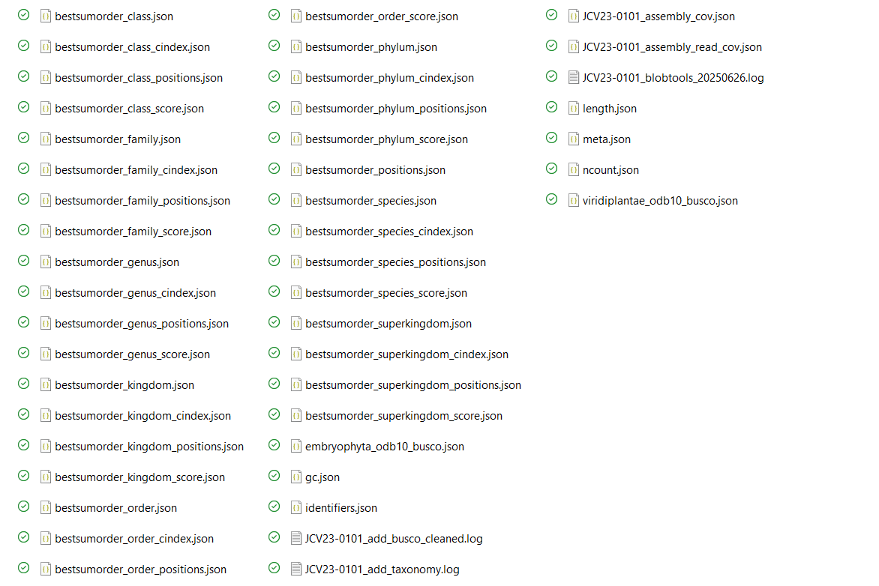
list of output files BlobTools2 Filter.

Final Output
The final FASTA files generated in this step represent a curated transcriptome dataset composed of:
- Transcripts with strong protein-level support (≥80% coverage).
- Sequences with significant similarity to known proteins.
- Transcripts taxonomically assigned to Viridiplantae.
These filtered assemblies were used as the starting point for downstream functional annotation and transcriptome analyses.

TransRate Assessment of Filtered Transcriptomes
After coverage-based and taxonomic filtering, the final Viridiplantae transcriptomes were evaluated using TransRate. This analysis assesses transcriptome quality by mapping the original RNA-seq reads back to the assembled transcripts and calculating several assembly support metrics.
Unlike BUSCO, which evaluates completeness using conserved orthologs, TransRate evaluates how well the sequencing reads support the assembled transcripts.
The analysis was performed using:
- Filtered Viridiplantae transcriptomes generated by BlobTools2.
- Original cleaned paired-end reads generated after Trimmomatic filtering.
Input files were obtained from:
13_BlobTools2_FilterKingdom_Zamia_RNA/
The resulting TransRate reports were stored in:
14_Transrate_FilteredFASTA/

TransRate quality metrics
TransRate calculates several assembly-support statistics, including:
- Read mapping rate.
- Contig coverage.
- Contig score.
- Assembly score.
- Number of supported transcripts.
- Number of poorly supported transcripts.
These metrics help identify assembly artifacts and provide an independent evaluation of transcriptome quality.

Interpretation of TransRate scores
Important metrics to consider include:
Metric | Interpretation
Assembly score | Overall quality of the transcriptome assembly
Mapping rate | Percentage of reads that align back to assembled transcripts
Good contigs | Number of transcripts strongly supported by reads
Low-supported contigs | Potential assembly artifacts or low-confidence transcripts
Higher assembly scores and mapping rates generally indicate more reliable transcriptome assemblies.

SLURM script used for TransRate analysis
SLURM script: 13_TransRate_FilterZamia_RNA.sh
#!/bin/bash
#SBATCH -J TraRate_Zam
#SBATCH -o TransRate_Zam_test.out
#SBATCH -p small
#SBATCH --cpus-per-task=2
#SBATCH --array=1-5,7-12
#SBATCH --mem=10G
#SBATCH --time=1-00:00:00
#SBATCH --mail-type=ALL
#SBATCH --mail-user=gfpeb@ulaval.ca
##############################################
# 1. Cargar módulos necesarios
##############################################
module load usearch/9.2.64_i86linux32
module load bowtie/2.3.4.1
module load eXpress/1.5.1
module load salmon/0.11.0
module load transrate/1.0.3
##############################################
# 2. Definir rutas base
##############################################
base_dir="/project/jcvaguilar/users/jcvil9/Gab_Zamia_Transcri"
samples_list="${base_dir}/samples_list.txt"
reads_base="${base_dir}/01_clean_reads_Zamia_RNA_trimmomatic"
filtered_fasta_base="${base_dir}/13_BlobTools2_FilterKingdom_Zamia_RNA"
results_base="${base_dir}/14_Transrate_FilteredFASTA"
mkdir -p "$results_base"
##############################################
# 3. Obtener nombre de muestra
##############################################
sample=$(sed -n "${SLURM_ARRAY_TASK_ID}p" "$samples_list" | tr -d '[:space:]')
fecha=$(date +%Y%m%d)
##############################################
# 4. Localizar archivo FASTA filtrado por reino
##############################################
filtered_fasta_dir=$(find "$filtered_fasta_base" -maxdepth 1 -type d -name "${sample}_*_filtered_Viridiplantae*" | sort | tail -n 1)
filtered_fasta=$(find "$filtered_fasta_dir" -maxdepth 1 -type f -name "${sample}_Viridiplantae_filtered.fasta" | head -n 1)
if [[ ! -f "$filtered_fasta" ]]; then
echo "[ERROR] No se encontró el archivo FASTA filtrado por reino para $sample" >&2
exit 1
fi
##############################################
# 5. Definir archivos de lectura y salida
##############################################
left_reads="${reads_base}/${sample}/${sample}_R1_paired.fastq.gz"
right_reads="${reads_base}/${sample}/${sample}_R2_paired.fastq.gz"
output_dir="${results_base}/${sample}_${fecha}_transrate_filtered"
log_file="${output_dir}/${sample}_transrate_filtered.log"
mkdir -p "$output_dir"
##############################################
# 6. Ejecutar Transrate con archivo filtrado
##############################################
transrate -a "$filtered_fasta" \
--left "$left_reads" \
--right "$right_reads" \
-t 2 \
--output "$output_dir" &> "$log_file"
echo "[INFO] Transrate completado para $sample"

Output files
14_Transrate_FilteredFASTA/
├── JCV23-0101_20250617_transrate_filtered/
│ ├── assemblies.csv
│ ├── contigs.csv
│ ├── scores.csv
│ ├── transrate.log
│ └── ...
├── JCV23-0102_20250617_transrate_filtered/
├── JCV23-0201_20250617_transrate_filtered/
└── ...
The TransRate reports provide a final quality assessment of the filtered transcriptomes before coding-sequence prediction and functional annotation.

TransDecoder: Prediction of Coding Sequences
Following transcriptome quality assessment, TransDecoder was used to identify candidate coding regions (Open Reading Frames; ORFs) within the filtered Viridiplantae transcriptomes.
TransDecoder predicts likely protein-coding sequences by identifying long open reading frames and evaluating coding potential.
This step generates the protein datasets required for downstream functional annotation and orthology analyses.
Input files were obtained from:
13_BlobTools2_FilterKingdom_Zamia_RNA/
The predicted coding sequences were stored in:
15_TransDecoder_Zamia_RNA/

TransDecoder workflow
The analysis was performed in two stages:

TransDecoder.LongOrfs
Identifies candidate open reading frames within transcript sequences.

TransDecoder.Predict
Evaluates candidate ORFs and predicts the most likely coding regions.

Key output files
TransDecoder generates several useful files:
File | Description
.pep | Predicted protein sequences
.cds | Predicted coding sequences
.gff3 | Coordinates of predicted ORFs
.bed | Genomic coordinates of ORFs
Among these, the protein FASTA (.pep) file is typically used for downstream annotation workflows.

SLURM script used for TransDecoder
SLURM script: 14_TransDecoder_Zamia_RNA.sh
#!/bin/bash
#SBATCH -J Tdecoder-zamia
#SBATCH -o TransDecoder_Zam_test.out
#SBATCH -p small
#SBATCH --cpus-per-task=2
#SBATCH --array=1-12
#SBATCH --mem=10G
#SBATCH --time=1-00:00:00
#SBATCH --mail-type=ALL
#SBATCH --mail-user=gfpeb@ulaval.ca
##############################################
module load transdecoder/5.5.0
module load usearch/9.2.64_i86linux32
##############################################
# 1. Rutas base
##############################################
base_dir="/project/jcvaguilar/users/jcvil9/Gab_Zamia_Transcri"
samples_list="${base_dir}/samples_list.txt"
# Entrada: FASTA filtrado por BlobTools2
viridi_root="${base_dir}/13_BlobTools2_FilterKingdom_Zamia_RNA"
# Salida: carpeta final organizada
transdecoder_root="${base_dir}/15_TransDecoder_Zamia_RNA"
tabla_out="${transdecoder_root}/resumen_transdecoder.tsv"
mkdir -p "$transdecoder_root"
if [[ "$SLURM_ARRAY_TASK_ID" == 1 && ! -f "$tabla_out" ]]; then
echo -e "sample\ttotal_orfs\tmin_len\tmax_len\tavg_len" > "$tabla_out"
fi
##############################################
# 2. Identificar muestra
##############################################
sample=$(sed -n "${SLURM_ARRAY_TASK_ID}p" "$samples_list" | tr -d '[:space:]')
fecha=$(date +%Y%m%d)
viridi_dir=$(find "$viridi_root" -maxdepth 1 -type d -name "${sample}_*_filtered_Viridiplantae" | sort | tail -n 1)
fasta_in="${viridi_dir}/${sample}_Viridiplantae_filtered.fasta"
if [[ ! -f "$fasta_in" ]]; then
echo "[ERROR] FASTA no encontrado: $fasta_in"
exit 1
fi
##############################################
# 3. Crear carpeta de trabajo y moverse all
##############################################
td_out="${transdecoder_root}/${sample}_${fecha}_transdecoder_out"
mkdir -p "$td_out"
cd "$td_out" || exit 1
##############################################
# 4. Ejecutar TransDecoder desde output_dir
##############################################
echo "[$(date +'%F %T')] Procesando $sample"
TransDecoder.LongOrfs -t "$fasta_in"
TransDecoder.Predict -t "$fasta_in"
##############################################
# 5. Extraer m tricas del archivo .pep
##############################################
pep_file="${td_out}/$(basename "$fasta_in").transdecoder.pep"
if [[ ! -f "$pep_file" ]]; then
echo "[ERROR] No se encontr el archivo .pep para $sample"
exit 1
fi
lens=($(awk '/^>/ {if (seq) print length(seq); seq=""} !/^>/ {seq=seq $0} END{print length(seq)}' "$pep_file"))
total=${#lens[@]}
min=${lens[0]}
max=${lens[0]}
sum=0
for len in "${lens[@]}"; do
(( sum += len ))
(( len < min )) && min=$len
(( len > max )) && max=$len
done
avg=$(awk -v s=$sum -v t=$total 'BEGIN{printf "%.2f", s/t}')
# Escribir en la tabla resumen
{
flock 200
echo -e "${sample}\t${total}\t${min}\t${max}\t${avg}" >> "$tabla_out"
} 200>"${tabla_out}.lock"
echo " TransDecoder finalizado para $sample"

Summary statistics generated
For each sample, a summary table was generated containing:
- Total number of predicted ORFs.
- Minimum protein length.
- Maximum protein length.
- Mean protein length.
These metrics provide a general overview of the coding potential recovered from each transcriptome assembly.

Output files
15_TransDecoder_Zamia_RNA/
├── resumen_transdecoder.tsv
├── JCV23-0101_20250617_transdecoder_out/
│ ├── JCV23-0101_Viridiplantae_filtered.fasta.transdecoder.pep
│ ├── JCV23-0101_Viridiplantae_filtered.fasta.transdecoder.cds
│ ├── JCV23-0101_Viridiplantae_filtered.fasta.transdecoder.gff3
│ └── ...
├── JCV23-0102_20250617_transdecoder_out/
├── JCV23-0201_20250617_transdecoder_out/
└── ...
The predicted protein sequences generated by TransDecoder constitute the final coding-sequence dataset and serve as the primary input for functional annotation, orthology inference, and comparative transcriptomic analyses.

TransDecoder Analysis of the Global Trinity Assembly
In addition to the per-sample analyses, TransDecoder was also applied to the global transcriptome assembly generated from all RNA-seq samples combined. This approach allows the identification of coding regions from the complete transcriptome dataset and provides a comprehensive protein-coding reference for downstream analyses.
The input transcriptome corresponded to the global Trinity assembly generated from all cleaned reads:
03_trinity_separated/Zamia_all_20250902_trinity/
The predicted coding sequences were stored in:
18_B_TransDecoder_All_Zamia_Trinity/

Purpose of the global analysis
Running TransDecoder on the combined assembly offers several advantages:
- Identification of coding regions from the complete transcriptome.
- Recovery of transcripts that may be absent or fragmented in individual assemblies.
- Generation of a comprehensive protein dataset for functional annotation.
- Creation of a reference protein catalog for comparative and evolutionary analyses.

TransDecoder workflow
The analysis followed the standard two-step TransDecoder workflow.

TransDecoder.LongOrfs
Identifies candidate open reading frames (ORFs) from the assembled transcripts.

TransDecoder.Predict
Evaluates the candidate ORFs and predicts the most likely protein-coding sequences.

Summary statistics generated
After ORF prediction, a summary table was automatically generated containing:
- Total number of predicted ORFs.
- Minimum protein length.
- Maximum protein length.
- Average protein length.
These metrics provide a general overview of the coding potential recovered from the global transcriptome assembly.

SLURM script used for global TransDecoder analysis
SLURM script: 17_B_TransDecoder_ALLZamia_trinity_RNA.sh
#!/bin/bash
#SBATCH -J Tdeco-Allzamia
#SBATCH -o TransDecoder_AllZam.out
#SBATCH -p medium
#SBATCH --cpus-per-task=5
#SBATCH --mem=30G
#SBATCH --time=7-00:00:00
#SBATCH --mail-type=ALL
#SBATCH --mail-user=gfpeb@ulaval.ca
##############################################
module load transdecoder/5.5.0
module load usearch/9.2.64_i86linux32
##############################################
# 1. Rutas
##############################################
base_dir="/project/jcvaguilar/users/jcvil9/Gab_Zamia_Transcri"
fasta_global="${base_dir}/03_trinity_separated/Zamia_all_20250902_trinity/Zamia_all_20250902.Trinity.fasta"
out_dir="${base_dir}/18_B_TransDecoder_All_Zamia_Trinity"
mkdir -p "$out_dir"
cd "$out_dir" || exit 1
##############################################
# 2. Ejecutar TransDecoder
##############################################
echo "[$(date +'%F %T')] Iniciando TransDecoder para FASTA global"
# Paso 1: Long ORFs
TransDecoder.LongOrfs -t "$fasta_global"
# Paso 2: Predict
TransDecoder.Predict -t "$fasta_global"
echo "[$(date +'%F %T')] TransDecoder finalizado."
##############################################
# 3. Estad sticas del .pep
##############################################
pep_file="$(basename "$fasta_global").transdecoder.pep"
resumen_out="${out_dir}/resumen_transdecoder.tsv"
if [[ ! -f "$pep_file" ]]; then
echo "[ERROR] No se encontr el archivo .pep"
exit 1
fi
lens=($(awk '/^>/ {if (seq) print length(seq); seq=""} !/^>/ {seq=seq $0} END{print length(seq)}' "$pep_file"))
total=${#lens[@]}
min=${lens[0]}
max=${lens[0]}
sum=0
for len in "${lens[@]}"; do
(( sum += len ))
(( len < min )) && min=$len
(( len > max )) && max=$len
done
avg=$(awk -v s=$sum -v t=$total 'BEGIN{printf "%.2f", s/t}')
echo -e "total_orfs\tmin_len\tmax_len\tavg_len" > "$resumen_out"
echo -e "${total}\t${min}\t${max}\t${avg}" >> "$resumen_out"
echo "? Tabla resumen generada: $resumen_out"

Output files
18_B_TransDecoder_All_Zamia_Trinity/
├── Zamia_all_20250902.Trinity.fasta.transdecoder.pep
├── Zamia_all_20250902.Trinity.fasta.transdecoder.cds
├── Zamia_all_20250902.Trinity.fasta.transdecoder.gff3
├── Zamia_all_20250902.Trinity.fasta.transdecoder.bed
├── longest_orfs.pep
├── longest_orfs.cds
├── resumo_transdecoder.tsv
└── ...

Description of the main output files
File | Description
.pep | Predicted protein sequences translated from candidate ORFs
.cds | Coding nucleotide sequences corresponding to predicted proteins
.gff3 | Coordinates of predicted ORFs within transcripts
.bed | BED-format coordinates of coding regions
resumen_transdecoder.tsv | Summary statistics of predicted proteins
The resulting protein dataset represents the predicted coding component of the complete Zamia transcriptome and can be used as input for functional annotation pipelines such as Trinotate, EggNOG, InterProScan, or comparative genomics analyses.

Trinotate: Functional Annotation of the Global Transcriptome
Trinotate is a comprehensive annotation framework designed to provide functional characterization of transcriptome assemblies. It integrates sequence similarity searches, protein domain identification, signal peptide prediction, Gene Ontology (GO) terms, and functional databases into a single SQLite database and annotation report.
Unlike the previous analyses, which were executed on the HPC cluster, the Trinotate workflow was performed locally on a workstation using the official Docker image provided by the Trinotate developers. This approach simplifies software installation and ensures compatibility with all required dependencies.
For additional information, see:
- Trinotate Wiki: https://github.com/Trinotate/Trinotate/wiki
- Trinotate via Docker: https://github.com/Trinotate/Trinotate/wiki/TrinotateViaDocker

Input files
The annotation was performed using the global Trinity assembly and the predicted coding sequences generated by TransDecoder.
Input files
├── Zamia_all_20250902.Trinity.fasta
├── Zamia_all_20250902.Trinity.fasta.gene_trans_map
├── Zamia_all_20250902.Trinity.fasta.transdecoder.pep
├── uniprot_sprot.ncbi.blastx.outfmt6
├── uniprot_sprot.ncbi.blastp.outfmt6
├── TrinotatePFAM_B_domtblout
└── signalp.out

Trinotate databases and annotation sources
Trinotate integrates several complementary sources of biological information:
Resource | Description
SwissProt BLASTX | Similarity between transcripts and curated protein sequences.
SwissProt BLASTP | Similarity between predicted proteins and curated protein sequences.
Pfam | Conserved protein domains identified with HMMER.
SignalP | Prediction of secreted proteins and signal peptides.
Gene Ontology (GO) | Functional annotation of biological processes, molecular functions, and cellular components.
EggNOG | Orthology and functional classification database.

Docker environment
The official Docker image was used to execute Trinotate and maintain a reproducible environment.
docker run -it --rm \
-v "Trinotate-v4.0.2:/usr/local/src/Trinotate" \
-v "databases:/databases" \
-v "ZamiaAll_trinity:/data" \
trinityrnaseq/trinotate:latest /bin/bash

Creation of the Trinotate database
A local SQLite database was generated using the most recent Trinotate release (v4.0.2).
/usr/local/src/Trinotate/Trinotate \
--db /data/Trinotate_03Mar2026.sqlite \
--create \
--trinotate_data_dir /databases

EggNOG database issue
During database construction, the automatic EggNOG download failed because the URL used by Trinotate was no longer active. To resolve this issue:
- The EggNOG annotation file was downloaded manually.
- The corresponding checkpoint file was generated.
- The download command inside Build_Trinotate_Boilerplate_SQLite_db.pl was temporarily disabled. Line # $pipeliner->add_commands(new Command("wget \"$EGGNOG_DAT_URL" -O NOG.annotations.tsv.gz”, “eggnog_download.ok”) );
- The database creation process was resumed.
This modification allowed successful completion of the SQLite database construction.

Initialization of the transcriptome database
The Trinity assembly, transcript-to-gene map, and predicted proteins were loaded into the newly created Trinotate database.
/usr/local/src/Trinotate/Trinotate \
--db Trinotate_03Mar2026.sqlite \
--init \
--gene_trans_map Zamia_all_20250902.Trinity.fasta.gene_trans_map \
--transcript_fasta Zamia_all_20250902.Trinity.fasta \
--transdecoder_pep Zamia_all_20250902.Trinity.fasta.transdecoder.pep

Loading functional annotation results
The different annotation datasets were incorporated into the SQLite database.

BLASTX against SwissProt
/usr/local/src/Trinotate/Trinotate \
--db Trinotate_03Mar2026.sqlite \
--LOAD_swissprot_blastx \
uniprot_sprot.ncbi.blastx.outfmt6
Number of BLASTX annotations loaded:
235,669 hits

BLASTP against SwissProt
/usr/local/src/Trinotate/Trinotate \
--db Trinotate_03Mar2026.sqlite \
--LOAD_swissprot_blastp \
uniprot_sprot.ncbi.blastp.outfmt6
Number of BLASTP annotations loaded:
321,403 hits

Pfam domains
/usr/local/src/Trinotate/Trinotate \
--db Trinotate_03Mar2026.sqlite \
--LOAD_pfam \
TrinotatePFAM_B_domtblout
Number of Pfam domain annotations:
386 hits

SignalP predictions
/usr/local/src/Trinotate/Trinotate \
--db Trinotate_03Mar2026.sqlite \
--LOAD_signalp \
signalp.out
Number of SignalP annotations:
4,166 hits

EggNOG annotations
/usr/local/src/Trinotate/Trinotate \
--db Trinotate_03Mar2026.sqlite \
--LOAD_EggnogMapper \
NOG.annotations.tsv.gz
Although the EggNOG table was successfully loaded, only a limited number of entries were recovered. Additional annotation using the current version of EggNOG-mapper may improve functional coverage.

Gene Ontology verification
The Gene Ontology tables were successfully populated during database creation.
sqlite3 Trinotate_03Mar2026.sqlite \
"SELECT COUNT(*) FROM go;"
sqlite3 Trinotate_03Mar2026.sqlite \
"SELECT COUNT(*) FROM go_slim_mapping;"
Results:
GO terms: 48,251
GO slim mappings: 35,338
These values indicate that GO annotations were correctly incorporated into the Trinotate database and are available for downstream functional analyses.

Generation of the final annotation report
The final annotation report was generated directly from the SQLite database.
/usr/local/src/Trinotate/Trinotate \
--db /data/Trinotate_03Mar2026.sqlite \
--report \
--incl_pep \
--incl_trans \
> /data/Trinotate_FINAL_04Mar2026.xls

Output files
16_Trinotate_Zamia_RNA/
├── Trinotate_03Mar2026.sqlite
├── Trinotate_FINAL_04Mar2026.xls
├── uniprot_sprot.ncbi.blastx.outfmt6
├── uniprot_sprot.ncbi.blastp.outfmt6
├── TrinotatePFAM_B_domtblout
├── signalp.out
└── annotation_logs/
The final Trinotate report integrates sequence similarity, protein domains, signal peptide predictions, orthology information, and Gene Ontology assignments, providing a comprehensive functional annotation resource for the global Zamia transcriptome.

Salmon: Transcript Abundance Estimation
Salmon is a fast and accurate tool for transcript quantification from RNA-seq data. It estimates transcript abundance by quasi-mapping sequencing reads to a reference transcriptome and reports normalized expression values such as TPM (Transcripts Per Million).
In this analysis, transcript abundance was estimated by mapping each sample against the global Trinity assembly generated from all Zamia samples. This approach allows expression values to be directly compared across samples because all reads are quantified against the same transcript reference.
For more information, see:
- Salmon: https://combine-lab.github.io/salmon/

Input files
The analysis used the global Trinity assembly as the reference transcriptome and the cleaned paired-end reads generated after Trimmomatic filtering.
Input files
├── Zamia_all_20250902.Trinity.fasta
├── Zamia_all_20250902.Trinity.fasta.gene_trans_map
├── sample_R1_paired.fastq.gz
└── sample_R2_paired.fastq.gz

Output directory
All abundance estimates and expression matrices were stored in:
20_B_TPM_abun_Zamia_trinity/

Salmon workflow
The workflow consisted of three main steps:
- Construction of a Salmon index from the global Trinity assembly.
- Quantification of transcript abundance for each sample independently.
- Generation of transcript-level and gene-level abundance matrices across all samples.

Important parameters
The following parameters were used during quantification:
Parameter | Description
salmon index | Builds an index of the transcriptome assembly.
-k 31 | K-mer size used for indexing.
-l A | Automatically detects library type.
-1 / -2 | Paired-end read files.
-p 8 | Uses 8 CPU threads.
--validateMappings | Improves mapping accuracy by validating candidate alignments.
These parameters provide a balance between computational efficiency and quantification accuracy.

SLURM script used for Salmon
#!/bin/bash
#SBATCH -J salmon
#SBATCH -o salmon-%j.out
#SBATCH -p medium
#SBATCH --array=2-12%1
#SBATCH --cpus-per-task=8
#SBATCH --mem=50G
#SBATCH --time=7-00:00:00
#SBATCH --mail-type=ALL
#SBATCH --mail-user=gfpeb@ulaval.ca
#############################################
# 1. Activar entorno
#############################################
module load python/3.6
module load htslib/1.8
module load samtools/1.13
module load bowtie/2.4.4
module load jellyfish/2.3.0
module load salmon/1.10.0
module load java/jdk/1.8.0_102
module load trinity/2.15.2
module load rnammer/1.2
module load tmhmm/2.0c
module load signalp/4.1
module load hmmer/3.3
module load ncbiblast/2.10.0
module load transdecoder/5.5.0
module load trinotate/3.2.0
#=================== 2. Rutas base ===================
base_dir="/project/jcvaguilar/users/jcvil9/Gab_Zamia_Transcri"
reads_base="${base_dir}/01_clean_reads_Zamia_RNA_trimmomatic"
# Archivos originales (Trinity global)
assembly="${base_dir}/03_trinity_separated/Zamia_all_20250902_trinity/Zamia_all_20250902.Trinity.fasta"
gene_map="${base_dir}/03_trinity_separated/Zamia_all_20250902_trinity/Zamia_all_20250902.Trinity.fasta.gene_trans_map"
# Carpeta de trabajo
output_base="${base_dir}/20_B_TPM_abun_Zamia_trinity"
mkdir -p "$output_base"
#=================== 3. Crear indice Salmon ===================
index_dir="${output_base}/salmon_index"
if [[ ! -f "${index_dir}/versionInfo.json" ]]; then
echo "Creando ndice Salmon en $index_dir"
mkdir -p "$index_dir"
salmon index -t "$assembly" -i "$index_dir" -k 31
fi
#=================== 4. Seleccionar muestra ===================
samples_list="${base_dir}/samples_list.txt"
sample=$(sed -n "${SLURM_ARRAY_TASK_ID}p" "$samples_list" | tr -d '[:space:]')
echo "Procesando muestra: $sample"
left_reads="${reads_base}/${sample}/${sample}_R1_paired.fastq.gz"
right_reads="${reads_base}/${sample}/${sample}_R2_paired.fastq.gz"
out_dir="${output_base}/${sample}_salmon"
mkdir -p "$out_dir"
#=================== 5. Ejecutar Salmon ===================
salmon quant \
-i "$index_dir" \
-l A \
-1 "$left_reads" -2 "$right_reads" \
-p $SLURM_CPUS_PER_TASK \
-o "$out_dir" \
--validateMappings
echo "Finalizado Salmon para $sample"
#=================== 6. Generar matrices ===================
if [[ ${SLURM_ARRAY_TASK_ID} -eq $(wc -l < "$samples_list") ]]; then
echo "Generando matrices de abundancia..."
/prg/trinityrnaseq/2.15.2/util/abundance_estimates_to_matrix.pl \
--est_method salmon \
--out_prefix ${output_base}/Zamia_all_TPM \
--name_sample_by_basedir \
--gene_trans_map "$gene_map" \
$(find ${output_base} -name "quant.sf")
echo "Matrices guardadas en ${output_base}/Zamia_all_TPM.*"
fi

Generation of abundance matrices
After all samples were quantified, Trinity’s utility script abundance_estimates_to_matrix.pl was used to combine the individual quant.sf files into expression matrices.
Two types of abundance matrices were generated:
Matrix | Description
Transcript matrix | TPM estimates for individual transcript isoforms.
Gene matrix | TPM estimates aggregated at the gene level using the Trinity gene-transcript map.
These matrices can be used for downstream analyses such as differential expression, clustering, PCA, co-expression networks, and functional enrichment.

Output files
For each sample, Salmon generates a quantification directory containing abundance estimates.
20_B_TPM_abun_Zamia_trinity/
├── salmon_index/
│
├── JCV23-0101_salmon/
│ ├── quant.sf
│ ├── cmd_info.json
│ ├── lib_format_counts.json
│ └── logs/
│
├── JCV23-0102_salmon/
├── JCV23-0201_salmon/
├── ...
│
├── Zamia_all_TPM.isoform.counts.matrix
├── Zamia_all_TPM.isoform.TPM.not_cross_norm
├── Zamia_all_TPM.gene.counts.matrix
└── Zamia_all_TPM.gene.TPM.not_cross_norm

Interpretation of the main output files
File | Description
quant.sf | Transcript abundance estimates for each sample.
isoform.counts.matrix | Raw counts at transcript level.
isoform.TPM.not_cross_norm | TPM-normalized transcript abundance matrix.
gene.counts.matrix | Raw counts aggregated by gene.
gene.TPM.not_cross_norm | TPM-normalized abundance matrix at gene level.
The TPM matrices generated by Salmon constitute the primary dataset used for downstream transcriptomic analyses because they provide normalized estimates of transcript abundance that are comparable among samples.

Final Remarks and Future Analyses
This report describes the complete workflow used to generate, evaluate, filter, annotate, and quantify the Zamia transcriptome. Through successive quality-control and contamination-filtering steps, a high-confidence reference transcriptome was obtained and functionally annotated.
Two key products of this pipeline will serve as the foundation for downstream biological analyses:

Reference Transcriptome
The final transcriptome assembly generated with Trinity and subsequently filtered using coverage and taxonomic criteria provides a curated set of transcript sequences representative of the Zamia transcriptome.
The principal files include:
Zamia_all_20250902.Trinity.fasta
Zamia_all_20250902.Trinity.fasta.transdecoder.pep
Trinotate_FINAL_04Mar2026.xls
Trinotate_03Mar2026.sqlite
These resources contain the assembled transcripts, predicted coding sequences, and functional annotations required for gene characterization and biological interpretation.

Transcript Abundance Matrices
Transcript abundance was estimated using Salmon by mapping each sample against the global Trinity assembly.
The principal output files include:
Zamia_all_TPM.isoform.counts.matrix
Zamia_all_TPM.isoform.TPM.not_cross_norm
Zamia_all_TPM.gene.counts.matrix
Zamia_all_TPM.gene.TPM.not_cross_norm
These matrices contain expression estimates at both transcript and gene levels and represent the primary dataset for quantitative transcriptomic analyses.

Future Analyses
The transcriptome assembly, functional annotation database, and expression matrices generated in this workflow will be used in subsequent analyses, including:
- Differential gene expression analysis between experimental conditions or biological groups.
- Identification of significantly upregulated and downregulated genes.
- Functional enrichment analyses using Gene Ontology (GO) categories.
- Pathway enrichment analyses based on functional annotations recovered through Trinotate.
- Exploration of biological processes, molecular functions, and cellular components associated with transcriptional responses.
- Identification of candidate genes potentially involved in physiological, developmental, or adaptive processes in Zamia.
Together, the Trinity assembly, Trinotate annotation, and Salmon abundance estimates provide a robust framework for investigating gene expression patterns and their biological significance in future transcriptomic studies.

