Crop protocols

Peñaloza-Bojacá, G.F.; Villarreal Lab.

2025-09

Table of Contents

# 1 Introduction

Protocols for the preparation and use of different culture media applied to for *Hornworts, Cyanobacteria, Cycas and Zamia Seedlings*. Each section includes media composition, step-by-step preparation, and notes for practical application used in the Villarreal Lab.

# 2 Hatcher medium (AG) for Hornwort solid and liquid culture

Optimized using Anthoceros agrestis OXFORD, Fay-Wei Li (Andika Gunadi (last updated 7/26/2021))

See *Hatcher, Raymond E.Towards the Establishment of a Pure Culture Collection of Hepaticae, 1965. DOI: 10.2307/3241021*

## 2.1 Stock solutions

**NOTE:** Gary Horvath can make Hatcher Nutrient Stocks A, B, and Iron stock. Van Eck lab makes 10mg/ml Hygromycin stock – ask before using. Please make your own filter-sterilized MES buffer (pH 6.5), any filter-sterilized antibiotic stock, and any other stock solution for modification of your Hatcher medium.

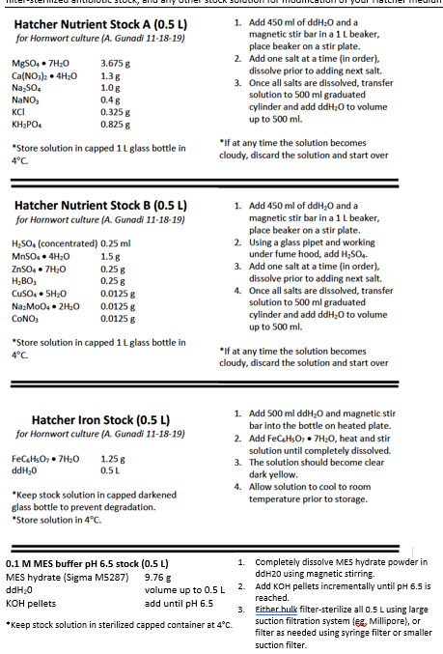

Hatcher Nutrient Stocks

* In our laboratory we have MES (sigma 1317 liquid at 1M)
* To dissolve **FeC₆H₅O₇ (ferric ammonium citrate)** more easily, it is recommended to place the solution on a magnetic stirrer and gently heat while stirring.

## 2.2 To make 1 Liter medium

**Composition of AG Medium (per 1 L)**

| Component | Amount |
| --- | --- |
| Hatcher Stock A | 100 ml |
| Hatcher Stock B | 3 ml |
| Hatcher Iron Stock | 1 ml |
| Ammonium nitrate | 0.4 g (0.4 g/L final) |
| Sucrose (optional for faster growth) | 2 g (0.2% final) |
| Gelzan (solid medium) | 4 g |
| MES buffer (0.1 M MES, pH 6.5) | 50 ml |
| ddH2O | up to 950 ml |

**Optional Additives and Selection Agents for AG Medium**

| Component | Amount |
| --- | --- |
| Activated Charcoal (Sigma C-3345) | 100 mg (100 mg/L final) |
| 1 mg/ml filtered BA stock | 2.25 ml (10 nM final) |
| 300 mg/ml filtered Timentin | 1 ml (300 mg/L final) |
| 10 mg/ml filtered Hygromycin | 1 ml (10 mg/L final) |
| 1 mM 2-Fluoroadenine (in DMSO) | 5 ml (5 µM final) |
| Benomyl (in DMSO) | 2.5 mg/L final |
| Imazalil (in water) | 20 µg/L final |
| Miconazole (in DMSO) | 10 mg/L final |
| Clomitrazole (in DMSO) | 10 µg/L final |
| Erythromycin (in DMSO) | 100 mg/L final |

Store sterilized media in an autoclave at 4°C for up to 4 months. For solid media, keep Petri dishes with the media facing down to prevent liquefaction.

**Selection agents:** Hygromycin: Selects for plant tissues expressing HygR gene (hptII) 2-Fluoroadenine: Selects for plant tissues with knocked-out or -down endogenous APT gene

**Antimicrobials:** Against general bacterial contamination: Timentin Against general fungal contamination: Benomyl, Imazalil, Miconazole, Clomitrazole Against cyanobacteria: Erythromycin

In our laboratory, for bacterial control, a mixture of *Penicillin G* (100 ml k U/L), *Tetracycline* (10 mg/L), and *Streptomycin* (72 k U/L) can be used in each 1 L of media.

For fungal control, *Ketaconazole* (5 mg/L) or *Cycloexamide* (50 mg/L) diluted in MDSO can be used in each 1 L of media.

## 2.3 Protocol for AG

1. In a beaker, add ~500 ml ddH2O first, then mix components (Stock A+ stock B + Ammonium nitrate + Sucrose + Iron Stock ) in solution using magnetic stirrer.
2. Add ddH2O to 950 ml total.
3. While stirring, add KOH using dropper to reach pH 6.5.
4. Divide the Gelzan into two 1 Liter bottles (for solid medium only).
5. Add 425 ml of the liquid solution into each bottle, no need to mix.
6. Loosely cap the bottles, then autoclave for 20 min in liquid setting.
7. After autoclaving, cool media in water bath, mix occasionally until ~55°C.
8. Add filtered **MES buffer** (pH 6.5) to 5 mM and BA stock to 10 nM final concentrations, mix well.
9. Add any other selection agent (s) and antimicrobials as needed. Mix well. For solid media, pour into tall petri dishes at ~35ml per dish. For liquid media, pour ~50ml per sterile 100 ml flask.

# 3 KnopII medium (Nakazato et al. 1999)

NAKAZATO T, KADOTA A & WADA M. 1999. Photoinduction of Spore Germination in Marchantia polymorpha L. is Mediated by Photosynthesis. Plant Cell Physiol 40: 1014–1020. <https://academic.oup.com/pcp/article-lookup/doi/10.1093/oxfordjournals.pcp.a029482>

Modified protocol for the culture of liverwort and hornwort (FEV/2025) pH is adjusted to 5.5 with KOH before autoclaving. Sucrose and agar can be added

**Composition of Knop II Medium (per 1 L)**

| Component | Amount |
| --- | --- |
| KNO₃ | 125 mg |
| Ca(NO₃)₂·4H₂O | 500 mg |
| MgSO₄·7H₂O | 125 mg |
| KH₂PO₄ | 125 mg |
| FeCl₃·6H₂O | 10 mg |
| Sucrose (optional) | 3 g (0.3%) |
| Agar (solid medium) | 3 g (0.3%) |

**Agar used at 0.5% (Bacto-agar) or 0.3% (Gelzan agar)**

## 3.1 Stock solutions

**Knop II Medium Stocks (Dissolve the reagents in 50 ml of deionized water)**

| Component | Amount |
| --- | --- |
| KNO₃ | 3.125 g |
| Ca(NO₃)₂·4H₂O | 12.5 g |
| MgSO₄·7H₂O | 3.125 g |
| KH₂PO₄ | 3.125 g |
| FeCl₃·6H₂O | 0.5 g |

Add 2 ml of each stock to 1 L of distilled (ddH2O) water

**Optional Additives and Selection Agents for KnopII Medium**

| Component | Amount |
| --- | --- |
| 300 mg/ml filtered Timentin | 1 ml (300 mg/L final) |
| 10 mg/ml filtered Hygromycin | 1 ml (10 mg/L final) |
| 1 mM 2-Fluoroadenine (in DMSO) | 5 ml (5 µM final) |
| Benomyl (in DMSO) | 2.5 mg/L final |
| Imazalil (in water) | 20 µg/L final |
| Miconazole (in DMSO) | 10 mg/L final |
| Clomitrazole (in DMSO) | 10 µg/L final |
| Erythromycin (in DMSO) | 100 mg/L final |

Store sterilized media in an autoclave at 4°C for up to 4 months. For solid media, keep Petri dishes with the media facing down to prevent liquefaction.

**Selection agents:** - Hygromycin: Selects for plant tissues expressing HygR gene (hptII) - 2-Fluoroadenine: Selects for plant tissues with knocked-out or -down endogenous APT gene

**Antimicrobials:** - Against general bacterial contamination: Timentin - Against general fungal contamination: Benomyl, Imazalil, Miconazole, Clomitrazole - Against cyanobacteria: Erythromycin

In our laboratory, for bacterial control, a mixture of: - *Penicillin G* (100 ml k U/L); - *Tetracycline* (10 mg/L); - *Streptomycin* (72 k U/L) can be used in each 1 L of media.

For fungal control, *Ketaconazole* (5 mg/L) or *Cycloexamide* (50 mg/L) diluted in MDSO can be used in each 1 L of media.

* To dissolve **FeCl₃·6H₂O** more easily, it is recommended to place the solution on a magnetic stirrer and gently heat while stirring.

## 3.2 Protocol for Knop II

1. In a beaker, add ~500 ml ddH2O first, then mix components in solution using magnetic stirrer.
2. Add ddH2O to 1000 ml total.
3. While stirring, add KOH using dropper to reach pH 5.5.
4. Divide the agar (example Gelzan agar) into two 1 Liter bottles (for solid medium only).
5. Add 500 ml of the liquid solution into each bottle, no need to mix.
6. Loosely cap the bottles, then autoclave for 20 min in liquid setting.
7. After autoclaving, cool media in water bath, mix occasionally until ~55°C.
8. Add antimicrobials as needed (After autoclaving). Mix well. For solid media, pour into tall petri dishes at ~35ml per dish.

# 4 Cyanobacteria – BG-11 Medium

BG-11 medium (Rippka 1979) is one of the most widely used media for culturing cyanobacteria.  
It can be prepared as a concentrated stock and diluted for immediate use.

## 4.1 Stock Solutions

Standard BG-11 Stock Solutions (quantities per 200 ml ddH₂O)

| Product | Amount_in_200ml |
| --- | --- |
| Solution 1: Disodium EDTA (Na2C10H14O8N2·2H2O) | 0.2 g |
| Solution 2: Citric acid (C6H8O7·H2O) | 1.2 g |
| Solution 3: Sodium nitrate (NaNO3) | 30 g |
| Solution 4: Dipotassium phosphate (K2HPO4) | 6.12 g |
| Solution 5: Magnesium sulfate (MgSO4·7H2O) | 15 g |
| Solution 6: Calcium chloride dihydrate (CaCl2·2H2O) | 7.2 g |
| Solution 7: Sodium carbonate anhydrous (Na2CO3) | 4 g |
| Solution 8: Ferric ammonium citrate (Fe 16.5–18.5%) | 1.2 g |

*Solution 9: Micronutrients*

Micronutrients for BG-11 Stock (per 200 ml ddH₂O)

| Component | Amount_in_200ml |
| --- | --- |
| Boric acid (H3BO3) | 0.572 g |
| Manganese chloride (MnCl2·4H2O) | 0.36 g |
| Zinc sulfate (ZnSO4·7H2O) | 0.044 g |
| Copper sulfate (CuSO4·5H2O or 4% w/v solution) | 0.016 g or 0.4 ml |
| Sodium molybdate (Na2MoO4·2H2O) | 0.078 g |
| Cobalt chloride (CoCl2·6H2O) | 0.008 g |

## 4.2 Protocol for Standard BG-11 Medium

To prepare **1 L of culture medium**:

1. Add **1 ml** of each stock solution listed above (except solutions 4, 8 and 9) into **991 ml** of deionized water.
2. pH should be adjusted to 7.44 - 7.48.
3. Addition the Gelzan agar (for solid medium only).
4. Sterilize the medium by autoclaving (20 min in liquid setting)
5. After autoclaving, cool media in water bath, mix occasionally until ~55°C, and add **1 ml** of each of the following stock solutions:
   * **Solution 4** (Dipotassium phosphate, K₂HPO₄)
   * **Solution 8** (Ferric ammonium citrate, Fe 16.5–18.5%)
   * **Solution 9** (Micronutrients)  
     These solutions must be **filter-sterilized (0.2 µm)** immediately before being added to the autoclaved medium.
6. Add antimicrobials as needed (After autoclaving). Mix well. For solid media
7. pour into tall petri dishes at ~35ml per dish.

**Note:**

* To dissolve **ferric ammonium citrate (FeC₆H₅O₇)** more easily, it is recommended to place the solution on a magnetic stirrer and gently heat while stirring.
* To prepare **nitrogen-free BG-11**, simply **omit stock solution 3 (NaNO₃)**.
* For **solid media**, add **10 g/L of Bacto Agar™** to the preparation before autoclaving.
* Store Petri dishes with **solid medium lid-side up** to avoid liquefaction or structural damage to the medium.
* Store sterilized media in fridge at 4°C for up to 5 months.

*Antimicrobials:*

* Against general bacterial contamination: Timentin
* Against general fungal contamination: Benomyl, Imazalil, Miconazole, Clomitrazole
* Against cyanobacteria: Erythromycin

In our laboratory, for bacterial control, a mixture of:

* *Penicillin G* (100 ml k U/L);
* *Tetracycline* (10 mg/L);
* *Streptomycin* (72 k U/L) can be used in each 1 L of media.

*fungal control*

* *Ketaconazole* (5 mg/L) **or** *Cycloexamide* (50 mg/L) diluted in MDSO can be used in each 1 L of media.

## 4.3 Final Mineral Concentrations in BG-11 Medium

Final Mineral Concentrations in BG-11 Medium (mg/L)

| Mineral | Concentration_mgL |
| --- | --- |
| Disodium EDTA (Na2C10H14O8N2·2H2O) | 1.00 |
| Citric acid (C6H8O7·H2O) | 6.00 |
| Sodium nitrate (NaNO3) | 150.00 |
| Dipotassium phosphate (K2HPO4) | 30.60 |
| Magnesium sulfate (MgSO4·7H2O) | 75.00 |
| Calcium chloride dihydrate (CaCl2·2H2O) | 36.00 |
| Sodium carbonate anhydrous (Na2CO3) | 20.00 |
| Ferric ammonium citrate (Fe 16.5–18.5%) | 6.00 |
| Boric acid (H3BO3) | 2.86 |
| Manganese chloride (MnCl2·4H2O) | 1.81 |
| Zinc sulfate (ZnSO4·7H2O) | 0.22 |
| Copper sulfate (CuSO4·5H2O) | 0.08 |
| Sodium molybdate (Na2MoO4·2H2O) | 0.39 |
| Cobalt chloride (CoCl2·6H2O) | 0.04 |

# 5 20:20:20 Fertilizer

The balanced NPK fertilizer **20:20:20** is commonly used for cultivating *Zamia* seedlings in growth chambers and greenhouse conditions.  
It provides macronutrients (N, P, K) and essential micronutrients in chelated form.

Composition of 20–20–20 Fertilizer

| Component | Content |
| --- | --- |
| Total Nitrogen (N) | 20% |
| Available Phosphoric Acid (P₂O₅) | 20% |
| Soluble Potash (K₂O) | 20% |
| Boron (B) | 0.02% |
| Chelated Copper (Cu) | 0.05% |
| Chelated Iron (Fe) | 0.10% |
| Chelated Manganese (Mn) | 0.05% |
| Molybdenum (Mo) | 0.0005% |
| Chelated Zinc (Zn) | 0.05% |
| EDTA (chelating agent) | 1.2% |

## 5.1 Protocol

* Prepare a **solution** by dissolving **200 mg of 20–20–20 fertilizer** in **1 L of deionized steril water**.
  + This yields a solution with approximately **10 mg of N per 50 ml**.
* Apply to plants as follows:
  + **Greenhouse:** water each plant with 25 ml, **twice per week**.
  + **Growth chamber:** water each plant with 50 ml, **once per week**.
* After some weeks of growth, switch fertilization to BG-11 medium for further cultivation.

**Note:** Fertilizer solution should be prepared fresh and sterilized after addition to avoid microbial contamination.

## 5.2 Laboratory Note – Growth Chamber Fertilizer Use for Stéphanie (Nov 2, 2021)

This note comes from laboratory files and is included here for reference.

### 5.2.1 Tasks

1. Water plants 1–2 times per week, prepare the fertilizer (sterilize after adding 1 g of fertilizer [20:20:20]), see below.
2. Measure the quantity of leaves and leaflets, and take photos of the plants in the greenhouse (once every 2–3 weeks).
3. In 3–4 weeks, begin using BG-11 medium (see Zamia article in *Symbiosis*) with seedlings in the growth chamber only.  
   The solutions are already prepared; they just need to be mixed. A graduate student will assist you.
4. In 4 weeks, germinate new *Zamia* seeds (a different species) in sterile vermiculite/sand. A graduate student will assist you.
5. In 6 weeks, transfer the seedlings, check morphology, presence of coralloid roots, and preserve cyanobacteria for metagenomic analyses. A graduate student will assist you.

### 5.2.2 Student Message

The important content is in the folder **“photo leaf area”**, where weekly photos of leaf area were taken.  
Leaf surface can be measured using ImageJ.  
There is also an Excel file **“Feuille de données serre”** with height and leaf counts.  
For methods, refer to the research proposal. For fertilization details, see the document **“Arrosage des plantes”**.

### 5.2.3 Important Files in the Folder

* Informations serre
* Template feuille de données
* Feuille de données – serres
* Photo leaf area
* Culture BG-11 cyanobacteries

### 5.2.4 Watering Schedule

* **Greenhouse:** 25 ml/plant, twice per week.
* **Growth chamber:** 50 ml/plant, once per week with fertilizer (switch later to BG-11).

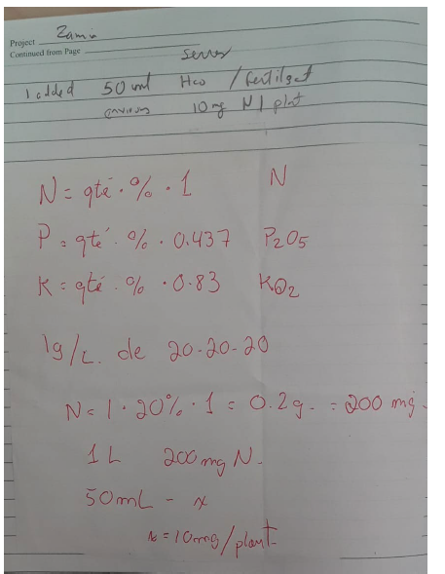

Laboratory note on fertilizer 20-20-20

## 5.3 Laboratory Note – Watering of *Zamia furfuracea* (June 21, 2021)

This note is preserved from internal lab instructions. It is **not part of the standardized protocol**, but documents how watering and fertilization were carried out in the greenhouse.

### 5.3.1 Arrosage des plants de *Zamia furfuracea*

* Fill **10 bottles** with tap water (not distilled water) up to 900 ml.  
  *Bottles are stored in lab 2211 next to the hood.*
* Autoclave the bottles (liquid cycle, 20 minutes).
  + Preferably autoclave in the morning or the day before to allow more cooling time.
  + It is also recommended to use the autoclave in the basement, since the sterilization service slows down during summer.
* Water the plants.

### 5.3.2 Fertilizer addition (Monday, June 21)

* Fertilizer used: **20–20–20** (see storage location below).
* Add **0.5 g fertilizer per bottle** using the balance.
  + It is advisable to bring a small spoon from the lab to measure the fertilizer.

### 5.3.3 Important information

* Plants must be watered **on Mondays and Thursdays**.
* The greenhouse doors are locked:
  + The **first door** requires a code: 225323Check with Juan Carlos Villarreal.

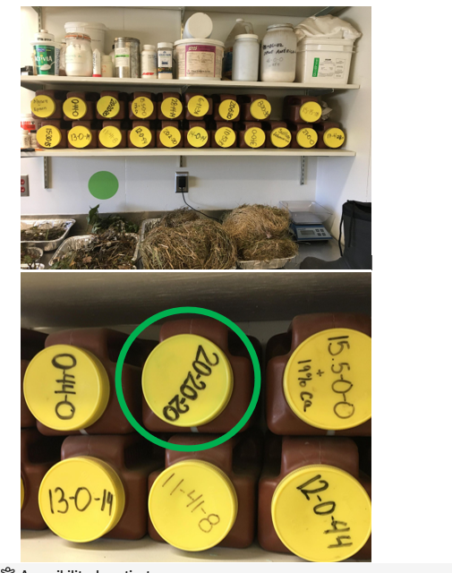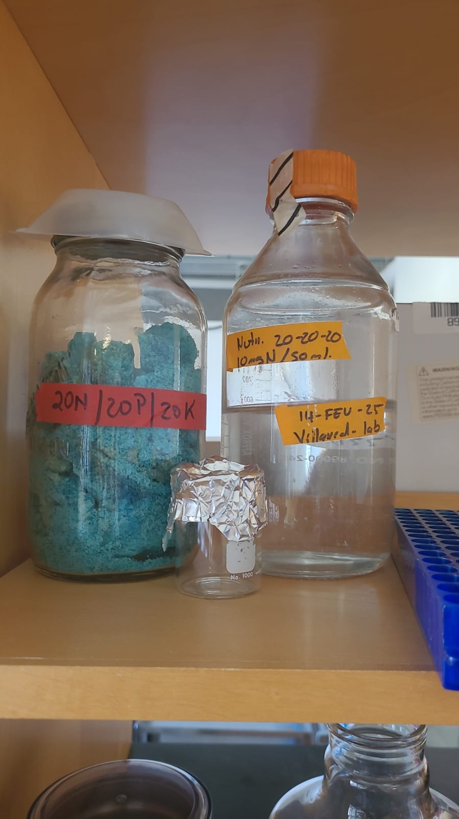

# 6 Seed Sterilization – Zamia and Cycas

* Remove the seed coat (testa) carefully with a scalpel or razor blade.
  + Avoid using a very sharp or thin blade that could damage the endosperm or embryo.
  + For seedlings, first wash vigorously with tap water to remove all soil.
* Expose the seeds to UV light for **30 minutes** to reduce contamination.
* Prepare the disinfection solutions:
  + **Fungicide solution:** 300 ml deionized water + 0.36 g fungicide.
  + **Alcohol 97%** (fresh).
  + **Alcohol 70%** (fresh).
  + **Sterile distilled water** for rinsing.
* Sequential disinfection (one seed at a time using sterile forceps):
  + Dip in **97% ethanol** for **30 seconds** (with gentle agitation).
  + Transfer to **70% ethanol** for **1 minute** (agitate gently).
  + Transfer to sterile distilled water and rinse thoroughly.
  + Transfer to **Fungicide solution** for **3 minute** (agitate gently).
  + Place seeds on sterile paper towel to dry briefly.
* After drying, transfer seeds to prepared sterile containers with sterile perlite/vermiculite/sand or directly to culture medium, depending on experimental design.

**Laboratory Note** – Additional Seed Cleaning Details

* Each seed was manipulated individually with large sterile forceps.
* After the ethanol washes, seeds were transferred through a series of beakers containing alcohols and finally fungicide.
* When all seeds had been processed, they were placed together in the fungicide solution and shaken vigorously for **3 minutes**.
* Seeds were then dried on sterile paper towels before sowing.
* For each container, 200 ml of deionized water was added after seed placement to maintain humidity.

# 7 Coralloid Root Sterilization Protocol

*References* - Bell‐Doyon, P.; Laroche, J.; Saltonstall, K.; Villarreal, J.C. Specialized Bacteriome Uncovered in the Coralloid Roots of the Epiphytic Gymnosperm, *Zamia pseudoparasitica*. *Environ. DNA* 2020, 1–11. <https://doi.org/10.1002/edn3.66>  
- Sierra, A.M.; Toupin, S.; Alonso-García, M.; Villarreal, J.C. Diversity of Symbiotic Cyanobacteria in Cycad Coralloid Roots Using a Short-Read *RbcL-X* Amplicon. *Symbiosis* 2024, 92, 271–288. <https://doi.org/10.1007/s13199-024-00972-w>

## 7.1 Pre-processing Storage Conditions

* Coralloid roots should be stored on **ice in a hermetically sealed container at 4 °C** for no more than **2 hours** prior to laboratory processing.

## 7.2 Required Materials

* Double-distilled water (ddH₂O; autoclaved)
* 1% Triton X-100 solution
* 1% commercial bleach (sodium hypochlorite)
* 95% ethanol
* 70% ethanol
* 40% ethanol
* Sterile 1.5 ml microcentrifuge tubes (for DNA or RNA extraction)

## 7.3 Surface Sterilization Procedure

* **Initial Cleaning**: Rinse the coralloid roots thoroughly with autoclaved ddH₂O until all visible debris is removed.
* **Detergent and Bleach Treatment**
  + Submerge the cleaned roots in **1% Triton X-100** solution for **1 minute**.
  + Immediately transfer them to **1% commercial bleach** for an additional **1 minute**.
* **Rinse**: Rinse the roots thoroughly with **ddH₂O for 5 minutes** to ensure complete removal of Triton X-100 and bleach residues.
* **Ethanol Wash Series**
  + 95% ethanol for 30 seconds
  + 70% ethanol for 60 seconds
  + 40% ethanol for 120 seconds
* **Final Rinse**: Rinse the roots **three times with ddH₂O** to remove any residual ethanol.
* **Storage**: Transfer the surface-sterilized coralloid roots into **sterile 1.5 ml microcentrifuge tubes** for subsequent DNA or RNA extraction.

**Notes** - It is recommended to complete the cleaning process and immediately immerse the roots in **liquid nitrogen**.  
- Frozen roots can be stored at **−80 °C**.  
- For **RNA extractions**, keep roots in liquid nitrogen during transport and throughout the initial stages of the extraction process.

# 8 Cultivation of *Nostoc* in Liquid and Solid Media

## 8.1 Medium

* **BG-11 without nitrogen (BG-11₀)** – prepared as stock following standard recipe, omitting NaNO₃.
* **Cycloheximide** – final concentration: **50 mg/L** (to inhibit eukaryotic contaminants).
* **Optional for solid medium:** 10 g/L Bacto Agar™.

## 8.2 Materials

* BG-11₀ medium (liquid or solid base)
* Cycloheximide (10 mg/ml sterile stock, filter sterilized)
* Autoclaved Erlenmeyer flasks or sterile Petri dishes
* Sterile pipettes and culture tools
* Inoculum of *Nostoc* (previously grown cultures)

## 8.3 Protocol – Liquid Medium

* **Prepare the medium**
  + Autoclave BG-11₀ medium.
  + Once cooled to room temperature, add cycloheximide to a final concentration of **50 mg/L**
* **Inoculation**
  + Transfer fresh *Nostoc* filaments aseptically into sterile Erlenmeyer flasks containing BG-11₀ + cycloheximide.
  + Typical working volume: **250 ml medium** in **500 ml flask**.
* **Incubation**
  + Grow cultures under continuous light or a 16/8 h light/dark cycle.
  + Temperature: **25–28 °C**.
  + Agitation: optional shaking at **100 -120 rpm** to prevent clumping and ensure aeration.

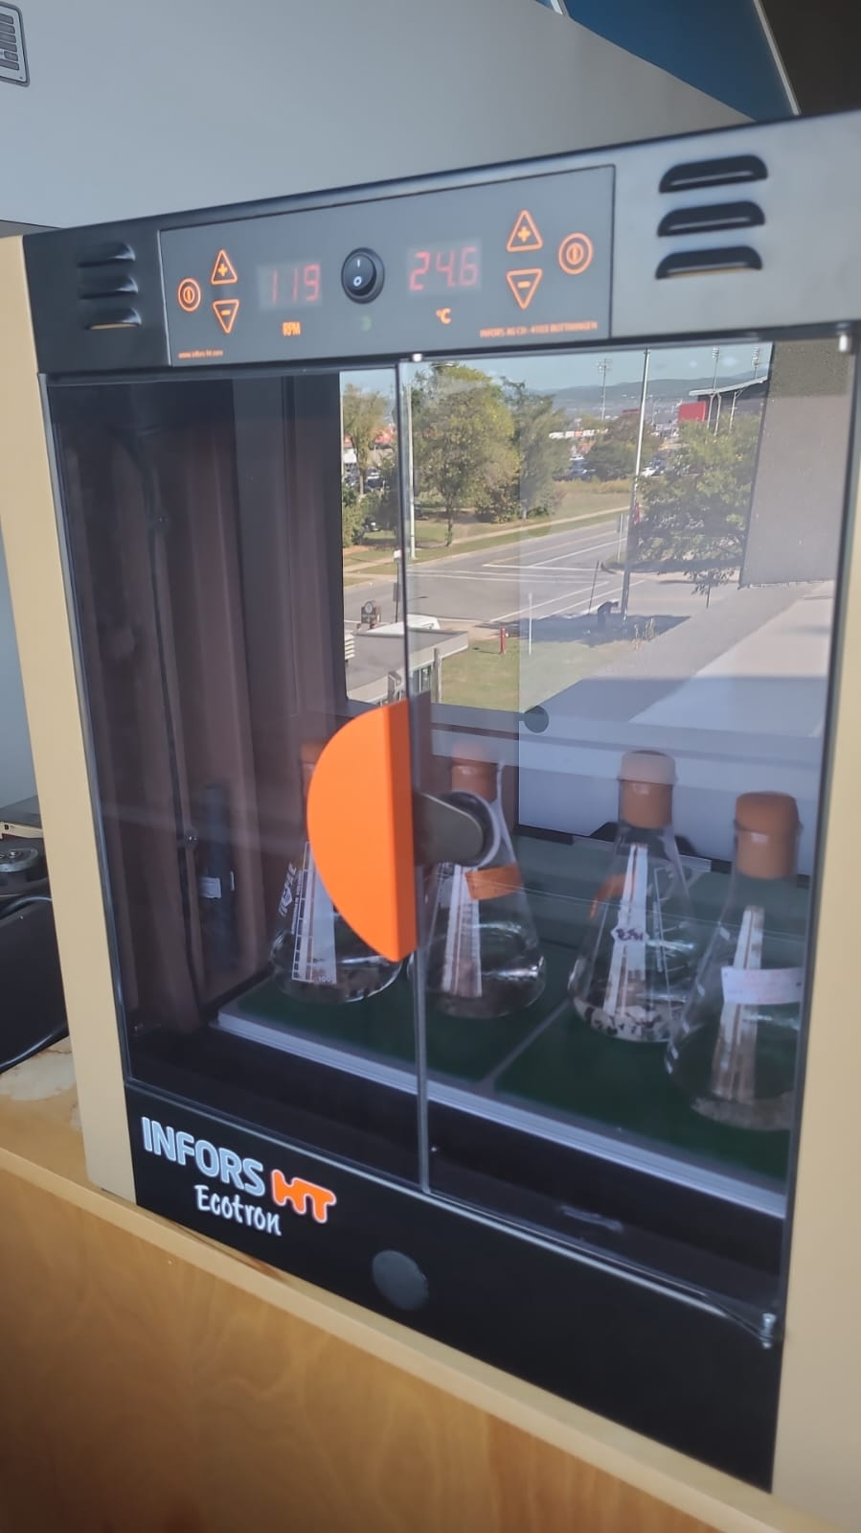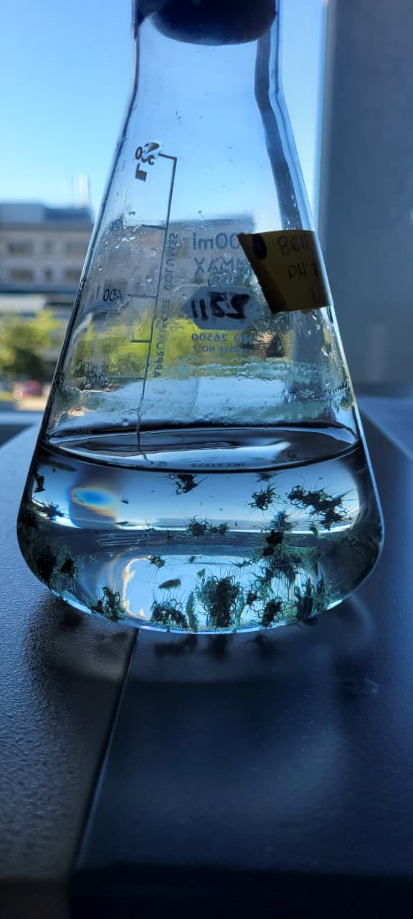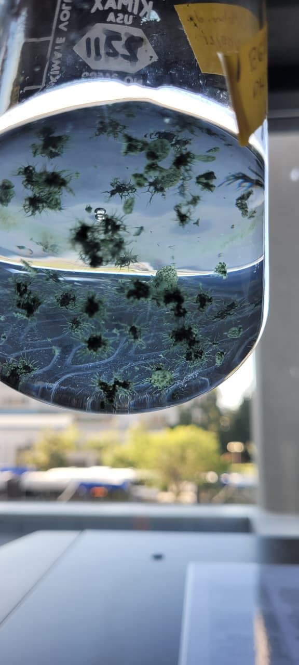

## 8.4 Protocol – Solid Medium

* **Prepare BG-11₀ agar plates**
  + Add **10 g/L Bacto Agar™** to BG-11₀ medium.
  + Autoclave, cool to 55 °C, and add cycloheximide (50 mg/L final) by mixing thoroughly before pouring.
* **Inoculation**
  + Place small filaments or droplets of liquid inoculum onto the agar surface.
  + Spread gently with sterile loop or glass rod.
* **Incubation**
  + Incubate plates at **25–28 °C**, under continuous light or 16/8 h cycle.
  + Maintain moderate humidity to prevent agar desiccation.  
    **Notes**
* Cycloheximide is **fungistatic** and reduces eukaryotic contaminants but does not affect cyanobacteria like *Nostoc*.
* For long-term maintenance, transfer colonies or liquid cultures to fresh BG-11₀ medium every **3–4 weeks**.
* Solid plates should be stored in sealed plastic bags or parafilm-wrapped to reduce drying.
* Petri dishes containing solid medium should be **incubated in the inverted position** (agar side up, lid side down).
* This prevents condensation from dripping onto the agar surface and reduces **evaporation** of the medium.