# Isco2 Load Marks (ilm) - Installation guide

1. Load Google Chrome Extension

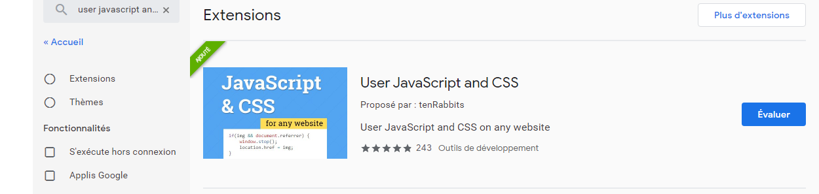

1. Open ISCO page. In the toolbar, open the extension

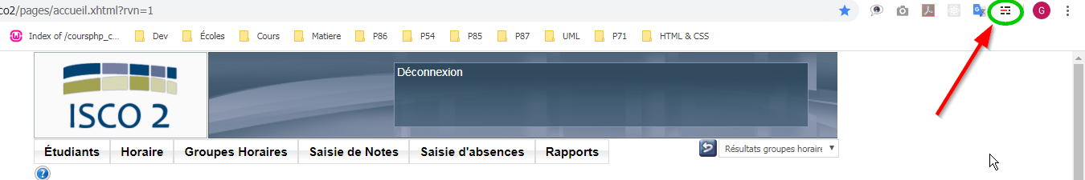

1. In the extension page, create a rule for Isco2 site:
   1. Activate extension for Isco2.
   2. Activate Javascript and CSS.
   3. Load JS code and CSS code (copy-paste them).
   4. Save

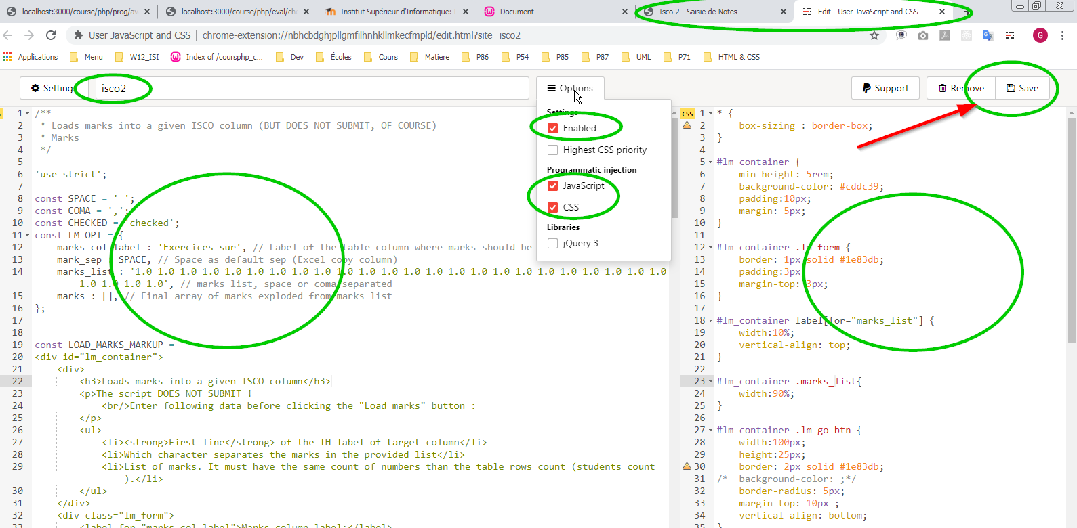

1. Reload Isco2 page. You should see green block under "Rechercher" button.

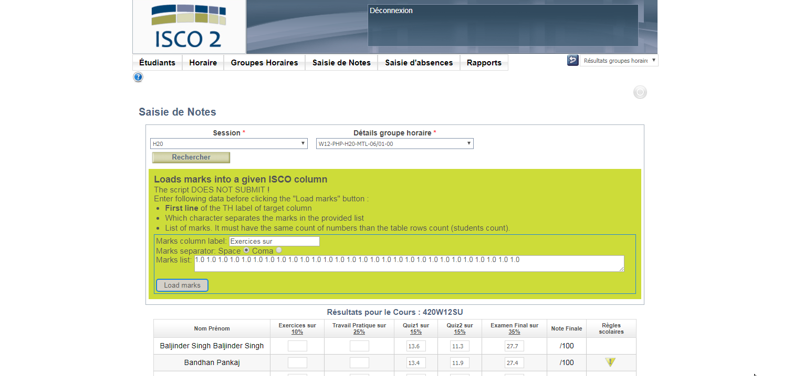

1. Follow indications on the page.
2. Enjoy how loading marks in ISCO2 is nice now !