**Unit 2 exercises**

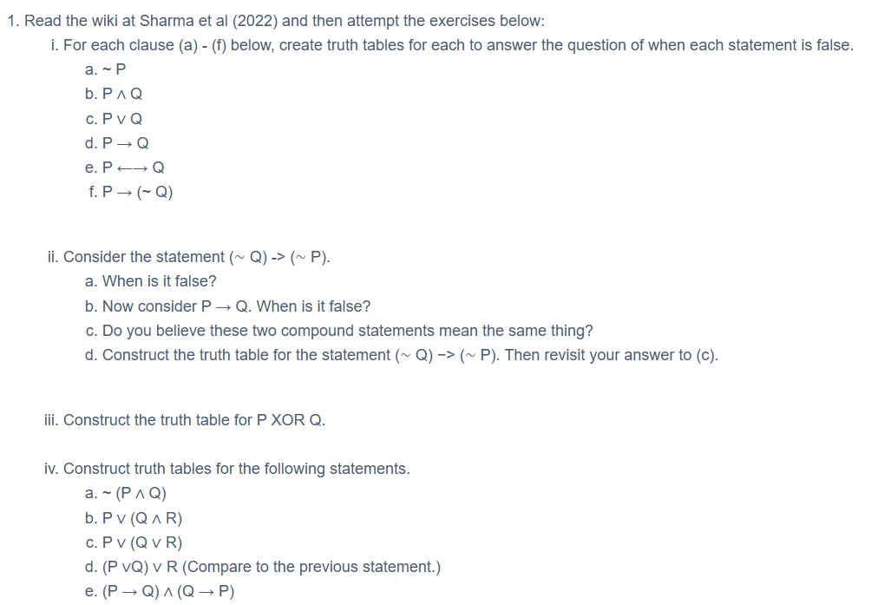

**Exercise 1**

|  |  |  |  |  |  |  |  |
| --- | --- | --- | --- | --- | --- | --- | --- |
| P | Q | a. ~P | b. P ∧ Q | c. P ∨ Q | d. P → Q | e. P ←→ Q | f. P → (~ Q) |
| T | T | F | T | T | T | T | F |
| F | T | T | F | T | F | F | T |
| T | F |  | F | T | T | F | T |
| F | F |  | F | F | T | T | T |

**Exercise 2**

a. (~Q) → (~P) is false when ~Q is true and ~P is false, which corresponds to the case where Q is false and P is true.

b. P → Q is false when P is true and Q is false

c. No – inverse relation

d.

|  |  |  |  |  |  |
| --- | --- | --- | --- | --- | --- |
| Q | P | ~Q | ~P | a. (~Q) → (~P) | b. P → Q |
| T | T | F | F | T | T |
| F | T | T | F | T | F |
| T | F | F | T | F | T |
| F | F | T | T | T | T |

**Exercise 3**

|  |  |  |
| --- | --- | --- |
| P | Q | P XOR Q |
| T | T | F |
| F | T | T |
| T | F | T |
| F | F | F |

**Exercise 4**

1. ~ (P ∧ Q)

|  |  |  |  |
| --- | --- | --- | --- |
| P | Q | P ∧ Q | ~ (P ∧ Q) |
| T | T | T | F |
| F | T | F | T |
| T | F | F | T |
| F | F | T | F |

1. P ∨ (Q ∧ R)

|  |  |  |  |  |
| --- | --- | --- | --- | --- |
| P | Q | R | Q ∧ R | P ∨ (Q ∧ R) |
| T | T | T | T | T |
| T | T | F | F | T |
| T | F | T | F | T |
| T | F | F | F | T |
| F | T | T | T | T |
| F | T | F | F | F |
| F | F | T | F | F |
| F | F | F | F | F |

1. P ∨ (Q ∨ R)

|  |  |  |  |  |
| --- | --- | --- | --- | --- |
| P | Q | R | Q ∨ R | P ∨ (Q ∨ R) |
| T | T | T | T | T |
| T | T | F | T | T |
| T | F | T | T | T |
| T | F | F | F | T |
| F | T | T | T | T |
| F | T | F | T | T |
| F | F | T | T | T |
| F | F | F | F | F |

1. (P ∨ Q) ∨ R

|  |  |  |  |  |
| --- | --- | --- | --- | --- |
| P | Q | R | P ∨ Q | (P ∨ Q) ∨ R |
| T | T | T | T | T |
| T | T | F | T | T |
| T | F | T | T | T |
| T | F | F | T | T |
| F | T | T | T | T |
| F | T | F | T | T |
| F | F | T | F | T |
| F | F | F | F | F |

Both P ∨ (Q ∨ R) and (P ∨ Q) ∨ R result in the same truth table as expected due to the associative property of OR.

1. (P → Q) ∧ (Q → P)

|  |  |  |  |  |
| --- | --- | --- | --- | --- |
| P | Q | P → Q | Q → P | (P → Q) ∧ (Q → P) |
| T | T | T | T | T |
| T | F | F | T | F |
| F | T | T | F | F |
| F | F | T | T | T |