**Unit 4 Seminar exercises**

1. *Prolog can be used to test the questions included in Unit 2. For example, to test exercise 1 carry out the following steps.*
   * *Surf to https://swi-prolog.org*
   * *Click on “try swi-prolog online”.*
   * *On the SWISH page click on notebook.*
   * *Click on Query.*
   * *In the ‘query’ box enter “member(c, [a,b,c,2,3,4])”.*
   * *Click the go (>) button – it should give the answer ‘true’ (I.e., c is a member of the set).*
   * *How many of the questions in exercise 1 can you check in this way?*

**Answer:**

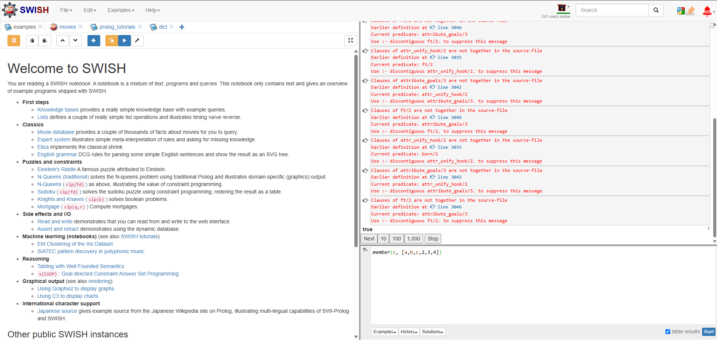

**Negation: ~P**

not_p(P) :- \+ P.

**Conjunction: P ∧ Q**

and_p_q(P, Q) :- P, Q.

**Disjunction: P ∨ Q**

or_p_q(P, Q) :- P; Q.

**Implication: P → Q**

implies_p_q(P, Q) :- \+ P; Q.

**Biconditional: P ↔ Q**

biconditional_p_q(P, Q) :- implies_p_q(P, Q), implies_p_q(Q, P).

**Complex: P → (~ Q)**

implies_p_not_q(P, Q) :- \+ P; \+ Q.

**Negation of Implication: (∼ Q) -> (∼ P)**

neg_implies_q_p(Q, P) :- Q, \+ P.

**Exclusive OR: P XOR Q**

xor_p_q(P, Q) :- (P, \+ Q); (\+ P, Q).

**Negation of Conjunction: ~(P ∧ Q)**

neg_and_p_q(P, Q) :- \+ (P, Q).

**Disjunction with Conjunction: P ∨ (Q ∧ R)**

or_p_and_q_r(P, Q, R) :- P; (Q, R).

**Nested Disjunction: P ∨ (Q ∨ R)**

or_p_or_q_r(P, Q, R) :- P; Q; R.

**Comparison of Disjunctions: (P ∨Q) ∨ R**

nested_or_p_q_r(P, Q, R) :- P; Q; R.

**Biconditional: (P → Q) ∧ (Q → P)**

and_implies_p_q_q_p(P, Q) :- implies_p_q(P, Q), implies_p_q(Q, P).

**Testing:**

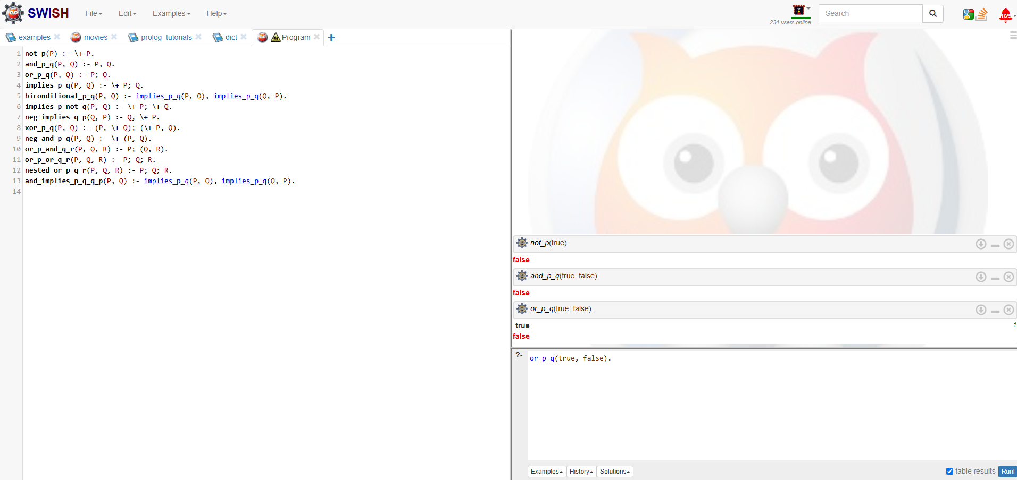

1. *Read Ritchie (2002) section 8.2 (starting on pg 12). Input the facts into the SWI-SWISH page and run the queries. To do this:*
   * *Click the + sign next to the word notebook.*
   * *Choose program.*
   * *Enter the facts (printed in the Ritchie book) into the large window.*
   * *On the right hand side of the screen you will see a smaller window, with a “?- “ at the top corner – this is the query box.*
   * *Enter your queries into the box then click the run button.*
   * *Try all the queries presented in sections 8.2 and 8.3 of the Ritchie book.*

**Answer:**

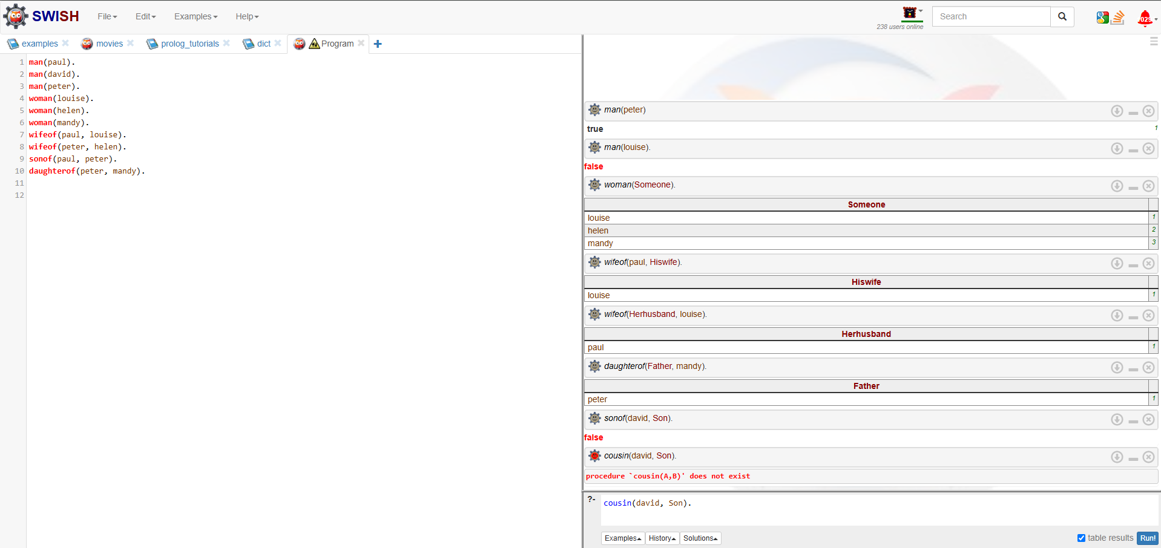

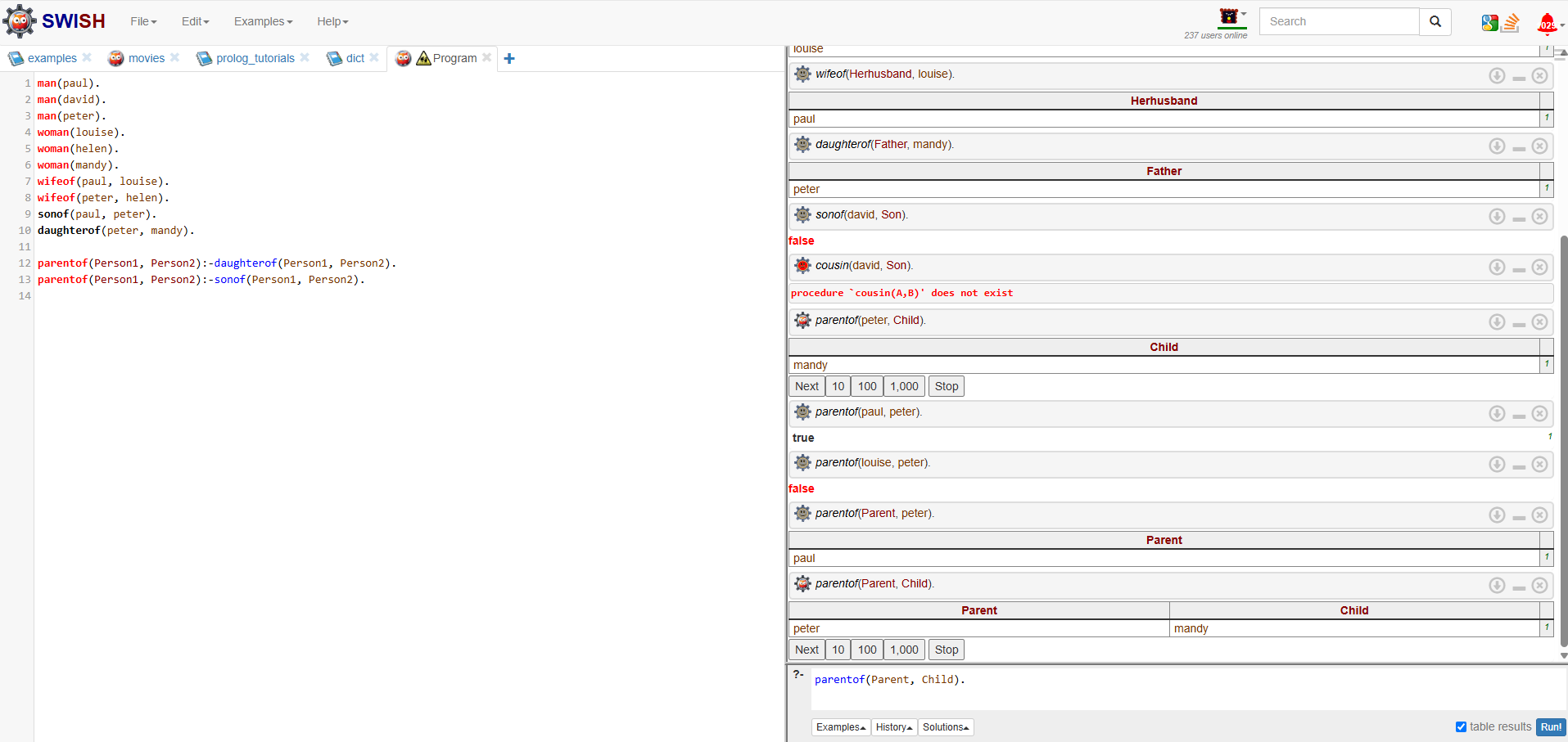

1. *Enter the Prolog version of the “crossing problem” into the SWISH program window and run it. What is the result?*

Unable to answer as the Prolog answer is not provided in the learning materials