**Unit 8 exercise – Simple Ontology building with Protégé**

I followed the exercises suggested in Chapter 4 of Debellis (Debellis, no date) to create a simple ontology describing pizza types, ingredients, and bases – as shown below.

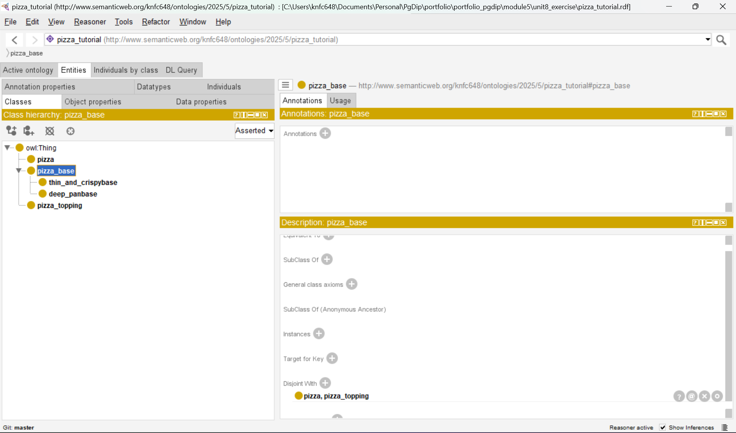

**References:**

Debellis, M. (no date) *A Practical Guide to Building OWL Ontologies Using Protégé 5.5 and Plugins*.