Most Important Study

Lead Statistician: R.A. Fisher

Contributions from: Secondary Author

Director: Mark Greenwood Ph.D.

This material is provided to communicate advice from SCRS statisticians based on our best understanding of your research needs. We encourage you to use this report in discussions with colleagues. Please do not publish any portion of this material without permission.

©R. A. Fisher

When you make use of our work for publications or presentations, please be sure to acknowledge the funding we receive from NIGMS using the following: “Research reported in this publication was supported by Institutional Development Awards (IDeA) from the National Institute of General Medical Sciences of the National Institutes of Health under Awards P20GM103474, U54GM115371, 5P20GM104417, and 2U54GM104944-06. The content is solely the responsibility of the authors and does not necessarily represent the official views of the National Institutes of Health.

Prepared for: Client Name

January 24, 2020

word1, word2

document subject here

Table of Contents

Prerequisites 1

Introduction 2

# Prerequisites

This is a *sample* book written in **Markdown**. You can use anything that Pandoc’s Markdown supports, e.g., a math equation $a^{2}+b^{2}=c^{2}$.

The **bookdown** package can be installed from CRAN or Github:

Remember each Rmd file contains one and only one chapter, and a chapter is defined by the first-level heading #.

To compile this example to PDF, you need XeLaTeX. You are recommended to install TinyTeX (which includes XeLaTeX): <https://yihui.name/tinytex/>.

# Introduction

You can label chapter and section titles using {#label} after them, e.g., we can reference Chapter 2. If you do not manually label them, there will be automatic labels anyway, e.g., Chapter 1.

Figures and tables with captions will be placed in figure and table environments, respectively.

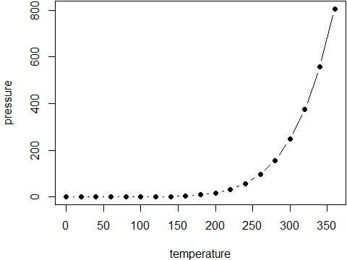

Figure 1: Here is a nice figure!

Reference a figure by its code chunk label with the fig: prefix, e.g., see Figure 1. Similarly, you can reference tables generated from knitr::kable(), e.g., see Table 1.

Table 1: Here is a nice table!

|  |  |  |  |  |
| --- | --- | --- | --- | --- |
| Sepal.Length | Sepal.Width | Petal.Length | Petal.Width | Species |
| 5.1 | 3.5 | 1.4 | 0.2 | setosa |
| 4.9 | 3.0 | 1.4 | 0.2 | setosa |
| 4.7 | 3.2 | 1.3 | 0.2 | setosa |
| 4.6 | 3.1 | 1.5 | 0.2 | setosa |
| 5.0 | 3.6 | 1.4 | 0.2 | setosa |
| 5.4 | 3.9 | 1.7 | 0.4 | setosa |
| 4.6 | 3.4 | 1.4 | 0.3 | setosa |
| 5.0 | 3.4 | 1.5 | 0.2 | setosa |
| 4.4 | 2.9 | 1.4 | 0.2 | setosa |
| 4.9 | 3.1 | 1.5 | 0.1 | setosa |
| 5.4 | 3.7 | 1.5 | 0.2 | setosa |
| 4.8 | 3.4 | 1.6 | 0.2 | setosa |
| 4.8 | 3.0 | 1.4 | 0.1 | setosa |
| 4.3 | 3.0 | 1.1 | 0.1 | setosa |
| 5.8 | 4.0 | 1.2 | 0.2 | setosa |
| 5.7 | 4.4 | 1.5 | 0.4 | setosa |
| 5.4 | 3.9 | 1.3 | 0.4 | setosa |
| 5.1 | 3.5 | 1.4 | 0.3 | setosa |
| 5.7 | 3.8 | 1.7 | 0.3 | setosa |
| 5.1 | 3.8 | 1.5 | 0.3 | setosa |

You can write citations, too. For example, this is R (R Core Team 2019) and one the most referenced book is (Ramsey and Schafer 2012).

Ramsey, Fred L, and Daniel W Schafer. 2012. *The Statistical Sleuth: A Course in Methods of Data Analysis: A Course in Methods of Data Analysis*. 3rd ed. Brooks Cole.

R Core Team. 2019. *R: A Language and Environment for Statistical Computing*. Vienna, Austria: R Foundation for Statistical Computing. <https://www.R-project.org/>.