Assignment3
Name: Pankaj Pandurang Gaikwad
Form No: 250603479
PRN: 250840128022

1. Design Vehicle Hierarchy with following specifications:
- The vehicle class has registration no, make, model and price
- Implement calculateInsurance() method as abstract method in the class

- Create TwoWheeler and FourWheeler as subclasses of Vehicle class
and implement calculateInsurance () method

For two wheeler the insurance amount is 5% of the price
For four wheeler the insurance amount is 10% of the price

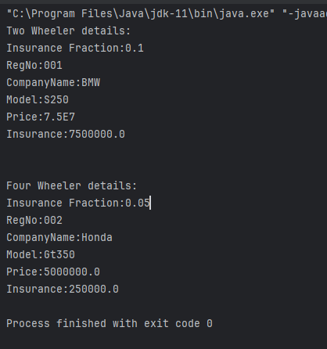

2. Design Account Hierarchy with following specifications:

- The account class has account no, name and balance
- Implement withdrawal and deposit methods in the class

- Create Savings and Current as subclasses of Account class

For Savings account min balance of 10000 should be maintained while withdrawal, if not fee of rs.
500 will be applicable

For current account maximum of 50000 rs can be withdrawn at a time

While deposit the minimum denomination should be rs 50

Outputs:
Account doesn’t exist:
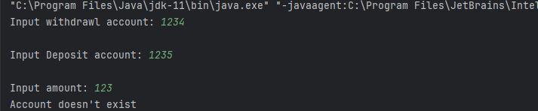

Saving withdrawl: min balance 10000 so Success but penalty:

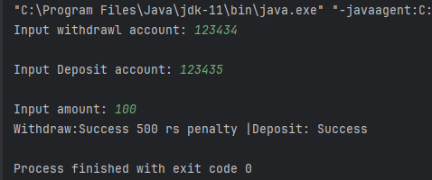

Withdraw from Current: amount greater than 50000, failure
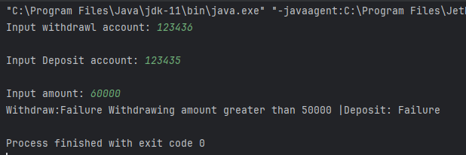

Current Deposit: cant deposit denominations less than 50:

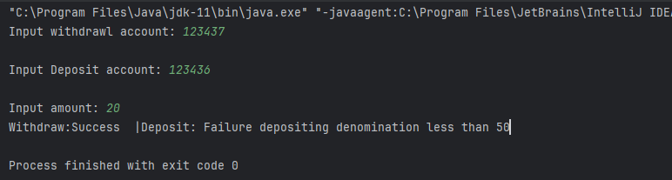

4. Understanding Package and Import
a. Create Date class in Folder1\src
b. Date class is in package com.mycompany.util
c. Create Calender class in Folder2

d. Compile Date class and keep the .class file in bin folder under Folder1
e. Complie Calender class [Add bin folder in class path]
f. Run Calender class
Folder2>java Calender

Output:
