Name: Pankaj Pandurang Gaikwad
Form No: 250603479
PRN: 250840128022
1. For Account class
Implement deposite and withdraw methods
Identify possible exceptions and create Custome exception classes for the same
Display meaningful error messages

Built in exception:
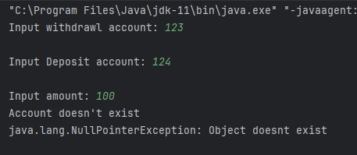

Custom exception, handled by the function:
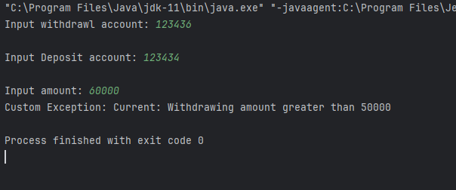

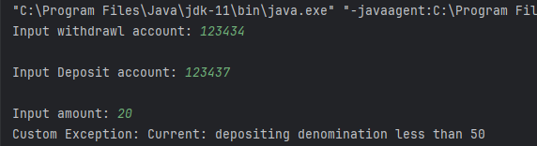

Custom Exception handled by callee function:
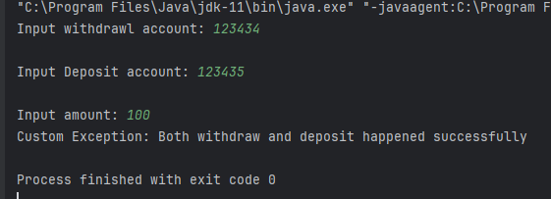

2. Strings
a. Check if two Strings are anagram
b. Count no of uppercase/lowercase/special char in a String
c. Check if String is upper case
d. Shift characters of the String to left
e. Implement equals and equalsIngoreCase methods
