Name: Pankaj Pandurang Gaikwad
Form No: 250603479

1.Write a program for checking prime numbers, calculate factorial(iterative)
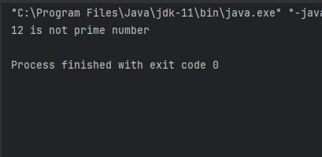

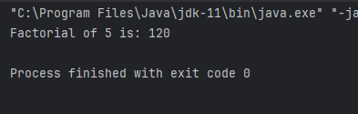

2. Create a student class with name and rollNo
Implement default as well as parameterized constructor
implement getter-setter and toString method
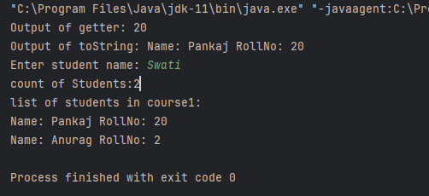

3.Write a java program to implement binary search

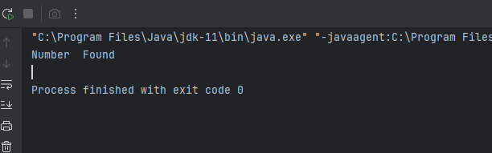

4.Sorting algorithm:
