1. Create program for Automated Curtain Controller where a Remote is used to operate the Curtain. If the curtain is in closed state remote will open it and if the Curtain is in open state the remote will closed it. The controller class will create the necessary objects and invoke the open and close methods

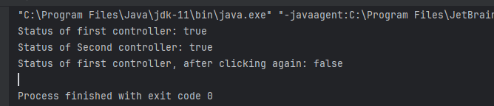

2. Create a Student class with rollno, name and array for storing marks 1. Calculate Average marks 2. Calculate percentage
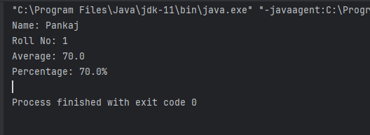

3 Create a Product class with prodid, name, price Create Store class with methods : 1. Display product list, 2. Search Product [To search a product first create Product array, and if id is found in the array return index at which it is found
