
G-PhoCS – Generalized Phylogenetic Coalescent Sampler
version 1.3
Contents
- About G-PhoCS
- Download and install
- Latest updates
- Overview of G-PhoCS analysis: input and output
- The sequence file
- The control file
6.1 Data size restrictions
- Using multiple control files
- Tuning the MCMC
- Multi thread support
- Trace analysis
- Errors and troubleshooting
- Control file generator

1. About G-PhoCS
G-PhoCS is a software package for inferring ancestral population sizes, population divergence times, and migration rates from individual genome sequences. G-PhoCS accepts as input a set of multiple sequence alignments from separate neutrally evolving loci along the genome. Parameter inference is done in a Bayesian manner, using a Markov Chain Monte Carlo (MCMC) to jointly sample model parameters and genealogies at the input loci.

G-PhoCS is derived from and inspired by MCMCcoal developed by Ziheng Yang. The original inference framework introduced in MCMCcoal was extended in several ways to make it appropriate for inference of population history rather than species history.

This user manual provides basic information for users of the software. Users should make sure to carefully read the manual before trying out the software. Sample files are also provided in the package. Additional important details about the method are provided in the supplement of the G-PhoCS paper: Gronau I, Hubisz MJ, Gulko B, Danko CG, Siepel A. Bayesian inference of ancient human demography from individual genome sequences. Nature Genetics 43 1031–1034. 2011.
The most relevant sections in the supplement are Section 1 (preparing data for analysis), section 4 (the G-PhoCS algorithm), and Section 5 (practical execution tips).
For questions, comments, and feature requests for G-PhoCS, please contact Ilan Gronau at: ilan.gronau@idc.ac.il

Good luck,
Ilan.
2. Download and install

G-PhoCS is developed on Linux, but can be compiled on any system. For the multi-threaded parallel version you will need to have a C compiler with OpenMP library installed.

- Clone the G-PhoCS source code from the Github repository
git clone https://github.com/gphocs-dev/G-PhoCS.git
- Move to the obtained directory
cd G-PhoCS

- Compile G-PhoCS. See Section 9 for multithreading support.
make
The G-PhoCS binaries (G-PhoCS and readTrace) can be now found in the bin/ subdirectory.
- Post-Install Test Run
bin/G-PhoCS sample-control-file.ctl

3. Latest updates
The main updates in version 1.3 include:
- Introductoin of a multi-threaded implementation, which allows reducing running time on multi-core CPUs. See details here.
- A control file generator Java applet for constructing setup files for G-PhoCS analysis. See details here.
The main updates in version 1.2.3 include:
- enabling analysis of ancient DNA samples by associating a sample age parameter with each ancient sample. See 'age' attribute in CURRENT-POP.

4. Overview of G-PhoCS analysis: input and output
When preparing your data for analysis by G-PhoCS, you will need to create a sequence file and a control file. The sequence file contains your sequence data, and the control file contains the specification for the prior distribution over model parameters and instructions for the sampler.

The main output of the MCMC sampler is produced in the trace file (whose path is specified in the control file). The first column in the trace file contains the number of MCMC iteration from which the sample is given (starting from 0). After that, there is a column for every model parameter (effective population sizes, population divergence times, migration rates). The last two columns correspond to the average data log likelihood (across all loci), and the full log likelihood (summed across loci, and considering the genealogy priors). All parameters are given with accuracy of 10⁻⁵. In order to obtain optimal relative accuracy, parameters can be printed in any factor (by setting the appropriate attributes in the control file). The trace file can be analyzed using the readTrace binary supplied with G-PhoCS. The trace file is also formatted so that it could be viewed by Tracer from the BEAST package.
Sample theta_A theta_B theta_C theta_D theta_AB theta_ABC theta_root tau_AB tau_ABC tau_root m_D->B Data-ld-ln Full-ld-ln
0 1.06147 1.02213 0.85924 1.09034 0.99918 0.91122 1.11978 0.04961 0.09858 0.54487 0.00000 -1345.658845 -1407136.676
1 1.09477 0.96538 0.85924 1.12269 0.99918 0.93931 1.11978 0.04961 0.09858 0.54487 20.24997 -1343.305172 -1405052.121
2 1.03987 0.96538 0.90605 1.12269 0.99918 0.93931 1.11978 0.04961 0.09797 0.54487 19.83021 -1342.676200 -1404146.180
3 0.99947 1.00241 0.90897 1.16359 1.00241 1.00738 1.12339 0.04977 0.09829 0.57991 19.18764 -1342.502793 -1403567.133
4 1.04238 1.02384 0.95178 1.16597 0.97595 1.03361 1.12569 0.04987 0.09849 0.58110 19.44754 -1342.036533 -1403214.705
5 1.08084 1.07690 0.95178 1.20241 0.94602 1.03361 1.12569 0.05291 0.09849 0.58110 19.27217 -1342.093022 -1403128.813
6 1.12640 1.11818 0.95178 1.24548 0.91416 1.03361 1.12569 0.05291 0.09849 0.58110 19.67596 -1341.907213 -1403025.000
7 1.08826 1.06609 0.95666 1.31251 0.95618 1.03891 1.18004 0.05318 0.09899 0.60630 19.88259 -1342.166514 -1402881.053
8 1.08826 1.03309 0.92669 1.31251 0.95618 1.06409 1.22692 0.05318 0.09899 0.60630 19.50578 -1342.120212 -1402792.119
9 1.03226 1.08487 0.99071 1.37284 0.92455 1.06409 1.26614 0.05318 0.09899 0.60630 19.16283 -1342.138429 -1402730.678
10 1.07730 1.14046 0.95068 1.45034 0.95010 1.06409 1.26614 0.05318 0.09899 0.60630 18.88338 -1342.148108 -1402704.529
An example trace file for ten iterations of the sample run

G-PhoCS also outputs a summary log onto the standard output. The output log starts with the G-PhoCS banner (with version and date indicated). Then there is possible information about the control file and sequence file used. After that, there is some information about the MCMC (number of iterations, burn-in, etc.). A more detailed version can be obtained by running G-PhoCS with the -v option. After this, the log contains an update on the progress of the MCMC. The status line is updated every X MCMC iterations (X is specified in the control file by the iterations-per-log attribute), and a new log line is generated every Y logs (Y is specified in the control file by the logs-per-line attribute). The columns of the log mostly describe acceptance rates of the various updates of the MCMC (see Tuning the MCMC) and are ordered as follows:
- column 1 – the number of MCMC iterations (samples)
- columns 2–4 – the acceptance rate of the local update steps of the MCMC (a local update step is one that modifies a single genealogy).
- Columns 5–6 – the acceptance rate of the updates for model parameters for the effective population sizes and migration rates
- columns 7–X – the acceptance rates of the updates associated with each ancestral population divergence time in the model.
- column X+1 – the rejection rate of divergence time updates attributed to migration-related rubber-band conflicts (RbberBnd). Such a rejection is caused by a migration event that is moved outside its feasible range due to the rubber-band operation performed during a divergence time update (see Section 4 and Figure E of the paper supplement).
- columns X+2–X+3 the acceptance rates for locus-specific mutation rate (if variable rates model is not used, these are 0), and the scaling (mixing) update.
- column X+4 – the average recorded data log likelihood across all loci and across all MCMC iterations during the time of log.
- Column X+5 – time since program started HH:MM:SS
An example log for the sample run
********************************************************************
* G-Phocs ver 1.3 Jan 2017 *
********************************************************************
Setting Maximum Thread Count to: 1
Reading control settings from file sample-control-file.ctl...
Done.
Reading sequence data... 1000 loci, as specified in sequence file seqs-sample.txt.
Reading loci (.=100 loci): ..........

Starting MCMC: 0 burnin, 5000 running, sampled every 0 iteration(s).
There are 11 parameters in the model.
Samples CoalTimes MigTimes SPRs Thetas MigRates TAU_ 4 TAU_ 5 TAU_ 6 RbberBnd MutRates Mixing | DATA-ln-ld | TIME
-----------------------------------------------------------------------------------------------------------------------------------------------
500 64.5% 96.2% 69.1% 63.9% 98.0% 23.5% 23.5% 2.0% 0.0% 0.0% 96.1% |-1348.092958| 0:31
1000 64.1% 97.1% 69.9% 67.2% 94.1% 3.9% 3.9% 11.8% 0.7% 0.0% 96.1% |-1348.113581| 1:01
1500 64.2% 98.2% 69.8% 68.1% 98.0% 7.8% 0.0% 11.8% 0.0% 0.0% 94.1% |-1348.206668| 1:33
2000 65.2% 97.4% 69.5% 67.5% 98.0% 0.0% 0.0% 7.8% 0.0% 0.0% 96.1% |-1347.278286| 2:06
2500 64.0% 97.6% 69.7% 67.2% 90.2% 7.8% 3.9% 17.6% 0.0% 0.0% 92.2% |-1347.845674| 2:35
3000 64.5% 94.5% 69.4% 63.9% 90.2% 19.6% 11.8% 11.8% 0.0% 0.0% 94.1% |-1347.915382| 3:04
3500 64.2% 97.4% 69.6% 70.6% 96.1% 21.6% 25.5% 7.8% 0.0% 0.0% 92.2% |-1348.376035| 3:33
4000 64.5% 98.7% 69.8% 68.1% 94.1% 49.0% 47.1% 3.9% 0.0% 0.0% 96.1% |-1347.770289| 4:03
4500 64.0% 98.0% 69.7% 65.3% 94.1% 3.9% 3.9% 15.7% 0.0% 0.0% 94.1% |-1348.385142| 4:33
5000 64.6% 98.3% 69.4% 68.1% 98.0% 2.0% 5.9% 9.8% 0.0% 0.0% 96.1% |-1347.663113| 5:02

MCMC finished. Time used: 5:02

5. The sequence file
The sequence file is a simple text file indicating the sequence alignments to be analyzed. Blank lines are ignored in this file, and different fields within a line should be separated by any type of whitespace. The first line contains the number of loci in the file. If L loci are indicated at the file header, but more than L loci are specified in the file, only the first L loci will be read. If less than L loci are present, then an error message will be given. After this line, there is a block for each locus. The first line in the block has three fields indicating the locus name (no more than 50 characters), the number of sequences N to read, and the sequence length K. The locus block then contains exactly N additional non-empty lines. Each line has two fields: a sample name for which this sequence is to be associated, and the sequence. The sequence must be exactly of length K, and must contain only IUPAC characters for DNA bases: A,C,G,T,R,Y,S,W,K,M, and N. Characters R,Y,S,W,K,M indicate heterozygous genotypes, and can only be used when the sample is specified as a diploid sample in the control file. Character N indicates missing (or masked) genotype. No other character is allowed (e.g., U, -, ?, etc.), and the sequence is case-insensitive.
1000

locus1 6 1000
one CCAGAGAGCaCGTAGTTCCGGTAATGGTTGTCCACATGGTAACGGACTCCGACGGAAGAGACCATCATAAATTAGATGCATAGGGCATGAGCCCATCGAGAAGAGGATTGAACTCCCACCTCTCGGGGGCTTCCT...
two CCAGAGAGCTCGTAGTTCCGGTAATGGTTGTCCACATGGTAACGGACTCCGACGGAAGAGACCATCATAAATTAGATGCATAGGGCATGAGCCCATCGAGAAGAGGATTGAACTCCCACCTCTCGGGGGCTTCCT...
three CCAGAGAGCTCGTAGTTCCGGTAATGGTTGTCCACATGGTAACGGACTCCGACGGAAGAGACCATCATAAATTAGATGCATAGGGCATGAGCCCATCGAGAAGAGGATTGAACTCCCACCTCTCGGGGGCTTCCT...
four CCAGAGAGCTCGTAGTTCCGGTAATGGTTGTCCACATGGTAACGGACTCCGACGGAAGAGACCATCATAAATTAGATGCATAGGGCATGAGCCCATCGAGAAGAGGATTGAACTCCCACCTCTCGGGGGCTTCCT...
five CCAGAGAGCTCGTAGTTCCGGTAATGGTTGTCCACATGGTAACGGACTCCGACGGAAGAGACCATCATAAATTAGATGCATAGGGCATGAGCCCATCGAGAAGAGGATTGAACTCCCACCTCTCGGGGGCTTCCT...
six CCAGAGAGCTCGTAGTTCCGGTAATGGTTGTCCACATGGTAACGGACTCCGACGGAAGAGACCATCATAAATTAGATGCATAGGGCATGAGCCCATCGAGAAGAGGATTGAACTCCCACCTCTCGGGGGCTTCCT...

locus2 6 1000
...
An example header of the sample sequence file

6. The control file
The control file allows the user to specify to G-PhoCS the model to use in its analysis, as well as other controls that affect the MCMC and output format. A control file typically has four modules (in this order): GENERAL-INFO, CURRENT-POPS, ANCESTRAL-POPS, and MIG-BANDS. The Control File Generator (CFG) is a graphical application that you may use to help set up the control file (see Section 11 for more details).
Some useful guidelines in building a control file: Each line in the file either defines the start or end of a module (or sub-module), or sets a certain attribute. In that case, it contains the attribute name and a value (or list of values, in some cases). Some attributes are obligatory, while others are optional (with default settings). The order of the different attributes within a module does not matter. Empty lines and white spaces are ignored, and any part of a line after a '#' character is also ignored (can be used for documentation).

GENERAL-INFO
The GENERAL-INFO module contains essentials arguments for running G-PhoCS. Below, we give a detailed list of all attributes one can set in this module. More information on setting up an effective MCMC run is given in the section titled Tuning the MCMC.

GENERAL-INFO-START

seq-file seqs-sample.txt
trace-file mcmc.out
mcmc-iterations 1000000

# automatic finetune finder
find-finetunes TRUE

tau-theta-alpha 1.0
tau-theta-beta 10000.0

mig-rate-alpha 0.002
mig-rate-beta 0.00001

GENERAL-INFO-END

An example of a basic GENERAL-INFO module
GENERAL-INFO attribute list:
seq-file | Name of file containing sequence alignments for analysis (see previous section)  Obligatory
trace-file | Name of file onto which trace will be written (see section on trace analysis)  Optional, default: “mcmc-trace.out”
num-loci | Number of Loci to read from sequence alignment file. Will read first N loci.  Optional, default: read all loci in file
random-seed | Seed for random number generator used in G-PhoCS  Optional, default: use value initialized by current time stamp
burn-in | Number of MCMC iterations performed before tracing to output. It is recommended to run the MCMC with a pre-set burn-in of 0, and to apply the actual burn-in only when post-processing the trace file (by ignoring the top part of the file).  Optional, default: 0
mcmc-iterations | Number of MCMC iterations performed after burn-in  Optional, default: 10,000
mcmc-sample-skip | Number of iterations between each two traced samples  Optional, default: 0 (means each sample is traced)
start-mig | Iteration at which migration starts being sampled (it is often useful to let the MCMC converge before introducing migration into the model  Optional, default: 0
iterations-per-log | Number of MCMC iterations between each logging to stdout  Optional, default: 100
logs-per-line | Number of log updates to write in one line to stdout  Optional, default: 100
tau-theta-print | A multiplicative factor to use when printing t and q parameters to trace file  Optional, default: 1.0
tau-theta-alpha  and  tau-theta-beta | a and b parameter for the Gamma distribution used for priors of all t and q parameters  Obligatory, unless the priors of all t and q parameter are individually set
mig-rate-print | A multiplicative factor to use when printing migration rates to trace file  Optional, default: 1.0
mig-rate-alpha  and  mig-rate-beta | a and b parameter for the Gamma distribution used for priors of all migration rates  Obligatory, unless the priors of all migration rates are individually set
locus-mut-rate | Determines the model used for rate variation across loci.  CONST – constant rate  VAR – variable rate across loci. The a parameter for Dirichlet prior for rate variation should be specified after VAR. E.g., locus-mut-rate VAR 1.0  FIXED – fixed rates. The name of a file containing relative mutation rates for all loci should be specified after FIXED. E.g., locus-mut-rate FIXED rate-file.txt. The rate file should contain a list of floating point numbers, separated by white spaces, indicating relative rates for the various loci, according to the order of appearance of these loci in the sequence file.  Optional, default: CONST
finetune-coal-time | Finetune parameter for the MCMC update of coalescence times  Obligatory, unless find-finetunes is set to TRUE.
finetune-mig-time | Finetune parameter for the MCMC update of migration event times  Obligatory, unless find-finetunes is set to TRUE.
finetune-theta | Finetune parameter for the MCMC update of all q parameters  Obligatory, unless find-finetunes is set to TRUE.
finetune-mig-rate | Finetune parameter for the MCMC update of all migration rates  Obligatory, unless find-finetunes is set to TRUE.
finetune-tau | Finetune parameter for the MCMC update of all t parameters  Obligatory, unless find-finetunes is set to TRUE, or the finetune parameters of all t parameters are set individually
finetune-locus-rate | Finetune parameter for the MCMC update of locus-specific mutation rates  Obligatory when locus-mut-rate is VAR, unless find-finetunes is set to TRUE.
finetune-mixing | Finetune parameter for the MCMC scaling update (called 'mixing')  Obligatory, unless find-finetunes is set to TRUE.
find-finetunes | When set to TRUE the automatic finetune finding procedure is invoked  Optional, default: FALSE
find-finetunes-num-steps | The number of update steps for the automatic finetune finding procedure  Optional, default: 100
find-finetunes-samples-per-step | The number of MCMC iterations per finetune update in the automatic finetune finding procedure  Optional, default: 100
no-mixing | If this optional flag is set, then mixing update step is not applied.  Used with arbitrary value (e.g. no-mixing TRUE).  Note that mixing is also not applied if one of the sampled populations is associated with a fixed non-zero age (see below). (v1.2.3 and up)

CURRENT-POPS
The CURRENT-POPS module contains specification of the samples used for analysis, and their assignment to different populations. Other parameters associated with these populations may also be specified. The CURRENT-POPS module consists of a list of POP sub-modules – one for each of the sampled populations. The central part of the POP sub-module is the samples line. A samples line starts with the token 'samples', and then has two fields for each sample analyzed in that population: a sample name, and a character h/d indicating whether it is a haploid or a diploid sequence. Sample name should be identical to the one used in the sequence file (same capitalization too). Sequences associated with a sample indicated as haploid (h) can have only genotypes of type A,C,G,T, and N. Sequences associated with a sample indicated as diploid (d) will be analyzed using the phasing integration technique implemented in G-PhoCS.
Sequences in the sequence file associated with samples that are not mentioned in the control file will be ignored. A sample indicated in the control file does not have to have a sequence associated with it at every locus, but is expected to have at least one sequence in one locus associated with it (otherwise, an error message is given). Other attributes that can be set in the POP sub-module are listed below.
CURRENT-POPS-START

POP-START
name A
samples one d
POP-END

POP-START
name B
samples two d
POP-END

POP-START
name C
samples three d
POP-END

CURRENT-POPS-END

An example of a basic CURRENT-POPS module

POP attribute list (for sampled population):
name | Name of the sampled population (50 characters max)  Obligatory
samples | Sample list (see description above)  Obligatory
theta-alpha  and  theta-beta | a and b parameter for the Gamma distribution used for prior of the q parameter associated with the population  Optional, default: global values set for all t and q parameters in the GENERAL-INFO module
theta-print | A multiplicative factor to use when printing q parameter to trace file  Optional, default: global value in the GENERAL-INFO module
age | Specify age for all samples in the populations. To be used for ancient DNA samples. This attribute must be given with a number specifying a starting age for the sampler and a flag ('e' or 'f') specifying whether the sampler should keep the age fixed (f) or estimate it (e). The sample age will appear in the trace in both cases, unless it is set to a fixed value of 0.0. If one of the current pops is given a positive fixed sample age, then the mixing update step is disabled in the sampler (because this step scales all parameters).  Optional, default: sample age is set to 0 and fixed. (v1.2.3 and up)  Example1: age 0.00045 f - the sampler will set the ages of all samples in the population to 0.00045 and will not change this value.  Example 2: age 0.00032 e - the sampler will set the ages of all samples in the population to 0.00032 and will treat the age as a free parameter to be estimated from data.
ANCESTRAL-POPS
The ANCESTRAL-POPS module specifies the structure of the population phylogeny, as well as parameters associated with the ancestral populations in the model. Like the CURRENT-POPS module, the ANCESTRAL-POPS module consists of a list of POP sub-modules – one for each of the ancestral populations. Attributes that can be set in the POP sub-module are listed below.
ANCESTRAL-POPS-START

POP-START
name AB
children A B
tau-initial 0.000005
tau-beta 20000.0
finetune-tau 0.0000008
POP-END

POP-START
name ABC
children AB C
tau-initial 0.00001
tau-beta 20000.0
finetune-tau 0.0000008
POP-END

ANCESTRAL-POPS-END

An example of a basic ANCESTRAL-POPS module
POP attribute list (for ancestral population):
name | Name of the ancestral population (50 characters max)  Obligatory
children | Names of exactly two daughter populations. The populations should be specified 'bottom-up', such that both children are always given before the parent.  Obligatory
theta-alpha | See current pop specification
theta-beta | See current pop specification
theta-print | See current pop specification
tau-alpha  and  tau-beta | a and b parameter for the Gamma distribution used for prior of the t parameter associated with the ancestral population  Optional, default: global values set for all t and q parameters in the GENERAL-INFO module
tau-print | A multiplicative factor to use when printing t parameter to trace file  Optional, default: global value in the GENERAL-INFO module
tau-initial | An initial value around which to start the MCMC; the initial value is sampled uniformly in the interval [0.8,1.2] X tau-initial  Optional, default: the prior mean for this t parameter
finetune-tau | Finetune parameter for the MCMC update of the t parameter  Optional, default: the global finetune specified in the GENERAL-INFO module, or dynamically chosen, if find-finetunes is set to TRUE.
MIG-BANDS
The MIG-BANDS module is the only one that can be empty, or missing. It specifies the migration bands to be used in the analysis. The MIG-BANDS module consists of a list of BAND sub-modules – one for each migration band. Attributes that can be set in the BAND sub-module are listed below. Some tips for working with migration bands are given in Section 5 of the paper supplement.
MIG-BANDS-START
BAND-START
source C
target B
mig-rate-print 0.1
BAND-END

BAND-START
source AB
target C
mig-rate-print 0.1
BAND-END

MIG-BANDS-END

An example of a basic MIG-BANDS module
BAND attribute list:
source | Name of the source population of migration (forward in time)  Obligatory
target | Name of the target population of migration (forward in time)  Obligatory
mig-rate-alpha  and  mig-rate-beta | a and b parameter for the Gamma distribution used for prior of the rate parameter associated with the migration band  Optional, default: global values set for all migration rates in the GENERAL-INFO module
mig-rate-print | A multiplicative factor to use when printing migration rates to trace file  Optional, default: global value in the GENERAL-INFO module

6.1 Data size restrictions
There are no strict restrictions on the number of populations or samples used in analysis. The restrictions are typically implied by the computational resources (time of computation and memory requirements). However, in order to simplify some of the memory allocation procedures in G-PhoCS, we implemented global upper bounds on the number of populations, migration bands and samples. These upper bounds are represented by constants defined at the top of the patch.c source file (#define NSPECIES 20, #define MAX_MIG_BANDS 40, #define NS 200 respectively). If your analysis requires larger numbers (say, more than 40 migration bands), you can modify these settings at the top of the patch.c source file, and recompile the source code. Another restriction we apply is for the maximum number of migration events per sampled genealogy (#define MAX_MIGS 10). If your analysis requires sampling more migration events, this bound can be modified as well. You will get an indication for this, if you get a “Fatal Error 0012” error message in the middle of your run.
7. Using multiple control files
It is possible to specify primary and secondary control files in the G-PhoCS command line. If two files are specified in the command line, the first is treated as the primary file, and the second as the secondary file. This feature is helpful when setting up several alternative runs on the same data. In such cases, a single primary control file can be used, with several secondary files describing alternative settings. The secondary file can contain either module GENERAL-INFO or module MIG-BANDS, or both, but it cannot contain modules CURRENT-POPS and ANCESTRAL-POPS. If a MIG-BANDS module is given in the second file, the MIG-BANDS module of the first file will be completely overridden. However, if a GENERAL-INFO module is given in the second file, the specific attributes given there override values set in the first file.

8. Tuning the MCMC
Model priors
In order to obtain robust estimates for the demographic parameters, it is important to explore different settings for the prior distribution. A Gamma distribution is used for all model parameters (except for the locus-specific mutation rate, which is governed by a Dirichlet prior). It is generally recommended to use priors with large variance, so that the prior does not strongly influence the posterior sample. However, more informative priors can be used to expedite convergence of preliminary runs. Parameters priors can be set globally, using the appropriate attributes in the GENERAL-INFO module (mig-rate-alpha, mig-rate-beta, tau-theta-alpha and tau-theta-beta). In addition, each model parameter can have its prior set individually in the appropriate place (t and q in the corresponding POP sub-module, and migration rate in the corresponding BAND sub-module).
Initial parameter values
The MCMC starts by selecting initial values for all model parameters. By default, values are chosen uniformly in the interval [0.8,1.2]xm, where m is the prior mean for the parameter. Due to constraints of the rubber-band operation applied in the updates of parameters for population divergence times, the convergence of these parameters can be slow. Therefore, G-PhoCS allows the user to manually set the initialization point for population divergence time parameters. This is done using the tau-initial attribute of the corresponding POP module.
Finetuning the MCMC updates
Most update steps of the MCMC are governed by finetune parameters. These parameters control the amount of change allowed in that update step. A large finetune will allow large steps that may result in low acceptance rates. Small finetunes are more conservative and lead to higher acceptance rates, but the smaller steps slow down convergence and mixing. Therefore, it is typically recommended to tune the updates to get intermediate acceptance rates (20–70%). The finetune parameters can be set manually by using the appropriate attributes in the control file. Note that G-PhoCS has a separate finetune parameter for each of the population divergence time parameters (t). This feature is useful, since these parameters tend to converge the slowest.
Another feature of G-PhoCS (introduced in version 1.2) is automatic setting for all finetune parameters. When this feature is turned on (by setting the find-finetunes attribute to TRUE), the MCMC uses the first X iterations to finetune the acceptance rates of all updates. This is done by searching for finetunes that will result in acceptance rates between 30–40%, through binary search. The user can specify the number of binary search steps (through the find-finetunes-num-step attribute), and the number of MCMC iterations in each step (through the find-finetunes-samples-per-step attribute). The number of iterations this automatic search takes is the product of these two numbers, and samples taken from these iterations should be discarded and treated as burn-in. The binary search starts with the values supplied in the control file (if such are supplied), and it assumes finetune parameters in the interval (0,10]. If a finetune of 10 results in acceptance rates higher than 40%, this is the finetune that will be used. The status log describes the updates made to the finetune parameters.
An example log for the sample run with automatic finetuning
********************************************************************
* G-Phocs ver 1.3 Jan 2017 *
********************************************************************
Setting Maximum Thread Count to: 1
Reading control settings from file sample-control-file.ctl...
Done.
Reading sequence data... 1000 loci, as specified in sequence file seqs-sample.txt.
Reading loci (.=100 loci): ..........

Starting MCMC: 0 burnin, 5000 running, sampled every 0 iteration(s).
There are 11 parameters in the model.
Samples CoalTimes MigTimes SPRs Thetas MigRates TAU_ 4 TAU_ 5 TAU_ 6 RbberBnd MutRates Mixing | DATA-ln-ld | TIME
-----------------------------------------------------------------------------------------------------------------------------------------------------
--- Dynamically finding finetune settings for the first 10000 samples, updating finetunes every 100 samples ----
-----------------------------------------------------------------------------------------------------------------------------------------------------
100 64.8% 98.5% 72.6% 63.9% 96.0% 19.8% 15.8% 28.7% 0.3% 0.0% 66.3% |-1348.755834| 0:09
5.0050000 5.1500000 5.0200000 5.0100000 0.5000000 0.0000004 0.0000004 0.0000014 0.5000000 5.0015000
200 64.9% 98.8% 70.6% 0.3% 40.6% 24.8% 19.8% 52.5% 0.0% 0.0% 0.0% |-1348.927122| 0:17
7.5025000 7.5750000 2.5300000 7.5050000 0.2500000 0.0000002 0.0000002 0.0000021 0.2500000 2.5022500
300 64.7% 100.0% 70.5% 0.4% 35.6% 39.6% 34.7% 29.7% 0.0% 0.0% 0.0% |-1348.894125| 0:24
8.7512500 8.7875000 1.2850000 7.5050000 0.1250000 0.0000002 0.0000002 0.0000018 0.1250000 1.2526250
400 64.8% 100.0% 70.6% 1.0% 45.5% 52.5% 38.6% 38.6% 0.0% 0.0% 0.0% |-1349.106040| 0:32
9.3756250 9.3937500 0.6625000 8.7525000 0.0625000 0.0000003 0.0000002 0.0000018 0.0625000 0.6278125
500 64.2% 100.0% 70.7% 6.2% 42.6% 16.8% 19.8% 35.6% 0.0% 0.0% 0.0% |-1348.886927| 0:39
9.6878125 9.6968750 0.3512500 9.3762500 0.0312500 0.0000002 0.0000001 0.0000018 0.0312500 0.3154062
600 64.3% 0.0% 70.7% 15.1% 45.5% 18.8% 30.7% 42.6% 0.0% 0.0% 1.0% |-1348.892750| 0:46
9.8439062 9.5453125 0.1956250 9.6881250 0.0156250 0.0000002 0.0000001 0.0000020 0.0156250 0.1592031
700 64.2% 100.0% 70.5% 29.6% 32.7% 21.8% 39.6% 34.7% 0.0% 0.0% 3.0% |-1348.918140| 0:54
9.9219531 9.6210938 0.1178125 9.6881250 0.0078125 0.0000001 0.0000001 0.0000020 0.0078125 0.0811016
800 64.7% 100.0% 70.5% 39.2% 42.6% 58.4% 58.4% 18.8% 0.0% 0.0% 19.8% |-1348.625812| 1:01
9.9609766 9.6589844 0.1178125 9.8440625 0.0039062 0.0000002 0.0000001 0.0000019 0.0039062 0.0420508
900 64.7% 100.0% 70.5% 38.6% 39.6% 51.5% 70.3% 26.7% 0.0% 0.0% 55.4% |-1348.714501| 1:09
9.9804883 9.6779297 0.1178125 9.8440625 0.0019531 0.0000003 0.0000003 0.0000014 0.0019531 0.0615762
1000 64.6% 100.0% 70.3% 40.9% 30.7% 57.4% 61.4% 43.6% 0.0% 0.0% 29.7% |-1349.013078| 1:16
9.9902441 9.6874023 0.1567187 9.8440625 0.0009766 0.0000005 0.0000003 0.0000016 0.0009766 0.0518135
Note: We highly recommend users to use the automatic tuning feature in preliminary runs, as a guide for finding good finetune parameters. However, do note that automatic tuning should not be blindly trusted and used. Acceptance rates may change as the MCMC explores different regions in parameter space, and rates may thus escape the 30%-40% intrerval reached during the tuning iterations.

9. Multi thread support
As of version 1.3, G-PhoCS can be run using multiple concurrent threads to expedite analysis. Experiments with various data sets indicate a near linear speed-up. For instance, running the program with 4 threads on a 4-core CPU leads to a 3x-3.6x speed up. The multi-threaded program is implemented using OpenMP.

Compiling the multi-threaded version:
- If you compile G-PhoCS as is, it will compile without multi-threading capabilities and without the need for OpenMP.
- First, check that OpenMP is installed on your machine. This can be done using the following command pipe in Ubuntu:
$ echo |cpp -fopenmp -dM | grep -i openmp
If you have OpenMP installed, then the command pipe will output something like
#define _OPENMP 201511
If the command prints out nothing, then OpenMP is probably not sintalled on your machine.
- Modify Makefile, by un-commenting the variable assignment on Line 7:
# Multi threading enabling flag
#ENABLE_OMP_THREADS = 1
To enable compilation of multi-threaded version, remove the # sign to un-comment line. To compile standard serial version, add the # sign in the beginning of line. Do not change value of variable.

OpenMP is configured at this point. Run “make” command to obtain the executables.

Running the multi-threaded version:
Indicate in the command line, how many threads you intent to utilize, with “-n NUM” option.
$bin/G-PhoCS sample-control-file.ctl -n 11
********************************************************************
* G-Phocs ver 1.3 Jan 2017 *
********************************************************************
Setting Maximum Thread Count to: 11
Reading control settings from file sample-control-file.ctl...
...

- If you do not specify the number of threads, then OpenMP chooses the number of threads based on the number of cores in your CPU and hyperthreading capabilities.
- This system default cannot be exceeded, even if you specify a larger number of threads in the command line with the -n option.

10. Trace Analysis
We encourage users to use Tracer (from the BEAST package) to view MCMC traces on the fly to evaluate convergence. readTrace is a simple program supplied with G-PhoCS, that helps perform simple analyses of the MCMC trace. The readTrace binary is created in the bin/ subdirectory when you invoke make.

Usage: bin/readTrace <trace-file-name> [options]
-b, --block-size SIZE Blocksize
-d, --discard NUMBER Number of samples to discard from beginning of file
-h, --help This help page

For example, when invoking bin/readTrace -b500 -d1000, readTrace discards of the first 1,000 MCMC lines in the trace file, and then writes a line for every 500 trace lines, with the average of the sampled model parameters across these lines. The last block might be smaller than the block size indicated. If the block size is greater than the number of trace lines (or if no block size is given), then a single block is used. Simple scripting languages, such as awk, can be used to show a summary for a subset of the model parameters.
bin/readTrace mcmc.log -d1000 -b500 | awk '{print $5, $6, $7, $8, $9, $10, $11 }'
yields the following output:

theta_AB theta_ABC theta_root tau_AB tau_ABC tau_root m_D->B
2.100942 3.158390 4.998728 0.043702 0.056219 0.835663 22.687913
1.632652 3.062018 4.914996 0.055938 0.058402 0.847974 11.878063
0.383683 2.689918 5.255840 0.054393 0.054838 0.699094 15.498366
0.329153 2.727465 5.228274 0.057620 0.058265 0.700874 16.517091
0.402760 2.738567 5.226142 0.057706 0.058898 0.748822 19.034865
0.991482 3.021537 5.045256 0.057257 0.058611 0.783434 21.304190
0.601048 2.789202 5.136031 0.059522 0.059800 0.766115 24.415976
0.855895 2.976421 5.014838 0.056684 0.057656 0.824366 18.043875

Output of readTrace

11. Errors and Troubleshooting

G-PhoCS makes regulars checks to test the consistency of its data structures. If an inconsistency is found, it exits with an error message. These errors are typically marked by “Fatal Error X”. Please send the exact error message together with a link to the sequence and control files that generated the error to ilan.gronau@idc.ac.il.

12. Control File Generator
The control file generator is a separate Java application that you may use to assist you in constructing a control file for setting up a G-PhoCS analysis. It is available from version 1.3.

Launching
$java -jar ControlFileGenerator/ControlFileGenerator.jar &

The main window consists of 5 tabs:
- General – for general setup of MCMC algorithm.
- Tree – define the population phylogeny and associate samples with populations
- Mig-bands – set up migration bands between branches of the population phylogeny
- Load/Save – load/save setup from/to a control file
- Help – link to this manual

The ControlFileGenerator is written in Java and runs under JRE version 7 and up If you don't have it installed on your computer, you may download it from https://java.com/en/download/

Step 1: General configuration settings
- Specify sequence file
- Specify output and print out parameters
- Set up prior distributions
- Constant / variable mutation rates across loci
- Specify finetune parameters for different update steps, or automatic finetuning (recommended)
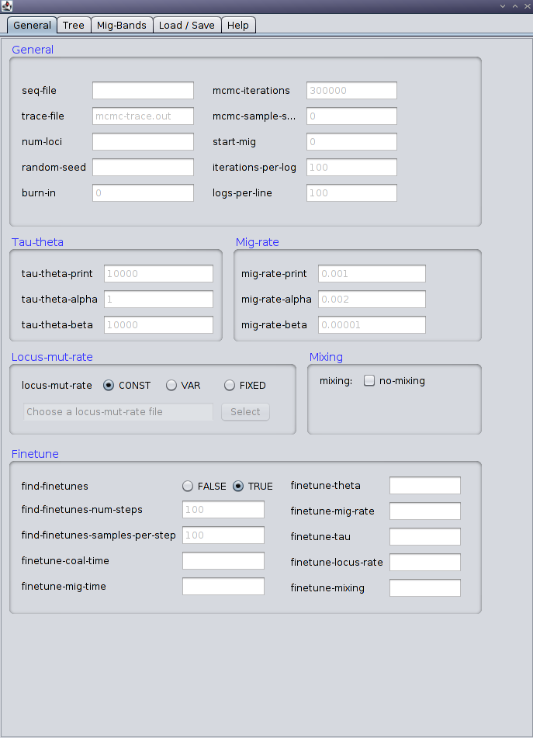

Step 2: Tree definition
- Specify population phylogeny using a generalized Newick format (with names for leaves and internal nodes)
- Specify a list of samples associated with each current population (leaves of phylogeny)
- Specify initial values for divergence tmes associated with ancestral populations
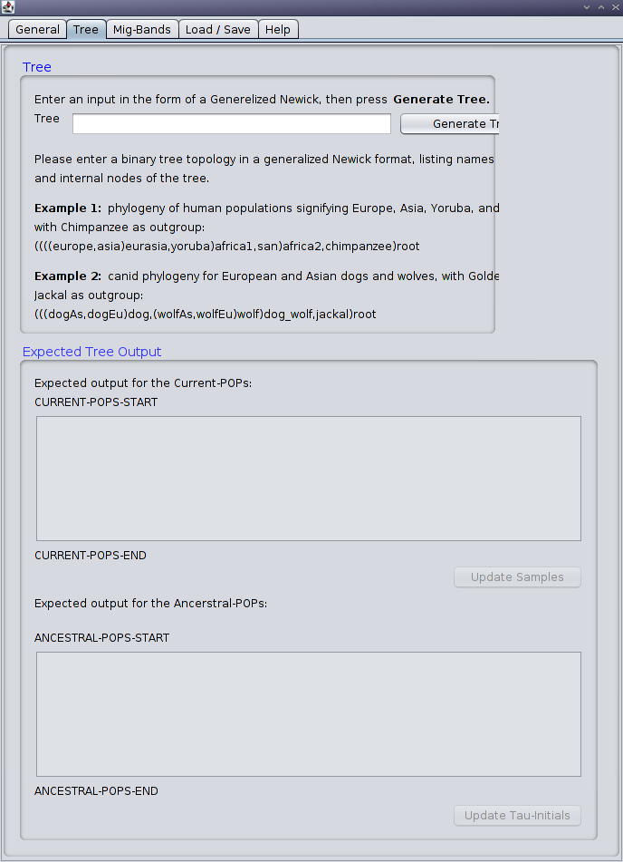

Step 3: Migration bands
- Add migration bands to the demographic model by selecting directed pairs of populations.
