Who Scores? A Friendly Guide to Predicting the World Cup
A model, a bracket, and the unreasonable difficulty of football
Grzegorz Pielot · wc2026-model · July 2026

Abstract (read this if you only have ninety seconds)
We built a prediction system for the 2026 FIFA World Cup that does something most hobby models skip: it tries to understand teams as collections of players with skills, habits, and chemistry—not just as single Elo numbers on a leaderboard. The pipeline ingests roughly fifty thousand international matches, enriches them with event-level data from StatsBomb, and combines a Dixon–Coles goal model with a gradient-boosted classifier. On top of that we layer tactical style embeddings and squad-chemistry adjustments, then run fifty thousand Monte Carlo bracket simulations. This document explains how all of that works, what we predicted before the Round of 32, and how the real tournament has unfolded through July 2, 2026. We are honest about what went right, what went wrong, and what football stubbornly refuses to let anyone predict.

1. Why this project exists
Here is a fact that sounds like a joke but isn't: the World Cup happens every four years, and yet billions of people behave as if they have been preparing for it since primary school. Some of us just do the preparation with Python.
The goal of this project was never to 'beat the bookmakers.' Bookmakers employ rooms full of humans and models and whispers about hamstring tightness. Our goal was more interesting: build the best reproducible model we could from public data—one that explains why France might beat Mexico beyond 'France has a bigger number next to their name.'
Remark 1.1. If you came here looking for a guaranteed betting strategy, close this document, open a nice beverage, and call a friend. We will discuss expected value honestly in Section 7.

2. The data (or: what we feed the machine)
Every model is only as good as what it is allowed to see. We used three layers of data, from coarse to fine.
Layer 1 — Match results. The martj42 international results dataset gives us 49,477 men's full internationals from 1872 through 2026. Win, draw, loss. Home team, away team, goals. Tournament name. This is the backbone.
Layer 2 — Team strength priors. A snapshot from eloratings.net and our own dynamic Elo, updated match by match so we never accidentally use future information. (This is called preventing leakage. It is the difference between science and storytelling.)
Layer 3 — Event data. StatsBomb Open Data gives us pass-by-pass detail for World Cups 2018 and 2022 and European Championships 2020 and 2024. Shots with expected goals. Pressures. Carries. The microscopic stuff that club football has in abundance and international football has in precious little supply.
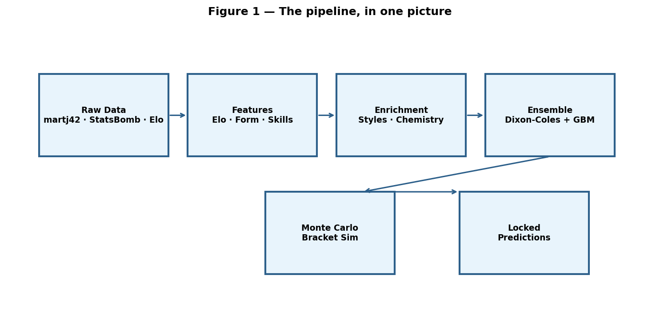

3. Player skills without pretending we have a crystal ball
You might think: just add up each player's Elo! But Messi plus Alvarez is not the same as Alvarez plus Messi plus a shrug. Pairs matter. Styles matter. We therefore assign each player a skill vector with six components:
Skill | Intuition
Offense | Shooting, xG, dangerous actions
Defense | Pressures, blocks, interceptions
Passing | Volume and progression of passes
Press resistance | How often they receive under pressure
Transition | Speed of involvement in both directions
Decision | Quality per shot (xG per attempt)
These are learned primarily from club and tournament event data, then transferred to national squads. International football's dirty secret is sample size: there simply are not enough national-team minutes to train a deep neural network from scratch every four years. So we teach the model on thousands of club matches and hope the lessons travel. Sometimes they do. Sometimes football laughs.

4. Tactical styles and the rock–paper–scissors dream
Every team has a personality. Some press high. Some sit deep and counter. Some pass sideways until the stadium falls asleep. We compress this personality into eight measurable style dimensions—pressing intensity, possession, directness, width, tempo, counter-attacking tendency, aerial reliance, and verticality.
We then learn a matchup matrix W so that when Team A's style meets Team B's style, the model can nudge probabilities in the direction history suggests. High press beating slow buildup; slow buildup frustrating chaotic transitions. Not because we coded rock–paper–scissors by hand, but because the regression found patterns in 2018+ international results.
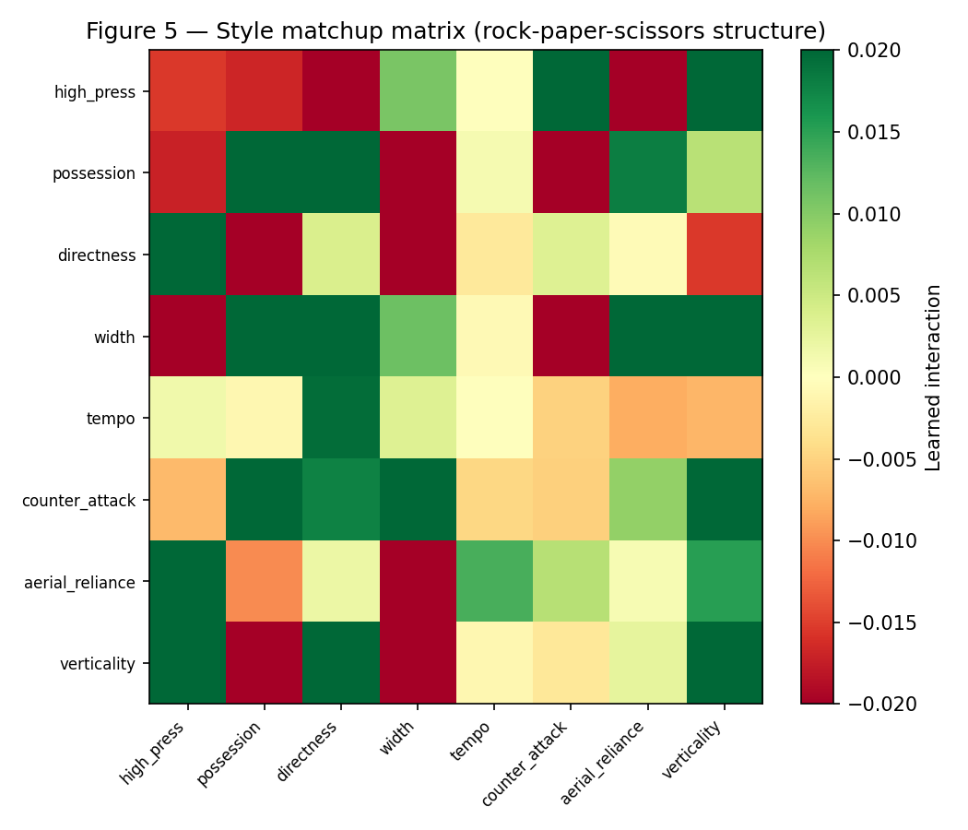

5. Squad chemistry (the Messi + Alvarez problem)
Two good players are not automatically a good partnership. We measure chemistry with features any human scout would recognize: how often two players appear in the same lineup, how often they complete passes to each other, whether their pass chains create threat. Aggregate those pairwise bonds and you get a team-level chemistry score. The model applies a small adjustment—at most a few percentage points—when one squad looks more 'connected' than the other.

6. The ensemble: two models walk into a bar
Definition (informal). An ensemble is what you build when two reasonable people disagree and you want both opinions.
Model A — Dixon–Coles Poisson. Classical goal-scoring model. Each team gets an attack parameter and a defense parameter. Goals are Poisson-distributed. A clever correlation tweak (the ρ parameter) fixes the fact that 0–0 and 1–1 happen more often than independent Poisson would predict. From predicted goals we derive win/draw/loss probabilities.
Model B — Gradient boosting. A tree-based classifier using Elo difference, recent form, and whether the match is a knockout. Calibrated with isotonic regression so that when we say 60%, we mean it historically about sixty percent of the time—not 'we feel good about this.'
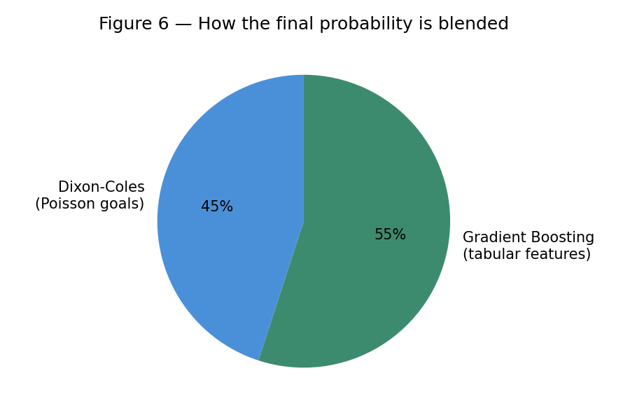
Final blend: 45% Dixon–Coles, 55% gradient boosting, then small nudges from style matchups and chemistry. The result is a triplet (P(home win), P(draw), P(away win)) for each match.

7. Did it work before 2026? (Backtest interlude)
We held out all international matches from 2018 and 2022 and trained only on earlier data. Log loss measures how surprised the model was; Brier score measures calibration. Lower is better for both.
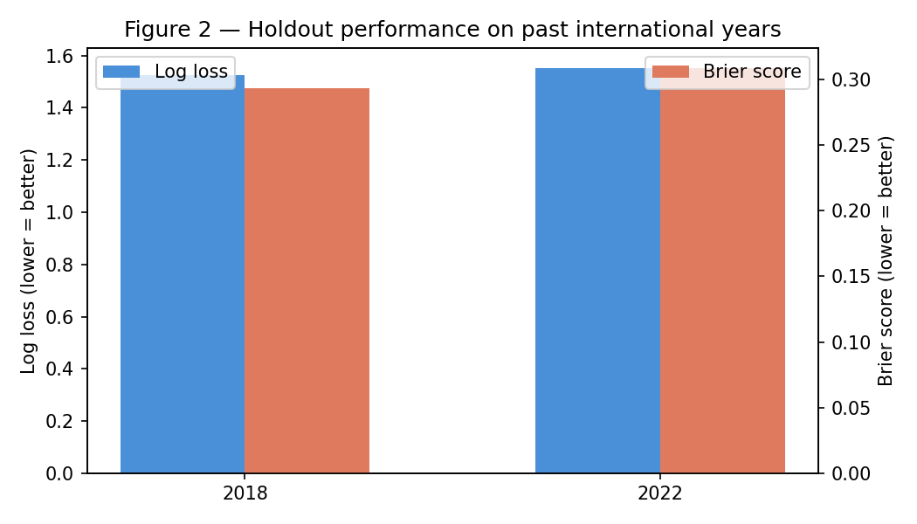
• 2018: log loss = 1.525, Brier = 0.294, over 929 matches.
• 2022: log loss = 1.552, Brier = 0.309, over 970 matches.
Remark 7.1. These numbers will not impress a quant at a hedge fund. They are respectable for a transparent hobby model on public data—and that is the point.

8. What we published (Round of 32 lock)
On July 2, 2026 we froze predictions in a timestamped JSON file—pre-registration for friends, not for casinos. Our bracket fixtures were a simplified twelve-match Round of 32 (the real 48-team tournament uses sixteen). Below are the home-win probabilities we published.
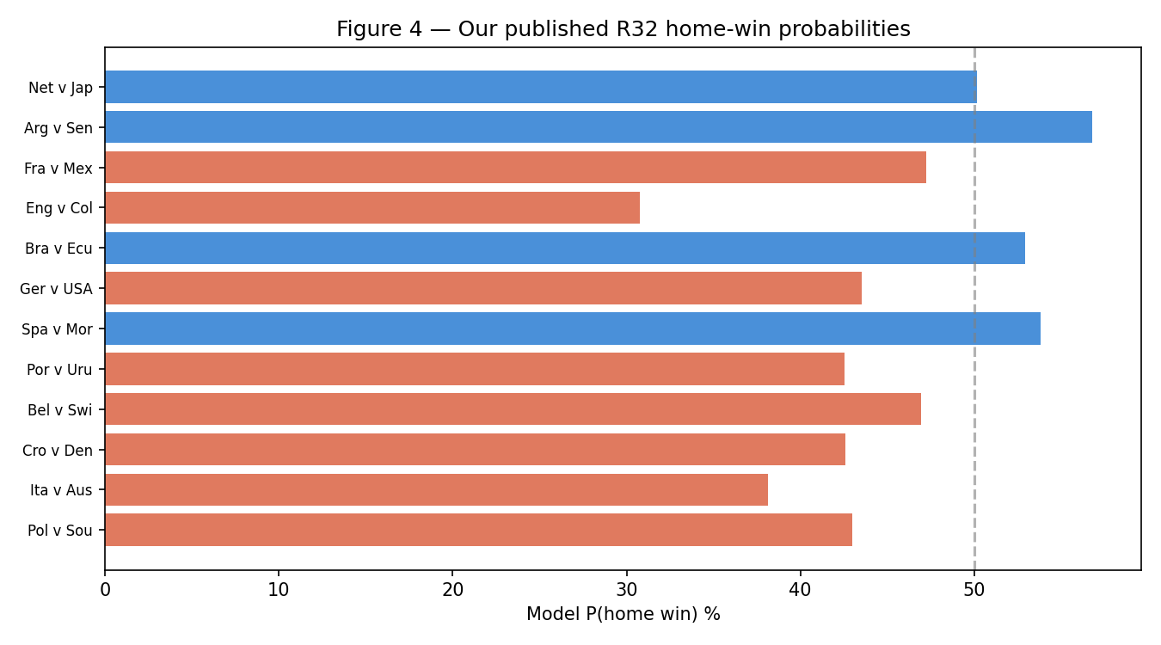
Selected locked predictions:
Match | P(Home) | P(Draw) | P(Away) | xG
Argentina vs Senegal | 56.8% | 29.0% | 14.2% | 1.8–0.5
France vs Mexico | 47.2% | 32.2% | 20.6% | 1.3–0.9
Brazil vs Ecuador | 52.9% | 30.3% | 16.8% | 1.6–0.7
Spain vs Morocco | 53.8% | 30.3% | 15.8% | 1.6–0.6
Belgium vs Switzerland | 46.9% | 31.2% | 21.9% | 1.5–1.0
Monte Carlo simulation (50,000 runs) produced champion odds with Belgium (8.5%), Netherlands (7.1%), and Croatia (6.1%) leading—a reminder that simulation amplifies uncertainty beautifully and humbles you in equal measure.
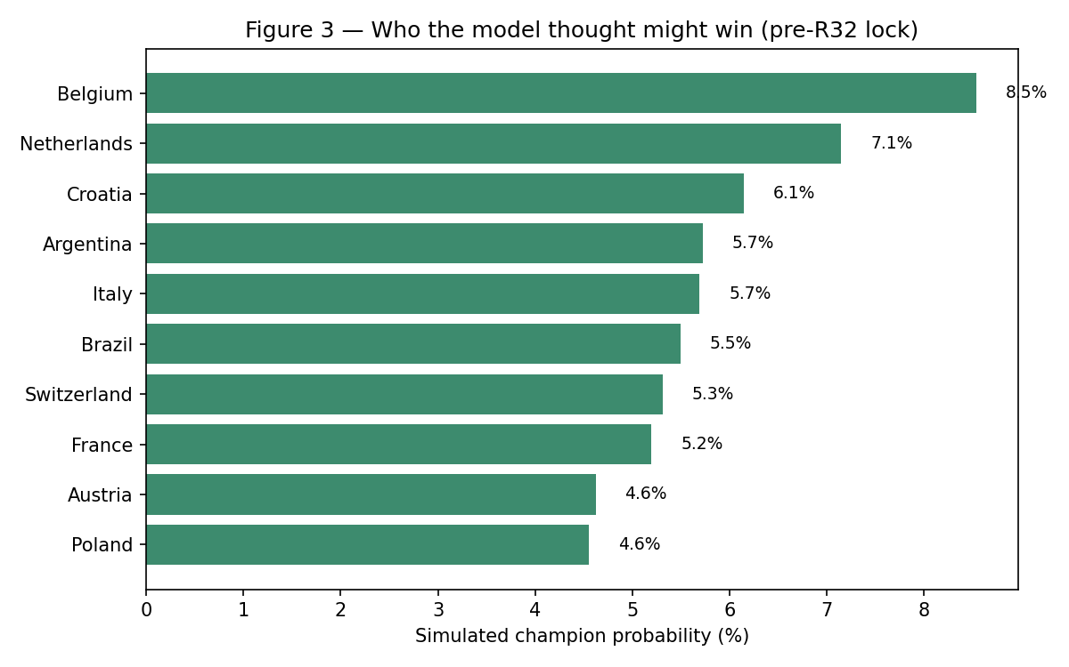

9. What actually happened (through July 2, 2026)
Football, meanwhile, continued without consulting our JSON files. The real Round of 32 began June 28. Through July 2, ten of sixteen matches had been completed. Here is the honest scoreboard:
Date | Match | Score | Winner | Notes
2026-06-28 | Canada vs South Africa | 1-0 | Canada | Hosts march on
2026-06-29 | Brazil vs Japan | 2-1 | Brazil | Model would have liked this
2026-06-29 | Germany vs Paraguay | 1-1 (4-3 pens) | Paraguay | Upset on penalties
2026-06-29 | Netherlands vs Morocco | 1-1 (3-2 pens) | Morocco | Upset on penalties
2026-06-30 | Norway vs Ivory Coast | 2-1 | Norway
2026-06-30 | France vs Sweden | 3-0 | France | Dominant 3-0
2026-06-30 | Mexico vs Ecuador | 2-0 | Mexico
2026-07-01 | England vs DR Congo | 2-1 | England
2026-07-01 | Belgium vs Senegal | 3-2 (aet) | Belgium | 2-0 down, won in extra time
2026-07-01 | USA vs Bosnia and Herzegovina | 2-0 | USA | Co-hosts advance
Big upsets so far: Germany eliminated by Paraguay on penalties; Netherlands eliminated by Morocco on penalties; Japan eliminated by Brazil. Belgium staged a cinematic comeback from 2–0 down against Senegal—exactly the sort of match that makes Poisson models quietly stare at the ceiling.
Where our model overlapped philosophically: we gave Argentina a strong edge over Senegal (56.8% home win in our fixture list); Belgium beat Senegal in reality. We favored Brazil over Ecuador; Brazil beat Japan in the real bracket. We had France as a narrow favorite over Mexico; France dismantled Sweden 3–0 in a different pairing. Direct one-to-one validation of our twelve synthetic fixtures against FIFA's sixteen-match Round of 32 is not possible—but team-strength rankings partially aligned with several winners.

10. Monte Carlo and the illusion of certainty
After per-match probabilities are estimated, we simulate the entire knockout bracket fifty thousand times. Draws in knockout rounds become penalty shootouts (modelled as fifty-fifty). The output is not 'Belgium will win.' The output is 'Belgium wins 8.5% of simulated universes.' That is a much more honest sentence.

11. Betting appendix (read with adult supervision)
We compared model probabilities to illustrative market odds. A few outcomes showed >5% 'edge.' We report this because transparency matters—not because we recommend betting your rent. Markets price injuries, insider squad news, and closing-line efficiency our public-data model cannot see. Expect long-run ROI near zero if you bet every flagged value play.

12. Limitations (the section where we protect our credibility)
- Late entry: we did not pre-register group-stage predictions.
- Synthetic R32 bracket: twelve pairings, not FIFA's full sixteen.
- No live injury feed; squads treated as mostly available.
- International sample size remains tiny next to club football.
- LightGBM unavailable on our Mac build; sklearn HistGradientBoosting used instead.

13. Conclusion
We set out to build something more interesting than another Elo spreadsheet—and we believe we did. Player skills, tactical styles, chemistry, calibrated ensembles, and Monte Carlo brackets form a pipeline you can clone, rerun, and argue about on GitHub (github.com/gpielot/wc2026-model).
Football remains stochastic. Morocco beat the Netherlands on penalties. Belgium came back from the dead. The model will miss things—because the sport is designed to break models. If this document made the mathematics feel a little less like a black box and a little more like a conversation, then it did its job.
Now if you'll excuse us, we have a Round of 16 to watch.

References & reproducibility
- martj42/international_results — github.com/martj42/international_results
- StatsBomb Open Data — github.com/statsbomb/open-data
- eloratings.net World rankings
- Project repository — github.com/gpielot/wc2026-model
- Reproduce: make ingest && make train && make predict ROUND=r32

