Add USB Game Controller to Arduino Leonardo/Micro

IMPORTANT NOTE: This article is for Arduino IDE version 1.6.5 (or below). To add a USB Game Controller to an Arduino Leonardo or Micro using Arduino IDE version 1.6.6 (or above) see the following Instructable: Arduino Leonardo/Micro as Game Controller/Joystick.
Out of the box the Arduino Leonardo and the Arduino Micro appear to the host computer as a generic keyboard and mouse. This article discusses how the Arduino Leonardo and the Arduino Micro can also appear as a generic Game Controller. This project will only work with Arduino products based on the ATmega32u4 microcontroller (i.e. the Arduino Leonardo and the Arduino Micro). It will not work with the Arduino Uno, because it is based on the ATmega328 microcontroller.
The Arduino generic Game Controller provides the following:
- X, Y, and Z axis
- 32 buttons
- X, Y, and Z axis rotation
- Rudder
- Throttle
- 2 Point of View Hat Switches

Step 1: Updating the Arduino Code
First make a backup copy of the following two files in the “%PROGRAMFILES%\Arduino\hardware\arduino\avr\cores\arduino” folder:
- USBAPI.h
- HID.cpp
Replace these two files with the ones attached to add a generic Game Controller to the Arduino Leonardo and the Arduino Micro.

Step 2: Running the Test Sketch
Compile and upload the attached UsbJoystickTest.ino sketch file onto the Arduino Leonardo or the Arduino Micro using the Arduino Software (IDE). I have tested this using version 1.6.1 through 1.6.5 of the software. For Arduino IDE version 1.6.6 and above, see the following Instructable: Arduino Leonardo/Micro as Game Controller/Joystick.
The following steps are for Windows 7. If you have a different version of Windows or a different operating system, these steps may differ.

Step 3: Windows Control Panel - Hardware and Sound
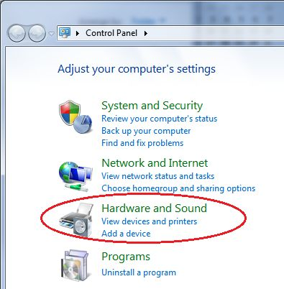
Go to the Windows Control Panel and select “Hardware and Sound”.

Step 4: Devices and Printers
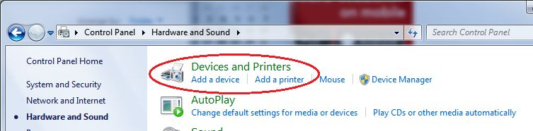
Then select “Devices and Printers”.

Step 5: Arduino should appear
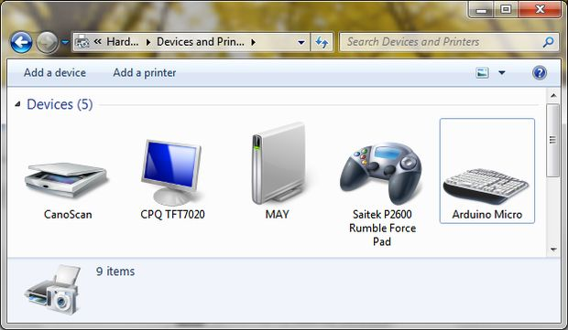
The Arduino Micro or Arduino Leonardo should appear in the list of devices.

Step 6: Arduino Settings
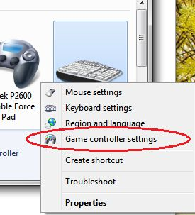
- Next right mouse click on the Arduino Leonardo or Arduino Micro to display the settings menu.
- Then select “Game controller settings” to get to the “Game Controllers” dialog.

Step 7: Game Controller Settings
The Arduino Micro or Arduino Leonardo should appear in the list of installed game controllers. Select the Arduino Micro or Arduino Leonardo and click the Properties button to display the game controller test dialog.

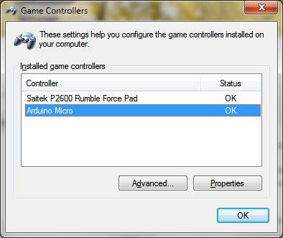

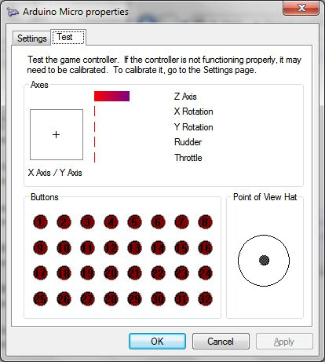

While this dialog has focus, ground pin A0 on the Arduino to activate the test script. The test script will test the game controller functionality in the following order:
- 32 buttons
- throttle and rudder
- X and Y Axis
- Z Axis
- 2 Hat Switches
- X and Y Axis Rotation

Step 9: Joystick Library
Now that the Arduino Leonardo or Arduino Micro has the Joystick library, the Arduino can be used for custom game controller projects. The following describes the Joystick library that is included in the updated USBAPI.h and HID.cpp files.
Joystick.begin(bool initAutoSendState)
Starts emulating a game controller connected to a computer. By default all methods update the game controller state immediately. If initAutoSendState is set to false, the Joystick.sendState method must be called to update the game controller state.
Joystick.end()
Stops the game controller emulation to a connected computer.
Joystick.setXAxis(byte value)
Sets the X axis value. Range -127 to 127 (0 is center).
Joystick.setYAxis(byte value)
Sets the Y axis value. Range -127 to 127 (0 is center).
Joystick.setZAxis(byte value)
Sets the Z axis value. Range -127 to 127 (0 is center).
Joystick.setXAxisRotation(int value)
Sets the X axis rotation value. Range 0° to 360°.
Joystick.setyAxisRotation(int value)
Sets the Y axis rotation value. Range 0° to 360°.
Joystick.setZAxisRotation(int value)
Sets the Z axis rotation value. Range 0° to 360°.
Joystick.setButton(byte button, byte value)
Sets the state of the specified button. The button is the 0-based button number (i.e. button #1 is 0, button #2 is 1, etc.). The value is 1 if the button is pressed and 0 if the button is released.
Joystick.pressButton(byte button)
Press the indicated button. The button is the 0-based button number (i.e. button #1 is 0, button #2 is 1, etc.).
Joystick.releaseButton(byte button)
Release the indicated button. The button is the 0-based button number (i.e. button #1 is 0, button #2 is 1, etc.).
Joystick.setThrottle(byte value)
Sets the throttle value. Range 0 to 255.
Joystick.setRudder(byte value)
Sets the rudder value. Range 0 to 255.
Joystick.setHatSwitch(byte hatSwitch, int value)
Sets the value of the specified hat switch. The hatSwitch is 0-based (i.e. hat switch #1 is 0 and hat switch #2 is 1). The value is from 0° to 360°, but in 45° increments. Any value less than 45° will be rounded down (i.e. 44° is rounded down to 0°, 89° is rounded down to 45°, etc.).
Joystick.sendState()
Sends the updated joystick state to the host computer. Only needs to be called if AutoSendState is false (see Joystick.begin for more details).

