Construction and Validation of a Guideline for migrating a Microservice Architecture to Function as a Service

Frankfurt University of Applied Sciences

Gianni Pasqual

18.03.2020

**Abstract**

Mit der Technologie Function as a Service ist nach der Microservice-Architektur eine noch feinere Modularisierungsstufe von Software erreicht worden. Mit dieser ist es möglich Software noch schneller bereitzustellen und im gleichen Zuge Einsparungen bei dem Betrieb der IT-Infrastruktur zu erzeielen. Dies erscheint auf den ersten Blick natürlich sehr lokrativ für viele Unternehmen, jedoch sollte die Entscheidung für den teilweisen oder gesamten Umzug der Service-Landschaft wohl überlegt sein. Wie bei jeder anderen Technologie hat auch diese ihre Potentiale und Herausforderungen die gemeistert werden müssen. Für Unternehemn, die sich dazu entschieden haben Function as a Service (FaaS) in ihre Infrastruktur einzubinden, soll diese Arbeit als Orientierung bei der Migration dienen. Da viele Unternehmen bereits von den monolithischen Anwendungen auf kleinere modularere Services umgestiegen sind, geht diese Arbeit von einer bereits vorliegenden Microserive-Architektur aus. Es gilt herauszufinden in welchem Maße und ob überhaupt strukturelle Anpassungen vorgenommen werden müssen, als auch der Frage nach ”Best-Practices”, nach nun knapp vier Jahren des Bestehens, nachzugehen.

Zudem soll sich vor allem mit dem von den verschiedenen Anbietern ausgehenden VendorLock-In auseinadner gesetzt werden und erarbeitet werden, welche Möglichkeiten bestehen, diesen zu umgehen bzw. zu mildern. Um mögliche Schwächen des Leitfadens aufzuzeigen, soll dieser beispielhaft an einem Service erprobt werden und auftretenden Fehler dokumentiert und behandelt werden.

**Index of abbreviations**

|  |  |
| --- | --- |
| ADF | Azure Durable Functions |
| API | Application Programming Interface |
| ASF | Amazon Step Functions |
| AWS | Amazon Web Services |
| BaaS | Backend as a Service |
| BDD | Behaviour Driven Development |
| CaaS | Container as a Service |
| CD | Continuous Delivery |
| CI | Continuous Integration |
| CLI | Command Line Interface |
| CNCF | Cloud Native Computing Foundatino |
| CPU | Central Processing Unit |
| CRD | Custom Resource Definition |
| DevOps | Development and Operations |
| DEV | Development |
| DSL | Domain Specific Language |
| FaaS | Function as a Service |
| HPA | Horizontal Pod Autoscaler |
| IAM | Identity Access Management |
| IaaS | Infrastructure as a Service |
| IaC | Infrastructure as Code |
| INT | Integration (Testing) |
| IT | Information Technology |
| JVM | Java Virtual Machine |
| NIST | National Institute of Standards and Technology |
| OOP | Object Oriented Progamming |
| OS | Operating System |
| PaaS | Platform as a Service |
| POM | Project Object Model |
| PR | Pull Request |
| PRD | Production (Environment) |
| RPC | Remote Procedure Call |
| SAM | Serverless Application Model |
| SDK | Software Development Kit |
| UAT | User-Acceptance (Testing) |
| VCS | Version Controle System |
| XaaS | Anything as a Service |

**Contents**

**1 Introduction** **5**

1.1 Objectives and Goals 5

1.2 Problem Statement 5

1.3 Thesis Structure 5

**2 Background** **5**

2.1 Definition Cloud Computing 5

2.2 Function as a Service 7

2.3 Dissociation of FaaS and Serverless 10

2.4 Benefits and Drawbacks 12

**3 Guideline on Migration** **17**

3.1 Describing the existing architecture 17

3.2 Scrutinising the Decision of Migration 19

3.3 Balancing between Open-Source and Cloud-Vendor 20

3.3.1 Open-Source Solutions 22

3.3.2 Proprietary Cloud-Providers 23

3.3.3 Orchestration and Concurrency 25

3.4 Selecting a suitable service 27

3.5 Effects on development 27

3.5.1 Impact on Teams 27

3.5.2 Version Control System 28

3.5.3 Programming Language 29

3.5.4 Tooling and Multi-Cloud 30

3.6 Effects on Testing 31

3.7 Implications on monitoring 32

3.8 Results 33

**4 Anwendung des Leitfadens** **35**

4.1 Auswertung der Ergebnisse 35

4.1.1 Beurteilung der Kollaborationsauswirkungen 35

4.1.2 Beurteilung der Stabilität 35

4.1.3 Beurteilung der Skalierbarkeit 35

4.1.4 Beurteilung des Monitorings 35

4.1.5 Beurteilung der Testmöglichkeiten 35

4.2 Korrektur und Anpassungen 35

**5 Abschließende Betrachtung** **35**

5.1 Absehbare Entwicklungen 35

5.2 Zusammenfassung 35

5.3 Weiterführende Forschung 35

# Introduction

## Objectives and Goals

## Problem Statement

## Thesis Structure

# Background

Ist eine Technologie, wie Function as a Service, noch relativ jung, so sind die Schritte der Findung einer in sich schlüssigen und allgemein vertretenen Definition oftmals noch nicht abgeschlossen. Auch bei der Definition von FaaS, Serverless und der Einordung dieser beiden Konzepte in die Infrastruktur des Cloud Computings8 [MG+11], ist dieser Prozess noch im Gange, wobei mitlerweile die unterschiedlichen Definitionen der offentlichen FaaS- und Serverless-Anbieter einige Gemeinsamkeiten aufweisen. Trotz alledem bestehen weiterhin Ungenauigkeiten, die es in den nächsten Jahren noch zu beseitigen gilt. Hierzu später mehr.

## Definition Cloud Computing

Der Begriff Cloud Computing ist laut eines Technology Report bis auf das Jahr 1996 zurückzuführen, wo er in einem Business-Plan des Unternehmens Compaq von ein paar Entwicklern genutzt worden sein sollen, um über die zukünftigen Entwicklungen des Internet-Businesses zu diskutieren [Reg11].

Auch wenn das Konzept des Cloud-Computings, die dynamische, skalierbare, zuverlässige und unbegrenzte Bereitstellung von Ressourcen als Dienst über das Internet, immer mal wieder in der Literatur auftauchte [Fox+09], so erlangte es erst ab 2006 einen immer größter werdenden Bekanntheitsgrad. 2006 veröffentlichte AWS das Produkt Elastic Compute Cloud (EC2), gefolgt von Goolges App Engine 2008. Bereits in diesem früher Stadium wurde mit App Engine das Prinzip einer sog. stateful“-Ebene, für das Speichern von des Aktuellen An-

”

wendungsstatus und einer stateless“-Ebene für die Ausführung des eigentlichen Programmes

”

unterschieden [Fox+09]. Des Weiteren wurde 2009 in einer Berkeley-Studie die sechs größten Potentiale des Cloud-Computings herausgearbeitet welche bis heute in den unterscheidlichen XaaS-Konzepten umgesetzt wurden. Im folgenden sind diese kurz auf gelistet.

1. Unbegrenzte Ressourcen wann immer sie benötgt werden.
2. Durch die Möglichkeit mit wenigen Ressourcen zu starten, vielen Nutzern zugang zu der Plattform zu gewähren.
3. Die genutzen Ressourcen so genau wie möglich nach dem Pay Per Use“-Prinzip zu

”

bezahlen.

1. Größenvorteile (Economies of scale) nutzen, um die Kosten durch eine dauerhafte, optimale Ausnutzung riesiger Datencenter auf ein Minimum zu reduzieren.
2. Operationelle Kosten so weit es geht zu senken und die Ressourcennutzung durch Virtualisierung so weit wie möglich auszunutzen.
3. Eine hohe Hardwareausnutzung durch Multiplexing“ der Auslastungen verschiedener ” Unternehmen zu erreichen.

Das National Institute of Standards and Technology (NIST) veröffentlichte 2011, nach 16 vorausgehenden Definitionen, schließlich eine finale Definition des Cloud-Computings, welche bis heute als orientierung Anwendung findet und in einer vielzahl an Werken aufgegriffen wird [MG+11]. Die Definition nach NIST beschreibt das Cloud model als eines aus fünf essentiellen Charakteristiken und drei Service Modellen, IaaS, PaaS und SaaS bestehendes Modell, mit insgesamt vier Deployment-Models.

*”Cloud Computing is a model for enabling ubiquitous, convenient, on-demand network access to a shared pool of configurable computing resources (e.g., networks, servers, storage, applications, and services) that can be rapidly provisioned and released with minimal management effort or service provider interaction.”* [MG+11].

NIST bricht die Definition mit Essentiellen Charakteristiken, Service-Models und DeploymentModels in drei Unterkategorien herunter, welche erfüllt sein müssen um dem Anspruch an Cloud Computing zu genügen.

Grob gefasst sind dies bei den Characteristiken, die automatische Bereitstellung der benötigten Ressourcen je nach bedarf (*On-demand self-service*), die Möglichkeit von allen gängigen Geräten darauf zugreifen zu können (*Broad network access*), die optimale Verteilung von Ressourcen auf die Kunden welche sie gerade benötigen, wobei hier die exakte lokation dieser von geringer Relevanz ist (*Resource pooling*), die automatische Skalierung von Ressourcen (*Rapid elasticity*) und die Möglichkeit der Uberwachung und Limitierung der Ressourcenaus-¨ nutzung, welche für den Kunden als auch den Anbieter transparent sein muss (*Measured service*).

Bei den Service Models werden hier lediglich IaaS, PaaS und SaaS unterschieden. Laut NIST gibt es um den Code in der Could bereitzustellen vier verschiedene Deployment-Models, welche genutzt werden können. Mit der *Private cloud*, obliegt es dem Unternehmen seine Infrastruktur komplett selber zu betreiben, jedoch muss diese dem Unternehmen dabei nicht selber gehören, sondern kann von eine dritten Partei gehostet werden. Mit dem deployment auf eine *Community cloud* teilen sich verschiedene Unternehemen eine Cloud, welche entweder von ihnen gemeinsm, oder von einem Drittanbieter betrieben wird. Zuletzt gibt es noch die Möglichkeit die von einem Cloud-Computing-Anbieter bereitgestellte öffentliche Cloud *Public cloud* zu nutzen, bei welcher das Unternhemen die Räumlichkeiten bzw. Ressourcen von einem Dittanbieter nutzt. Das letzt Deployment-Model stellt die sog. *Hybird cloud* dar, welche eine Kombination aus den vorherigen darstellt [MG+11].

Figure 1: Ubersicht Service-Models Cloud-Computing¨

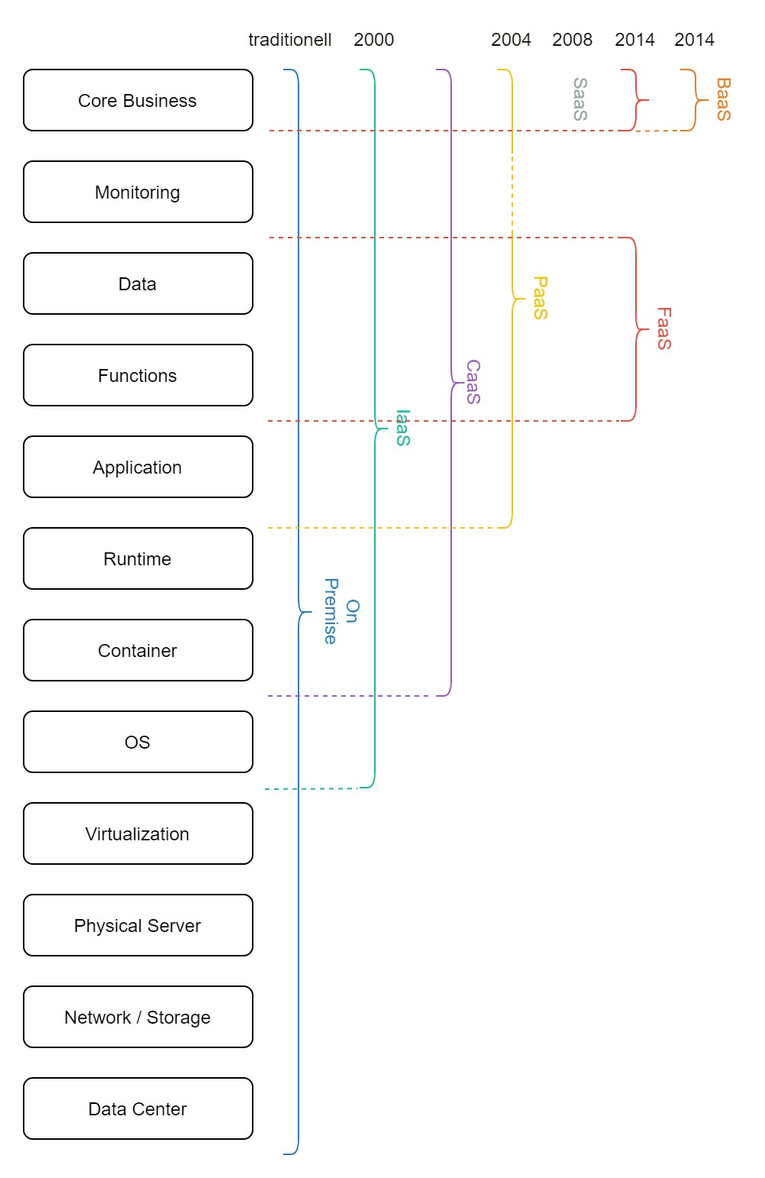

Neben den bereits genannten Service Models IaaS, PaaS und SaaS gibt es jedoch noch weitere, welche sich im Laufe der Zeit etabliert haben. Abbildung 1 gibt einen Uberblick¨ hierüber.

## Function as a Service

Function as a Service (FaaS) ist ein sogenanntes Serverless“ Cloud-Computing Konzept,

”

welches erstmals 2014 von AWS mit Lambda Functions als Preview Release und schließlich 2015 zur kommerziellen Nutzung zur Verfügung gestellt wurde[1]. Es kann nach IaaS und PaaS als ein weiterer Schritt in der Entwicklung des Cloud Computings gesehen werden, welcher das Management von Infrastruktur, Servern und Ressourcen weg von dem Entwickler nimmt und hin zu dem Cloud-Anbieter delegiert. Ein knappes Jahr später, 2016, traten Microsoft mit Azure Functions, Google mit Google Cloud Functions und IBM mit OpenWhisk in den bis dahin von Amazon dominierten Markt ein. Mittlerweile gibt es eine vielzahl an Open-Source sowie proprietären Anbietern, welche um die Gunst der Kunden werben und einen stetigen Wettbewerb aufrecht erhalten. Ein ausführliche Ubersicht über die jeweiligen Anbiter findet¨ sich online von der CNCF[2]

Da es sich mit FaaS und Serverless um eine noch recht junge Technologie handelt gibt es zu diesem Konzept keine offiziell dokumentierte Definition. bsp. von NIST o.ä., in der Literatur, wie es beispielsweise beim Cloud-Computing [MG+11] der Fall ist. Die Anbieter sind sich jedoch über die Funkitionalität von FaaS größtenteils einig, was das Spektrum an Funktionalitäten anbegeht. So definiert Microsoft Azure Functions als: [...] event-driven ”

serverless compute platform that can also solve complex orchestration problems. Build and debug locally without additional setup, deploy and operate at scale in the cloud, and integrate services using triggers and bindings. “[3]. Hiermit beschreibt der Anbieter bereits die Kernfunktionalitäten von FaaS und drückt den Kerngedanken hinder FaaS aus. Das Konzept soll genutzt werden können, um bei dem Auftreten eines zuvor definierten sog. Triggers auf ein Event aus der eigenen Applikation oder der des Abieters reagieren zu können. Dabei stellen die meisten Anbieter wie Google, Azure oder AWS neben einem einfachen event-basierten HTTP-Trigger oder widerkehrenden zeitbasierten Triggern noch weitere, an die jeweilige Infrasturktur des Anbieters angepasste, Trigger zur Verfügung. Diese ergeben sich meist aus den BaaS Angeboten, hierzu mehr in *Abgrenzung von FaaS zu Serverless*, welche in Form von Datenbank Triggern bei einer CRUD-Operation, dem Anlegen eines Nutzers oder der Integration mit einem Push-Notification Service [AWS SSN, Google Pub/Sub etc.] auftreten können.

Figure 2: 4

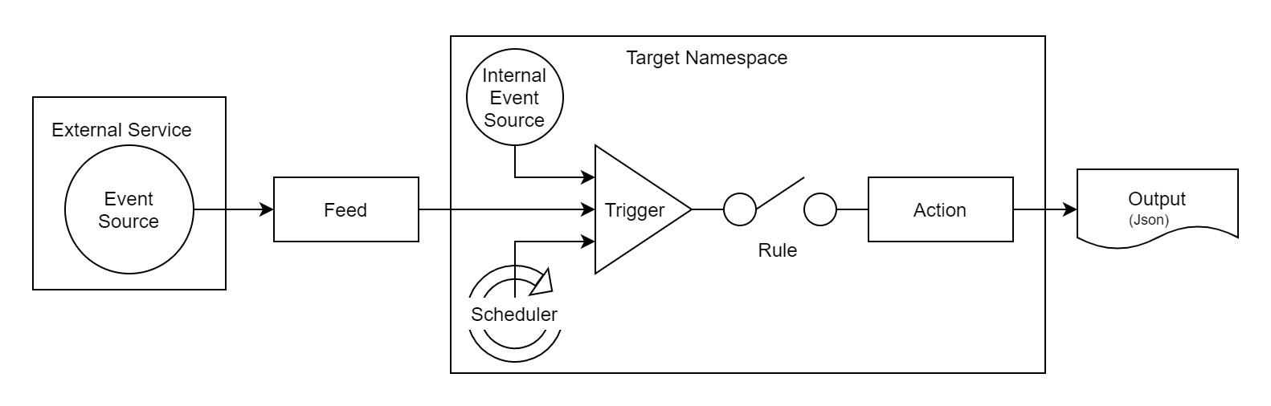

Abbildung 2 gibt hierbei eine Ubersicht über die verscheidenen Event-Trigger, welche¨ derzeit bei den großen, proprietären Anbietern (AWS, Google, Microsoft) existieren. Da hinter OpenWhisk mit IBM eine großes Unternehmen steht, wird dieses Modell in der Literatur häufig als Referenz in Bezug auf die anderen Anbieter verwendet. Es kann angenommen werden, dass andere Abieter ein ähnliches Konzept bei ihrer FaaS Architektur verfolgen, da Apache OpenWhisk in einer großen Cloud (IBM) bereitgestellt wird [VE+19]. Eine weit-

ere fundamentale Eigenschaft ist die erwähnte Skalierbarkeit, welche nach dem sog. Pay ”

Per Use“-Modell abgerechnet wird. Gemeint ist hiermit, dass der Kunde nur das bezahlt was er auch wirklich verbraucht hat, wobei die Verrechnung extrem granular nach genutzten Ressourcen und gelaufener Zeit erfolgt. Der Kunde bezahlt daher nicht für die benötgten Ressourcen, wie er es bei PaaS (wobei es hier variierende und bereits granularere Modell gibt) oder IaaS der Fall ist, sondern nur für die tatsächlich genutzten Ressourcen.

Grundsätzlich ist zwar der Preis der für das Laufen einer einminütigen Funktionsaussführung verglichen mit dem Laufen des selben Codes auf einem von den Ressourcen her ähnlich bestückten PaaS-Server günstiger [Jon+19], jedoch der Anwendungszweck ein ganz anderer. Während mit PaaS Anwendungen bedient werden, die eine dauerhaft hohe Nachfrage erfahren, sollen mit Funktionen primär einfache stark frequentierende Aufgaben geläst werden, bei denen der Nutzer nur für die Ressroucen bezahlen muss die die Funktion bei dem Aufruf nutzt und nicht für jene die ohen einkommende Aufrufe provisioniert wurden.

Ein weiterer wichtiger Punkt, welcher sich auch bei anderen Anbietern findet, ist in der

Definition von OpenWhisk zum einen mit [...] you can focus on building amazing and effi-

”

cient applications [...]“ und zum anderen mit developers write functional logic [...] in any

” [4]. Ersteres meint supported programming language, that can be dynamically scheduled [...]“ die Abstraktion der Infrastruktur, welche dem Nutzer zum Bereitstellen von lauffähigem, skalierbaren, sicheren Backend-Code nicht bekannt sein muss. Die automatische Skalierung und optimale Verteilung von Ressourcen obliegt der Hoheit des Anbiters, und ist dem Nuzter nicht zugänglich, zumindest bei den proprietäre Anbietern. Letzteres ist zwar keine einzigartige Eigenschaft von FaaS, da dieses Konzept beriets lange bekannt ist und auch bei der Microservice-Enticklung häufig zum Einsatz kommt, jedoch ist die Auswahl aus vielen verschiedenen Programmiersprachen wie Java, Go, Javascript (Typescript), Python, PHP usw. (abhängig von dem jeweiligen Anbieter) unter dem Gesichtspunkt der direkten Nutzung zu sehen. Es muss keinerlei zusätzliches Setup oder andere Konfigurationen in der Umgebung vorgenommen werden, da dies der Anbieter übernimmt. Er kümmert sich um Patches und das Upgraden auf die aktuellste Version, was dem Entwickler ein großes Maß anflexibilität bei der Entwicklung der Anwendung einräumt. Eine weitere häufig in der Literatur referenzierte Defninition ist [Fow18], von Mike Roberts, welche die Beschreibung von AWS Lambda näher erläutert und im groben die oben genannten Punkte wiedergibt. Natürlich sind diese Eigenschaften mit einem gewissen Venodr Lock-In dieser jedoch weder als schlecht noch gut zu bewerten ist und vielmehr nüchtern auf seine Vor- und Nachteile anasystiert werden sollte. verbunden, da dieser Enstcheidungen über die Infrastruktur trifft, mehr dazu in *Potentiale und Herausforderungen*.

Abbildung 3 verdeutlicht hierbei noch einmal die Wirkungsweise von FaaS. Oben rechts ist der Funktionspool zu sehen, welcher bei dem jeweiligen Cloud Provider steht und in welchen der Entwickler seine Funktionne lädt. Wird eine Funktion von einem Client aufgerufen, so wird bei Aktivierung eines Triggers eine Kopie der jeweiligen Funktion instantiiert und alle mit diese Funktion verbundenen Abhänigkeiten geladen (bspw. benötigte Module). Je nachdem wie frequentiert die Funktionen von den Clients angefordert werden, werden die vorhandenen

Instanzen automatisch von dem Provider

Figure 3: Anwendung mit FaaS und (P)BaaS, angelehnt an [SKM20]

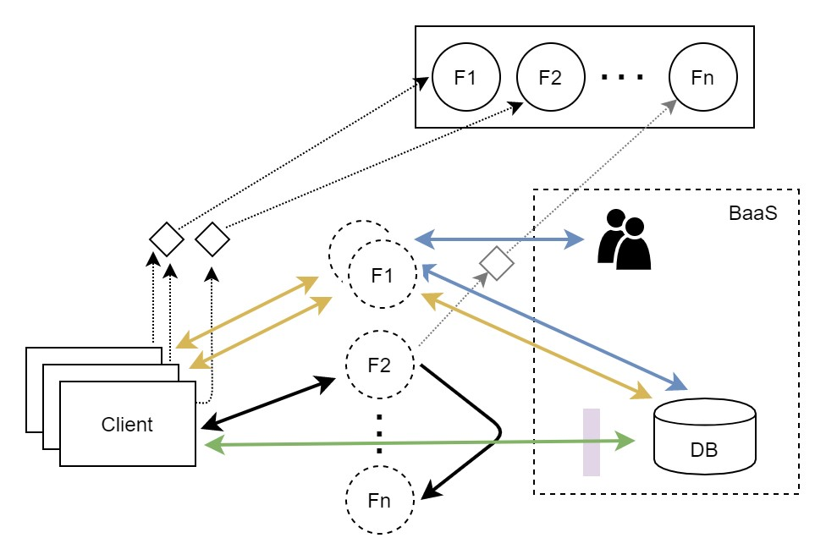

hochskaliert, um den eingehenden Anfragen gerecht zu werden. Hierbei kann die Funktion eine Aufgabe direkt ausführen und das Resultat an den Client zurückgeben, oder wie bei F1 auf die im hintergrund laufende BaaS Infrasturktur zugreifen. Diese reicht von einfachen Datenbankabfragen bis hin zu anlegen eines neuen Nutzers etc. Limitiert werden die Möglichkeiten hierbei lediglich von dem Service-Okosystem des jeweiligen Anbieters. Genauso¨ ist es natürlich möglich Funktionen sich gegenseitig aufrufen zu lassen oder direkt mit BaaSServicen zu interagieren, siehe *Abgrenzung von FaaS zu Serverless*.

Um FaaS besser und einheitlicher definieren zu könne und damit einen plattformübergreifenden Standart zu schaffen, wird in der Industrie und Forschung das Verlangen nach einer Referenzarchitektur, wie sie beispielsweise für das Cloud oder Grid Computing vorhanden ist [Liu+11], [FK03] lauter. Die Abwesenheit einer solchen Architektur behindere die Etablierung von Best-Practices, Design Pattern und einen genaueren Uberblick darüber zu erhalten, wie¨ sich das Feld rund um Function as a Service entwickele [Lei+19]. Erste Vorschläge wie die Referenzarchitektur von FaaS aussehen könnte, haben sich mit [VE+19] durch die über die Jahre, von 2016 an, gestiegenen Popularität von Faas in der Forschung und der Literatur bereits herausgebildet. War hier die Thematik bis 2016 nicht addressiert worden, so stieg die Präsenz von hier an kontinuierlich bis 2019, in Journals, Konferenzen und Workshops an [Yus+19].

## Dissociation of FaaS and Serverless

Serverless-Computing, oftmals auch als Serverless bezeichnet, ist eine Teildisziplin des CloudComputings, welche sich aus der Virtualisierung von Rechenleistung, Speicher und Netzwerken aus entwickelt hat [JC18]. Wie so häufig ist die Abgrenzung bzw. die Unterscheidung bei sich neu entwickelden Technologien nicht ganz einfach. Zunächst stand Serverless für Anwendungen welche teilweise oder komplett auf Drittanbieter zurückgriffen, auf sog. Backends as a Service (BaaS) [siehe Abbildung. 4], um serverseitige Aufgaben wie Datenbankabfragen, Nutzerverwaltung o.ä. zu regeln [Fow18].

Mit FaaS wurde das Serverless-Konzept dahingehend erweitert, dass die Serverlogik nicht mehr vollständig von einer dritten Partei zur Verfügung gestellt wird, sondern vom Entwickler selber implementiert werden kann. Serverless ist dabei eines der in den letzten Jahrne häufig genutzten Buzzwords in der IT, wobei der Begriff an sich etwas anderes suggeriert, als das was damit tatsächlich gemeint ist. Der Begriff impliziert die Abwesenheit von Servern, wobei damit

lediglich eine Verschiebung der Zuständigkeiten einher geht. Entwickler einer Serverlosen“”

Anwendung bspw. mit FaaS, müssen sich nicht mit den operationellen Tätigkeiten wie dem *Provisioning*, Monitoring, der Wartung der Infrastruktur, der Skalierbarkeit dieser und der Robustheit des Systems befassen [Bal+17]. Jedoch geht mit der Abgabe an Zuständigkeiten auch ein gewisser Vendor Lock-In einher, wobei die Anbeiter darauf achten, das mit FaaS eine möglichst große Zahl der in ihrem Service-Okosystem vorhandene Services genutzt werden¨ [KS18]. Es sollen möglichst viele der bereits im vorherigen Abschnitt vorgestellten Trigger bei dem Bau von Anwendungen genutzt werden.

Function as a Service ist somit zum Großteil aus dem Event-Driven Computing, welches vor allem bei der UI-Entwicklung genutzt wird, abgeleitetes Konzept, welches ServerlessComputing adaptiert hat. Nichts desto trotz wird der Begriff Serverless in vielen Fällen, laut [Lei+19] in 58% der Fälle, mit FaaS gleichgesetzt, was eine Abgrenzung erschwert. Abbildung 4 verdeutlicht in welcher Beziehung die unterschiedlichen Konzepte stehen.

Figure 4: Serverless Concept, including FaaS and BaaS

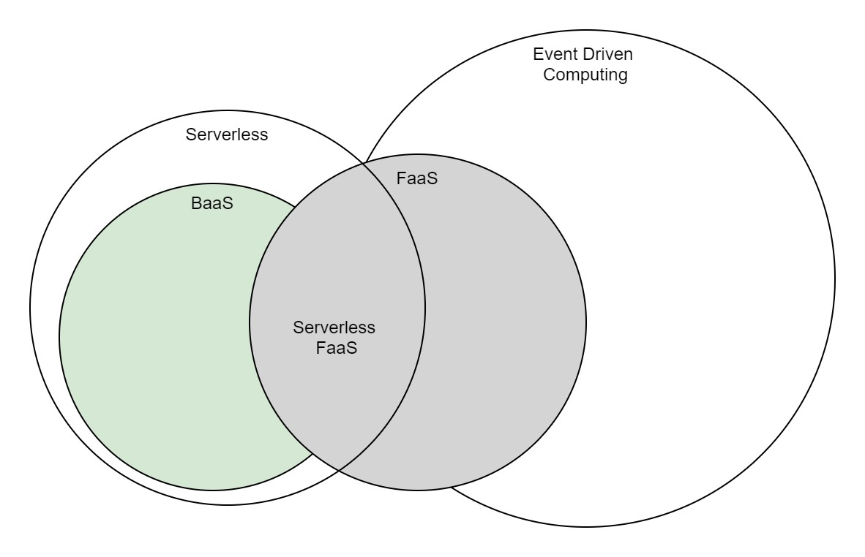

Besteht eien Anwendung in der Folge lediglich aus den zwei serverlosen“ Komponenten, ”

FaaS und BaaS, so ist häufig die Rede von einer pure serverless“, also einer Anwendung, deren

”

operationeller Teil vollständig an einen Cloud-Anbieter ausgelagert wurden und einer hybrid

” serverless“ Anwendung unterschieden [Lei+19]. Bei letzterem fungieren die Kunktionen häufig als sog. Glue“, der meisten zeitlich variierend Aufgaben übernimmt, da IDLE-Zeit, wie man

”

sie aus IaaS oder PaaS kennt, nicht berechnet wird.

Nun mag der ein oder andere argumentiern, das ein Großteil der infrasturkurellen Aufgaben auch bei PaaS von dem Cloud-Anbieter übernommen werden, womit er natürlich recht hat. FaaS geht an dieser Stelle jedoch noch einen Schritt weiter. Bei Paas werden vorgefertigte *Packages* einer Anwendung auf der Runtime der entsprechenden Plattfrom bereitgestellt, womit sich die Entwickler immer noch im die Anwenungsstruktur kümmern müssen [Kap19]. In FaaS hingegen wird dieser Teil übernommen und der Entwickler konzetriert sich lediglich auf die Business logik und die jeweiligen Event-*Trigger*.

Zuletzt soll noch auf einen weiteren Punkt, NoOps“, eingegangen werden, der oft mit Server-

” ¨ less gleichgestellt wird. Es wird zwar durch die Ubernahme des Loadbalancing, der automatischen Skalierung, Sicherheitsaspekten und Patches ein Großteil der Wartung ausgelagert, jedoch ist dies nicht mit der Annahme des Wegfalls der Operations von DevOps gleichzusetzten, wie suggeriert wird [Fow18]. Es obliegt weiterhin den Entwicklern qualitativ hochwertigen Code zu schrieben und diesen in der Cloud-Umgebung zu testen, um dessen Performanz sicherzustellen. Die Komplexität entfällt daher nicht vollkommen, sondern verlagert sich zu einem gewiessen Teil [Eiv17]. Schaut man sich beispielsweise AWS an, so muss eine vielzahl an Konfigurationen vorgenommen werden. Zwar kann später eine vorhanden auf alle Funktionen angewendet werden, jedoch ist diese in der Folge von essentieller Bedeutung in einer riesigen Multitennacy“-Umgebung.

”

## Benefits and Drawbacks

Die im Folgenden aufgelisten Potential und Herausforderungen, denen sich Literatur und Anwender von FaaS gegenübersehen, sind zu Teilen dem Konzept selber, zu Teilen aber auch der Implementation der jeweiligen Anbeiter bzw. Open-Source Lösungen geschuldet. Es werden daher auf Seiten der Herausforderungen diese zunächst erläutert und falls in der Literatur bereits adressiert, vorgeschlagen Lösungen aufgezählt. Bei beiden, Potentiale und Herausforderungen, wird sowol Bezug auf FaaS als auch auf BaaS genommen, da diese beieden Kategorien in den meisten Fällen in Kombination genutzt werden bzw. architektionisch beding in Kombination genutz werden müssen [siehe Abbildung 4 und statelessness“ Abschnitt ” *Function as a Service*].

**Potentiale**

**Kosteneffizienz**

**Time to Market / Lead Time Development**

**DevOps**

**Testing**

**Optimale Auslastung von Rechenzentren** Greener Computing [SKM20] [Fow18]

#### Herausforderungen

**Vendor Lock-In** Auch wenn diese Eigenschaft sowohl **Physische Lokation**

Eine weiterer Punkt ist die physische Lokation der Funktionen. Dadurch, dass es dem Provider obliegt, die Ressourcen seiner Infrastruktur optimal zu nutzen, entscheidet dieser auch auf welcher Node eine Funktion ausgeführt wird. Platziert der Provider in der Folge Funktionen, die eine hohe Datenabhänigkeit haben, physische weit voneinander entfernt, so wird sich dies auf die Performance der Anwendung auswirken und letztlich als Latenz bei dem Endverbraucher zu spüren sein [SKM20]. Es gibt zwar bereits bei vielen Anbietern, wie AWS, Microsoft oder Google die Möglichkeit die Region beziehungsweise ein sog. Cluster festzulegen, jedoch lässt sich damit die Lokation lediglich eingrenzen, aber nicht rechenzentren-genau festlegen. Mit der Performance von serverful“-Applikationen kann damit nicht gleichgezogen

”

werden [SKM20].

#### Serverless“

”

Es ist an dieser Stelle zwar relativ trivial, trotz alledem ein Nachteil verglichen mit Lösungen wie PaaS oder IaaS. Die Rede ist von dem Verlust der serverseitigen Optimierung. Wie bereits durch den Namen deutlich gemacht, existieren die Server für den Nutzer nicht bzw. hat er bei einer auf BaaS basierenden Softwarelösung keine Kontrolle über das Backend. Er kann lediglich die Datenbanken, Objektspeicher oder Authentifizierung an die Struktur seiner

Daten anpassen und über Regeln“Zugriffsbeschränkugen umsetzen. Die Services sind von

”

dem jeweiligen Vendor vorgegeben und können bspw. nicht nach dem Backend For Fron-

[5] auf die entprechenden Client-Typen, wie Tablet, Mobile-Phone oder Desktop” tend“-Muster angepasst werden. Es existieren von jeder Sorte (Datenbanken, Objektspeicher, Authentifizierung usw.) nur eine Version auf welche man beschränkt ist. Jegliche benutzerdefinierte Logik muss daher in den Client ausgelagert werden, da es nicht auf backendseitig implementiert werden kann [Fow18]. Mit FaaS kann dieser Effekt gemindert werden, indem ein leichtgewichtige Logik in form von Funktionen serverseitig umgesetzt wird. Hierbei erfolg die Interaktion mit den unterschielichen BaaS-Servicen über die vom Anbieter beschränkten Trigger [siehe Abschnitt *Function as a Service*].

#### Statelessness“

”

Mit der statelessness“, also der Zustandslosigkeit von Funktionen, geht eine weitere Prob-

”

lematik von FaaS einher. Der Kern von Anwendungen ist es Aufgaben zu lösen, wofür viele verschiedene Schritte von Nöten sind, welche sinnvoll miteinander verbunden werden müssen. So ist es auch bei dem funktionsbasierten Aufbau von Applikationen wichtig, dass diese untereinander kommunizieren können und den Programmstatus voneinander abfragen können, ohne das es zu Inkonsistenzen kommt. Bedingt durch die kurze Laufzeit der Funktionen ist es essentiell, dass auch der Austausch in entsprechender Geschwindigkeit erfolgt. Wie in einem Report von Berkeley [Jon+19] herausgearbeitet, erweist sich das schnelles und exaktes State-

” Sharing“ jedoch immer noch als problematisch dar, betrachtet man die Geschwindigkeit von Serverless“-Anwendungen im Vergleich mit Serverful“-Anwendungen.

” ”

Grund hierfür sind die von den Anbietern zur Verfügung gestellten BaaS-Lösungen für das persistente Speichern des Programmstatus. Objektspeicher der verschiedenen Anbieter (AWS S3, Google Cloud Storage, Azure Blob Storage) sind zwar nicht teuter sehr teuter wenn es um das Speichern mehrerer GB geht, jedoch sind die Kosten beim Zugreifen auf die Speicher hoch und die Latenzzeiten von bis zu 20ms zu hoch [Jon+19]. Die Key-Value-Speicher der Anbieter sind in diesem Falle die bessere Wahl, da ihre Ansprechzeiten mit 8 - 15ms geringer sind, jedoch sind sie, bezogen auf ihre Input/Output Operationen pro Sekunde, deutlich teurer als die der Objektspeicher.

Neben dem schnellen Informaitonsaustausch der Funktionen mit einem externen Speichermedium, kann es bei einer Kopplung von Funktionen aus performancetechnischen Gründen sinnvoller sein, den aktuellen Programmstatus direkt and die nächst Funktion weiter zu geben. Wie zuvor bei der *physischen Lokation* der Funktionen erwähnt, ist es wahrscheinlich, dass Funktionen nicht auf der selben Node gestartet werden. Der Loadbalancer des jeweiligen Providers entscheidet je nach Auslastung der Infrasturktur, auf welcher Node eine Kopie der

Funktion ausgeführt wird. Auch wenn im Idealfall die Weitergabe des application states“

”

schneller ist als der Zugriff auf ein externes Speichermedium, so wird dies durch Startup”

Latencies“und physischer Distanz wieder relativiert. Um dem entgegenzuwirken schlagen Shafiei et al. [SKM20] vor, mit einem *Dependency-Graphen* miteinander verwobene Funktionen zu kennzeichnen und direkt bei dem initialen Aufruf einer Funktion mögliche Folgefunktionen zu starten.

Würde man dem Nutzer die Möglichkeit geben zu bestimmen auf welcher Instanz (Node) eine Funktion laufen soll, so das Konzept von FaaS damit untergraben werden (siehe *Optimale Auslastung*). Es würde dazu führen, dass erneut Kapazität zurückgehalten wird, über welche der Provider nicht mehr frei verfügen könnte.

Figure 5: Dependency Graph nach [SKM20]

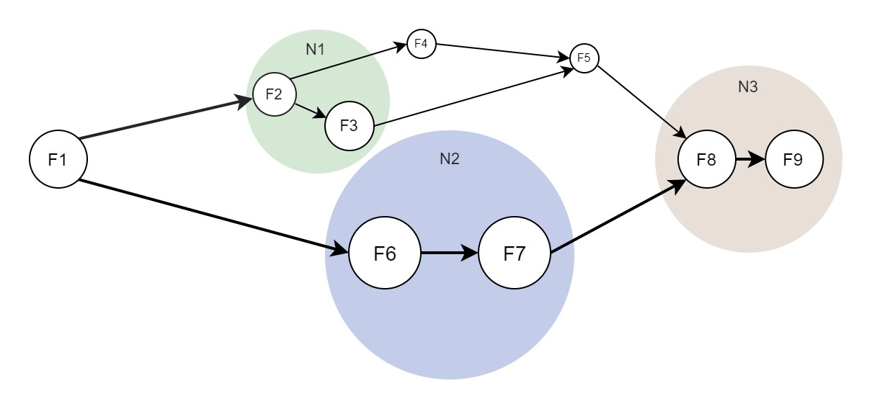

Wenn jeder Nuter bestimmen könnten auf welcher Node, bspw. Node-X, seine Funktionen laufen sollen, um den Progrmamstatus mit so wenig physisch bedingter Latenz wie möglich weiterzugeben, so wäre eine optimale Auslastung nicht mehr garantiert. Der Provider müsste stets Kapazität von Node-X zurückhalten und könnte sie nicht für andere Nutzerfunkitonen freigeben. Er muss stets einen Teil der Kapazität von Node-X zurückhalten, für den fall dass inaktive, aber der Node zugeteilte Funktionen aufgerufen werden. Mit einem *DependencyGraphen* wie in Abbildung 5 zu sehen würde dieses Problem umgangen werden. Der *LoadBalancer* des Anbieters könnte unbeinträchtigt die Funktionen wie gewohnt je nach Aus-

lastung auf freie Nodes verteilen, da er die korrelierenden Funktionen gleichzeitig“ starten

”

kann. Da die Latenzen beim Starten eines Services erheblich höher sind, wobei die Programmiersprache dies zusätzlich beinflussen kann [Man+18], als jene durch die Lokation bedingt [Adi+19] [JC18], würde deren Eliminierung die Weitergabe des *States* erheblich beschleunigen.

Generell betrachtet könnte die Geschwindigkeit der Kommunikation von Funktionen untereinander beschleunigt werden. Verbindet man das ganze noch mit einem einfachen neuronalen Netz, um beispielsweise vorherzusagen mit welcher Wahrscheinlichkeit Funktion zwei (F2) im Vergleich zu Funktion sechs (F6) angesprochen wird, so könnte die Performance sogar noch ressourcenschonender auf Seiten des Cloud-Providers gestaltet werden. Zunächst käme es entweder zu einer höhreren Belastung, sollte man zu Beginne alle Funktionen starten oder zu einer höheren Latenz, sollte man die Funktionen einzeln starten und aus dem sich ergebenden Verlauf lernen. Nach einer kurzen Lernphase würde die Auslastung der Infrastruktur jedoch erhöht werden.

#### Multitenancy“

”

Obgleich das Konzept von FaaS darauf beruht, dass der Anbieter eine Vielzahl von Funktionen verschiedener Kunden steuert und pflegt, so soll sich jeder Kunde fühlen, als sei der der Einzige. Allerdings stellt dies die Betreiber der Plattformen vor weitere Herausforderungen, da sie die Ressourcenisolation sowie Zugriffsbeschränkugen zuverlässig gewährleisten müssen. Dies ist jedoch leichter gesagt als getan, da es teilweise nicht nur von dem Provider selber, sondern auch von der richtigen Konfiguration der Sicherheitseinstellungen der Nutzer[6],[7] abhängt, ob die Daten unzugänglich für Dritte sind.

Obwohl Anbieter wie AWS Mittlerweile erfahren genug sein sollten, dass solche Probleme nicht mehr zu erwarten sind [Fow18], ist weiterhin Vorsicht geboten. Es nichts an der Tatsache, dass auch sie sich mit Sicherheitsaspekten, der Robustheit und Performance ihrer Infrastruktur ständig weiter auseinadner setzten müssen. Kein Kunde darf die Daten eines anderen sehen, kein Fehler die Stabilität anderer Funktionen gefährden und kein plötzlich auftretender *Spike* eines Kunden die Performance der Funktionen eines anderen beeinträchtigen. Das Zusammenspiel von RPCs und der Containersicherheit muss dauerhaft gegeben sein und durch sorgfältiges *Security Managament* sichergestellt werden [MB17].

**Testing**

#### Cold-Starts

*Cold Starts* beziehen sich auf das Starten eines Containers, in welchem eine Kopie der benötigten Funktionen zur Verfügung gestellt wird. Ist eine Funktion lange nicht genutzt worden oder wird zum ersten Mal angesprochen, so muss für die Ausführung zunächst alles vorberietet werden. Vor allem bei sehr kurzen Funktionen stellen sie ein erhebliches Problem dar, da ihre *Start-Up*-Zeit bis zu ein Zehnfaches der eigentlichen Ausführungszeit einnehmen kann [SBW19]. Ein Container muss auf einer Node gestartet werden und die Funktion, sowie deren Abhänigkeiten geladen werden. Die Zeit die es dauert, bis die Instanz bereit ist hängt dabei von verscheidenen Faktoren, wie der Programmiersprache, der benötigten Bibliotheken (*Libraries*), der Größe der Funktion (menge an Code) und der Hardware [SKM20] [Jon+19] ab, auf der die Funktion instantiiert wird. Wird eine Funktion dabei sehr frequentiert aufgerufen, so halten die Plattformen diese Funktionen für eine gewisse Zeit vor ( warm“, bei AWS bis zu ”

einer Stunde [RC17], wodurch die Wahrscheinlichkeit eines erneuten *Cold Starts* gegen Null tendiert. Bei Funktionen die hingegen nur einmal pro Stunde bemüht werden, sind die Folgen von *Cold Start* deutlich häufiger zu spüren [RC17].

Um dem entgegenzuwirken schlägt [Cas+19] vor, eine Art stammzellen Container vorzuhalten. Diese würden für die unterstützten Programmiersprachen bereits instantiiert aber leere Container vorhalten. Diese Container sind nicht Kundenspezifischen und generisch nutzbar. Damit würden zwei der obene genannten Punkte, die Programmiersprache und die Hardware, welche die *Startup*-Zeit der Funktionen negativ beeinflussen, eleminiert werden. Lediglich die größe der Funktionen und deren *Dependencies* müssen noch geladen werden. [IMS18] hat zudem gezeigt, dass mit der Erhöhung der Speicherkapazität die Zeit bis eine Funktion bereit ist einen *Request* zu bearbeiten verringert werden kann. Kombiniert man dies mit dem Stammzellen-Ansatz, so wird das Laden des Programmcodes und der *Libraries* beschleunigt. Natürlich kommt der zusätzliche Speicher nicht umsonst, jedoch liegt es in dem Fall bei dem Unternehemn zwischen den Mehrkosten und dem Performancezuwachs abzuwägen.

# Guideline on Migration

The below-presented guideline for migrating parts of existing microservice architecture to the relatively new cloud-computing concept, Function as a Service, is structured as follows. At first, the decision to migrate is questioned by challenging the motives of adopting this new technology and giving advice on when to migrate. Afterwards, criteria for selecting the right service will be stated. Those criteria gear towards the possibilities that come along with FaaS. When a reasonable service has been found, a provider needs to be identified, which best meets the company’s requirements. There are two types of providers that primarily differ in the service-ecosystem inherent to them and the degree of vendor lock-in. Whereas proprietary platforms like AWS, Azure, or Google provide a vast ecosystem of feature services and Backend as a Service offering, open-source frameworks like OpenWhisk, Fission, OpenFaaS or Kubeless dedicate greater control to developers. When implementing FaaS, the open-source solution can be far more adjusted and configured to best suit an organization’s needs. Next, impacts on the general process of software development will be investigated. Changes in an organizational structure regarding the development team, effects on the CI/CD pipeline, challenges faced with local testing and the VCS, will be addressed. At this point, it should be outlined, that this thesis differentiates between the testing that is done locally during development and testing, which needs to be done on the ecosystem of the platform itself. With the development process covered, the guideline on migration will end with the operational part. Alternations on the process of monitoring, maintenance, and testing instances will be covered, and advice on coping with them will be given.

To better follow along with the guideline, the subsequent section will provide an overview of the current microservice infrastructure. The development process, as well as the operational tasks, will be described, along with the underlying service-landscape. Ending with a summary on the constructed guideline, changes affecting the current infrastructure will be outlined.

## Describing the existing architecture

In the afterwards, the current process of development and operations is described, to later on better illustrate the effects of introducing Function as a Service to the existing microservice architecture, see [New15]. Figure 6 provides a high-level overview of the prevalent DevOpsPipeline. In the final stage of this section, by summing up on the construction of the guideline, figure 6 will be examined regarding necessary changes.

Starting with the development team, it consists of around eleven developers that are working after Scrum, an agile process framework,see [Pic13]. During a sprint, the team splits up in groups of two to four, to work on the tasks they committed on. Thereby the primary language used for developing the services is Java. Following a typical pattern, the basic structure of a service is defined in a YAML-file [8]. In this file configurations regarding the endpoints of a service, its request and response parameters and other basic configuration can be made. The YAML-file then gets passed to swagger-codegen, which generates a service skeleton with the according interfaces. Using Maven as an automation tool for service development, when building the service, all required dependencies, specified in the POM, will be loaded. The POM itself is an XML-file, including information about the service. The file documents target locations, dependencies, versions and other default configurations for building the service.

After the initial build of the service, the business logic can be implemented. To keep track of different versions of services as well as the entire service landscape of the platform, a VCS like Github, Bitbucket or Tortoise can be used. While working on the business logic, the service will be built and tested several times. The tests are executed in the local development environment, using mock data form test-databases. By the time the service is documented, a PR can be created. To guarantee a certain service-quality, all services embrace parts of a so-called core-service. The core-service enforces certain standard functionalities in terms of logging, messaging, caching, circuit breakers, standard exceptions and many other tasks, other services have to incorporate. Given that the service implements the standard correctly and the code-review reveals no flaws, by approving the PR, the CI/CD pipeline is triggered.

Figure 6: DevOps Pipeline

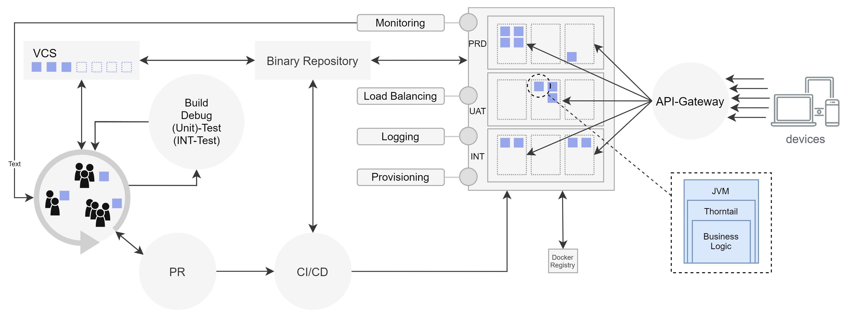

Looking at the CI/CD pipeline, different products can be used for automation. Two popular choices are Jenkins and TeamCity. The purpose of the pipeline is to build a service, execute tests, and provide the services war-files and jar-files to a binary repository. The binary repository itself is connected with the VCS as well as with the CI/CD pipeline. By triggering a build process for one of the services its binaries as well as complementary program parts – such as Git, the JVM, Thorntail etc. –, will be put into a Dockerfile. Based on the Dockerfile, a baseimage will be built, containing all specified programs that are needed for the program to run correctly. This baseimage will be forwarded to a container where the application runs on in the end and is stored in the Docker registry for later usage. When a new instance of a service is needed, it can be loaded directly from the Docker-registry. To ease working with containers, Kubernetes was installed, which is an open-source framework for automating deployments, scaling and management of containerized applications.

Microservices are usually hosted on-premise, PaaS or IaaS solutions and run in a container. A pre-defined amount of memory and computing resources are allocated to a container, enabling it to handle a certain magnitude of incoming traffic. When the traffic exceeds a predetermined threshold, another instance of the service will be provided on the platform, using the baseimage from the docker registry. Due to the horizontal scaling nature of containers, each instance has a fixed amount of resources which are constructed to deal with incoming traffic. In practice, the containers are running most of the time in IDLE. Even though microservices already have decoupled many monolithic applications into smaller, more manageable systems, they still incorporate different functionalities. In reality, microservices can get quite large and therefore need to be grouped by bounded context to better suit the concept of FaaS. Because of their size, it takes time to launch a new container, in case the incoming traffic rapidly increases. Therefore it is good practice to provision at least two service instances if historical data has shown frequent bursts in load.

## Scrutinising the Decision of Migration

Whereas migrating from a monolithic application to Function as a Service seems far more challenging, due to the assumed size and complexity of the monolith, migrating from a microservice architecture to FaaS can be challenging as well. With a monolithic application, partitions need to be identified in the first place and afterwards be broken down into small services. Microservices, on the other hand, might already be small enough that they supply only certain functionalities. Still, in some cases, they do incorporate too many functionalities to be converted to functions right away. Nevertheless, issues that have to be dealt with will remain. When migrating, a solution for outsourcing the internal state of the microservice has to be taken into account. Furthermore, dependencies need to be reduced to a minimum and the code probably has to optimized to suit the concept of FaaS better.

Before starting to introduce this new technology into the service landscape, it is essential to contrast the current state of the system with the desired state. When a system is already composed of many small services, the underlying infrastructure likely consists of VMs or containers. Those containers often run in a PaaS environment, and it is not possible to scale them to zero to free reserved computing capacity, in favour of other services to consume it. To do so or even to outsource the expense of provisioning services, managing the underlying infrastructure and coping with operational tasks, such as monitoring, load balancing. Function as a Service can help to achieve this desired state. The restrictions that come along with the ease of development have to be traded off against its benefits.

To profit as much as possible of introducing FaaS, the services, which should be migrated, have to be inspected regarding dependencies, size, version, language, and complexity. It is recommended to reduce dependencies to a minimum, due to their effect on start-up times [Man+18]. Especially with Python, Nodejs, and Java [PS17], loading all dependencies required can have an impact on cold starts. Also, the dependencies might again interconnect with other dependencies, resulting in a considerable number of dependencies, that should not be underestimated. With FaaS, each unnecessary dependency will increase the start-up time of every single Function being started.

The next issue which needs to be addressed is state management. As mentioned in section two, *benefits and drawbacks*, there is no persistent state an application can rely on. Being precise, there is a persistent state in the container of a function, but whether an incoming request will hit a particular container, is unpredictable. When a service does not receive any request or is running for a long time, the provider will eventually kill its container to free capacity. In the case of AWS Lambda, the current maximum amount of time, of a frequently called function until it gets killed, is 45 minutes[9]. Later on, when comparing cloud providers with open-source frameworks, there will be guidance on finding an appropriate solution to meet a company’s purpose. Still, for now, the following must be considered. When using an open-source framework like OpenWhisk, the external state management system can be covered with Redis or another low latency database. Whereas using a cloud provider platform, one of its integrated database solutions will presumably be the best choice. If it is necessary to have full control over the performance and configuration of the database, an open-source framework has to be chosen.

The latency and frequency of a service will also decide upon its aptitude for being a candidate to get migrated to FaaS. If the service is called very frequent and experiences most of the time very high traffic, the concept of Function as a Service will not apply to it [Jon+19]. Due to a limit of concurrent running functions, that can vary between the different providers and frameworks; incoming traffic can only be handled upon a certain amount. Moreover, the same application experiencing the same vast amount of traffic, once running on a FaaS platform and once running in a docker container on PaaS, will be more expensive implemented with FaaS, than it will be with PaaS [Jon+19]. Therefore, services with various workloads, having eventually high peeks and then some time of inactivity, are more applicable to the concept of serverless, than their counterparts.

Latency should also not be a critical component of the system due to the before mentioned cold starts. Latency sensitive applications like trading platforms, which strongly rely on real-time data, are not a suitable candidate for Function as a Service. Another pitfall is the promise of not having to maintain, provision, scale, or monitor the infrastructure and thereby reducing complexity and operational tasks. On one side, the cloud provider will, to some extent, take care of load balancing, scaling, provisioning, versioning and providing monitoring solutions. On the other side, new complexity will appear in other areas. To cope with the complexity given by a potentially large number of functions, the issue of mono-repo and poly-repo arises, as discussed in a later section.

Lastly, attention needs to be drawn to the programming language and lead time development. FaaS can provide a reduction in lead time development and time to market, thanks to its small codebase and rapid development [SS18] [Lei+19]. Developers can make changes, fix issues, test, and finally deploy a new version to production in a view minutes. Prerequisite, even though this might sound trivial, is the language support for the language used in the application or service. If the platform does not provide the required language, to avoid the hassle of finding a workaround, an alternative solution should be chosen. Although the big cloud providers already support many programming languages, application logic might have to be rewritten, if that specific language is not supported. In the case of version incompatibility, parts of the application needs to be rewritten as well. Especially when the provider’s version is below the version of the application, it becomes an issue.

## Balancing between Open-Source and Cloud-Vendor

Choosing an open-source over a cloud vendor, or the other way round, depends on the purpose of utilization. Neither is the so-called vendor lock-in a drawback nor a limitation, compared to an open-source solution; it is solely a tradeoff between the benefits of two different approaches of the same model. Nevertheless, the decision on one of them will affect the possibilities in the process of development and migration. To answer the question on which one to choose, the following things need to be considered.

If the primary purpose is to start rapid development with not having to configure any infrastructure, a cloud vendor seems to be a promising solution, especially when a project has no legacy application that needs to be refactored or rewritten. Which vendor should be taken is dealt with in the following section.

With Amazon Web Services (AWS) Lambda, Microsofts Azure Functions, IBM Cloud Functions or Google Cloud Functions, each of the large serverless providers has a considerable amount of services in its ecosystem. The ecosystem is utterly compatible with itself, making the need to find a custom workaround for processes like CI/CD obsolete. AWS and Azure even provide a premade solution for that purpose. Moreover, if an application requires user authentication, different types of databases, messaging services and hosting, each of the platforms can satisfy these needs. Adding to that, they provide an appealing pricing model with free contingents each month, which makes them a feasible candidate for experimenting with different cloud services.

Unfortunately, these benefits do not come without restrictions. By ceding the responsibility of provisioning, load-balancing, scaling, error-handling, monitoring and many more duties to the cloud provider, one is dependent on the tooling provided by the platform. Just because the responsibility of maintenance and provisioning is outsourced to the provider, this does not mean that there is no need for an additional monitoring practice, as later stated in *implications on monitoring*. In case something goes wrong on the platform, it is recommended to have, besides the tools offered by the provider, additional information to rely on. To reproduce the error, the custom logging data can be crucial to find the cause of the problem and solve the problem.

Another point that has to be considered is the outage of the platform, which is per se not exclusively a cloud provider issue, but something that might have to be dealt with. A possible solution to this is a framework sitting between development and the platform, enabling multi-cloud application that can produce relief.

Depending on how one looks at it, Function as a Service in conjunction with Backend as a Service can be depicted as an advantage or disadvantage. Even though the two concepts undertake many tasks, for many tasks, additional services need to be consulted. E.g. when building a serverless application, for messaging an SNS-service, for storing the state a database-service, for registring new users an authentication-service and form monitoring a monitoring-service needs to be included. Not yet mentioned CI/CD integration, API-Gateway and many more.

If the concept of FaaS should be introduced to a company or project along with staying in control of the entire infrastructure, a cloud provider solution is not applicable. In this case, an open-source provider needs to be chosen. If the present application is built upon Kubernetes, for the purpose of virtualization, Kubeless, OpenWhisk, OpenFaaS and Fission are feasible FaaS options, that can be integrated with little effort [PKC19]. Using an open-source provider, configurations in terms of computing time and resource capacity can be customized, due to being in control of the underlying platform. Introducing FaaS to an upfront ecosystem will increase its performance and efficiency by freeing unused resources. At the same time, an operations team will be needed that is in charge of implementing a monitoring solution and configuring the properties of the FaaS framework [MPDF+18].

Furthermore, the team needs to acquire new skills to configure security policies correctly, interconnect function with each other, define different triggers on functions, deal with concurrency setting [10], and many more aspects add complexity to new fields. If the company aims at reducing infrastructural complexities, then Function as a Service can provide support on the listed tasks, but when its primary purpose is to reduce operational efforts, as often suggested with the term NoOps“ [Eiv17], FaaS, again, is not the right choice. ”

### Open-Source Solutions

Depending on the decision made in the previous section, there are various frameworks and platforms at choice. Below, several solutions for each approach are presented. Starting with open-source frameworks, Fission, Kubeless, OpenFaaS and OpenWhisk will briefly be introduced.

*Kubeless* is a Kubernetes native serverless framework, being a straight forward extension for a Kubernetes API-Server. Kubeless itself has no API-Server and no data store to store any files, objects, binary data and other formats in. Since it is reusing everything from Kubernetes, Kubeless solely relies on the API-integration. To scale functions, Kubeless makes use of the Horizontal-Pod-Autoscaler included in Kubernetes. Depending on the runtime, metric data can be monitored with Prometheus.

Regarding the deployment of new Functions, the API, ConfigMaps and Ingress are utilised[11]. Thus being built on top of Kubernetes, making use of its CRDs[12] to create functions, users, familiar with the Kubernetes-API, can process as usual. The language-runtime itself is encapsulated in a container image which will be set in the Kubeless configuration. A list on supported runtimes can be found on *github*[13][14]. Each function will be deployed in a separate Pod, supervised by Kubernetes HPA. When a function is not used, the HPA will kill the pod to free capacity. Prerequisite is the deployment of the function with a CPU request limit. Depending on the runtime, metric data can be monitored by Prometheus.

*Fission* is a serverless framework build on top of an underlying Kubernetes infrastructure. Just like Kubeless, Fission does not inherit a resource store and therefor depends on communicating with the Kubernetes API-Service, in order to get access to secrets and ConfigMaps. As well as the former, Fission supports a large number of programming languages. Also, CPU and memory resource limits can be configured, ceding great control to the developer. Two aspects which make Fission unique compared to the other three is, for one thing, its ability to define the number of pre-warmed pods and for another thing its richness of possessing a Workflow-System. Whereas the pool of pre-warmed pods can be utilized to mitigate the cold start issue, the Workflow-System makes it easier to handle an increasing number of functions. Besides that, the Workflow-System facilitates scheduling and executing more complex workflows [see [KS18]]. In contrast to Fission, Kubeless uses event chaining to create workflows which makes it harder to maintain the workflow graph, when an application keeps on growing

15.

OpenFaaS provides a so-called *faas-provider* interface, letting it integrate with any provider that has implemented the interface. Currently, these providers are Kubernetes, Docker Swarm and *faas-memory*. Each function will be packaged into a docker image and deployed via the OpenFaaS CLI. With its API-Gateway, OpenFaaS can respond to any event, and by making use of its auto-scaling functionality the min/max amount of replicas can be configured[15].

Lastly, OpenWhisk is a serverless framework which has initially been developed by IBM and is now backed by Apache. Because OpenWhisk was backed by a large company, its application model is often referenced in literature when the application model of other large cloud providers is indicated. It can be assumed that other vendors are using a similar concept due to OpenWhisk being provided in a large cloud environment [VE+19]. As an orchestration tool, Kubernetes can be used in conjunction with OpenWhisk, as well as IBMs Composer. As with the other three language runtime support here too, is quite large, ranging from Go over Java and Python all the way to Nodejs[16].

In addition, all four open-source frameworks natively support three different types of triggers [see figure 2], namely HTTP, Event and Schedule. Adding to that, Fission, Kubeless and OpenFaaS are written in Go, OpenWhisk in Scala. Concurrency testers on Kubless, OpenFaaS and Fission have shown that the latter framework with 2ms has the fastest response time of all three. Moreover, its response times are consistent regardless of the number of replicas present and the number of concurrent users [MPDF+18]. The test was conducted with 1, 25 and 50 replicas. Kubeless and OpenFaaS experience an exponential increase in response time. Although the response time increases an is higher compared to Fission, OpenFaaS is showing a slight decrease in response time the more replicas are prevalent. Finally, Fission has a success ratio of 100% in all three tests, whereas Kubeless and OpenFaaS are facing a slight decrease from one to four percent.

Figure 7: Median response time for each serverless framework with (a) 1 replica, (b) 25 replicas, and (c) 50 replicas [MPDF+18]

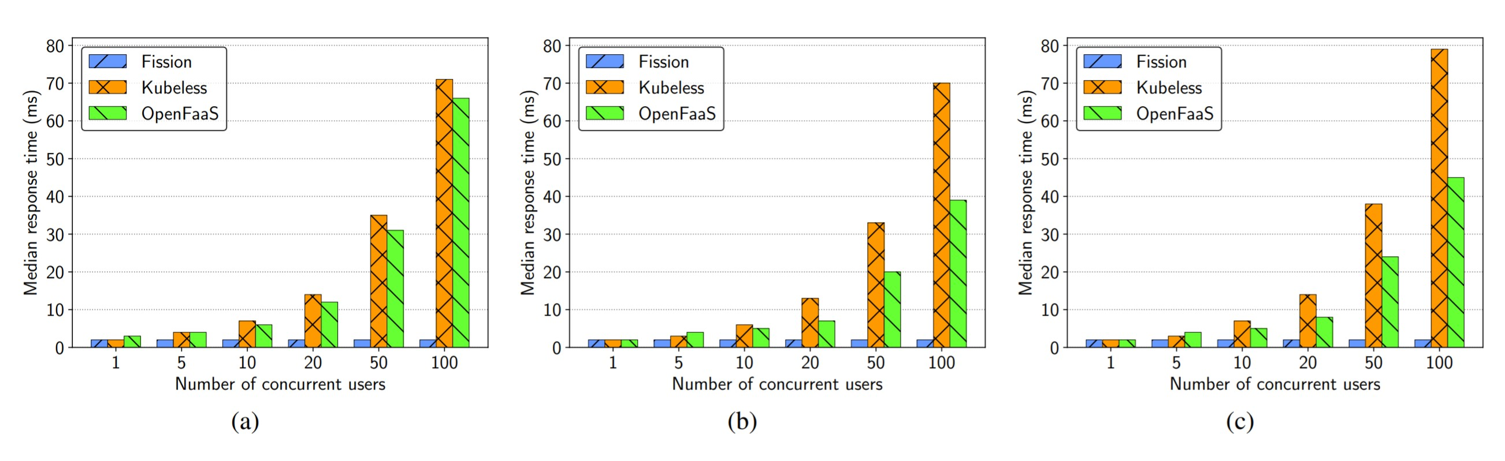

### Proprietary Cloud-Providers

Speaking of proprietary Function as a Service solutions, there are currently three market leaders with AWS, Azure and Google, respectively [Kum19]. By offering a vast amount of tooling and services, it can be challenging to choose one of these three, even though their underlying model does not differ much. By all three providers, functions are billed on their number of incoming requests, the time a function runs to process a request, billed at a tenth of a second, and the memory allocated to a function. Due to the cloud, especially serverless, being such a volatile market, listing on pricing and memory size would presumably be obsolete in a few months and therefor this thesis is referencing to the provider’s websites. Instead, performance evaluations, concurrency and runtime will be used as an indicator for choosing a platform.

Currently, on AWS, the maximum amount of time a single function will last is 15 minutes.

After that time, the container the function is running in will be killed, no matter whether it has finished processing. On Azure Functions, 5 min are the maximum by default, which can be upgraded to 10 if needed. Google Cloud Functions comes last, with a standard execution time of one minute, which can be raised up to 9 minutes. Looking at the limits on concurrent instances, on AWS Lambda, the limit varies between 500 - 1000 depending on the region. Independently, the burst con currency limit can reach a maximum of 1000-3000 concurrent instances. Those numbers only describe the initial limits, allowing to add each minute 500 additional instances. At this point, it is important to mention that these limits refer to an account, not a function. 1000 might sound a lot in this context, but depending on the number of functions, 1000 concurrent running functions can be reached quite fast [17].

Regarding the execution time of AWS Lambda and Azure Functions, the platforms not only differ in the execution time of cold and warm starts but also when comparing two programming languages. As a compiler language, with its JVM, Java functions require more time to execute than an interpreted language like JavaScript. Tests have revealed, that there can be a significant gap receiving a result with a difference from 0.6 (JavaScript) and 1.7 (Java) seconds from cold to warm start on AWS and 9.8 (JavaScript) and 24.8 (Java) seconds on Azure [Man+18]. Moreover, Manner et al. have detected that the cold start time of Java compared to JavaScript is on each memory size on AWS by a factor of two to three higher. Azure with a factor of 2.5 shows equal latencies in cold starts. Due to different memory allocation approaches, explicit configuration on AWS and dynamic allocation on Azure, the findings of latencies between the platform can not be compared to each other directly [Man+18].

Observed by other researchers as well, AWS appears to be very predictable in its memory size to performance ratio [PFM19]. Even though the performance-memory ratio is stable, the maximum CPU-performance increase seems to be reached with 2048MB of memory. 3008MB exhibits only a slight improvement on AWS. IBM and Google experience similar ratios but not as stable. In terms of delay, on AWS it was incestigated that with more memory capacity the delay, when starting a new instance, decreases. On the other hand Googles start-up delays are generally constant and do not seem to be impacted by higher or lower memory sizes. On IBM tough, it seems that by requesting larger amounts of resources the consumption time to consume the instance or resources, increases [PFM19]. Function throughput, which is an indicator of concurrent processing capacity, AWS reaches its maximum throughput most rapid, followed by IBM, Azure and Google, respectively. Whereas Google at the lower end increases throughput steadily, with a rise in calls, AWS stays sturdy at its maximum. IBM and Azure experience a small decrease over a long time.

Lastly looking at the runtime overhead of AWS, IBM, Google and Azure, on AWS it is almost evenly low regardless of a compiler or interpreter language. On Azure, C# creates the least overhead, still being twice as much as AWS highest language runtime overhead, and Python the largest. On IBM the overhead is similarly high across the languages, and Google has the least overhead with Nodejs [PFM19].

### Orchestration and Concurrency

Another point to consider, when migrating parts of existing architecture to Function as a Service is orchestration. The orchestration solutions vary between different cloud and open-source providers. The respective orchestration tool decides upon performance when executing functions in parallel and upon runtime overheads. Moreover, pricing needs to be considered when configuring concurrency options across different providers. As mentioned before, depending on the memory size chosen, the performance can be increased, but pricing will increase as well. Whereas in small projects, concurrency and pricing might not be the main issue, in medium to large-sized projects, memory and pricing of the various providers should be taken into account.

As stated in section *Benefits and Drawbacks* under *statelessness* when chaining functions, passing state from the sending to the receiving function is key for intercommunication. With a higher speed of state-transfer, latencies are reduced. Only with a seamless interaction of functions, complex applications can be built on a larger scale. Looking at proprietary cloud providers, the two largest platforms, AWS Lambda and Azure Functions, will be depicted and further investigated. On the side of open-source frameworks, OpenWhisk is taken into consideration.

Lopes et al. have investigated on the named frameworks in greater detail and detected significant differences in state transfer on both sequential and parallel orchestration [L´op+18]. For the tests conducted, all functions were executed on warm instances/ containers, to mitigate inaccuracies caused by varying cold-start times, see [Man+18] and [JC18]. In terms of executing sequential functions, called sequential processing, IBM’s Composer and ASF proved to be significantly faster compared to ADF. The overhead, describing the time that was not used to carry out any processing of business logic inside a function, was 1.1s for IBM Composer and 1.2s for AWS Step Functions with 40 functions connected in series. Azure Durable Functions, on the other hand, took 8s for the same 40 functions. In further implementations with [5, 10, 20, 40 and 80] it turned out, that IBM Composer only supports the orchestration of functions up to a number of 50 sequential functions. Anything beyond that limit has to be controlled by a third party orchestration tool [L´op+18]. ADF and ASF, on the other hand, can define workflows which can run for days and months.

The evaluation of the overhead for functions connected in parallel was carried out for ASF and ADF, solely. Starting with five functions and, as described above, scaling up to 80, the results showed a significant increase in overhead of Azure Functions. With a total of 80 functions, Azure Durable Functions with an average overhead of 32.1s had almost twice the volume of AWS Step Functions with an average overhead of 18.3s. The results also suggested that ASF is more reliable than ADF in predicting the overhead to be expected. Microsoft’s overhead has not always grown exponentially like Amazon’s, making it difficult to predict future behaviour.

When evaluating the suitability of parallel function execution, IBM’s Composer dropped out of the test portfolio right from the start, since parallel function execution was not supported as of 2018 [L´op+18]. Meanwhile, 2020, IBM includes support for parallel execution of functions via Composer. Furthermore, IBM states that parallel execution is not restricted to a certain number of concurrent functions and can be configured as needed [18]. However, it is explicitly mentioned that the Composer theoretically has no limits, but OpenWhisk does. Exceeding OpenWhisk’s limits of parallel execution will result in failures: [...] many concurrent invoca”

tions may hit OpenWhisk limits leading to failures: failure to execute a branch of a parallel composition or failure to complete the parallel composition [...]“ [19]. The current limitation of concurrent functions in OpenWhisk is placed at 100 functions per namespace.

Finally, the three orchestration solutions were examined concerning transferring application state. Due to the state limitation of ASF to 32KB that can be passed to the next function, the same size was chosen for the other two solutions as well. This time only five sequential functions were tested. In 2018 the official limit of IBM Cloud Functions was at 1MB, being raised upon 5MB by the time writing this thesis [20]. ADF enables state transfer up to 60KB. It was found that IBM Composer and AWS Step Functions had an overhead of 175.7ms and 168.0ms, respectively, when executed without any additional payload. With payload, the overhead in ms for Composer was 298.4ms and 287.0ms for AWS Step Function, which represents an increase of 70%, see figure **??**. Azure Durable Functions stood out clearly in this test. With an overhead of 766.2ms without payload and 859.5ms with payload, the basic overhead is significantly higher than with the previous two but only increases by 12% under load [L´op+18].

Figure 8: Overhead bei 5 sequentiellen Funktionen mit einem Payload von 32KB, nach

[L´op+18]

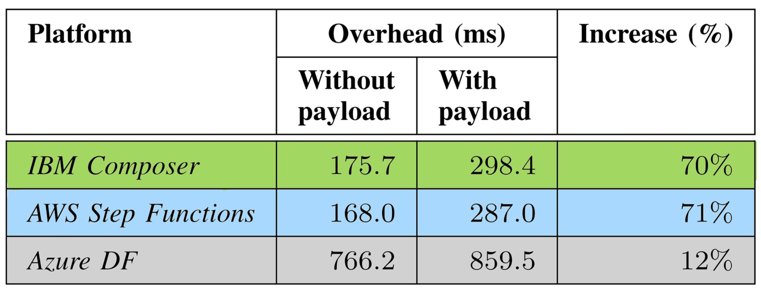

As shown by Lopez et al., AWS provides the most mature solution in terms of orchestration. Not only for sequential but also parallel execution AWS provides long-lived and short-lived function chaining. Also, the limitations on state transfer to 32KB enable AWS to provide clear information on pricing, compared with the other frameworks tested. When FaaS is mainly used for lightweight function chaining tasks, OpenWhisk in conjunction with IBM Composer is a suitable solution. With its limitation on chaining functions only up to 50 in number, OpenWhisk is slightly faster than AWS in that lower segment. For scheduling long-term running sequences, running for days or even month, OpenWhisk can not be recommended. If the focus is on the exchange of large application states between functions and more significant latency can be accepted, Azure is capable of such a use case. With a capacity of 60KB it its, by far, ahead of its competitors. Even sequences that run for an extended period can be configured. Moreover using async/await syntax with sequential function chaining and fan-out/fan-in[21] for parallel execution, simplifies development over solutions from AWS and IBM [L´op+18].

## Selecting a suitable service

The service for starting the migration should manifest specific characteristics. As mentioned above, and in section two, *benefits and drawbacks*, there are a view things that need to be taken into account. Due to Javas CPU-intense runtime and the time for loading potentially large amounts of libraries, the language is likely to raise the time of cold starts, eventually resulting in higher latencies [BRH18]. Also, the object-oriented model of Java must be restructured to meet the requirements of the original functional programming style of FaaS. Concepts embraced by Java, such as getters, setters, empty methods, constructors, and singletons, need to be considered when mapping an object-oriented programming language to decoupled functional units.

Considering these additional steps of migrating a service, written in an OOP language [Lei+19], it might be more rational to start with a service written in a functional programming language. The development team has to decide on the issue of refactoring in favour of rewriting. When the goal is to maintain consistency in language, accross the entire platform, the former decision is in favour. Otherwise, converting the service into a functional language, by rewriting it, could be another option. In the latter case, JavaScript, PHP, and Python, primarily being functional functional, are suitable candidates for conversion.

Furthermore, the majority of practitioners use functional programming languages over OOP languages [Lei+19], increasing the likelihood of finding solutions to problems on the internet. In contrast to legacy applications and the majority of PaaS and IaaS architectures, the service that is about to be converted should not experience permanent high traffic. Besides that, looking at the existing microservice architecture and identifying services that spend most of their time in IDLE, can be considered for migration. Weiter darauf eingehen. Und use-cases an dieser stelle noch einbauen

## Effects on development

During development, teams are working according to certain process models, trying to improve their efficiency. Therfore different tools and frameworks are used to enhance productivity and improve working velocity. Some are utilized in order to maintain the platfrom, to not lose track of its present state, others apply on the actual coding/ service-development process. Nevertheless with changes in technical concepts new operational and organizational cahnges evolve. In the following several effects of Function as a Service on the existing structures will be investigated on.

### Impact on Teams

When a microservice architecture is prevalent, FaaS can be adopted with fewer changes than a monolithic architecture [Fox+17]. With a microservice architecture, concepts like agile development, continuous delivery and continuous integration, as well as a different mindset amongst the development team, are probably more common. Nevertheless, FaaS goes a step further, then developing microservice with PaaS does, which suggests the assumption that the PaaS-adapted development structure will change.

Starting with agile development and DevOps“, Function as a Service forces companies and

”

teams to adopt an agile mindset and agile techniques [Ben+18]. The necessity of iterative cycles is accounted for by the concepts great modularity compared to microservices. Persuing procedures form older waterfall driven projects are still prevalent, the implications of the sequential process model would not satisfy the needs of Serverless, respectively, FaaS. With a significant reduce in lead time development, long periods of requirement engineering will hinder the effectiveness of FaaS. Teams that already incorporated agile process frameworks, such as scrum, will have an advantage over those still remaining to acquire experience. Serverless development will enhance the importance of continuous delivery and continuous integration. Integrating procedures like unit testing and integration testing, to diminish time to market to a minimum, need to be further investigated. Depending on the size and complexity, which should be kept to a minimum as well, the chances are that FaaS will be considerably faster than the current microservice development. To prepare for integration, slow processes have to be identified and eiter speeded up or thier effects mitigated. This way bottlenecks will be eliminated.

Furthermore, the size of the teams, to be more accurate, the number of developers working on a function, should experience a decrease. Whereas now two to four developers are working on a microservice, this number likely gets reduced to only one developer for each function. With separation of concerns and further decoupeling functionalities of a service, FaaS naturally decreases complexity, at least on the code level. Also, reducing complexity and focussing on a specific functionality can help to optimize each function further. By doing so, besides the reduction in startup latency, with the shorter execution time, the platform will charge less [SKM20].

### Version Control System

However, when maintaining a microservice infrastructure, each service and each version is likely to have a separate repository. With Function as a Service, this approach will be challenged regarding the number of functions that make up the application or service. Having a repository for each function, the odds are in favour of experiencing an overhead in version control and keeping track on the application landscape. Hence teams pursuing this approach are facing duplication in their code base, because the existing functions, can not be gathered with little effort [Rac+19]. This complexity and duplication seem to be the cause of why many users follow a mono-repository approach over having many small repositories [Bro19].

With that said, FaaS seems to be conflicting with itself to some extent. Although its modularity suits the poly-repository approach quite well, ther is accompanying complexity, while an application keeps growing. Not having a clear overview of the codebase and especially a potentially vast amount of functions redundancy is likely to increase. The consequence of that is inefficiency while maintaining and expanding the application landscape. This is in a sort analogous with the scripting practice in larger software projects. If a quick fix for incompatible components is needed, a script is often used to cope with the issue. The results are myrads of scripts, that are had to maintain, because the next problem is likely to be fixed by another script. In parctice, the scripts of are not in one place, probably even stored in the repository of the service itslef. Providing they are strongly context bound, this is not a big issue, but many time they are of a far more general nature. Resulting in a lack of reusability, redundancys are faced and efficiency is reduced [*internal source*].

As a suggestion, there should be a mono-repository-approach for each (Scrum)-team and a ploy-repo approach for each division. Both would coexist with the present VCS of the microservice-architecture. This way, redundancy of code in a team is kept very low, by simultaneously having a manageable amount of repositories across a division of a company. With this approach, complexity can not be eliminated, but at least mitigated to a certain degree. Moreover, having seperated repositories for different teams will simplify the use of many accounts for development and production, as discussed in a later section.

### Programming Language

Another issue that can emerge during the process of development is affected by the programming language used. Looking at Java, which mainly is an object-oriented programming language, even tough concepts such as Lambdas, added in version eight, the question of refactoring arises. However, besides these Lambda expressions, the core of a Java application is OOP-based. Migrating microservies that are Java-based to FaaS, it is necessary to map Java classes to functional units that can be deployed onto the serverless platform. Moreover, concepts like empty methods, getters, setters, constructors and singletons have to be taken into account [SD17]. Looking further, the absence of conventions outside the actual code, like the usual presence of a *src*-folder, have to be investigated. During the process of transformation, the Java-based services need to be split up into bounded contexts allowing the business logic to be seperated. With regard to the effects of many dependencies, a reduction of mutual dependencies has to be made to decreasing startup latencies. Two functions should not load the same dependencies if not necessary. This way, startup latencies will be kept to a minimum. Spillner et. al suggested an approach to automatically transform Java code to AWS-Lambda functions, consisting of six steps.

1. Conducting a static code analysis based on the service code in the VCS.
2. Decomposing the code into context-bound parts.
3. Translating the split code into functional units which are uploaded to a target repository.
4. Compiling the code and inspect issues and failures and upload the code to the binary repository.
5. Deploy the data form the binary repository to AWS
6. Test and verify the code.

Even though the last two steps are Lambda specific, the former ones provide a generic starting point. Unfortunately, this concept, especially in conjunction with automation, is as stated by [SD17] only applicable for simple Java applications. Moreover, migrating from an objectoriented approach, respectively Java, state changes in classes and objects need to be treated separately. In a functional unit, keywords such as *this*, referencing itself in a Java-class, are not applicable. To address this issue, the self-reference, as suggested by Wright et al. [Wri+98], should be provided with the method signature that is passed to a function. This way, the same underlying object structure can be equally invoked with every new instance of a function being started. Operations on the container do not interfere with objects in other containers, and saving the state in external databases will not cause redundancy between the different objects [SD17].

### Tooling and Multi-Cloud

Literature is currently facing a lack of tooling, in terms of the variety and maturity provided by present sloutions [Yus+19], [Lei+19]. With a share of around 80% [Lei+19] of practitioners using the Serverless[22] framework, this tool is the most frequently used in the market. Besides the Serverless Framework, Terraform[23] and CloudFormation[24] are mentioned as well, but their appearance is far less. Especially in conjunction with the CI/CD pipeline, the use of tooling can play an important role. By using one of the tools mentioned above, the deployment is configured withing those tools, providing an abstraction layer between the contemporary architecture and the provider’s platform.Thereby these tools enable hybrid architectures across multiple cloud providers. Terraform and the Serverless Framework both manage resource configuration and therefore need to be connected with the providers. The connection will be established depositing authentication data for all cloud solutions to be managed on the framework. By striving to gain independence and reduce the effect of vendor lock-in [see *benefits and drawbacks*], these frameworks are supporting that process. Especially the Serverless Framework, thanks to its vast amount of plugins, provides, e.g. an offline simulation of AWS Lambda and the AWS Gateway [Lin+18].

Within this conjunction, additional operational tasks should not remain unmentioned. Even though Serverless, Terraform, and CloudFormation provide the opportunity to register many accounts from all kinds of serverless providers, including AWS, Azure, IBM and more, they face an initial load in configuration. Another issue that needs to be addressed is that new features offered by a platform will not be adjusted to third parties, which engenders latency time until the third party might provide the feature. Thus, these IaC frameworks do not come for free[25]. They can be used for free to a certain extent, but when it comes to more advanced tasks, they will charge the user. Finally, they do as well represent some vendor lock-in.

Depending on the purpose of multi-cloud solutions, there might be higher costs than using just one provider. If functions form one provider need to access another’s providers function, its functions will be affected by cold starts. Moreover, the physical distance between the two data centres will affect latencies. If the primary purpose of deploying an application to different cloud providers is to have redundant systems in case one fails, the cost will not be affected too much. Still, additional operational tasks are required to guarantee a stable backup. Testing needs to be done not only on one but on all cloud providers, the application is mirrored to, which will cause additional costs besides the operational overhead of monitoring and testing.

Regarding the deployment pipeline, in practice, many tasks are handled via scripts, as mentioned before. Introducing serverless, special tooling for deploying a function to the desired platform is necessary and needs to be included in the existing pipeline. If not using one of the IaC frameworks mentioned above, the providers specific CLI has to be integrated, in the case of AWS Lambda CloudFormation. Integration can vary depending on the provider but is inevitable, according to practitioners [IS18].

## Effects on Testing

There are several ways to test a serverless application. A distinction is made between local unit-testing, canary releases, as well as A/B testing and integration testing. While OpenWhisk was the first framework offering local unit testing, the other providers have adopted this as well. Looking at AWS, Amazon provides with their open-source Serverless Application Model (SAM)[26] the possibility to build, test and debug the application locally. On Azure, Microsoft provides the so-called *Function Core Tools* as integration for running functions locally[27]. Even though the underlying business logic can be tested locally, there is no guarantee that the code will work the same when the function is deployed into the actual ecosystem. A reason for that is the interaction with triggers, events, databases, functions and other services which, again, can not be simulated accordingly in a local environment. In contrast to that, hosting an application on-premise or via IaaS or PaaS, it often is possible to not only unit-test locally but also simulate integration testing locally. Due to being in charge of the platform, there are often local copies of databases or message queues which are quite similar or identical to those running in production. Not only are there copies but real databases that

can be accest locally far more easy, due to being in charge of the database-service“ ”

Moreover, it is hard to provide all configurations made on the different services locally. Key figures, such as the execution time of a function, the speed of loading all dependencies and potential latencies due to cold starts will be different on the cloud platform. Also, the unawareness on which type of server the function will be started makes predictions on performance difficult [Rac+19]. Due to the complexity being abstracted to the cloud vendor, the user has no further control over these services, ececpt of what the platform allows them to do. This restriction is not affected when performing unit tests, which is very easy, based on the small code base of the functions. With all these implications, it is inevitable to test the service on the provider’s platform to get reliable results on compatibility and performance, even though tested locally.

When testing on the platform, there are several possibilities that can be chosen form. Starting with canary releases, considering the size of serverless functions, changing solely specific behaviour becomes far more feasible. After a new version is deployed, changes can be made to the API-Gateway of the serverless platform, in order to redirect a defined group of users. These cloud then test only a new version of a function or the entire application. Without being charged for code stored on the platform, only for code being run, it is possible to mirror the entire application to another account, without experiencing an increase in pricing. On that account, the new feature can be tested. Regarding the operational overhead of the mirroring process, mirroring appears to be more comparative on major changes to the application and or a function. For patches, solving defects, or minor changes, adding new features to an application, not affecting is API, the effort of mirroring might not be necessary. Using AWS, Azure or Google, canary releases can be scheduled via the CLI. On AWS in particular, canary releases can be achieved either via *aws-lambda-deploy* or AWS Step Functions. Although the opportunity of canary releases and A/B testing theoretically exist, it is not very often used by operators [Lei+19]. One reason cloud be the operational overhead, another the implications on performance, when not having a separate development and production account. Especially load tests are likely to affect performance on an account. In case only one account is used for testing and production, latencies can have a noticeable effect on the application, affecting end consumers. Therefore, it is advisable to have at least two different types of accounts — one for production and one for testing purposes. Despite the additional overhead, load tests can be done safely without any impact on the actual application [Lei+19].

## Implications on monitoring

Debugging and monitoring are crucial parts of any application. They ensure that the application is stable. The two metrics are indispensable in determining the health of an application during testing and later on in production. After going through the different testing environments, DEV, INT, UAT right up to PRD, the data gathered can be used as a baseline of the normal behaviour of a service. Whenever running out of memory or failing to provide a new instance of a service, the monitoring solution will, in a perfect world, alert the operator before issues in production cause severe damage. Whereas the team has full control over their servers when using a PaaS or IaaS solutions, with a container environment like Kubernetes on top, it is quite different when switching to FaaS.

Figure 9: Monitoring cloud functions, by [MKW19]

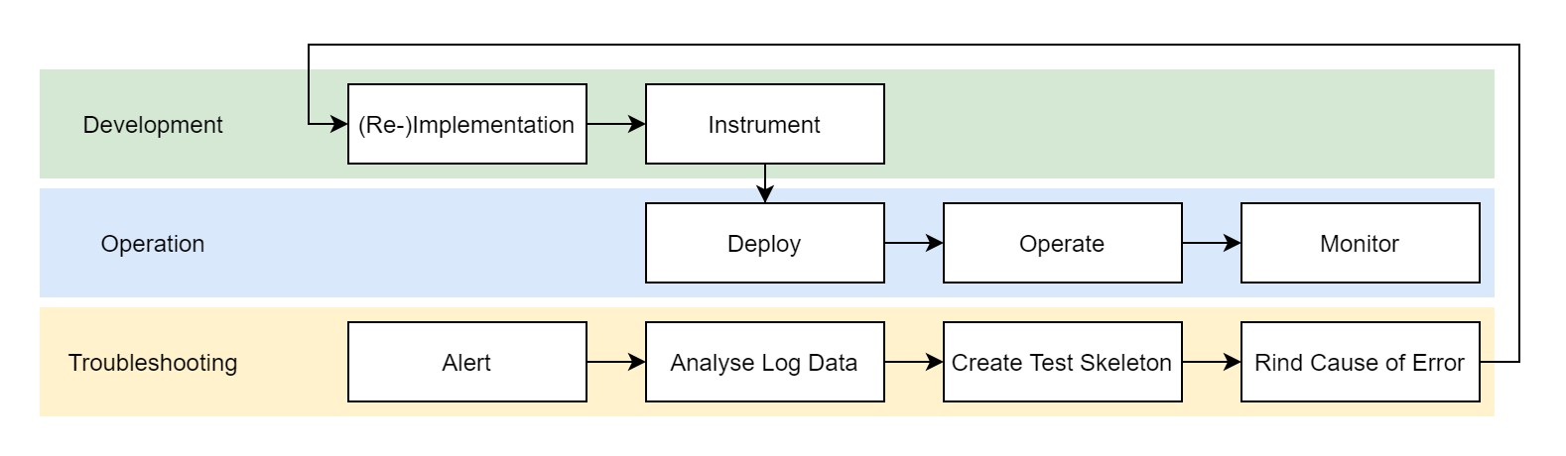

According to several papers [[RC17], [Bal+17]], the field of serverless, mainly Functions as a Service, exhibits a lack of monitoring, logging and debugging solutions [KS18]. Facing a lack of custom metrics, the operator solely relies on logging additional information needed, that are not provided by the platforms monitoring service. Not having access to the platforms infrastructure, bound to the autonomy of the cloud provider for provisioning his platform. Enabling precise debugging on the environment would, as stated by [MKW19], take away the provider’s control, to free capacity when not needed and scale functions as efficient as possible. Due to not having any control over the platform, it is crucial to monitor the functions constantly. In order to address this issue, Manner et al. provide a monitoring and debugging approach. Because of its comprehensiveness, it will be recommended to be used for setting up a monitoring and debugging solution for cloud vendor platforms. For convenience only, figure 9 shows the concept proposed by Manner et al. in a slightly modified way. The concept is split into three segments, namely development, operation and troubleshooting.

In the development-phase, the function should be implemented with three parameters that are going to be logged to an external database or monitoring service. These parameters are the input, the context and the output of the function which is being called. The limitation to three parameters is chosen, to not have too many repercussions on the execution time of the function. At the same time, the functions are providing enough data to reproduce failures when they occur [MKW19]. After the functions have been tested on a development account, they will be forwarded to the production account. As a result of this, a clear distinction between the production and the development account is not necessary since they are identical. In the second phase, the operational phase, the developer has to make use of monitoring services, which collect the data logged from each function. The received logging data will be further processed to determine a corridor for the execution times of a function. Whenever a function falls underneath a predefined execution time, an event will be triggered, which informs the operations team. In DevOps there is no seperation between developers and operatior. The developers are, as well as the operators, in charge of the product they have built, according to the concept: You build it, you run it!“. ”

With an alert beeing send, the troubleshooting-phase is launched. In order to create a test skeleton consisting of the three logged parameters, all functions failed or exceeding the corridor are filtered to retrieve their logging-data. Afterwards, the placeholders of the skeleton are replaced with the actual data to find the cause of the error [MKW19]. This process will ideally be combined with the development account, not to affect the performance of the production account. At last, it is essential to log the data asynchronously before the function returns a response. After returning a response, the container will be discarded immediately stopping any processing.

Looking at open-source frameworks, it is crucial to be aware of the modularity which comes along with Function as a Service. When monitoring an environment, logging data from services and complementary parts will be collected. The data collected has to be stored within a database, being able to run aggregation, sorting and other types of evaluation metrics upon. Implementing an open-source FaaS framework into existing infrastructure, function monitoring can be included in the present monitoring solution. Being in charge of the infrastructure, metrics can be collected on a far deeper scale, e.g. the container runtime itself and as well as from the underlying OS. In case the former landscape consists of several more extensive services, potential bottlenecks need to be determined and have to be eliminated. The bottlenecks could occur in the form of connection pools to databases and need to be adjusted. With potentially many functions, that again have many instances; the connection pool has to scale dynamically. Another solution is a central message queue; all functions can provide their logging data to. As the message queue usually is faster than the database, it will collect the asynchronously logged data and forward it to the database.

## Results

Hypothesis 1: Computational performance of a cloud function is proportional to function size. This is true for AWS Lambda and Google Cloud Functions, with the exception of about 5% cases when Google function runs faster than expected. This is not true for IBM and Azure since the performance does not depend on the function size. Hypothesis 2: Network performance (throughput) of a cloud function is proportional to function size. This is confirmed for AWS and Google, with the same restriction as Hypothesis 1. We have not measured transfers for IBM and Azure, so this still needs to be verified. Hypothesis 3: Overheads do not depend on cloud function size and are consistent for each provider. This hypothesis was generally confirmed for all the providers. Hypothesis 4: Application server instances are reused between calls and are recycled at regular intervals. This was nicely demonstrated by our experiments, and we also observed that the instance lifetime differs between providers. Hypothesis 5: Functions are executed on heterogeneous hardware. While we were able to get results only for two of four providers, we can clearly see that the hardware that runs FaaS infrastructure is heterogeneous. We have to note that, while our hypotheses are generally confirmed, the most interesting observations are those when we see some exceptions or deviations from the general patterns. The specific resource allocation policies as these of Google or different variances of the results have to be taken into account when making decisions about choosing the provider and the function size. Moreover, the price/performance analysis needs to be carefully performed to avoid unnecessary costs

Figure 10: Modified DevOps pipeline

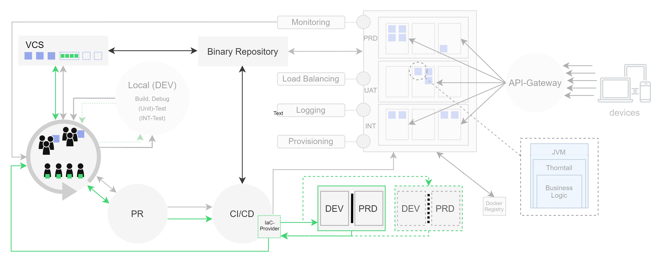

# Anwendung des Leitfadens

## Auswertung der Ergebnisse

With FaaS, memory problems are less dangerous. Any OBject affecting heap or stack, wont matter to the platform, due to the functions being suspeded after returning a resonse or exceeting the timelimit of the platfrom.

Configuring memory for thorntail JVM ... from the two GB a pod can provide Another issue that arises are scrity concerns.

### Beurteilung der Kollaborationsauswirkungen

### Beurteilung der Stabilität

### Beurteilung der Skalierbarkeit

### Beurteilung des Monitorings

### Beurteilung der Testmöglichkeiten

## Korrektur und Anpassungen

# Abschließende Betrachtung

## Absehbare Entwicklungen

[AAS19] Serverless immer mehr bekanntheit und mehr Papers etc. ... Später market für funktionen die optimiert sind etc. [SKM20]

Real time communication tool [SKM20]

Real time tracking gps [SKM20] da beide nicht auf dem Application state benötigen/ beruhen

[SKM20]

[Hel+18]

## Zusammenfassung

## Weiterführende Forschung

Serverless Computing: A Survey of Opportunities, Challenges and Applications store for functions [SBW19]

**References**

|  |  |
| --- | --- |
| [Wri+98] | Andrew Wright et al. “Compiling Java to a typed lambda-calculus: A preliminary report”. In: *International Workshop on Types in Compilation*. Springer. 1998, pp. 9–27. |
| [FK03] | Ian Foster and Carl Kesselman. *The Grid 2: Blueprint for a new computing infrastructure*. Elsevier, 2003. |
| [Fox+09] | Armando Fox et al. “Above the clouds: A berkeley view of cloud computing”. In: *Dept. Electrical Eng. and Comput. Sciences, University of California, Berkeley, Rep. UCB/EECS* 28.13 (2009), p. 2009. |
| [Liu+11] | Fang Liu et al. “NIST cloud computing reference architecture”. In: *NIST special publication* 500.2011 (2011), p. 292. |
| [MG+11] | Peter Mell, Tim Grance, et al. “The NIST definition of cloud computing”. In: (2011). |
| [Reg11] | Antonio Regalado. “Who coined ‘cloud computing’”. In: *Technology Review* 31 (2011). |
| [Pic13] | Roman Pichler. *Scrum: agiles Projektmanagement erfolgreich einsetzen*. dpunkt.  verlag, 2013. |
| [New15] | Sam Newman. *Building microservices: designing fine-grained systems*. ” O’Reilly Media, Inc.”, 2015. |
| [Bal+17] | Ioana Baldini et al. “Serverless computing: Current trends and open problems”. In: *Research Advances in Cloud Computing*. Springer, 2017, pp. 1–20. |
| [Eiv17] | Adam Eivy. “Be wary of the economics of” Serverless” Cloud Computing”. In: *IEEE Cloud Computing* 4.2 (2017), pp. 6–12. |
| [Fox+17] | Geoffrey C Fox et al. “Status of serverless computing and function-as-a-service (faas) in industry and research”. In: *arXiv preprint arXiv:1708.08028* (2017). |
| [MB17] | Garrett McGrath and Paul R Brenner. “Serverless computing: Design, implementation, and performance”. In: *2017 IEEE 37th International Conference on Distributed Computing Systems Workshops (ICDCSW)*. IEEE. 2017, pp. 405– 410. |
| [PS17] | Hussachai Puripunpinyo and MH Samadzadeh. “Effect of optimizing Java deployment artifacts on AWS Lambda”. In: *2017 IEEE Conference on Computer Communications Workshops (INFOCOM WKSHPS)*. IEEE. 2017, pp. 438–  443. |
| [RC17] | Michael Roberts and John Chapin. *What Is Serverless?* O’Reilly Media, Incorporated, 2017. |
| [SD17] | Josef Spillner and Serhii Dorodko. “Java code analysis and transformation into AWS lambda functions”. In: *arXiv preprint arXiv:1702.05510* (2017). |
| [BRH18] | Daniel Bardsley, Larry Ryan, and John Howard. “Serverless Performance and Optimization Strategies”. In: *2018 IEEE International Conference on Smart Cloud (SmartCloud)*. IEEE. 2018, pp. 19–26. |
| [Ben+18] | Alexander Benlian et al. “The transformative value of cloud computing: a decoupling, platformization, and recombination theoretical framework”. In: *Jour-* |

*nal of management information systems* 35.3 (2018), pp. 719–739.

|  |  |
| --- | --- |
| [Fow18] | Martin Fowler. “Serverless Architectures”. In: *martinfowler.com* (2018). https://www.martinfowle |
| [Hel+18] | Joseph M Hellerstein et al. “Serverless computing: One step forward, two steps back”. In: *arXiv preprint arXiv:1812.03651* (2018). |
| [IMS18] | Vatche Ishakian, Vinod Muthusamy, and Aleksander Slominski. “Serving deep learning models in a serverless platform”. In: *2018 IEEE International Conference on Cloud Engineering (IC2E)*. IEEE. 2018, pp. 257–262. |
| [IS18] | Vitalii Ivanov and Kari Smolander. “Implementation of a DevOps pipeline for serverless applications”. In: *International Conference on Product-Focused Software Process Improvement*. Springer. 2018, pp. 48–64. |
| [JC18] | David Jackson and Gary Clynch. “An Investigation of the Impact of Language Runtime on the Performance and Cost of Serverless Functions”. In: *2018 IEEE/ACM International Conference on Utility and Cloud Computing Companion (UCC Companion)*. IEEE. 2018, pp. 154–160. |
| [KS18] | Kyriakos Kritikos and Pawel Skrzypek. “A review of serverless frameworks”. In: *2018 IEEE/ACM International Conference on Utility and Cloud Computing Companion (UCC Companion)*. IEEE. 2018, pp. 161–168. |
| [Lin+18] | Wei-Tsung Lin et al. “Tracking causal order in AWS lambda applications”. In: *2018 IEEE International Conference on Cloud Engineering (IC2E)*. IEEE. 2018, pp. 50–60. |
| [L´op+18] | Pedro Garc´ıa L´opez et al. “Comparison of faas orchestration systems”. In: *2018 IEEE/ACM International Conference on Utility and Cloud Computing Companion (UCC Companion)*. IEEE. 2018, pp. 148–153. |
| [Man+18] | Johannes Manner et al. “Cold start influencing factors in function as a service”. In: *2018 IEEE/ACM International Conference on Utility and Cloud Computing Companion (UCC Companion)*. IEEE. 2018, pp. 181–188. |
| [MPDF+18] | Sunil Kumar Mohanty, Gopika Premsankar, Mario Di Francesco, et al. “An Evaluation of Open Source Serverless Computing Frameworks.” In: *CloudCom*. 2018, pp. 115–120. |
| [SS18] | Mohit Sewak and Sachchidanand Singh. “Winning in the era of serverless computing and function as a service”. In: *2018 3rd International Conference for Convergence in Technology (I2CT)*. IEEE. 2018, pp. 1–5. |
| [Adi+19] | Paarijaat Aditya et al. “Will Serverless Computing Revolutionize NFV?” In: *Proceedings of the IEEE* 107.4 (2019), pp. 667–678. |
| [AAS19] | Mohammed Al-Ameen and Josef Spillner. “A systematic and open exploration of FaaS research”. In: *ESSCA, Zurich, Switzerland, December 21, 2018*. CEURWS. 2019, pp. 30–35. |
| [Bro19] | Nicolas Brousse. “The issue of monorepo and polyrepo in large enterprises”. In: *Proceedings of the Conference Companion of the 3rd International Conference on Art, Science, and Engineering of Programming*. 2019, pp. 1–4. |
| [Cas+19] | Paul Castro et al. “The server is dead, long live the server: Rise of Serverless Computing, Overview of Current State and Future Trends in Research and Industry”. In: *arXiv preprint arXiv:1906.02888* (2019). |
| [Jon+19] | Eric Jonas et al. “Cloud programming simplified: A berkeley view on serverless |

computing”. In: *arXiv preprint arXiv:1902.03383* (2019).

|  |  |
| --- | --- |
| [Kap19] | Ayhan Kaplan. “Framework for migrating deployed serverless applications”. MA thesis. 2019. |
| [Kum19] | Manoj Kumar. “Serverless Architectures Review, Future Trend and the Solutions to Open Problems”. In: *American Journal of Software Engineering* 6.1 (2019), pp. 1–10. |
| [Lei+19] | Philipp Leitner et al. “A mixed-method empirical study of Function-as-a-Service software development in industrial practice”. In: *Journal of Systems and Software* 149 (2019), pp. 340–359. |
| [MKW19] | Johannes Manner, Stefan Kolb, and Guido Wirtz. “Troubleshooting Serverless functions: a combined monitoring and debugging approach”. In: *SICS SoftwareIntensive Cyber-Physical Systems* 34.2-3 (2019), pp. 99–104. |
| [PKC19] | Andrei Palade, Aqeel Kazmi, and Siobh´an Clarke. “An Evaluation of Open Source Serverless Computing Frameworks Support at the Edge”. In: *2019 IEEE World Congress on Services (SERVICES)*. Vol. 2642. IEEE. 2019, pp. 206–211. |
| [PFM19] | Maciej Pawlik, Kamil Figiela, and Maciej Malawski. “Performance considerations on execution of large scale workflow applications on cloud functions”. In: *arXiv preprint arXiv:1909.03555* (2019). |
| [Rac+19] | Louis Racicot et al. “Quality Aspects of Serverless Architecture: An Exploratory Study on Maintainability”. In: *Proceedings of the 14th International Conference on Software Technologies, ICSOFT*. 2019, pp. 26–28. |
| [SBW19] | Mohammad Shahrad, Jonathan Balkind, and David Wentzlaff. “Architectural implications of function-as-a-service computing”. In: *Proceedings of the 52nd Annual IEEE/ACM International Symposium on Microarchitecture*. 2019, pp. 1063– 1075. |
| [VE+19] | Erwin Van Eyk et al. “The SPEC-RG Reference Architecture for FaaS: From Microservices and Containers to Serverless Platforms”. In: *IEEE Internet Computing* (2019). |
| [Yus+19] | Vladimir Yussupov et al. “A Systematic Mapping Study on Engineering Functionas-a-Service Platforms and Tools”. In: *Proceedings of the 12th IEEE/ACM International Conference on Utility and Cloud Computing (UCC 2019)*. ACM, Dec. 2019, pp. 229–240. doi: 10.1145/3344341.3368803. |
| [SKM20] | Hossein Shafiei, Ahmad Khonsari, and Payam Mousavi. “Serverless Computing: A Survey of Opportunities, Challenges and Applications”. In: (2020). |

1. https://docs.aws.amazon.com/lambda/latest/dg/lambda-releases.html
2. https://github.com/cncf/wg-serverless
3. https://azure.microsoft.com/en-us/services/functions/
4. http://OpenWhisk.apache.org/
5. https://samnewman.io/patterns/architectural/bff/
6. https://awsinsider.net/articles/2017/06/20/voter-data-leak.aspx
7. https://searchsecurity.techtarget.com/news/450422962/Another-AWS-cloud-data-leakage-due-tomisconfiguration
8. https://yaml.org/
9. https://aws.amazon.com/de/lambda/
10. https://docs.aws.amazon.com/lambda/latest/dg/configuration-concurrency.html
11. https://kubeless.io/
12. https://kubernetes.io/docs/concepts/extend-kubernetes/api-extension/custom-resources/
13. https://github.com/kubeless/runtimes/tree/master/stable
14. https://docs.fission.io/
15. https://www.openfaas.com/
16. https://OpenWhisk.apache.org/
17. https://aws.amazon.com/lambda/
18. https://github.com/apache/OpenWhisk-composer
19. https://github.com/apache/OpenWhisk-composer
20. https://cloud.ibm.com/docs/OpenWhisk?topic=cloud-functions-limits
21. https://docs.microsoft.com/en-us/azure/azure-functions/durable/durable-functions-cloud-backup
22. https://serverless.com/
23. https://www.terraform.io/
24. https://aws.amazon.com/cloudformation/
25. https://serverless.com/pricing/
26. *https* : *//aws.amazon.com/de/serverless/sam/*?*nc*1 = *hls*
27. https://docs.microsoft.com/en-us/azure/azure-functions/functions-develop-local