https://fortune.com/company/sysco/fortune500/

https://www.fool.com/investing/stock-market/types-of-stocks/dividend-stocks/dividend-aristocrats/

https://www.simplysafedividends.com/intelligent-income/posts/139-sysco-a-food-distributor-paying-higher-dividends-every-year-since-1970

https://www.ers.usda.gov/topics/food-markets-prices/food-service-industry/market-segments/

* Highlight:

Sysco is **America’s biggest and most profitable wholesale food distributor**. While the Houston company took in $60.1 billion in 2019, up 2.4% from the year prior, it slid two places in the Fortune 500 rankings. Rising food costs, due to inflation and international tariffs, plus higher labor expenses, exacerbated by a shortage of commercial truck drivers, gnawed at the bottom line**. Regardless, Sysco grew profits by 17% to $1.6 billion**, partly through layoffs, subsidiary consolidation in France, and facility closures in Canada and Europe. Now, as the coronavirus pandemic shutters restaurants around the world, Sysco’s new CEO, **Kevin Hourican**, formerly of CVS Health, will have to figure out how to keep the business cooking.

Sysco Corporation is an American multinational corporation involved in marketing and distributing food products, smallwares, kitchen equipment and tabletop items to restaurants, healthcare and educational facilities, hospitality businesses like hotels and inns, and wholesale to other companies that provide foodservice (like **Aramark** and **Sodexo**).

Sysco, an acronym for **Systems and Services Company**, is the world's largest broadline food distributor; it has more than 600,000 clients in a wide array of fields. Management consulting is also an integral part of their services. The company operates approximately 330 distribution facilities worldwide; providing service to over 90 countries.

* History

Sysco: A Food Distributor Paying Higher Dividends Every Year Since 1970

Founded in **1969**, Sysco (SYY) is **the largest global distributor of food**, essentially acting as a **middleman** between food producers and retail consumers.

The company provides a full line of food products and non-food items to more than **650,000 customer** locations, including **restaurants (62% of sales)**, **schools and governments (9%)**, **hotels and travel companies (9%)**, **healthcare facilities (8%)**, and other **foodservice customers (12%)**.

Sysco sells fresh and **frozen meats (19% of revenue)**, canned and dry products (17%), frozen fruits, vegetables, and bakery items (15%), poultry (10%), dairy products (10%), fresh produce (8%), paper products (7%), seafood (6%), beverages (4%), janitorial products (2%), equipment (1%), and medical supplies (1%).

While Sysco has a presence in more than 80 countries, the U.S. is its most important region, accounting for more than **70% of total revenue**.

* The Business

At the end of the day, food manufacturers need **a cost-efficient way** to get their products to retailers, restaurants, and consumers.

The best operators offer **prompt and accurate delivery of orders**, a **broad assortment of products**, and **competitive pricing**. Since distributors are middlemen, their margins are very low (Sysco's operating **margin has averaged less than 5%** over the last decade), and players must either establish themselves as price or niche leaders in a given region.

Not surprisingly, Sysco’s scale plays a big advantage. Since its formation 50 years ago, Sysco has grown its **annual revenue from $115 million to more than $60 billion** (acquisitions have been a significant growth driver).

As the **largest food products distributor** in North America with approximately **16% share of the $300 billion foodservice market in the U.S**., Sysco works with thousands of suppliers to offer the broadest assortment of products (over **400,000**) on favorable terms.

Few companies have the **capital, supply chain network, and expertise** to match Sysco’s assortment.

However, locally managed customers such as **independent restaurants** are **more profitable** for Sysco since they **can't command meaningful volume discounts**. In this market segment, the company generates **nearly half of its revenue from Sysco-branded products which carry higher margins**.

Besides being able to serve large and small businesses, **Sysco's network of warehouses and distribution systems (more than 14,000 delivery vehicles)** allows it to offer **daily delivery** to most of its customers and provide very competitive rates.

With a **dense delivery network around its warehouses** (thanks to serving 650,000 customer locations), Sysco can **leverage its fixed costs to offer more competitive pricing** than other distributors that attempt to play in its geographic regions.

* Numbers

Still profitable first half of fiscal year despite -23% decline in the top-line results

Still gaining market share

16% market share of 300-billion-dollar market

We serve 50% of independent restaurant in U.S.

Only investment grade foodservice distributor

In 2019, the share of food at home was 45.2 percent, and **food away from home was 54.8 percent**.

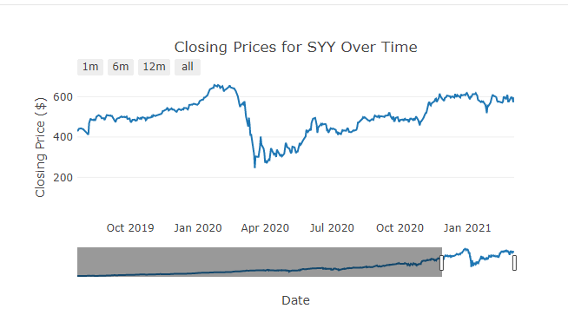

Transferable Skills:

* Great team player
* Problem solver
* Quick learner
* Great communication skills
* Computer / Technology savvy
* Research skills / know how to find the answers
* Delivery good results under pressure / tight timelines
* Excellent customer service