Revision History
Date Description Author Comments
December | Version 1 | Yegeta Fekadu | First Draft
November | Version 2 | Yegeta Fekadu | Final Draft

Document Approval

The following Software Requirements Specification has been accepted and approved by the following:

Signature Printed Name Title Date
 | Mr. Betsegaw Lemma | Advisor

Table of contents

Definitions, Acronyms, and Abbreviations

Admin: Administrator
FR: Functional Requirements
HTTP: Hypertext Transfer Protocol
SRS: Software Requirement Specification
TCP/IP: Transmission Control Protocol/ Internet Protocol
UC: Use Case
UX: User Experience

DECLARATION

1. Introduction

1.1 Purpose

1.2 Scope

1.3 Overview

2. General Description

2.1 Product Perspective

2.2 Product Functions

2.3 User Characteristics

2.4 General Constraints

2.5 Assumption and Dependencies

3. Specific Requirements

3.1 External Interface Requirements

3.1.1 User Interfaces

3.1.1.2 User interfaces Prototype

3.1.1.2.1 Sign in for Admin

3.1.1.2.2 Add Houses

3.1.1.2.3 Remove Houses

3.1.1.2.4 Users Home Page

3.1.1.2.5 View House

3.1.1.2.6 Search House

3.1.1.2.7 Create Account

3.1.1.2.8 Contact Us

3.1.2 Hardware Interface
The system doesn’t Require Hardware interface

3.1.3 Software Interface

3.1.4 Communication Interface

3.2 Functional Requirements
3.2.1 FR-01 View House
Table 1: View house
Name | FR-01 View House
Introduction | The system shall allow the user view houses
Description | The system shall allow the user want to view different houses
Input | None
Output | Display houses
Error handling | The system shows an error when user is unable to view the houses

3.2.2 FR-02 Search House
Table 2: Search House
Name | FR-02 Search House
Introduction | The system shall allow the user search houses
Description | The system shall allow to find wanted house by key word and the system contains categories and places
Input | House type or place
Output | Display the searched and related houses
Error handling | The system shows a message when a user searched for wrong key word

3.2.3 FR-03 Rent House
Table 3: Rent House
Name | FR-03 Rent House
Introduction | The system shall allow the user rent house
Description | The system shall allow the users to rent houses online from the system
Input
Output
Error handling | The system

3.2.4 FR-04 Add House
Table 4: Add House
Name | FR-04 Add House
Introduction | The system shall allow the admin add houses
Description | The system shall allow add houses for addition of new houses
Input | House information
Output | Successfully add new houses
Error handling | The system will not allow the admin to add house if their credential is not correct

3.2.5 FR-05 Remove House
Table 5: Remove House
Name | FR-05 Remove House
Introduction | The system shall allow the admin remove houses
Description | The system shall allow removal of rented houses
Input | House information
Output | Successfully remove rented houses
Error handling | The system will not allow the admin to remove house if their credential is not correct

3.2.6 FR-06 Tour Guide
Table 6: Tour Guide
Name | FR-06 Tour Guide
Introduction | The system shall allow the users to get tour guide
Description | The system shall allow the users get tour guide when they rent the house
Input
Output
Error handling

3.3 Use Cases

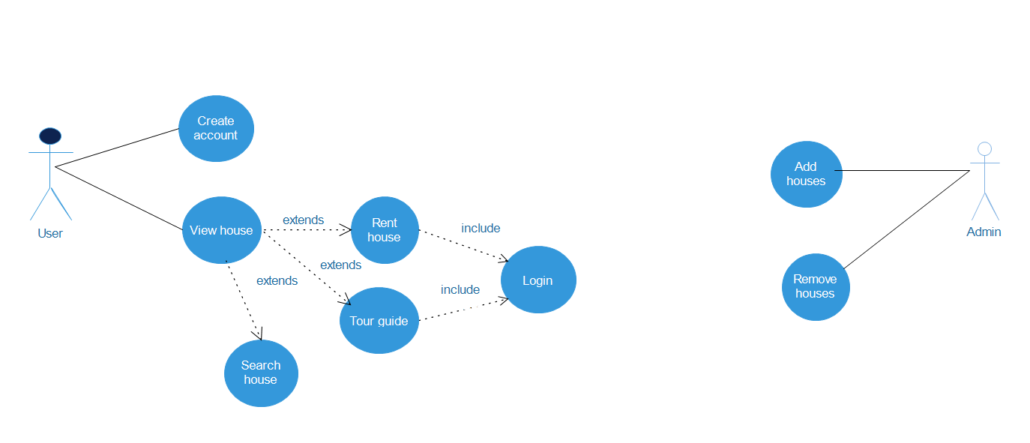

UC-01: View House
Use Case Name: View House
Goal: The user needs to view any house posted
Primary Actor: User
Scope:
Level: User
Success End: User has view house
Failure End: User unable to view house
Trigger: Opening the web page
Main Success Scenario
1. User opens the web page
2. System display houses

UC-02: Search House
Use Case Name: Search House
Goal: The user needs to search houses
Primary Actor: User
Scope:
Level: User
Success End: User has search house he/she wanted
Failure End: User unable to search house
Trigger: Opening the web page
Main Success Scenario
1. User selects the search house option
2. User enters search item into search box
3. System displays the searched and related house
Variations
2a.1 User searches houses by filter (by place, by type,…)
3a.1 System shows the searched house does not exist

UC-03: Rent House
Use Case Name: Rent House
Goal: The user needs to rent house
Primary Actor: User
Scope:
Level: User
Preconditions:
Success End: User have rented a house
Failure End:
Trigger:
Main Success Scenario
1. User choose a specific house
2. User selects rent house option
3. System displays confirmation message
4.
UC-04 Add House
Use Case Name: Add House
Goal: The admin wants to add new houses into the system
Primary Actor: Admin
Scope:
Level: Admin
Precondition: Admin must be logged in
Success End: Admin added new house
Failure End: System fails to add a new house
Trigger: New houses are available
Main Success Scenario
1. Admin opens web page
2. System displays web page with login screen
3. Admin inputs his/her credentials
4. Admin selects add house option
5. System displays required information about the house
6. Admin inputs required information about the house
7 Admin confirm to register changes
Extensions: 5a. The house already existed
5a.1. system shows the house is already exist to the admin

UC-05 Remove House
Use Case Name: Remove House
Goal: The admin wants to remove rented houses from the system
Primary Actor: Admin
Scope:
Level: Admin
Precondition: Admin must be logged in
Success End: Houses are no longer member of the system
Failure End: System fails to remove rented houses
Trigger: Admin requires to remove houses
Main Success Scenario
1. Admin selects remove house option
2. System displays selected information
3. Admin confirm to delete house
4. System confirm admin registration changes

UC-06 Tour Guide
Use Case Name: Tour Guide
Goal:
Primary Actor:
Scope:
Level:
Success End:
Failure End:
Trigger:
Main Success Scenario

UC-07 Create Account
Use Case Name: Create Account
Goal:The user wants to be member
Primary Actor: User
Scope:
Level: User
Success End: User has created account successfully
Failure End: User unable to create account
Trigger: User wants to member of the system
Main Success Scenario
1. System displays the web page with create account screen
2. System requests the user’s information
3. User enter required information
Extensions
3a User does not fill the required information
3a.1 System popups an error message indicating to fill the input
3a.2 System cannot find the user’s email address
UC-08 Log In
Use Case Name: Log In
Goal:
Primary Actor: User
Scope:
Level: User
Success End: User has log in successfully
Failure End: User not able to log in
Trigger: User wants to log in to her/his account
Main Success Scenario
1. User opens login page
2. System displays login form
3. User enter her/his credential
4. System verify account
5. System redirect to specific page
Extensions
3a. Error Name/Email Address
3a.1 System popup error message
3a.2 System return to login form
3b. Error password
3b.1 System popup error message
3b.2 System return to login form

3.4 Non-Functional Requirements
3.4.1 Performance:
3.4.2 Reliability:
3.4.3 Availability:
3.4.4 Security:
3.4.5 Usability:
3.5 Inverse Requirements

3.6 Design Constraints

3.7 Logical Database Requirements
Table 6: Database Structure
Data | Attributes | Use
House data | House cost  Place of house | This data gives ease of access to user for where the house located and the price of the house.
Transaction data
Membership data | Username / Email  Password | Uses to verify members

Entity Relationship (ER) Diagram
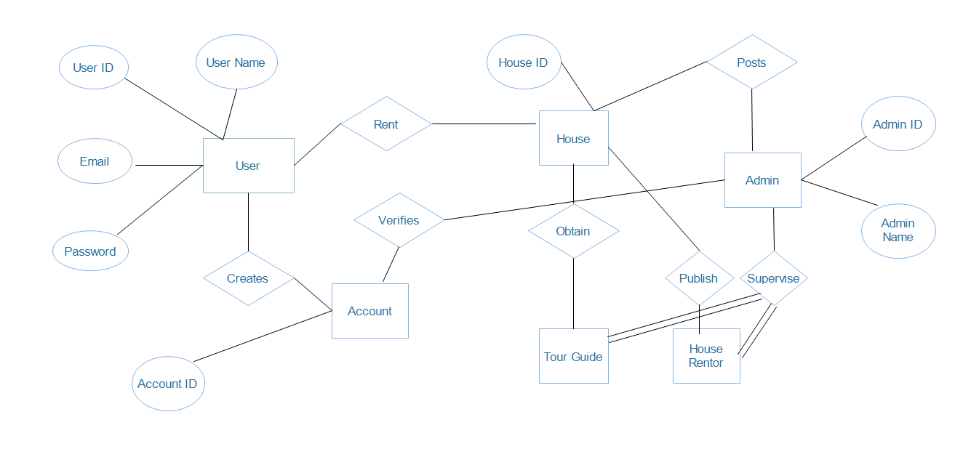
Figure 10: ER Diagram

3.8 Other Requirements

4. Change Management process

References

