Critique of Crossing-Based Pointing Interaction
I have chosen to critique a very popular pointing technique that is found in many pen-based or gesture-driven interfaces such as Microsoft paint, Figma, and other creative-based applications known as crossing-based pointing and interaction. An example is given below. Instead of requiring users to click on a target, this method allows the user to select items by simply moving the cursor across a boundary or through an element. It aims to streamline user interactions by eliminating the need for clicking and grouping many different projects.

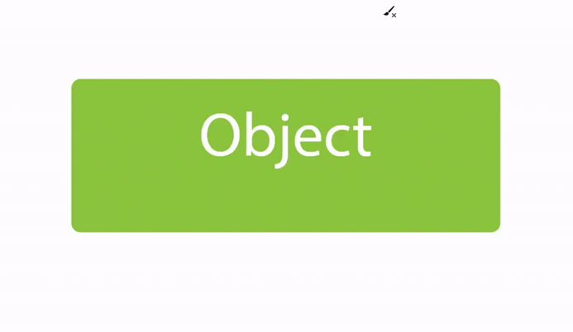

How does it work?
In a typical crossing interaction, users will move the cursor across predefined activation zones to trigger actions such as selection. For example, a menu may consist of horizontal bars, and instead of clicking on each individual an item, users activate it by moving the cursor through the menu option. The system detects when the pointer enters and exits a region, registering a selection once the crossing is completed. Others incorporate gesture-based crossings, allowing users to select multiple items in one motion.
Flaws and Possible Improvements:
Unfortunately, crossing-based interaction has several weaknesses. One major issue is accidental selection—since movement alone is used to trigger actions, users may unintentionally activate items while navigating. This can be frustrating, especially in dense UI layouts where multiple selectable elements are close together. Another drawback is lack of feedback. Unlike clicking, which gives an immediate tactile response, crossing often relies on subtle visual changes (such as color shifts) that can be easy to miss. This makes it harder for users to feel confident in their selections.

Lastly, precision is a challenge when dealing with small or closely packed targets. If menu items or buttons are too narrow, users may find it difficult to cross only the intended option, leading to selection errors. While crossing interaction is a creative alternative to clicking, these usability issues show that it still needs refinements to be a truly seamless selection method.

