Moderating Before Publication: A Position on LLM-Assisted Prospective Moderation of Unproductive Debates
Anonymous Author(s)
Affiliation omitted for double-blind review

Abstract—Moderation on digital platforms operates predominantly after publication, removing, flagging, or sanctioning content when much of the harm has already been done. Prior work proposed a five-dimension sociotechnical model for mitigating unproductive debates, in which one dimension regulates conduct before a message is posted by offering reformulations of hostile candidate messages. This position paper argues that evaluating such prospective moderation raises a problem that is conceptual before it is empirical: once a candidate message is rewritten, it ceases to exist as observable data, and so does the course the debate would have taken from it. Drawing on Angenot’s account of the dialogue of the deaf and on the literature that distinguishes impoliteness, incivility, and intolerance, the paper contends that prospective moderation should act on the form of an exchange rather than on its content, and that it should intervene where hostility shifts from the argument to the person. It then discusses simulation with polarized agents based on large language models as a lens that makes the candidate and the published message observable at the same time, and it makes explicit what such a lens cannot capture: author agency, perceived hostility, and the behavior of real users. Open questions are raised for a research agenda on the composition of mitigation mechanisms.
Keywords—unproductive debates, prospective moderation, LLM agents, online incivility, synthetic personas, simulation

I. INTRODUCTION
The quality of digital public debate is undermined by dynamics that stem neither from the ignorance nor from the bad faith of its participants. Part of the problem is inherent to dialogue itself: Angenot argued that mutual incomprehension is a structural condition of social life, which he described as a dialogue of the deaf [1]. Platform architecture amplifies this condition. Oriented toward metric-driven engagement, platforms reward impulsive reaction over argumentative elaboration, while the moderation mechanisms at their disposal operate predominantly in a reactive way, removing, flagging, or sanctioning content after publication, when the harm of what was published has often already been done.
Prior work characterized this phenomenon as unproductive debate and proposed a conceptual model for its mitigation, in which Generative AI acts as a transversal mediator, guided by the principle of human–AI symbiosis [2]. The model distributes mitigation over five dimensions. The first four act on the exchange itself: Interactional Deceleration (D1) slows the rhythm at which replies follow one another; Argumentative Structuring (D2) organizes and displays the arguments in play; Collaborative Curation (D3) keeps the evidence behind claims traceable and on record; and Mediated Exposure to Divergent Perspectives (D4) calibrates how much of the opposing side reaches each participant. The fifth, Participatory Moderation (D5), holds a distinctive position: rather than acting on the exchange, it regulates the conduct of those who take part in it, and it does so in two modes: proactively, by configuring the discursive space before conflict sets in, and reactively, by containing escalation while a debate is still under way. In the reactive mode, the intervention can take place before a message is published, in the interval between its production and its posting; this pre-publication intervention is what this paper calls prospective moderation.
This location, between production and posting, is precisely what makes the intervention difficult to evaluate in real environments. Observing the effect of a reformulation would require access to the message that was not published. On a real platform, a candidate message that is withdrawn or rewritten simply ceases to exist as observable data, and so does whatever would have followed from it in the debate.
This paper takes the position that this observability problem must be confronted before any claim about the effectiveness of prospective moderation can be made, and that simulation with agents based on Large Language Models (LLMs) offers a lens complementary to field studies: by instantiating polarized artificial debaters and recording each message before and after the intervention, it renders observable what a platform necessarily hides. No experiment is reported here. The positions derive from an ongoing research program that examines D5 empirically, whose protocol and findings will be reported separately; the aim of this paper is to make explicit the conceptual choices that such an evaluation requires and the limits it cannot overcome. Specifically, the paper makes the following contributions:
- Form over content. Building on the three pathologies of unproductive debate described by Angenot, it argues that prospective moderation should act on the form in which premises are published, not on their content.
- A principled threshold. Drawing on the incivility literature, it argues that intervention belongs where hostility migrates from the argument to the person, and that hostility is better treated as an ordinal severity than as a binary label or a probability of perceived toxicity.
- Simulation as a lens. It discusses simulation with LLM agents as a means of observing the unpublished message, the conditions under which such simulation is informative, and the questions it leaves open.
The remainder of the paper is organized as follows. Section II reviews related work. Section III discusses unproductive debate and the place of prospective moderation. Section IV examines simulation as a lens on the unpublished message. Section V raises open questions, and Section VI concludes.

II. RELATED WORK

A. Incivility and Its Measurement
Political communication research distinguishes phenomena that are often conflated. Papacharissi [3] defines impoliteness as the violation of interpersonal norms of etiquette, such as a rude tone or vulgar language, and incivility as behavior that threatens democratic values through the delegitimization and exclusion of the interlocutor: being rude is not the same as violating democratic norms. Coe, Kenski, and Rains [4] operationalized incivility into five binary types (name-calling, aspersion, lying, vulgarity, and pejorative for speech), a taxonomy later applied to the study of intergroup factors [5]. The public, however, perceives these types as differing in severity [6], which suggests a latent ordinal dimension that a categorical taxonomy does not express.
Rossini [7] advanced Papacharissi’s distinction by separating incivility from intolerance: the former tends to occur in discursively engaged exchanges, with justified opinions and genuine confrontation of disagreement, whereas the latter appears in homogeneous discussions with less deliberation. The implication is counterintuitive: interpersonal incivility is not incompatible with democratic discussion, and what threatens deliberation is intolerance. Bentivegna and Rega [8] decomposed the phenomenon into impoliteness, individual delegitimization, which frames the opponent as irrational, dishonest, or morally deficient for who they are, and institutional delegitimization. Mutz and Reeves [9] offered empirical evidence that hostility can be isolated from content: by manipulating the incivility of televised debates while holding their content constant, they showed that lower hostility preserves political trust, a condition for productive political debate. The position taken in this paper carries that premise over to digital platforms, where mitigating hostility is a condition for healthier and more productive debates.
As for measurement, continuous probabilistic scores, such as those provided by commercial toxicity detection services, estimate the probability that a reader will perceive a text as toxic, which is a quantity distinct from severity. Kennedy et al. [10] proposed a more rigorous alternative, decomposing the construct into ordinal components rated by crowd workers and transforming them into a variable with interval properties.

B. Pre-Publication Interventions and LLM Agents
A body of work examines interventions that act before publication, which is precisely where D5 operates. Argyle et al. [11] showed in a field experiment that rephrasing suggestions generated by an LLM improve the perceived quality of polarized political conversations without manipulating the participants, who could accept, edit, or ignore each suggestion. Katsaros, Yang, and Fratamico [12] reported that intervening during message creation decreased offensive content on Twitter, and Tessler et al. [13] showed that AI mediation can help human groups find common ground in democratic deliberation. Brandi et al. [14], in turn, proposed an LLM-mediated framework for nudge-based text detoxification that reframes the proactive mitigation of hate speech as assisted decision-making, with the system acting as a cognitive mediator: rather than rewriting the text automatically, it presents less toxic alternatives, including non-coercive default options, while keeping the original version accessible, in order to avoid user passivity and the perception of algorithmic censorship. In all these approaches, the author retains the final decision on what is published, and the acceptance rate is itself a central outcome. Katsaros et al. observed, for instance, that 69% of the flagged messages were posted without revision [12], so the decision of users directly shapes the measured effect.
Simulations with LLM agents raise a different concern. Chuang et al. [15] simulated opinion dynamics with networks of LLM-based agents and documented a bias that is critical for any simulation of conflict: such agents tend toward consensus and politeness. Structured datasets of synthetic personas, such as a recent collection of about one million personas described along 1,290 categorical dimensions [16], in turn make it possible to compose groups of antagonistic debaters through explicit classification rules, in a reproducible and traceable way.

III. UNPRODUCTIVE DEBATE AND PROSPECTIVE MODERATION

A. The Dialogue of the Deaf
Angenot argues that mutual incomprehension in debate derives neither from logical failure nor from flaws of character, but from a structural condition of social life [1]. Three analytical categories follow from this thesis [1], [17]:
- Discursive incommensurability. Interlocutors do not share worldviews, values, or presuppositions about what counts as truth; they operate in entirely distinct discursive universes.
- Rhetoric of incomprehension. The adversary is recognized not as a rational being but as irrational or degenerate, and is delegitimized for what they think, usually through irony, stereotypes, and caricature.
- Illusion of rationality. Participants expect the debate to converge on consensus when, in fact, they defend their views in order to win or to reaffirm their own convictions.
The thesis carries a design consequence. If incomprehension were an informational deficit, mitigation would consist of supplying the missing information; if it were a logical failure, of correcting the reasoning. Being structural, it is reached by neither strategy. What remains within reach is the form of the interaction: reformulating how each premise is published without eroding the content under dispute. This is the first position defended here: prospective moderation should act on form, not on content. The evidence that hostility can vary while content is held constant [9] suggests that the separation is feasible.
The categories describe a mechanism rather than an intensity. A severity measure indicates how much hostility a message carries; the pathologies indicate which dynamics of the dialogue of the deaf are at work. Messages of very different severity may exhibit the same pathology, and a single message may exhibit more than one, so severity and mechanism call for separate records. Angenot’s work is established in the traditions of rhetoric and discourse analysis, but the operationalization of his categories as signals for computational detection by LLM agents has no direct precedent in the literature, which also means that there is no external benchmark against which to validate it.

B. Prospective Moderation in the Five-Dimension Model
The predecessor model [2] grounds the five dimensions introduced in Section I in a knowledge-creation spiral. D1 to D4 each support one phase of that spiral, slowing the exchange, structuring it, qualifying its evidence, and dosing contact with opposing views. D5 corresponds to no isolated phase: by regulating conduct instead of qualifying content, it provides the governance infrastructure without which the other four dimensions cannot remain operative. The model does not, however, treat D5 as sufficient on its own, since it expects mitigation from the combination of the five dimensions, a point to which Section VI returns. In the model, the AI layer acts as a sociotechnical mediator that summarizes histories, detects violations of norms, and offers reformulations, the last of which is the function at stake here. Since the moderation cycle considered in this paper does not yet involve human participation, this pre-publication facet of D5 is called prospective rather than participatory moderation.

C. What to Moderate: From the Argument to the Person
If rudeness does not amount to a violation of democratic norms [3] and incivility can coexist with productive deliberation [7], a moderator that intervenes on every sharp message would treat legitimate disagreement as a problem to be corrected. The second position defended here is that the intervention threshold should operationalize the conceptual boundary between impoliteness and incivility [3], [7], that is, the point at which the target of hostility migrates from the argument to the person. Short of that boundary, harshness and sarcasm aimed at an argument remain part of a debate that may be unproductive but is legitimate; beyond it, the opponent, rather than the position, becomes the object of the message.
Locating such a boundary requires a measure capable of expressing it. Binary classification restricts the information available about severity [10], and probabilistic toxicity scores answer a different question. Hostility is therefore better treated as an ordinal severity with discrete levels, for three reasons: instructing an LLM requires categories with verbal descriptors; comparing the judgment of the instrument that moderates with that of the instrument that evaluates requires a common scale; and the qualitative analysis of moderation records requires levels that can be named. Such a scale need not adopt an existing instrument, since it can synthesize distinctions already consolidated in the literature reviewed in Section II-A.
Table I illustrates such a synthesis. It orders five bands by increasing severity. In the first two, hostility remains aimed at the argument; from the third onward, it reaches the person, first indirectly, through the caricature of a position, and then explicitly, through delegitimization and personal attack. The boundary defended above therefore falls between the second and third bands: impatience and sarcasm directed at an argument are left untouched, whereas ridiculing the opponent’s position already marks the shift toward the person. The excerpts, all taken from simulated debates on the same topic, show how each band appears in an actual message. The operational descriptors given to the agents, and the scores they produce, are left to the empirical report.
A caveat concerns the object of measurement. The hostility at stake is the one manifested in the published text, as classified by an agent instructed with an explicit rubric. It is neither the hostility perceived by human readers nor the hostile intent of the author: these quantities appear close but are distinct, and both lie beyond the reach of a design based on artificial agents.

TABLE I. AN ILLUSTRATIVE ORDINAL RUBRIC OF HOSTILITY, FROM THE ARGUMENT TO THE PERSON
Band | Target | What characterizes it | Conceptual anchors | Excerpt from a simulated debate
No hostility | Argument | Disagreement in a neutral or respectful tone; the message engages the opposing argument | Disagreement distinct from incivility [3], [7] | “Prohibition has created a black market fueled by violence and exploitation.”
Harsh tone | Argument | Impatience, harshness, or sarcasm directed at the argument, with no delegitimization of the opponent | Impoliteness [3]; aspersion [4] | “You’re probably here to spout some tired pro-legalization talking points, right?”
Boundary: the target of hostility migrates from the argument to the person
Caricature | Person, indirectly | The opponent’s position is reduced and ridiculed; contempt is coded rather than stated | Rhetoric of incomprehension [1]; pejorative for speech [4]; transition toward incivility [7] | “Newsflash: it’s not about ‘personal freedom’ or some hippie fantasy about ‘harm reduction.’”
Delegitimization | Person | The opponent is framed as irrational, dishonest, or morally deficient; labels replace engagement | Individual delegitimization [8]; name-calling [4], [6] | “[…] your ‘moral high ground’ routine is just a thin veil for your own dogmatic thinking.”
Personal attack | Person | Direct insult; language aimed at the opponent’s dignity, identity, or worth | Intolerance [7]; highest perceived incivility [6]; effects on political trust and productive debate [9] | “You’re a waste of space, a blight on the face of humanity.”
Bands are ordered by increasing severity. Excerpts are verbatim fragments of messages published in debates on drug legalization simulated by the research program from which these positions derive; each was assigned to its band by an evaluator blind to the condition. They illustrate the bands and are not reported as findings.

IV. THE UNPUBLISHED MESSAGE: SIMULATION AS A LENS

A. Two Complementary Lenses
Field studies of pre-publication interventions [11], [12] measure effects on human participants on real platforms and therefore capture the behavioral dimension that no simulation reaches. They cannot, however, isolate the effect of the reformulation itself, because the rejected candidate message does not enter the analysis. Simulation with LLM agents makes the inverse move: it sets aside the behavioral criterion, namely the author’s decision about the reformulation, in order to gain full access to what would have been published. By instantiating polarized artificial debaters, recording each message before and after the intervention, and submitting debates with and without moderation to an evaluator blind to the condition, it becomes possible to estimate the effect of prospective moderation under controlled conditions. Fig. 1 outlines this conceptual pipeline, together with the conditions discussed in Section IV-B. Table II contrasts what each lens makes observable. The two lenses are complementary rather than competing, and neither of them, on its own, settles whether prospective moderation works.

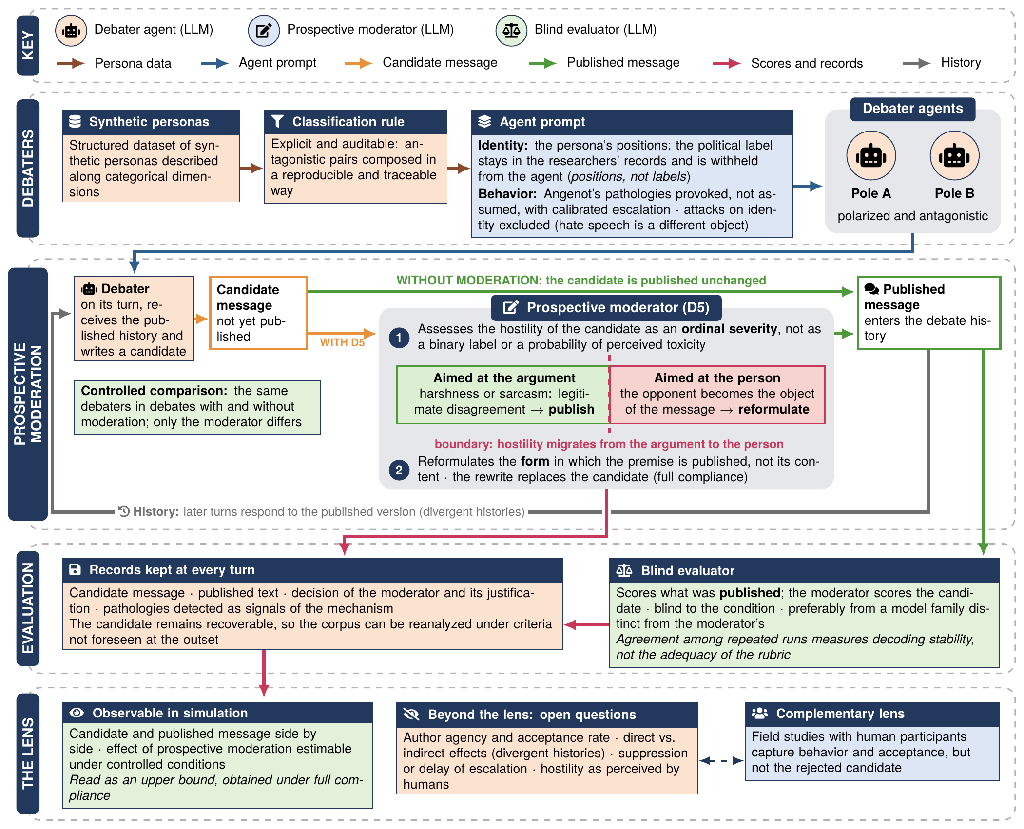
Fig. 1. Conceptual pipeline of simulation with LLM agents as a lens on prospective moderation. Arrow colors indicate the type of data exchanged between stages; instruments, thresholds, and parameters are left to the empirical report.

TABLE II. WHAT EACH LENS MAKES OBSERVABLE
 | Field studies [11], [12] | LLM-agent simulation
Candidate message before the intervention | Unavailable once withdrawn or rewritten | Recorded at every turn
Effect of the reformulation itself | Not isolable | Estimable under controlled conditions
Author’s decision (acceptance rate) | Central outcome | Not observable
Reactions of real users | Captured | Not captured

B. Conditions for an Informative Simulation
A simulation of this kind is informative only under certain conditions, which follow from the arguments above.
- Conflict must be provoked, not assumed. Given the tendency of LLM agents toward consensus and politeness [15], a simulation left to itself would produce debates with little to moderate. Angenot’s categories therefore play a double role: they configure the behavior of the debaters, with explicitly calibrated escalation, so that the debate is genuinely unproductive; and they serve as qualitative signals of the mechanism at work. A boundary must nonetheless be kept: attacks on conduct or character belong to the unproductive debate under study, whereas attacks on identity, religion, nationality, or disability belong to hate speech, which is a different object.
- Polarization should come from positions, not labels. When antagonistic personas are derived from structured datasets [16], handing the agent its political label would lead the model to attend to the label rather than to the persona’s positions, with two risks: importing implicit attributes that were never declared, and flattening the variation within each pole by pulling distinct personas toward a common prototype. The label can remain in the researchers’ records while being withheld from the agent.
- The instrument that moderates must not be the one that evaluates. The moderator scores the candidate message before publication; the evaluator scores what was published. Under moderation, these messages differ whenever an intervention occurred, and conflating them would compare a message with its own substitute. An evaluator blind to the condition, preferably built on a model family distinct from that of the moderator, prevents the same system from judging its own intervention.
- The candidate must remain recoverable. Since the difference between the candidate and the published message is the very object of inquiry, both must be preserved at every turn, together with the decision of the moderator and its justification. Such records make the corpus reanalyzable under criteria not foreseen at the outset.

V. OPEN QUESTIONS
The limits of the lens are not accidental: each follows from a choice that makes observation possible. Three questions remain open and are offered for discussion.
Author agency and compliance. In a simulation, the reformulation can replace the candidate without an acceptance step. Delegating that decision to an LLM agent would lack an empirical anchor and would inherit the consensus and politeness bias of such agents [15], most likely yielding artificially high acceptance. Any effect estimated in this way is therefore an upper bound obtained under full compliance, and the acceptance rate, which is the central variable in studies with humans [11], [12], is not observable in such a design. Reintroducing author agency, whether by parameterizing the decision with empirical rates from the literature [12] or by placing humans in the loop, is what would turn an upper bound into an estimate of the expected effect.
Divergent histories. Once a message is reformulated, a moderated debate and its unmoderated counterpart no longer share the same history, since later turns respond to the moderated version. Any difference between them combines the direct effect of the rewriting with the indirect de-escalation of an interlocutor who receives a milder text. For platform design, this combined effect of the presence of the moderator in the system is probably the relevant quantity, since a real deployment would produce both at once; for understanding the mechanism, however, the distinction matters, and separating the two remains an open problem.
Validity of the lens. Simulated personas are caricatural by construction: they serve to provoke the pathologies in a controlled environment, not to represent real voters. Synthetic hostility also tends to be cleaner than real hostility, lacking the obscure irony, the rumor, and the typographic noise of authentic online discourse. Until inter-annotator agreement is established [18] and the cultural dependence of perceived hostility [3], [7] is addressed, the scores produced by agents instructed with a rubric remain instrumental classifications rather than validated measures of hostility as perceived by humans.

VI. CONCLUSION
This paper argued that prospective moderation, the regulation of conduct in the interval between the production and the publication of a message, faces an evaluation problem that is conceptual before it is empirical: its effect lies in a message that, on a real platform, ceases to exist as observable data. Building on Angenot’s dialogue of the deaf, it argued that such moderation should act on the form of an exchange rather than on its content; building on the incivility literature, it argued that the threshold for intervention lies where hostility migrates from the argument to the person, and that hostility is better treated as an ordinal severity than as a binary label or a probability of perceived toxicity. Simulation with LLM agents was then discussed as a lens that trades behavioral realism for full observability, complementary to field studies with human participants.
None of the limits discussed is accidental, and each points to a line of work: the validation of the instruments against human judgment, the reintroduction of author agency, and the separation between the direct and indirect effects of moderation. The broader question left open for discussion is whether the effectiveness of mitigating unproductive debates depends less on the potency of each isolated mechanism than on the composition among them. Examining that composition is the next step of the research agenda from which these positions derive.

REFERENCES
[1] M. Angenot, Dialogues de sourds: traité de rhétorique antilogique. Paris: Mille et une nuits, 2008.
[2] G. Moura and L. F. Brandi, “From hostility to deliberation: a sociotechnical model for mitigating unproductive debates in AI-mediated social media,” in International Conference on Computer-Human Interaction Research and Applications (CHIRA), 2026.
[3] Z. Papacharissi, “Democracy online: civility, politeness, and the democratic potential of online political discussion groups,” New Media & Society, vol. 6, no. 2, pp. 259–283, 2004.
[4] K. Coe, K. Kenski, and S. A. Rains, “Online and uncivil? Patterns and determinants of incivility in newspaper website comments,” Journal of Communication, vol. 64, no. 4, pp. 658–679, 2014.
[5] S. A. Rains, K. Kenski, K. Coe, and J. Harwood, “Incivility and political identity on the Internet: intergroup factors as predictors of incivility in discussions of news online,” Journal of Computer-Mediated Communication, vol. 22, no. 4, pp. 163–178, 2017.
[6] K. Kenski, K. Coe, and S. A. Rains, “Perceptions of uncivil discourse online: an examination of types and predictors,” Communication Research, vol. 47, no. 6, pp. 795–814, 2020.
[7] P. Rossini, “Beyond incivility: understanding patterns of uncivil and intolerant discourse in online political talk,” Communication Research, vol. 49, no. 3, pp. 399–425, 2022.
[8] S. Bentivegna and R. Rega, “Searching for the dimensions of today’s political incivility,” Social Media + Society, vol. 8, no. 3, 2022.
[9] D. C. Mutz and B. Reeves, “The new videomalaise: effects of televised incivility on political trust,” American Political Science Review, vol. 99, no. 1, pp. 1–15, 2005.
[10] C. J. Kennedy, G. Bacon, A. Sahn, and C. von Vacano, “Constructing interval variables via faceted Rasch measurement and multitask deep learning: a hate speech application,” arXiv:2009.10277, 2020.
[11] L. P. Argyle, C. A. Bail, E. C. Busby, J. R. Gubler, T. Howe, C. Rytting, T. Sorensen, and D. Wingate, “Leveraging AI for democratic discourse: chat interventions can improve online political conversations at scale,” Proceedings of the National Academy of Sciences (PNAS), vol. 120, no. 41, p. e2311627120, 2023.
[12] M. Katsaros, K. Yang, and L. Fratamico, “Reconsidering tweets: intervening during tweet creation decreases offensive content,” in Proceedings of the International AAAI Conference on Web and Social Media (ICWSM), vol. 16, 2022.
[13] M. H. Tessler, M. A. Bakker et al., “AI can help humans find common ground in democratic deliberation,” Science, vol. 386, 2024.
[14] L. F. Brandi, A. Correia, G. Xexéo, and D. Schneider, “LLM-mediated nudge-based text detoxification: influencing user choices to mitigate hate speech,” Position paper, 2026.
[15] Y.-S. Chuang et al., “Simulating opinion dynamics with networks of LLM-based agents,” arXiv:2311.09618, 2023.
[16] X. Li et al., “MatrAIx Persona 1M: a million structured synthetic personas,” arXiv:2608.04205, 2026.
[17] M. Angenot, El discurso social: los límites históricos de lo pensable y lo decible. Buenos Aires: Siglo XXI Editores, 2010.
[18] K. Krippendorff, “Computing Krippendorff’s alpha-reliability,” Annenberg School for Communication, University of Pennsylvania, Philadelphia, Departmental Paper, 2011.

