BICT242: Data Scalability and Analytics
DATA ANALYSIS REPORT
BY
QUERY QUEENS
ChoiceIQ: IT Career Recommendation System
Content-Based Career Recommendation Using ESCO Data and South African Occupation Validation

Executive Summary
ChoiceIQ is a student-facing IT career recommendation system developed for the BICT242 Data Scalability and Analytics course project. The data analysis phase prepares occupation and skill data so that a student’s quiz responses and IT careers can be represented in the same numerical feature space. The final processed dataset contains 30 curated ICT careers and nine engineered career-interest features: data and analytics, programming, mathematics, cybersecurity, networking, problem solving, creativity and design, systems and cloud, and communication and business.
The project uses five supplied ESCO data files. The largest source is the occupation-skill relationship file with 126,051 rows, followed by 13,960 skill records and 3,043 occupation records. After filtering to the selected ICT careers, 2,221 occupation-skill relationships remain: 823 essential and 1,398 optional relationships. These relationships, occupation descriptions and transparent title-based priors are transformed into nine normalized feature scores between 0 and 1.
South African labour-market relevance is handled as a separate validation layer using the supplied Department of Higher Education and Training 2024 National List of Occupations in High Demand and the Department of Home Affairs 2023 Critical Skills List. Of the 30 ChoiceIQ careers, 21 have an exact or related match in at least one supplied official list. This validation is intentionally not used to alter the recommendation score; it is displayed as contextual evidence after a career has been recommended.
The resulting dataset is suitable for the content-based recommendation stage because each career has a consistent nine-dimensional profile, supporting direct comparison with the nine-dimensional student profile created from the ChoiceIQ questionnaire.

Table of Contents
1. Introduction
2. Data Analysis Objectives
3. Data Collection and Sources
4. Data Understanding
5. Data Preprocessing
6. Exploratory Data Analysis
7. Feature Engineering
8. South African Occupation Validation
9. Final Model-Ready Dataset
10. Data Quality, Limitations and Ethics
11. Conclusion
References

1. Introduction
The BICT242 project requires the development of a recommendation system using data analytics techniques. ChoiceIQ applies this requirement to the education and career-guidance domain. The application asks students a structured set of interest questions and recommends three IT careers that most closely match the resulting interest profile.
This report focuses only on the data-analysis component of ChoiceIQ: how the source data was collected, understood, cleaned, filtered, transformed and engineered into a model-ready dataset. Model selection and model evaluation are documented separately in the Model Selection and Evaluation Report.

1.1 Problem addressed by the data analysis
Raw career data is not immediately suitable for a personalized recommendation algorithm. ESCO occupation records contain text descriptions, occupation codes and many detailed skill relationships, while ChoiceIQ requires a small set of consistent numeric attributes that can be compared with questionnaire responses. The data-analysis task is therefore to convert detailed occupational information into interpretable career-interest profiles without losing traceability to the source occupations and skills.

1.2 Proposed analytical approach
The project uses a content-based representation. Each selected career is described by nine engineered numeric features. Student quiz responses are mapped to the same features in the deployed application. This creates a shared vector space in which a student profile can be compared directly with a career profile.
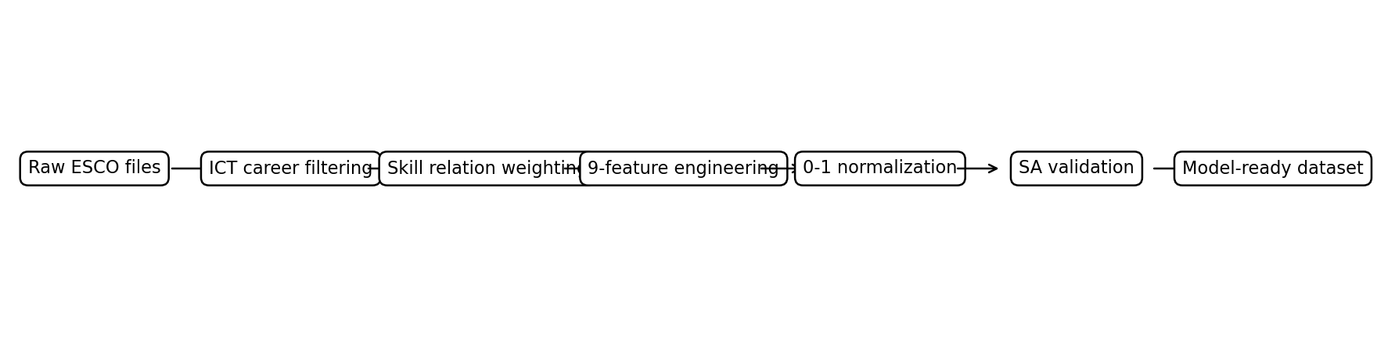
Figure 1. ChoiceIQ data preparation workflow from raw ESCO data to the model-ready career dataset.

2. Data Analysis Objectives
The data-analysis stage has the following objectives:
- Identify reliable occupation and skill data relevant to information and communication technology (ICT).
- Reduce the large source datasets to a manageable set of student-friendly IT careers for the prototype.
- Preserve occupation identifiers, descriptions and skill evidence for traceability.
- Convert detailed text-based skills into a consistent set of numerical features suitable for recommendation.
- Differentiate essential skills from optional skills when generating career profiles.
- Normalize engineered features so that career profiles use a comparable 0-1 scale.
- Validate local relevance against the supplied South African occupation lists without allowing labour-market validation to bias the similarity score.
- Produce clean CSV files that can be used by notebooks, model-training scripts and the Streamlit application.

3. Data Collection and Sources

3.1 ESCO source data
The core project data is the supplied English-language ESCO occupation and skills data. ESCO (European Skills, Competences, Qualifications and Occupations) represents occupations and their associated skills in structured form. The project package contains the following five raw CSV files:
File | Role in ChoiceIQ | Rows | Columns
occupations_en.csv | Occupations | 3,043 | 15
skills_en.csv | Skills | 13,960 | 13
occupationSkillRelations_en.csv | Occupation-skill relations | 126,051 | 6
digitalSkillsCollection_en.csv | Digital skills collection | 1,284 | 10
ISCOGroups_en.csv | ISCO groups | 619 | 8
Although all five files are retained in the raw-data folder for completeness and reproducibility, the dataset-building script primarily reads occupations_en.csv and occupationSkillRelations_en.csv. The other source files provide additional taxonomy and digital-skill context and remain available for further analysis.
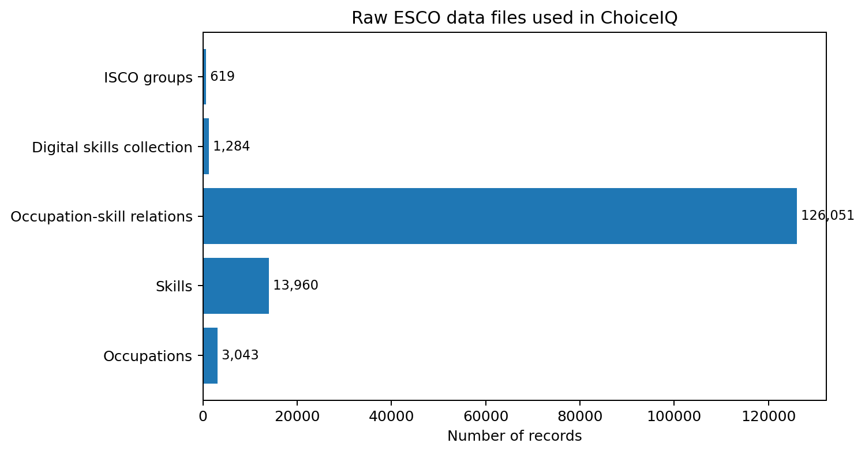
Figure 2. Record counts for the five raw ESCO files supplied with the project.

3.2 South African validation sources
Two Government Gazette documents are used to validate whether selected ICT career titles have an exact or closely related South African occupation. The first is the Department of Higher Education and Training (DHET) National List of Occupations in High Demand: 2024. The document states that the list is intended, among other purposes, to inform career guidance for learners and work-seekers. The second is the Department of Home Affairs Critical Skills List published in Government Gazette No. 49402 on 3 October 2023.
These two documents are not used as the primary source for career skills. Instead, they are used as a separate contextual validation layer after the ESCO career profiles have been built. This separation prevents a career from receiving a higher recommendation score merely because it appears on an official labour-market list.

4. Data Understanding

4.1 Important source fields
Source | Field | Use
occupations_en.csv | conceptUri | Unique ESCO occupation identifier used for joins.
occupations_en.csv | iscoGroup | ISCO occupational group used to isolate ICT families.
occupations_en.csv | preferredLabel | Human-readable occupation title.
occupations_en.csv | description | Occupation description used as additional textual evidence.
occupations_en.csv | code | Detailed ESCO occupation code retained for traceability.
occupationSkillRelations_en.csv | occupationUri | Foreign key linking a skill relation to an occupation.
occupationSkillRelations_en.csv | relationType | Indicates whether the skill relation is essential or optional.
occupationSkillRelations_en.csv | skillLabel | Human-readable skill/knowledge label used in feature engineering.

4.2 Scale reduction
The source occupation file contains 3,043 occupations and the relation file contains 126,051 occupation-skill links. Processing all occupations would be unnecessary for the defined application because ChoiceIQ is intentionally limited to IT career guidance. The analysis therefore narrows the data to ICT occupation groups and then to a curated list of 30 careers that are suitable for a student-facing prototype.
The selected careers cover software development, data, artificial intelligence, databases, cybersecurity, networking, systems administration, cloud computing, IT support, business analysis, testing and interface design. This provides variety while keeping the recommendation space understandable during demonstration and evaluation.

5. Data Preprocessing

5.1 Loading and selecting required columns
The build_career_dataset.py script loads only the columns needed from the occupation and occupation-skill relationship files. Restricting columns reduces unnecessary memory use and keeps the transformation logic focused on identifiers, labels, descriptions, codes and skill relations.

5.2 ICT filtering
Occupations are first filtered using ISCO group prefixes associated with ICT professionals and technicians. The implemented prefixes are 25, 351 and 3522. A second filter keeps only occupations whose preferred ESCO label appears in the project’s curated list of 30 careers. Duplicate occupation records are then removed using the ESCO concept URI as the unique key.

5.3 Relationship filtering and joining
The occupation-skill relationship table is filtered to the ESCO occupation URIs retained after career selection. This ensures that only skills belonging to the 30 final careers are processed. The resulting relation table contains 2,221 rows. A second join back to the occupation table preserves readable occupation labels for the exported skill-evidence file.
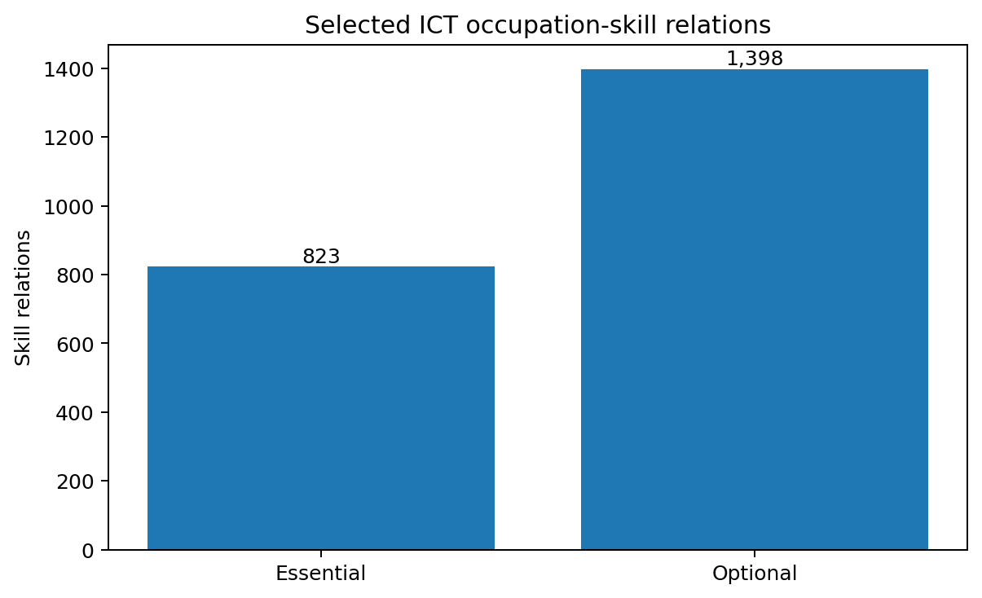
Figure 3. Essential and optional skill relations retained for the 30 selected ICT careers.

5.4 Essential versus optional skill weighting
The preprocessing step retains the distinction between essential and optional ESCO relations. An essential relation contributes a weight of 1.00 when its skill text matches a feature keyword, while an optional relation contributes 0.55. This means optional skills still influence a career profile but cannot contribute as strongly as essential skills.
Relation type | Weight in feature construction | Rationale
Essential | 1.00 | Represents a core ESCO skill/knowledge requirement for the occupation.
Optional | 0.55 | Provides supporting evidence while reducing its influence relative to essential skills.

5.5 Missing values and text preparation
Occupation descriptions are checked before use. If a description is missing, an empty string is substituted so that feature extraction can continue without an error. Skill labels and descriptions are converted to lowercase before keyword matching. The pipeline does not impute fabricated skills or career descriptions.

5.6 Output from preprocessing
The preprocessing and feature-engineering script writes three principal processed CSV files: choiceiq_careers.csv (career profiles and metadata), choiceiq_skill_evidence.csv (the retained ESCO occupation-skill relations), and south_africa_validation.csv (the local validation metadata). These outputs are reproducible by rerunning build_career_dataset.py.

6. Exploratory Data Analysis

6.1 Career distribution by ISCO group
The final 30 careers are distributed across 10 ISCO groups. The largest group in the selected set is 2511 with eight careers, followed by 2529 with five careers and 2512 with four careers. This distribution reflects the project’s focus on software, data, systems, security and network-related ICT occupations rather than attempting to represent every occupation in ESCO.
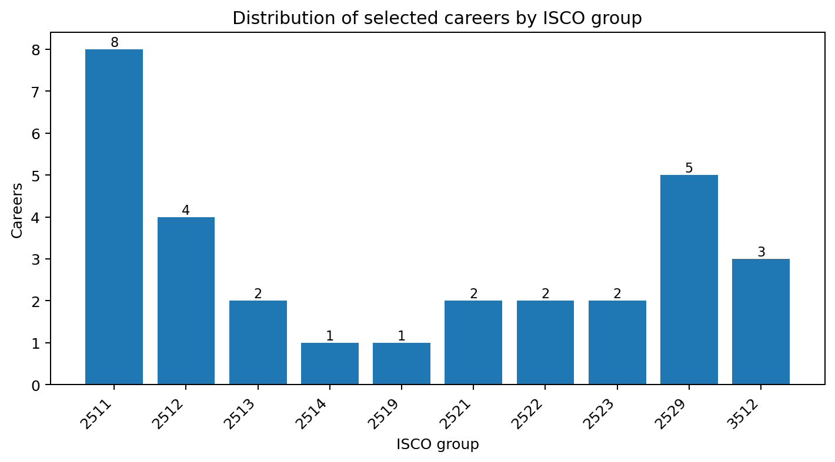
Figure 4. Distribution of the 30 selected careers by ISCO group.

6.2 Skill-relation depth
Across the 30 careers, the selected evidence contains 823 essential and 1,398 optional skill relations. The average career has 27.4 essential relations and 46.6 optional relations. The amount of source evidence is not identical for every occupation; consequently, normalized features and title priors are used to create comparable career profiles.
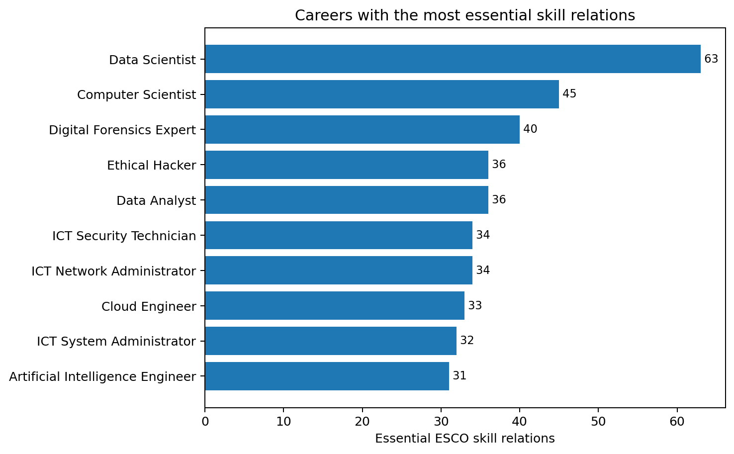
Figure 5. Ten selected careers with the highest number of essential ESCO skill relations.

6.3 Engineered feature distribution
The average feature scores show that problem solving and systems/cloud have the highest mean values across the selected occupations, followed by programming. Mathematics has the lowest mean because it is strongly relevant to a smaller subset of careers, such as data science and algorithm-intensive roles. These averages describe the curated career set; they should not be interpreted as population estimates for the wider IT labour market.
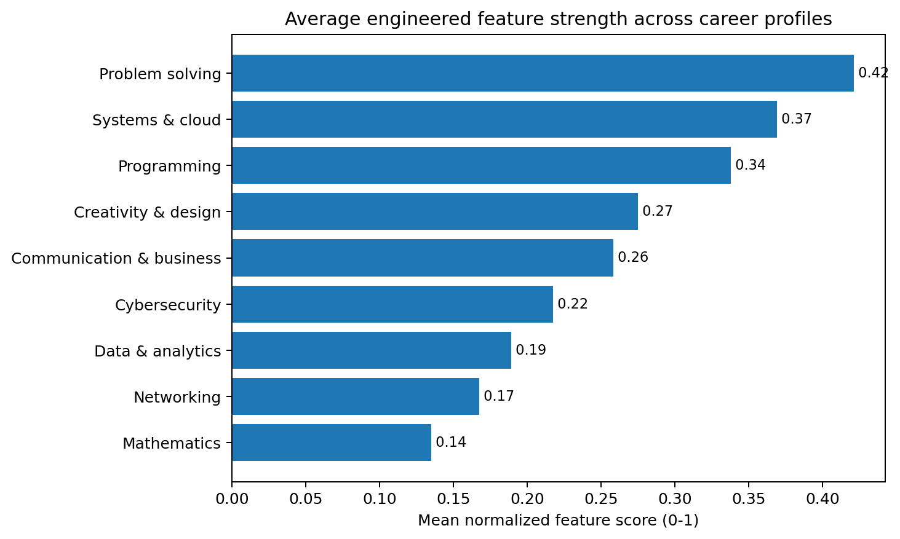
Figure 6. Mean normalized values of the nine engineered features across the final career dataset.

7. Feature Engineering

7.1 Shared feature space
ChoiceIQ requires career profiles and questionnaire responses to be comparable. Nine broad features were therefore selected as a common representation of IT interests and career characteristics. The same feature names are used by the dataset-building pipeline and by the Streamlit quiz logic.
Feature | Interpretation
Data & analytics | Data handling, analytics, statistics, database work, information modelling and business intelligence.
Programming | Programming, coding, software development, scripting, algorithms, debugging and application development.
Mathematics | Mathematics, statistics, probability, quantitative reasoning and algorithmic content.
Cybersecurity | Security, cyber threats, vulnerabilities, forensics, incident response, risk, penetration testing and encryption.
Networking | Computer networks, telecommunications, routers, switches, connectivity and related infrastructure.
Problem solving | Problem solving, troubleshooting, diagnosis, analysis, testing, quality and resolution activities.
Creativity & design | Design, user interfaces, user experience, prototyping, usability, visual and creative work.
Systems & cloud | Systems, cloud, servers, operating systems, virtualization, DevOps, deployment, architecture and configuration.
Communication & business | Communication, clients, business requirements, stakeholders, consulting, support and documentation.

7.2 Keyword-based evidence extraction
For each career, the script scans retained ESCO skill labels for feature-related keywords. A matching essential skill adds 1.00 to the feature score and a matching optional skill adds 0.55. Occupation descriptions are also searched; if a feature keyword is present in the occupation description, 0.75 is added. This approach makes the transformation transparent because the rules are explicit and can be traced back to source text.

7.3 Occupation-title priors
Some short occupation titles contain strong domain information that may be underrepresented in the available skill wording. The project therefore adds small, explicit title-based priors. For example, titles containing “software” or “developer” strengthen programming; “network” strengthens networking and systems/cloud; “security” or “cyber” strengthens cybersecurity; and “database” strengthens data analytics and systems/cloud. These priors are rule-based rather than learned from user behaviour and are documented in build_career_dataset.py.
Title priors should be understood as a prototype design choice. They improve interpretability and coverage for the current curated set but should be replaced or recalibrated using empirical user data in a future production version.

7.4 Normalization
Raw feature scores can differ greatly because occupations have different numbers of associated skills. Each feature column is therefore divided by the maximum value observed for that feature across the 30 careers. Values are rounded to four decimal places. This produces a 0-1 scale for every feature while preserving relative differences among careers within the curated dataset.

7.5 Example of a processed career profile
Feature | Normalized value for Data Scientist
Data & analytics | 0.9273
Programming | 0.0298
Mathematics | 1.0000
Cybersecurity | 0.0000
Networking | 0.0972
Problem solving | 0.4919
Creativity & design | 0.4366
Systems & cloud | 0.1273
Communication & business | 0.2333
The Data Scientist record also retains its ESCO label, ISCO group 2511, ESCO code 2511.4, source description, 63 essential skill relations and 34 optional skill relations. This metadata supports explainability and data lineage.

8. South African Occupation Validation

8.1 Validation logic
The supplied official South African documents are used to tag each selected career using one of three statuses: Exact official occupation, Related official occupation, or Not directly matched in supplied lists. An exact match is used when the project career corresponds directly to an occupation title in the supplied source. A related match is used when a defensible closest official occupation exists but the wording is not identical. No direct match means that the two supplied documents do not provide a sufficiently direct title match for the ChoiceIQ career.

8.2 Validation results
Of the 30 careers, 4 are marked as exact official occupations, 17 are mapped to a related official occupation and 9 have no direct match in the supplied lists. In total, 21 careers have validation from at least one of the two sources; 19 are associated with the 2024 high-demand list, 18 with the 2023 critical-skills list, and 16 with both.
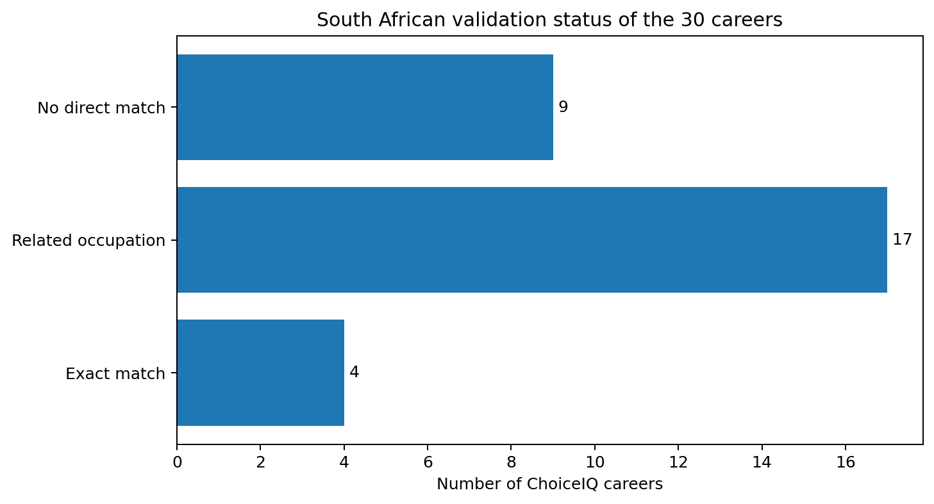
Figure 7. South African validation status for the 30 ChoiceIQ careers.
ChoiceIQ career | Validation status | Official match | High demand 2024 | Critical skills 2023
Artificial Intelligence Engineer | Not directly matched in supplied lists |  | No | No
Cloud Engineer | Related official occupation | Computer Network and Systems Engineer | Yes | Yes
Data Analyst | Not directly matched in supplied lists |  | No | No
Data Scientist | Exact official occupation | Data Scientist | Yes | Yes
Ethical Hacker | Related official occupation | ICT Security Specialist | Yes | Yes
ICT System Analyst | Exact official occupation | ICT Systems Analyst | Yes | Yes
Software Developer | Exact official occupation | Software Developer | Yes | Yes
Web Developer | Exact official occupation | Web Developer | Yes | No
The validation layer is intentionally stored separately from the nine recommendation features. It provides South African context in the application but does not increase or decrease cosine similarity. This design reduces the risk of presenting labour-market demand as if it were a student-interest characteristic.

9. Final Model-Ready Dataset
The final file choiceiq_careers.csv contains 30 rows and 22 columns. One row represents one selected IT career. It combines traceability fields, source-skill counts, nine normalized recommendation features and South African validation metadata.
Dataset property | Value
Unit of analysis | One selected IT career per row
Rows | 30
Columns | 22
Engineered recommendation features | 9 numeric features, normalized to 0-1
Selected career-skill evidence | 2,221 relations
South African validated careers | 21 of 30 in at least one supplied list
Storage format | CSV
Primary downstream use | Content-based career recommendation

9.1 Integration with the student questionnaire
The deployed Streamlit application currently contains ten required single-choice questions. Each answer has explicit weights for one or more of the same nine features used in the career dataset. The ten answers are accumulated into a user profile and normalized by the largest user-feature value. Because both user and career profiles share the same nine dimensions, the recommendation stage can calculate similarity without needing to retrain on individual student records.
The question design therefore acts as the bridge between qualitative student preferences and the quantitative career matrix prepared in this report.

10. Data Quality, Limitations and Ethics

10.1 Data quality strengths
- Career metadata and skill relations retain ESCO identifiers and labels, supporting traceability.
- Essential and optional skill relations are preserved and weighted differently.
- Feature rules are explicit in source code instead of being hidden inside a black-box transformation.
- South African validation is kept separate from student-career similarity.
- Processed datasets can be regenerated from raw files using a single script.

10.2 Limitations
- The 30 careers are deliberately curated for a prototype and do not cover the full IT career landscape.
- Feature engineering relies on keyword matching and manually specified title priors. Synonyms not covered by the rules can be missed, while broad keywords may occasionally match text in an unintended context.
- Feature normalization is relative to the 30-career set; adding or removing careers may change normalized values.
- South African validation uses only the two supplied official documents and should not be interpreted as proof that an unlisted career does not exist or is not viable in South Africa.
- The current questionnaire uses fixed single-choice responses. Real students may have multiple simultaneous interests, so future versions could allow multi-select responses and collect user feedback.
- Career recommendations are guidance, not a final career decision. Personal circumstances, academic prerequisites, labour-market conditions and professional advice may also matter.

10.3 Ethical considerations
ChoiceIQ should not present a similarity score as a guarantee of career success or employment. The application therefore describes recommendations as guidance. The current prototype does not require user accounts or store personal identities, which reduces privacy risk. If future versions collect student histories, demographics or feedback, informed consent, secure storage and bias testing would become necessary.

11. Conclusion
The ChoiceIQ data-analysis pipeline transforms large, detailed ESCO occupation and skill data into a compact and explainable dataset for personalized IT career recommendation. Starting from thousands of occupations and more than one hundred thousand occupation-skill relations, the process filters the data to 30 student-facing ICT careers, retains 2,221 relevant skill relations, engineers nine normalized features and adds an independent South African validation layer.
The final dataset meets the data-preparation needs of the BICT242 recommendation-system project because it is clean, traceable, numerically consistent and directly compatible with the student questionnaire. Its main strength is explainability: each career profile is built from documented ESCO skill evidence, descriptions and explicit transformation rules. The main opportunities for future improvement are expansion of the career set, broader semantic feature extraction, multi-select student responses and empirical calibration from real student feedback.

References
- Department of Higher Education and Training (DHET). (2024). National List of Occupations in High Demand: 2024. Government Gazette No. 50510, 16 April 2024.
- Department of Home Affairs. (2023). Critical Skills List. Government Gazette No. 49402, 3 October 2023.
- European Commission / ESCO. English occupation, skill, occupation-skill relationship, ISCO group and digital skills datasets supplied with the ChoiceIQ project package.
- ChoiceIQ project source code. build_career_dataset.py, sa_validation.py and app.py, project package dated September 2026.

