BICT242: Data Scalability and Analytics
MODEL SELECTION AND EVALUATION REPORT
BY
QUERY QUEENS
ChoiceIQ: IT Career Recommendation System
Selection and evaluation of a content-based career recommender using cosine and Euclidean nearest-neighbour models

Executive Summary
ChoiceIQ is a content-based IT career recommendation system that converts a student's answers to a ten-question interest quiz into a nine-dimensional user profile. The user profile is compared with 30 engineered IT career profiles. This report documents the selection and evaluation of the recommendation model used to rank careers and return the three closest matches.
Two nearest-neighbour ranking approaches were implemented and compared: cosine distance and Euclidean distance. Both operate on the same normalized career feature matrix and therefore provide a controlled comparison of similarity measures. Evaluation used 10 predefined benchmark student profiles, each with three expected relevant careers. Because the project does not yet contain historical student ratings or verified career outcomes, these benchmark metrics are demonstration metrics rather than claims of real-world predictive accuracy.
The cosine model achieved Precision@3 = 0.60, Recall@3 = 0.60, F1@3 = 0.60, and Mean Reciprocal Rank (MRR) = 0.82. The Euclidean comparison model achieved Precision@3 = 0.47, Recall@3 = 0.47, F1@3 = 0.47, and MRR = 0.81. Cosine was selected because it produced stronger Top-3 relevance on the benchmark profiles and remains straightforward to explain during system presentation.

1. Introduction
The BICT242 course project requires the design and implementation of a recommendation system, including model selection, training, evaluation and deployment. ChoiceIQ applies recommendation techniques to IT career guidance. Instead of recommending products or media, it recommends careers whose skill and interest characteristics are most similar to a student's stated preferences.
The purpose of this report is to document the recommendation model used by ChoiceIQ, explain why it was selected, describe how it is fitted and evaluated, present the evaluation results, and state the limitations that affect interpretation of those results.

2. Recommendation Problem Definition
ChoiceIQ is formulated as a Top-N ranking problem. A student provides quiz responses; the system transforms those responses into a numeric vector; and the recommendation engine ranks available careers by similarity to that vector. The application returns the top three careers.
Component | ChoiceIQ implementation
User | A student completing the ten-question interest quiz.
Items | 30 curated IT careers prepared from ESCO occupation and skill data.
User representation | Nine normalized interest dimensions.
Item representation | The same nine normalized feature dimensions for each career.
Recommendation task | Rank all careers and return the Top 3 most similar careers.
Feedback available | No historical ratings, clicks, applications or career outcomes are currently available.
Because the system has no historical user-item interaction matrix, collaborative filtering is not appropriate for the current prototype. Content-based filtering is suitable because both users and careers can be represented using interpretable features.

3. Model Selection

3.1 Selected recommendation family: content-based filtering
Content-based recommendation compares the characteristics of an item with the characteristics or preferences of a user. In ChoiceIQ, a student and an IT career are both represented in the same nine-dimensional feature space. The approach supports cold-start use because a first-time student can receive recommendations immediately after completing the quiz; previous activity is not required.

3.2 Candidate Model A: cosine nearest neighbours
The first model uses scikit-learn NearestNeighbors with cosine distance and a brute-force search. Cosine similarity focuses on the direction or pattern of the feature vectors. For user vector u and career vector v, cosine similarity is calculated as:
cosine_similarity(u, v) = (u · v) / (||u|| ||v||)
The Streamlit application receives distances from the cosine nearest-neighbour model and converts them to a similarity score using similarity = 1 - cosine distance. A higher value indicates a closer match.

3.3 Candidate Model B: Euclidean nearest neighbours
The comparison model uses the same career matrix but ranks careers using Euclidean distance. Euclidean distance measures straight-line distance between the user and career vectors:
euclidean_distance(u, v) = sqrt(sum((u_i - v_i)^2))
Using the same features and career set for both models isolates the effect of the similarity measure. Euclidean k-NN acts as a simple baseline rather than a separate feature-engineering approach.

3.4 Why collaborative filtering and deep learning were not selected
Collaborative filtering normally requires interaction data such as ratings, clicks, saved careers or prior choices from many users. ChoiceIQ does not currently have that dataset. Deep-learning methods would also introduce unnecessary complexity for a small, interpretable dataset of 30 careers. The selected content-based approach therefore matches the available data, project timeframe and requirement that the model be explainable to the lecturer and student user.

4. Model Inputs and Outputs

4.1 Feature vector
Both candidate models use the following nine features, each on a 0-1 scale:
Feature | Meaning
Data & analytics | Data analytics
Programming | Programming
Mathematics | Mathematics
Cybersecurity | Cybersecurity
Networking | Networking
Problem solving | Problem solving
Creativity & design | Creativity design
Systems & cloud | Systems cloud
Communication & business | Communication business

4.2 Career matrix
The fitted recommendation models contain 30 career vectors. The matrix therefore has 30 rows and 9 feature columns. The model does not learn coefficients in the way a regression model would; fitting a nearest-neighbour model stores and indexes the reference career vectors so that distances can be calculated when a query vector is supplied.

4.3 Student vector from the ten-question quiz
The current Streamlit system asks ten single-choice questions. Each answer contributes predefined weights to one or more of the nine features. The contributions from all answers are summed, then the resulting vector is normalized by its largest component so that its strongest feature has a value of 1.0. This vector is passed to the selected model.
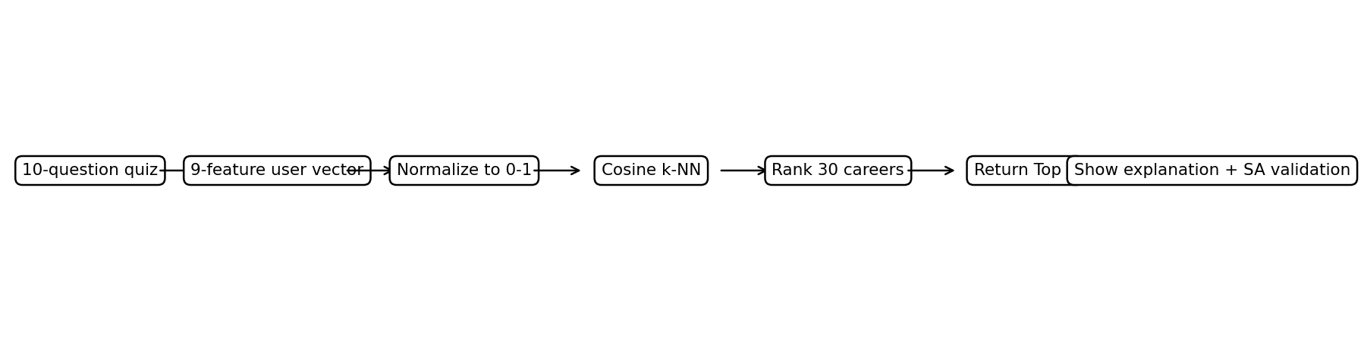
Figure 1. Deployed ChoiceIQ recommendation workflow.

5. Model Fitting and Saved Artifacts
The train_models.py script loads choiceiq_careers.csv, selects the nine feature columns and converts them into a NumPy matrix. Two scikit-learn NearestNeighbors models are then fitted: one using metric="cosine" and one using metric="euclidean". The brute-force algorithm is used because the career set is small and exact distance calculations are computationally inexpensive.
Artifact | Purpose
models/cosine_knn.joblib | Selected nearest-neighbour model used by the Streamlit application.
models/euclidean_knn.joblib | Comparison model used during evaluation.
models/career_feature_bundle.joblib | Career names, feature names and feature matrix bundled for reproducibility.
models/model_metadata.json | Records selected model, selection reason, features and summary evaluation metrics.
Data/processed/model_evaluation.csv | Aggregate evaluation results for each model.
Data/processed/model_evaluation_details.csv | Per-profile ranking results and metrics.
Data/processed/evaluation_profiles.csv | Benchmark vectors and expected relevant careers.

6. Evaluation Methodology

6.1 Benchmark profiles
No historical student-rating dataset is available. The project therefore evaluates the ranking logic using 10 predefined prototype profiles. Each profile is represented by the same nine features and is assigned three careers that are treated as relevant for evaluation. These profiles cover the major career themes represented in the dataset.
Benchmark profile | Expected relevant careers
Data & research | Data Scientist | Data Analyst | Data Engineer
Software builder | Software Developer | Web Developer | Mobile Application Developer
Cyber investigator | Digital Forensics Expert | Cyber Incident Responder | Ethical Hacker
Network infrastructure | Ict Network Engineer | Ict Network Administrator | Ict Network Architect
Cloud platform | Cloud Engineer | Cloud Architect | Cloud Devops Engineer
Security operations | Ict Security Administrator | Ict Security Technician | Cybersecurity Risk Manager
Systems analysis | Ict System Administrator | Ict System Analyst | Ict System Architect
UX interface | User Interface Designer | Web Developer | Software Developer
Database | Database Administrator | Database Developer | Data Engineer
IT support | Ict Help Desk Agent | Ict Technician | Ict System Administrator

6.2 Evaluation procedure
For each benchmark profile, the system ranks all 30 careers with each candidate model. The first three careers are treated as the recommendation set. The predicted Top 3 are compared with the three expected relevant careers. In addition, the full ranking is inspected to determine the position of the first relevant item for Mean Reciprocal Rank.

6.3 Evaluation metrics
Metric | Definition in this project | Interpretation
Precision@3 | Number of relevant careers in the Top 3 divided by 3. | How much of the recommendation list is relevant.
Recall@3 | Number of relevant careers in the Top 3 divided by the number of expected relevant careers. | How much of the expected relevant set is recovered in the Top 3.
F1@3 | Harmonic mean of Precision@3 and Recall@3. | Balances precision and recall.
MRR | Mean of 1/rank of the first relevant career. | Rewards models that place at least one relevant career very near the top.
Each benchmark contains exactly three expected relevant careers and the system returns exactly three recommendations. For that reason Precision@3 and Recall@3 are numerically equal in the current experiment. This is a property of the evaluation design, not a general property of recommendation systems.
Mean squared error (MSE) was not used because ChoiceIQ is evaluated as a ranking problem and does not predict a continuous rating or score with known ground-truth values. Precision, recall, F1 and MRR are therefore more directly aligned with the Top-3 recommendation task.

7. Evaluation Results

7.1 Overall comparison
Model | Precision@3 | Recall@3 | F1@3 | MRR | Profiles
Cosine | 0.600 | 0.600 | 0.600 | 0.820 | 10
Euclidean | 0.467 | 0.467 | 0.467 | 0.808 | 10
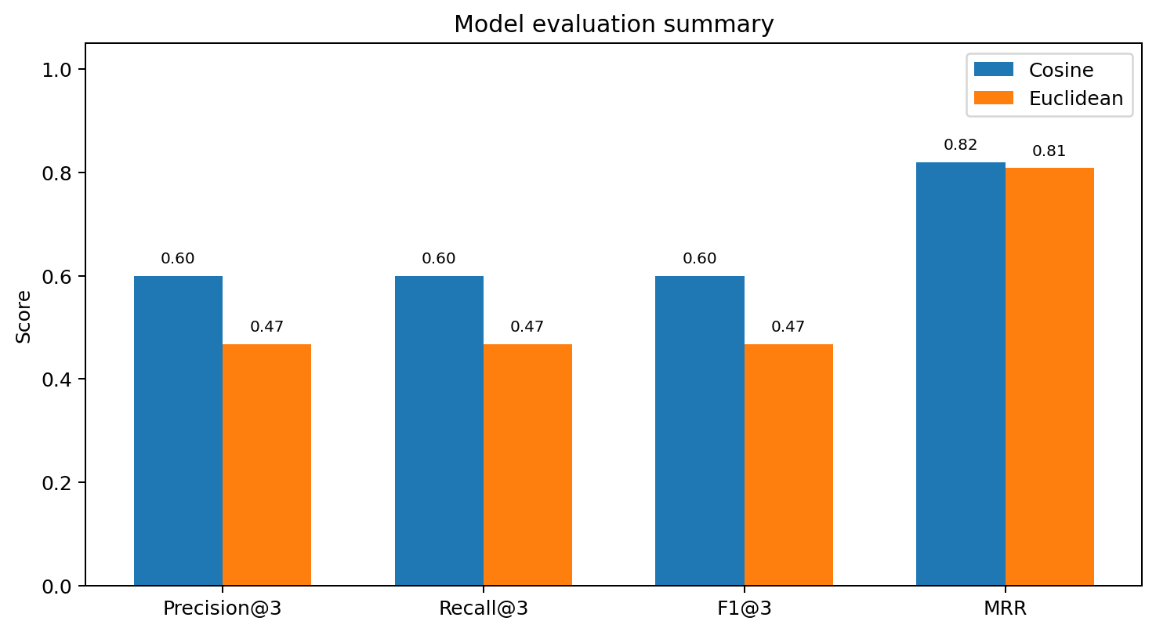
Figure 2. Aggregate evaluation scores for cosine and Euclidean models.
Cosine achieved an average of 0.60 for Precision@3, Recall@3 and F1@3, compared with 0.467 for Euclidean. This corresponds to 18 relevant careers appearing across the 30 available Top-3 recommendation slots for cosine, compared with 14 for Euclidean. MRR was also slightly higher for cosine (0.82 versus 0.808).

7.2 Results by benchmark profile
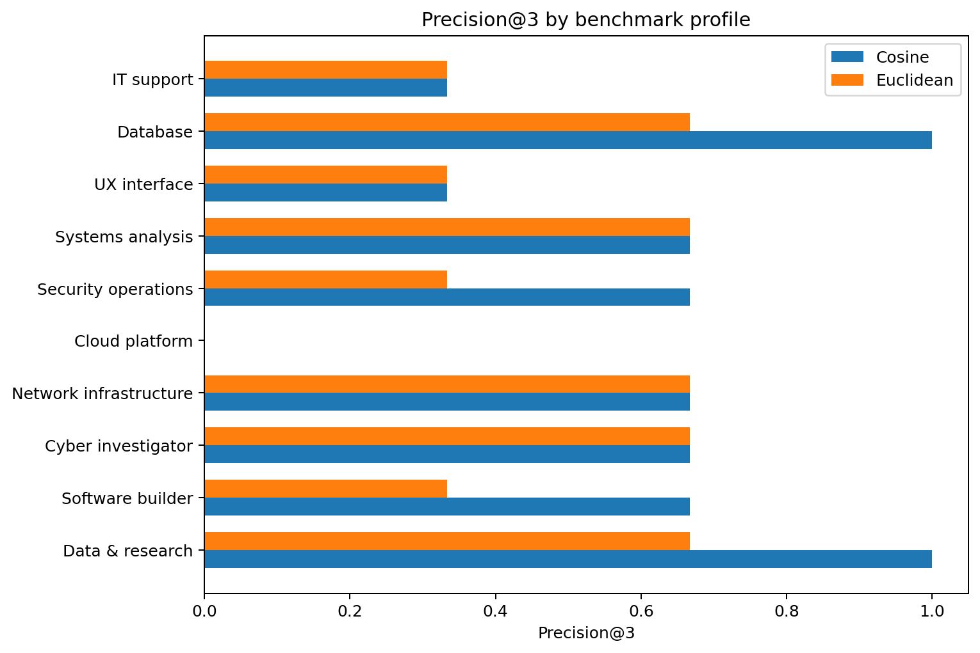
Figure 3. Precision@3 for each benchmark profile.
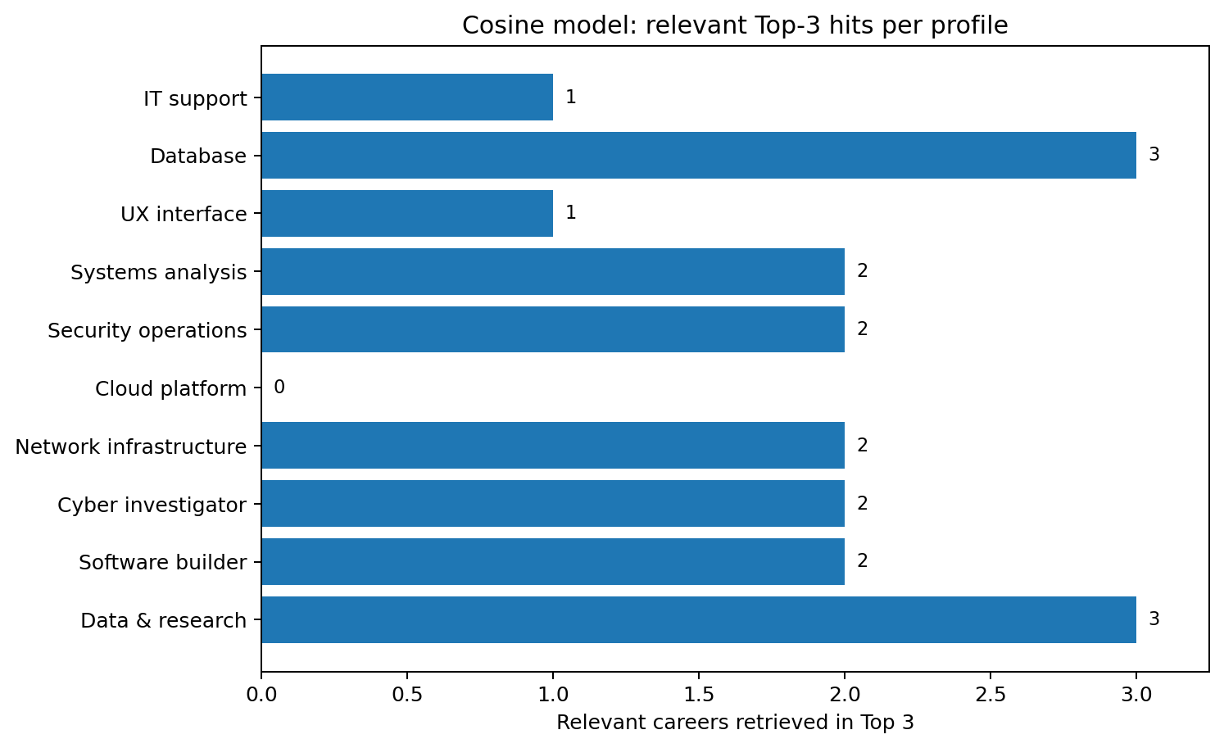
Figure 4. Number of relevant careers returned in the cosine Top 3 for each benchmark profile.
Cosine performed particularly well for the Data & research and Database profiles, retrieving all three expected careers in the Top 3. It retrieved two of three relevant careers for Software builder, Cyber investigator, Network infrastructure, Security operations and Systems analysis. Performance was weaker for UX interface and IT support, where one relevant career appeared in the Top 3. The Cloud platform profile produced no Top-3 hits, showing that the current engineered career profiles do not yet separate cloud-specific careers strongly enough from broader network and systems occupations.
Profile | Cosine Top 3 | Hits | P@3 | Reciprocal rank
Data & research | Data Analyst; Data Scientist; Data Engineer | 3 | 1.000 | 1.000
Software builder | Software Tester; Web Developer; Software Developer | 2 | 0.667 | 0.500
Cyber investigator | Ethical Hacker; Ict Security Technician; Digital Forensics Expert | 2 | 0.667 | 1.000
Network infrastructure | Ict Network Administrator; Ict System Administrator; Ict Network Architect | 2 | 0.667 | 1.000
Cloud platform | Ict Network Administrator; Ict Technician; Ict System Administrator | 0 | 0.000 | 0.200
Security operations | Ict Security Administrator; Ict Security Technician; Ethical Hacker | 2 | 0.667 | 1.000
Systems analysis | Ict System Analyst; Ict Network Administrator; Ict System Architect | 2 | 0.667 | 1.000
UX interface | User Interface Designer; Ict System Architect; Artificial Intelligence Engineer | 1 | 0.333 | 1.000
Database | Database Developer; Database Administrator; Data Engineer | 3 | 1.000 | 1.000
IT support | Ict System Analyst; Ict Help Desk Agent; Ict Network Administrator | 1 | 0.333 | 0.500

8. Model Selection Decision
The cosine content-based nearest-neighbour model was selected for deployment. The decision is based on three considerations:
- It produced the highest Precision@3, Recall@3 and F1@3 in the benchmark evaluation.
- It also achieved a slightly higher MRR, indicating that relevant careers tended to appear near the top of the ranking.
- Cosine similarity is appropriate for comparing the pattern of normalized interests across feature dimensions and is easy to explain to users and assessors.
The selected model is stored as models/cosine_knn.joblib and is loaded by the Streamlit application. The Euclidean model remains in the project as evidence of model comparison and as a reproducible baseline.

9. Deployment in the Streamlit Recommendation System
The deployed ChoiceIQ application is intentionally student-facing and minimal. A student answers ten questions and selects one option for each question. The app uses the ANSWER_WEIGHTS mapping to construct a normalized nine-feature profile, passes the profile to cosine k-NN, retrieves the three nearest career rows, and displays each career with a percentage-like similarity score.
For explainability, the application multiplies the user vector and each recommended career vector feature by feature, then reports the strongest overlapping dimensions as the reasons for the match. South African High Demand and Critical Skills information is displayed as contextual validation metadata where available. This validation does not change the cosine similarity score and therefore does not bias the recommendation ranking.
The displayed percentage is derived from 1 - cosine distance and should be interpreted as a similarity indicator, not as the probability that a student will succeed in the career.

10. Limitations and Evaluation Risks
- The 10 benchmark profiles are manually defined prototype cases rather than observations from real students.
- The expected relevant career sets are judgement-based. Different experts could choose different acceptable careers for the same profile.
- Each profile contains exactly three relevant careers, which causes Precision@3 and Recall@3 to be equal in this experiment.
- The evaluation set is small, so differences between models should not be treated as population-level performance estimates.
- The career matrix contains 30 curated IT careers and does not represent every possible ICT occupation or specialization.
- The quiz uses predefined answer-to-feature weights. These weights have not yet been calibrated using student outcome or satisfaction data.
- The model measures similarity between interests and career profiles; it does not measure aptitude, academic eligibility, job availability, salary, employability or future success.
- The weak Cloud platform result indicates an area where the feature engineering or career coverage needs refinement.

11. Recommended Future Evaluation
A stronger production evaluation would collect anonymous feedback from real students after they receive recommendations. Students could rate each suggested career as relevant or not relevant, save careers of interest, and optionally report whether recommendations helped their decision-making. With sufficient interaction data, the project could evaluate Precision@K, Recall@K, nDCG, click-through or save rates and user satisfaction on a held-out test set.
Future experiments could also compare the current rule-based content model with TF-IDF similarity over ESCO skill text, learned embeddings, hybrid content-plus-feedback ranking, or collaborative filtering once enough user interactions are available. Any additional complexity should be justified by measurable improvement rather than added for its own sake.

12. Conclusion
ChoiceIQ uses a transparent content-based recommendation approach that is suitable for the project's available data and student-facing use case. Cosine and Euclidean nearest-neighbour models were implemented on the same 30-career, nine-feature matrix and evaluated using 10 benchmark profiles. Cosine produced stronger Top-3 precision, recall and F1 and was therefore selected for deployment.
The evaluation provides evidence that the recommender behaves sensibly on a controlled prototype test set while also identifying weaknesses, especially for cloud-focused recommendations. Because the benchmark profiles are not real-user ground truth, the reported scores should be treated as demonstration results. The current model is appropriate for an academic prototype, and future work should validate and recalibrate it using real student feedback.

References and Project Artifacts
Source | Use in this report
BICT242 Course Project Brief | Developing a Recommendation System for an application of your choice; requirements for model selection, evaluation and deployment.
ChoiceIQ train_models.py | Defines cosine and Euclidean nearest-neighbour models, benchmark profiles and ranking metrics.
ChoiceIQ app.py | Implements the ten-question quiz, user-vector construction, cosine recommendation and explanation logic.
choiceiq_careers.csv | Processed 30-career feature matrix used by the recommendation models.
evaluation_profiles.csv | Ten predefined benchmark profiles and expected relevant careers.
model_evaluation.csv | Aggregate model evaluation results.
model_evaluation_details.csv | Per-profile Top-3 recommendations and metric values.
model_metadata.json | Selected model metadata and recorded model-selection rationale.
scikit-learn NearestNeighbors | Python library component used to fit and query the cosine and Euclidean nearest-neighbour models.

