# Movement:

## Wheels

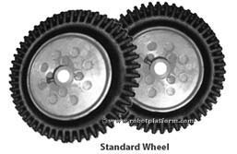

## Rotor Blade

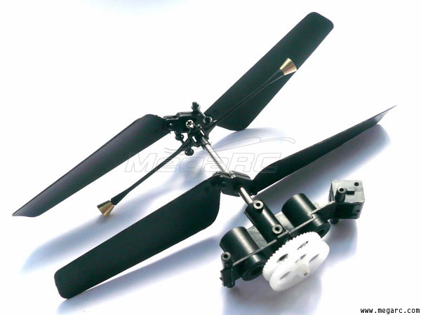

## Caterpillar Tracks

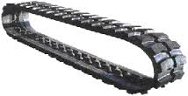

## Legs (Crawling Mechanism)

# Steering

## Ackerman Steering Mechanism

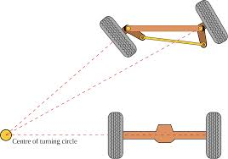

## Davis Mechanism

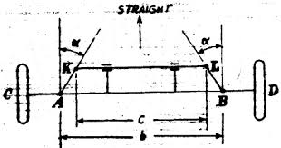

## Rudder

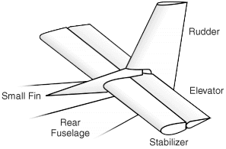

## Differential Drive

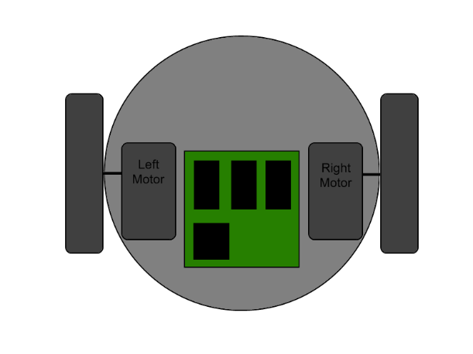

## Another set of wheels

## Rotating wheelbase or Rotating Track

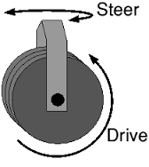

## Dead Weight

## Differential Gear box with brakes for individual wheels.

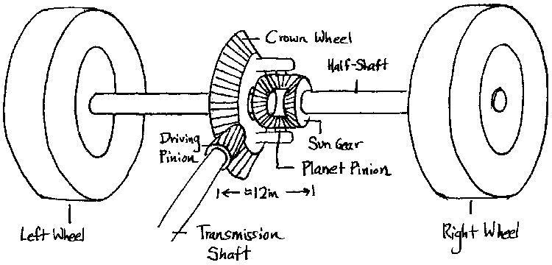

## Legs (Crawling Mechanism)

# Speed Control

## Gearbox

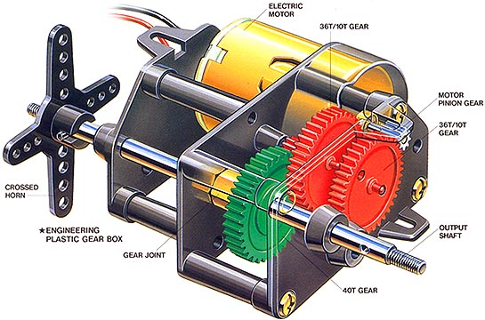

## Belt Drive

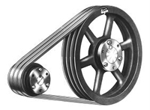

## Chain Drive

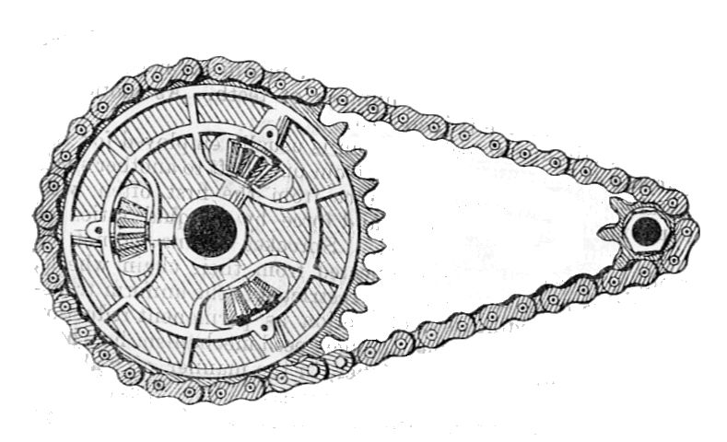

## Electronic circuit

## Dead weight

# Stopping Mechanism

## Disc Brakes

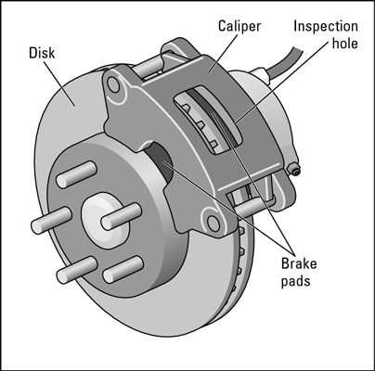

## Cutting off the power supply.

## Automatic self-destruction of the vehicle at the end point.

1. Movement:

1.1 Wheels

1.2 Rotor Blade

1.3 Caterpillar Tracks

1.4 Legs (Crawling Mechanism)

2. Steering

2.1 Ackerman Steering Mechanism

2.2 Davis Mechanism

2.3 Rudder

2.4 Differential Drive

2.5 Another set of wheels

2.6 Rotating wheelbase or Rotating Track

2.7 Dead Weight

2.8 Differential Gear box with brakes for individual wheels.

2.9 Legs (Crawling Mechanism)

3. Speed Control

3.1 Gearbox

3.2 Belt Drive

3.3 Chain Drive

3.4 Electronic circuit

3.5 Dead weight

4. Stopping Mechanism

4.1 Disc Brakes

4.2 Cutting off the power supply.

4.3 Automatic self-destruction of the vehicle at the end point.