Aug. 2022 – Joined HR Squad as FullStack Software Engineer.
Sep. 2022 – Team requested me to become their Scrum Master. At the time, the squad had a storming phase, and we needed help as soon as possible. After some hires, exits, and refine our team agreements and procedures, the team started performing.
Oct. 2022 – Got the official Professional Scrum Master certificate.
April 2023 – Launched a new version of our Onboarding Frontend Application using our webcomponents library and with a new fresh design.
Jun. 2023 – Developed and launched Knowledge Assistant. It is a paid plus feature that Nmbrs offers in the product. These are specialized functionalities that fall outside the core HR & Payroll. The Nmbrs Knowledge Assistant is an AI-powered tool designed to help HR Professionals and Payroll Experts stay updated on HR and Payroll rules and regulations. With a chat interface and instant access to curated source documents like the Handboek Loonheffingen and Collective Labour Agreements, the Knowledge Assistant provides accurate responses within seconds. This tool aims to enhance efficiency and improve customer satisfaction for Payroll Experts while offering HR Professionals a reliable source of information. The aim is to support all the documents used by a salary administrator to successfully finish their payroll cycles. It will analyze the question and use the best suited source to answer the question of the user. Besides that, The Knowledge Assistant uses Azure AI Search to retrieve relevant documents (such as the payroll handbook and collective labor agreements) from indexed knowledge sources, then uses Azure OpenAI's ChatGPT to generate contextual answers based on the retrieved content. The system streams responses back to users in real-time, supports multi-turn conversations with follow-up questions, and can execute additional tools via MCP (Model Context Protocol) when needed. We used Python for Backend and React for Frontend.
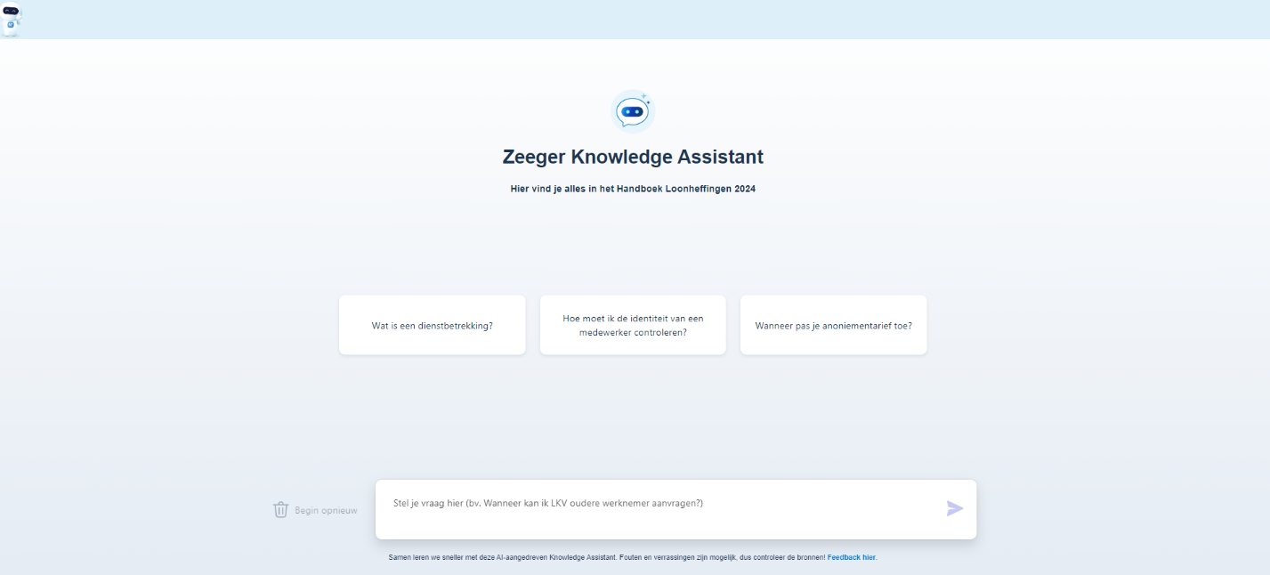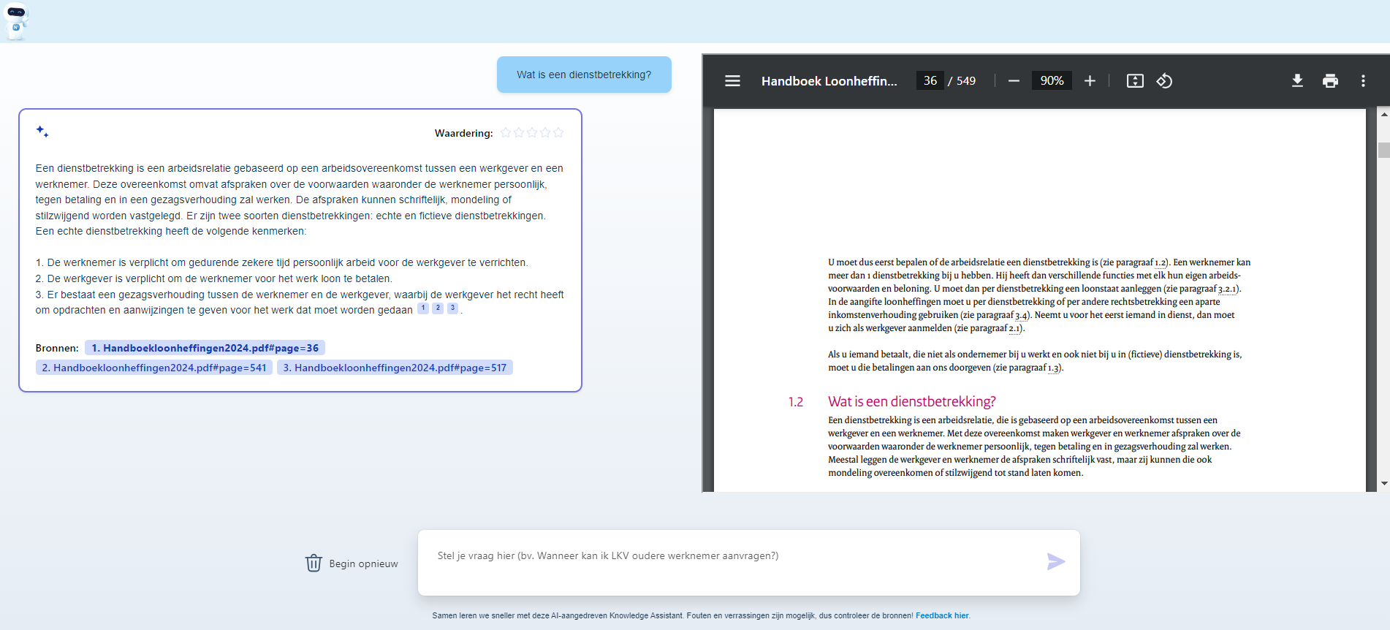
Jul. 2023 – I got the official Professional Scrum Master II (PSMII)
Oct. 2023 - The purpose of this mission is to have our Fabric Azure Packages and our Internal SDK packages up to date on every project. We have our tech goal to keep our "Package Management Under Control". The motivation is described in the goal: “We currently are facing a great threat, not only on security but also on functionality and having a great risk of sudden dependencies stop working because of using deprecated or old version of dependencies.”
^{Oct} 2023 – As I joined Chapter Scrum Masters in Sep. 2022, at this time, we raised the flag that we weren’t working good together. Due to that reason, we decided to start fresh and with a new structure. We were all part of that decision and the strategy on how to help company move faster with us.
Jan 2024 – Joined Squad Core as a Full Stack Software Engineer.
Feb 2024 – For two months, I was Scrum Master of Squad Infra, where I helped them being an observer and suggested some minor changes in the way of working.
Mar 2024 – Joined my second tech mission. The objective of our mission is to ensure that our Web Components library remains current, future-proof, and able to accept contributions from various squads.
Web Components serve as a critical element in our UI landscape. They facilitate the creation of reusable UI elements, with their functionality encapsulated, separate from the rest of the codebase. This encapsulation allows a standardized approach to our UI design.
However, these components necessitate regular maintenance. Over the past few years, they have been neglected, leading to several issues:
- Obsolete components
- Security risks from outdated components
- Non-execution of tests that ensure consistency
- Absence of clear ownership by the squads
Addressing these issues is crucial for the continued efficiency and security of our UI landscape.
Milestones
1 - Up to date components
Guarantee that we are using the latest components, gaining the benefits of security, and receiving the latest improvements in the components improving it’s usability.
- Update the current version of Lit is V.3 and we're still using V.2.3.1.
- Generate a report from npm-check package, that will help us understand the packages that can have vulnerabilities and some that need to be updated.
Approach
- To successfully update to the latest version of Lit, we need to make several structural changes.
- Some packages that are incompatible with the latest version need to be removed.
- We need to revise our approach to adding style to our Web Components, as the current CSS and SCSS loaders pose a problem.
- Our unit tests need to be migrated to the boilerplate recommended by Lit.

2 - Unit tests working
Ensure that contributions are welcomed giving confidence in the code and making it ready to evolve at a faster pace.
- Fix issues with unit tests and pipelines, leading to bad development practices.
- Add at least 80% of test coverage. Currently, it is affecting the development community.
- Enable again the unit tests on the pipelines.

3 - Deploy pipelines reviewed
The deployment of the components should be standardize and using the latest best practices. This will ensure that we can deploy fast and confident
- Review the UIComponents pipelines;
- Migrate to YAML;
- Do a comprehensive examination of the packaging process.

4 - XSS Standard Layer
We should be safeguarded against Cross-Site Scripting (XSS) through the implementation of a standard protection layer across all components. This will guarantee security and that further contributions are also protected
- Centralized sanitization inputs to protect XSS.
At the end, we showed how important is to have a squad focused on frontend and the company created a new squad “Design System”.
Apr 2024 – Team requested me to become their Scrum Master. It was hard to gain their trust but we saw multiple performance boost when they started believed in embrancing the changes. They were a senior team.
Apr 2024 – Developed and launched the second version of the App Switcher. We want Visma Accounting applications to be more integrated so they can be sold as a package to compete with similar offers that exist in the market. To help with that we need to build an app switcher like Google or Jira that enables the users to easily switch between apps. We (NMBRS) also want to use the same app switcher for our add-ons, especially the ones that are also Visma apps. This component works seamlessly in all Visma applications.
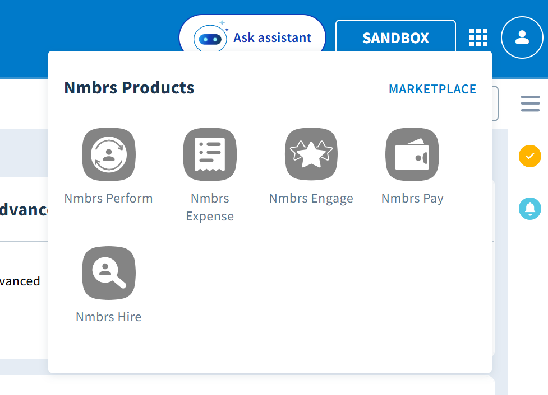
For this project we even add to create two addoc projects. First, The App Switcher Event Bus to handles events from the Visma App Switcher. When a user clicks on an Application, the App Switcher will send HTTP requests to a Node.js API. This API stores asynchronously queues with the event data. In paralled, the Node.js Server gets a chunk of queues from the queue storage, and managed the event by adding information on a Table Storage. Second, a Application Management feature, where you can edit or add new applications to the App Switcher.
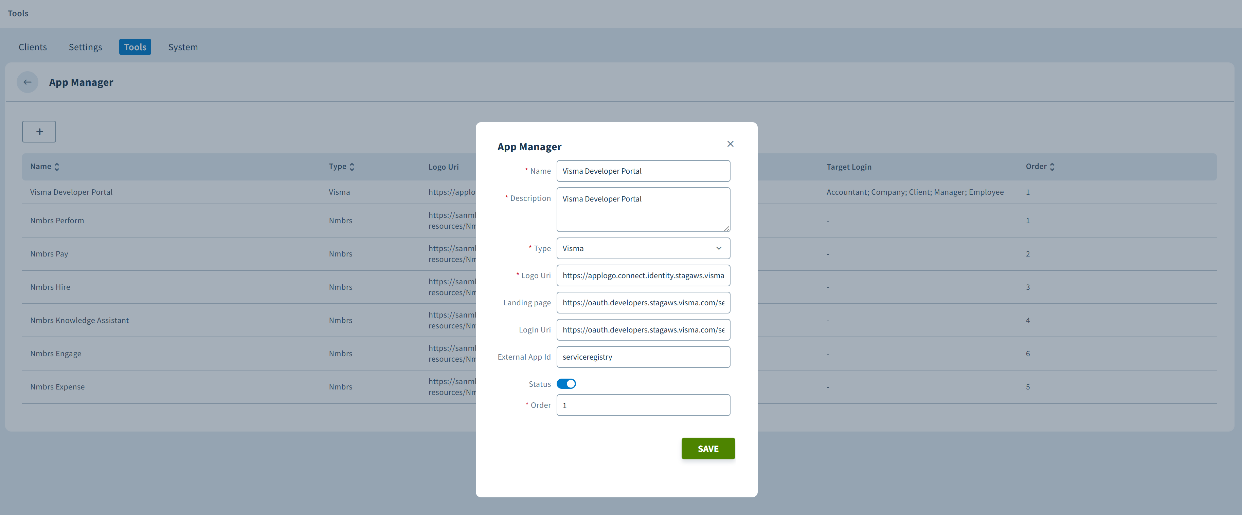
Jun 2024 – We created the second AI chatbot for leave requests. It never got live. We never got an explanation on why we didn’t pick up the project.
Aug 2024 – Developed and launched a second version of backstage.
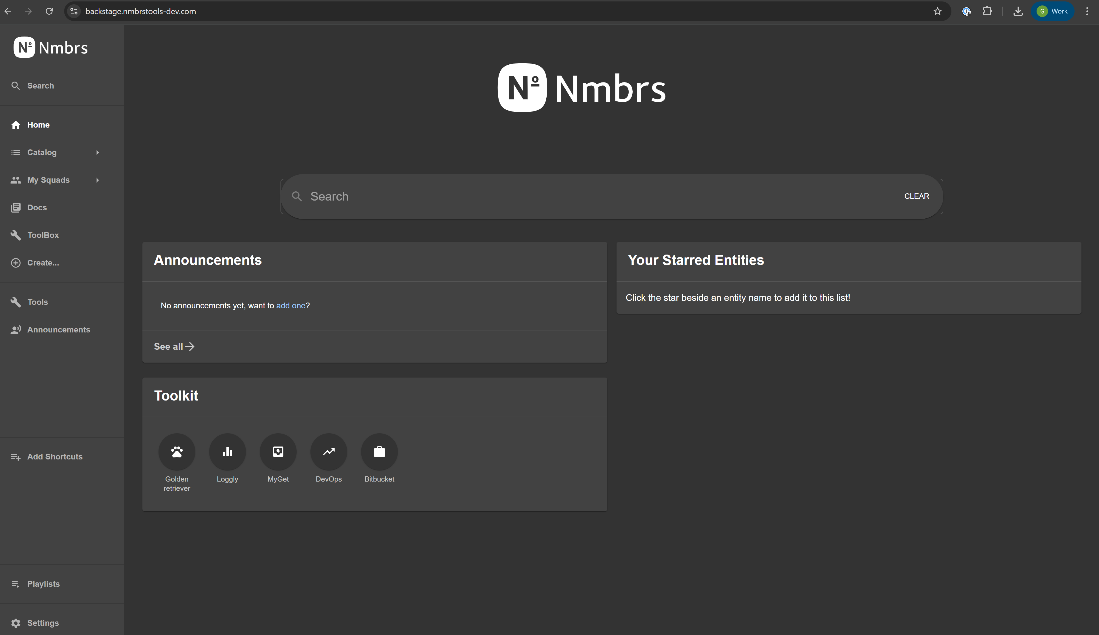
Backstage is an open-source tool created by Spotify developer to help developers in their daily work. We created it to help developers at Nmbrs.
Nov 2024 – New Navigation System via Left Menu Navigation, where We want to better showcase our features while also making our product more user friendly; We do this by grouping together similar functionalities and also by having our Plus Features in a highlighted place; Left menu has intuitive interactions which help the user navigate to/from different Features. In the left menu, you can navigate to any part of the product, including debtors, companies and employees. This changed was huge because we changed a legacy code with 12 years old, and added on top the concept of visibility vs permissions.
Feb 2025 – Started chaging our pricing strategy model, moving from one full product to have multiple packages that the user can buy.
Mar 2025 – Along with Chapter Frontend, we started thinking on the new architecture for a new frontend application.
May 2025 – Created a Template Switcher tool to help our customers migrate from one template to another without any issue.
Jun 2025 – Created an AI prompt to help migrate our webforms control pages to microfrontends that we call widgets (standalone js, html and css).
Jun 2025 – Created an AI prompt to update our packages in Fabric: “---
description: Request to update a fabric package
globs:
alwaysApply: false
---
# Updating Rules for Nmbrs Fabric Package

Always output the current step of this process in the chat.

## Steps to Implement
1. Validate if there's already test projects for the given package.
2. Create tests based on .cursor/rules/testing-rules.mdc
- After creating test projects, add them to the main solution file (Nmbrs.Fabric.sln) using `dotnet sln add` command
- Test if the test projects build correctly
3. Run the tests, and check if they are all green. If not, fix them. Don't change the current package behavior.
4. Remove unused packages references
5. Run the tests, and check if they are all green
6. **IMPORTANT**: Before updating any packages, check the "No Update" packages list below and ask the user if this package is used in the Monolith application
7. Update non Nmbrs packages, and tell us what are the main breaking changes
8. Run the tests, and check if they are all green
9. If Nmbrs package dependency, exist please update and run the tests
10. Write documentation following the .cursor/guidelines/documentation_guidelines.mdc file:
- Create feature documentation in `.docs/features/<category>/<package-name>/index.md`
- Create reference documentation in `.docs/references/<category>/<package-name>-package.md`
- Include architecture diagrams, class diagrams, and usage examples
- Document all breaking changes and known limitations
- Update README.md in the package root with basic information and links to detailed documentation
- You can infer the <category> by the folder name the project is located. Example: monitoring, common, communications
11. Wait for user confirmation
12. If validation is ok. Check if tests project are using .NET 8 and latest packages. If not run convert test project to .NET 8 and run steps 3, 4, 7, 8 for the test project, make sure all packages are updated and tests are green.
13. Make sure the .csproj contains the propertygroup attributes:
<RestorePackagesWithLockFile>true</RestorePackagesWithLockFile>
<RestoreLockedMode Condition="'$(ContinuousIntegrationBuild)' == 'true'">true</RestoreLockedMode>
<PackageOutputPath>$(LOCAL_NUGET_PACKAGE_OUTPUT_PATH)</PackageOutputPath>

## Important Notes
1. Library/Package projects must ALWAYS remain targeting netstandard2.0
2. Only test projects should be upgraded to .NET 8
3. Update packages to their latest versions that are compatible with netstandard2.0

## "No Update" Packages
For various reasons, some packages can't be updated in any Nmbrs component or just in a specific component. **Always ask the user if this package is used in the Monolith application before updating any of these packages.**

| Package | Version | Range | Why |
|---------|---------|-------|-----|
| Polly | 6.1.2 | Globally | Monolith has conflict issues with any version above 7. This doesn't break the build but in runtime |
| Moq | >=4.20 | Globally | Don't update to 4.20 or higher: there is a privacy concern |
| System.Net.Http | > 4.3.4 | Monolith | It breaks |
| FluentAssertions | >= 8.0.0 | Globally | Now it's a paid version, $130 per developer |
| MassTransit | >= 9 | Globally | Since V9 it is a paid version |
| AutoMapper | >= v15.0 | Globally | AutoMapper: The Object-Object Mapper - AutoMapper (more info) |
| MediatR | >= v13.0 | Globally | MediatR: The Simple Yet Powerful Mediator (more info) |

## You Should:
1. If unit test, please follow the guidelines in .cursor/guidelines/unit-test-guidelines.mdc.
2. If integration test, the project name should be <package_name>.Tests.Integration
3. Add the new test project to the test dir. For instance, if the package is in src/Common, the test project should be in test/Common
4. Always add newly created test projects to the main solution file (Nmbrs.Fabric.sln)
5. For documentation:
- Follow the structure defined in documentation_guidelines.mdc
- Include all required sections (Purpose, Architecture, Dependencies, Usage, etc.)
- Use diagrams where appropriate
- Keep documentation up-to-date with code changes
- Cross-reference related documentation
- Include practical examples and best practices
“
Jul 2025 – Launched an Admin Feature to help our community to change or create new packages.
Oct 2025 – AI Masterclass Instructor.

