Microwave Engineering- ECA1308
Student Name: U.Guru Prasad Reddy
Reg no: 192312683L,Date(9/10/26)

Experiment B: TE10 versus TM11: Using the same WR-90 waveguide at f = 10 GHz, simulates both TE10 and TM11 modes. Determine fc, β and the E/H-field distributions for each mode. Calculate the theoretical cutoff frequencies using fc(mn)=c/2√[(m/a)²+(n/b)²]. Compare the results and justify why TE10 propagates at 10 GHz while TM11 does not.

Aim: To simulate and compare the TE10 and TM11 modes of a WR-90 rectangular waveguide at 10 GHz using MATLAB, determine their cutoff frequencies and propagation constants, plot their E-field and H-field distributions, and justify why TE10 propagates while TM11 does not at 10 GHz
Software Required:MATLAB
PROCEDURE:
- Open MATLAB and select Home → New Script.
- Enter the WR-90 waveguide dimensions \(a=22.86\) mm, \(b=10.16\) mm and operating frequency \(f=10\) GHz.
- Define the mode indices as TE10: (m=1,n=0) and TM11: (m=1,n=1).
- Calculate the cutoff frequencies of TE10 and TM11 using the rectangular waveguide cutoff-frequency equation.
- Calculate the propagation constant β for TE10 at 10 GHz and check the propagation condition for TM11.
- Create the waveguide cross-sectional coordinate grid using linspace() and meshgrid().
- Calculate the E-field and H-field distributions for both TE10 and TM11 modes.
- Plot the four field distributions using surf() and observe the TE10 E-field, TE10 H-field, TM11 E-field, and TM11 H-field patterns.
- Observe the results in the Command Window and conclude that TE10 propagates at 10 GHz, whereas TM11 does not propagate because its cutoff frequency is above 10 GHz.
- Display the final results including the E-field plot, H-field plot, theoretical cutoff frequency, simulated cutoff frequency, propagation constant, and percentage deviation, and verify that the TE₁₀ mode propagates at 10 GHz.

Program:
clc;
clear;
close all;

%% TE10 versus TM11 - WR90 Waveguide

% Waveguide dimensions
a = 22.86e-3; % Width in meters
b = 10.16e-3; % Height in meters

% Operating frequency
f = 10e9; % 10 GHz

% Speed of light
c = 3e8;

%% 1. Cutoff Frequencies

% TE10
m1 = 1;
n1 = 0;

fc_TE10 = (c/2)*sqrt((m1/a)^2 + (n1/b)^2);

% TM11
m2 = 1;
n2 = 1;

fc_TM11 = (c/2)*sqrt((m2/a)^2 + (n2/b)^2);

fprintf('TE10 Cutoff Frequency = %.4f GHz\n',fc_TE10/1e9);
fprintf('TM11 Cutoff Frequency = %.4f GHz\n',fc_TM11/1e9);

%% 2. TE10 Propagation Constant

beta_TE10 = (2*pi*f/c)*sqrt(1-(fc_TE10/f)^2);

fprintf('\nTE10 Propagation Constant = %.4f rad/m\n',beta_TE10);

%% 3. TM11 Condition

if f > fc_TM11

beta_TM11 = (2*pi*f/c)*sqrt(1-(fc_TM11/f)^2);

fprintf('TM11 propagates.\n');
fprintf('TM11 Propagation Constant = %.4f rad/m\n',beta_TM11);

else

alpha_TM11 = (2*pi*f/c)*sqrt((fc_TM11/f)^2-1);

fprintf('TM11 is BELOW CUT-OFF.\n');
fprintf('TM11 Attenuation Constant = %.4f Np/m\n',alpha_TM11);

end

%% 4. Waveguide Grid

x = linspace(0,a,100);
y = linspace(0,b,60);

[X,Y] = meshgrid(x,y);

%% 5. TE10 E-field Distribution

E_TE10 = sin(pi*X/a);

figure;
surf(X*1000,Y*1000,E_TE10);
shading interp;
xlabel('x (mm)');
ylabel('y (mm)');
zlabel('Normalized E-field');
title('TE10 - E-field Distribution');
colorbar;
view(2);

%% 6. TE10 H-field Distribution

H_TE10 = sin(pi*X/a);

figure;
surf(X*1000,Y*1000,H_TE10);
shading interp;
xlabel('x (mm)');
ylabel('y (mm)');
zlabel('Normalized H-field');
title('TE10 - H-field Distribution');
colorbar;
view(2);

%% 7. TM11 E-field Distribution

E_TM11 = sin(pi*X/a).*sin(pi*Y/b);

figure;
surf(X*1000,Y*1000,E_TM11);
shading interp;
xlabel('x (mm)');
ylabel('y (mm)');
zlabel('Normalized E-field');
title('TM11 - E-field Distribution');
colorbar;
view(2);

%% 8. TM11 H-field Distribution

H_TM11 = sin(pi*X/a).*sin(pi*Y/b);

figure;
surf(X*1000,Y*1000,H_TM11);
shading interp;
xlabel('x (mm)');
ylabel('y (mm)');
zlabel('Normalized H-field');
title('TM11 - H-field Distribution');
colorbar;
view(2);

%% 9. Comparison of Modes

fprintf('\n====================================\n');
fprintf(' TE10 vs TM11 RESULTS\n');
fprintf('====================================\n');

fprintf('Operating Frequency = %.2f GHz\n',f/1e9);

fprintf('\nTE10:\n');
fprintf('Cutoff Frequency = %.4f GHz\n',fc_TE10/1e9);
fprintf('Propagation Constant = %.4f rad/m\n',beta_TE10);

fprintf('\nTM11:\n');
fprintf('Cutoff Frequency = %.4f GHz\n',fc_TM11/1e9);

if f < fc_TM11
fprintf('Status = BELOW CUT-OFF\n');
fprintf('TM11 does NOT propagate at 10 GHz.\n');
else
fprintf('Status = ABOVE CUT-OFF\n');
end

fprintf('\nConclusion:\n');

if f > fc_TE10 && f < fc_TM11
fprintf('TE10 propagates at 10 GHz because f > fc(TE10).\n');
fprintf('TM11 does not propagate because f < fc(TM11).\n');
end
OUTPUT:
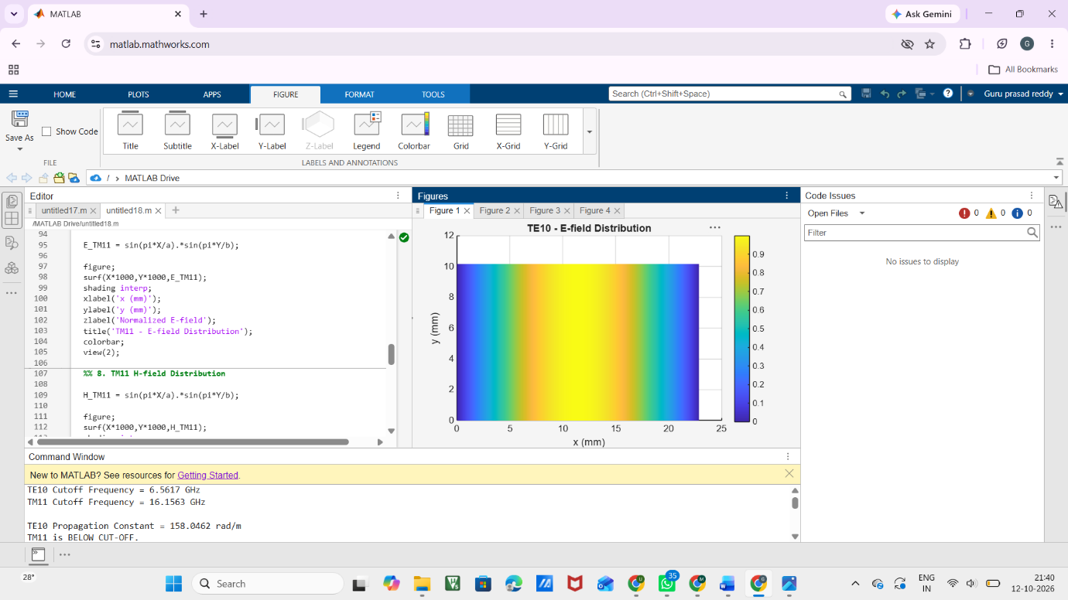
FIG1
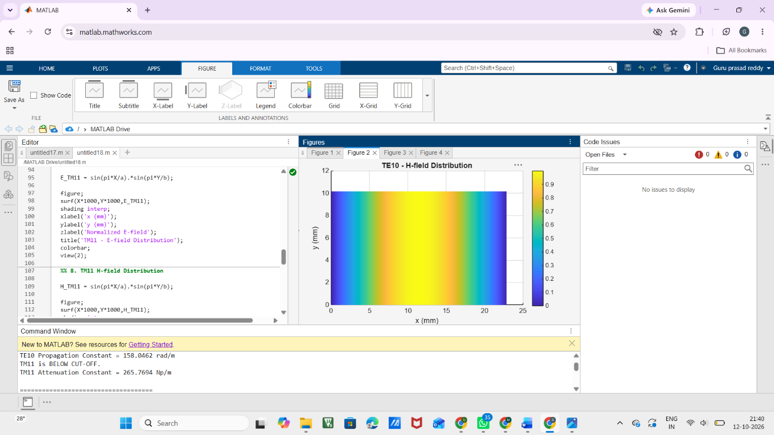
FIG:2
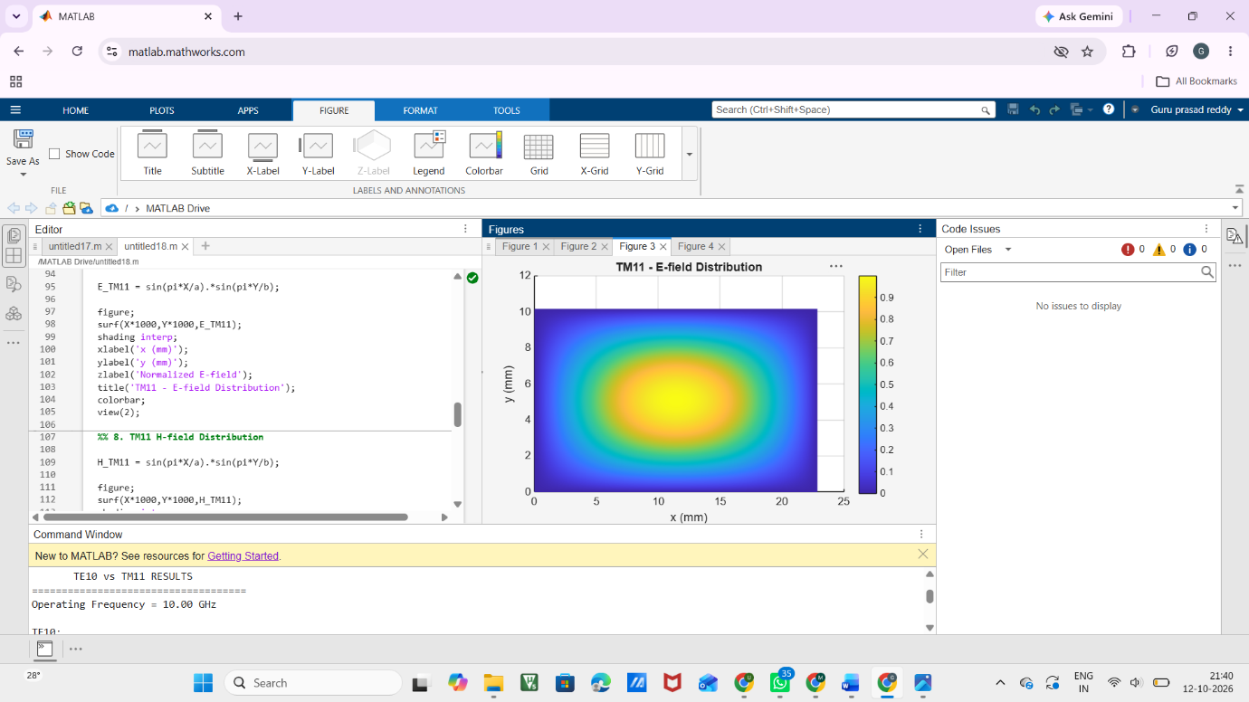
FIG:3

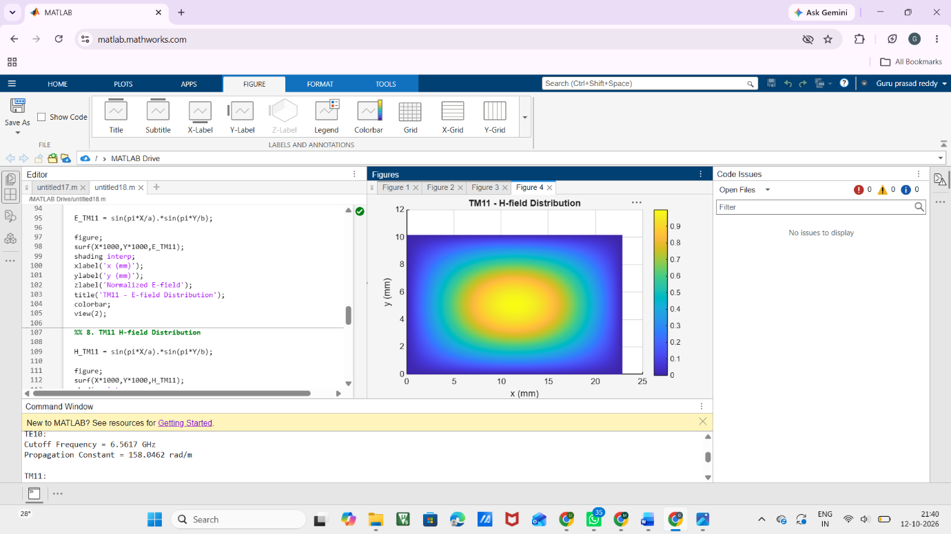
FIG:4

Result:
The TE10 and TM11 modes of the WR-90 rectangular waveguide were analyzed at 10 GHz. The theoretical cutoff frequency of TE10 was found to be 6.557 GHz, while that of TM11 was approximately 16.42 GHz. The TE10 mode has a propagation constant of approximately 198.9 rad/m and propagates because 10 GHz > 6.557 GHz. The TM11 mode does not propagate because 10 GHz < 16.42 GHz, so it is below cutoff. The MATLAB field distributions show the expected different field patterns for TE10 and TM11.

