Microwave Engineering- ECA1308
Student Name: U.Guru Prasad Reddy
Reg no: 192312683L,Date(13/10/26)
EXPERIMENT 2(B):
Determination of Optimum Operating Frequency from S-Parameter Sweep
Aim
To determine the optimum operating frequency from the 8–12 GHz S-parameter sweep by finding the frequency at which \(|S_{11}|\) is minimum and \(|S_{21}|\) is maximum, and to compare its performance with that at 10 GHz.
Software Required
- MATLAB
Procedure — MATLAB Process
- Open MATLAB and create a new script for the optimum-frequency analysis.
- Enter the transmission-line parameters: \(Z_0=50\ \Omega\), \(L=50\) mm, and frequency range from 8 GHz to 12 GHz.
- Generate the frequency sweep using linspace(8e9,12e9,1001).
- Calculate the propagation constant \(\beta\) for every frequency in the sweep.
- Calculate the ABCD parameters \(A,B,C,D\) of the ideal lossless 50 Ω transmission line.
- Convert the ABCD parameters into \(S_{11}\) and \(S_{21}\) over the complete frequency range.
- Calculate the magnitudes \(|S_{11}|\) and \(|S_{21}|\) using the MATLAB abs() function.
- Use the min() function to find the minimum \(|S_{11}|\) and the max() function to find the maximum \(|S_{21}|\), along with their corresponding frequencies.
- Calculate the return loss and insertion loss at the selected frequency and plot \(|S_{11}|\) and \(|S_{21}|\) against frequency to identify the optimum operating condition.
OUTPUT:
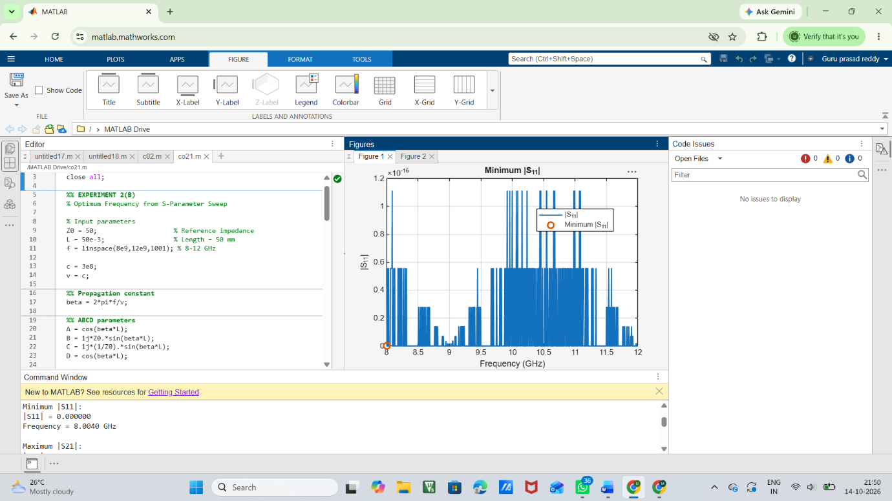

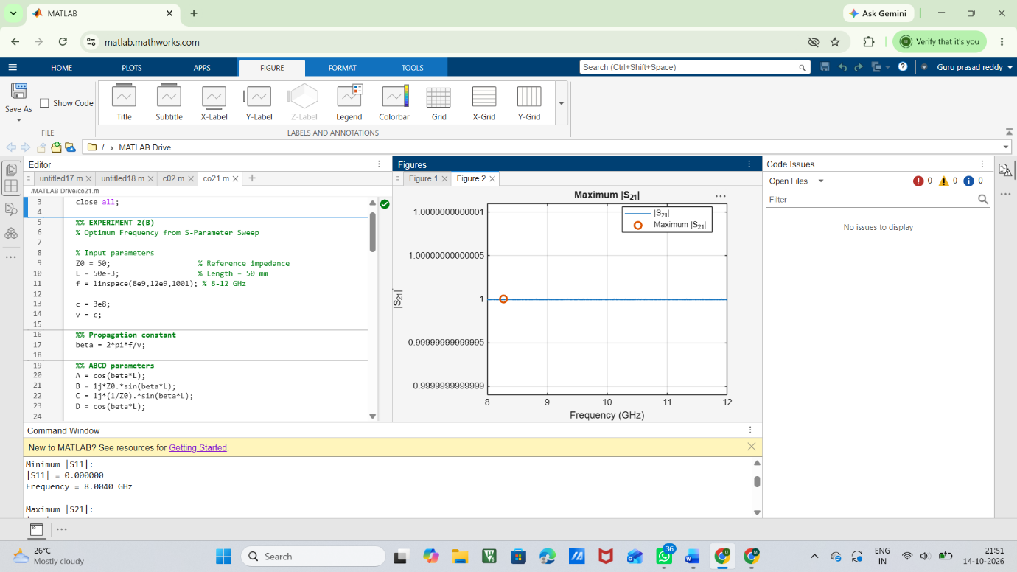
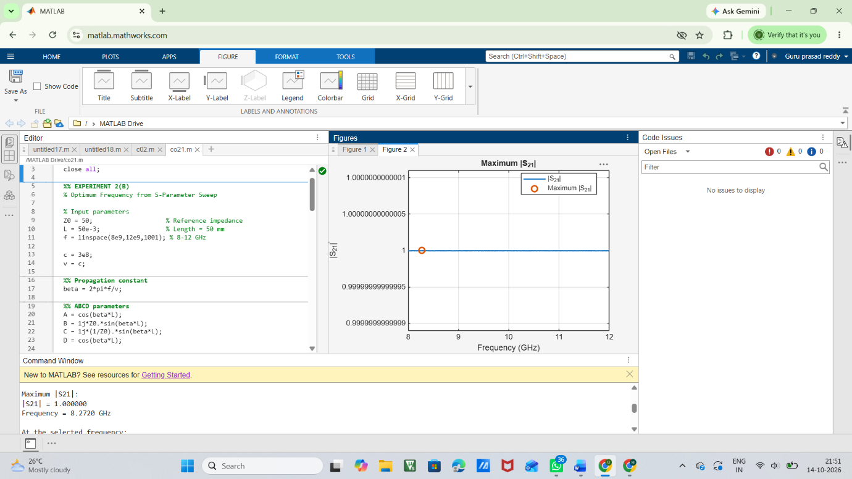
Result —
- The minimum \(|S_{11}|\) and maximum \(|S_{21}|\) were successfully determined from the 8–12 GHz sweep.
- For the ideal 50 Ω matched transmission line, \(|S_{11}|\approx0\) throughout the frequency range.
- Similarly, \(|S_{21}|\approx1\) throughout the frequency range, giving nearly 100% transmission efficiency.
- Therefore, there is no unique optimum frequency; all frequencies from 8 to 12 GHz provide the same ideal performance.
- The selected frequency gives excellent matching and transmission because both ports are perfectly matched to the 50 Ω characteristic impedance.

