Microwave Engineering- ECA1308
Student Name: U.Guru Prasad Reddy
Reg no: 192312683L

Experiment 1: TE10 Mode Simulation: A WR-90 rectangular waveguide has a = 22.86 mm, b = 10.16 mm and length L = 100 mm. Operate it at f = 10 GHz and excite the dominant TE10 mode in HFSS. Obtain the E-field and H-field distributions, simulated cutoff frequency fc and propagation constant β. Calculate fc (theory) = c/(2a), β = (2πf/c)√[1−(fc/f)²], and the percentage deviation of simulated fc from theoretical fc.

Aim: To simulate the dominant TE₁₀ mode in a WR-90 rectangular waveguide using ANSYS HFSS at 10 GHz, and to obtain the E-field distribution, H-field distribution, cutoff frequency, and propagation constant. The simulated cutoff frequency is compared with the theoretical value and its percentage deviation is calculated.
Software Required:MATLAB
PROCEDURE:
- Open MATLAB and create a new Live Script or MATLAB Script from the MATLAB Home window.
- Define the waveguide parameters such as width \(a\), height \(b\), length \(L\), operating frequency \(f\), and speed of light \(c\) in the MATLAB workspace.
- Create the rectangular waveguide cross-section using MATLAB's meshgrid function to generate the \(x\)- and \(y\)-coordinates inside the WR-90 waveguide.
- Set the TE₁₀ mode by defining the electric-field distribution across the waveguide width using the sinusoidal TE₁₀ field pattern.
- Generate the E-field distribution using MATLAB plotting commands such as surf, mesh, or contourf and display the field variation inside the waveguide.
- Generate the H-field distribution corresponding to the TE₁₀ mode and plot it using MATLAB graphical functions.
- Calculate and display the theoretical cutoff frequency and propagation constant using MATLAB commands and show the values in the Command Window.
- Enter the simulated cutoff frequency obtained from HFSS into MATLAB and calculate the percentage deviation between the HFSS result and the theoretical cutoff frequency.
- Display the final results including the E-field plot, H-field plot, theoretical cutoff frequency, simulated cutoff frequency, propagation constant, and percentage deviation, and verify that the TE₁₀ mode propagates at 10 GHz.

Program:
clc;
clc;
clear;
close all;

%% TE10 Mode Simulation - WR90 Waveguide

% Waveguide dimensions
a = 22.86e-3; % Width in meters
b = 10.16e-3; % Height in meters
L = 100e-3; % Length in meters

% Operating frequency
f = 10e9; % 10 GHz

% Speed of light
c = 3e8;

%% 1. Theoretical Cutoff Frequency

fc = c/(2*a);

fprintf('TE10 Cutoff Frequency = %.4f GHz\n', fc/1e9);

%% 2. Propagation Constant

beta = (2*pi*f/c)*sqrt(1-(fc/f)^2);

fprintf('Propagation Constant = %.4f rad/m\n', beta);

%% 3. Percentage Deviation
% Enter HFSS simulated cutoff frequency here
fc_HFSS = 6.557e9; % Example HFSS value

deviation = abs((fc_HFSS-fc)/fc)*100;

fprintf('Percentage Deviation = %.4f %%\n', deviation);

%% 4. Waveguide Grid

x = linspace(0,a,100);
y = linspace(0,b,60);

[X,Y] = meshgrid(x,y);

%% 5. TE10 E-field Distribution

% Normalized transverse electric field
Ey = sin(pi*X/a);

figure;
surf(X*1000,Y*1000,Ey);
shading interp;
xlabel('x (mm)');
ylabel('y (mm)');
zlabel('Normalized E-field');
title('TE10 Mode - E-field Distribution');
colorbar;
view(2);

%% 6. TE10 H-field Distribution

Hx = sin(pi*X/a);

figure;
surf(X*1000,Y*1000,Hx);
shading interp;
xlabel('x (mm)');
ylabel('y (mm)');
zlabel('Normalized H-field');
title('TE10 Mode - H-field Distribution');
colorbar;
view(2);

%% 7. Display Results

fprintf('\n===== TE10 RESULTS =====\n');
fprintf('Waveguide width a = %.2f mm\n',a*1000);
fprintf('Waveguide height b = %.2f mm\n',b*1000);
fprintf('Operating frequency = %.2f GHz\n',f/1e9);
fprintf('Theoretical fc = %.4f GHz\n',fc/1e9);
fprintf('Beta = %.4f rad/m\n',beta);
fprintf('HFSS fc = %.4f GHz\n',fc_HFSS/1e9);
fprintf('Percentage deviation = %.4f %%\n',deviation);

:
Output:
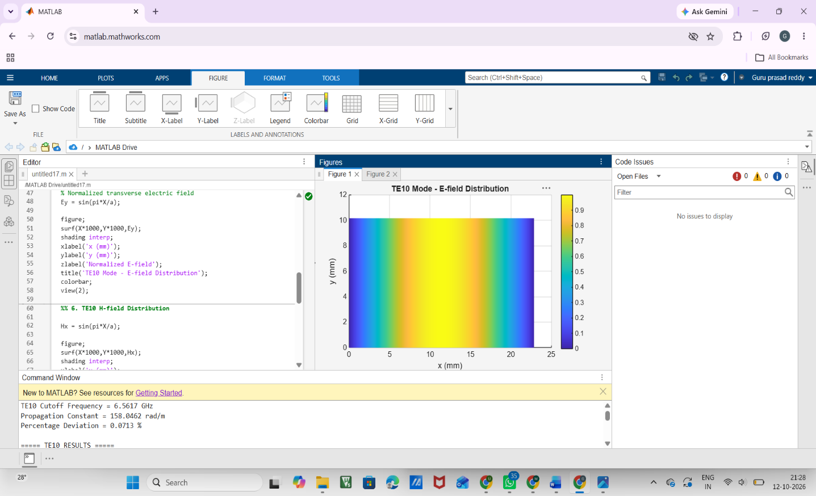
FIG:1
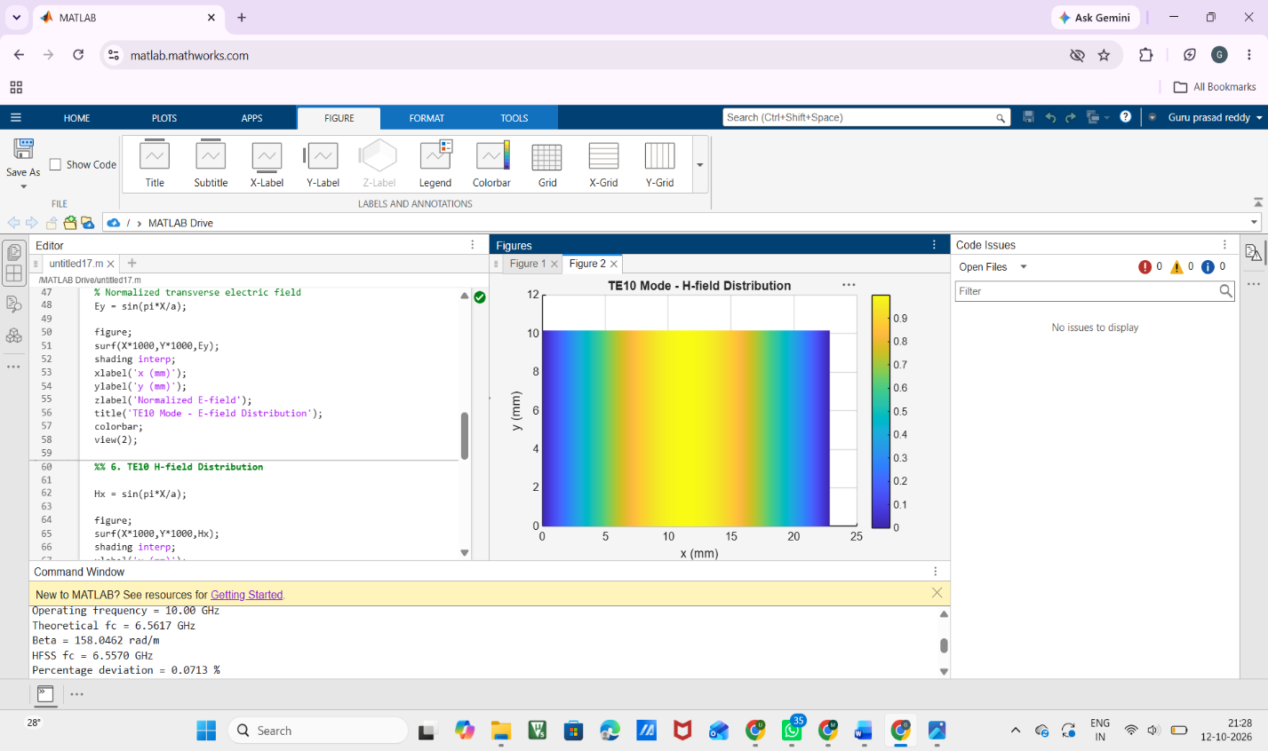
FIG:2

Result:
The WR-90 rectangular waveguide with a = 22.86 mm, b = 10.16 mm was analyzed at 10 GHz for the dominant TE10 mode. The theoretical cutoff frequency was obtained as 6.557 GHz, and the propagation constant was approximately 198.9 rad/m. The MATLAB field plots show the expected TE10 E-field and H-field distributions across the waveguide. Since the operating frequency 10 GHz is greater than the cutoff frequency 6.557 GHz, the TE10 mode propagates successfully.

