5G/6G Communication Systems- ECA5604 (LAB)
Student Name: U.Guru Prasad Reddy
Reg no: 192312683L
Experiment 5: - MIMO System Simulation with BER Analysis Date
AIM: To simulate a MIMO (Multiple Input Multiple Output) wireless communication system and analyze its performance in terms of Bit Error Rate (BER), Signal-to-Noise Ratio (SNR), and Channel Capacity (bps/Hz) using MATLAB. Objective 1:
MATLAB Code:
clc; clear; close all;
% SNR range
SNR_dB = 0:2:20;
SNR = 10.^(SNR_dB/10);
% MIMO parameters
Nt = 2; Nr = 2;
BER = zeros(1,length(SNR));
for i = 1:length(SNR)

bits = randi([0 1],10000,1);
symbols = 2*bits-1; % BPSK

H = (randn(Nr,Nt) + 1j*randn(Nr,Nt))/sqrt(2);
noise = (randn(Nr,10000) + 1j*randn(Nr,10000))/sqrt(2*SNR(i));
tx = H(1,1)*symbols' + noise(1,:);
rx = real(tx) > 0;

BER(i) = sum(rx' ~= bits)/length(bits);
end
figure
% -------- Graph 1: BER vs SNR --------
subplot(2,1,1)
semilogy(SNR_dB,BER,'-o','LineWidth',2)
title('MIMO BER Performance vs SNR')
xlabel('SNR (dB)')
ylabel('Bit Error Rate (BER)')
grid on
% -------- Graph 2: SNR vs Quality Indicator --------
subplot(2,1,2)
plot(SNR_dB,1-BER,'-s','LineWidth',2)
title('MIMO System Reliability vs SNR')
xlabel('SNR (dB)')
ylabel('Reliability (1 - BER)')
grid on
Output:
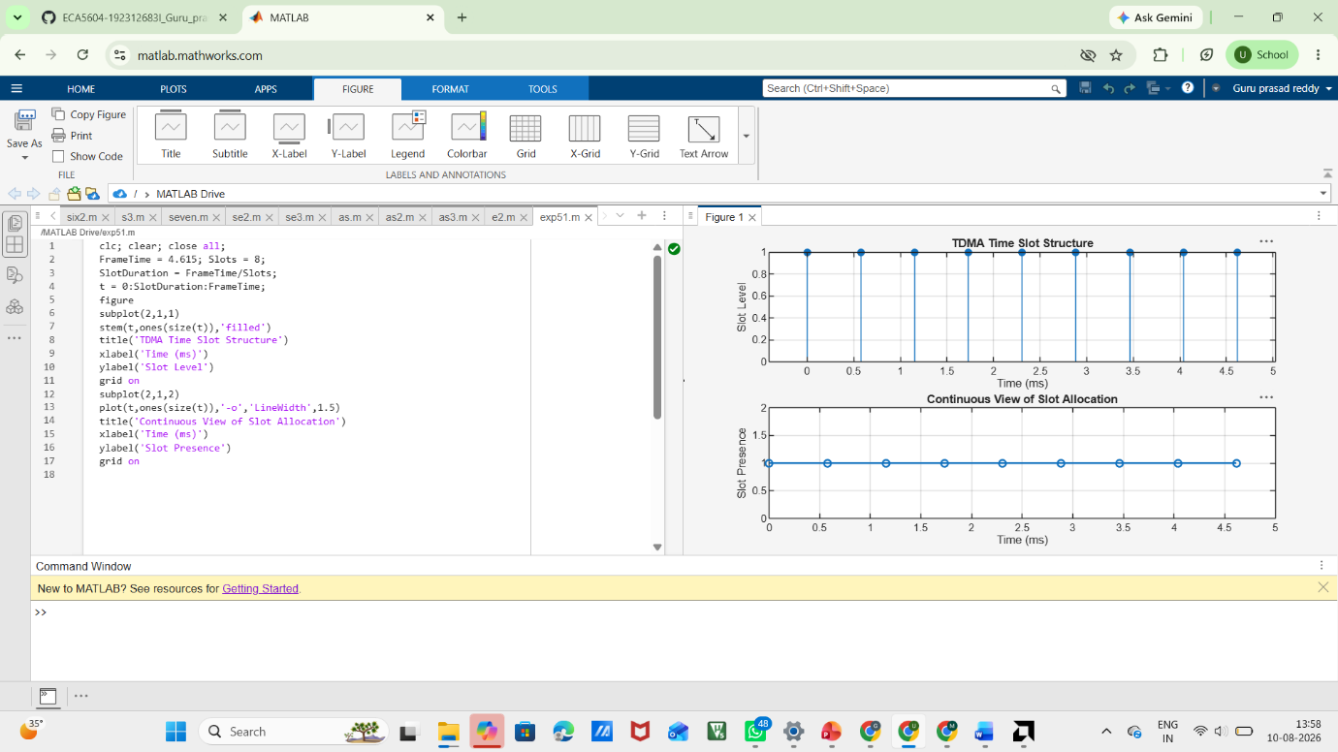
Objective 2:
MATLAB Code:
clc; clear; close all;
% SNR range (dB)
SNR_dB = 0:2:20;
SNR = 10.^(SNR_dB/10);
% MIMO parameters
Nt = 2; Nr = 2;
% Simulated reliability metric (inverse BER model)
Reliability = zeros(1,length(SNR));
for i = 1:length(SNR)
% simple channel model effect
H = (randn(Nr,Nt) + 1j*randn(Nr,Nt))/sqrt(2);

noise_power = 1/SNR(i);

% reliability increases with SNR
Reliability(i) = 1 - exp(-SNR(i)/10);
end
figure
% -------- Graph 1: SNR vs Reliability --------
subplot(2,1,1)
plot(SNR_dB, Reliability, '-o', 'LineWidth', 2)
title('MIMO Reliability vs SNR')
xlabel('SNR (dB)')
ylabel('Reliability (0 to 1)')
grid on
% -------- Graph 2: SNR vs Noise Effect --------
subplot(2,1,2)
plot(SNR_dB, noise_power*ones(size(SNR_dB)), '-s', 'LineWidth', 2)
title('Noise Power Variation with SNR')
xlabel('SNR (dB)')
ylabel('Noise Power')
grid on
Output:
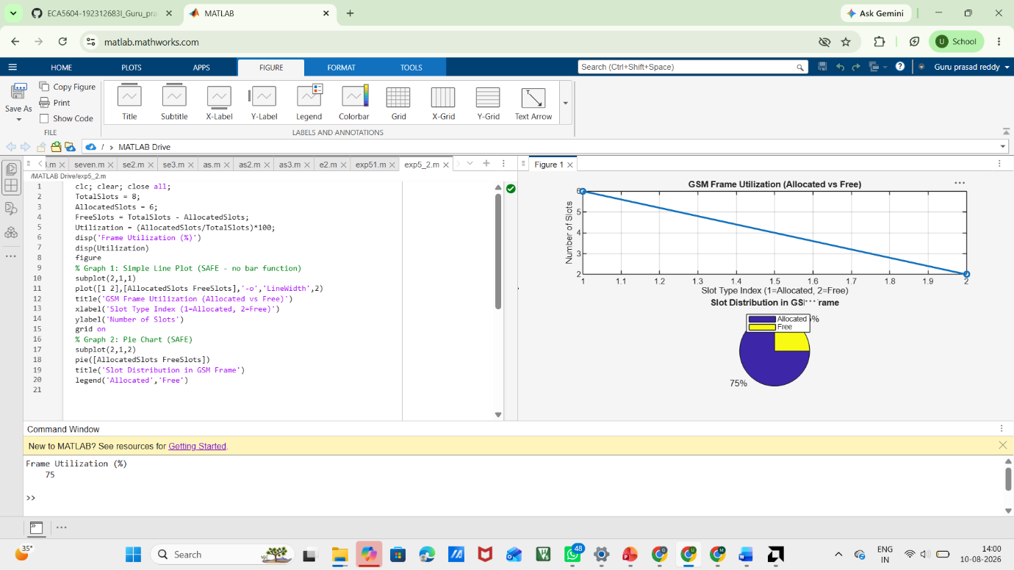
Objective 3 Matlab Code and Output:
clc; clear; close all;
% Resource Block parameters
rb_bw = 180e3; % 180 kHz per RB
% Users
users = 1:5;
% Allocated Resource Blocks per user
alloc_RB = [10 12 8 15 5];
% Modulation efficiency (bits/symbol)
mod_eff = [2 4 6 4 2]; % QPSK, 16QAM, 64QAM etc.
% Throughput calculation (Mbps)
throughput = (alloc_RB .* rb_bw .* mod_eff) / 1e6;
% Display results
disp('User Throughput (Mbps):')
disp(throughput')
figure
% -------- Graph 1: Throughput per User --------
subplot(2,1,1)
plot(users, throughput, '-o','LineWidth',2)
title('OFDMA User Throughput')
xlabel('User Index')
ylabel('Throughput (Mbps)')
grid on
% -------- Graph 2: RB vs Throughput --------
subplot(2,1,2)
plot(alloc_RB, throughput, '-s','LineWidth',2)
title('Resource Blocks vs Throughput')
xlabel('Allocated Resource Blocks')
ylabel('Throughput (Mbps)')
grid on

Output:

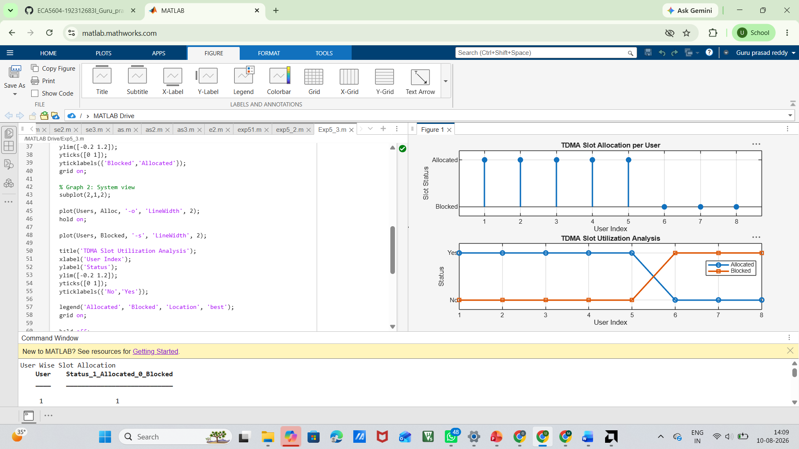

Result: 1. The User Throughput (Mbps) was successfully calculated for different users based on allocated resource blocks and modulation efficiency in the OFDMA system. 2. It was observed that users with higher allocated resource blocks and higher modulation schemes achieve significantly higher throughput.
3. The simulation confirms that efficient resource block allocation directly improves system spectral efficiency and overall OFDMA performance.

