CS 6301: Special Topics in Computer Science
CLOUD COMPUTING
Project #1 Report
Prabhakar Ganesamurthy (pxg130030)

Abstract
Developed a MapReduce program to compute number of crimes of each crime type per region from a large dataset. The regions are defined by a 6 digit number. The region definitions used in the program are
in the format (1XXXXX,1XXXXX), (12XXXX,12XXXX), (123XXX,123XXX).Under different settings such as different number of mapper and reducer tasks, region definitions, input as a single large file, many small files, inconsistent input etc., Hadoop's behavior was studied. File distribution, mapper and reducer distribution, performance of mapper, reducer tasks, memory usage under these settings are studied and discussed in this report.
Cluster used: cluster04@master

File Distribution in Hadoop:
By default block size in hadoop is set to 64MB. So to study the distribution of files among the data nodes
a file lesser than 64MB in size (15MB.csv) and a file greater than 64MB in size(137MB.csv) were uploaded on 2/21/2014 at 18:03
This snapshot shows the commands for uploading the files to hadoop.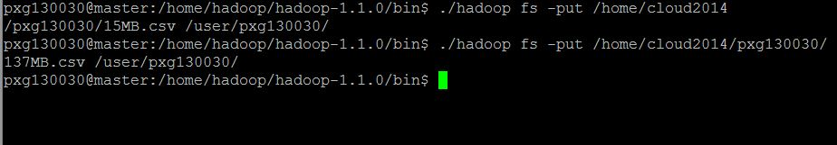

This snapshot shows the files (137MB.csv and 15MB.csv) as contents of /user/pxg130030/ along with timestamp.
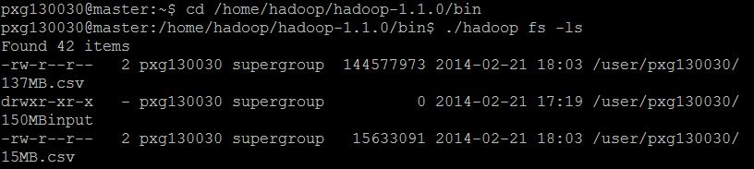

In cluster04 the data nodes are slave02 and slave03.
The logs of slave02 and slave03 were accessed and the following snapshots show how the two files are distributed.
hadoop-hadoop-datanode-slave2.log.2014-02-21(15MB.csv):
The 15MB.csv file is being sent from 192.168.0.120 (master) to 192.168.0.122 (slave02). As 15MB<64MB the file is not split and it is stored as a whole in the block.

hadoop-hadoop-datanode-slave2.log.2014-02-21(137MB.csv):
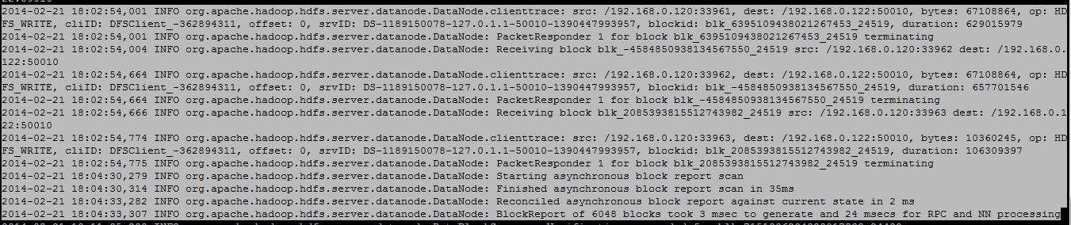
The 137.csv file is sent from 192.168.0.120 (master) to 192.168.0.122 (slave02).
As 137MB>64MB the file is split up into three pieces(64+64+9.88) and stored.

hadoop-hadoop-datanode-slave3.log.2014-02-21(15MB.csv and 137MB.csv)
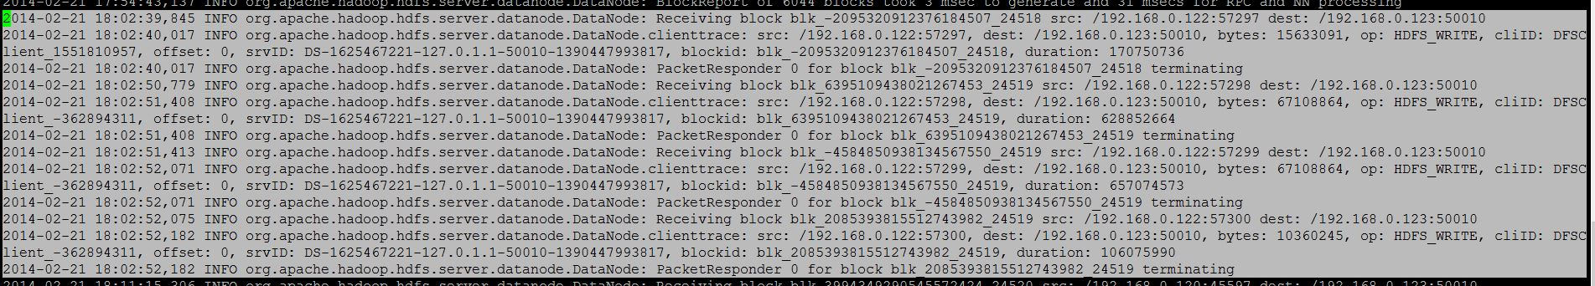
The 15MB.csv file is being sent from 192.168.0.122 (slave02) to 192.168.0.123 (slave03). As 15MB<64MB the file is not split and it is stored as a whole in the block.
The 137.csv file is sent from 192.168.0.122 (slave02) to 192.168.0.123 (slave03).
As 137MB>64MB the file is split up into three pieces(64+64+9.88) and stored.

Note that the file is copied from slave02 and not master.

Inference:
- Files greater than block size are split up and stored in the block
- Files lesser than block size are not split up.
- Files are duplicated among data-nodes (which enables parallel processing in hadoop)
- The files are copied to from master to slave02 to slave 03.
- The files are split up and stored in blocks in slave03 first and then in slave02(from timestamp in log file)

Distribution & Performance of Mapper and Reducer Tasks:
The various settings under which the performance of mapper and reducer tasks were studied are as follows:

Input files:
1. Single large Input file
2. Many small Input files (the large file split into 1341 files)

Mapper and Reducer Numbers: 1, 2, or 5.

Region definitions considered: (1XXXXX,1XXXXX), (12XXXX,12XXXX), (123XXX,123XXX)

Parameters studied: Execution time per task and job, memory usage.

Distribution of Mapper and Reducer Tasks:
As there only two task nodes in the cluster, the mapper tasks are spit up among them i.e., slave02 and slave03 as shown in the following log.
The settings are:
For Many Small Input Files:
Map | Reduce | Definition | Output Folder Name
1 | 1 | 1 | manyMap1Red1Def1
1 | 1 | 2 | manyMap1Red1Def2
1 | 1 | 3 | manyMap1Red1Def3
5 | 5 | 1 | manyMap5Red5Def1
Execution time:
The execution times were calculated from the corresponding log files.
The Observation is visualized below:
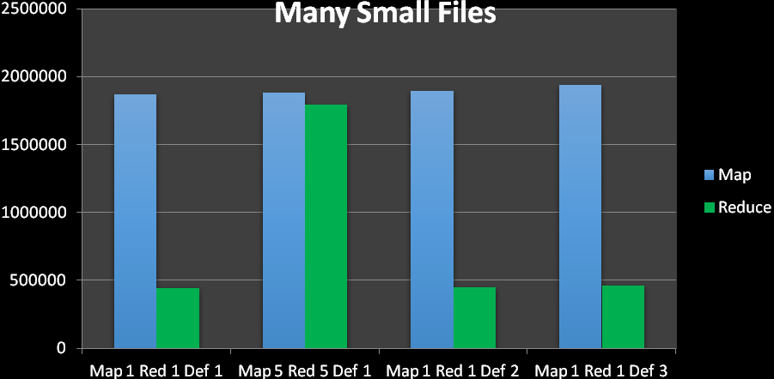

In all the cases the Mapping takes more time than reducing.
There are a total of 1341 files and they are mapped to the mappers.
From the chart it is observed that when the number of reducers is 5, the time taken for reducing is more. This is because the number of slave nodes is 2 and at most 2 reducers can work at a time and the remaining reducers have to wait for the working reducers to complete. This increases the total time taken for reduction.

There is slight increase in time for Mapping and Reduce while using region definition 2 and 3 compared to definition 1. This is because the number of map and reduce records in the order
Def1<Def2<Def3 ((1XXXXX,1XXXXX) < (12XXXX,12XXXX) <(123XXX,123XXX)). Hence the slight increase in Def2 and Def3.

The execution time per task for manyMap5Red5Def1 as follows:
Map Tasks
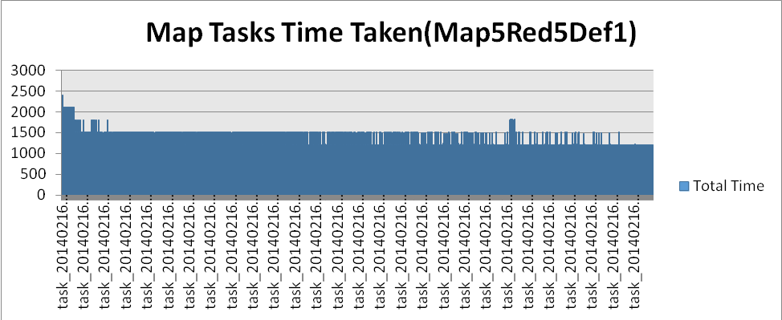
Reduce Tasks:
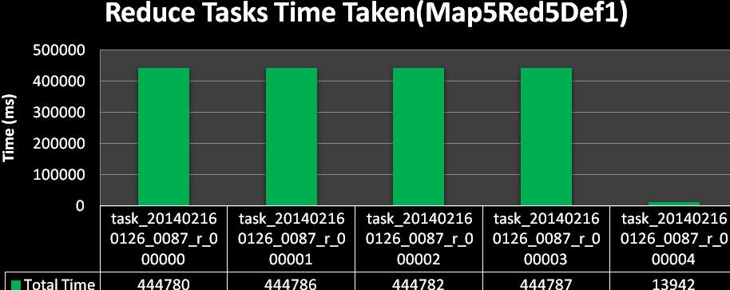

The last reduce task has very execution time. This is because the output of Map tasks are shuffled and sorted and divided among the Reducers. The first 4 reducers got equal amount of records whereas the remaining small of amount of records are sent to the last record. Hence the small execution time.

Map vs Reduce:
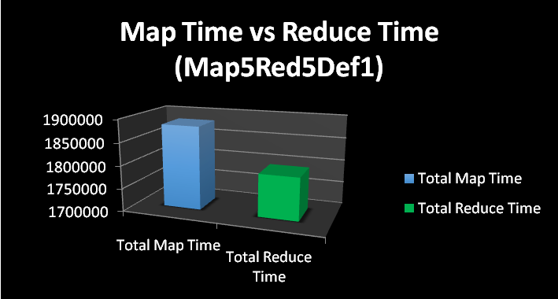

A similar per-task and per-job execution time analysis is done.

Memory Usage:
The memory usage of each setting is obtained from the corresponding log files.
It is visualized below.
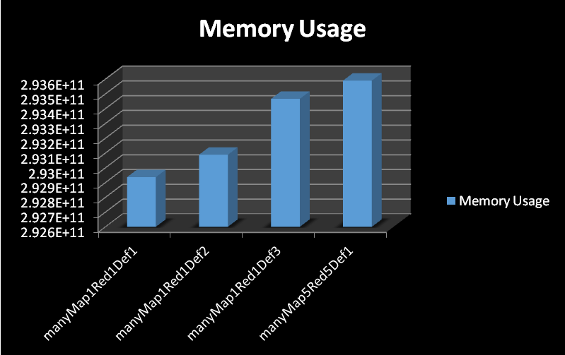

From the above chart the first 3 bars represent Def1, Def2, Def3 region definitions that are run under same number of Map and Reduce tasks. As the number of records are in the order Def3>Def2>Def1, it explains why the order of memory usage is Def3>Def2>Def1.
Having 5 reducers which is more than the actual number of slave nodes results in the use of more memory.

For Single large Input file:
Map | Reduce | Definition | Output Folder Name
1 | 1 | 1 | singleMap1Red1Def1
1 | 1 | 2 | singleMap1Red1Def2
1 | 1 | 3 | singleMap1Red1Def3
1 | 2 | 1 | singleMap1Red2Def1
1 | 2 | 2 | singleMap1Red2Def2
1 | 2 | 3 | singleMap1Red2Def3
2 | 1 | 1 | singleMap2Red1Def1
2 | 1 | 2 | singleMap2Red1Def2
2 | 1 | 3 | singleMap2Red1Def3
2 | 2 | 1 | singleMap2Red2Def1
2 | 2 | 2 | singleMap2Red2Def2
2 | 2 | 3 | singleMap2Red2Def3
5 | 1 | 1 | singleMap5Red1Def1
5 | 5 | 1 | singleMap5Red5Def1

Execution Time:
The execution times were calculated from the corresponding log files.
The Observation is visualized below:
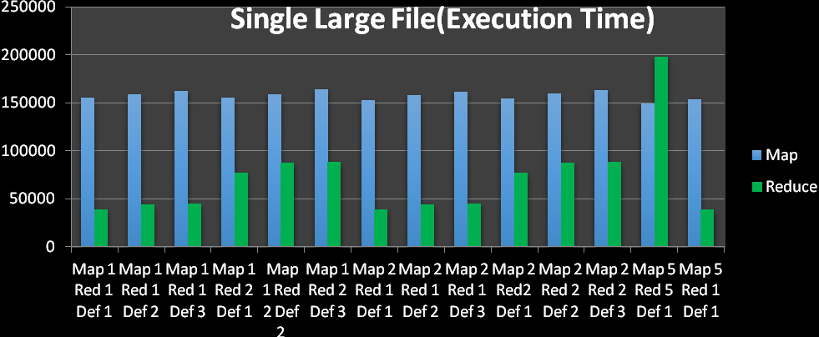

From the above chart, it is seen that the more the number of records to process(for example region definition 3), the more the execution time for mapper and reducer. Also as the total number of slave nodes is 2, when the number of reducers is 2 or more, the reducers have to wait for previous reducers to complete thereby increasing the total time taken for reduce tasks.
In the setting of Map 5 Red 5 and Def 1, the number of reducers is very high that the total time taken for reducer tasks is more than that of mapper tasks. This is bad setting is corrected in the next case Map5 Red5 Def1 , where the total time taken for reduce task is significantly lowered.

The per task execution time of the setting Map 5 Red 1 Def 1 is shown below:

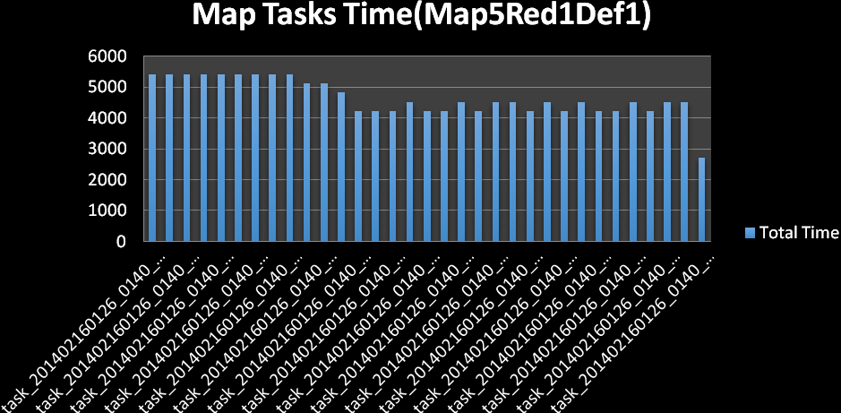
The single large file is split up into 33 parts and sent to the Mappers.

Map vs Reduce:
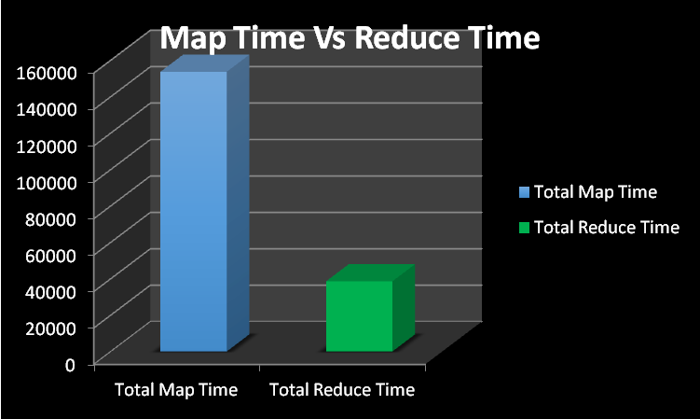

Memory Usage:
The memory usage of each setting is obtained from the corresponding log files.
It is visualized below.
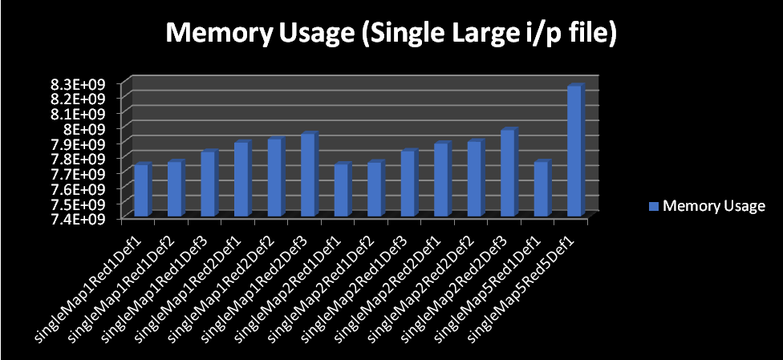

Like observed before for many small inputs, memory usage is more when the number of records to process is more(def3) and when there are more reducers than the number of slave nodes(map5red5def1).

Single Large Input File Vs Many Small Input Files:
Contents of the single large file and many small input files are the same. But there is difference in execution time and memory usage.
Execution Time:
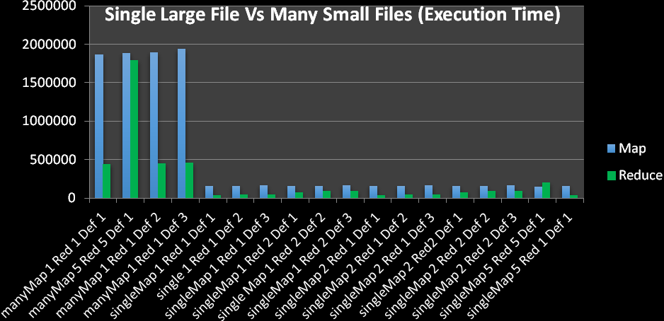
From the above chart, it is clear that the time taken to process many small inputs is much higher compared to the time taken to process a single large file. This is because while processing the single large file, it is split into 33 parts whereas while processing many small inputs each file is sent to mapper if it's not too big for the mapper to process making it 1341 parts(1341 files). Hence the difference.

Memory usage:
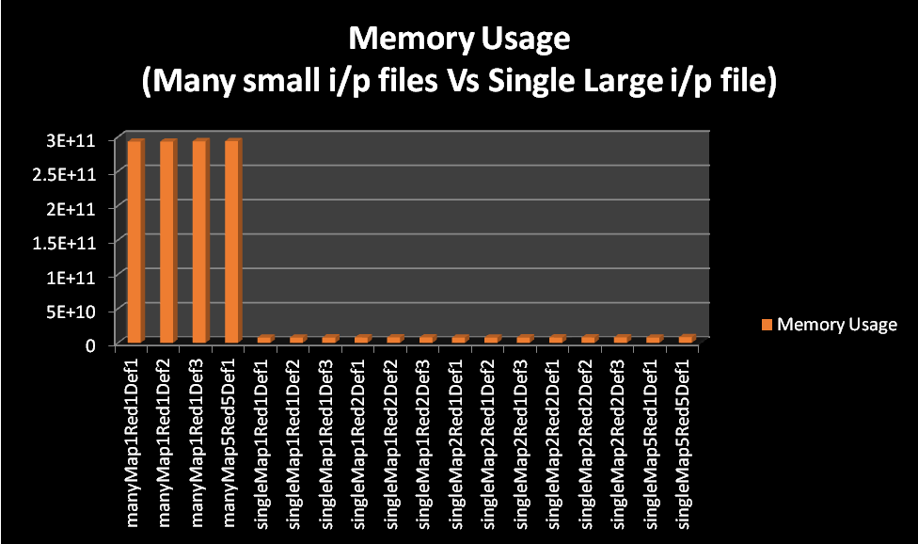

From the above chart is evident that memory usage when processing many small files is very high compared that of single large file. This is because each mapper and reducer don't get to process to their complete capacity in small input files as a small input file may contain data very small compared to the capacity of data a mapper can handle. In processing of a single large file, the file is split in a way that a mapper gets the maximum amount data it can process, hence memory usage is minimized.
Shuffling and Sorting:
Shuffling and sorting tasks occur after mapper tasks. The shuffle and sort the output records of the mapper and send them to the reducers. So the reducer input is always sorted.

Error handling:
A runtime error was introduced while processing a set of input files in hadoop and how hadoop handled the error was observed.
Error introduced: After starting the processing of input files, one of the input files was removed.
Hadoop generated the following log:
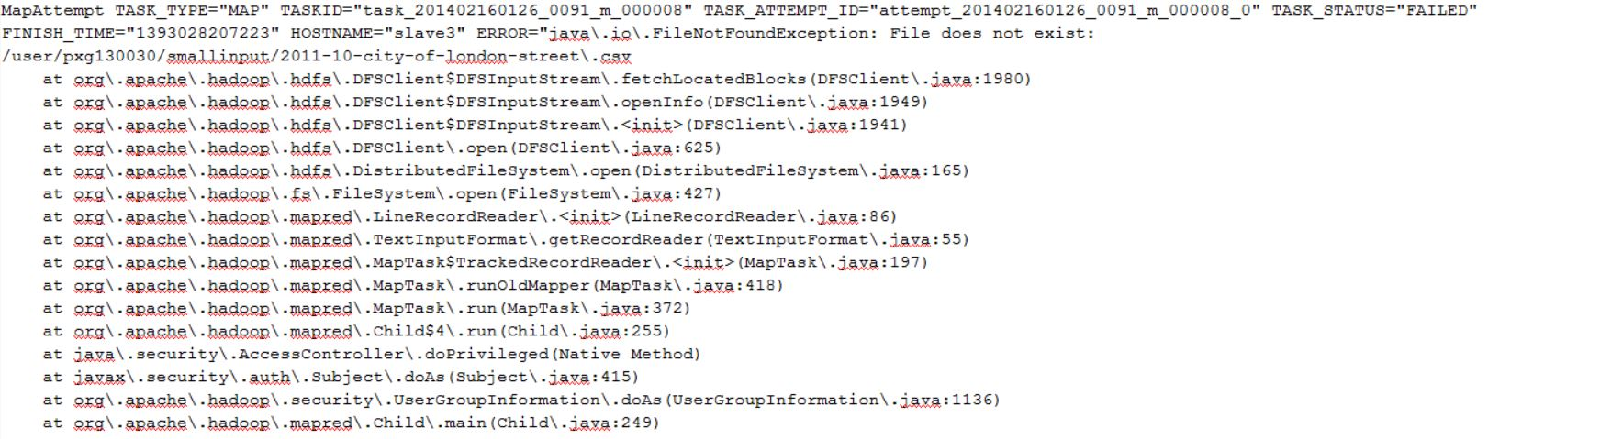
Hadoop throws a FileNotFoundException during the m_000008(map) task as the corresponding file was deleted during runtime from the HDFS.

Conclusion:
From the above analysis of Hadoop's behavior under different settings are studied.
The following can be inferred from this analysis
- The mappers-reducers should be configured properly and sensibly. i.e., the number of mappers should be configured according to the input size and the number of reducers should be configured according to the number of available slaves.(less or equal to)
- Hadoop always performs better on a large file rather than a set of small files
- Data distribution in HDFS
- Error Handling by Hadoop

