21000123 – 2021/CS/012
R.G.P. Arunashantha
Scala Tutorial #2
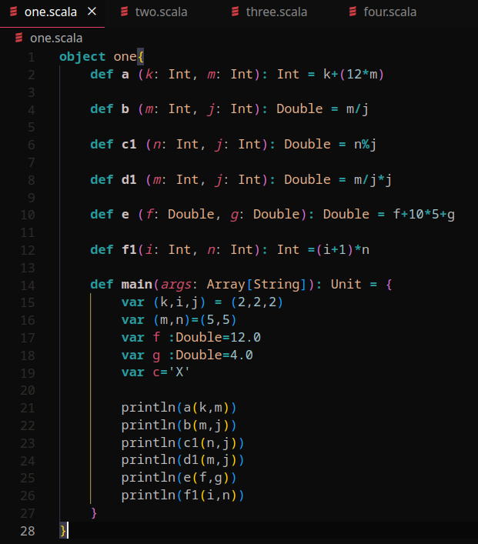

62
2.0
1.0
4.0
66.0
15

- Scala’s syntax is more expressive than Java and lets programmers use compact code.
- While both languages supports OOP scala is able to combine its functional programming concepts with OOP. Java also includes functional programming support but its mainly treated as an OOP language.
- Both has a static stype system but sometimes scala is flexible so the compiler can deduce types.
- Java has built-in multithreading and concurrent programming support. While scala provides higher-level abstractions for concurrency and parallelism. Also scalas’s immuatble data structures and types provide ‘safe concurrent programming’
- Java is widely used in enterprise applications while scala focuses more on scaleable and functional programming.
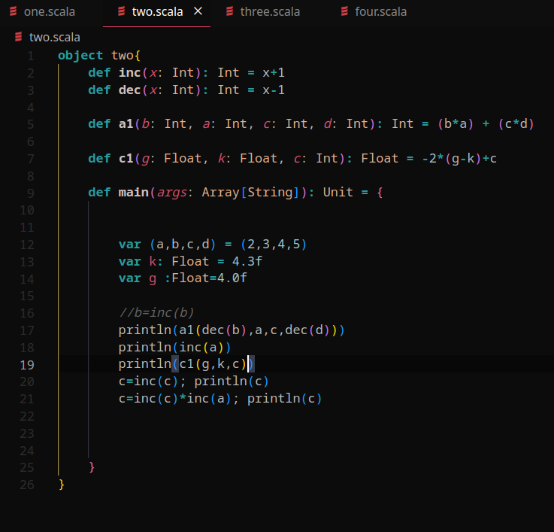

20
3
4.6000004
5
18

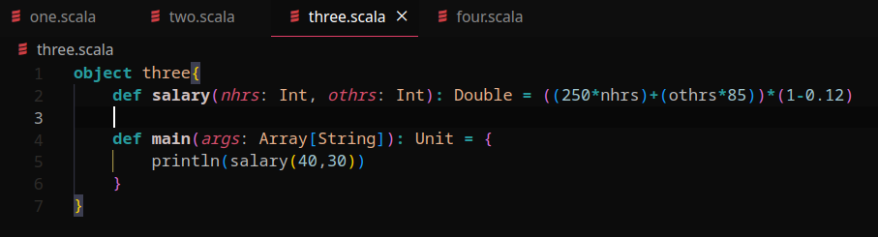
11044.0

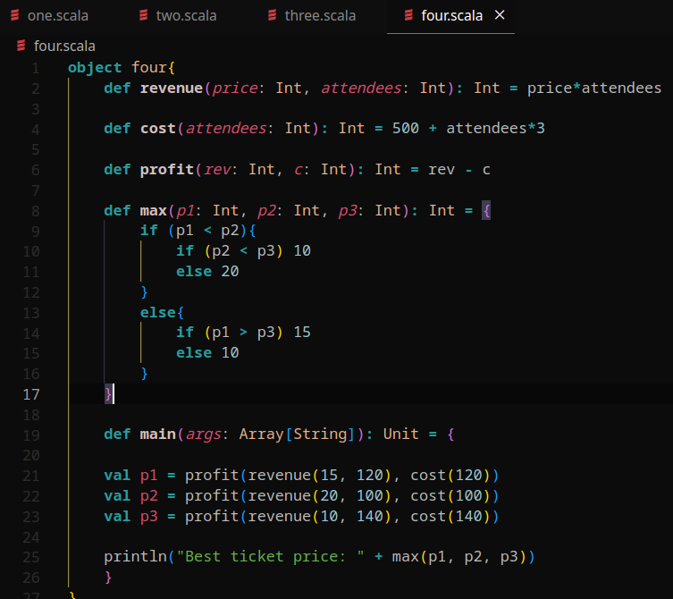

Best ticket price: 20

