  - SECURITY IMPLEMENTATION RETROSPECTIVE

W5-002 and W5-003
Security Implementation —
Complete Learning Review
Document identity
W5-SECURITY-LEARNING-001
Learning and security implementation retrospective

Field | Value
Repository | https://github.com/gprai/enterprize_ai_platform
Branch | main
Inspected HEAD | 9963f2b24d9c42c03c62b97615fd650ab0eb5bc8
Tracker | Enterprise AI Architecture 6 Week Execution Tracker v1.3.5
Analysis date | 2026-09-06
Formal W5-002 status | TEST-001 — FAIL; candidate REJECTED / INELIGIBLE
Formal W5-003 status | PASS within the approved offline policy boundary
Production readiness | NOT ESTABLISHED

Truth statement
This review preserves W5-002's formal FAIL even though many component checks passed. It does not approve a release, deployment, cloud execution, CVE waiver, tracker update or production readiness.

Document control and source precedence
Priority | Authority | Use
1 | Owner-supplied final results and closure decisions | Controls final classifications and lifecycle facts.
2 | Final-approved canonical evidence | Primary source for counts, versions, findings, retained resources and limitations.
3 | Implemented source, tests, workflows and policies | Explains mechanisms; cannot upgrade NOT RUN.
4 | Git history and diffs | Reconstructs boundaries and historical changes.
5 | Tracker v1.3.5 | Defines planned intent and task ownership.
6 | Labelled analytical explanation | Teaching and phase reconstruction only; not an owner decision.

PASS, FAIL, NOT RUN, INDETERMINATE, DEFERRED, SKIPPED, DESELECTED and ACCEPTED WARNING retain their literal meanings. Tool execution, scan execution, policy success, formal approval and production readiness are separate facts.

Table of contents
Document control and source precedence 2
Table of contents 2
1. Executive business summary 5
2. One connected layman analogy: a regulated airport 5
3. W5-002 purpose, scope and actual implementation 6
4. W5-003 purpose, scope and actual implementation 6
5. Relationship between W5-002 and W5-003 7
Diagram 7. W5-002 and W5-003 dependency relationship 8
6. W5-002 L1, L2 and L3 phase reconstruction 8
6.1 L1 — bounded implementation 9
6.2 L2 — reproducible materialization 9
6.3 L3 — offline verification 9
Diagram 6. L1/L2/L3 timeline 9
7. W5-002 security architecture 10
Diagram 1. Secure software-supply-chain architecture 10
Diagram 3. Security-gate decision flow 11
8. W5-003 policy enforcement architecture 12
Diagram 2. Offline policy enforcement architecture 12
9. GitHub OIDC trust design 13
Diagram 4. OIDC trust flow 13
10. Commands appendix — verified or explicitly NOT RUN 13
11. Important code and configuration extracts 14
12. Complete relevant software and dependency inventory 17
13. SBOM learning 19
Diagram 5. SBOM and provenance comparison 19
14. Vulnerability-gate failure analysis 20
15. Challenges, failures and remediation register 20
16. Security principles learned 21
16.1 Shift-left security 21
16.2 Fail-closed gates 21
16.3 Least privilege 21
16.4 Short-lived OIDC 21
16.5 Immutable pinning 21
16.6 Dependency locking 22
16.7 Composition analysis 22
16.8 SBOMs 22
16.9 Provenance 22
16.10 Policy as code 22
16.11 Secret scanning 22
16.12 Synthetic-secret safety 22
16.13 Integrity hashing 23
16.14 Controlled exceptions 23
16.15 Deterministic builds 23
16.16 Release eligibility 23
16.17 Rollback/teardown 23
16.18 Evidence retention 23
16.19 Implementation vs eligibility 23
16.20 Blocking is correct 24
17. Testing and result reconciliation 24
18. Why the work took two days 25
19. Business value and control cost 25
20. Open backlog — no authorization implied 26
21. Interview questions and project-specific answers 26
22. Decision recap 28
23. Final status statement 29
24. Source and evidence inventory reviewed 29
24.1 Exact implementation and phase manifests 30
25. Final Owner Review — Pending 32

1. Executive business summary
W5-002 addressed two business risks: changes reaching the repository without repeatable gates, and deployable artifacts whose contents, build identity or vulnerabilities are unknown. It implemented local CI contracts, immutable identities, hash-locked dependencies, a pinned BuildKit build, OCI evidence, vulnerability scanning, SBOM generation, controlled GitHub OIDC design and fail-closed release eligibility logic.
W5-003 addressed a connected risk: infrastructure that is syntactically valid but violates enterprise controls. It implemented an offline OPA and Checkov policy pack for Region, tags, expiry, S3, KMS, IAM, network, OpenSearch, ECR, secrets and exception governance before later plan or deployment work.
Why W5-002 FAIL is valuable
The build completed and scanners ran, but Trivy found five critical vulnerabilities in the Bookworm application candidate. The mandatory zero-critical gate rejected it. The control worked: unsafe cargo did not leave the facility.

The work reduced credential risk, dependency ambiguity, policy drift and supply-chain uncertainty. It produced reusable local validation and retained SBOM evidence. A fixed compatible base-image digest, rebuild, rescan, provenance, eligibility reconciliation, hosted CI/OIDC, AWS operations, registry publication, deployment and production verification are still required before a deployable release exists.

2. One connected layman analogy: a regulated airport
Airport element | Project component | Meaning
Passenger/cargo | Source at an exact commit | Material entering the controlled process.
Check-in manifest | Hash-locked dependencies | Expected software and allowed download hashes.
Security checkpoints | Ruff, MyPy, Pytest, Checkov, TFLint, OPA | Independent inspections for different defects.
Verified staff badge | GitHub OIDC claims | Short-lived identity for exact repo/ref/environment/audience.
Packing facility | Pinned BuildKit | Creates the package under a known engine.
Tamper-evident seal | OCI SHA-256 | Detects byte changes; does not prove safety.
Explosives inspection | Trivy and Grype | Detects known vulnerabilities.
Cargo contents list | SPDX/CycloneDX SBOM | Records what the candidate contains.
Custody history | Provenance | How/where/from what source it was built; NOT RUN.
Construction code | W5-003 policy as code | Same approved rules for each blueprint.
Departure gate | Release eligibility | Stops cargo unless every gate passes.

The cargo was packed and inventoried, but inspection found critical issues. The departure gate stayed closed. Therefore 'the scanner ran' cannot be translated into 'the image is cleared.'

3. W5-002 purpose, scope and actual implementation
Tracker steps W5-07 and W5-08 group under prompt W5-002. W5-07 plans pull-request CI and a Terraform-plan workflow using GitHub OIDC. W5-08 plans an immutable image build, Trivy/Grype scanning and Syft SBOM generation. The repository contract also binds Python, Terraform, actions, provider, builder, image and scanner identities.
Capability | Implemented | Executed result | Boundary
PR CI workflow | Yes | Static contracts and Actionlint PASS | GitHub-hosted run NOT RUN
Trusted sandbox plan workflow | Yes | Static contracts PASS | OIDC, AWS and plan NOT RUN
Supply-chain workflow | Yes | Local equivalent partly executed | Hosted workflow NOT RUN
Dependency locks | Yes | CPU runtime/CI and isolated Checkov validated | Linux Python 3.11.16
Provider locks | Yes | Terraform 1.16.1; AWS provider 6.55.0 | No plan/apply
Container build | Yes | Local OCI build PASS | Not loaded/pushed/deployed
Vulnerability gate | Yes | Scan executed; zero-critical FAIL | Candidate rejected
SBOM | Yes | SPDX/CycloneDX retained | Rejected candidate only
Provenance/eligibility | Code/workflow implemented | NOT RUN for candidate | Blocked after gate failure
Rollback/cleanliness | Automated contracts | PASS where executed | Operational lifecycle NOT RUN

The bounded implementation was 19 CREATE, 20 UPDATE and 0 DELETE paths. The later detect-secrets baseline reconciliation recorded exactly reviewed non-secret public hashes and pins without weakening detector settings or thresholds.

4. W5-003 purpose, scope and actual implementation
W5-003 implements tracker step W5-06. OPA evaluates a strict Terraform plan-shaped contract; Checkov statically scans Terraform source with downloads and result upload disabled. Both engines must pass. Malformed, unsupported, incomplete or unknown input fails closed.
Its boundary was 7 CREATE, 11 UPDATE and 0 DELETE paths. Owner testing ended PASS within the approved offline policy scope, followed by final owner approval. This is not cloud, real-plan or deployment evidence.
# | Policy ID | Severity | Purpose | Remediation
1 | W5-PLAN-001 | CRITICAL | Reject malformed/unsupported input | REJECT_UNEVALUATED_INPUT
2 | W5-REG-001 | CRITICAL | Require ap-southeast-1 | USE_APPROVED_REGION
3 | W5-TAG-001 | HIGH | Exact mandatory tags | APPLY_MANDATORY_TAGS
4 | W5-TAG-002 | HIGH | ExpiresAt within 24 hours | SET_BOUNDED_EXPIRY
5 | W5-PLAN-002 | HIGH | Owner review for destruction | REQUIRE_OWNER_REVIEW
6 | W5-S3-001 | CRITICAL | S3 public block | ENABLE_S3_PUBLIC_BLOCK
7 | W5-S3-002 | CRITICAL | S3 KMS encryption | USE_APPROVED_S3_KMS
8 | W5-S3-003 | HIGH | S3 versioning/lifecycle | ENABLE_S3_LIFECYCLE
9 | W5-S3-004 | CRITICAL | Deny non-TLS S3 | ENFORCE_S3_TLS
10 | W5-KMS-001 | CRITICAL | Rotation + 7-day deletion | ENABLE_KMS_ROTATION
11 | W5-IAM-001 | CRITICAL | No action wildcard | NARROW_IAM_ACTIONS
12 | W5-IAM-002 | CRITICAL | Scoped IAM/trust | NARROW_IAM_SCOPE
13 | W5-NET-001 | CRITICAL | Private topology | USE_PRIVATE_NETWORK
14 | W5-NET-002 | CRITICAL | No public ingress | RESTRICT_SECURITY_GROUP
15 | W5-OS-001 | CRITICAL | Harden OpenSearch | HARDEN_OPENSEARCH
16 | W5-OS-002 | HIGH | Encrypted logs/delivery | CONFIGURE_OPENSEARCH_LOGS
17 | W5-ECR-001 | CRITICAL | Immutable/scanned/KMS ECR | HARDEN_ECR
18 | W5-ECR-002 | HIGH | Ten-image retention | RETAIN_TEN_IMAGES
19 | W5-SEC-001 | CRITICAL | Reject secret material | REMOVE_SECRET_MATERIAL
20 | W5-EXC-001 | CRITICAL | Strict exception registry | REPAIR_EXCEPTION_REGISTRY

Mandatory tags are Project=enterprise-ai-platform, Environment=sandbox, Owner=Gyan-Prakash-Rai, ManagedBy=terraform, CostCenter=Personal-Learning, Feature=MVP-001, Repository=enterprise-ai-platform and bounded ExpiresAt. The logical Repository tag intentionally differs from the GitHub repository spelling.
The exception registry begins empty and uses ten exact keys. Exceptions bind one exemptible policy to 1–10 explicit resources, cannot use wildcards, require the named owner/approver and expire within seven days. Plan-input, secret-boundary and exception-registry controls are non-exemptible. Findings expose only seven safe fields.

5. Relationship between W5-002 and W5-003
Concern | W5-002 responsibility | W5-003 responsibility | Combined value
Change validation | CI orchestration and report contracts | Infrastructure policy decisions | Pipeline cannot silently bypass policy.
Infrastructure safety | Terraform checks/future trusted plan | Region, tags, encryption, IAM, network | Intent checked before mutation.
Artifact security | Build, scan, inventory and gate OCI | Does not own artifact scanning | Independent infrastructure/artifact controls.
Identity | Exact OIDC trust design | IAM trust/scope policy | Temporary identity constrained twice.
Exceptions | No Phase-A CVE waivers | Strict resource exceptions | No blanket bypass.
Evidence | Safe CI/supply-chain reports | Seven-field policy findings | Audit without raw secrets.

Diagram 7. W5-002 and W5-003 dependency relationship
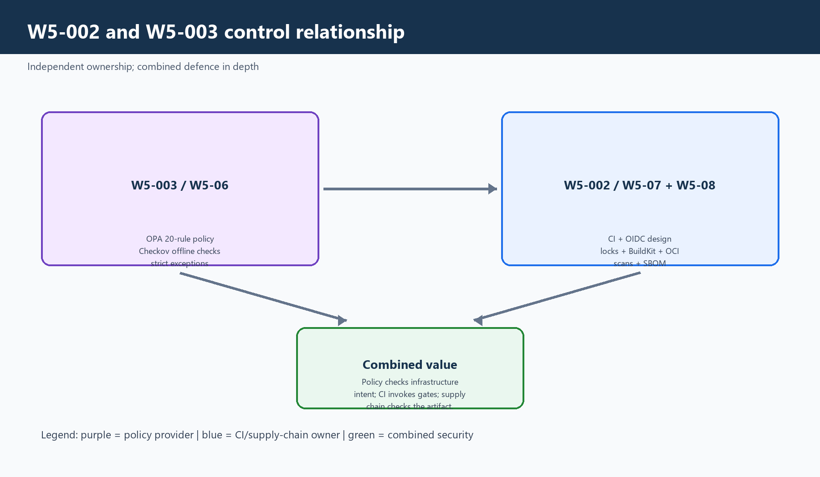
Purple: policy producer. Blue: CI/supply-chain owner. Green: combined defence in depth.
W5-003 provides the policy layer; W5-002 owns workflow, identity and artifact gates. No feature ownership is silently transferred.

6. W5-002 L1, L2 and L3 phase reconstruction
Analytical reconstruction
The repository does not consistently name L1/L2/L3. This mapping comes from the implementation commit, owner approvals and final evidence; it is not a new owner decision.

Phase | Start | Artifacts | Security/tools | Problems | Remediation | Actual
L1 — implementation | Clean W5-003 baseline at 706ac… | 19 CREATE / 20 UPDATE | Workflows, Dockerfile, validator, config, tests | Lint/format/stale tests/path contracts | Bounded corrections | Implementation and focused tests passed
L2 — materialization | Locks/tools missing or incomplete | Linux CPU locks, Checkov lock, provider locks, external tools | Python, uv/pip-tools, Terraform, scanners | Platform mismatch; GPU candidate; slow hashes; Docker faults | Linux uv CPU resolution + verified tools | Locks/tools materialized
L3 — offline verification | L2 outputs available | Read-only locks/manifests/residue | Pinned Python and validators | Initial test env incomplete | Docker-native volume + pip check | Offline verification passed
TEST-001 | L1–L3 ready | No unapproved expansion | Quality, policy, OCI, scan, SBOM | OCI format mismatch then criticals | Layout routing; no CVE waiver | FORMAL FAIL

6.1 L1 — bounded implementation
L1 created three workflows, the CI contract, a digest-pinned non-root Dockerfile, three hash-locked requirement files, two provider locks, reporting logic and focused tests. It updated platform validation, feature mapping, runtime paths and cleanliness boundaries. The design contains no automatic deployment.

6.2 L2 — reproducible materialization
L2 made dependency/provider graphs reproducible. Windows Python 3.11.9 candidates were compared with the Linux Python 3.11.16 target. Slow pip-tools hashing and read-only /tmp/Docker failures led to the approved uv 0.12.9 metadata-based Linux resolver. A GPU-bearing candidate exposed transitive CUDA/NVIDIA/Triton risk; final locks use torch 2.13.0+cpu and the official CPU index. Checkov remains isolated because its boto3 line differs. Terraform/provider locks include Linux and Windows hashes.

6.3 L3 — offline verification
L3 verified locks, manifests, versions and residue without testing. The later test environment used a Docker-native volume because an interrupted bind-mounted environment lacked transitives. The replacement installed the complete hash-locked CI environment and pip check passed before tests.

Diagram 6. L1/L2/L3 timeline
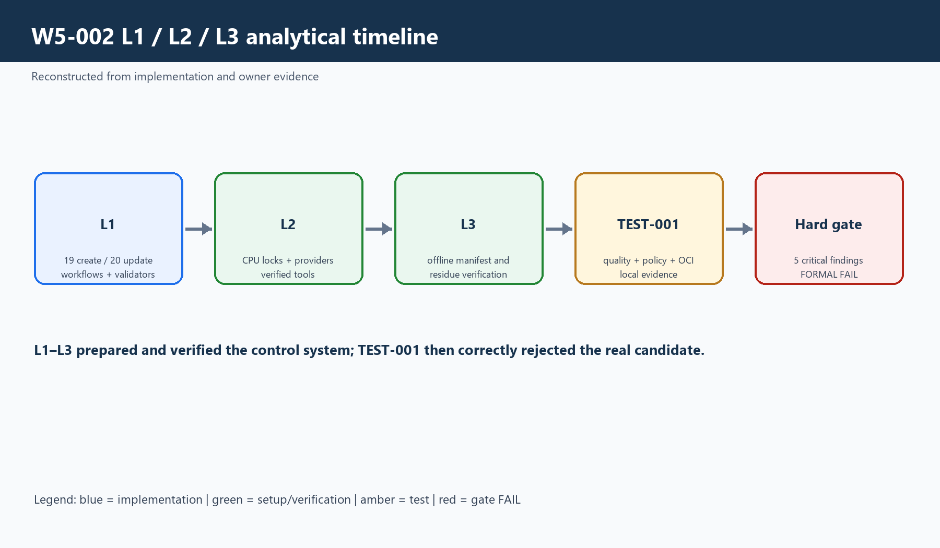
Blue: implementation. Green: setup/verification. Amber: testing. Red: hard-gate FAIL.
L1–L3 prepared and checked the control system; TEST-001 then applied the real vulnerability gate and rejected the candidate.

7. W5-002 security architecture

Diagram 1. Secure software-supply-chain architecture
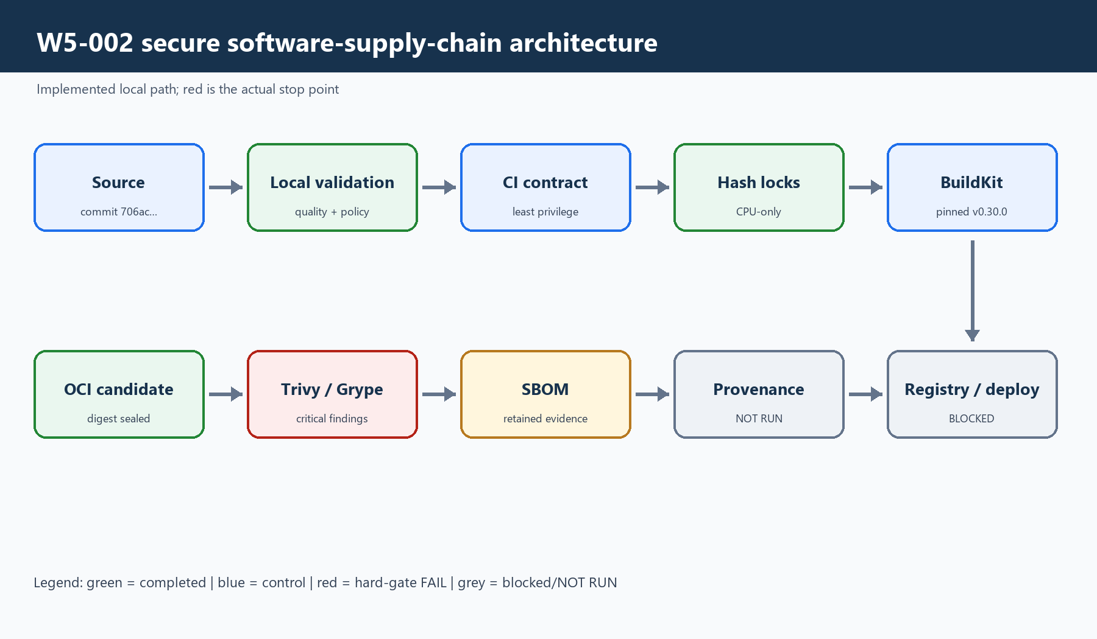
Green: completed evidence. Blue: control. Red: mandatory failure. Grey: blocked/NOT RUN.
The flow reached an immutable OCI candidate and scanning. Critical findings stopped release. SBOMs were later retained, while provenance, eligibility reconciliation, registry and deployment stayed NOT RUN.
Digests answer whether bytes changed; locks constrain packages/hashes; least-privilege permissions reduce token reach; OIDC replaces stored keys with claim-bound identity; scanners evaluate known risk; SBOMs inventory contents; provenance would bind source/build; eligibility combines all mandatory facts and fails closed.

Diagram 3. Security-gate decision flow
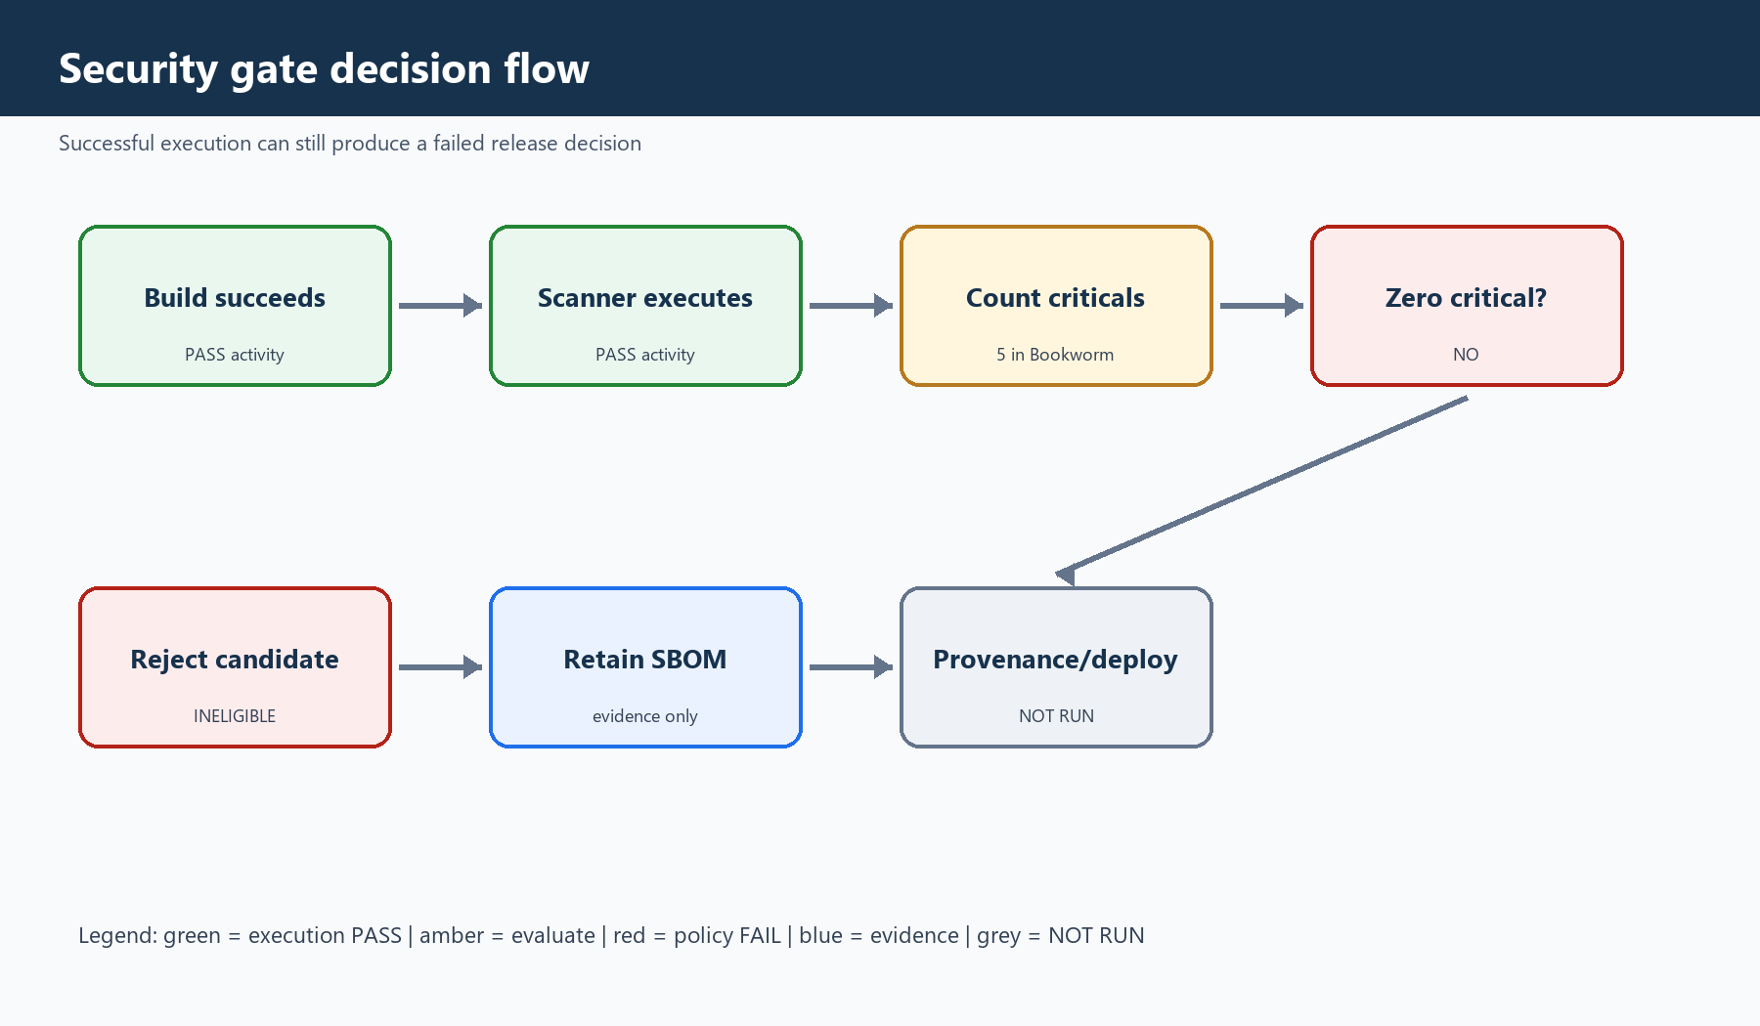
Green: execution PASS. Amber: evaluation. Red: policy FAIL. Blue: evidence. Grey: NOT RUN.
The scanner succeeded operationally by reporting findings. The policy failed because criticals were non-zero. A produced report is not a safe release.

8. W5-003 policy enforcement architecture

Diagram 2. Offline policy enforcement architecture
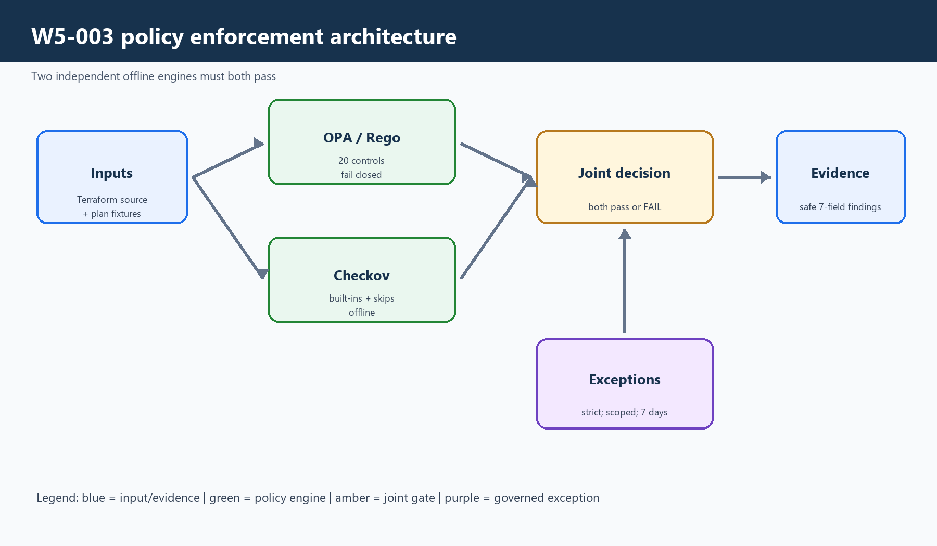
Blue: input/evidence. Green: engines. Amber: joint gate. Purple: exceptions.
OPA evaluates plan facts and Checkov source. Partial execution, disagreement, invalid exceptions or unresolved findings cannot be PASS—like a building inspector applying the same checklist to every blueprint.
Unsupported types, unknown values, malformed actions, absent related controls, invalid time context or malformed exceptions produce denial. Findings carry identifiers/remediation codes rather than raw infrastructure or secrets.

9. GitHub OIDC trust design

Diagram 4. OIDC trust flow
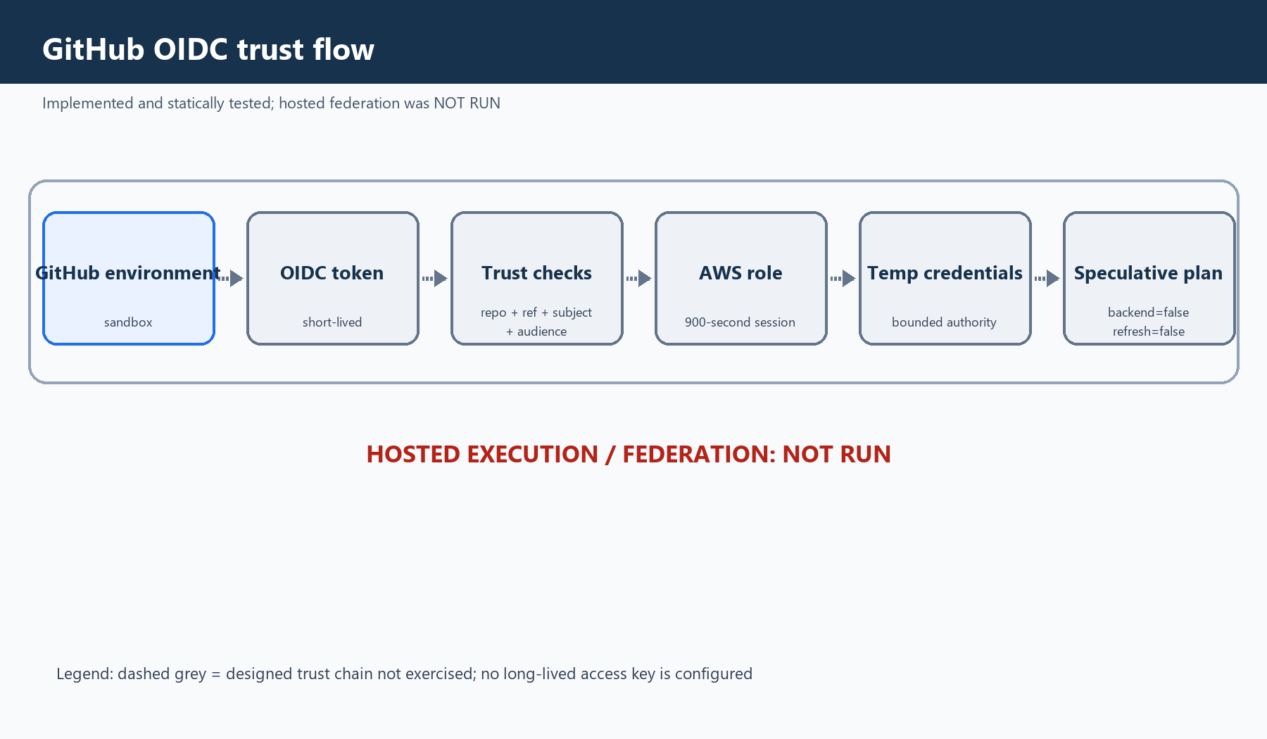
Dashed path: configured and statically tested, but not executed on GitHub/AWS.
Only the trusted sandbox-plan job gets id-token: write. It revalidates repository, main ref, exact commit and environment before token request. Subject, audience and 900-second session are bounded. Runtime federation remained NOT RUN.

10. Commands appendix — verified or explicitly NOT RUN
Topic | Exact verified command (sensitive IDs redacted) | Purpose | Expected | Actual | Risk/access
Canonical Python | docker run --rm --platform linux/amd64 --network none python:3.11.16-slim-bookworm@sha256:b1add8a6…cca250 python --version | Verify target runtime | Python 3.11.16/Linux AMD64 | PASS | Offline identity check
Dependency integrity | /venv/bin/python -m pip check | Detect missing/incompatible packages | No broken requirements | PASS | Offline reusable volume
Ruff lint | /venv/bin/python -B -m ruff check --no-cache src tools tests | Static lint | No findings | All checks passed | Offline/local
Ruff format | /venv/bin/python -B -m ruff format --check --no-cache src tools tests | Canonical formatting | No change | 278 files formatted | Offline/local
MyPy | /venv/bin/python -B -m mypy --no-incremental --cache-dir=/dev/null | Strict typing | No error | 108 source files clean | Static only
Full Pytest | /venv/bin/python -B -m pytest -q -p no:cacheprovider --basetemp=/tmp/w5-002-full | Regression | No failures | 895 passed; 15 skipped; 4 deselected; 1 warning; 10 subtests | Skips remain NOT RUN
Platform contract | /venv/bin/python -B -m tools.platformctl validate | Repository contract | PASS | CODE-STAGE/W5-002 PASS | No cloud
Secrets | detect-secrets scan --baseline .secrets.baseline | Compare reviewed baseline | No new finding | Pre-commit PASS | No secret reproduced
Terraform bootstrap | terraform -chdir=infra/bootstrap init -backend=false -lockfile=readonly; terraform -chdir=infra/bootstrap validate | Validate root | Valid/no backend | PASS; residue removed | Provider network only if cache missed
Terraform sandbox | terraform -chdir=infra/environments/sandbox init -backend=false -lockfile=readonly; terraform -chdir=infra/environments/sandbox validate | Validate root | Valid | PASS; residue removed | No plan/apply/AWS
TFLint | tflint --chdir=infra/bootstrap; tflint --chdir=infra/environments/sandbox | AWS Terraform lint | No issues | Owner-reported PASS | Local plugin cache
Checkov | checkov --config-file .checkov.yml -d infra | Offline static scan | Configured gate | 226 pass; 0 fail; 20 skip | No download/upload
OPA strict | opa check --strict policies/opa | Compile Rego v1 | No error | PASS | Offline
OPA tests | opa test policies/opa --verbose | Policy fixtures | All pass | 41/41 in W5-002 run | Offline; real plan NOT RUN
Actionlint | actionlint .github/workflows/ci.yml .github/workflows/plan-sandbox.yml .github/workflows/security-scan.yml | Workflow validation | No finding | PASS | No hosted run
OCI build | docker buildx build --builder enterprise-ai-platform-w5-002 --platform linux/amd64 --file docker/application.Dockerfile --output type=oci,dest=<TASK_RUNTIME>/candidate.oci --provenance=false --sbom=false . | Build one archive | No load/push | PASS; SHA ac4be6…329ba | Approved sources only
Trivy OCI | tar -xf candidate.oci -C <TEMP_LAYOUT>; trivy image --input <TEMP_LAYOUT> --format json --output <RAW_RESULT> | Scan layout | Zero critical required | Execution PASS; gate FAIL (5 critical) | Layout removed
Grype OCI | grype oci-archive:./candidate.oci -o json > <RAW_RESULT> | Independent scan | Complete scan | 312 matches; 13 critical | Scanner-specific
SPDX SBOM | syft oci-archive:./candidate.oci -o spdx-json=reports/w5-002/sbom.spdx.json | SPDX inventory | Valid JSON | PASS; 261 packages | Network none
CycloneDX SBOM | syft oci-archive:./candidate.oci -o cyclonedx-json=reports/w5-002/sbom.cyclonedx.json | CycloneDX inventory | Valid JSON | PASS; 792 components | Network none
Integrity | Get-FileHash -LiteralPath <ARTIFACT> -Algorithm SHA256 | Verify bytes | Digest match | PASS for OCI/SBOMs | Read-only
Hosted CI | GitHub-hosted execution of .github/workflows/ci.yml | Exercise runner | Required for hosted assurance | NOT RUN | Separate approval
Trusted plan | workflow_dispatch plan-sandbox.yml with exact source_commit | Exercise OIDC/plan | Trusted redacted summary | NOT RUN | GitHub/AWS approval required

11. Important code and configuration extracts
.github/workflows/ci.yml — least-privilege PR job
permissions: {}
jobs:
quality:
permissions:
contents: read
steps:
- uses: actions/checkout@9c091bb21b7c1c1d1991bb908d89e4e9dddfe3e0
with:
persist-credentials: false
Explanation | Security purpose | Without it | Test/evidence | Status
The workflow starts with no permissions, grants repository read only and does not persist checkout credentials. | Reduce token and third-party action reach. | A compromised step could inherit write authority. | W5-002 workflow security contracts | PASS locally; hosted NOT RUN

.github/workflows/plan-sandbox.yml — trusted OIDC preflight
permissions:
contents: read
id-token: write
run: |
test "$GITHUB_REPOSITORY" = "gprai/enterprize_ai_platform"
test "$GITHUB_REF" = "refs/heads/main"
test "$(git rev-parse HEAD)" = "${{ inputs.source_commit }}"
Explanation | Security purpose | Without it | Test/evidence | Status
Only the trusted job can request OIDC and it revalidates exact context first. | Prevent unreviewed code from acquiring cloud identity. | Context confusion could assume a role from the wrong commit. | workflow contract and security tests | Static PASS; OIDC NOT RUN

docker/application.Dockerfile — immutable non-root runtime
FROM python:3.11.16-slim-bookworm@sha256:b1add8a6f2aca6bcfcf0b9c9b522352f7ce0d62a3d556a2f2f32511aa0cca250
RUN groupadd --gid 10001 app \
&& useradd --uid 10001 --gid 10001 --no-create-home --shell /usr/sbin/nologin app
RUN python -m pip install --require-hashes --no-deps -r requirements-runtime.lock
USER 10001:10001
Explanation | Security purpose | Without it | Test/evidence | Status
Base bytes, package hashes and runtime UID are fixed. | Reduce drift, substitution and privilege. | Mutable inputs/root widen compromise impact. | supply-chain and security contracts | Build PASS; gate FAIL

tools/w5_002_ci.py — CPU-only lock validation
if "--hash=sha256:" not in text or "git+" in text.casefold():
raise ContractError("dependency lock must be hash-locked and contain no VCS source")
prohibited = sorted(name for name in packages if name.startswith(("cuda", "nvidia", "triton")))
if prohibited:
raise ContractError("dependency lock contains a prohibited GPU package: " + prohibited[0])
Explanation | Security purpose | Without it | Test/evidence | Status
Rejects unhashed, VCS and GPU-bearing locks. | Keep deterministic CPU-only resolution. | Unreviewed binaries/platform drift could enter. | test_dependency_lock_rejects_every_prohibited_gpu_package | PASS

tools/w5_002_ci.py — safe report content
if key in SENSITIVE_KEY_PARTS or key.endswith(sensitive_suffixes):
raise ContractError(f"sensitive field prohibited at {location}.{raw_key}")
if any(pattern.search(value) for pattern in SENSITIVE_VALUE_PATTERNS):
raise ContractError(f"sensitive value prohibited at {location}")
Explanation | Security purpose | Without it | Test/evidence | Status
Rejects credential-bearing keys/values without echoing the value. | Prevent evidence exfiltration. | Artifacts could publish secrets/provider payloads. | secret-shaped runtime fragment tests | PASS

tools/w5_002_ci.py — fail-closed eligibility
eligibility = {
"critical_vulnerabilities": critical,
"deployable": False,
"eligible_for_owner_approval": critical == 0,
"mandatory_gates": gates,
}
if critical:
raise ContractError("CRITICAL vulnerabilities reject the Phase A candidate")
Explanation | Security purpose | Without it | Test/evidence | Status
Eligibility derives from evidence; deployable remains false and criticals hard-fail. | Keep build success separate from release approval. | A green build could bypass vulnerability policy. | schema and report-set tests | Logic PASS; candidate rejected

.github/workflows/security-scan.yml — OCI routing and cleanup
mkdir "$OCI_LAYOUT"
tar -xf "$OCI_ARCHIVE" -C "$OCI_LAYOUT"
test -f "$OCI_LAYOUT/index.json"
test -f "$OCI_LAYOUT/oci-layout"
trivy image --input "$OCI_LAYOUT" --format json --output "$RAW_TRIVY_IMAGE"
grype "oci-archive:$OCI_ARCHIVE" -o json > "$RAW_GRYPE"
trap cleanup EXIT
Explanation | Security purpose | Without it | Test/evidence | Status
Trivy receives an unpacked layout; Grype/Syft keep the archive; temp data cleans on exit. | Match each consumer without altering candidate bytes. | Wrong format blocks scans or leaves residue. | OCI composition/security/cleanup tests | Remediation PASS

.checkov.yml — offline Checkov
framework:
- terraform
skip-download: true
skip-results-upload: true
download-external-modules: false
soft-fail: false
Explanation | Security purpose | Without it | Test/evidence | Status
Terraform-only, no policy/module download or upload, no soft fail. | Local deterministic blocking scan. | Remote drift/upload or soft-fail could weaken control. | policy security/feature tests | PASS; 20 skips retained

policies/opa/terraform_plan.rego — non-exemptible foundation
non_exemptible_policy_ids := {
"W5-PLAN-001",
"W5-SEC-001",
"W5-EXC-001",
}
required_tags := {
"Project": "enterprise-ai-platform",
"Environment": "sandbox",
"ManagedBy": "terraform",
}
Explanation | Security purpose | Without it | Test/evidence | Status
Input integrity, secrets and exception integrity cannot be waived; tags are exact. | Prevent blanket governance bypass. | Exceptions could neutralize the policy engine. | exception/security/rollback tests | PASS

policies/opa/terraform_plan.rego — IAM action/scope violations
raw_violations contains violation("W5-IAM-001", change.address) if {
policy := policy_text(change)
policy_has_action_wildcard(policy)
}
raw_violations contains violation("W5-IAM-002", change.address) if {
policy := policy_text(change)
iam_scope_invalid(policy)
}
Explanation | Security purpose | Without it | Test/evidence | Status
Separates action wildcard/prohibited action checks from principal/resource scope. | Enforce least privilege. | Broad scope can expose the account. | policy security tests and fixtures | PASS after action-field fix

policies/opa/exceptions.json — empty registry
{
"schema_version": "w5-003.policy-exceptions.v1",
"exceptions": []
}
Explanation | Security purpose | Without it | Test/evidence | Status
Committed policy starts with no exception. | Require future deviations to be explicit, scoped and expiring. | Invisible inherited waivers create policy debt. | policy exception contract | PASS

12. Complete relevant software and dependency inventory
Software | Version | Source | Purpose | Security role | Status | Boundary | Limitation
Python | 3.11.16 | config/pinned image | Canonical runtime | Platform identity | Executed/tested | Linux AMD64 image + volume | Windows 3.11.9 historical only
pip | 26.2.1 | config/evidence | Install locks | Installer identity | Executed | CI volume | --no-deps depends on complete lock
uv | 0.12.9; SHA ec7a99…1460 | config/evidence | Linux locks | Fast metadata resolution | Executed L2 | External Linux binary | Controlled refresh
pip-tools | 7.6.1; SHA 695556…e01 | evidence | Initial resolver | Provenance comparison | Executed then replaced | External | Slow hashing/tmp issue
Pytest | 9.1.1 | CI lock | Automated tests | Regression/security | Executed | Linux CI volume | 15 skipped; 4 deselected
Ruff | 0.16.6 | CI lock | Lint/format | Quality gate | Executed | CI volume | Format before hashes
MyPy | 1.20.2 | CI lock | Typing | Static defect gate | Executed | CI volume | Static only
pre-commit | 4.6.2 | CI lock | Hook orchestration | Local gate | Executed | Project env | Not hosted CI
detect-secrets | 1.5.0 | CI lock/baseline | Secret scan | Leak prevention | Executed | Reviewed baseline | New findings still block
Terraform | 1.16.1 | CI config | IaC validation | Version integrity | Executed init/validate | External tool | Plan/apply NOT RUN
AWS provider | 6.55.0 | provider locks | Terraform AWS schema | Provider integrity | Validated | Linux+Windows hashes | No AWS call
TFLint | 0.60.0 | config/evidence | Terraform lint | AWS rules | Executed | External | Local only
AWS TFLint rules | 0.48.0 | .tflint.hcl | AWS lint | IaC correctness | Executed | Plugin cache | Not cloud test
Checkov | 3.3.16 | isolated lock | Terraform static scan | Built-in security | Executed | Isolated env | 20 skips; older boto3 line
OPA/Rego | 1.20.0/Rego v1 | policy/evidence | Plan policy | Fail closed | Executed | External | Real plan NOT RUN
Docker | Desktop 4.88.1/Engine 29.7.2 | owner output | Containers | Local isolation | Executed | desktop-linux | Engine instability occurred
BuildKit | 0.30.0; SHA 57269d…ccdfc | config/evidence | OCI build | Build identity | Executed | Task builder | network.host capability advertised, unused
Base image | Python 3.11.16 Bookworm; SHA b1add8…cca250 | Dockerfile | Runtime base | Immutable input | Built/scanned | Linux AMD64 | Critical OS findings
Trivy | 0.74.0 | config/evidence | Vuln/secret scan | Mandatory hard gate | Executed | Tool+DB cache | 5 critical Bookworm
Grype | 0.118.0 | config/evidence | Independent scan | Corroboration | Executed | Tool+DB | 13 critical matches
Syft | 1.51.1 | config/evidence | SBOM | Inventory | Executed | External | Cache denied non-blockingly
Cosign | 3.1.2 | owner evidence | Verify provenance files | Tool integrity | Executed | External | mutable metadata accepted with exact bundle/hashes
Actionlint | 1.7.12 | config/evidence | Workflow lint | Workflow integrity | Executed | External | Hosted workflow NOT RUN
GitHub Actions | 6 exact commit pins | CI config | CI orchestration | Action integrity | Static tested | GitHub | Hosted NOT RUN
boto3/botocore | 1.43.89 runtime; 1.35.49/1.35.99 Checkov | locks | AWS SDK/transitives | Separation | Installed | Separate locks | Do not flatten conflict
PyYAML | 6.0.3 | locks | YAML parsing | Safe parsing | Installed/tested | All profiles | BaseLoader fixed
FastAPI | 0.141.1 | locks | API | Runtime | Installed/tested | runtime/CI | Accepted warning
Torch | 2.13.0+cpu | locks | ML runtime | CPU-only boundary | Installed/tested | PyTorch CPU index | Base-family compatibility
Transformers / sentence-transformers | 5.16.1 / 5.7.0 | locks | Model/embedding | Composition | Installed | runtime/CI | Real model skip
Qdrant client | 1.19.0 | locks | Vector client | Runtime | Installed | runtime/CI | Real integration skipped
LangChain / LangGraph | 1.4.0 / 1.2.11 | locks | Orchestration | Runtime | Installed | runtime/CI | Not eligibility evidence
OpenTelemetry SDK | 1.44.0 | locks | Telemetry | Observability | Installed | runtime/CI | Production NOT RUN
Presidio Analyzer | 2.2.364 | locks | PII analysis | Data protection | Installed | runtime/CI | Production privacy NOT RUN
JSON validators | Exact custom schemas | w5_002_ci.py | Safe evidence | Reject extra/secret data | Tested | Repository code | Candidate provenance NOT RUN

13. SBOM learning

Diagram 5. SBOM and provenance comparison
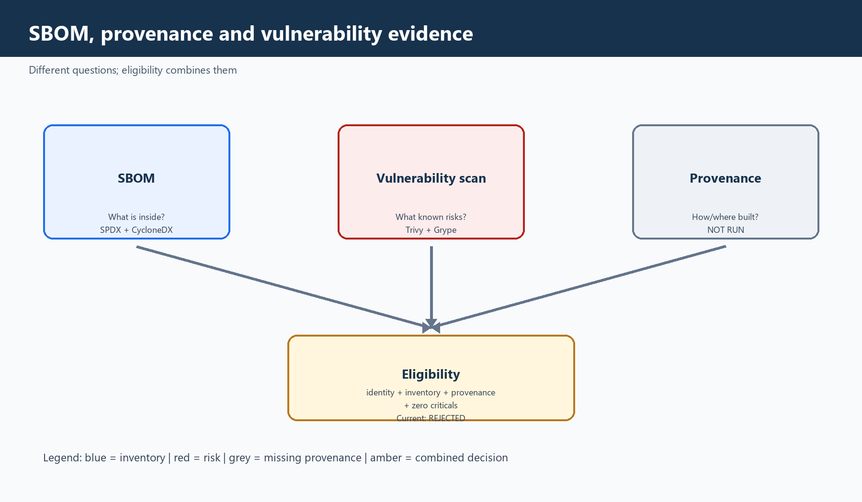
Blue: inventory. Red: risk. Grey: missing provenance. Amber: combined eligibility.
An SBOM says what is present; provenance says how/where/from what source it was built; vulnerability scanning compares contents with known advisories. Eligibility requires all mandatory evidence.
Format | Spec | Count | Bytes | SHA-256 | Status
SPDX JSON | 2.3 | 261 packages | 1,914,593 | cb997284ba6ef99e522d5b4c6bff6d8df5799eb39849f50d6254a0b59b7af3b2 | PASS generation; rejected image
CycloneDX JSON | 1.7 | 792 components | 876,144 | bdbbaa8e41b253771a4a2337cb284b5ef534c5ab42225a74d9ee466aab39637d | PASS generation; rejected image

SPDX and CycloneDX use different object models and granularity. SPDX emphasizes packages, licenses and relationships; CycloneDX can enumerate OS, language and nested components differently. Thus 261 packages versus 792 components is not automatically contradictory. Each output was separately validated as its declared format with a non-empty inventory.
SHA-256 proves the retained file bytes match the recorded digest; it does not prove completeness, safety, trusted build origin or deployability. The source OCI remained ac4be6c885c21414b508f75f39b65f370109fb317bebe57000d777908ba329ba. Syft 1.51.1 used no network. Optional user-cache creation was denied non-blockingly, and no Syft user cache was created.
A rejected image's SBOM is valuable for investigation, later rescans and audit because it records what was actually built rather than only what dependency declarations intended.

14. Vulnerability-gate failure analysis
Candidate/evidence | Identity | Finding | Decision | Explanation
Bookworm app candidate | OCI SHA ac4be6…329ba | Trivy: 5 critical, 57 high | FAIL / REJECTED | Criticals associated with Debian libsqlite3-0, perl-base and zlib1g; not identified in app code/Python deps.
Trixie/slim base | sha256:d1053354624536b044162aaab1e418bd000ea35184fb1ae098ab3166b1072e72 | Trivy: 3 critical, 53 high | FAIL / no replacement | All on perl-base 5.40.1-6; two affected, one fix_deferred; no complete fixed version.
Grype Bookworm view | Same OCI | 312 matches: 13 critical, 77 high, 99 medium, 15 low, 84 negligible, 24 unknown | Corroborating evidence | Scanner-specific counts did not weaken the mandatory Trivy gate.

Trixie improved the count but did not satisfy zero criticals. Accepting it would silently change the policy from 'zero' to 'fewer.' No repository base-image change and no CVE waiver was approved. Retest waits for an official compatible fixed digest, or a separate base-family review covering Python, PyTorch CPU and native-library compatibility.

15. Challenges, failures and remediation register
Phase | Problem | Symptom | Root cause | Security | Remediation | Retest | Final | Lesson
W5-003 | Rego syntax | Parse error | Invalid v1 membership form | Policy unavailable | Correct expression | OPA passed | FAIL→PASS | Compile early
W5-003 | Recursive data | Recursion/unsafe data | Broad data reference | Decision integrity | Bind explicit leaves | Regression passed | Remediated | Load explicit data
W5-003 | Fixtures | Two assertions failed | Tags/wildcard representation | False decisions | Bounded fixture fixes | Tests passed | Remediated | Fixtures are contracts
W5-003 | IAM matching | Resource suffix seen as action wildcard | Raw-text match | Reject valid policy | Scope to Action fields | Regression passed | Remediated | Parse semantics
W5-003 | Ruff | Line/format findings | Noncanonical edits | Quality block | Bounded format | PASS | Remediated | Format first
W5-002 L1 | YAML/import lint | 6 Ruff errors | BaseLoader/import drift | Unsafe parsing | Safe loader/import sort | PASS | Remediated | Tests need security lint
W5-002 L1 | Secret assertion | .secrets.baseline matched secrets. | Naïve substring | False failure | Semantic expression match | 35 tests passed | Remediated | Avoid substrings
W5-002 L1 | Path/lifecycle | Focused failures | Windows/stale expectations | Cross-platform drift | Exact Linux path; preserve W4 | 62 passed | Remediated | Model OS paths
W5-002 L1 | pytest import | F821 | Missing import | Collection risk | Add import only | Ruff PASS | Remediated | Lint after edits
W5-002 L2 | Resolver platform | Windows 3.11.9 vs Linux 3.11.16 | Wrong target | CI mismatch | Canonical Linux compare | Candidates generated | Remediated | Resolve target platform
W5-002 L2 | pip-tools stall | Long hashes/read-only tmp | Artifact hashing/Docker tmp | Unbounded/incomplete | Verified uv metadata resolver | CPU locks generated | Method replaced | Choose efficient resolver
W5-002 L2 | GPU candidate | CUDA/NVIDIA/Triton | Torch graph | Unapproved binaries | CPU pin/index + rejection | Locks validated | Rejected retained | Inspect transitives
W5-002 L2 | Docker engine | 500/EOF | Unhealthy engine | Interrupted work | Non-destructive restart | Recovered | Remediated | Health preflight
W5-002 L3 | Partial venv | pip check missing deps | Interrupted no-deps install | False confidence | Docker-native volume/full lock | pip check PASS | Remediated | Integrity before tests
TEST-001 | Tools absent | Executable not found | Inventory incomplete | Test blocked | Verified external installs | Versions PASS | Remediated | Inventory first
TEST-001 | Grype attestation | GitHub 404 | Publisher used signed checksums | Provenance gap | Cosign publisher signature | Verified OK | Remediated | Support verified alternatives
TEST-001 | Trivy OCI input | manifest/index errors | Archive vs layout | Scan blocked | Temporary OCI layout | 15 tests + scan PASS | Remediated | Preflight formats
TEST-001 | Critical CVEs | 5 Bookworm; 3 Trixie | Base OS packages | Release risk | No waiver; reject | No passing candidate | FORMAL FAIL | Block is success
SBOM | Cache denied | No user cache | Sandbox boundary | Optional only | Cacheless generation | Two valid SBOMs | Accepted warning | Separate optional cache
Closure | Cleanup deferred | Local residue retained | Owner preservation decision | Storage remains | Record exact retained state | Evidence preserved | DEFERRED | Lifecycle truth

16. Security principles learned

16.1 Shift-left security
Technical | Layman | W5 example | Business value | Mistake | Interview takeaway
Check before release/deploy | Inspect before boarding | OPA/Checkov + CI contracts | Lower blast radius | Optional checks | Security starts in design

16.2 Fail-closed gates
Technical | Layman | W5 example | Business value | Mistake | Interview takeaway
Missing/negative evidence blocks | Broken reader keeps door locked | OPA invalid input; criticals reject | No ambiguous approval | Soft fail | Tool failure differs from policy failure

16.3 Least privilege
Technical | Layman | W5 example | Business value | Mistake | Interview takeaway
Minimum permissions | One-room visitor badge | contents:read; scoped id-token | Limits compromise | Global write | Scope at narrow job

16.4 Short-lived OIDC
Technical | Layman | W5 example | Business value | Mistake | Interview takeaway
Claim-bound temporary identity | Expiring boarding pass | Exact repo/ref/env/audience, 900s | No stored keys | Token before context check | OIDC still needs strict trust

16.5 Immutable pinning
Technical | Layman | W5 example | Business value | Mistake | Interview takeaway
Exact bytes | Tamper seal | Actions/BuildKit/base pins | Visible drift | Mutable tags | Identity is not safety

16.6 Dependency locking
Technical | Layman | W5 example | Business value | Mistake | Interview takeaway
Exact packages/hashes/target | Batch-specific recipe | CPU locks + Checkov isolation | Reproducible installs | Host freeze reuse | Match deployment platform

16.7 Composition analysis
Technical | Layman | W5 example | Business value | Mistake | Interview takeaway
Inventory and risk match | Cargo recall check | Trivy/Grype/Syft | Find inherited risk | Tests cover CVEs | Risk may be in base layers

16.8 SBOMs
Technical | Layman | W5 example | Business value | Mistake | Interview takeaway
Component inventory | Ingredient list | SPDX/CycloneDX | Audit/rescan | Security certificate | Inventory not approval

16.9 Provenance
Technical | Layman | W5 example | Business value | Mistake | Interview takeaway
Source/build custody | Chain of custody | Schema/workflow; NOT RUN | Origin assurance | Digest equals provenance | How vs what

16.10 Policy as code
Technical | Layman | W5 example | Business value | Mistake | Interview takeaway
Executable controls | Same checklist | 20 OPA + Checkov | Consistent rules | No negative tests | Test/version policies

16.11 Secret scanning
Technical | Layman | W5 example | Business value | Mistake | Interview takeaway
Find credential patterns | Prohibited bag check | detect-secrets + safe reports | Reduce leaks | Blind baseline | Review false positives

16.12 Synthetic-secret safety
Technical | Layman | W5 example | Business value | Mistake | Interview takeaway
Non-reusable test values | Training prop | Detection/redaction/residue tests | Prove safely | Echo in error | Never disclose fixture

16.13 Integrity hashing
Technical | Layman | W5 example | Business value | Mistake | Interview takeaway
Hash finalized bytes | Seal after packing | OCI/SBOM hashes | Detect changes | Format after hash | Normalize then hash

16.14 Controlled exceptions
Technical | Layman | W5 example | Business value | Mistake | Interview takeaway
Scoped expiring deviations | Room-specific permit | 10 keys; ≤7 days | Prevents bypass | Blanket waiver | Non-exemptible core

16.15 Deterministic builds
Technical | Layman | W5 example | Business value | Mistake | Interview takeaway
Constrain source/platform/tools | Repeat recipe | Commit+platform+pins | Traceability | One flag guarantees | System property

16.16 Release eligibility
Technical | Layman | W5 example | Business value | Mistake | Interview takeaway
All mandatory evidence | Every gate stamp | Zero critical + evidence | Stops partial success | Build=deployable | Eligibility is derived

16.17 Rollback/teardown
Technical | Layman | W5 example | Business value | Mistake | Interview takeaway
Restore vs remove | Safe plan vs empty hangar | Automated PASS; operational NOT RUN | Incident/cost control | Cleanup=rollback | Separate proofs

16.18 Evidence retention
Technical | Layman | W5 example | Business value | Mistake | Interview takeaway
Preserve auditable facts | Keep rejection report | OCI/scans/SBOMs retained | Future review | Delete failures | Retention needs owner

16.19 Implementation vs eligibility
Technical | Layman | W5 example | Business value | Mistake | Interview takeaway
Working control ≠ safe product | Inspector works by stopping cargo | Controls PASS; candidate FAIL | No accidental risk acceptance | Average away red gate | Report layers separately

16.20 Blocking is correct
Technical | Layman | W5 example | Business value | Mistake | Interview takeaway
Violation must stop release | Closed gate protects | 5 criticals; no waiver | Avoid exposure | Fix the gate not risk | Correct decisions matter

17. Testing and result reconciliation
Task/control | Scope | Result | Evidence | Limitation
W5-002 Pytest | Linux 3.11.16 | PASS | 895 pass, 15 skip, 4 deselect, 1 warning, 10 subtests; 189.72s | Skips/deselections NOT RUN
Ruff lint/format | src/tools/tests | PASS | All checks; 278 formatted | Local
MyPy | 108 files | PASS | No issues | Static
Platform validation | Repository | PASS | CODE-STAGE/W5-002 PASS | No cloud
Terraform | fmt/init/validate roots | PASS | Backend false; residue removed | Plan/apply NOT RUN
TFLint | Both roots | PASS | Owner-reported 0.60.0 + AWS 0.48.0 | Local
Checkov | Terraform | PASS scope | 226 pass, 0 fail, 20 skip | Skips not pass
OPA | Offline | PASS | strict; 41/41 in W5-002 | Real plan NOT RUN
Workflows/actionlint | 3 workflows | PASS | Static contracts | Hosted NOT RUN
Security/rollback/cleanliness | Automated local | PASS where run | Focused/full suites | Operational NOT RUN
OCI build/identity | Local BuildKit | PASS activity | Archive/identity | Not eligibility
Trivy Bookworm | OCI | FAIL gate | 5 critical, 57 high | Execution succeeded
Grype Bookworm | OCI | Evidence | 13 critical, 77 high, 312 total | Scanner-specific
Trixie/slim | Base audit | FAIL gate | 3 critical, 53 high | No replacement
SBOM | Rejected OCI | PASS generation | SPDX 261; CDX 792 | Not safety
Provenance | Candidate | NOT RUN | No provenance.json | Deferred
Eligibility reconciliation | Candidate | NOT RUN | No eligibility.json | Rejected
GitHub-hosted CI | Hosted | NOT RUN | Static only | No hosted proof
OIDC/AWS | Sandbox | NOT RUN | Design only | No cloud identity
Plan/apply | AWS IaC | NOT RUN | No state/plan | No mutation
Registry/deploy | Lifecycle | NOT RUN | Never pushed/deployed | No readiness
Operational rollback/teardown | Cloud | NOT RUN | Contracts only | No cloud resource
W5-003 quality/security/regression | Offline policy | PASS | Owner-approved evidence | Counts not asserted by aggregate
W5-003 joint gate | Fixtures/source | PASS | secure accepted; insecure rejected | 20 Checkov skips
W5-003 rollback/cleanliness | Automation | PASS | Temp/cache absent | Real rollback NOT RUN
W5-003 cloud/real plan | Cloud | NOT RUN | Canonical evidence | No readiness

18. Why the work took two days
This was a sequence of control design, provenance, target-platform reconciliation, tool installation, failure analysis and owner approvals—not one long test. Multiple tools had to agree without broadening scope, and every artifact had to remain tied to exact source, platform and digest.
Necessary security work | Avoidable rework | Future improvement
Resolve Linux locks and verify sources | Windows-first/slow pip-tools hashing | Choose target platform/resolver before Column L
Isolate Checkov's dependency graph | Repeated environment explanation | Publish reusable environment compatibility matrix
Prove external tool provenance | Missing tools discovered during TEST-001 | Inventory toolchain before test window
Validate OCI consumers | Two Trivy archive failures | Use a small input-format preflight
Audit CVEs/alternate base | Docker engine interruptions | Health-check Docker/tmp first
Generate both SBOMs | Late evidence-vs-eligibility clarification | Define evidence completion separately
Preserve history/status | Many tiny remediation gates | Batch deterministic quality corrections

Correct order: format before hashing; validate locks before installing; pip check before tests; verify scanner input before full scans; scan before provenance/eligibility; never erase historical FAIL with a later PASS.

19. Business value and control cost
Value | Business effect
Vulnerable image blocked | Avoid known critical production exposure.
Auditable inventory | Supports incident, licensing, rescans and audit.
Consistent IaC policy | Reduces manual review variance.
Short-lived identity design | Avoids stored AWS keys.
Evidence-based release | Build success cannot masquerade as approval.
Immutable identities/locks | Makes drift visible.
Bounded lifecycle contracts | Clarifies destructive scope/ownership.

Cost | Implication
Engineering time | More configuration/reconciliation.
Tool complexity | Version/input compatibility maintenance.
Lock/policy upkeep | Controlled refresh required.
Evidence storage | Local artifacts persist until cleanup.
Delivery delay | Mandatory gates intentionally block risk.
Local cost | CPU/storage/electricity/time real but unpriced.

20. Open backlog — no authorization implied
Item | Owner | Prerequisite | Status | Future approval | Risk
Fixed base digest | Gyan Prakash Rai | Official compatible image/review | DEFERRED | Separate provenance/security approval | Candidate unusable
Rebuild/rescan | Gyan Prakash Rai | Approved fixed digest | NOT RUN | Build/scanner approval | No eligible artifact
Provenance | Gyan Prakash Rai | Zero-critical candidate | NOT RUN | Evidence approval | Origin assurance incomplete
Eligibility reconciliation | Gyan Prakash Rai | All gates pass | NOT RUN | Reconciliation approval | No promotion
Hosted CI | Gyan Prakash Rai | Workflow authorization | NOT RUN | GitHub approval | Hosted behavior unproved
OIDC runtime | Gyan Prakash Rai | Hosted trusted workflow | NOT RUN | Cloud approval | Trust unexercised
AWS/plan/apply | Gyan Prakash Rai | Identity and reviewed inputs | NOT RUN | Paid/cloud approval | IaC behavior unproved
Registry/deploy | Gyan Prakash Rai | Eligible digest | NOT RUN | Release approval | No production artifact
Production verification | Gyan Prakash Rai | Deployment/SLO plan | NOT RUN | Operations approval | No SLO evidence
Operational rollback | Gyan Prakash Rai | Deployment/plan | NOT RUN | Rollback approval | Only contracts
Cloud teardown | Gyan Prakash Rai | Future resources | NOT RUN | Teardown approval | Future cost risk
Evidence cleanup/retention | Gyan Prakash Rai | Owner decision | DEFERRED | Cleanup approval | Local residue
W5-003 real-plan | Gyan Prakash Rai | W5-004 evidence | DEFERRED | Task approval | Offline only
ADR-015 | Gyan Prakash Rai | Governance review | DEFERRED | Doc approval | Governance gap

21. Interview questions and project-specific answers
Q1. Why did W5-002 fail?
Answer: The Bookworm OCI candidate had five Trivy critical findings. The approved policy required zero, so TEST-001 closed FAIL and the candidate remained rejected/ineligible.
Q2. Can a failed security task deliver value?
Answer: Yes. The gate blocked risk and produced tested controls, immutable identity and retained SBOM evidence without rewriting FAIL as PASS.
Q3. What is BuildKit?
Answer: Pinned BuildKit v0.30.0 built one Linux AMD64 OCI archive from exact source and base without loading or pushing.
Q4. What is an OCI layout?
Answer: A directory with oci-layout, index.json and blobs. Trivy consumed a temporary unpacked layout; Grype/Syft consumed the original archive.
Q5. What does an immutable digest prove?
Answer: The bytes match the recorded artifact. It does not prove safety, provenance or deployability.
Q6. What did Trivy check?
Answer: Filesystem/OCI known vulnerabilities and secrets. It reported five critical and 57 high findings in the app candidate.
Q7. Why is an SBOM not a vulnerability report?
Answer: An SBOM inventories components. A scanner compares them with current advisories; results can change as intelligence changes.
Q8. SPDX versus CycloneDX?
Answer: Different standard data models and granularity. This SPDX had 261 packages and CycloneDX 792 components without automatic contradiction.
Q9. SBOM versus provenance?
Answer: SBOM says what is inside; provenance says how/where/from what it was built. Provenance remained NOT RUN.
Q10. Why use Syft?
Answer: Syft 1.51.1 generated both standard inventories from the exact rejected OCI with no network.
Q11. Why Checkov, TFLint and OPA together?
Answer: TFLint checks Terraform/provider correctness, Checkov broad built-in static controls, and OPA project-specific plan governance.
Q12. Why pin GitHub Actions?
Answer: Tags can move. Full commit SHAs fix the reviewed third-party implementation.
Q13. How does OIDC improve security?
Answer: Exact GitHub claims can obtain a temporary 900-second AWS role session without stored access keys; runtime federation was NOT RUN.
Q14. What is fail closed?
Answer: Missing, malformed, inconsistent or negative evidence blocks progress. OPA invalid input and image criticals both block.
Q15. Why reject CVE waivers?
Answer: Phase A allowed none and the owner granted none. Trixie still had three criticals, so a waiver would weaken the gate.
Q16. How are synthetic-secret tests safe?
Answer: Use non-reusable patterns, assert detection/redaction, never echo values, and verify no residue.
Q17. Why format before hashing?
Answer: Formatting changes bytes; hashing first creates immediately stale integrity evidence.
Q18. Why stage the secret baseline before pre-commit?
Answer: The hook must evaluate the reviewed candidate baseline. Staging exposes it to the hook without committing it.
Q19. What is artifact eligibility?
Answer: A derived decision that every mandatory identity, scan, SBOM, provenance and policy gate passed—not build success.
Q20. How handle critical OS findings?
Answer: Confirm package/image, await/test an official fixed compatible digest and rescan; do not blame app code or change family casually.
Q21. What does rollback testing prove?
Answer: Automated rejection/disable behavior. Real release or infrastructure restoration remained NOT RUN.
Q22. What does cleanliness testing prove?
Answer: Bounded residue rules, not deletion of all retained evidence/caches/builders; overall cleanup was deferred.
Q23. What was local versus cloud tested?
Answer: Quality, policy, Terraform validation, build, scans and SBOMs were local. Hosted CI, OIDC, AWS, plan/apply, registry and deployment were NOT RUN.
Q24. What is needed before production?
Answer: Fixed digest, rebuild/rescan, provenance/eligibility, hosted CI/OIDC/AWS, immutable promotion, deployment checks and rollback/teardown readiness.
Q25. What improves next cycle?
Answer: Inventory tools first, fix target platform/resolver early, preflight scanner formats, batch trivial quality fixes, and separate evidence completion from eligibility.
Q26. Why isolate Checkov?
Answer: Checkov 3.3.16 locks boto3 1.35.49 while the app uses 1.43.89. Separate locks prevent tool transitives from dictating app dependencies.
Q27. Why not replace Bookworm with Trixie?
Answer: Three criticals are fewer but not zero; no complete fixed version existed, and fewer is not the approved criterion.

22. Decision recap
Decision | Reason | Alternative | Trade-off | Effect
Multiple tools | Different defect classes | One scanner | Maintenance | Defence in depth
Exact pins | Prevent mutable drift | Tags/ranges | Reviewed refreshes | Reproducible identity
Action SHAs | Third-party integrity | Tags | Less readability | Action drift detectable
Base digest | Exact build input | Mutable slim | Known CVEs persist | Traceable but rejected
Zero critical | Mandatory threshold | Allow selected criticals | Delivery delay | Unsafe image blocked
No CVE waiver | No risk acceptance | Temporary exception | No release | FAIL preserved
Exact OIDC claims | Least privilege | Keys/broad subject | More config | Runtime NOT RUN
Linux locks | Match target | Windows freeze | Resolver effort | CPU reproducibility
Isolated Checkov | Avoid boto3 collision | One env | Extra lock | Graphs independent
Two SBOM formats | Different consumers | One format | Two artifacts | Interoperability
Defer provenance | Rejected hard gate | Complete downstream anyway | Known gap | NOT RUN preserved
OPA + Checkov | Project + built-in coverage | One engine | Disagreement blocks | Stronger gate
Local before hosted | Reduce access risk | Immediate cloud | Hosted unproved | Safe validation
Retain evidence | Audit/learning | Immediate delete | Storage | Failure evidence available
Defer cleanup | Owner preservation | Delete | Residue remains | Explicit owner control
Close as FAIL | Truthful hard gate | Call implementation PASS | Negative label | Defensible release decision

23. Final status statement
W5-002 — formal outcome
Secure CI/supply-chain controls were implemented. Local quality, policy, Terraform validation, workflow contracts, build identity and SBOM activities passed in their recorded scopes. The Bookworm candidate failed the mandatory zero-critical gate; Trixie/slim also failed. Candidate: REJECTED / INELIGIBLE. Provenance, eligibility, hosted CI/OIDC, AWS, plan/apply, registry, deployment, operational rollback and cloud teardown remain NOT RUN. Retest requires a compatible fixed digest and separate approval.

W5-003 — formal outcome
The offline OPA/Checkov policy pack passed its approved owner-tested scope and received final owner approval. It enforces 20 ordered controls, strict exceptions, safe findings and joint-engine behavior. Real plans, hosted integration, AWS, deployment and operational/cloud lifecycle remain NOT RUN. ADR-015 and real-plan evidence remain deferred.

Neither task establishes production readiness. W5-003's PASS does not override W5-002's candidate FAIL; W5-002 documentation approval does not make the artifact eligible. The controls delivered value because they preserved those boundaries.

24. Source and evidence inventory reviewed
Category | Sources | Use
Governance | docs/governance/Enterprise_AI_Architecture_6_Week_Execution_Tracker_v1.3.5.xlsx | W5-06/07/08 intent and ownership
W5-002 evidence | W5-002.md; W5-07-ci.txt; W5-08-supply-chain.txt; README | Results and closure
W5-003 evidence | W5-003.md; W5-06-policy.txt; W5-policy.txt; README | Results and closure
Workflows | ci.yml; plan-sandbox.yml; security-scan.yml | Permissions, OIDC, build, scans, SBOM
Configuration | configs/ci/w5-002.json; .checkov.yml; .tflint.hcl; feature-matrix.yaml | Pinned identities/policy
Build/dependencies | application.Dockerfile; requirements locks; provider locks | Base/non-root/locks
Policy | terraform_plan.rego; tests; exceptions.json | 20 controls and exceptions
Implementation | tools/w5_002_ci.py; platformctl validator | Schemas, safe reports, eligibility
Tests | W5-002 and policy contract/feature/integration/security/rollback/teardown/unit | Fail-closed/residue
Git | 706ac891… and 9963f2b… | Boundaries and chronology

24.1 Exact implementation and phase manifests
W5-002 L1 repository implementation — CREATE 19:
# | CREATE path
1 | .github/workflows/ci.yml
2 | .github/workflows/plan-sandbox.yml
3 | .github/workflows/security-scan.yml
4 | configs/ci/w5-002.json
5 | docker/application.Dockerfile
6 | docker/application.Dockerfile.dockerignore
7 | infra/bootstrap/.terraform.lock.hcl
8 | infra/environments/sandbox/.terraform.lock.hcl
9 | requirements-checkov.lock
10 | requirements-ci.lock
11 | requirements-runtime.lock
12 | tests/contract/test_w5_002_workflow_contract.py
13 | tests/feature/test_w5_002_supply_chain.py
14 | tests/integration/test_w5_002_ci_composition.py
15 | tests/rollback/test_w5_002_workflow_rollback.py
16 | tests/security/test_w5_002_ci_security.py
17 | tests/teardown/test_w5_002_cleanliness.py
18 | tests/unit/test_w5_002_ci.py
19 | tools/w5_002_ci.py

W5-002 L1 repository implementation — UPDATE 20:
# | UPDATE path
1 | .gitignore
2 | Makefile
3 | feature-matrix.yaml
4 | pyproject.toml
5 | requirements.txt
6 | src/enterprise_ai_platform/config.py
7 | src/enterprise_ai_platform/release_rollback/identity.py
8 | tests/feature/test_feature_matrix.py
9 | tests/feature/test_w2_002_embedder_contract.py
10 | tests/feature/test_w2_003_ingestion_contract.py
11 | tests/integration/test_dependency_contract.py
12 | tests/security/test_precommit_controls.py
13 | tests/teardown/test_repository_cleanliness.py
14 | tests/teardown/test_terraform_state_boundary.py
15 | tests/teardown/test_w4_002_agent_cleanliness.py
16 | tests/teardown/test_w4_011_release_rollback_cleanliness.py
17 | tests/unit/test_config.py
18 | tests/unit/test_platformctl.py
19 | tests/unit/test_release_rollback_identity.py
20 | tools/platformctl/validate.py

The later .secrets.baseline reconciliation and Column M evidence/tracker edits are historical closure changes, not silently added to the 19/20 L1 implementation manifest. L2 materialized the three Python locks and two Terraform provider locks above and created owner-managed external tool/cache/workspace resources. L3 was read-only verification and created no repository path.
W5-003 repository implementation — CREATE 7 and UPDATE 11:
Type | # | Path
CREATE | 1 | .checkov.yml
CREATE | 2 | policies/opa/exceptions.json
CREATE | 3 | tests/contract/test_policy_exception_contract.py
CREATE | 4 | tests/feature/test_policy_gate.py
CREATE | 5 | tests/rollback/test_policy_pack_rollback.py
CREATE | 6 | tests/security/test_policy_pack.py
CREATE | 7 | tests/teardown/test_policy_pack_cleanliness.py
UPDATE | 1 | Makefile
UPDATE | 2 | feature-matrix.yaml
UPDATE | 3 | tools/platformctl/validate.py
UPDATE | 4 | tests/feature/test_feature_matrix.py
UPDATE | 5 | tests/unit/test_platformctl.py
UPDATE | 6 | policies/opa/terraform_plan.rego
UPDATE | 7 | policies/opa/terraform_plan_test.rego
UPDATE | 8 | tests/integration/test_dependency_contract.py
UPDATE | 9 | infra/environments/sandbox/terraform.tfvars.example
UPDATE | 10 | infra/environments/sandbox/variables.tf
UPDATE | 11 | tests/contract/test_terraform_module_contract.py

25. Final Owner Review — Pending
Field | Status
Reviewer | PENDING
Decision | PENDING
Approval timestamp/timezone | PENDING
Accepted risks | PENDING
Accepted retained resources | PENDING
Cleanup owner | PENDING
Tracker-update confirmation | PENDING

This learning document is not finally owner-approved. A later bounded documentation-closure approval is required. Existing W5-002/W5-003 task approvals remain historical facts and do not approve this document.

