ENTERPRISE AI ARCHITECTURE
Architecture Objective, Six-Week Plan and Reversible Delivery Controls
A layman-friendly source of truth for planning, interviews and presentations
Core objective: Turn approved enterprise knowledge into safe, cited AI answers and controlled actions, while ensuring every feature is understood, tested, approved, recoverable and cleanly removable.

Blueprint v1.1: Controlled Development and Reversible Architecture
Document owner: Gyan Prakash Rai
15 August 2026

Document control
Field | Value
Purpose | Authoritative planning reference for architecture understanding, implementation sequencing, interviews and presentations.
Status | Controlled planning baseline - source of truth
Version | 1.1
Owner | Gyan Prakash Rai
Baseline source | Architecture planning discussion and attached Pasted markdown.md
Review trigger | Material architecture decision, security requirement, evaluation result, incident lesson, implementation milestone or lifecycle-control change.

How to use this document
• For learning: read Sections 1-7 before beginning Week 1 implementation.
• For interviews: use Section 10 for the two-minute answer and follow-up discussion.
• For presentations: use the architecture diagram and the seven-slide talking-point sequence.
• For implementation: treat the weekly checkpoints as gates; do not progress only because code exists.
• For controlled development: implement one feature at a time and require design, tests, evidence and approval before progression.
• For environment lifecycle: distinguish release rollback, infrastructure rollback and complete teardown.
• For governance: update the decision log whenever a material choice changes.

Contents
Overview Executive summary | 8. Risks, controls and governance
1. Scenario and business objective | 9. SRE and DevSecOps operating model
2. Requirements, assumptions and success measures | 10. Interview explanation and verbal answer
3. Architecture design in layman terms | 11. Presentation talking points
4. End-to-end flow and failure behaviour | 12. Glossary and planning questions
5. Components and why they matter | 13. Change-control baseline
6. Six-week implementation plan | 14. Controlled development and reversible architecture
7. Architecture decisions and trade-offs | A. Master Codex instruction pack

Executive summary
We are building an enterprise AI assistant that can use approved company knowledge to answer questions and, later, perform selected actions under strict controls. The first deliverable is a reliable RAG application, not a newly trained large language model.
RAG makes the LLM behave like an open-book assistant. The application finds relevant authorized content, gives that evidence to the model and requires the response to include valid sources. When evidence is insufficient, the safe outcome is to abstain rather than guess.
The architecture separates the knowledge pipeline, request-time AI application, agent workflow, AWS infrastructure and operational controls. This allows each part to be tested, secured, observed and replaced independently.
Version 1.1 adds two mandatory engineering controls. First, the complete environment must support reviewed deployment, last-known-good rollback and verified teardown. Second, development proceeds one feature at a time through documented design, test, security, cost, approval and evidence gates.
Key message: The LLM is only one component. Enterprise readiness depends equally on trusted data, authorization, evaluation, guardrails, delivery controls, observability and human oversight.

1. Scenario and business objective
The platform is a secure digital assistant with access to an approved company library. It can search, explain and summarize information, but it cannot access everything or perform important actions without authorization.

What the assistant should eventually do
• Read approved company documents and operational knowledge.
• Understand a user's question and intent.
• Find the most relevant authorized information.
• Use an LLM such as Amazon Bedrock to prepare an evidence-based answer.
• Return the answer with traceable source references.
• Use approved tools through a controlled agent workflow.
• Request human approval before consequential actions.

Business objective
Objective: Provide useful AI assistance using trusted enterprise data while maintaining security, traceability, reliability, cost control and human oversight.

Potential enterprise use cases
• Production incident investigation and evidence summarization.
• Runbook and operational procedure recommendations.
• Terraform, cloud-policy and platform knowledge assistance.
• Architecture-document and design-review analysis.
• SRE incident timelines, handovers and post-incident summaries.
• Controlled automation of repetitive support tasks.

2. Requirements, assumptions and success measures

Initial assumptions
• Start with a small, non-sensitive sample dataset.
• Use Qdrant locally and design an OpenSearch adapter for AWS.
• Use a local embedding model during development.
• Use Amazon Bedrock as the primary AWS LLM provider.
• Prove question answering before enabling agent actions.
• Deploy to an AWS sandbox before considering production.
• Require explicit authorization and human approval for important actions.
• Treat deployability, release rollback, infrastructure rollback and full teardown as product capabilities.
• Generate and review saved Terraform plans before applying or destroying infrastructure.
• Build one traceable feature at a time; do not progress without test evidence and owner approval.

MVP non-goals
• Training a foundation model from scratch.
• Building unrestricted autonomous agents.
• Processing production-confidential data during initial development.
• Solving multi-region disaster recovery before the local RAG flow works.
• Adopting every vector database, monitoring vendor or model-serving platform at once.

Success measures
Area | Plain-language success definition
Answer quality | The response correctly addresses the user's question.
Grounding | The response is supported by retrieved evidence.
Citations | The user can identify which documents supported the answer.
Safe refusal | The system says it lacks evidence instead of inventing an answer.
Security | A user retrieves only content they are authorized to see.
Agent safety | Important actions cannot execute without required approval.
Reliability | Latency, errors and dependency failures are measurable and actionable.
Repeatability | Code and Terraform can recreate the environment consistently.
Portability | LLM and vector backends can change without rewriting the domain logic.
Cost control | Model tokens, infrastructure usage and unnecessary calls are measured.
Release reversibility | A failed application release restores the last known-good immutable version.
Environment teardown | All removable resources are destroyed in dependency order and an orphan scan proves cleanliness.
Development control | Every feature traces from purpose and design through code, tests, evidence, approval and rollback.

3. Architecture design in layman terms
The platform contains two main production lines: one prepares trusted knowledge before a question is asked, and the other answers a user's question at request time. Security, delivery and reliability controls surround both lines.
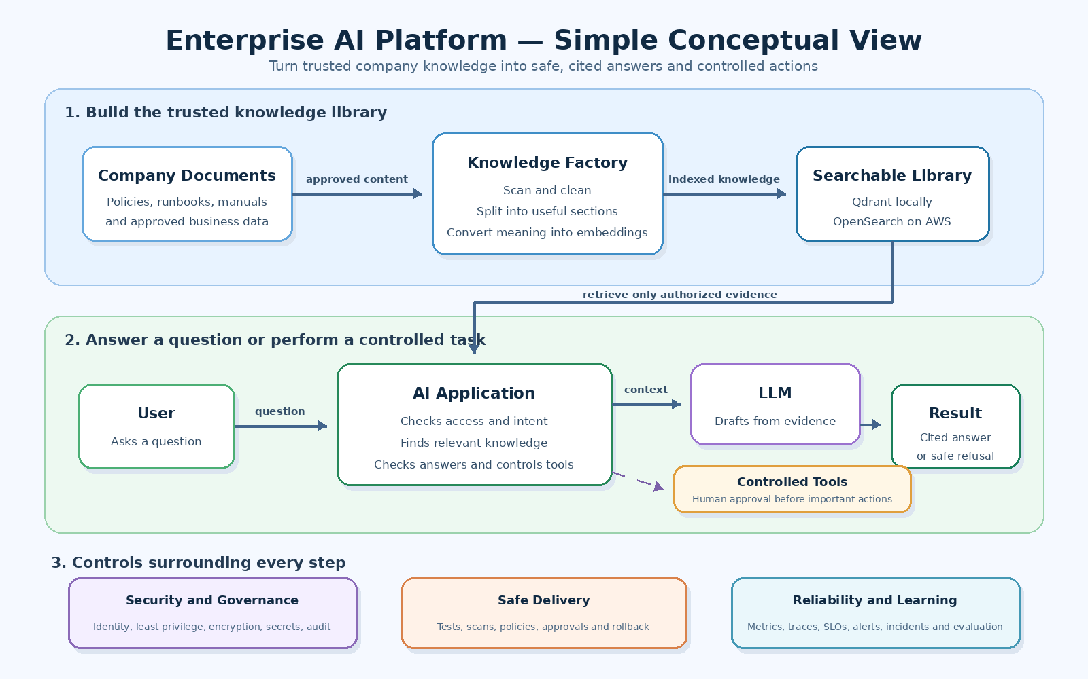
Figure 1. Enterprise AI platform - simple conceptual view

The simple analogy
Architecture component | Layman analogy
S3 | The document warehouse.
Ingestion pipeline | The librarian who checks, cleans and organizes material.
Embeddings | The subject index that represents meaning, not only keywords.
Qdrant/OpenSearch | The searchable library catalogue.
FastAPI application | The front desk receiving questions and returning results.
Bedrock LLM | The language expert that drafts an answer from supplied evidence.
LangGraph | The workflow supervisor deciding the next permitted step.
Guardrails and IAM | The security desk checking who may see or do what.
OpenTelemetry and dashboards | The monitoring room showing performance and failures.

4. End-to-end flow and failure behaviour

A. Preparing the company knowledge
1. Approved documents are placed in the local source and later in an encrypted S3 landing area.
2. The ingestion pipeline checks type, size, classification and processing eligibility.
3. Sensitive information can be detected, redacted or quarantined.
4. Large documents are divided into smaller sections called chunks.
5. Each chunk is converted into an embedding, which numerically represents its meaning.
6. Chunks, embeddings, source details and authorization metadata are stored in Qdrant or OpenSearch.

B. Answering a user's question
1. The user sends a question to the FastAPI application.
2. The application authenticates the user and determines permitted data scope.
3. The question is converted into an embedding.
4. The vector database returns the most relevant authorized chunks.
5. The application sends the question and retrieved evidence to the LLM.
6. The LLM prepares a draft response from that evidence.
7. The application validates citations, output structure and guardrail results.
8. The user receives a cited answer, safe refusal or controlled dependency error.

C. Introducing agentic AI
The agent is a controlled workflow, not unlimited autonomy. LangGraph coordinates the following sequence:
1. Understand and validate the request.
2. Check identity and authorization.
3. Retrieve relevant evidence.
4. Decide whether the evidence is sufficient.
5. Answer or propose an allowlisted tool.
6. Request approval where the tool is consequential.
7. Execute the approved action using validated arguments and an idempotency key.
8. Record the decision and outcome for audit and learning.
Safety principle: If the platform cannot retrieve and explain information reliably, giving it tools only increases risk. We prove retrieval, answer quality and safety before planning, tools and actions.

D. Failure and recovery behaviour
Failure | Safe behaviour
No relevant evidence | Abstain and explain that sufficient information was not found.
Unauthorized user | Deny before retrieving protected content.
Vector database unavailable | Fail readiness, alert and return a controlled dependency error.
LLM timeout or throttle | Apply bounded retries, deadline and approved fallback or error.
Invalid tool request | Reject malformed or non-allowlisted action.
Agent budget exceeded | Stop the workflow safely and record the reason.
Deployment regression | Roll back the application, prompt, model, graph or index version.
Infrastructure regression | Apply the reviewed last-known-good Terraform version; do not use destroy as an ordinary rollback.
Teardown dependency remains | Stop, report the residual resource and remove it in dependency order before declaring the environment clean.

5. Components and why they matter
Component | Role and importance
FastAPI | Receives questions and returns typed, controlled responses.
LangChain | Provides connectors for models, prompts, documents and retrievers.
LangGraph | Controls state, routing, budgets, approvals and terminal outcomes.
Embedding model | Converts the meaning of text into comparable vectors.
Qdrant | Provides the local searchable knowledge library.
OpenSearch | Provides AWS vector and hybrid search with enterprise controls.
Amazon Bedrock | Provides foundation-model access without operating GPUs.
S3 | Stores the approved, versioned document source of truth.
Glue/Lambda | Validates, prepares and processes documents.
Step Functions/EventBridge | Coordinates background ingestion and re-indexing.
EKS/ECR | Runs and stores the containerized application on AWS.
KMS | Protects stored data using managed encryption keys.
Secrets Manager | Keeps secret values outside code, images and Terraform state.
IAM | Defines precisely which workload may access each resource.
OpenTelemetry | Links API, retrieval, LLM and tool telemetry.
Prometheus/Grafana/CloudWatch | Provide metrics, dashboards, alerts and investigations.
Terraform | Creates reviewable and repeatable AWS infrastructure.
GitHub Actions | Tests, scans, builds and promotes approved changes.

6. Six-week implementation plan
Each week produces a usable capability and a learning checkpoint. We progress because the acceptance checkpoint is met, not merely because files were created.
Week | Focus | What we build | End-of-week checkpoint
1 | Control foundation | Repository, feature matrix, CI gates, separated Terraform state/platform roots and cleanup verifier. | Prove local preflight, test, reviewed-plan and cleanup workflows before building RAG.
2 | Local searchable knowledge | Typed configuration, document models, chunking, local embeddings, Qdrant and feature tests. | Deploy, test, roll back and fully remove the local retrieval feature.
3 | Cited RAG and guardrails | Bedrock adapter, prompts, citations, safe refusal, retrieval adapters and evaluation dataset. | A query returns a grounded answer or abstention; regression and rollback tests pass.
4 | Controlled API and agent | FastAPI, LangGraph state, read tool, mocked write tool, budgets, approval and telemetry. | Important actions cannot execute without policy and approval; previous release can be restored.
5 | AWS lifecycle proof | Terraform for AWS services, saved plans, GitHub Actions approvals, deploy, destroy and orphan-resource scan. | Sandbox deploy and destroy plans pass; no plaintext secrets or unmanaged resources exist.
6 | EKS, SRE and final proof | Immutable image, EKS, workload identity, health checks, HPA/PDB, SLOs, chaos and rollback. | End-to-end RAG works; release rollback, full teardown and cleanliness evidence are demonstrated.

Post-MVP weeks 7-12
• Scale ingestion with Glue/Spark, data quality and event-driven orchestration.
• Evaluate fine-tuning using PyTorch, Transformers and PEFT/LoRA only if a measured gap remains.
• Compare vector backends and hybrid retrieval using shared contract tests.
• Test backup, restore, disaster recovery and controlled AWS Fault Injection Service scenarios.
• Strengthen multi-tenant authorization, cost governance and operational readiness.

7. Architecture decisions and trade-offs

Qdrant locally; OpenSearch on AWS
Qdrant provides simple local development. OpenSearch aligns with AWS IAM, VPC, encryption and operations. A shared vector-store contract limits coupling.

Bedrock before custom training
It validates the use case without GPU operations. SageMaker and PEFT/LoRA are introduced only when evaluation proves that prompting and RAG are insufficient.

RAG before agents
Reliable evidence retrieval is a prerequisite for safe tool use. Agent capability is added only after grounding and abstention are measurable.

Local application before EKS
Kubernetes should not hide weaknesses in RAG logic. The application is proven locally, then containerized and deployed.

Provider interfaces
LLM, embedding, vector and evaluation adapters allow future migration and controlled experiments.

Human approval for consequential actions
The productivity gain from autonomous writes does not justify uncontrolled production risk.

When these choices should be revisited
• Evaluation shows the current model or retrieval method cannot meet quality targets.
• Latency, scale or cost materially exceeds the approved operating envelope.
• Data-residency, privacy or regulatory requirements change.
• A security incident exposes an authorization or agent-control weakness.
• Operational load demonstrates that a managed or simpler compute platform is preferable.

8. Risks, controls and governance
Risk | Preventive, detective and recovery controls
Hallucinated answer | Evidence-bound prompts, citation validation, evaluation and abstention.
Unauthorized retrieval | Identity-based filtering before retrieval and isolation tests.
Prompt injection in documents | Treat retrieved text as untrusted input; isolate instructions from evidence.
Unsafe agent action | Allowlisted tools, schemas, step/time budgets, approval and audit.
Secrets exposure | Secrets Manager, workload identity and log/trace redaction.
Excessive model cost | Token budgets, approved models, caching and cost telemetry.
Vendor lock-in | Provider interfaces, normalized domain models and re-index capability.
Poor production support | OpenTelemetry, SLOs, alerts, runbooks and ownership.
Unsafe change | CI gates, evaluation regression checks, approval and rollback.

Governance principles
• Identity and authorization are enforced by application and platform controls, not by model instructions.
• Secret values never enter source code, container images, Terraform variables or logs.
• Documents, chunks, embeddings, prompts, models, graphs and evaluation datasets are versioned.
• Exceptions have an owner, reason, approval, compensating control and expiry date.
• Production data is not sent to third-party services until privacy, residency and retention have been approved.
• Material architecture changes update this document and the associated decision record.

9. SRE and DevSecOps operating model

What we observe
• API availability and end-to-end latency.
• Retrieval latency, result count and quality.
• LLM first-token/completion latency, throttling and token consumption.
• Citation failures, abstention reasons and guardrail blocks.
• Agent tool calls, approval outcomes and execution failures.
• Ingestion acceptance, rejection, quarantine and re-index status.

Initial SLO direction
SLI | Initial target for validation
Eligible query availability | 99.9% over 30 days.
End-to-end latency | 95% below 4 seconds; 99% below 10 seconds.
Retrieval latency | 99% below 750 milliseconds.
Grounded response | At least 95% citation-valid answer or safe abstention.
Golden-set retrieval | Recall@5 of at least 0.85.
Tenant isolation | 100%; any cross-tenant result is a critical incident.
Agent safety | 100% of consequential actions policy-valid and approved.

Safe delivery path
1. Create the feature brief, acceptance criteria, file manifest, risk assessment and rollback test before coding.
2. Run pre-commit formatting, linting, type checks and secret detection.
3. Run unit, integration, feature, contract and RAG evaluation tests.
4. Run Terraform formatting, validation, tflint, Checkov and OPA policy checks.
5. Run dependency, filesystem, container and SBOM scanning.
6. Use GitHub OIDC for short-lived AWS credentials and require environment approval.
7. Deploy an immutable image digest, run health and feature checks, and prove release rollback.
8. When the environment is no longer needed, review a destroy plan and verify zero orphaned resources.
Operational principle: The service is not production-ready merely because the model answers correctly. It must also be observable, supportable, secure, recoverable and safe to change.

10. Interview explanation and verbal answer

Lead-level explanation
Interview answer: I am designing an enterprise RAG platform where approved documents are securely ingested, classified, chunked, embedded and stored in a vector search platform. At request time, the application authenticates the user, applies authorization filters, retrieves relevant evidence and uses Bedrock to generate a cited response. LangGraph manages controlled agent workflows with budgets, allowlisted tools and human approval for consequential actions. Every feature moves through a test-first, traceable delivery gate. Terraform is separated into bootstrap and platform lifecycles so we can deploy from a reviewed plan, restore a last-known-good release, destroy the sandbox in dependency order and prove that no orphaned resources remain. OpenTelemetry, SLOs and runbooks make the service operationally supportable.

Concise verbal answer
We are building a secure company-knowledge assistant. First, we prepare approved documents and store them in a searchable form. When a user asks a question, the application checks their access, finds the relevant document sections and gives that evidence to an LLM such as Bedrock. The answer must contain valid sources; otherwise, the system refuses to guess.
After reliable question answering works, we add a controlled AI agent that can use approved tools. Important actions require policy checks and human approval. Terraform, GitHub Actions, security scanning, observability, SLOs and runbooks make the platform suitable for enterprise operation.
The development process is equally controlled: one feature is designed, explained, tested, reviewed and approved at a time. A failed release restores the previous immutable version; a disposable sandbox can be destroyed completely and checked for orphaned resources.

Likely follow-up questions
• Why choose RAG instead of fine-tuning?
• How is document-level or tenant-level authorization enforced?
• How do you measure retrieval and answer quality?
• How do you defend against prompt injection in retrieved documents?
• What happens when Bedrock or OpenSearch is unavailable?
• Which agent actions require human approval?
• How do you control model and infrastructure cost?
• How would you migrate from Qdrant to OpenSearch or another provider?
• How do you distinguish release rollback, infrastructure rollback and complete teardown?
• How do you prove that Terraform destroy did not leave AWS resources behind?

11. Presentation talking points
Slide | Topic | Core message
1 | Problem | General LLMs do not know approved internal knowledge and may provide unsupported answers.
2 | Objective | Deliver safe, cited enterprise assistance using trusted data and controlled actions.
3 | Knowledge flow | Approve, scan, clean, chunk, embed and index company documents.
4 | Question flow | Authenticate, authorize, retrieve evidence, generate, validate and answer or abstain.
5 | Agent controls | Allowlisted tools, validated arguments, budgets, idempotency and human approval.
6 | Controlled delivery | One feature at a time: test-first design, CI/security gates, reviewed plans and approval.
7 | Reversibility and outcome | Restore releases, destroy disposable environments and prove zero orphaned resources.

Three messages to repeat
• The model is not the architecture; trusted data and controls make it enterprise-ready.
• Authorization happens before retrieval, and consequential actions require approval.
• Quality, reliability, security and cost are measured release gates, not post-production additions.

12. Glossary and planning questions
Term | Meaning
RAG | Retrieval-Augmented Generation: retrieve relevant evidence before asking the LLM to answer.
LLM | Large Language Model: the component that understands and generates language.
Chunk | A small, searchable section of a larger document.
Embedding | A numerical representation of text meaning.
Vector database | A system that finds information with similar meaning.
Grounding | Constraining an answer to supplied evidence.
Hallucination | A plausible-sounding but unsupported or incorrect model response.
Guardrail | A validation or policy control applied to input, output or actions.
Agent | A controlled workflow that can reason over state and invoke approved tools.
Tool | A narrowly defined function the agent is allowed to call.
SLI/SLO | A measured reliability indicator and its target.
Error budget | The acceptable amount of SLO failure used to govern change risk.
OpenTelemetry | A vendor-neutral standard for traces, metrics and logs.
HPA/PDB | Kubernetes controls for autoscaling and disruption availability.

Planning questions to resolve before implementation
• Which initial business use case and sample documents will represent success?
• Who owns document approval, classification, retention and deletion?
• What user identity and authorization attributes will drive retrieval filtering?
• Which Bedrock model and AWS region are approved for the sandbox?
• What evaluation thresholds must pass before agent tools are introduced?
• Which actions are read-only, low risk, consequential or prohibited?
• What budget, latency and availability targets should stakeholders validate?
• Will an existing EKS cluster be used, or must the sandbox cluster be provisioned?
• Which evidence must be retained after a sandbox purge, and where will that evidence live?
• Which account and region are approved for full teardown testing?
• Which resources may use immediate sandbox deletion and which require a recovery window?

13. Change-control baseline
This document is the planning source of truth. It should be updated when a material requirement, decision, control, risk, implementation checkpoint or operating assumption changes.
Change type | Required update
Architecture decision | Update rationale, alternatives, trade-offs, risk and revisit trigger.
Security or data requirement | Update authorization, encryption, privacy, audit and test controls.
Evaluation result | Update quality baseline, threshold, selected model/retriever and decision.
Implementation milestone | Record actual outcome, variance from plan and next acceptance gate.
Incident or test lesson | Update failure behaviour, observability, runbook and prevention control.

Current status: Version 1.1 is the controlled planning baseline. Implementation begins only after the initial use case, sample data, AWS sandbox inputs, success thresholds and lifecycle-control gates are understood.

14. Controlled development and reversible architecture
This section establishes two mandatory platform capabilities. The environment must be reproducibly deployable, recoverable and removable; and every feature must progress through a visible, testable and approved development cycle. These controls apply during learning, sandbox deployment and later enterprise rollout.
Control objective: A change is complete only when we can explain it, test it, deploy it, observe it, restore the previous state and remove its environment without unmanaged residue.

14.1 Business and engineering importance
• Prevents an AI learning exercise from creating unknown, long-running or billable AWS resources.
• Makes generated code understandable and reviewable instead of treating Codex output as a black box.
• Creates interview-ready evidence of architecture governance, release safety, SRE thinking and FinOps discipline.
• Reduces blast radius by changing one feature at a time and proving rollback before progression.
• Separates application recovery from environment destruction so the wrong recovery action is not used during an incident.

14.2 Lifecycle operations
Operation | Purpose | Required outcome
Release rollback | An application, prompt, graph or configuration release fails. | Restore the last known-good immutable image/configuration and re-run health and feature tests.
Infrastructure rollback | A Terraform change causes a platform regression. | Review and apply the last known-good Git/Terraform version; do not treat destroy as an ordinary rollback.
Complete teardown | The learning or sandbox environment is no longer needed. | Destroy resources in dependency order, remove the remote-state backend last and produce a cleanliness report.

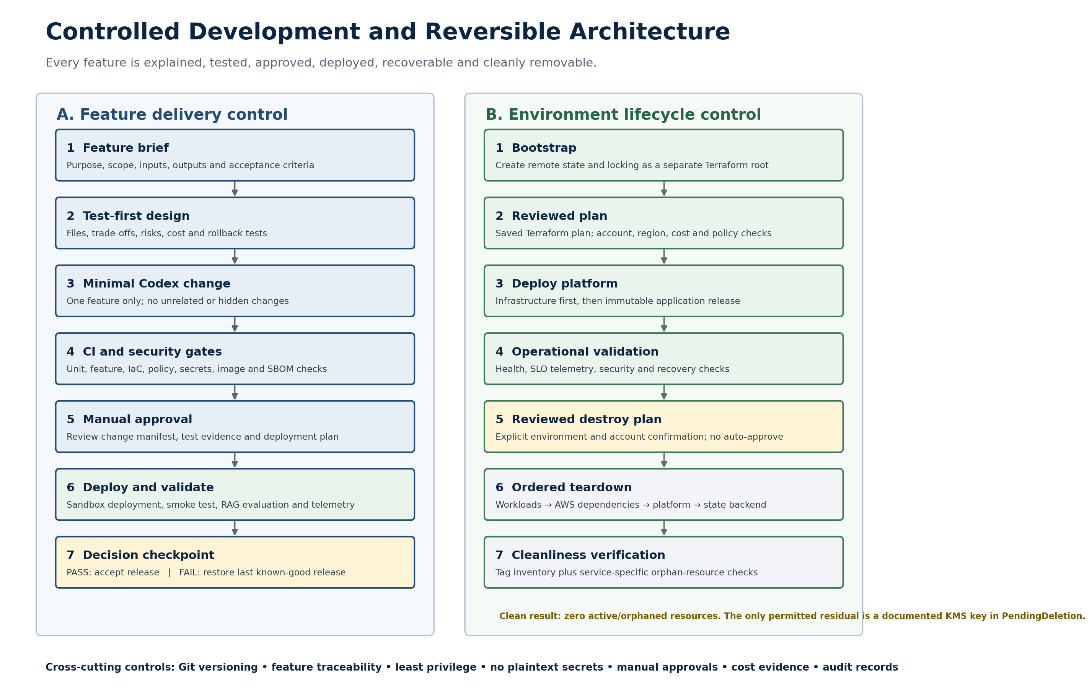
Figure 2. Controlled feature delivery and reversible environment lifecycle

14.3 Teardown modes
Mode | Use | Behaviour
destroy-safe | Production-like environments | Reviewed destroy plan, ordered deletion, recoverable secret/key windows, retained evidence and a residual-resource report.
purge-sandbox | Disposable learning environment only | Empty versioned buckets, delete images/logs, force-delete sandbox secrets, remove state last, schedule KMS deletion and scan for orphans.

AWS deletion constraint: A customer-managed KMS key cannot disappear immediately. AWS requires a 7-30 day waiting period. A documented, unusable key in PendingDeletion is the only permitted residual after an otherwise clean sandbox teardown.

14.4 Required deployment and teardown sequence
1. Run preflight checks for caller identity, AWS account, region, tool versions, configuration and budget limits.
2. Create or verify the separate bootstrap stack for Terraform remote state and locking.
3. Generate a saved Terraform plan and publish its readable summary, cost change and policy results.
4. Obtain manual approval and apply exactly the reviewed saved plan.
5. Deploy the immutable application artifact and record its image digest, configuration and feature set.
6. Run health, smoke, feature, security, RAG evaluation and telemetry validation.
7. If validation fails, restore the last known-good release and verify recovery.
8. For teardown, remove Helm/Kubernetes workloads and wait for finalizers and cloud-created dependencies.
9. Generate and approve a saved Terraform destroy plan for the platform stack.
10. Destroy platform resources, empty protected storage where sandbox policy permits, and remove the bootstrap stack last.
11. Query tags and service-specific APIs for EKS, ELB, EBS, ENI, EIP, OpenSearch, S3, ECR, logs, secrets, KMS, IAM, Lambda, Glue, Step Functions and EventBridge.
12. Produce a signed cleanliness report containing deleted, pending-deletion, unexpected and manually reviewed resources.

14.5 Mandatory resource tags
Tag | Required value
Project | enterprise-ai-platform
Environment | local | sandbox | production
Owner | TODO_USER_OR_TEAM
ManagedBy | terraform | helm
CostCenter | TODO_COST_CENTER
Feature | FEATURE_ID
ExpiresAt | TODO_ISO8601_TIMESTAMP
Repository | TODO_REPOSITORY

14.6 Controlled feature-development cycle
1. Define the feature's business purpose, user outcome and exclusions.
2. Record inputs, outputs, dependencies, assumptions and organization-specific TODO values.
3. Identify every file and AWS resource that may change.
4. Write measurable acceptance criteria and tests before implementation.
5. Assess security, privacy, reliability, cost and rollback impact.
6. Ask Codex to generate the smallest working change for this feature only.
7. Review every changed file, function, interface, Terraform resource and configuration value.
8. Run local unit, integration, feature, policy and security gates.
9. Review the code diff, dependency change, Terraform plan and cost evidence.
10. Approve and deploy only to the sandbox.
11. Run smoke, RAG-quality, telemetry and rollback tests; store the evidence.
12. Accept the feature or restore the previous version; do not begin the next feature without owner approval.

Feature traceability record
feature_id: RAG-001
name: local-qdrant-retrieval
status: planned
purpose: Retrieve relevant document chunks from local Qdrant
requirements:
- Sample documents can be ingested
- A query returns the five most relevant authorized chunks
files: []
tests: []
security_impact: none
cost_impact_usd: 0
deployment_method: docker-compose
rollback_method: restore previous image and configuration
teardown_method: remove container, volume and network
evidence: []
approved_by: TODO_USER

14.7 Repository changes
enterprise-ai-platform/
|-- docs/{architecture,adr,features,test-evidence,deployment-records}/
|-- docs/{rollback-records,cost-estimates,resource-cleanliness}/
|-- tools/platformctl/{bootstrap,plan,deploy,validate}.py
|-- tools/platformctl/{rollback,destroy,verify_clean}.py
|-- infra/{bootstrap,modules,environments/sandbox}/
|-- tests/{unit,integration,feature,smoke,security,teardown}/
|-- policies/
|-- feature-matrix.yaml
`-- Makefile

The bootstrap root is separate because the platform must be destroyed before the remote-state backend that records it. The control CLI is implemented in Python so lifecycle checks are testable, explicit and aligned with the learning objective.

14.8 Standard operator commands
make preflight
make test
make security-scan
make plan-sandbox
make deploy-sandbox
make validate-sandbox
make rollback-release
make plan-destroy-sandbox
make destroy-sandbox
make verify-clean

Deployment and destruction commands must verify the explicit environment, expected account ID and region. They require a reviewed saved plan and typed confirmation. The project must not use automatic approval for apply or destroy.

14.9 Testing and evidence gates
Gate | Required evidence
Python | Formatting, Ruff, type checks and pytest unit results.
Feature | A feature test mapped to each acceptance criterion.
Integration | Qdrant/OpenSearch/AWS adapter integration results.
RAG quality | Retrieval, groundedness, faithfulness, citation and abstention results.
Agent safety | Tool allowlist, schema, iteration, timeout and approval tests.
Terraform | Format, validate, tflint, Checkov, OPA and reviewed plan.
Container | Trivy result, Syft SBOM and Grype result.
Secrets | Pre-commit and CI secret-scan result.
Deployment | Readiness, health, smoke and immutable-artifact evidence.
Rollback | Previous version restored and revalidated.
Teardown | Destroy plan, deletion record and clean-resource report.

Weekly exit evidence
• Feature demonstration and acceptance result.
• Test, evaluation and security evidence.
• Infrastructure and AI-platform cost impact.
• Deployment record with artifact and configuration versions.
• Rollback proof and recovery result.
• Cleanup verification and residual-resource report.
• Owner decision to accept, revise or stop before the next feature.

14.10 Acceptance criteria
• The same documented commands can recreate the sandbox from source control.
• No deployment or destruction happens without a reviewed plan and explicit approval.
• A failed release restores the last known-good application and passes smoke tests.
• The full sandbox can be destroyed without unmanaged EKS, networking, storage, search, IAM, logging or orchestration resources.
• The cleanup verifier returns zero active unexpected resources and lists any KMS PendingDeletion key as an expected residual.
• Every merged feature has purpose, changed files, tests, security/cost assessment, evidence and rollback instructions.
• Codex never advances to the next feature until the owner approves the current checkpoint.

14.11 Architecture decisions and trade-offs
Decision | Rationale and trade-off
Separate bootstrap and platform roots | Makes final state-backend teardown possible; adds a controlled two-stage lifecycle.
Saved plan plus approval | Prevents unseen infrastructure actions; adds deliberate review time.
One feature per cycle | Improves learning, traceability and rollback; reduces parallel development speed.
Tags plus native service checks | Finds more residual resources than either method alone; requires a maintained verifier.
KMS PendingDeletion exception | Respects the AWS safety window while still proving zero active platform resources.
No automatic apply/destroy | Protects the learning account and cost boundary; deployment remains intentionally human-gated.

14.12 Interview explanation
Lead-level answer: I treat deployability and reversibility as platform features. Application rollback restores the last known-good immutable release, infrastructure rollback applies a reviewed prior Terraform version, and full teardown is a separate controlled workflow. Terraform state bootstrap is isolated from the platform so the environment can be destroyed before its backend. Every feature begins with acceptance tests and moves through code, security, policy, cost, approval, sandbox validation and rollback gates. After teardown, a Python verifier uses project tags and service-specific AWS APIs to prove that no orphaned resources remain; the only documented exception is a KMS key waiting for AWS-mandated deletion.

Appendix A. Master Codex instruction pack
The following block is the mandatory preamble for every implementation prompt. Feature-specific requirements are appended below it; the control instructions are not removed or weakened.
CONTROLLED DEVELOPMENT REQUIREMENTS
Work on only the requested feature.
BEFORE GENERATING CODE
1. Restate the feature purpose and measurable acceptance criteria.
2. List assumptions, dependencies and TODO organization values.
3. List every file and managed resource to create or modify.
4. Explain the design, alternatives and important trade-offs.
5. Define unit, integration, feature, security and rollback tests.
6. State AWS and AI-platform cost impact.
7. Stop if ambiguity could materially alter the design.
WHILE GENERATING CODE
1. Generate the smallest working implementation for this feature only.
2. Use Python 3.11+ and Terraform 1.5+.
3. Do not introduce plaintext secrets or long-lived AWS credentials.
4. Do not create unmanaged resources or modify unrelated files.
5. Tag every supported AWS resource with the required project tags.
6. Do not run terraform apply or terraform destroy automatically.
7. Add explicit TODO markers for organization-specific values.
8. Preserve idempotency and provide bounded retries and timeouts.
AFTER GENERATING CODE
1. Explain every changed file, function, interface and Terraform resource.
2. Provide exact validation commands and expected outputs.
3. Run or define all required tests and record the evidence location.
4. Provide release rollback, infrastructure rollback and teardown steps.
5. List potential residual AWS resources and the verification method.
6. Update feature-matrix.yaml and relevant architecture/ADR records.
7. Summarize security, reliability and cost impact.
8. Stop for owner review before starting another feature.

Mandatory approval boundaries
• Codex may generate and test code within the approved feature scope.
• Codex may generate Terraform plans and readable plan summaries.
• Codex must not apply infrastructure, destroy resources, force-delete data or approve its own release.
• The owner approves feature scope, deployment, rollback and teardown independently.
• Any unexpected resource, cost, policy bypass or destructive requirement stops the workflow for review.

Per-feature Codex inputs
Input | Required content
Feature ID and purpose | One outcome with explicit exclusions.
Expected outputs | Files, APIs, resources, artifacts and evidence.
Required inputs | Environment variables, interfaces and non-secret configuration.
Acceptance criteria | Measurable functional, security, reliability and teardown checks.
Example usage | Commands, request/response and expected result.
Rollback trigger | The health, quality, security or cost condition that rejects the change.

Technical references
• Terraform plan and destroy mode: https://developer.hashicorp.com/terraform/cli/commands/plan
• Terraform saved-plan apply mode: https://developer.hashicorp.com/terraform/cli/commands/apply
• AWS KMS key deletion: https://docs.aws.amazon.com/kms/latest/developerguide/deleting-keys.html
• AWS Secrets Manager deletion: https://docs.aws.amazon.com/secretsmanager/latest/userguide/manage_delete-secret.html
• AWS Resource Groups Tagging API: https://docs.aws.amazon.com/resourcegroupstagging/latest/APIReference/API_GetResources.html

Version history
Version | Date | Change
1.0 | 14 August 2026 | Initial architecture objective, layman explanation, decisions and six-week plan.
1.1 | 15 August 2026 | Added controlled feature development, reviewed deploy/rollback/teardown lifecycle, cleanup verification, revised weekly gates and master Codex contract.

Implementation authority: Version 1.1 supersedes Version 1.0 for all implementation work. If code, Terraform or a Codex prompt conflicts with these controls, this document is the source of truth until a reviewed architecture decision updates it.

