《大智度論》經論科判對應表

1.1-1.1【卷1開頭是「論的歸敬偈」，沒有對應的經，為了方便左右欄對照，姑且用p.28的經「1.1如是我聞：一時」來對應（鄰近）】

1.1-1.2

1.1-1.3

1.1-1.4

1.1-1.5

1.1-1.6

1.1-1.7

1.1-1.8

1.1-1.9

1.1-1.10

1.1-1.11

1.1-1.12

1.1-1.13

1.1-1.14

1.1-1.15

1.1-1.16

1.1-1.17

1.1-1.18

1.1-1.19

1.1-1.20

1.1-1.21

1.1-1.22

1.1-1.23

1.1-1.24

1.1-1.25

1.1-1.26

1.1-1.27

1.1-1.28

1.1-1.29

1.1-1.30

1.1-1.31

1.1-1.32

1.1-1.33

1.1-1.34

1.1-1.35

1.1-1.36

1.1-1.37

1.1-1.38

1.1-1.39

1.1-1.40

1.1-1.41

1.1-1.42

1.1-1.43

1.1-1.44

1.1-1.45

1.1=2.0【p.28的經「1.1如是我聞：一時」，包含了論的2.0至3.30，所以用等號=】

1.1=2.1

1.1=2.2

1.1=2.3

1.1=2.4

1.1=2.5

1.1=2.6

1.1=2.7

1.1=2.8

1.1=2.9

1.1=2.10

1.1=2.11

1.1=2.12

1.1=3.0

1.1=3.1

1.1=3.2

1.1=3.3

1.1=3.4

1.1=3.5

1.1=3.6

1.1=3.7

1.1=3.8

1.1=3.9

1.1=3.10

1.1=3.11

1.1=3.12

1.1=3.13

1.1=3.14

1.1=3.15

1.1=3.16

1.1=3.17

1.1=3.18

1.1=3.19

1.1=3.20

1.1=3.21

1.1=3.22

1.1=3.23

1.1=3.24

1.1=3.25

1.1=3.26

1.1=3.27

1.1=3.28

1.1=3.29

1.1=3.30

4.0=4.1【p.53的經「壹、釋佛之德號」，包含了論的4.1至4.58，所以用等號=】

4.0=4.2

4.0=4.3

4.0=4.4

4.0=4.5

4.0=4.6

4.0=4.7

4.0=4.8

4.0=4.9

4.0=4.10

4.0=4.11

4.0=4.12

4.0=4.13

4.0=4.14

4.0=4.15

4.0=4.16

4.0=4.17

4.0=4.18

4.0=4.19

4.0=4.20

4.0=4.21

4.0=4.22

4.0=4.23

4.0=4.24

4.0=4.25

4.0=4.26

4.0=4.27

4.0=4.28

4.0=4.29

4.0=4.30

4.0=4.31

4.0=4.32

4.0=4.33

4.0=4.34

4.0=4.35

4.0=4.36

4.0=4.37

4.0=4.38

4.0=4.39

4.0=4.40

4.0=4.41

4.0=4.42

4.0=4.43

4.0=4.44

4.0=4.45

4.0=4.46

4.0=4.47

4.0=4.48

4.0=4.49

4.0=4.50

4.0=4.51

4.0=4.52

4.0=4.53

4.0=4.54

4.0=4.55

4.0=4.56

4.0=4.57

4.0=4.58

5.0=5.1

5.0=5.2

5.0=5.3

5.0=5.4

5.0=5.5

5.0=5.6

5.0=5.7

5.0=5.8

5.0=5.9

5.0=5.10

5.0=5.11

5.0=5.12

5.0=5.13

5.14=5.15 【p.72的經「貳、釋「耆闍崛山中」」，包含了論的5.15至5.51，但其中5.18至5.43插入「二、佛何故住王舍城及多住舍婆提」之討論，所以採「鄰近」的減號-。】

5.14=5.16

5.14=5.17

5.14-5.18

5.14-5.19

5.14-5.20

5.14-5.21

5.14-5.22

5.14-5.23

5.14-5.24

5.14-5.25

5.14-5.26

5.14-5.27

5.14-5.28

5.14-5.29

5.14-5.30

5.14-5.31

5.14-5.32

5.14-5.33

5.14-5.34

5.14-5.35

5.14-5.36

5.14-5.37

5.14-5.38

5.14-5.39

5.14-5.40

5.14-5.41

5.14-5.42

5.14-5.43

5.14=5.44

5.14=5.45

5.14=5.46

5.14=5.47

5.14=5.48

5.14=5.49

5.14=5.50

5.14=5.51

6.0=6.1

6.0=6.2

6.0=6.3

6.0=6.4

6.0=6.5

6.0=6.6

6.0=6.7

6.0=6.8

6.0=6.9

6.0=6.10

6.0=6.11

6.0=6.12

6.0=6.13

6.0=6.14

6.0=6.15

6.0=6.16

6.0=6.17

6.0=6.18

6.0=6.19

6.0=6.20

6.21=^3.4【論的3.4段落號與經的6.21貳、釋「大數五千分」對應】

6.22=^3.5【論的3.5段落號與經的6.22參、釋「阿羅漢」對應】

6.23=^3.6【論的3.6段落號與經的6.23肆、釋「諸漏已盡」對應】

6.24=^3.7【論的3.7段落號與經的6.24伍、釋「無復煩惱」對應】

6.25=6.26

6.25=6.27

6.25=6.28

6.25=6.29

6.25=6.30

6.25=6.31

6.25=6.32

6.33=6.34

6.33=6.35

6.33=6.36

6.37=6.38

6.37=6.39

6.37=6.40

6.37=6.41

6.42=6.43

6.42=6.44

6.42=6.45

6.42=6.46

6.42=6.47

6.42=6.48

6.42=6.49

6.42=6.50

6.42=6.51

6.42=6.52

6.42=6.53

6.54=6.55

6.54=6.56

6.54=6.57

6.54=6.58

6.59=6.60

6.59=6.61

6.59=6.62

6.59=6.63

6.64=6.65

6.64=6.66

6.64=6.67

6.64=6.68

6.64=6.69

6.64=6.70

6.64=6.71

6.64=6.72

6.73=6.74

6.73=6.75

6.73=6.76

6.73=6.77

6.73=6.78

6.73=6.79

6.73=6.80

6.73=6.81

6.73=6.82

6.73=6.83

6.84=6.85

6.84=6.86

6.84=6.87

6.84=6.88

6.84=6.89

6.84=6.90

6.84=6.91

6.84=6.92

6.84=6.93

6.84=6.94

6.84=6.95

6.84=6.96

6.97=6.98

6.97=6.99

6.97=6.100

6.97=6.101

6.97=6.102

6.97=6.103

6.97=6.104

6.97=6.105

6.97=6.106

綠色4.1「復有菩薩摩訶薩」【p.101的經綠色4.1之下「復有菩薩摩訶薩」是否補一序號，以便與論之7.0至7.124對應？】

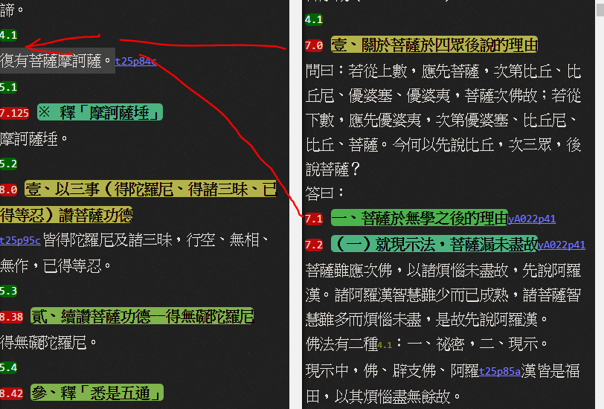

^4.1-7.0~29

^4.1=7.30~36【此處正釋「菩薩」故用等號=，其餘是旁論故用減號-】

^4.1-7.37~124

7.125=7.126

7.125=7.127

7.125=7.128

7.125=7.129

7.125=7.130

7.125=7.131

7.125=7.132

7.125=7.133

7.125=7.134

7.125=7.135

7.125=7.136

7.125=7.137

7.125=7.138

7.125=7.139

7.125=7.140

7.125=7.141

7.125=7.142

7.125=7.143

7.125=7.144

7.125=7.145

8.0=8.1

8.0=8.2

8.0=8.3

8.0=8.4

8.0=8.5

8.0=8.6

8.0=8.7

8.0=8.8

8.0=8.9

8.0=8.10

8.0=8.11

8.0=8.12

8.0=8.13

8.0=8.14

8.0=8.15

8.0=8.16

8.0=8.17

8.0=8.18

8.0=8.19

8.0=8.20

8.0=8.21

8.0=8.22

8.0=8.23

8.0=8.24

8.0=8.25

8.0=8.26

8.0=8.27

8.0=8.28

8.0=8.29

8.0=8.30

8.0=8.31

8.0=8.32

8.0=8.33

8.0=8.34

8.0=8.35

8.0=8.36

8.0=8.37

8.38=8.39

8.38=8.40

8.38=8.41

8.42=8.43

8.42=8.44

8.42=8.45

8.42=8.46

8.42=8.47

8.42=8.48

8.42=8.49

8.42=8.50

8.42=8.51

8.42=8.52

8.42=8.53

8.42=8.54

8.42=8.55

8.42=8.56

8.42=8.57

8.42=8.58

8.59=8.60

8.61=^5.6【論的綠色5.6段落號與經的8.61伍、釋「無復懈怠」對應】

8.62=^5.7【論的綠色5.7段落號與經的8.62陸、釋「已捨利養、名聞」對應】

8.63=^5.8【論的綠色5.8段落號與經的8.63柒、釋「說法無所悕望」對應】

8.64=8.65

8.64=8.66

8.64=8.67

8.64=8.68

8.64=8.69

8.64=8.70

8.64=8.71

8.64=8.72

8.73=8.74

8.73=8.75

8.76=8.77

8.76=8.78

8.76=8.79

8.76=8.80

8.76=8.81

8.76=8.82

8.76=8.83

8.76=8.84

8.76=8.85

8.76=8.86

8.76=8.87

8.76=8.88

8.76=8.89

8.76=8.90

8.76=8.91

8.76=8.92

8.76=8.93

8.76=8.94

8.76=8.95

8.76=8.96

8.97=8.98

8.97=8.99

8.97=8.100

8.101=8.102

8.101=8.103

8.101=8.104

8.101=8.105

8.101=8.106

8.107=8.108

8.107=8.109

8.107=8.110

8.111=^5.15【論的綠色5.15段落號與經的8.111 拾肆、釋「顏色和悅、常先問訊、所語不麁」對應】

8.112=8.113

8.112=8.114

8.112=8.115

8.112=8.116

8.117=8.118

8.117=8.119

8.117=8.120

8.117=8.121

9.0=9.1

9.0=9.2

9.0=9.3

9.0=9.4

9.0=9.5

9.0=9.6

9.0=9.7

9.0=9.8

9.0=9.9

9.0=9.10

9.0=9.11

9.0=9.12

9.0=9.13

9.0=9.14

9.0=9.15

9.0=9.16

9.0=9.17

9.0=9.18

9.0=9.19

9.0=9.20

9.0=9.21

9.0=9.22

9.0=9.23

9.0=9.24

9.0=9.25

9.0=9.26

9.0=9.27

9.0=9.28

9.0=9.29

9.0=9.30

9.0=9.31

9.0=9.32

9.0=9.33

9.0=9.34

9.0=9.35

9.0=9.36

9.0=9.37

9.0=9.38

9.0=9.39

9.0=9.40

9.0=9.41

9.0=9.42

9.0=9.43

9.0=9.44

9.0=9.45

9.0=9.46

9.0=9.47

9.0=9.48

9.0=9.49

9.0=9.50

9.0=9.51

9.0=9.52

9.0=9.53

9.0=9.54

9.0=9.55

9.0=9.56

9.0=9.57

9.0=9.58

9.0=9.59

9.0=9.60

9.0=9.61

9.0=9.62

9.0=9.63

9.0=9.64

9.0=9.65

9.0=9.66

9.0=9.67

9.0=9.68

9.0=9.69

9.0=9.70

9.0=9.71

9.0=9.72

9.0=9.73

9.0=9.74

9.0=9.75

9.0=9.76

9.0=9.77

9.0=9.78

9.0=9.79

9.0=9.80

9.0=9.81

9.82=9.83

9.82=9.84

9.82=9.85

9.82=9.86

9.82=9.87

9.82=9.88

10.0=10.1

10.0=10.2

10.0=10.3

10.0=10.4

10.0=10.5

10.0=10.6

10.0=10.7

10.0=10.8

10.0=10.9

10.10=10.11

10.10=10.12

10.10=10.13

10.10=10.14

10.10=10.15

10.10=10.16

10.10=10.17

10.10=10.18

10.10=10.19

10.10=10.20

10.10=10.21

10.10=10.22

10.23=10.24

10.23=10.25

10.23=10.26

10.23=10.27

10.23=10.28

10.23=10.29

10.23=10.30

10.23=10.31【卷006結束】

11.1=11.2【缺11.1之序號？？卷007，p.187，紅色11.0之下似應補「11.1一、釋「願受無量諸佛世界」】

11.1=11.3

11.1=11.4

11.1=11.5

11.1=11.6

11.1=11.7

11.1=11.8

11.9=11.10

11.9=11.11

11.9=11.12

11.9=11.13

11.9=11.14

11.9=11.15

11.9=11.16

11.9=11.17

11.9=11.18

11.9=11.19

11.9=11.20

11.21=11.22

11.21=11.23

11.21=11.24

11.21=11.25

11.21=11.26

11.21=11.27

11.21=11.28

11.21=11.29

11.21=11.30

11.21=11.31

11.21=11.32

11.21=11.33

11.34=11.35

11.34=11.36

11.34=11.37

11.34=11.38

11.34=11.39

11.34=11.40

11.41=11.42

11.41=11.43

11.41=11.44

11.41=11.45

11.46=^7.6【論的綠色7.6段落號與經的「11.46六、菩薩成就無量功德」對應】

11.47=11.48

11.47=11.49

11.47=11.50

12.0=12.1

12.0=12.2

12.0=12.3

12.0=12.4

12.0=12.5

12.0=12.6

12.0=12.7

12.0=12.8

12.0=12.9

12.0=12.10

12.0=12.11

12.0=12.12

12.0=12.13

12.0=12.14

12.0=12.15

12.0=12.16

12.0=12.17

12.0=12.18

12.0=12.19

12.0=12.20

12.0=12.21

12.0=12.22

12.0=12.23

12.0=12.24

12.0=12.25

12.0=12.26

12.27=12.28

12.27=12.29

12.27=12.30

12.27=12.31

12.27=12.32

12.27=12.33

12.27=12.34

12.27=12.35

12.27=12.36

12.27=12.37

12.27=12.38

12.27=12.39

12.27=12.40

12.27=12.41

12.27=12.42

12.43=12.46

12.44=12.46【經的12.44、12.45應該移到12.43之下方才對】

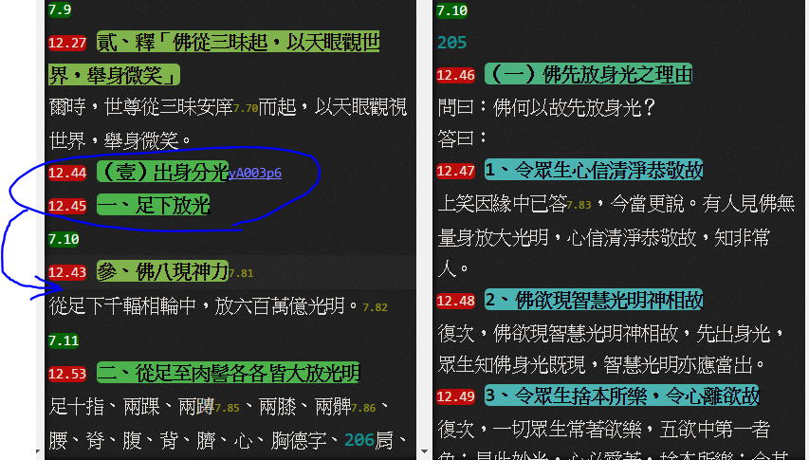

12.45=12.46

12.45=12.47

12.45=12.48

12.45=12.49

12.45=12.50

12.45=12.51

12.45=12.52

12.53=12.54

12.53=12.55

12.53=12.56

12.53=12.57

12.53=12.58

12.53=12.59

12.60=12.61

12.60=12.62

12.60=12.63

12.60=12.64

12.60=12.65

12.60=12.66

12.60=12.67

12.60=12.68

12.60=12.69

12.60=12.70

12.60=12.71

12.60=12.72

12.60=12.73

12.60=12.74

12.60=12.75

12.60=12.76

12.60=12.77

12.60=12.78

12.60=12.79

12.80=^7.14【論的綠色7.14段落號與經的12.80「（貳）出毛孔光」對應】

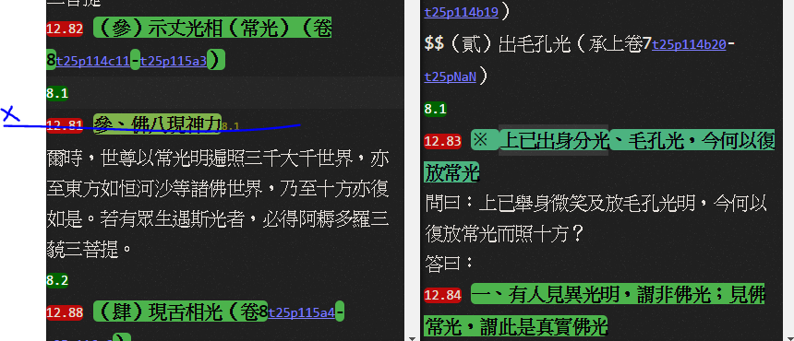

12.82=12.83

12.82=12.84

12.82=12.85

12.82=12.86

12.82=12.87

12.88=12.89

12.88=12.90

12.88=12.91

12.88=12.92

12.88=12.93

12.88=12.94

12.88=12.95

12.88=12.96

12.88=12.97

12.88=12.98

12.88=12.99

12.88=12.100

12.88=12.101

12.88=12.102

12.88=12.103

12.88=12.104

12.88=12.105

12.88=12.106

12.88=12.107

12.88=12.108

12.88=12.109

12.88=12.110

12.88=12.111

12.88=12.112

12.113=12.115

12.113=12.116

12.113=12.117

12.113=12.118

12.113=12.119

12.113=12.120

12.113=12.121

12.113=12.122

12.113=12.123

12.113=12.124

12.113=12.125

12.113=12.126

12.113=12.127

12.114=12.128

12.114=12.129

12.114=12.130

12.114=12.131

12.114=12.132

12.114=12.133

12.114=12.134

12.114=12.135

12.114=12.136

12.137=^8.5【論的綠色8.5段落號與經的12.137 三、釋「地皆柔軟，令眾生和悅」對應】

12.138=12.139

12.138=12.140

12.138=12.141

12.138=12.142

12.138=12.143

12.138=12.144

12.138=12.145

12.138=12.146

12.138=12.147

12.148=12.149

12.148=12.150

12.148=12.151

12.148=12.152

12.148=12.153

12.148=12.154

12.155=12.156

12.155=12.157

12.155=12.158

12.155=12.159

12.160=12.161

12.160=12.162

12.160=12.163

12.160=12.164

12.160=12.165

12.160=12.166

12.160=12.167

12.160=12.168

12.160=12.169

12.160=12.170

12.160=12.171

12.160=12.172

12.160=12.173

12.160=12.174

12.160=12.175

12.160=12.176

12.160=12.177

12.160=12.178

12.160=12.179

12.160=12.180

12.160=12.181

12.160=12.182

12.160=12.183

12.160=12.184

12.160=12.185

12.160=12.186

12.160=12.187

12.160=12.188

12.160=12.189

12.160=12.190

12.160=12.191

12.160=12.192

12.160=12.193

12.160=12.194

12.160=12.195

12.160=12.196

12.160=12.197

12.160=12.198

12.199=12.200

12.199=12.201

12.199=12.202

12.199=12.203

12.199=12.204

12.199=12.205

12.199=12.206

12.199=12.207

12.199=12.208

12.199=12.209

12.199=12.210

12.199=12.211

12.199=12.212

12.199=12.213

12.199=12.214

12.199=12.215

12.199=12.216

12.199=12.217

12.199=12.218

12.199=12.219

12.199=12.220

12.199=12.221

12.199=12.222

12.199=12.223

12.199=12.224

12.199=12.225

12.199=12.226

12.199=12.227

12.228=12.230

12.229=12.230

12.229=12.231

12.229=12.232

12.229=12.233

12.229=12.234

12.229=12.235

12.229=12.236

12.229=12.237

12.229=12.238

12.239=12.241

12.240=12.241

12.240=12.242

12.240=12.243

12.240=12.244

12.240=12.245

12.240=12.246

12.240=12.247

12.240=12.248

12.240=12.249

12.240=12.250

12.240=12.251

12.240=12.252

12.240=12.253

12.240=12.254

12.240=12.255

12.240=12.256

12.257=12.258

12.257=12.259

12.260=12.261

12.260=12.262

12.263=^9.5【p.242，論的綠色9.5段落號與經的12.263四、釋「華臺、瓔珞遍滿三千大千世界」對應】

12.264=^【論的綠色9.6段落號與經的12.264 五、釋「十方如恒河沙等諸佛世界皆作金色」對應】

12.265=12.266

12.265=12.267

12.268=12.269

12.268=12.270

12.268=12.271

12.268=12.272

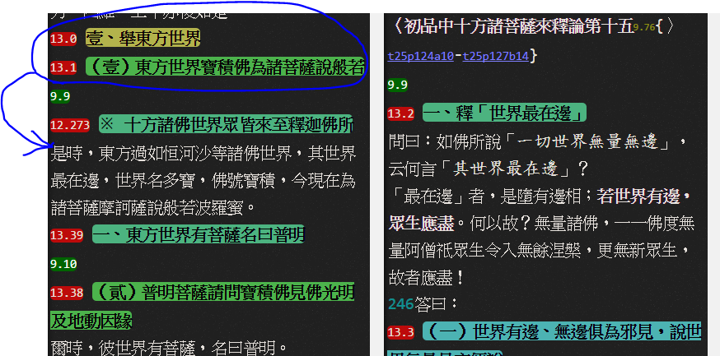

12.273=13.2

13.0=13.2【13.0、13.1移至12.273之下，12.273或許可更換序號或省略序號】

13.1=13.2

13.1=13.2

13.1=13.3

13.1=13.4

13.1=13.5

13.1=13.6

13.1=13.7

13.1=13.8

13.1=13.9

13.1=13.10

13.1=13.11

13.1=13.12

13.1=13.13

13.1=13.14

13.1=13.15

13.1=13.16

13.1=13.17

13.1=13.18

13.1=13.19

13.1=13.20

13.1=13.21

13.1=13.22

13.1=13.23

13.1=13.24

13.1=13.25

13.1=13.26

13.1=13.27

13.1=13.28

13.1=13.29

13.1=13.30

13.1=13.31

13.1=13.32

13.1=13.33

13.1=13.34

13.1=13.35

13.1=13.36

13.1=13.37

13.38=13.40

13.39=13.40

13.39=13.41

13.42=12.43

13.42=12.44

13.42=12.45

13.42=12.46

13.42=12.47

13.42=12.48

13.49=12.50

13.49=12.51

13.49=12.52

13.49=12.53

13.49=12.54

13.49=12.55

13.49=12.56

13.57=12.58

13.57=12.59

13.57=12.60

13.61=13.62

13.61=13.63

13.61=13.64

13.61=13.65

13.61=13.66

13.61=13.67

13.61=13.68

13.61=13.69

13.61=13.70

13.61=13.71

13.61=13.72

13.61=13.73

13.61=13.74

13.61=13.75

13.61=13.76

13.61=13.77

13.61=13.78

13.61=13.79

13.61=13.80

13.61=13.81

13.61=13.82

13.61=13.83

13.61=13.84

13.61=13.85

13.61=13.86

13.61=13.87

13.61=13.88

13.61=13.89

13.61=13.90

13.61=13.91

13.61=13.92

13.61=13.93

13.61=13.94

13.61=13.95

13.61=13.96

13.97=13.99【p.265】

13.98=13.99

13.98=13.100

13.98=13.101

13.98=13.102

13.98=13.103

13.98=13.104

13.98=13.105

13.98=13.106

13.107=13.108

13.107=13.109

13.107=13.110

13.107=13.111

13.107=13.112

13.113=13.114

13.113=13.115

13.113=13.116

13.113=13.117

13.113=13.118

13.113=13.119

13.113=13.120

13.121=13.122

13.121=13.123

13.121=13.124

13.121=13.125

13.121=13.126

13.121=13.127

13.121=13.128

13.121=13.129

13.121=13.130

13.121=13.131

13.121=13.132

13.121=13.133

13.121=13.134

13.121=13.135

13.121=13.136

13.137=13.138

13.137=13.139

13.137=13.140

13.137=13.141

13.137=13.142

13.137=13.143

13.137=13.144

13.137=13.145

13.146=13.147

13.146=13.148

13.146=13.149

13.146=13.150

13.151=13.152

13.151=13.153

13.154=13.155

13.154=13.156

13.154=13.157

13.154=13.158

13.154=13.159

13.154=13.160

13.154=13.161

13.154=13.162

13.154=13.163

13.154=13.164

13.154=13.165

13.166=13.167

13.166=13.168

13.169=13.171

13.170=13.171

13.170=13.172

13.170=13.173

13.170=13.174

13.170=13.175

13.170=13.176

13.170=13.177

13.170=13.178

13.170=13.179

13.170=13.180

13.170=13.181

13.170=13.182

13.170=13.183

13.170=13.184

13.170=13.185

13.170=13.186

13.187=13.188

13.187=13.189

13.187=13.190

13.187=13.191

13.187=13.192

13.193=13.194

13.193=13.195

13.193=13.196

13.193=13.197

13.193=13.198

13.193=13.199

13.193=13.200

13.193=13.201

13.193=13.202

13.193=13.203

13.193=13.204

13.193=13.205

13.193=13.206

13.193=13.207

13.193=13.208

13.193=13.209

13.193=13.210

13.193=13.211

13.193=13.212

13.193=13.213

13.193=13.214

13.193=13.215

13.193=13.216

13.193=13.217

13.193=13.218

13.193=13.219

13.193=13.220

13.193=13.221

13.193=13.222

13.193=13.223

13.193=13.224

13.193=13.225【卷010結束】

14.0=14.1【卷011開始】

14.0=14.2

14.0=14.3

14.0=14.4

14.0=14.5

14.0=14.6

14.0=14.7

14.0=14.8

14.0=14.9

14.0=14.10

14.11=14.12

14.11=14.13

14.11=14.14

14.11=14.15

14.11=14.16

14.11=14.17

14.11=14.18

14.11=14.19

14.11=14.20

14.11=14.21

14.11=14.22

14.11=14.23

14.11=14.24

14.11=14.25

14.11=14.26

14.11=14.27

14.11=14.28

14.11=14.29

14.11=14.30

14.11=14.31

14.32=14.33

14.32=14.34

14.32=14.35

14.32=14.36

^11.4=15.0~110

^12.1=16.0~149【卷12】

^13.1=17.0~178【卷13尸羅波羅蜜】

^14.1=18.0~146【卷14-15忍波羅蜜】

^15.1=19.0~150【卷16精進波羅蜜】

^17.1=20.0~164【卷17禪波羅蜜】

^18.1=21.0~163【卷18般若波羅蜜】

^19.1=22.0~207【卷19三十七道品】

22.208=22.209~510【卷20-21貳、空三昧等八種定法】

22.511=22.512~562【卷21參、九相（九想）】

22.563=22.564~815【卷22肆、八念】

22.816=22.817~928【卷23伍、十想】

22.929=22.930~1034【卷23陸、十一智】

22.1035=22.1036~1054【卷23柒、三三昧】

22.1055=22.1056~1054【卷23捌、三根】

^24.1=23.0~623【卷24-26十力-十八不共法】

【厚觀備註：24.1節點之下「經」無「壹～陸」之科判，僅有「柒」之科判】

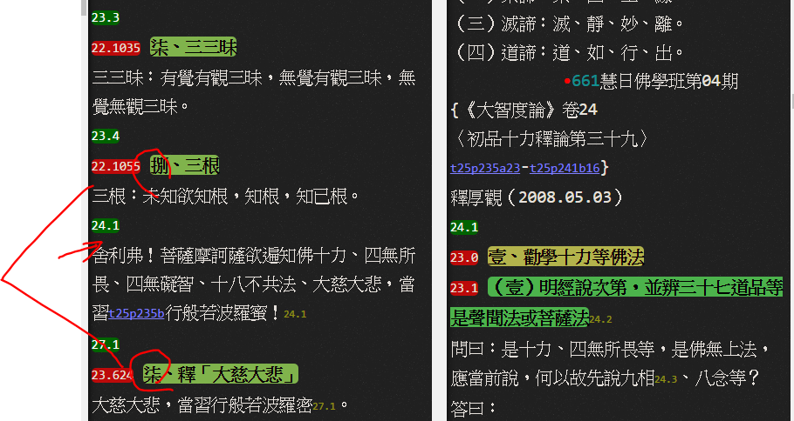

23.624=23.625~658【卷27柒、釋「大慈大悲」】

24.0=24.1~46【卷27壹、釋「道慧、道種慧」】

24.47=24.48~92【卷27貳、釋「一切智、一切種智」】

24.93=24.94~146【卷27參、釋「斷煩惱習」】

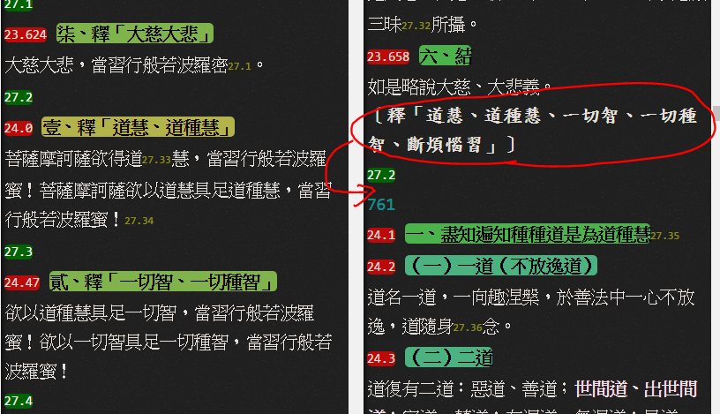

【YAP：論之〔道慧、道種慧、一切智、一切種智、斷煩惱智〕這幾個字應移至27.2節點之下】

25.0=25.1~23【卷27壹、釋「上菩薩位」】

25.24=25.25~54【卷27貳、釋「過聲聞、辟支佛地，住阿鞞跋致地」】

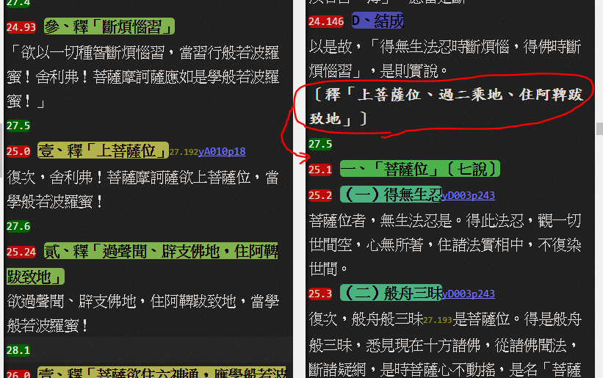

【YAP：論之〔釋「上菩薩位、過二乘地、住阿鞞跋致地」〕這幾個字應移至27.5節點之下】

26.0=26.1~37【卷28六神通】

26.38=26.39~55

26.56=26.57~83

26.84=26.85~128

27.0=27.1~16

27.17=27.18~40

28.0=28.1~49【卷29迴向】

28.50=28.51~71

28.72=28.73~139

28.140=28.141~169

29.0=29.1~18【卷30 善根供養】

29.19=29.20~59

29.60=29.61~128

29.129=29.130~146

30.0=30.1~20

30.21=30.22~27

30.28=30.29~38

30.39=30.40~55

^31=30.56~366【以下卷31：十八空。YAP：此處是卷31，「30.56~366」之序號與上一卷無關連，序號最好變更。】

31.0=31.1~61【卷32 四緣】

31.62=31.63~109

31.110=31.63~126

31.127=31.128

31.127=31.129

31.127=31.130

31.131=31.132

31.131=31.133

31.131=31.134

31.131=31.135

31.136=31.137

31.136=31.138

31.136=31.139

31.136=31.140

31.136=31.141

31.136=31.142

31.136=31.143

31.144=31.145

31.144=31.146

31.144=31.147

31.144=31.148

31.144=31.149

31.144=31.150

31.144=31.151

31.144=31.152

31.144=31.153

31.144=31.154

31.144=31.155

31.144=31.156

31.157=31.158

31.157=31.159

31.157=31.160

31.157=31.161

31.157=31.162

31.157=31.163

31.157=31.164

31.157=31.165

31.157=31.166

31.157=31.167

31.157=31.168

31.157=31.169

31.157=31.170

31.157=31.171

31.157=31.172

31.157=31.173

31.157=31.174

31.157=31.175

31.157=31.176

31.157=31.177

31.178=31.179

31.178=31.180

31.178=31.181

31.178=31.182

31.178=31.183

31.178=31.184

31.178=31.185

31.178=31.186

31.178=31.187

31.178=31.188

31.189=31.190

31.189=31.191

31.189=31.192

31.189=31.193

32.0=32.1【卷33到彼岸】

32.0=32.2

32.3=32.4

32.3=32.5

32.3=32.6

32.3=32.7

32.3=32.8

32.3=32.9

32.3=32.10

32.3=32.11

32.3=32.12

32.3=32.13

32.3=32.14

32.3=32.15

32.16=32.17

32.16=32.18

32.16=32.19

32.16=32.20

32.16=32.21

32.16=32.22

32.16=32.23

32.16=32.24

32.16=32.25

32.16=32.26

32.16=32.27

32.16=32.28

32.16=32.29

32.16=32.30

32.16=32.31

32.16=32.32

32.16=32.33

32.16=32.34

32.16=32.35

32.16=32.36

32.16=32.37

32.16=32.38

32.16=32.39

32.16=32.40

32.16=32.41

32.42=32.43

32.42=32.44

32.42=32.45

32.42=32.46

32.42=32.47

32.42=32.48

32.42=32.49

32.42=32.50

32.51=32.52

32.51=32.53

32.51=32.54

32.51=32.55

32.51=32.56

32.51=32.57

32.51=32.58

32.51=32.59

32.51=32.60

32.51=32.61

32.51=32.62

32.51=32.63

32.51=32.64

32.51=32.65

32.51=32.66

32.51=32.67

32.51=32.68

32.51=32.69

32.51=32.70

32.51=32.71

32.51=32.72

32.51=32.73

32.51=32.74

32.51=32.75

32.51=32.76

32.51=32.77

32.51=32.78

32.51=32.79

32.51=32.80

32.51=32.81

32.51=32.82

32.51=32.83

32.51=32.84

32.51=32.85

32.51=32.86

32.51=32.87

32.51=32.88

32.51=32.89

32.51=32.90

32.51=32.91

32.51=32.92

32.51=32.93

32.51=32.94

32.51=32.95

32.51=32.96

32.51=32.97

32.51=32.98

32.51=32.99

32.51=32.100

32.51=32.101

32.51=32.102

32.51=32.103

32.51=32.104

32.51=32.105

32.51=32.106

32.51=32.107

32.51=32.108

32.51=32.109

32.110=32.111

32.110=32.112

32.110=32.113

32.110=32.114

32.110=32.115

32.110=32.116

32.110=32.117

32.118=32.119

32.118=32.120

32.118=32.121

32.118=32.122

32.118=32.123

32.118=32.124

32.118=32.125

32.118=32.126

32.118=32.127

32.118=32.128

32.118=32.129

32.130=32.131

32.130=32.132

32.130=32.133

32.130=32.134

32.130=32.135

32.130=32.136

33.0=33.1

33.0=33.2

33.0=33.3

33.0=33.4

33.0=33.5

33.0=33.6

33.0=33.7

33.0=33.8

33.0=33.9

33.0=33.10

33.0=33.11

33.12=33.13

33.12=33.14

33.12=33.15

33.12=33.16

33.12=33.17

33.12=33.18

33.12=33.19

33.12=33.20

33.12=33.21

33.12=33.22

33.12=33.23

33.12=33.24

33.12=33.25

33.12=33.26

33.12=33.27

33.12=33.28

33.12=33.29

33.12=33.30

33.12=33.31

33.12=33.32

33.12=33.33

33.12=33.34

33.12=33.35

33.12=33.36

33.12=33.37

33.12=33.38

33.12=33.39

33.12=33.40

33.12=33.41

33.12=33.42

33.12=33.43

33.12=33.44

33.12=33.45

33.12=33.46

33.12=33.47

33.12=33.48

33.12=33.49

33.12=33.50

33.12=33.51

33.12=33.52

33.12=33.53

33.12=33.54

33.12=33.55

33.12=33.56

33.12=33.57

33.12=33.58

33.12=33.59

33.60=33.61

33.62=33.63

33.62=33.64

33.62=33.65

33.62=33.66

33.67=33.68

33.67=33.69

33.67=33.70

33.67=33.71

33.67=33.72

33.67=33.73

33.67=33.74

33.67=33.75

33.67=33.76

33.67=33.77

33.78=33.79

33.78=33.80

33.78=33.81

33.82=33.83

33.82=33.84

33.82=33.85

33.82=33.86

33.82=33.87

33.88=33.89

33.88=33.90

33.88=33.91

33.88=33.92

33.88=33.93

33.88=33.94

33.88=33.95

33.88=33.96

33.88=33.97

33.98=33.99

33.100=33.101

33.100=33.102

33.100=33.103

33.104=33.105

33.104=33.106

33.104=33.107

33.104=33.108

33.104=33.109

33.104=33.110

33.104=33.111

33.112=33.113

33.112=33.114

33.112=33.115

33.112=33.116

33.112=33.117

33.112=33.118

33.112=33.119

33.112=33.120

33.112=33.121

33.112=33.122

33.112=33.123

33.112=33.124

33.112=33.125

33.112=33.126

33.127=33.128

33.127=33.129

33.127=33.130

33.127=33.131

33.127=33.132

33.133=33.134

33.133=33.135

33.133=33.136

33.133=33.137

33.133=33.138

33.139=33.140

33.139=33.141

33.142=33.143

33.142=33.144

33.142=33.145

33.142=33.146

33.142=33.147

33.148=33.149

33.148=33.150

33.148=33.151

33.148=33.152

33.148=33.153

33.148=33.154

33.148=33.155

33.148=33.156

33.148=33.157

33.148=33.158

33.148=33.159

33.148=33.160

33.148=33.161

33.148=33.162

33.148=33.163

33.148=33.164

33.148=33.165

33.148=33.166

33.148=33.167

34.0=34.1【卷34 信持無三毒】

34.0=34.2

34.0=34.3

34.0=34.4

34.0=34.5

34.0=34.6

34.0=34.7

34.0=34.8

34.0=34.9

34.0=34.10

34.11=34.12

34.11=34.13

34.11=34.14

34.11=34.15

34.11=34.16

34.11=34.17

34.18=34.19

34.18=34.20

34.18=34.21

34.18=34.22

34.18=34.23

34.18=34.24

34.18=34.25

34.18=34.26

34.18=34.27

34.18=34.28

34.18=34.29

34.18=34.30

34.18=34.31

34.18=34.32

34.18=34.33

34.18=34.34

34.18=34.35

34.18=34.36

34.18=34.37

34.18=34.38

34.18=34.39

34.18=34.40

34.18=34.41

34.18=34.42

34.18=34.43

35.0=35.1【卷35報應品(2)】

35.0=35.2

35.0=35.3

35.0=35.4

35.0=35.5

35.0=35.6

35.0=35.7

35.0=35.8

35.0=35.9

35.0=35.10

35.0=35.1

35.0=35.12

35.0=35.13

35.0=35.14

35.0=35.15

35.0=35.16

35.0=35.17

35.0=35.18

35.19=35.20

35.19=35.21

35.19=35.22

35.19=35.23

35.24=35.25

35.24=35.26

35.24=35.27

35.24=35.28

35.24=35.29

35.24=35.30

35.24=35.31

35.24=35.32

35.24=35.33

35.24=35.34

35.24=35.35

35.24=35.36

35.24=35.37

35.24=35.38

35.24=35.39

35.24=35.40

35.24=35.41

35.24=35.42

35.24=35.43

35.24=35.44

35.24=35.45

35.24=35.46

35.24=35.47

35.24=35.48

35.49=35.50

35.49=35.51

35.49=35.52

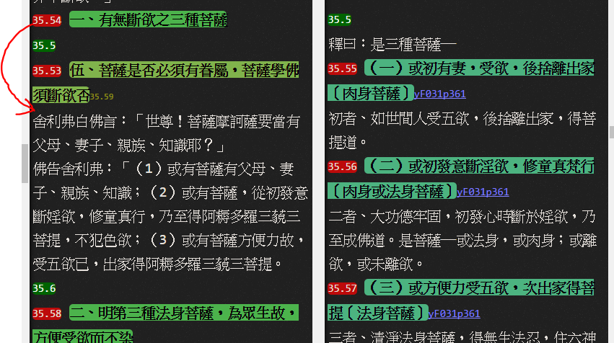

【YAP：經35.54位置錯誤，應該移到經35.53之下才對！】

35.54=35.55

35.54=35.56

35.54=35.57

35.58=35.59

35.58=35.60

35.58=35.61

35.58=35.62

35.58=35.63

35.58=35.64

35.58=35.65

35.58=35.66

35.67=35.68

35.67=35.69

35.67=35.70

35.67=35.71

35.67=35.72

35.67=35.73

35.67=35.74

35.67=35.75

35.67=35.76

35.67=35.77

35.67=35.78

35.67=35.79

35.67=35.80

35.67=35.81

35.67=35.82

35.67=35.83

35.67=35.84

35.67=35.85

35.67=35.86

35.67=35.87

35.67=35.88

35.67=35.89

35.67=35.90

35.67=35.91

35.67=35.92

35.67=35.93

35.67=35.94

35.67=35.95

35.67=35.96

35.67=35.97

35.67=35.98

35.67=35.99

35.67=35.100

36.0=36.1【卷35習相應品(3)】

36.0=36.2

36.0=36.3

36.0=36.4

36.0=36.5

36.0=36.6

36.0=36.7

36.0=36.8

36.0=36.9

36.0=36.10

36.0=36.11

36.0=36.12

36.0=36.13

36.0=36.14

36.0=36.15

36.0=36.16

36.0=36.17

36.0=36.18

36.0=36.19

36.0=36.20

36.0=36.21

36.0=36.22

36.0=36.23

36.0=36.24

36.25=36.28

36.26=36.28

36.27=36.28

36.27=36.29

36.27=36.30

36.27=36.31

36.27=36.32

36.27=36.33

36.27=36.34

36.27=36.35

36.27=36.36

36.27=36.37

36.27=36.38

36.27=36.39

36.27=36.40

36.27=36.41

36.27=36.42

36.27=36.43

36.27=36.44

36.27=36.45

36.27=36.46

36.27=36.47

36.48=36.49

36.48=36.50

36.51=36.53

36.52=36.53

36.52=36.54

36.55=36.57

36.56=36.57

36.56=36.58

36.56=36.59

36.56=36.60

36.56=36.61

36.56=36.62

36.56=36.63

36.56=36.64

36.56=36.65

36.56=36.66

36.56=36.67

36.56=36.68

36.56=36.69

36.56=36.70

36.56=36.71

36.56=36.72

36.56=36.73

36.56=36.74

36.56=36.75

36.56=36.76

36.56=36.77

36.56=36.78

36.56=36.79

36.80=36.82

36.81=36.82

36.81=36.83

36.81=36.84

36.81=36.85

36.81=36.86

36.81=36.87

36.81=36.88

36.81=36.89

36.81=36.90

36.81=36.91

36.81=36.92

36.81=36.93

36.81=36.94

36.81=36.95

36.81=36.96

36.81=36.97

36.81=36.98

36.81=36.99

36.81=36.100

36.81=36.101

36.81=36.102

36.103=36.104

36.103=36.105

36.103=36.106

36.107=^35.15

36.109=^35.16【缺36.108】

36.110=^35.16

36.111=^35.17

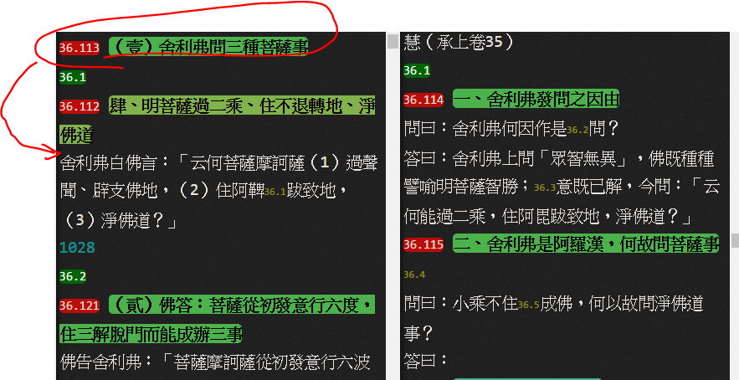

【YAP：36.113應該移到36.112下面才對！】

36.112=36.114

36.113=36.114

36.113=36.115

36.113=36.116

36.113=36.117

36.113=36.118

36.113=36.119

36.113=36.120

36.121=36.122

36.121=36.123

36.121=36.124

36.121=36.125

36.121=36.126

36.121=36.127

36.121=36.128

36.121=36.129

36.121=36.130

36.121=36.131

36.132=^36.3

36.133=^36.3

36.134=^36.4

36.135=^36.4

36.136=^36.5

36.136=36.137

36.136=36.138

36.136=36.139

36.136=36.140

36.141=36.142

36.141=36.143

36.141=36.144

36.141=36.145

36.141=36.146

36.147=36.148

36.147=36.149

36.147=36.150

36.147=36.151

36.147=36.152

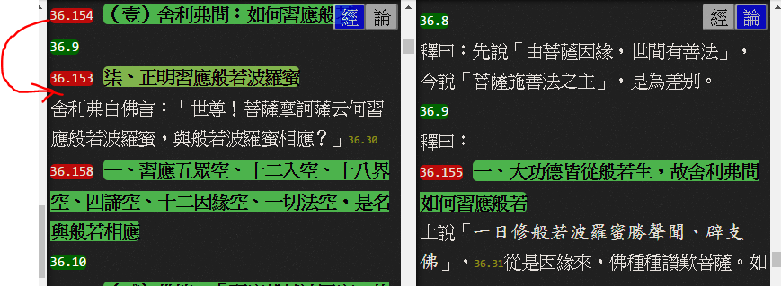

【YAP:經之36.154應該移到36.153之下才對！】

36.153=36.155

36.154=36.155

36.154=36.156

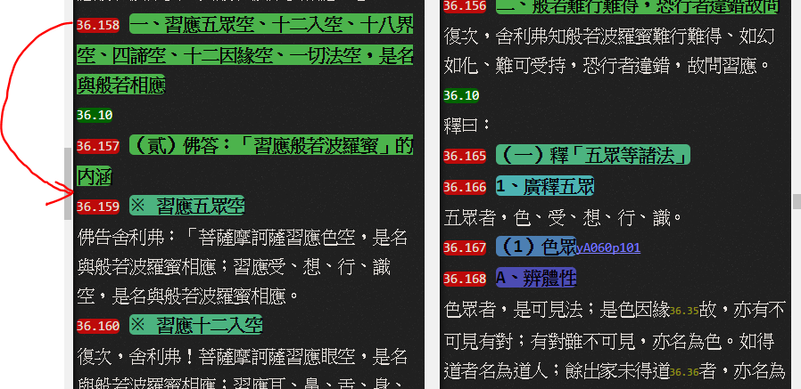

【YAP:經之36.158應該移到36.157之下才對！】

36.158=36.165

36.159=36.165~227

36.159=36.250~263

36.160=36.249

36.161=36.249

36.162=36.249

36.163=36.249

36.164=36.249

36.264=36.266

36.265=36.266

36.265=36.267

36.265=36.268

36.265=36.269

36.265=36.270

36.265=36.271

36.265=36.272

36.265=36.273

36.265=36.274

36.265=36.275

36.265=36.276

36.265=36.277

36.265=36.278

36.265=36.279

36.265=36.280

36.265=36.281

36.265=36.282

36.265=36.283

36.265=36.284

36.265=36.285

36.265=36.286

36.265=36.287

36.288=36.289

36.288=36.290

36.288=36.291

36.288=36.292

36.288=36.293

36.288=36.294

36.288=36.295

36.288=36.296

36.288=36.297

36.298=^36.15

36.299=^36.16

^36.17=36.300

^36.17=36.301

^36.17=36.302

36.303=36.304

36.303=36.305

36.303=36.306

36.303=36.307

36.303=36.308

36.303=36.309

36.303=36.310

36.303=36.311

36.303=36.312

36.303=36.313

36.303=36.314

36.303=36.315

36.303=36.316

36.303=36.317

36.303=36.318

36.303=36.319

36.303=36.320

36.303=36.321

36.303=36.322

36.303=36.323

36.303=36.324

36.325=36.326

36.325=36.327

36.325=36.328

36.325=36.329

36.325=36.330

36.325=36.331

36.325=36.332

36.325=36.333

36.334=36.337

36.335=36.337

36.336=36.337

36.336=36.338

36.336=36.339

36.336=36.340

36.341=36.342

36.341=36.343

36.341=36.344

36.341=36.345

36.347=36.349

36.348=36.349

36.348=36.350

36.348=36.351

36.348=36.352

36.348=36.353

36.348=36.354

36.348=36.355

36.348=36.356

36.348=36.357

36.348=36.358

36.348=36.359

36.348=36.360

36.348=36.361

36.348=36.362

36.348=36.363

36.364=36.365

36.364=36.366

36.367=36.368

36.367=36.369

36.367=36.370

36.367=36.371

36.367=36.372

36.367=36.373

36.367=36.374

36.375=36.376

36.367=36.377

36.367=36.378

36.379=36.381

36.380=36.381

36.380=36.382

36.380=36.383

36.380=36.384

36.380=36.385

36.380=36.386

36.380=36.387

36.380=36.388

36.380=36.389

36.390=36.393

36.391=36.393

36.391=36.394

36.391=36.395

36.391=36.396

36.391=36.397

36.391=36.398

36.391=36.399

36.391=36.400

36.391=36.401

36.391=36.402

36.391=36.403

36.391=36.404

36.391=36.405

36.391=36.406

36.391=36.407

36.391=36.408

36.391=36.409

36.392=36.410

36.392=36.411

36.392=36.412

36.392=36.413

36.414=36.416

36.415=36.416

36.415=36.417

36.415=36.418

36.419=36.420

36.419=36.421

36.419=36.422

36.419=36.423

36.419=36.424

36.419=36.425

36.426=36.427

36.426=36.428

36.426=36.429

36.426=36.430

36.426=36.431

36.426=36.432

36.426=36.433

36.426=36.434

36.435=36.437

36.436=36.437

36.436=36.438

36.436=36.439

36.436=36.440

36.436=36.441

36.436=36.442

36.436=36.443

36.436=36.444

36.436=36.445

36.436=36.446

36.436=36.447

36.436=36.448

36.436=36.449

36.436=36.450

36.436=36.451

36.436=36.452

36.436=36.453

36.436=36.454

36.436=36.455

36.436=36.456

36.436=36.457

36.436=36.458

36.436=36.459

36.436=36.460

36.436=36.461

36.436=36.462

36.436=36.463

36.436=36.464

36.436=36.465

36.436=36.466

36.436=36.467

36.468=36.469

36.468=36.470

36.468=36.471

36.468=36.472

36.468=36.473

36.468=36.474

36.468=36.475

36.468=36.476

36.468=36.477

36.468=36.478

36.468=36.479

36.468=36.480

36.481=36.483

36.482=36.483

36.482=36.484

36.482=36.485

36.482=36.486

36.482=36.487

36.482=36.488

36.482=36.489

36.482=36.490

36.482=36.491

36.482=36.492

36.482=36.493

36.482=36.494

36.482=36.495

36.482=36.496

36.482=36.497

36.482=36.498

36.499=36.500

36.499=36.501

36.499=36.502

36.499=36.503

36.499=36.504

36.499=36.505

36.506=36.507

36.506=36.508

36.509=36.510

36.509=36.511

36.512=36.513

36.512=36.514

36.515=^37.17

36.516=36.517

36.516=36.518

36.516=36.519

36.516=36.520

36.516=36.521

36.516=36.522

36.516=36.523

36.516=36.524

36.516=36.525

36.516=36.526

36.516=36.527

36.516=36.528

36.529=36.532

36.530=36.532

36.530=36.533

36.530=36.534

36.530=36.535

36.530=36.536

36.530=36.537

36.530=36.538

36.530=36.539

36.530=36.540

36.530=36.541

36.530=36.542

36.530=36.543

36.530=36.544

36.530=36.545

36.530=36.546

36.530=36.547

36.530=36.548

36.530=36.549

36.530=36.550

36.530=36.551

36.530=36.552

36.530=36.553

36.530=36.554

36.530=36.555

36.530=36.556

36.530=36.557

36.530=36.558

36.530=36.559

36.530=36.560

36.530=36.561

36.530=36.562

36.530=36.563

36.530=36.564

36.530=36.565

36.530=36.566

36.530=36.567

36.530=36.568

36.531=36.569

36.531=36.570

36.531=36.571

36.531=36.572

36.531=36.573

36.531=36.574

36.531=36.575

37.0=37.4【卷38往生品(4)】

37.0=37.5

37.0=37.6

37.0=37.7

37.0=37.8

37.0-37.9

37.0-37.10

37.0-37.11

37.0-37.12

37.0-37.13

37.0=37.14

37.0=37.15

37.0=37.16

37.0=37.17

37.0=37.18

37.0=37.19

37.1=37.20

37.1=37.21

37.2=37.22

37.3=37.23

37.3=37.24

37.3=37.25

37.26=37.31

37.26=37.32

37.26=37.33

37.26=37.34

37.26=37.35

37.26=37.36

37.26=37.37

37.26=37.38

37.26=37.39

37.26=37.40

37.26=37.41

37.26=37.42

37.26=37.43

37.26=37.44

37.26=37.45

37.26=37.46

37.26=37.47

37.26=37.48

37.26=37.49

37.26=37.50

37.27=37.51

37.27=37.52

37.27=37.53

37.27=37.54

37.27=37.55

37.27=37.56

37.27=37.57

37.28=37.58

37.28=37.59

37.28=37.60

37.28=37.61

37.28=37.62

37.28=37.63

37.28=37.64

37.28=37.65

37.28=37.66

37.28=37.67

37.28=37.68

37.28=37.69

37.28=37.70

37.28=37.71

37.28=37.72

37.28=37.73

37.28=37.74

37.28=37.75

37.28=37.76

37.28=37.77

37.29=37.78

37.29=37.79

37.29=37.80

37.29=37.81

37.29=37.82

37.29=37.83

37.30=37.84

37.30=37.85

37.30=37.86

37.30=37.87

37.30=37.88

37.30=37.89

37.30=37.90

37.30=37.91

37.30=37.92

37.30=37.93

37.30=37.94

37.30=37.95

37.30=37.96

37.97=37.98

37.97=37.99

37.97=37.100

37.97=37.101

37.97=37.102

37.97=37.103

37.97=37.104

37.97=37.105

37.97=37.106

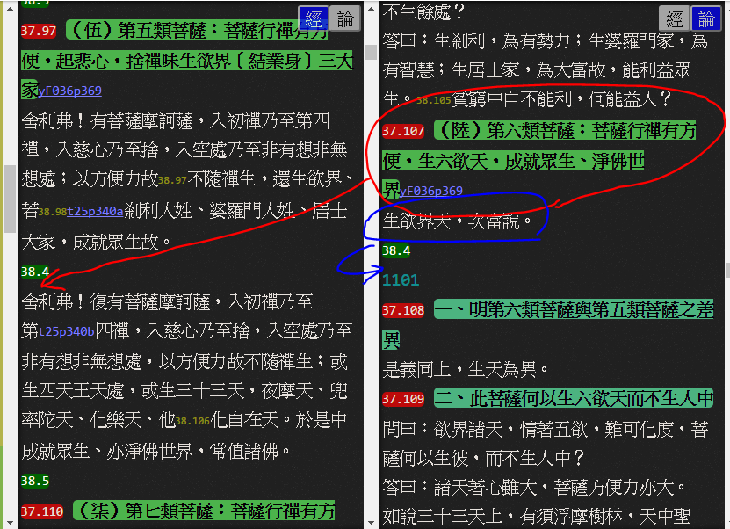

【YAP:論37.107應移至經38.4節點之下】

【YAP:論「生欲界天，次當說」這幾個字應移至論38.4節點之下】

厚觀案：

如依目前節點經論對照的話應作：「^38.4=37.107~109」

如「論37.107」移至經38.4節點之下，則經論對應序號會改變！？？

^38.4=37.107~109【暫訂】

37.110=37.111

37.110=37.112

37.110=37.113

37.114=37.117

37.115=37.117

37.115=37.118

37.115=37.119

37.115=37.120

37.115=37.121

37.115=37.122

37.115=37.123

37.115=37.124

37.115=37.125

37.115=37.126

37.115=37.127

37.115=37.128

37.115=37.129

37.115=37.130

37.115=37.131

37.115=37.132

37.115=37.133

37.115=37.134

37.115=37.135

37.116=37.136

37.116=37.137

37.116=37.138

37.116=37.139

37.116=37.140

37.116=37.141

37.116=37.142

37.116=37.143

37.116=37.144

37.116=37.145

37.116=37.146

37.116=37.147

37.116=37.148

37.149=37.153

37.149=37.154

37.150=37.153

37.150=37.154

37.151=37.153

37.151=37.154

37.152=37.153

37.152=37.154

37.155=37.156

37.155=37.157

37.155=37.158

37.155=37.159

37.155=37.160

37.155=37.161

37.155=37.162

37.163=37.166

37.163=37.167

37.163=37.168

37.163=37.169

37.163=37.170

37.163=37.171

37.163=37.172

37.163=37.173

37.163=37.174

37.164=37.175

37.177=37.178【卷39往生品】

37.177=37.179

37.177=37.180

37.177=37.181

37.177=37.182

37.177=37.183

37.177=37.184

37.185=37.186

37.185=37.187

37.185=37.188

37.185=37.189

37.185=37.190

37.185=37.191

37.192=37.194

37.192=37.195

37.192=37.196

37.198=^39.5

37.199=37.200

37.199=37.201

37.202=^39.7

37.203=^39.8

37.204=37.205

37.204=37.206

37.204=37.207

37.204=37.208

37.204=37.209

37.204=37.210

37.204=37.211

37.204=37.212

37.204=37.213

37.214=37.215

37.214=37.216

37.214=37.217

37.214=37.218

37.219=37.220

37.219=37.221

37.219=37.222

37.219=37.223

37.219=37.224

37.225=37.226

37.225=37.227

37.228=37.229

37.228=37.230

37.228=37.231

37.228=37.232

37.228=37.233

37.234=37.235

37.234=37.236

37.237=37.238

37.237=37.239

37.237=37.240

37.237=37.241

37.237=37.242

37.237=37.243

37.244=37.246

37.245=37.246

37.245=37.247

37.245=37.248

37.245=37.249

37.245=37.250

37.245=37.251

37.245=37.252

37.245=37.253

37.254=37.256

37.255=37.256

37.255=37.257

37.255=37.258

37.259=37.260

37.259=37.261

37.259=37.262

37.259=37.263

37.259=37.264

37.259=37.265

37.259=37.266

37.259=37.267

37.259=37.268

37.259=37.269

37.259=37.270

37.259=37.271

37.272=37.272

37.272=37.273

37.272=37.274

37.272=37.275

37.272=37.276

37.272=37.278

37.272=37.279

37.272=37.280

37.272=37.281

37.272=37.282

37.283=^39.22

37.284=^39.23

37.285=^39.23

37.286=37.288

37.287=37.289

37.287=37.290

37.287=37.291

37.287=37.292

37.293=37.297

37.294=37.297

37.295=37.298

37.296=37.299

37.296=37.300

37.296=37.301

37.296=37.302

37.296=37.303

37.296=37.304

37.296=37.305

37.296=37.306

37.296=37.307

37.296=37.308

37.296=37.309

37.296=37.310

37.296=37.311

37.296=37.312

37.296=37.313

37.296=37.314

37.296=37.315

37.296=37.316

37.296=37.317

37.296=37.318

37.319=37.320

37.319=37.321

37.319=37.322

37.319=37.323

37.319=37.324

37.319=37.325

37.319=37.326

37.327=37.328

37.327=37.329

37.327=37.330

37.327=37.331

37.327=37.332

37.327=37.333

37.327=37.334

37.327=37.335

37.327=37.336

37.327=37.337

37.327=37.338

37.327=37.339

37.327=37.340

37.327=37.341

37.327=37.342

37.327=37.343

37.327=37.344

37.327=37.345

37.327=37.346

37.327=37.347

37.327=37.348

37.327=37.349

37.327=37.350

37.327=37.351

37.327=37.352

37.327=37.353

37.327=37.354

37.327=37.355

37.327=37.356

37.327=37.357

37.327=37.358

37.361=37.364

37.361=37.365

37.361=37.366

37.361=37.367

37.361=37.368

37.361=37.369

37.361=37.370

37.361=37.371

37.361=37.372

37.361=37.373

37.361=37.374

37.361=37.375

37.361=37.376

37.361=37.377

37.361=37.378

37.359=37.364

37.360=37.365

37.360=37.366

37.360=37.367

37.360=37.368

37.360=37.369

37.360=37.370

37.360=37.371

37.360=37.372

37.360=37.373

37.360=37.374

37.360=37.375

37.360=37.376

37.361=37.377

37.362=37.378

37.363=37.379

37.363=37.380

37.363=37.381

37.363=37.382

37.363=37.383

37.363=37.384

37.363=37.385

37.363=37.386

37.363=37.387

37.363=37.388

37.363=37.389

37.363=37.390

37.363=37.391

37.363=37.392

37.393=37.395

37.394=37.395

37.394=37.395

37.394=37.396

37.394=37.397

37.394=37.398

37.394=37.399

37.394=37.400

37.394=37.401

37.394=37.402

37.394=37.403

37.394=37.404

37.394=37.405

37.394=37.406

37.394=37.407

37.394=37.408

37.394=37.409

37.394=37.410

37.394=37.411

37.394=37.412

37.394=37.413

37.394=37.414

37.394=37.415

37.394=37.416

37.394=37.417

37.394=37.418

37.419=37.427

37.420=37.427

37.420=37.428

37.420=37.429

37.420=37.430

37.420=37.431

37.420=37.432

37.420=37.433

37.420=37.434

37.420=37.435

37.420=37.436

37.420=37.437

37.420=37.438

37.420=37.439

37.420=37.440

37.420=37.441

37.421=37.442

37.422=37.442

37.423=37.442

37.424=37.442

37.425=37.442

37.426-37.443

37.444=37.454

37.445=37.455

37.446=37.455~459

37.447=37.460

37.448=37.460

37.449=37.460

37.450=37.460

37.451=37.460

37.452=37.461

37.453=37.462

37.463=^40.5

37.463=37.464

37.463=37.465

37.463=37.466

37.463=37.467

37.463=37.468

37.463=37.469

37.463=37.470

37.463=37.471

37.463=37.472

37.463=37.473

37.463=37.474

37.475=37.478

37.476=37.478

37.476=37.479

37.476=37.480

37.476=37.481

37.476=37.482

37.476=37.483

37.476=37.484

37.476=37.485

37.476=37.486

37.476=37.487

37.476=37.488

37.476=37.489

37.476=37.490

37.477=37.491

37.477=37.492

37.477=37.493

37.477=37.494

37.477=37.495

38.0=38.11【卷40歎度品(5)】

38.1=38.12

38.2=38.13

38.2=38.14

38.2=38.15

38.2=38.16

38.2=38.17

38.2=38.18

38.3=38.19

38.3=38.20

38.4=38.21

38.5=38.21

38.6=38.22

38.7=38.23

38.8=38.24

38.9=38.25

38.10=38.26

38.10=38.27

38.10=38.28

38.10=38.29

38.10=38.30

38.10=38.31

38.10=38.32

38.10=38.33

38.10=38.34

38.10=38.35

38.10=38.36

38.10=38.37

39.0=39.12【卷40舌相品(6)】

39.1=39.13

39.1=39.14

39.1=39.15

39.2=39.13

39.3=39.13

39.4=39.13

39.5=39.13

39.6=39.13

39.7=39.13

39.8=39.13

39.9=39.13

39.10=39.16

39.11=39.17

39.11=39.18

39.11=39.19【卷40止】