Line Follow Robot

# Overview:

A Line Following Robot is an autonomous robot designed to detect and follow a pre-defined path, typically marked by a line (black or white) on the floor, using infrared (IR) or optical sensors to guide its movement. The robot continuously adjusts its position by processing sensor data and making real-time corrections to stay on the path. It can be used in industrial automation, transportation systems, and robotic competitions. The robot's ability to follow curves and navigate intersections depends on the complexity of the control algorithm and sensor accuracy.

**Objectives:**

# *Understanding Sensor Technology – Learn how IR and optical sensors work and how to use them for detecting lines and guiding the robot.*

# *Programming and Control Systems – Develop skills in writing control algorithms to process sensor input and adjust the robot’s movement in real-time.*

# *Microcontroller Integration – Gain hands-on experience in programming and interfacing microcontrollers (like Arduino) with sensors and motors.*

# *Motor Control and Navigation – Learn how to control motors for precise movement, including turning and adjusting speed based on sensor feedback.*

# Components Required:

## Arduino Uno:

### Arduino Uno is an 8-bit ATmega328P microcontroller. To support the microcontroller, it uses components such as a crystal oscillator, serial communication, voltage regulator, etc. It has 14 digital I/O pins (6 pins can be used as PWM pins). It has six separate analog input pins, a USB connection, a power barrel jack, an ICSP header, and a reset button.

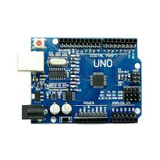

## Infrared Sensor

### An infrared sensor emits light to detect certain surroundings. In the infrared spectrum, all the objects radiate some form of thermal radiation that is invisible to our eyes, but an IR sensor can detect these radiations.

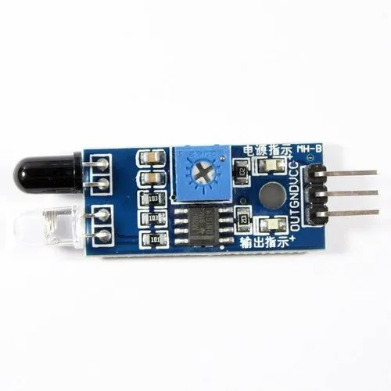

## L298N Motor Driver

### L298N is one of the easiest and best ways to control DC motors. It is the two-channel motor driver that can control the speed and spinning direction of DC motors.

### This L298N motor driver is a high-power motor driver module. It is used for driving DC and stepper motors. This motor driver consists of an L298N motor driver IC and a 78M05 5V voltage regulator, resistors, capacitor, power LED, and 5V jumper in an integrated circuit.

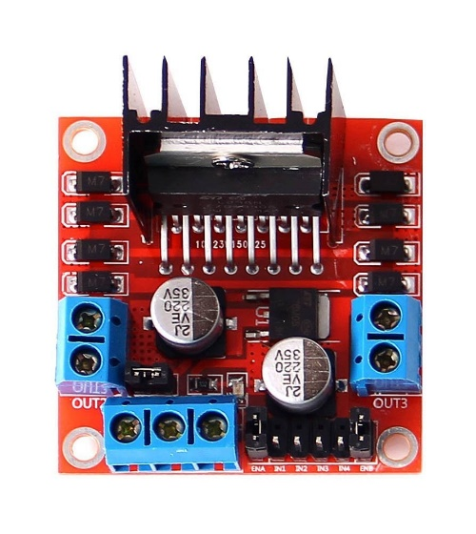

## BO Motors

A BO motor is known as a battery-operated motor. These motors are commonly used in hobby-grade projects where the user requires a small DC motor as a simple actuator.

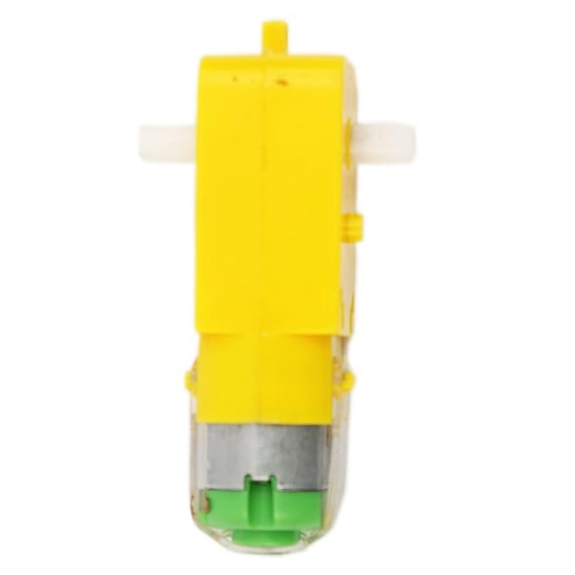

**Images:**

