I used the cellular decomposition approach to solve the problem.
The cellular decomposition approach has a drawback that the paths won’t look smooth. This is because of the round off errors. Each time we calculate the next possible state of position and orientation using the discretized non-holonomic constraints, we get a decimal value which needs to be rounded off for simulation purposes.

I developed the following algorithm for solving the problem:

- Define start and goal points;
- Initialize DISTANCE list to infinity;
- Assign DISTANCE of start points to zero;
- Predicted distance from current node to end = Euclidian_distance(start, end);
- Push the start point into a priority queue with priority = DISTANCE[start] + Euclidian_distance(start, goal);
- Control Variables = (ua, ub);
- Discretize ua and ub into a set of values;
- while(priority queue is not empty):
- pop the top most element;
- Identify the current position and heading;
- Initialize an empty list of possible_states;
- for all combinations of ua and ub:
- Calculate the next position and heading based on the kinematic equations;
- if (vehicle is collision free for the calculated position and heading):
push the state into possible_states;
- for all states in possible_states:
- if (DISTANCE[state] > DISTANCE[current_state] + Euclidian_dist(current_state, state):
- DISTANCE[state] = DISTANCE[current_state] + Euclidian_dist(current_state, state);
- push the state into the priority queue with priority = DISTANCE[state] + Euclidian_dist(state, end);
- if (end point is reached):
- Trace Path;
- return True;
- else:
- return False;

The following are the path plots and simulation snapshots from start to goal points for various robots:

- DiWheel Path :

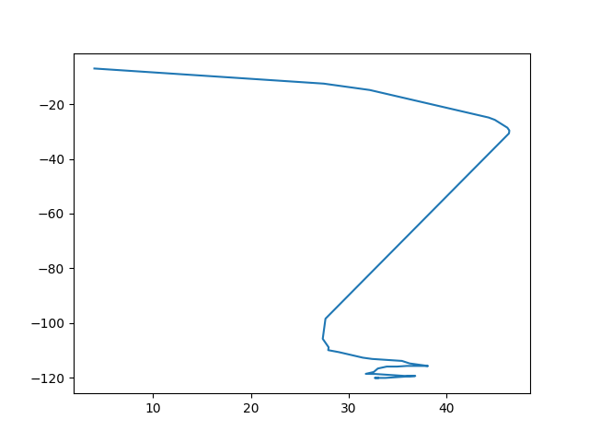
The following are the snapshots of the simulation:

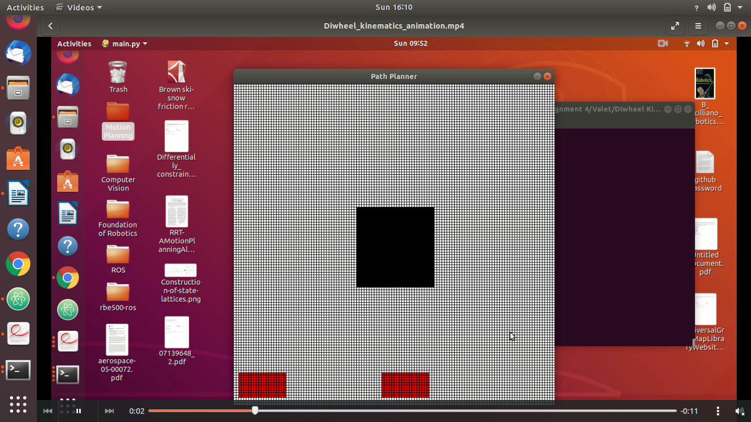

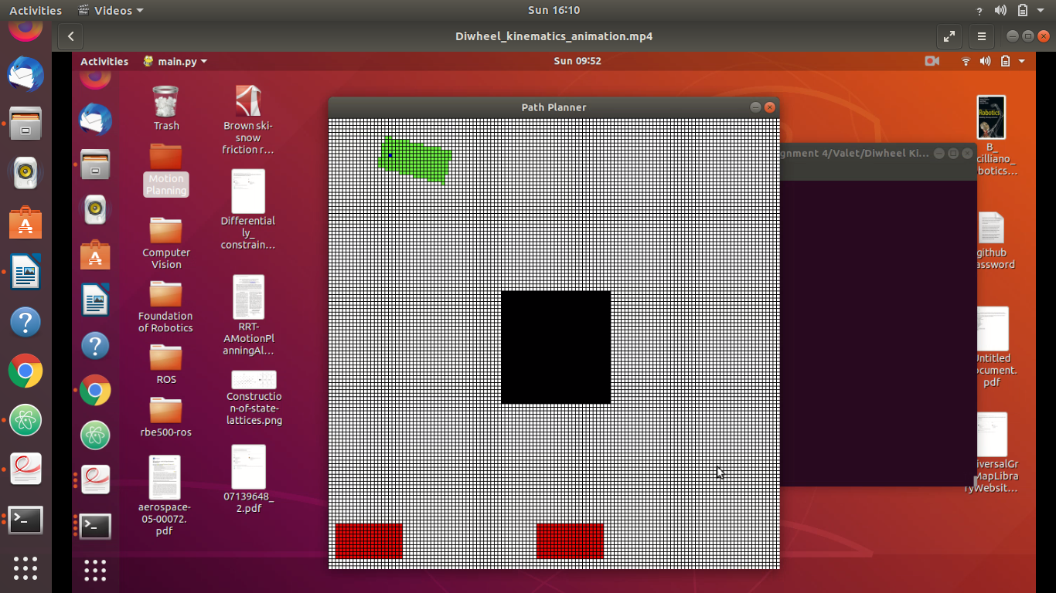

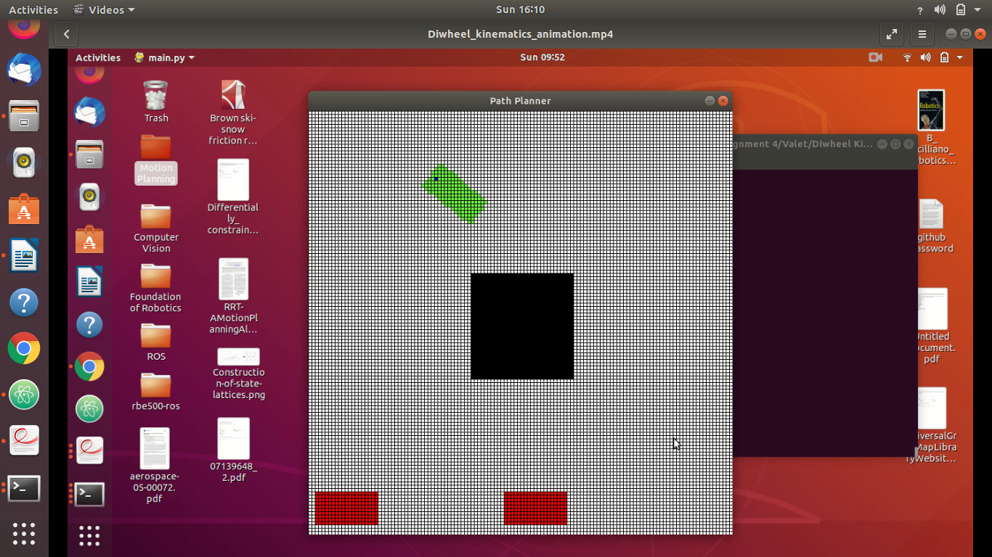
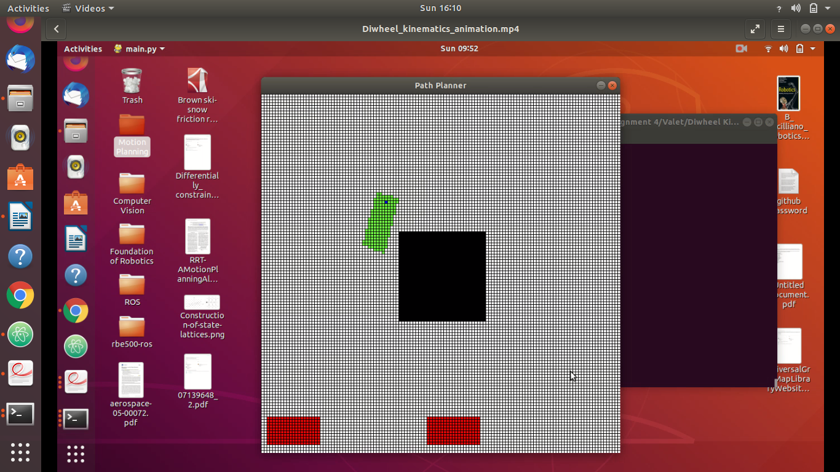

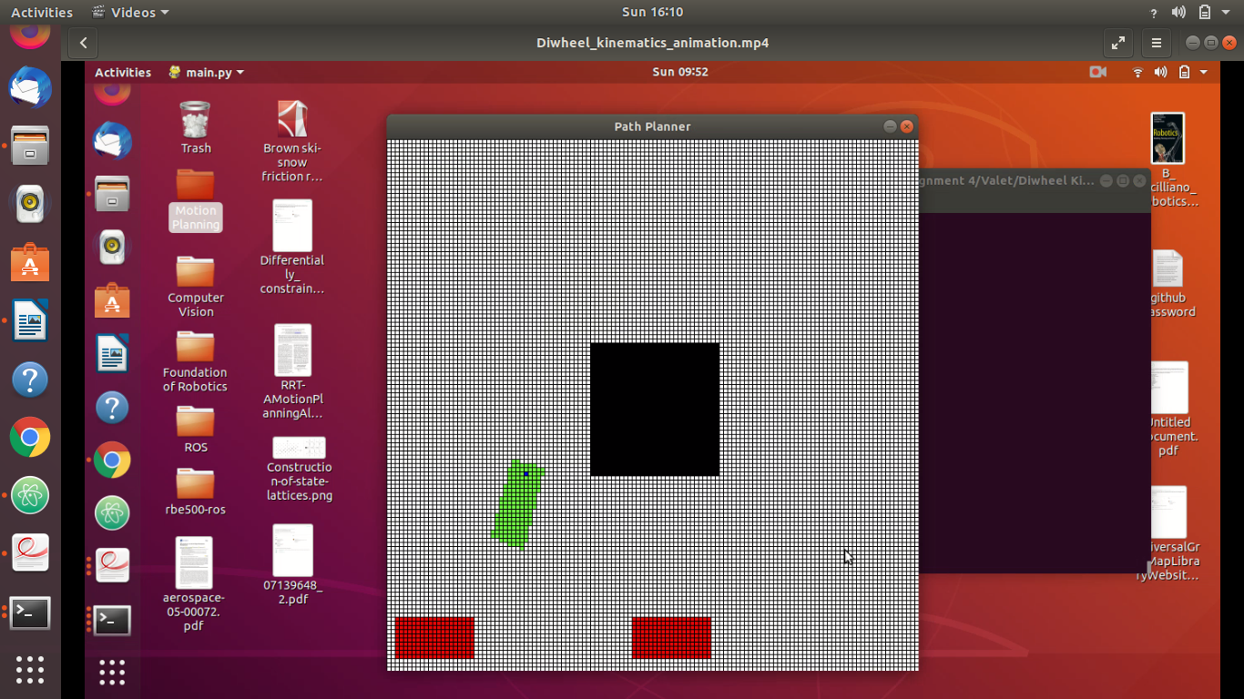

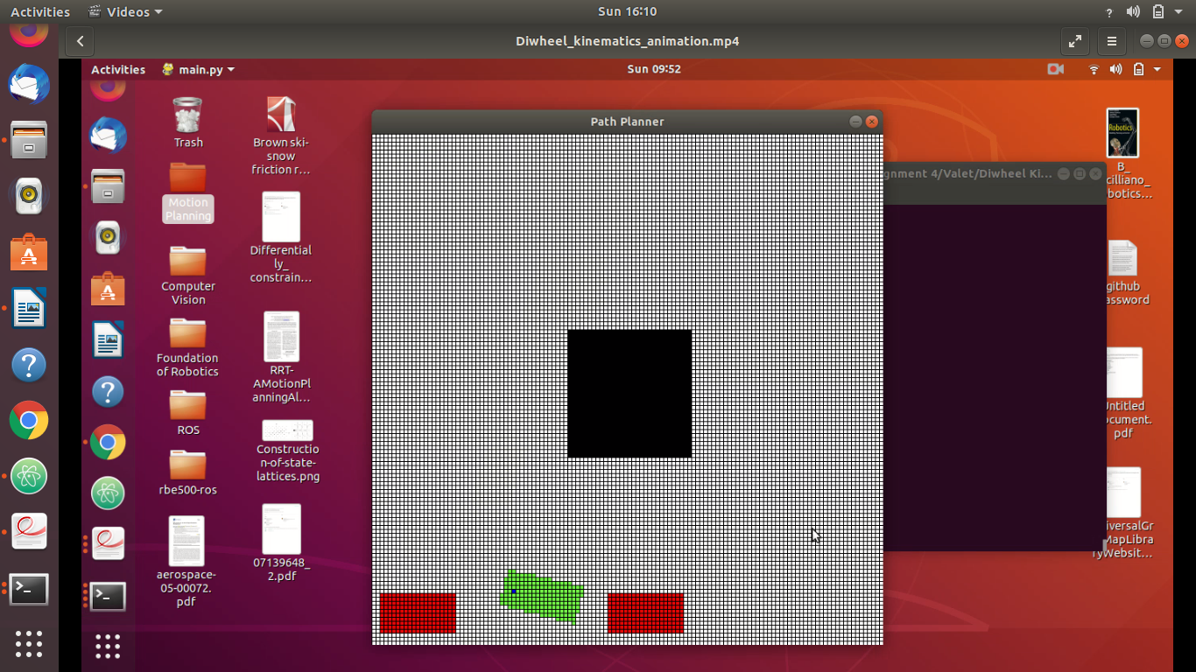
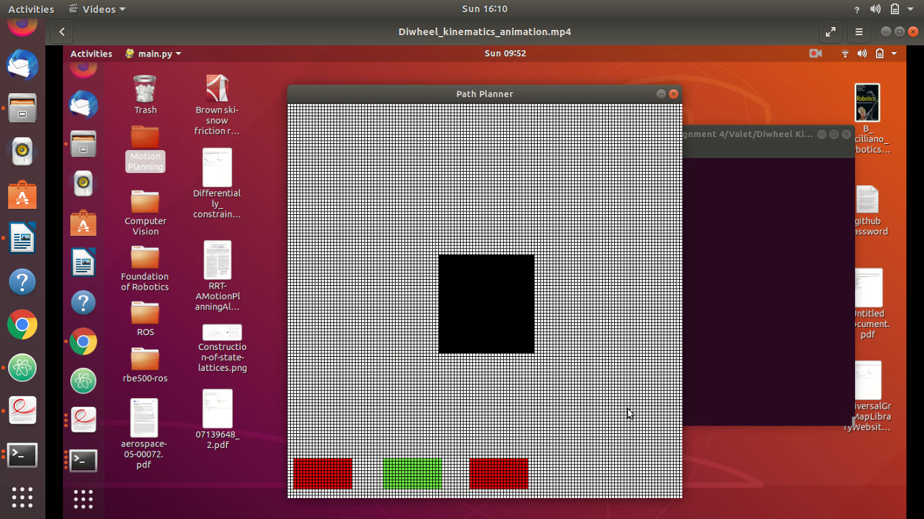

- Akerman Path Depection:
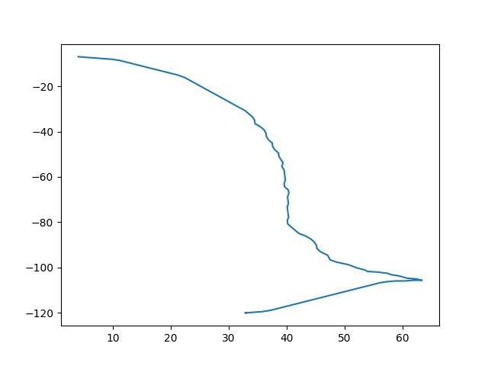

The following are the snapshots of the simulation:

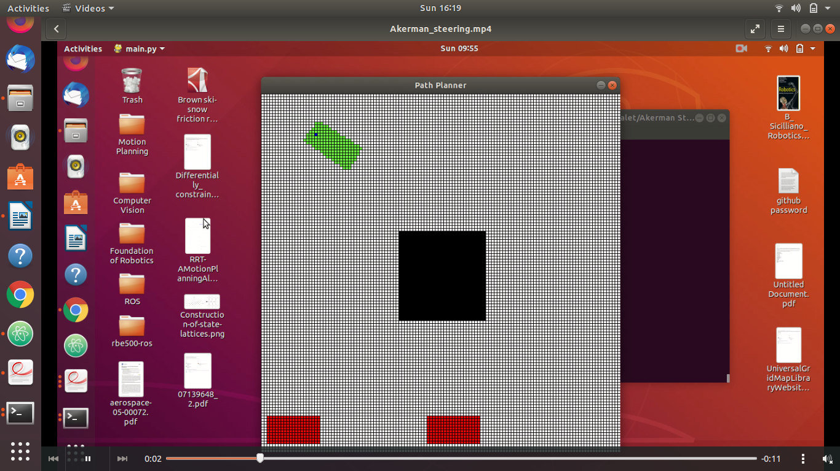

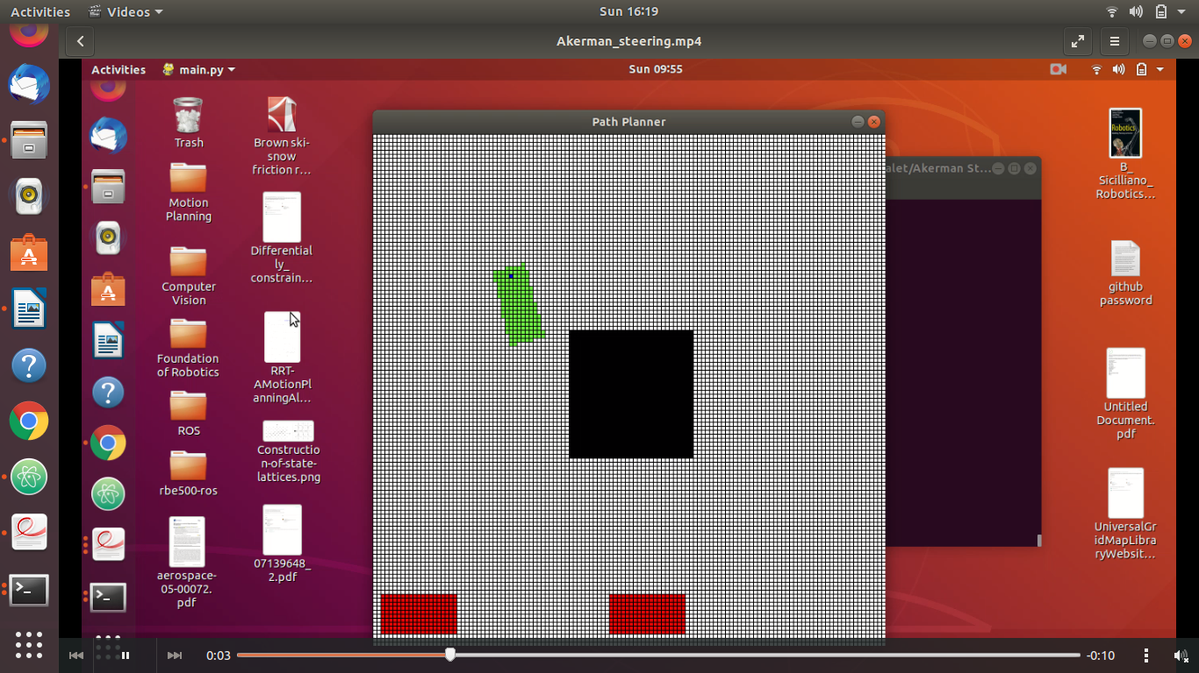

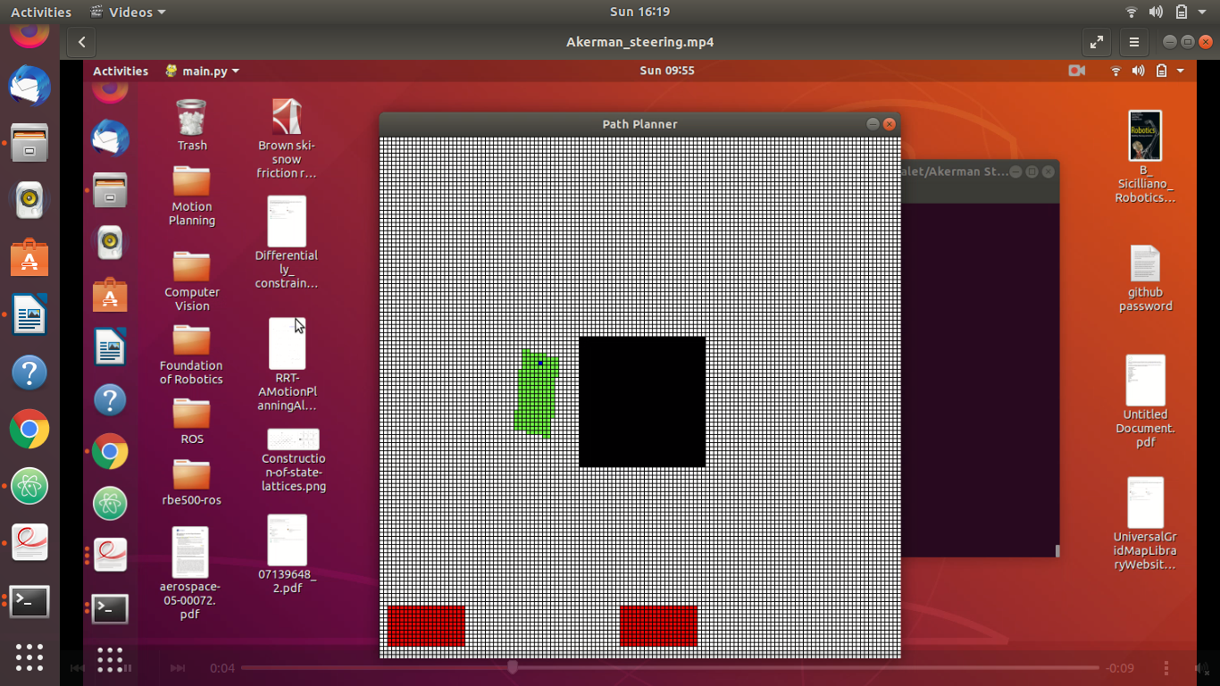

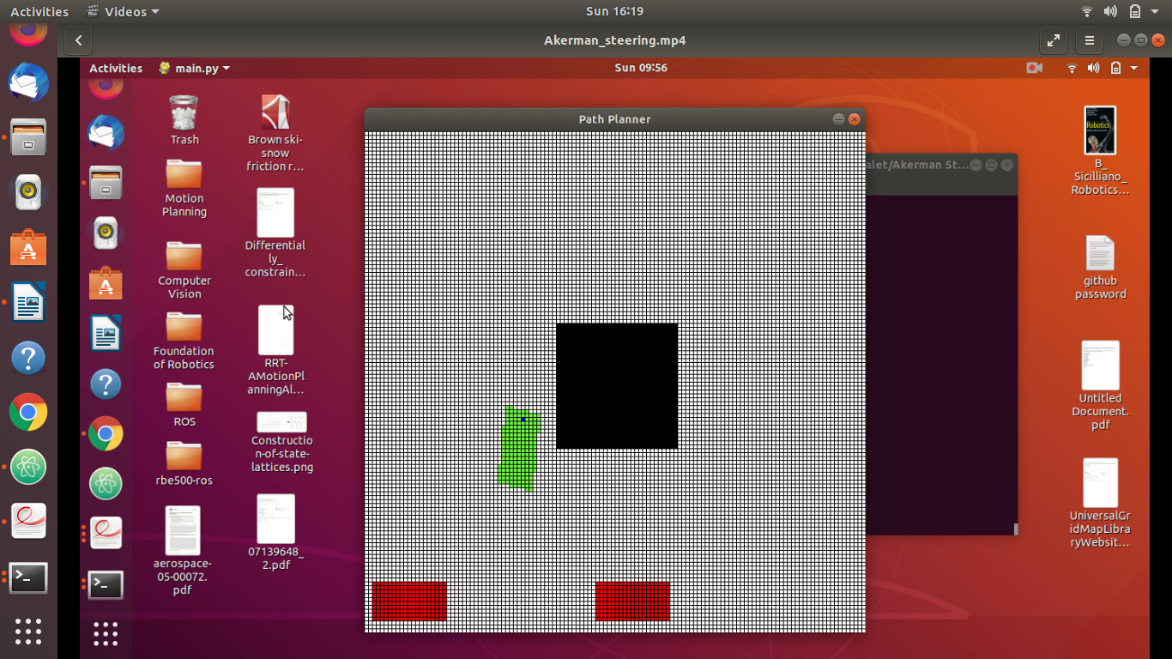
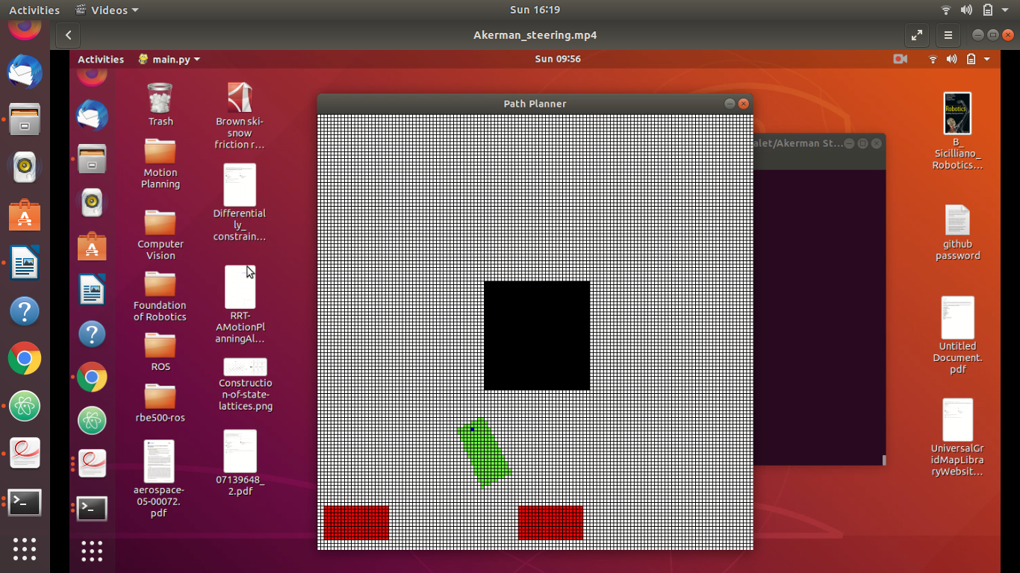

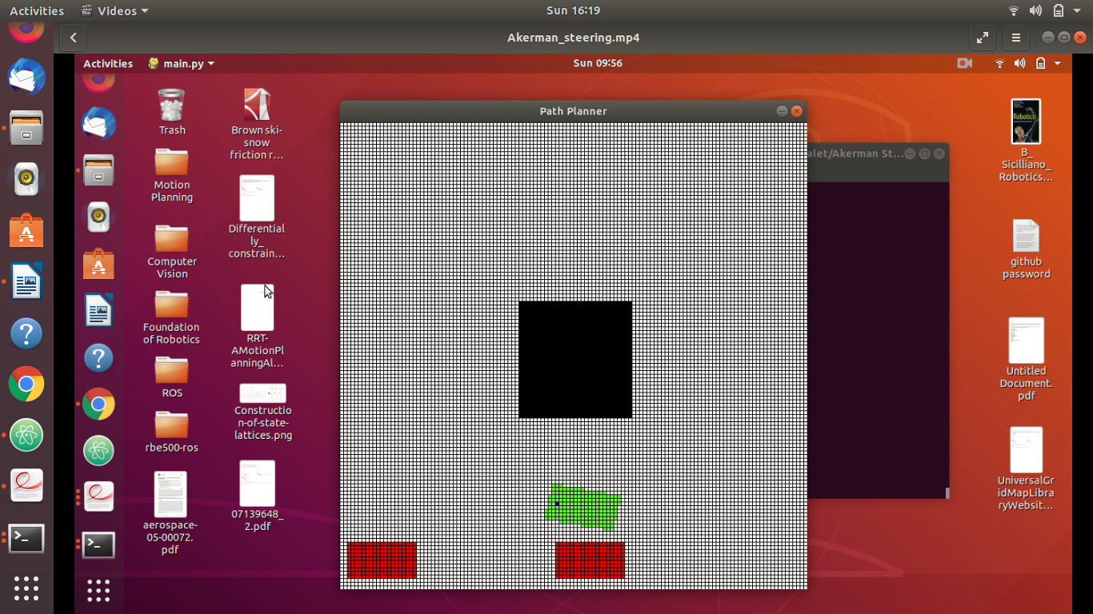
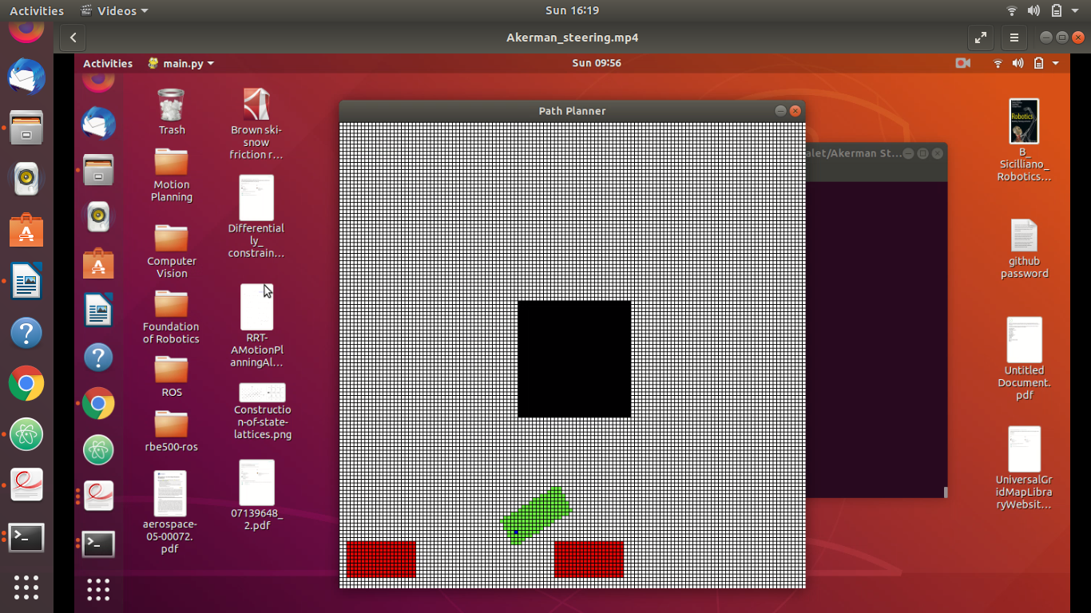

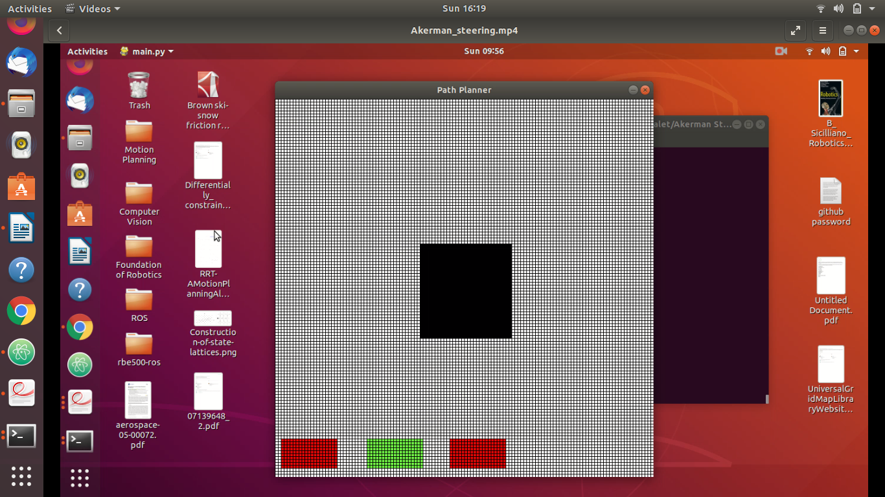
- Car Pulling Trailer Path Depection:

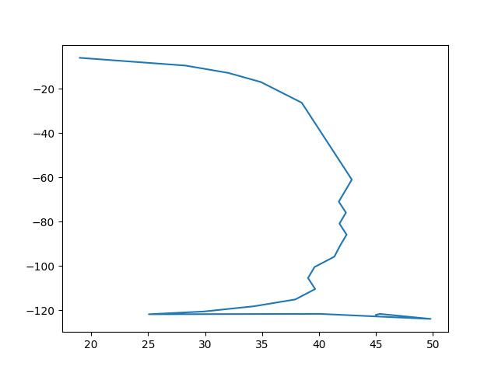
The following are the snapshots of the simulation:



