##### **Project report**

##### **on**

**Tutor Quest**

A Dissertation submitted in partial fulfillment of the academic requirements for the award of the degree.

**Bachelor of Technology**

**In**

**Computer Science & Engineering**

Submitted by

**D. Sai Teja**

(19H51A05F6)

**G. Sushma**

(19H51A05F7)

**G. Pranay Kumar**

(19H51A05F8)

Under the esteemed guidance of

B. Pavan

Assistant Professor



**Department of Computer Science & Engineering**

**CMR College of Engineering & Technology**

(An Autonomous Institution under UGC & JNTUH, Approved by AICTE, Permanently Affiliated to JNTUH, Accredited by NBA.)

KANDLAKOYA, MEDCHAL ROAD, HYDERABAD - 501401.

**2019 - 2023**

**CMR COLLEGE OF ENGINEERING & TECHNOLOGY**

KANDLAKOYA, MEDCHAL ROAD, HYDERABAD – 501401

**DEPARTMENT OF COMPUTER SCIENCE AND ENGINEERING**



**CERTIFICATE**

This is to certify that the Mini Project-1 report entitled **"Tutor Quest"**, being submitted by D. Sai Teja (19H51A05F6), G. Sushma (19H51A05F7), G. Pranay Kumar (19H51A05F8)in partial fulfillment for the award of **Bachelor of Technology** in Computer Science and Engineering is a record of bonafide work carried out his/her under his guidance and supervision.

###### The results embodies in this project report have not been submitted to any other University or Institute for the award of any Degree.

**B. Pavan Dr. K Vijaya Kumar**

**Assistant Professor Professor and HOD**

**Dept. of CSE Dept. of CSE**

Submitted for viva voce Examination held on _________

**External Examiner**

**TABLE OF CONTENTS**

|  |  |  |  |  |
| --- | --- | --- | --- | --- |
| **CHAPTER**  **NO.** |  |  | **TITLE** | **PAGE NO.** |
|  | **LIST OF FIGURES** | | | i |
|  | **ABSTRACT** | |  | ii |
| **1** | **INTRODUCTION** | | | 1 |
|  | 1.1 | Aim | | 2 |
|  | 1.2 | Objective | | 2 |
| **2** | **BACKGROUND WORK** | | | 3 |
|  | 2.1 | Existing Systems | | 4 |
| **3** | **PROPOSED SYSTEM**  3.1 Approach  3.2 Hardware Requirements  3.3 Software Requirements | | | 5  5  6  7 |
| **4** | **DESIGNING** | |  | 8 |
|  | 4.1 | UML Diagrams | | 9 |
|  | 4.2 | ER Diagrams | | 9 |
| **5** | **RESULTS AND DISCUSSION** | | | 10-14 |
| **6** | **CONCLUSION AND FUTUREWORK**  6.1 Summary  6.2 Future Scope | | | 15  15  15 |
| **7** | **REFERENCES** | |  | 16 |

**List of Figures**

|  |  |  |
| --- | --- | --- |
| **FIGURE**  **NO.** | **TITLE** | **PAGE NO.** |
| 2.1.1 | UrbanPro | 3 |
| 2.1.2 | Vedantu | 4 |
| 2.1.3 | Ghar pe Shiksha | 4 |
| 4.1 | Class Diagram | 8 |
| 4.2 | Activity Diagram | 9 |
| 4.3 | ER Diagram | 9 |
| 5.1 | Home Page | 10 |
| 5.2 | Student Login page | 11 |
| 5.3 | Student Signup page | 11 |
| 5.4 | Teacher Login Page | 12 |
| 5.5 | Teacher Signup Page | 12 |
| 5.6 | Organization Login Page | 13 |
| 5.7 | Organization Signup page | 13 |
| 5.8 | Admin’s Login Page | 14 |
| 5.8.1 | Students Data and Requests | 14 |
| 5.8.2 | Teacher’s and Organization’s data & Requests | 14 |

**ABSTRACT**

Due to the pandemic many of the private teachers are losing their jobs. Parents also are facing difficulties as many online platforms are providing 1:1 instructor class but are charging very high amount. Our project’s aim is to connect such Teachers and Students where they can create account on our website and create profile which includes filling in their details. Students can browse through the list of teachers according to their requirement and contact them by their email-id/phone number provided in their description. It’s not limited to students as even organizations can find teachers if needed. Our project can be created using front-end and backend technologies. We used HTML, CSS for front-end and PHP, MySQL for backend. Through this website we can connect such teachers and students which is beneficial.

1. **INTRODUCTION**

Every person has right to study and every person who has knowledge can share their knowledge and teach people without any barriers. At present since the pandemic has shaken the whole world, people lost their jobs, students were dropped out of schools and colleges due to financial crisis. There are platforms for students to find an online teacher and for an educator to teach. Many online platforms are providing 1:1 instructor class but are charging very high amount and has been turning into profitable organizations rather than building a bridge between such students and teachers.

For instance, Pradeep Poonia, a software engineer with Cisco, says his social media account was repeatedly suspended when he tried to post feedback about WhiteHatJr. “WhiteHat Jr and Byju’s are misusing their position, for more than a month I have been trying to post about WhiteHatJr. On whichever platform I go to, either my accounts get suspended or my posts get deleted,” he wrote in his [LinkedIn blog](https://www.linkedin.com/pulse/whitehatjr-byjus-stop-acting-like-mafias-pradeep-poonia/).

According to Poonia, his two Reddit accounts have been permanently suspended, besides one Twitter account, two YouTube accounts and one Quora account temporarily suspended. Poonia says in his blog, “WhiteHat Jr isn’t letting me post any review about their platform. I started with a video titled ‘Who is Wolf Gupta?’. This particular video has been removed 3 times by now. @WhiteHatJr Why? We all know this kid is fictitious, does not exist. His age keeps on changing between 9-14 y/o. And his salary between 1.2 crores, 20 crores, and 150 crores. To some of you, it might be a normal marketing gimmick but most people would agree that this is not acceptable when target consumers are 6-year-old kids! Such ‘White’ lies are not allowed.”

**1.1 AIM**

To build a platform for students and organizations to find teachers.

**1.2 OBJECTIVE**

Our main objective is to build “TUTOR QUEST” web application.

Users are only teachers, students, organizations.

Proper verification of each is done to be able to sign up.

**2. BACKGROUND WORK**

**2.1 EXISTING SYSTEMS**



***Fig: 2.1.1: Urbanpro***

1. UrbanPro has started acting as a middleman in between students and teachers and takes commission for every class that conducted.

2. They deduct teacher’s coins (which you earn by paying them to contact students or let students find you on their platform) for each and everything.

3. There are no checks for fake or real enquiry. **“70% enquiries are fake and there is no refund or close to no refund on coin deduction.”,** said by one of the tutors.

4. Teachers are forced to take classes on their platform whether teacher and student are comfortable or not.

5. Students should pay them and not to the teacher. Then teachers have to follow up, for which they send automated responses to their emails.



***Fig: 2.1.2: Vedantu***

1. High fees

2. More focused on marketing.

3. Promised refund policy but most of them aren't receiving the refund.



***Fig:2.1.3: Ghar pe shiksha***

1. Assurance of getting tutor job by taking money.

2. Annoy customers to give 5-star rating.

**3. PROPOSED SYSTEM**

**3.1 APPROACH**

Our proposed solution's main objective is to provide a platform for connecting students and teachers. Registration of students, teachers and organization is done with proper verification. There is no commission taken by us and so our project is non-profitable. We provide teacher’s list to students and organizations and are allowed to request based on their requirements. Based on their availability teachers accept their request and once accepted their mobile number is visible. Teachers can post their online meet links to students via our platform.

There is an admin panel in which a person who is an admin verifies the documents uploaded by the users and accept them (allow them to create account on our platform) after proper verification.

If any students, teachers or organizations are found to be fake or creating unnecessary issues admin has option to block their account.

Thus, our project acts as a platform for connecting students and teachers without any annoying agreements.

**3.2 HARDWARE REQUIREMENTS**

* Processor: Intel/AMD/ARM X84
* Ram: 4GB
* Hard Disk: 16GB
* Laptop/PC

**3.3 SOFTWARE REQUIREMENTS**



The Hyper Text Markup Language, or HTML is the standard markup language for documents designed to be displayed in a web browser. It can be assisted by technologies such as Cascading Style Sheets and scripting languages such as JavaScript.



Cascading Style Sheets is a style sheet language used for describing the presentation of a document written in a markup language such as HTML. CSS is a cornerstone technology of the World Wide Web, alongside HTML and JavaScript.



* PHP is an acronym for "PHP: Hypertext Pre-processor"
* PHP is a widely-used, opensource scripting language
* PHP scripts are executed on the server
* PHP is free to download and use



MySQL is an open-source relational database management system. Its name is a combination of "My", the name of co-founder Michael Widenius's daughter, and "SQL", the abbreviation for Structured Query Language.

**4. DIAGRAMS**

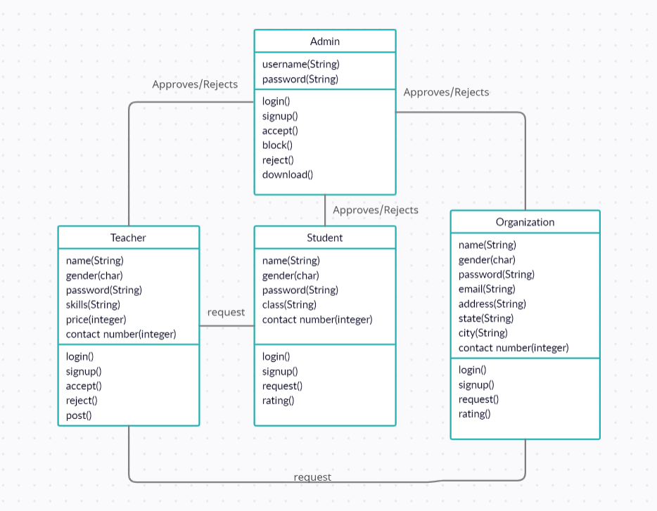

***4.1 Class Diagram***

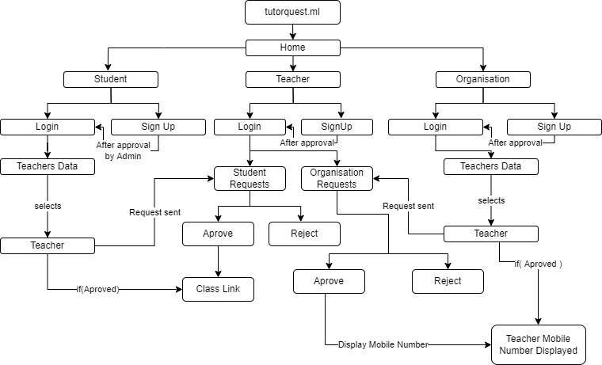

***4.2 Activity Diagram***

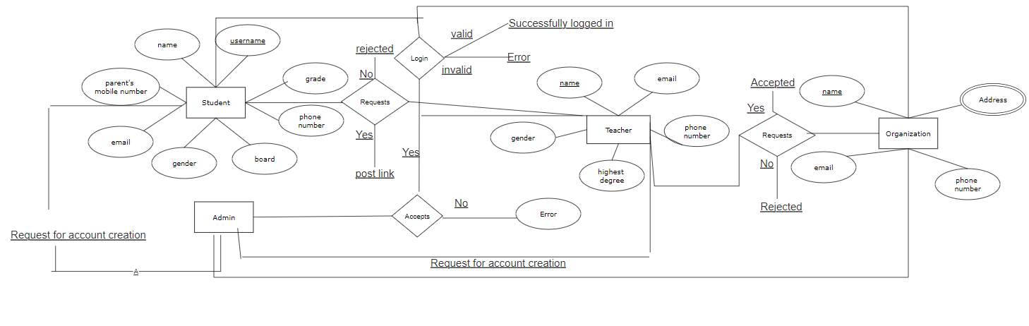

***4.3 ER Diagram***

**5. RESULTS AND DISCUSSIONS**

We created a web application for finding tutors online for students as well as organizations. It is made in such a way that is user-friendly, easy to use. Thorough verification of each is done i.e., teachers, students and organizations before getting registered on our web application. Admin is present who verifies if the user is valid by checking the documents uploaded by the them.

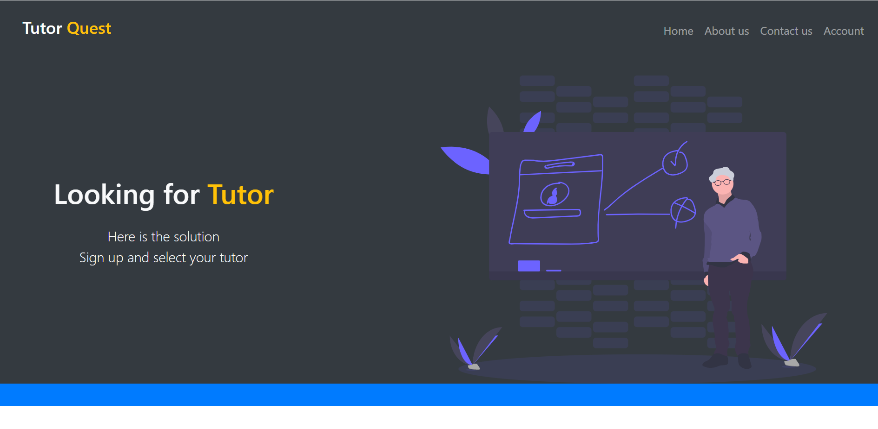

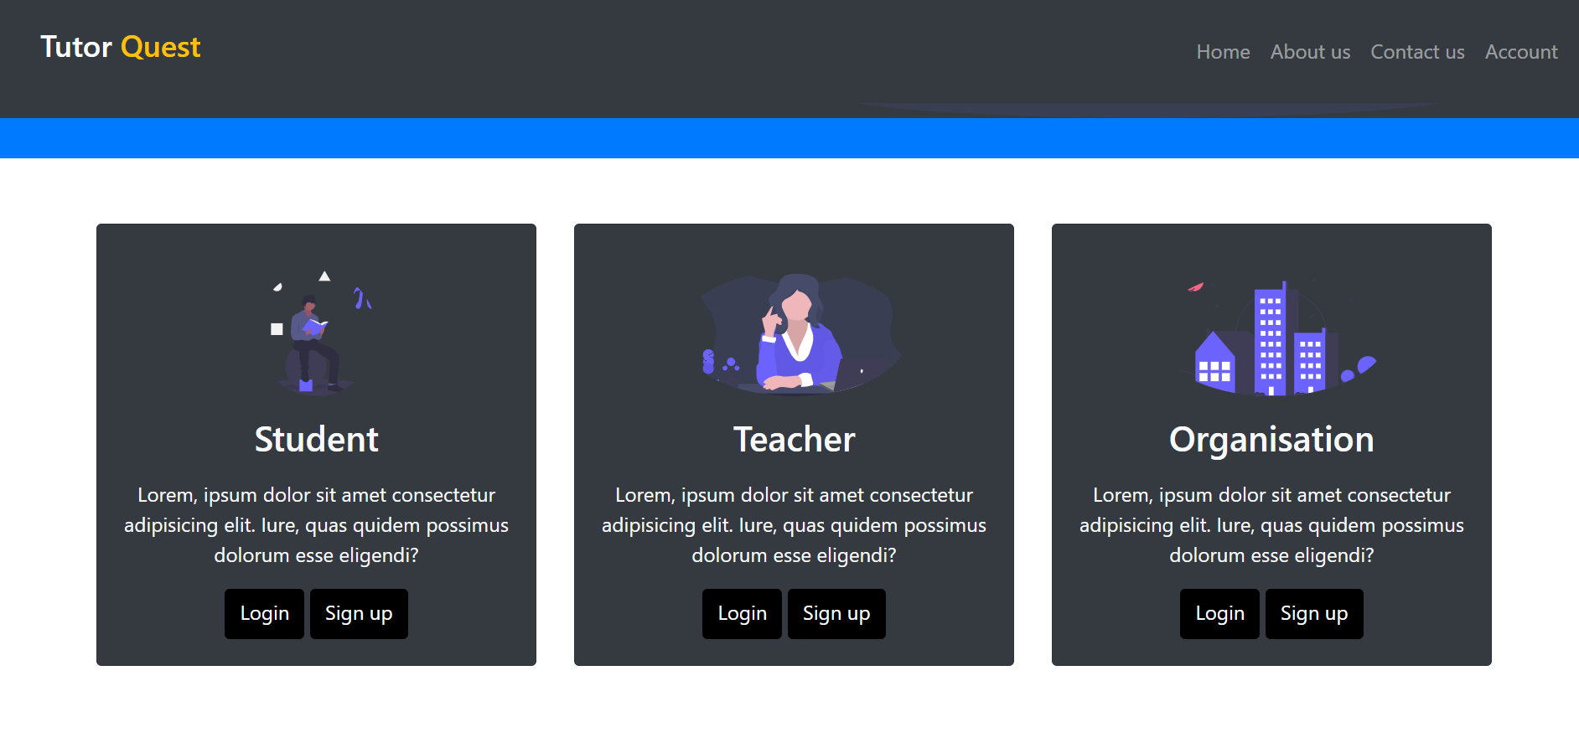

***Fig: 5.1: Home Page***

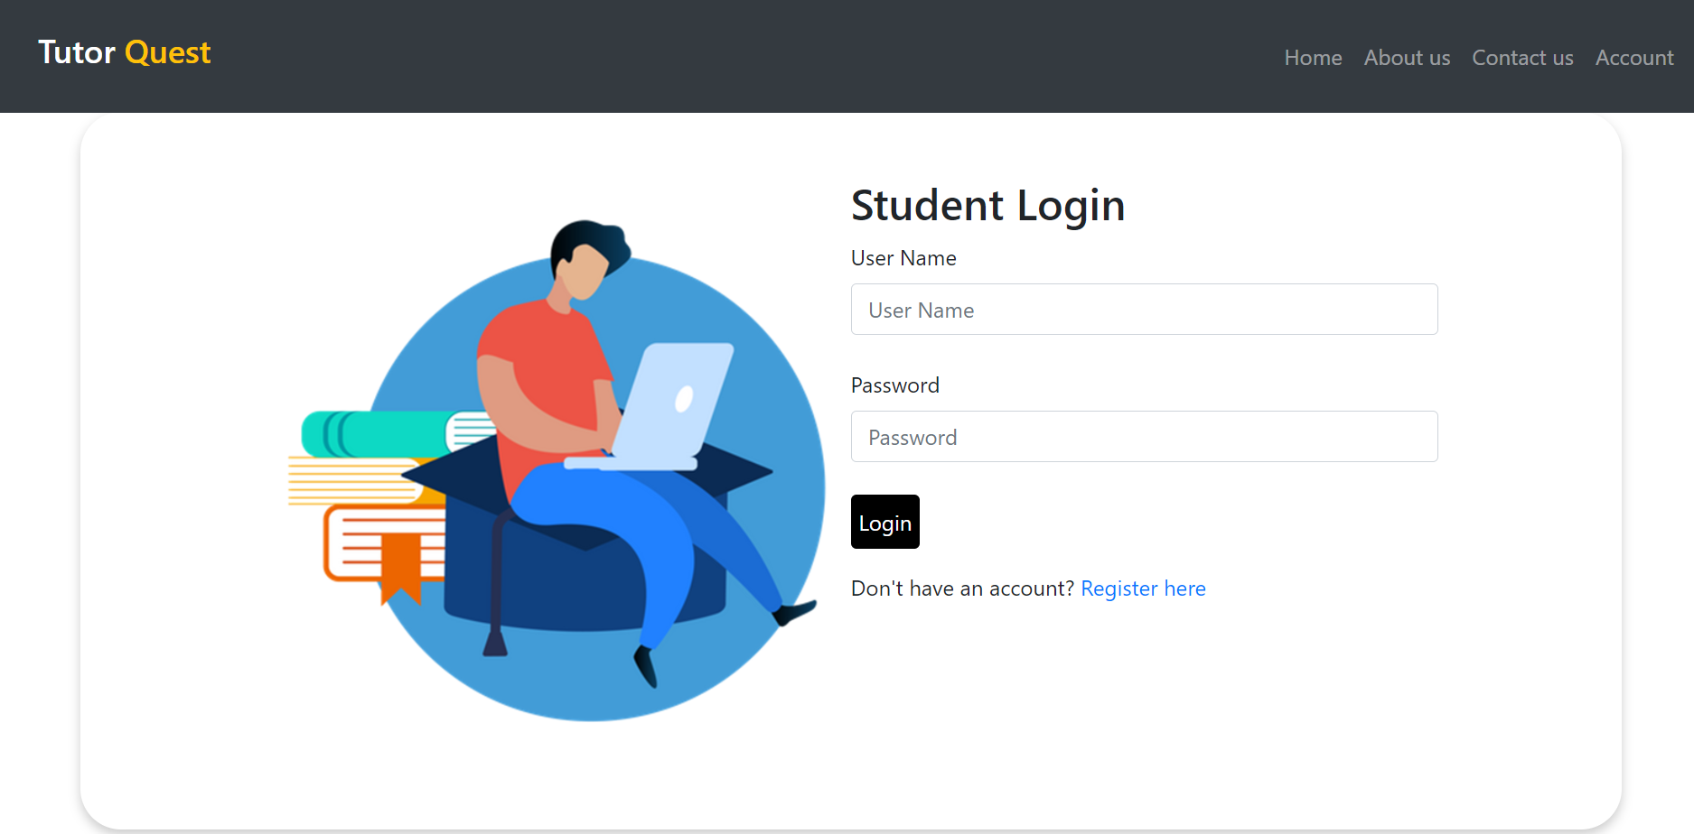

***Fig: 5.2: Student Login Page***

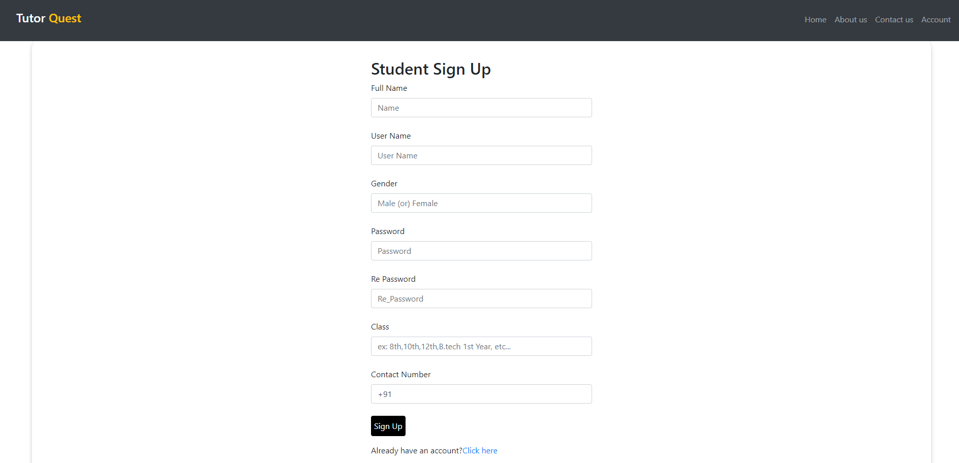

***Fig: 5.3: Student Sign Up Page***

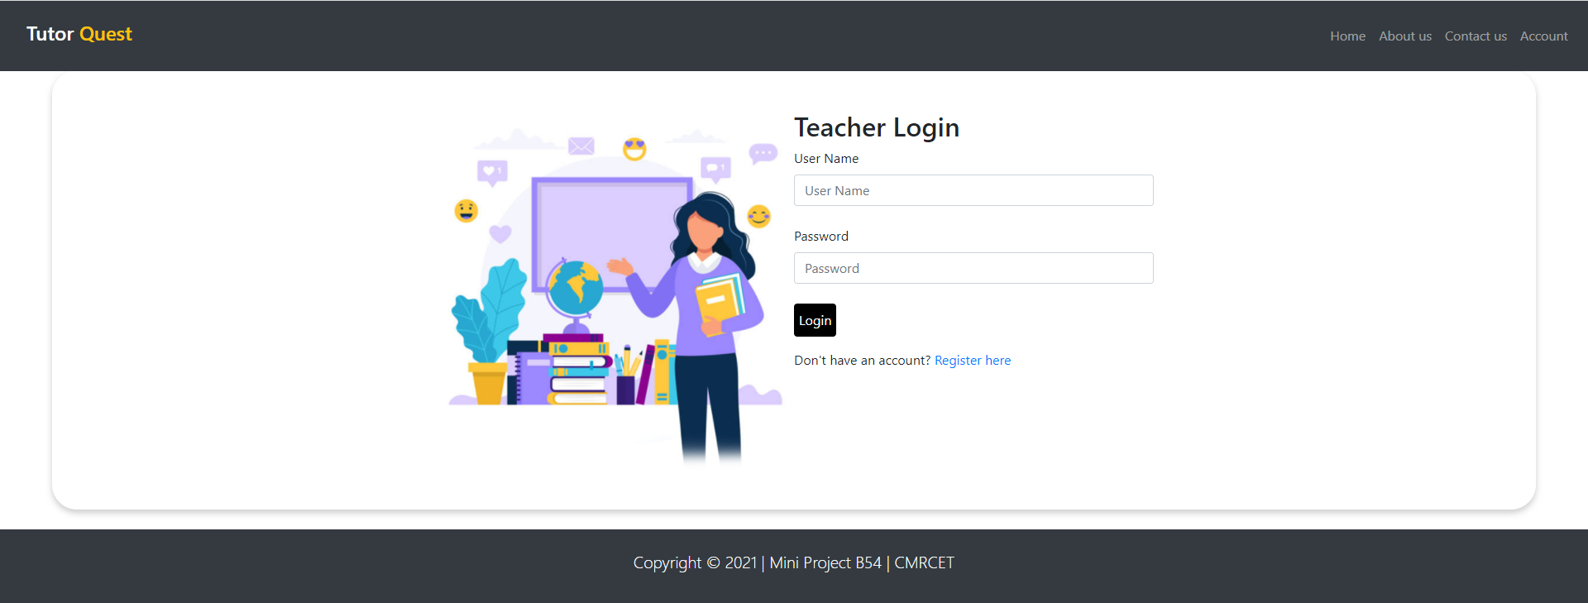

***Fig: 5.4: Teacher Login Page***

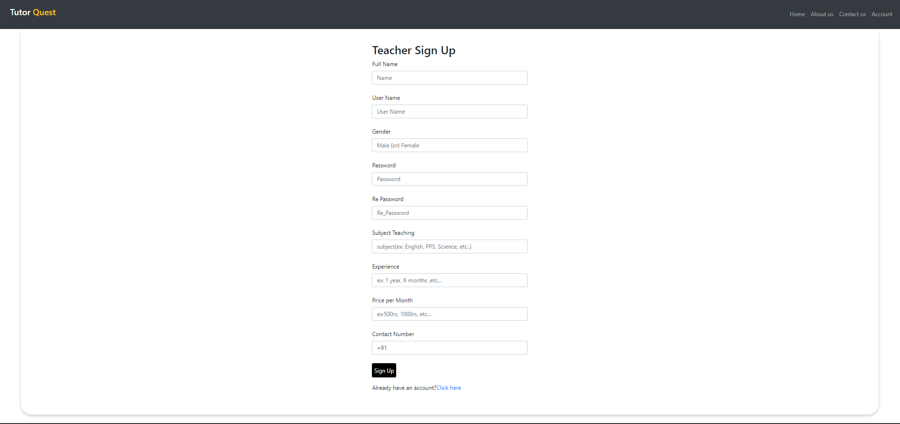

***Fig: 5.5: Teacher Sign Up Page***

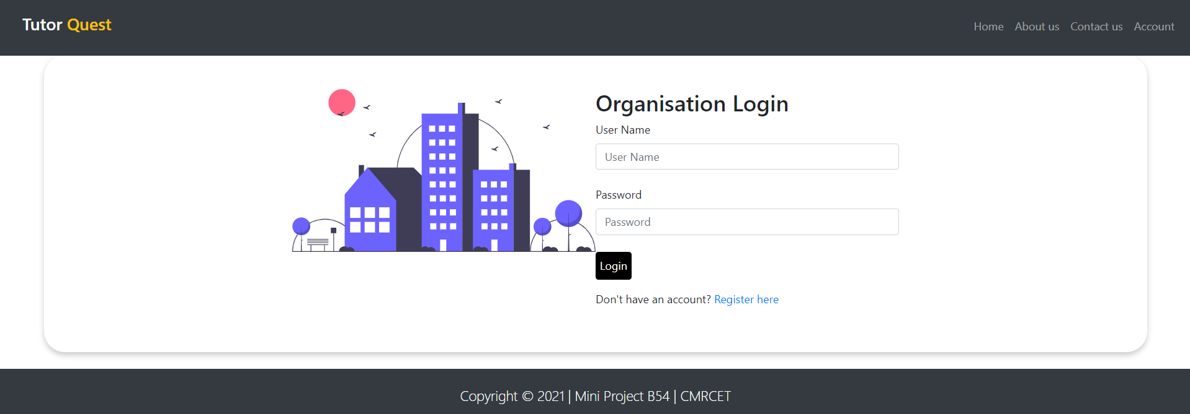

***Fig: 5.6: Organisation Login Page***

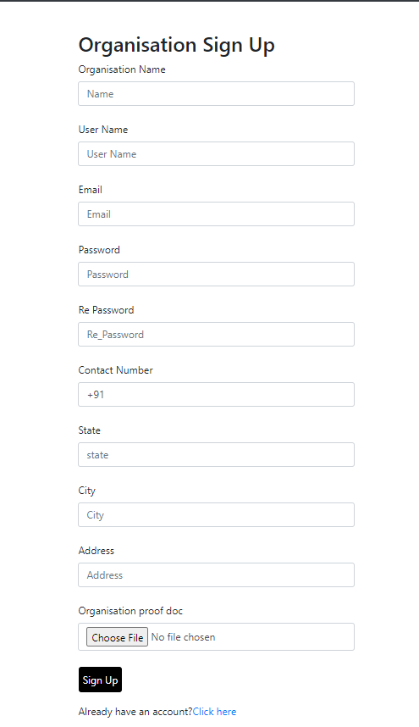

***Fig: 5.7: Organisation Sign Up Page***

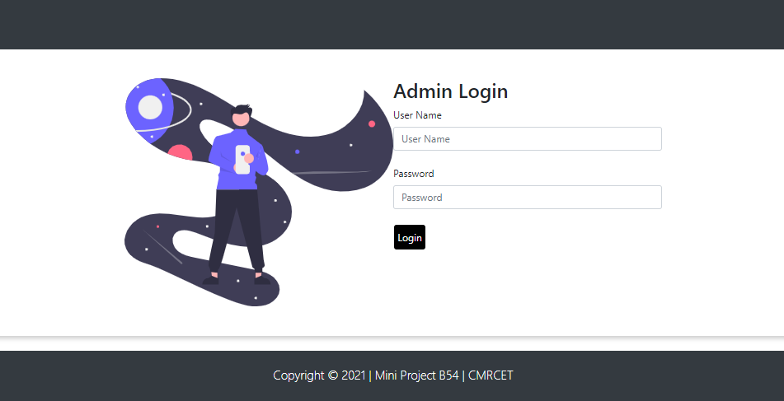

***Fig: 5.8: Admin Login Page***

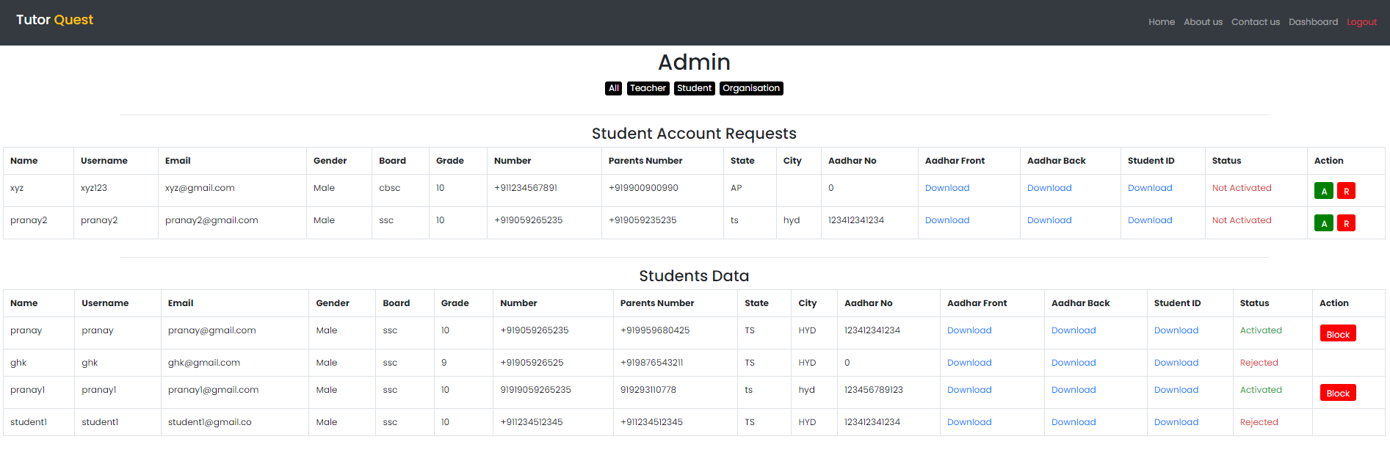

***Fig:5.8.1: Student’s Data and requests***

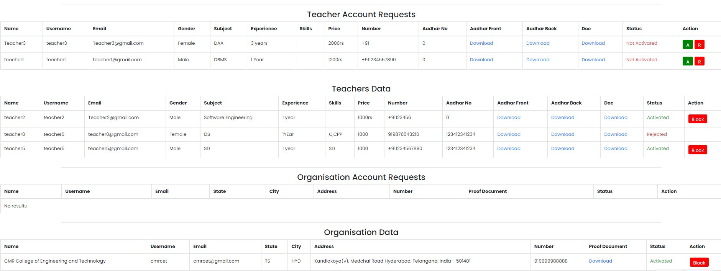

***Fig: 5.8.2: Teacher’s and Organisation’s Data and Requests***

**6. CONCLUSION AND FUTUREWORK**

**6.1 SUMMARY**

A platform for students who are passionate to learn new things, teachers who want to make future better by sharing their knowledge as well as making their ends meet and organization for recruiting teachers is made using HTML, CSS for front-end and PHP, MySQL for backend.

**6.2 FUTURE SCOPE**

* Try automating the verification process.
* Integrating the application with its own video conferencing software.
* Developing it further to make it scalable and reliable.

**7. REFERENCES**

1. <https://www.w3schools.com/php/>
2. <https://www.freepressjournal.in/viral/why-are-some-people-furious-with-byjus-whitehat-jr>
3. <https://www.weforum.org/agenda/2020/04/coronavirus-education-global-covid19-online-digital-learning/>
4. <https://www.edworkingpapers.com/sites/default/files/ai21-350.pdf>
5. <https://www.mysqltutorial.org/php-mysql/>
6. <https://www.siteground.com/tutorials/php-mysql/>
7. <https://developer.mozilla.org/en-US/docs/Learn/CSS>